*Ice – The World’s Most Important Resource That Is Literally Melting Away*

**Table of Contents –**

*Abstract* 2

*Ice Background/Importance* 3

*Climate Change Background/Importance*  3

*Save the Polar Bears* 4

*What has the World Done so Far?*  5

*How Can Future Climate Change be Stopped?* 6

*Conclusion*7

Abstract –

Ice has always played an important role in the earth’s climate. It serves one very important function, to reflect the sun’s heat and maintain homeostasis in the earth’s temperature. We all have heard about the melting ice caps at one point or another, but the unfortunate truth is that it is often forgotten about. The world is not doing its due diligence in preventing other forms of climate change, but ice tends to be a side of it that is frequently neglected altogether. Whether or not the change is reversable is up for debate, but we cannot ever truly understand if reversal is possible until we take the steps needed to prevent the melting. In this paper, I will be discussing the importance of ice, the importance of climate change, and present multiple ways to prevent the melting of the world’s ice. We do not have much time.

**Ice Background/Importance –**

Sea ice has long been one of the most important regulators of the world’s climate. The ice and snow that covers the north/south poles of the world reflect nearly 80-90% of all light that it contacts. This problem ‘snowballs,’ when you consider that when the exposed water is absorbing heat, it is heating the oceans which in turn cause more ice to melt.

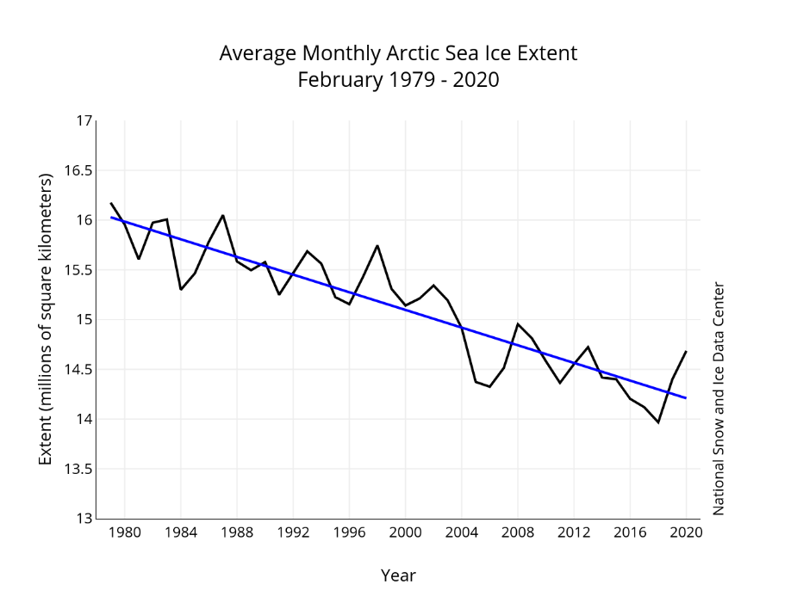While the ice on earth absorbs that 90% of light, water can only reflect close to 50% of the light. This shows how drastically important it is to provide as much reflection as possible.

https://nsidc.org/arcticseaicenews/files/2020/03/Figure3.png

This snowballing effect causes an intense sensitivity in the earth’s poles to the seasonal changes throughout the year. The National Snow and Ice Data Center can show the increasingly urgent need to reduce the melting of the world’s ice.

**Climate Change Background/Importance –**

Solving climate change and global warming has amazing upsides and affects more than is visible at face value. By addressing global warming, you can fix the warming itself, aid in the preservation of habitats (both warm and cold), and reduce unpredictable weather events that occur throughout the year. When the ice is melted away and water is left to absorb that heat, there are extreme impacts to not only the habitats that exist there, but also to habitats around the world. Not only are the colder environments impacted, other habitats are also affected by warmer seasons, extreme weather, and food webs.

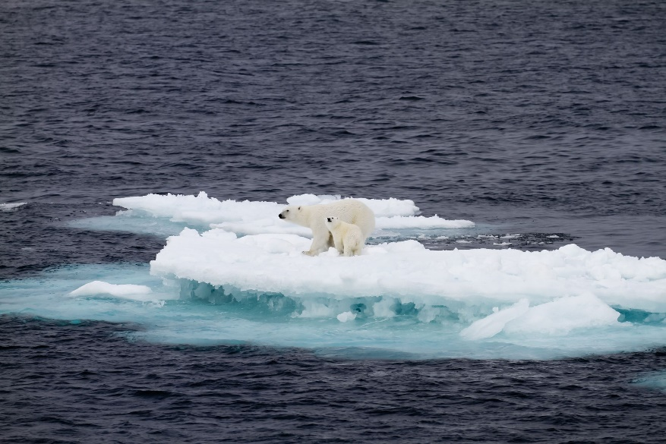**Save the Polar Bears –**

Not only can you save colder habitats like these, the benefits of fixing climate change go much further.

* Global temperatures are reduced when there is an ample amount of ice present to reflect the sun’s harsh beams.

https://www.thoughtco.com/thmb/9siqcgbL66Ochn8yTfoo3ThGnZ0=/2121x1414/filters:fill(auto,1)/GettyImages-155141288-5c513be646e0fb00014a2f4c.jpg

* 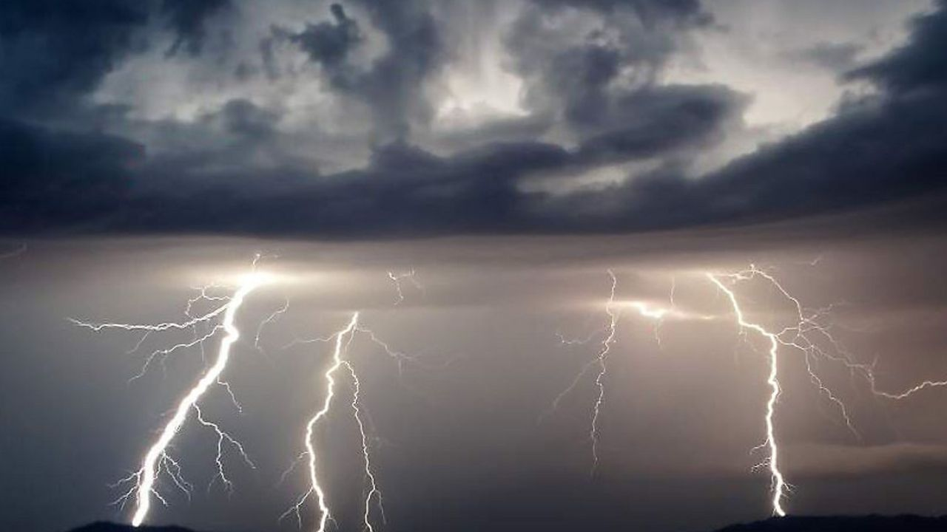By fixing the temperatures around the globe, you can also help to prevent the extreme weather patterns that have been afflicting humans significantly over the last few years. It’s not a coincidence.



* Not only could these habitats/storms be prevented, the biggest upside to addressing global ice melt is the chance that the harm that has been done could be reversed. We will never know until we try. Whether or not it is too expensive, it’s worth giving our earth a chance.

https://i.kym-cdn.com/photos/images/newsfeed/001/507/489/a11.png

**What has the World Done so Far? –**

Currently, there are a few things being done to prevent climate change. Without knowing what is already being done, we cannot know where to go next.

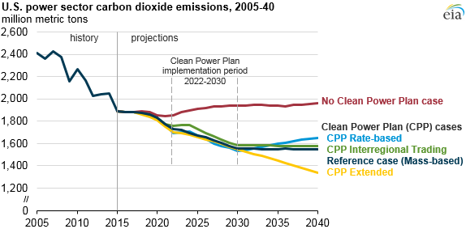One of the most effective ways that climate change has been indirectly addressed is through the efforts of the EPA. The Environmental Protection Agency has brought malpractice by businesses to the forefront of the political debate around the changing environment. Their global laws, which involve many different nations, have reduced emissions significantly.

https://www.eia.gov/todayinenergy/images/2016.06.21/main.png

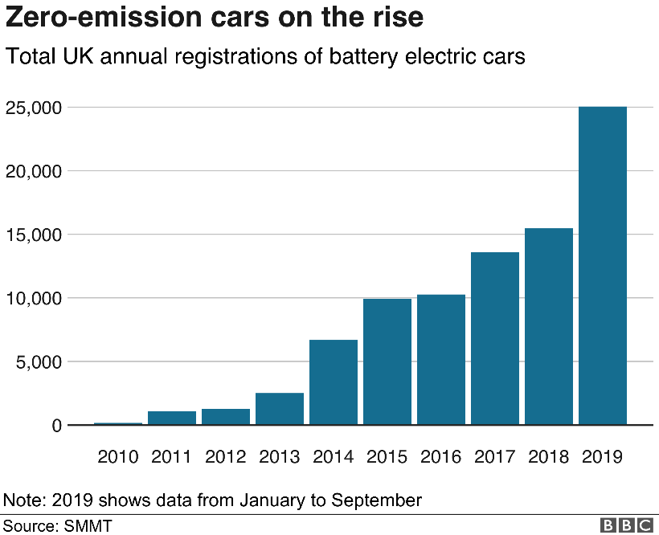Painting companies in a more positive light, the increasing popularity of using renewable energy has shown to be amazingly effective in not only reducing emissions, but also in changing the way that people thing about the environment. Through both the increase in renewable energy sources (solar, wind, electric), and the refinement of conventional energy sources (car mileage, etc) this is a step in the right direction.

https://ichef.bbci.co.uk/news/410/cpsprodpb/E395/production/_109316285_zeroemissioncars-nc.png

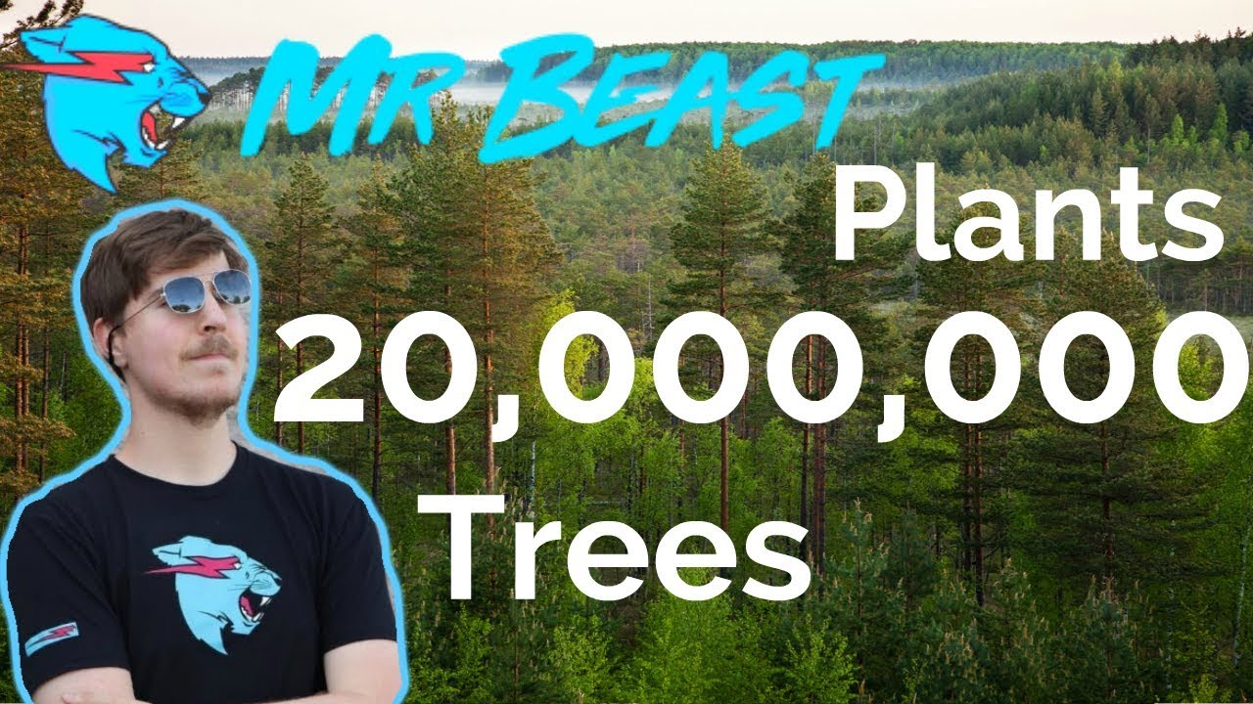Controlling carbon dioxide emissions through reusable and sustainable efforts is also extremely important. Though using better renewable energy sources is a great step, doing things such a reducing deforestation and focusing on reforestation would be a great way to sustain these changes. Fortunately, this idea has taken a hold of a wider audience namely v.i.a Mr Beast. A very popular youtuber, Mr Beast has planted over 20m trees worldwide. The video he posted received over 44 million views and has set a path for environmental awareness for all 44 million people. Changing people’s mindset about preserving the environment and preventing climate change is nearly just as important as the change itself.

https://i.ytimg.com/vi/XsidRedrSq0/maxresdefault.jpg

**How Can Future Climate Change be Stopped? –**

Using the previous example of how social media can be used to influence change, I’ll lead into my first suggestion as to how further change can be prevented.

***Influence –***

Through the influence of popular singers, actors, and even youtubers – there is such much potential in the effects they have on people’s mindsets. If someone like Mr Beast, a relatively unknown person for most of the population, can raise 21 million dollars, the effectiveness of real stars can be super effective. Work on contacting and reaching out to these pop figures could be extremely effective and should not be overlooked.

***Global Reach –***

Part of the reason this new route of spreading the message v.i.a influencers is so important is because of you, Greenpeace. Greenpeace is an organization that is involved world-wide in environment policy. Rather than only taking advantage of the audience in the US, like Mr. Beast did, Greenpeace can help to expand their message across the globe. The sustainability of the environmental movement us just as important as the message it sends. Once change is made, enough people have to care about the impacts of those changes. By involving influencers at a world level, we can better spread the message through people in their respective countries/cultures trust and are familiar with.

***Government Policy –***

Even though the EPA has made significant impacts on the way that companies are held accountable for their effects on the environment, more effort is required. Greenpeace as an organization has been at the forefront of environmental conservation, and proactively looking for more ways to unite people is a surefire way to help save the earth. This, in combination with increased support from people globally, should make a significant impact on the current path of the environment’s demise.

***Conclusion –***

All in all, ice is an extremely important part of the environment and has drastic effects on habitats, weather, and the globe’s temperature. Greenpeace can use its wide reach in order to gain the support of influencers across the world. Through the efforts of influencers and finding more ways to unite and educate people about climate change, someday maybe it will be stopped. Who knows, maybe then we will be able to reverse the detrimental effects that humans have had on it.