**HOME SCREEN**

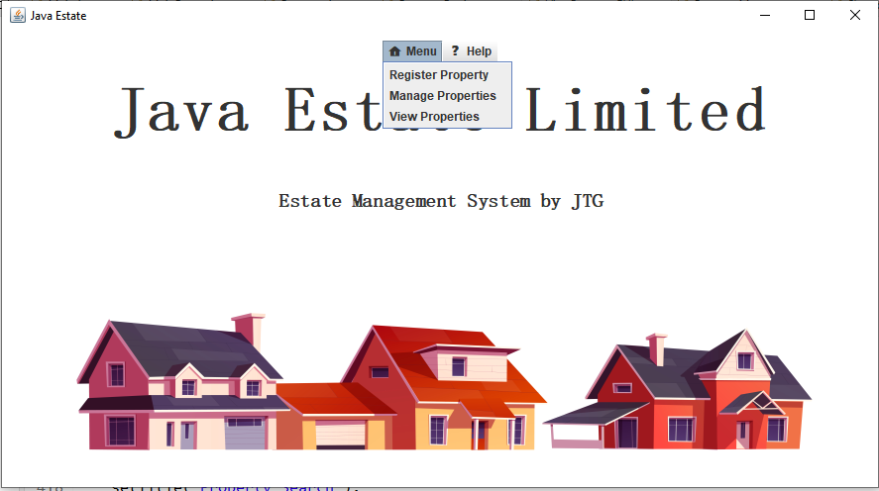

The home screen provides an intuitive interface for accessing the different sections of the application. The following sections are available:

1. Menu - This section allows you to perform various actions related to adding , managing(edit or delete) and view properties. The available options are:
   1. Register Property - This button allows you to register a new property by providing its details such as address, number of bedrooms and bathrooms, square footage, price, agent name, owner name, and images.
   2. Manage Properties - This button allows you to view and edit the details of existing properties, such as changing the price or updating the images.
   3. View Properties - This button allows you to view a list of all properties currently registered in the system.
2. Help - This section provides additional resources and support for using the application. The available options are:
   1. View User Documentation - This button provides access to detailed documentation on how to use the application and its features.
   2. Contact Coder - This button allows you to get in touch with the developer if you encounter any issues or have any suggestions for improving the application.

**PROPERTY REGISTRATION FORM**

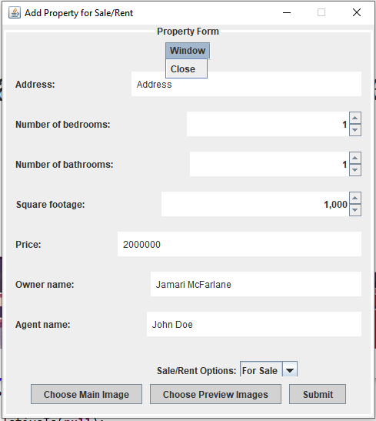

This section allows the user to add a new property to the database. The user needs to provide information about the property, including:

1. Address: The physical address of the property.
2. Bedrooms: The number of bedrooms in the property.
3. Bathrooms: The number of bathrooms in the property.
4. Square Footage: The total area of the land in square footage.
5. Price: The cost of the property for rent or sale.
6. Type: Whether the property is for sale or rent.
7. Owner Name: The name of the owner of the property.
8. Agent Name: The name of the agent representing the property.
9. Preview Images: A collection of images of the property's interior.
10. Main Image: An image of the property's exterior.

Once all the information has been entered, the user can click the "Add Property" button to save the property to the database.

**PROPERTY MANAGEMENT SCREEN**

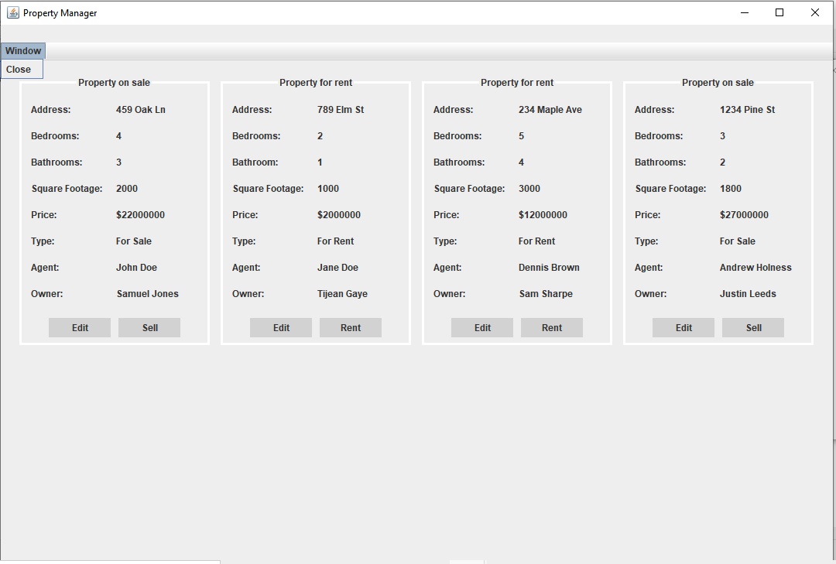

The Property Manager allows the user to make changes to specific properties in the database. It provides a listing of properties and allows the user to:

1. Sell or rent (delete) a property
2. Edit attributes of a property such as:
   1. Address of the property
   2. Number of bathrooms in the property
   3. Number of bedrooms in the property
   4. Area of the land of the property in square footage
   5. Price of the property for rent or sale
   6. Type of property (is it for sale or is a rental property?)
   7. Name of the owner
   8. Name of the agent
   9. Preview images (interior of the house)
   10. Main image (exterior of the house)

**EDIT PROPERTY FORM**  
  
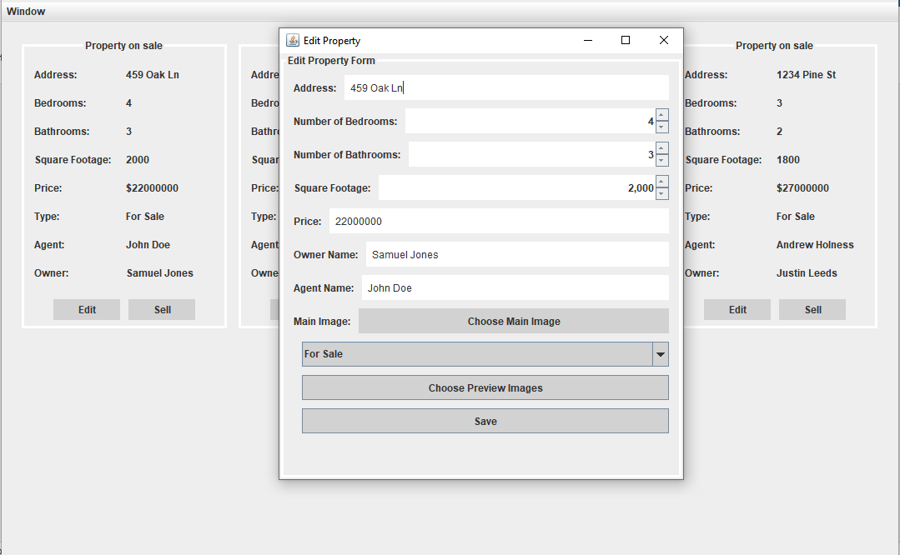

When you click on the "edit" button for a specific property, the data for that property is automatically loaded into the form by default. This means that you don't have to manually enter all the information again, which makes it easier to edit the property quickly and efficiently.

If you make changes to the information in the form and save it, the old property will be replaced by the updated version. This means that any changes you make will be reflected in the system and the previous version will no longer be accessible.

**PROPERTY RENT OR SELL OPTION**

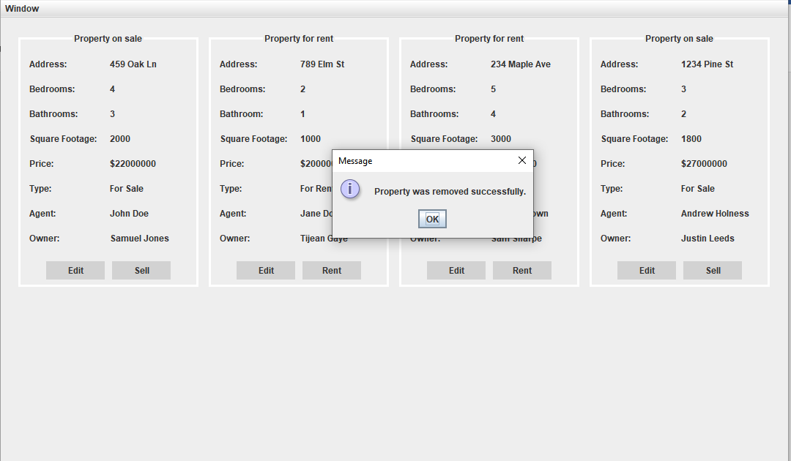

The management section of our platform provides also users with the ability to rent or sell their properties. Once a property has been sold or rented, the "sell/rent" button for that property will be greyed out. This indicates that the property has been removed from the available properties database and is no longer available for rent or sale.

This feature helps to ensure that potential renters or buyers do not waste their time or effort inquiring about a property that is no longer available. It also helps to keep our database up-to-date and accurate, which benefits both property owners and those searching for properties.

**VIEW PROPERTY LISTING SCREEN**

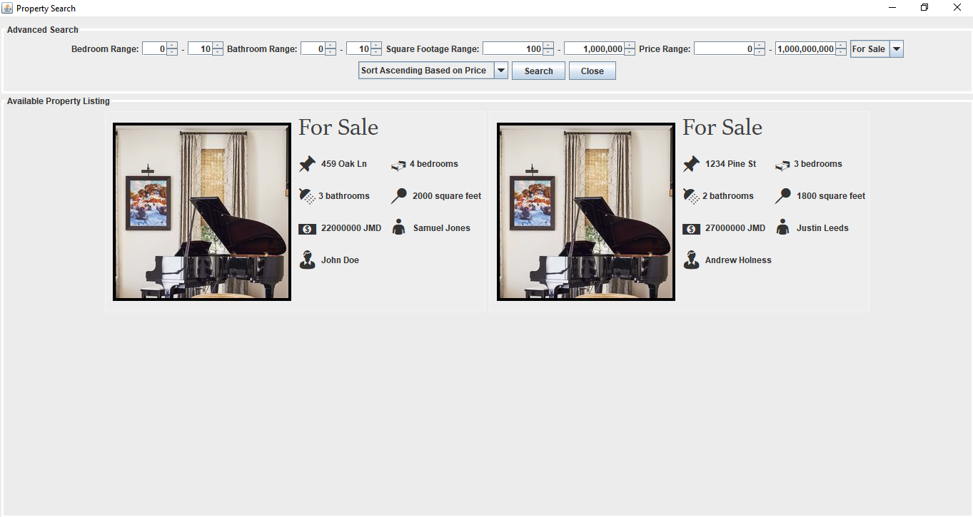

In this section, users can view the different properties that our company has up for sale or rent. We also provide an advanced feature that allows users to filter the properties based on various attributes, making it easier to find properties that meet their specific needs.

The filter functionality allows users to narrow down their search results by selecting specific criteria. Users can filter properties based on the number of bedrooms and bathrooms they have, within a range that the user can specify. Additionally, users can filter properties based on square footage and price.

By using these filters, users can quickly and easily find properties that meet their specific requirements, making the property search process more efficient and effective.

**HELP SECTION**

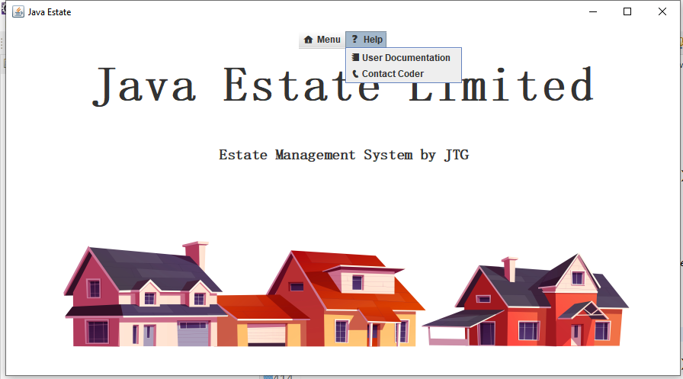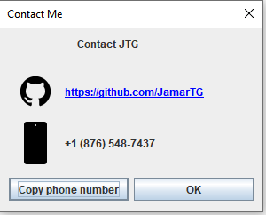

Our help menu contains two buttons that provide users with important information and resources.

The view “documentation” button allows users to access the documentation of the system. This documentation provides an overview of the system's functionality and features, as well as detailed instructions on how to use each feature. This documentation can be a helpful resource for users who are new to the system or need assistance with specific tasks.

The “contact creator” button allows users to view the contact information of the creator of the software. This information can be useful for users who need to report issues or provide feedback, or for those who have questions or concerns that they would like to address directly with the creator of the software.