By Jamarcus Orr Williams

|  |  |  |  |  |
| --- | --- | --- | --- | --- |
| Test case # | Input | Actual Input | Expected Output | Actual output |
| 1 | Wind Chill Calculator  Please enter the temperature in Fahrenheit (must be &gt;= -45 and &lt;= 40): 20  Please enter the wind speed (must be &gt;= 5 and &lt;= 60): 55 | Wind Chill Calculator  Please enter the temperature in Fahrenheit (must be &gt;= -45 and &lt;= 40): 20  Please enter the wind speed (must be &gt;= 5 and &lt;= 60): 55 | Wind chill temperature:  -3.4748397706315686  degrees Fahrenheit  Programmer name: Jamarcus Orr Williams | The Wind chill temperature is : -3.4748397706315686 degrees Fahrenheit.  Programmer name: Jamarcus Orr Williams |
| 2 | Wind Chill Calculator  Please enter the temperature in Fahrenheit (must be &gt;= -45 and &lt;= 40): 10  Please enter the wind speed (must be &gt;= 5 and &lt;= 60): 35 | Wind Chill Calculator  Please enter the temperature in Fahrenheit (must be &gt;= -45 and &lt;= 40): 10  Please enter the wind speed (must be &gt;= 5 and &lt;= 60): 35 | Wind chill temperature:  -13.63755390792145  degrees Fahrenheit | The Wind chill temperature is : -13.63755390792145 degrees Fahrenheit.  Programmer name: Jamarcus Orr Williams |
| 3 | Wind Chill Calculator  Please enter the temperature in Fahrenheit (must be &gt;= -45 and &lt;= 40): -15  Please enter the wind speed (must be &gt;= 5 and &lt;= 60): 45 | Wind Chill Calculator  Please enter the temperature in Fahrenheit (must be &gt;= -45 and &lt;= 40): -15  Please enter the wind speed (must be &gt;= 5 and &lt;= 60): 45 | Wind chill temperature:  degrees Fahrenheit |  |

|  |  |
| --- | --- |
| Psuedocode | Java code |
| Initializes the temperature and wind speed variable.  Prompts the user for temperature input.  Gets the users input for temperature.  Checks to verify that the users’ input meets the requirement.  Prints error message.  Prompts the user for wind speed.  Gets users’ input.  Checks to verify that the users’ input meets the requirement.  Prints error message.  Calculates Wind Chill  Prints Wind chill  Prints Programmer name | import java.util.Scanner;  public class Windchill {  public static void main(String[] args) {  // TODO Auto-generated method stub    double tempInfar ,windmph;    System.out.println("Please enter the temperature in Fahrenheit (must be >= -45 and <= 40):");  Scanner imput = new Scanner(System.in);      tempInfar = imput.nextDouble();    if (tempInfar < -45 || tempInfar > 40 )    {    System.out.println("Please enter valid temperature in Fahrenheit.(must be >= -45 and <= 40): ");    }    else    {    System.out.println("Please enter the wind speed (must be >= 5 and <= 60):");    Scanner imput2 = new Scanner(System.in);  windmph = imput2.nextDouble();    if ( windmph < 5 || windmph > 60 )    {    System.out.println("Please enter valid wind speed.(must be >= 5 and <= 60): ");    }    else    {  windChill = 35.74 + 0.6215* tempInfar + (0.4275* tempInfar - 35.75) * Math.pow(windmph , 0.16);    System.out.println("\nThe Wind chill temperature is : "+ windChill + " degrees Fahrenheit.\n");    System.out.println("Programmer name: Jamarcus Orr Williams\n");    }        }  }  } |

Test 1

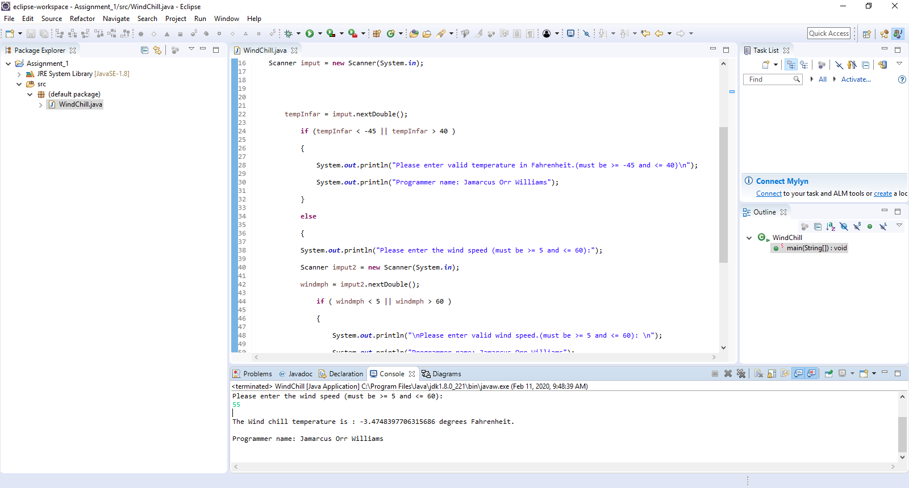

Test 2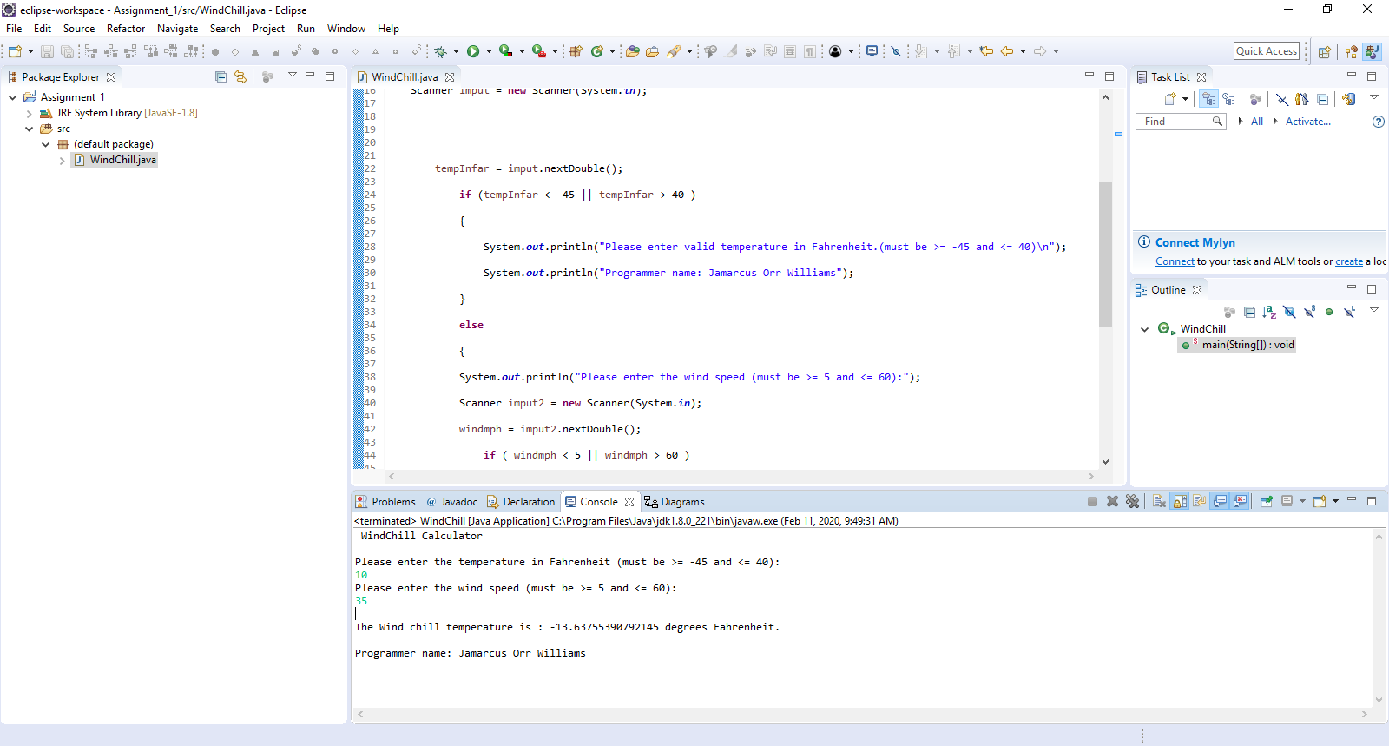

Test 3

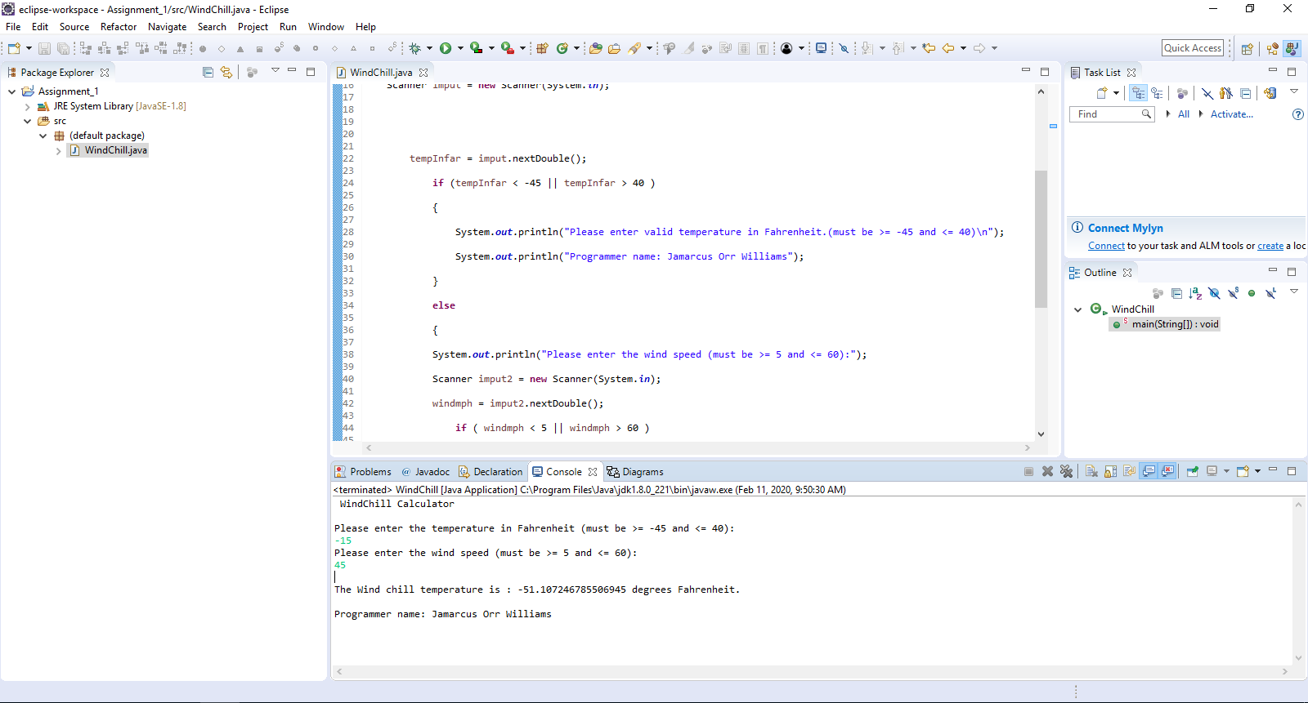

Command line 1

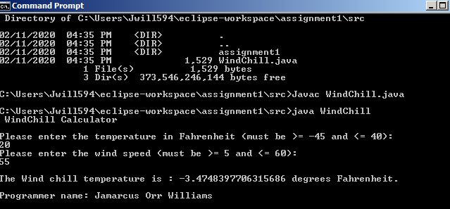

Command line 2

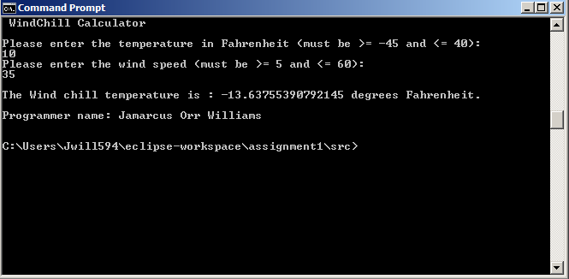

Command line 3

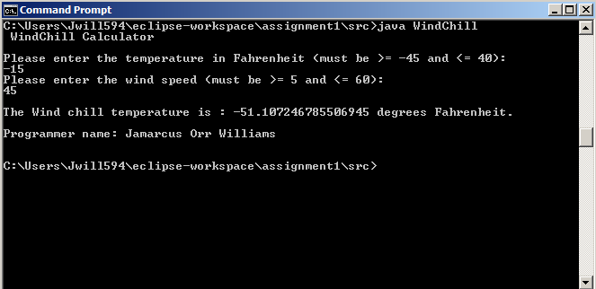

Learning Experience:

I learned how to use the scanner class and how to correctly get input from the user using the scanner class I also learned how to use the if statement in Java and how to use the conditional operators. It was a challenge using the command line but I asked for help and got the screen chots needed for the project.