**App working screenshot**

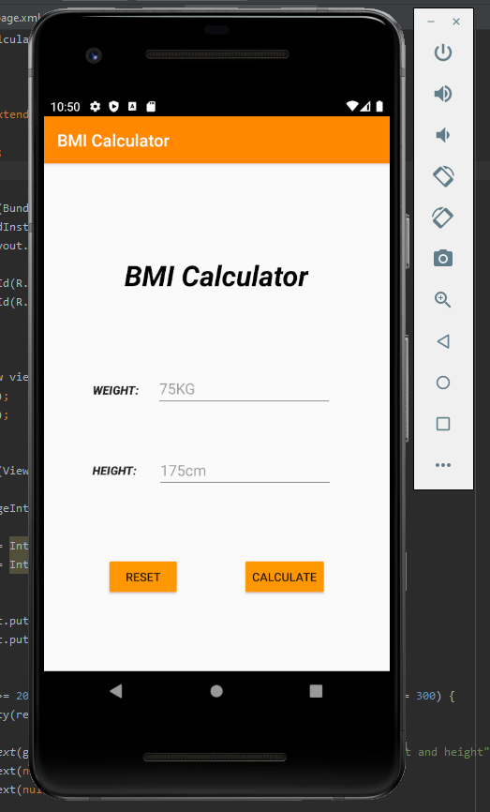

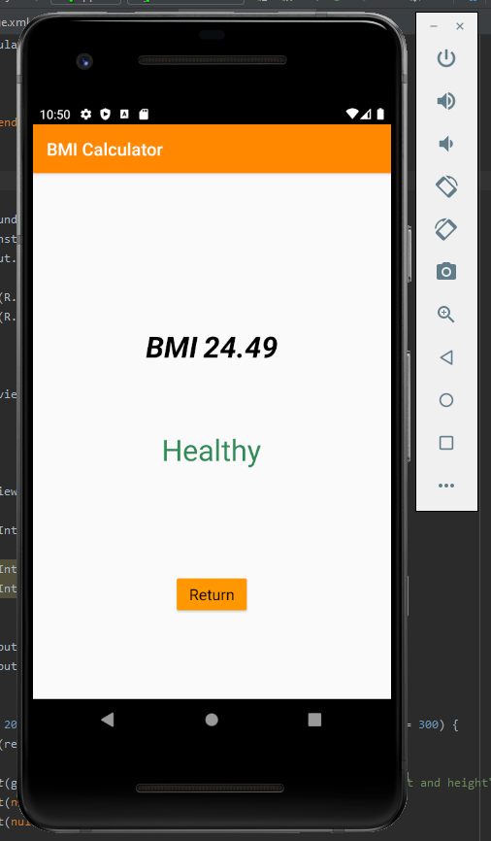

**Activitry_main.xml code**

*<?***xml version="1.0" encoding="utf-8"***?>*<**androidx.constraintlayout.widget.ConstraintLayout xmlns:android="http://schemas.android.com/apk/res/android"  
 xmlns:app="http://schemas.android.com/apk/res-auto"  
 xmlns:tools="http://schemas.android.com/tools"  
 android:layout_width="match_parent"  
 android:layout_height="match_parent"  
 tools:context=".MainActivity"**>  
  
 <**TextView  
 android:id="@+id/titleHeading"  
 android:layout_width="wrap_content"  
 android:layout_height="wrap_content"  
 android:layout_marginStart="94dp"  
 android:layout_marginTop="110dp"  
 android:layout_marginEnd="95dp"  
 android:accessibilityHeading="true"  
 android:text="BMI Calculator"  
 android:textAllCaps="false"  
 android:textAppearance="@style/TextAppearance.AppCompat.Display1"  
 android:textColor="#000000"  
 android:textStyle="bold|italic"  
 app:layout_constraintEnd_toEndOf="parent"  
 app:layout_constraintStart_toStartOf="parent"  
 app:layout_constraintTop_toTopOf="parent"** />  
  
 <**EditText  
 android:id="@+id/etWeight"  
 android:layout_width="wrap_content"  
 android:layout_height="wrap_content"  
 android:layout_marginTop="90dp"  
 android:layout_marginEnd="68dp"  
 android:ems="10"  
 android:hint="75KG"  
 android:inputType="number"  
 android:visibility="visible"  
 app:layout_constraintEnd_toEndOf="parent"  
 app:layout_constraintTop_toBottomOf="@+id/titleHeading"** />  
  
 <**EditText  
 android:id="@+id/etHeight"  
 android:layout_width="wrap_content"  
 android:layout_height="wrap_content"  
 android:layout_marginTop="52dp"  
 android:layout_marginEnd="67dp"  
 android:ems="10"  
 android:hint="175cm"  
 android:inputType="number"  
 app:layout_constraintEnd_toEndOf="parent"  
 app:layout_constraintTop_toBottomOf="@+id/etWeight"** />  
  
 <**TextView  
 android:id="@+id/textView2"  
 android:layout_width="wrap_content"  
 android:layout_height="wrap_content"  
 android:layout_marginStart="53dp"  
 android:layout_marginTop="104dp"  
 android:layout_marginEnd="16dp"  
 android:text="WEIGHT:"  
 android:textAppearance="@style/TextAppearance.AppCompat.Body2"  
 android:textStyle="bold|italic"  
 app:layout_constraintEnd_toStartOf="@+id/etWeight"  
 app:layout_constraintHorizontal_bias="0.555"  
 app:layout_constraintStart_toStartOf="parent"  
 app:layout_constraintTop_toBottomOf="@+id/titleHeading"** />  
  
 <**TextView  
 android:id="@+id/textView3"  
 android:layout_width="wrap_content"  
 android:layout_height="wrap_content"  
 android:layout_marginStart="58dp"  
 android:layout_marginTop="76dp"  
 android:layout_marginEnd="16dp"  
 android:text="HEIGHT:"  
 android:textAppearance="@style/TextAppearance.AppCompat.Body2"  
 android:textStyle="bold|italic"  
 app:layout_constraintEnd_toStartOf="@+id/etHeight"  
 app:layout_constraintHorizontal_bias="0.0"  
 app:layout_constraintStart_toStartOf="parent"  
 app:layout_constraintTop_toBottomOf="@+id/textView2"** />  
  
 <**Button  
 android:id="@+id/btnCalculate"  
 android:layout_width="wrap_content"  
 android:layout_height="wrap_content"  
 android:layout_marginBottom="88dp"  
 android:backgroundTint="#FF9800"  
 android:onClick="doCalculate"  
 android:text="Calculate"  
 app:layout_constraintBottom_toBottomOf="parent"  
 app:layout_constraintEnd_toEndOf="parent"  
 app:layout_constraintHorizontal_bias="0.5"  
 app:layout_constraintStart_toEndOf="@+id/btnReset"** />  
  
 <**Button  
 android:id="@+id/btnReset"  
 android:layout_width="wrap_content"  
 android:layout_height="wrap_content"  
 android:layout_marginBottom="88dp"  
 android:backgroundTint="#FF9800"  
 android:onClick="doReset"  
 android:text="Reset"  
 app:layout_constraintBottom_toBottomOf="parent"  
 app:layout_constraintEnd_toStartOf="@+id/btnCalculate"  
 app:layout_constraintHorizontal_bias="0.5"  
 app:layout_constraintStart_toStartOf="parent"** />  
  
</**androidx.constraintlayout.widget.ConstraintLayout**>

**Activity_result_page.xml code**

*<?***xml version="1.0" encoding="utf-8"***?>*<**androidx.constraintlayout.widget.ConstraintLayout xmlns:android="http://schemas.android.com/apk/res/android"  
 xmlns:app="http://schemas.android.com/apk/res-auto"  
 xmlns:tools="http://schemas.android.com/tools"  
 android:id="@+id/tvResultMessage"  
 android:layout_width="match_parent"  
 android:layout_height="match_parent"  
 tools:context=".ResultPage"**>  
  
 <**Button  
 android:id="@+id/btn"  
 android:layout_width="wrap_content"  
 android:layout_height="wrap_content"  
 android:layout_marginStart="162dp"  
 android:layout_marginEnd="162dp"  
 android:layout_marginBottom="96dp"  
 android:backgroundTint="#FF9800"  
 android:onClick="doBack"  
 android:text="Return"  
 android:textAppearance="@style/TextAppearance.AppCompat.Medium"  
 android:textColor="#000000"  
 app:layout_constraintBottom_toBottomOf="parent"  
 app:layout_constraintEnd_toEndOf="parent"  
 app:layout_constraintHorizontal_bias="0.514"  
 app:layout_constraintStart_toStartOf="parent"** />  
  
 <**TextView  
 android:id="@+id/tvInfoMessage"  
 android:layout_width="0dp"  
 android:layout_height="wrap_content"  
 android:layout_marginStart="130dp"  
 android:layout_marginTop="176dp"  
 android:layout_marginEnd="176dp"  
 android:text="BMI"  
 android:textAppearance="@style/TextAppearance.AppCompat.Display1"  
 android:textColor="#000000"  
 android:textStyle="bold|italic"  
 app:layout_constraintEnd_toEndOf="parent"  
 app:layout_constraintHorizontal_bias="0.0"  
 app:layout_constraintStart_toStartOf="parent"  
 app:layout_constraintTop_toTopOf="parent"** />  
  
 <**TextView  
 android:id="@+id/tvBMI"  
 android:layout_width="wrap_content"  
 android:layout_height="wrap_content"  
 android:layout_marginTop="176dp"  
 android:layout_marginEnd="169dp"  
 android:textAlignment="center"  
 android:textAppearance="@style/TextAppearance.AppCompat.Display1"  
 android:textColor="#000000"  
 android:textStyle="bold|italic"  
 app:layout_constraintEnd_toEndOf="parent"  
 app:layout_constraintStart_toEndOf="@+id/tvInfoMessage"  
 app:layout_constraintTop_toTopOf="parent"** />  
  
 <**TextView  
 android:id="@+id/tvFinalBMI"  
 android:layout_width="wrap_content"  
 android:layout_height="wrap_content"  
 android:layout_marginStart="136dp"  
 android:layout_marginEnd="137dp"  
 android:textAppearance="@style/TextAppearance.AppCompat.Display1"  
 app:layout_constraintBottom_toTopOf="@+id/btn"  
 app:layout_constraintEnd_toEndOf="parent"  
 app:layout_constraintStart_toStartOf="parent"  
 app:layout_constraintTop_toBottomOf="@+id/tvInfoMessage"  
 app:layout_constraintVertical_bias="0.38"** />  
  
</**androidx.constraintlayout.widget.ConstraintLayout**>

**MainActivity.java code**

**package** jamie.itsligo.bmicalculator;  
  
**import** androidx.appcompat.app.AppCompatActivity;  
  
**import** android.content.Intent;  
**import** android.os.Bundle;  
**import** android.view.View;  
**import** android.widget.EditText;  
**import** android.widget.Toast;  
  
**public class** MainActivity **extends** AppCompatActivity {  
  
 EditText **weight**, **height**;  
  
 @Override  
 **protected void** onCreate(Bundle savedInstanceState) {  
 **super**.onCreate(savedInstanceState);  
 setContentView(R.layout.***activity_main***);  
  
 **weight** = findViewById(R.id.***etWeight***);  
 **height** = findViewById(R.id.***etHeight***);  
  
 }  
  
 **public void** doReset(View view) {  
 **weight**.setText(**null**);  
 **height**.setText(**null**);  
 }  
  
 **public void** doCalculate(View view) {  
  
 Intent resultPageIntent = **new** Intent(view.getContext(), ResultPage.**class**);  
  
 **int** heightCalc = Integer.*valueOf*(**height**.getText().toString());  
 **int** weightCalc = Integer.*valueOf*(**weight**.getText().toString());  
  
  
 resultPageIntent.putExtra(**"WeightPassed"**, weightCalc);  
 resultPageIntent.putExtra(**"HeightPassed"**, heightCalc);  
  
  
 **if** (weightCalc >= 20 && weightCalc <= 200 && heightCalc >= 80 && heightCalc <= 300) {  
 startActivity(resultPageIntent);  
 } **else** {  
 Toast.*makeText*(getApplicationContext(), **"Please enter a usable weight and height"**, Toast.***LENGTH_LONG***).show();  
 **weight**.setText(**null**);  
 **height**.setText(**null**);  
 }  
  
  
  
  
 }  
}

**ResultPage.java code**

**package** jamie.itsligo.bmicalculator;  
  
**import** androidx.appcompat.app.AppCompatActivity;  
  
**import** android.content.Intent;  
**import** android.graphics.Color;  
**import** android.os.Bundle;  
**import** android.view.View;  
**import** android.widget.EditText;  
**import** android.widget.TextView;  
  
**import** java.text.DecimalFormat;  
  
**public class** ResultPage **extends** AppCompatActivity {  
  
 **double w** = 0, **h** = 0,**hCalc** = 0,**finalCalc** = 0, **RoundCalc** = 0;  
 String **under** = **"Underweight"**,**healthy** = **"Healthy"**,**ovewrweight** = **"Overweight"**,**obese** = **"Obese"**;  
  
 TextView **BMI**, **Result**;  
  
 @Override  
 **protected void** onCreate(Bundle savedInstanceState) {  
 **super**.onCreate(savedInstanceState);  
 setContentView(R.layout.***activity_result_page***);  
  
 *// link the xml to the local variables* **BMI** = findViewById(R.id.***tvBMI***);  
 **Result** = findViewById(R.id.***tvFinalBMI***);  
  
  
 *// just woke up  
 // look into the pipe* **w** = getIntent().getIntExtra(**"WeightPassed"**, 0 );  
 **h** = getIntent().getIntExtra(**"HeightPassed"**, 0);  
  
 *//formula KG / meters squared* **hCalc** = **h** / 100;  
  
 **finalCalc** = (**w**/(**hCalc**\***hCalc**));  
  
 DecimalFormat f = **new** DecimalFormat(**"##.00"**);  
  
 *// displaying the data in the text views on the screen* **BMI**.setText(String.*valueOf*(f.format(**finalCalc**)));  
  
 **if** (**finalCalc** < 18.5){  
 **Result**.setText(**under**);  
 **Result**.setTextColor(Color.*rgb*(0,191,255));  
  
 } **else if**(**finalCalc** >= 18.5 && **finalCalc** <= 24.9 ) {  
 **Result**.setText(**healthy**);  
 **Result**.setTextColor(Color.*rgb*(46,139,87));  
 } **else if**(**finalCalc** >= 25 && **finalCalc** <= 29.9 ) {  
 **Result**.setText(**ovewrweight**);  
 **Result**.setTextColor(Color.*rgb*(252,165,0));  
 } **else** {  
 **Result**.setText(**obese**);  
 **Result**.setTextColor(Color.*rgb*(255,44,0));  
 }  
  
  
 }  
  
 **public void** doBack(View view) {  
 Intent mainActivityIntent = **new** Intent(view.getContext(), MainActivity.**class**);  
 startActivity(mainActivityIntent);  
 }  
}

**Conclusion**

**• State if you completed the lab or how far you managed to get**

I completed the lab in full.

**• State the part of the lab you spent the most time on or what issue was the hardest to overcome**

The area of the lab I spent the most time on was the overall tidying up and creating a appealing look and feel to the app. The hardest part of the lab was getting the constraints to do what I wanted them to do.

**• Specify a goal for yourself for next time**

From this lab I noticed that I was not as comfortable with Constraints as I originally thought I was at the beginning. My plan is to possibly read some documentation to help gain a better knowledge of the constraints mechanic and how to use them properly.