**App working screenshot**

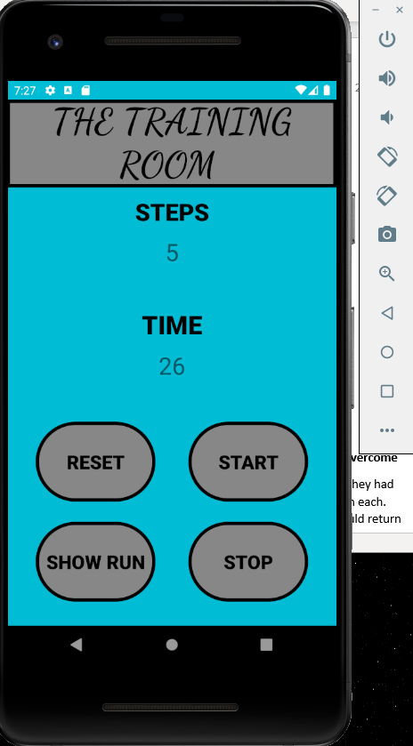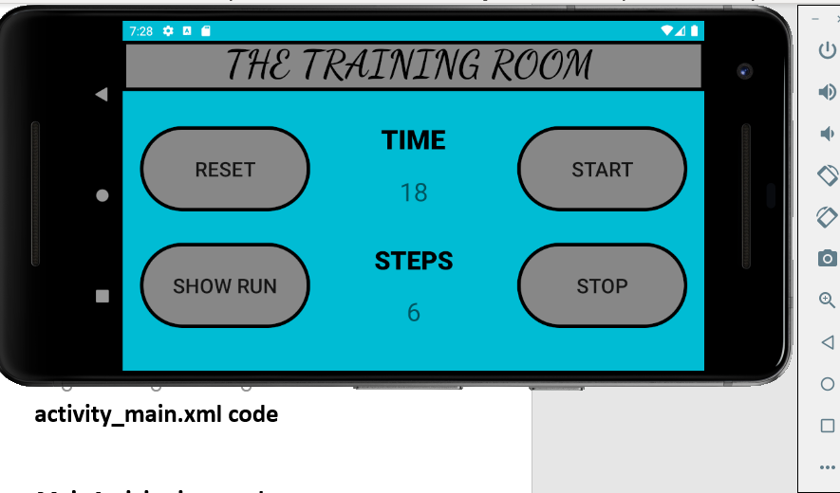

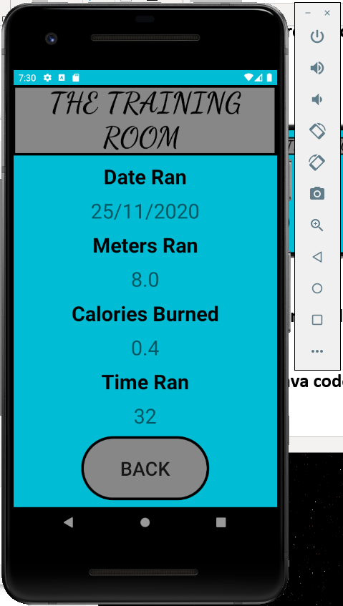

**activity_main.xml code (Portrait)**

*<?***xml version="1.0" encoding="utf-8"***?>*<**androidx.constraintlayout.widget.ConstraintLayout xmlns:android="http://schemas.android.com/apk/res/android"  
 xmlns:app="http://schemas.android.com/apk/res-auto"  
 xmlns:tools="http://schemas.android.com/tools"  
 android:layout_width="match_parent"  
 android:layout_height="match_parent"  
 android:background="#00BCD4"  
 tools:context=".MainActivity"**>  
  
 <**Button  
 android:id="@+id/btnReset"  
 android:layout_width="150dp"  
 android:layout_height="wrap_content"  
 android:layout_marginStart="35dp"  
 android:layout_marginBottom="25dp"  
 android:background="@drawable/pill"  
 android:onClick="doReset"  
 android:text="Reset"  
 android:textColor="#000000"  
 android:textSize="24sp"  
 android:textStyle="bold"  
 app:layout_constraintBottom_toTopOf="@+id/btnShow"  
 app:layout_constraintStart_toStartOf="parent"** />  
  
 <**Button  
 android:id="@+id/btnStart"  
 android:layout_width="150dp"  
 android:layout_height="wrap_content"  
 android:layout_marginEnd="35dp"  
 android:layout_marginBottom="25dp"  
 android:background="@drawable/pill"  
 android:onClick="doStart"  
 android:text="Start"  
 android:textColor="#000000"  
 android:textSize="24sp"  
 android:textStyle="bold"  
 app:layout_constraintBottom_toTopOf="@+id/btnStop"  
 app:layout_constraintEnd_toEndOf="parent"** />  
  
 <**Button  
 android:id="@+id/btnShow"  
 android:layout_width="150dp"  
 android:layout_height="wrap_content"  
 android:layout_marginStart="35dp"  
 android:layout_marginBottom="30dp"  
 android:background="@drawable/pill"  
 android:onClick="doShow"  
 android:text="Show Run"  
 android:textColor="#000000"  
 android:textSize="24sp"  
 android:textStyle="bold"  
 app:layout_constraintBottom_toBottomOf="parent"  
 app:layout_constraintStart_toStartOf="parent"** />  
  
 <**Button  
 android:id="@+id/btnStop"  
 android:layout_width="150dp"  
 android:layout_height="wrap_content"  
 android:layout_marginEnd="35dp"  
 android:layout_marginBottom="30dp"  
 android:background="@drawable/pill"  
 android:onClick="doStop"  
 android:text="Stop"  
 android:textColor="#000000"  
 android:textSize="24sp"  
 android:textStyle="bold"  
 app:layout_constraintBottom_toBottomOf="parent"  
 app:layout_constraintEnd_toEndOf="parent"** />  
  
 <**TextView  
 android:id="@+id/tvMetersRun"  
 android:layout_width="wrap_content"  
 android:layout_height="40dp"  
 android:layout_marginTop="10dp"  
 android:text="0"  
 android:textAlignment="center"  
 android:textSize="30sp"  
 app:layout_constraintEnd_toEndOf="parent"  
 app:layout_constraintHorizontal_bias="0.5"  
 app:layout_constraintStart_toStartOf="parent"  
 app:layout_constraintTop_toBottomOf="@+id/textView"** />  
  
 <**TextView  
 android:id="@+id/tvTime"  
 android:layout_width="wrap_content"  
 android:layout_height="wrap_content"  
 android:layout_marginTop="10dp"  
 android:text="0"  
 android:textAlignment="center"  
 android:textSize="30sp"  
 app:layout_constraintEnd_toEndOf="parent"  
 app:layout_constraintHorizontal_bias="0.5"  
 app:layout_constraintStart_toStartOf="parent"  
 app:layout_constraintTop_toBottomOf="@+id/textView2"** />  
  
 <**TextView  
 android:id="@+id/textView"  
 android:layout_width="wrap_content"  
 android:layout_height="wrap_content"  
 android:layout_marginTop="120dp"  
 android:fontFamily="sans-serif-black"  
 android:text="STEPS"  
 android:textAlignment="center"  
 android:textColor="#000000"  
 android:textSize="30sp"  
 android:textStyle="bold"  
 app:layout_constraintEnd_toEndOf="parent"  
 app:layout_constraintHorizontal_bias="0.5"  
 app:layout_constraintStart_toStartOf="parent"  
 app:layout_constraintTop_toTopOf="parent"** />  
  
 <**TextView  
 android:id="@+id/textView2"  
 android:layout_width="wrap_content"  
 android:layout_height="wrap_content"  
 android:layout_marginTop="50dp"  
 android:fontFamily="sans-serif-black"  
 android:text="TIME"  
 android:textAlignment="center"  
 android:textColor="#000000"  
 android:textSize="32sp"  
 android:textStyle="bold"  
 app:layout_constraintEnd_toEndOf="parent"  
 app:layout_constraintHorizontal_bias="0.5"  
 app:layout_constraintStart_toStartOf="parent"  
 app:layout_constraintTop_toBottomOf="@+id/tvMetersRun"** />  
  
 <**TextView  
 android:id="@+id/textView3"  
 android:layout_width="413dp"  
 android:layout_height="110dp"  
 android:autoText="false"  
 android:background="@drawable/sqaure"  
 android:contextClickable="false"  
 android:fontFamily="cursive"  
 android:freezesText="false"  
 android:includeFontPadding="false"  
 android:text="The Training Room "  
 android:textAlignment="center"  
 android:textAllCaps="true"  
 android:textColor="#000000"  
 android:textSize="45sp"  
 android:textStyle="bold"  
 app:layout_constraintEnd_toEndOf="parent"  
 app:layout_constraintTop_toTopOf="parent"** />  
</**androidx.constraintlayout.widget.ConstraintLayout**>

**activity_main.xaml (Landscape)**

*<?***xml version="1.0" encoding="utf-8"***?>*<**androidx.constraintlayout.widget.ConstraintLayout xmlns:android="http://schemas.android.com/apk/res/android"  
 xmlns:app="http://schemas.android.com/apk/res-auto"  
 xmlns:tools="http://schemas.android.com/tools"  
 android:layout_width="match_parent"  
 android:layout_height="match_parent"  
 android:background="#00BCD4"  
 tools:context=".MainActivity"**>  
  
 <**Button  
 android:id="@+id/btnReset"  
 android:layout_width="wrap_content"  
 android:layout_height="wrap_content"  
 android:layout_marginStart="20dp"  
 android:layout_marginTop="100dp"  
 android:background="@drawable/pill"  
 android:onClick="doReset"  
 android:text="Reset"  
 android:textSize="24sp"  
 app:layout_constraintStart_toStartOf="parent"  
 app:layout_constraintTop_toTopOf="parent"** />  
  
 <**Button  
 android:id="@+id/btnShow"  
 android:layout_width="wrap_content"  
 android:layout_height="wrap_content"  
 android:layout_marginStart="20dp"  
 android:layout_marginBottom="50dp"  
 android:background="@drawable/pill"  
 android:onClick="doShow"  
 android:text="Show Run"  
 android:textSize="24sp"  
 app:layout_constraintBottom_toBottomOf="parent"  
 app:layout_constraintStart_toStartOf="parent"** />  
  
 <**Button  
 android:id="@+id/btnStop"  
 android:layout_width="wrap_content"  
 android:layout_height="wrap_content"  
 android:layout_marginEnd="20dp"  
 android:layout_marginBottom="50dp"  
 android:background="@drawable/pill"  
 android:onClick="doStop"  
 android:text="Stop"  
 android:textSize="24sp"  
 app:layout_constraintBottom_toBottomOf="parent"  
 app:layout_constraintEnd_toEndOf="parent"** />  
  
 <**Button  
 android:id="@+id/btnStart"  
 android:layout_width="wrap_content"  
 android:layout_height="wrap_content"  
 android:layout_marginTop="100dp"  
 android:layout_marginEnd="20dp"  
 android:background="@drawable/pill"  
 android:onClick="doStart"  
 android:text="Start"  
 android:textSize="24sp"  
 app:layout_constraintEnd_toEndOf="parent"  
 app:layout_constraintTop_toTopOf="parent"** />  
  
 <**TextView  
 android:id="@+id/textView"  
 android:layout_width="wrap_content"  
 android:layout_height="wrap_content"  
 android:layout_marginBottom="20dp"  
 android:fontFamily="sans-serif-black"  
 android:text="STEPS"  
 android:textAlignment="center"  
 android:textColor="#000000"  
 android:textSize="30sp"  
 android:textStyle="bold"  
 app:layout_constraintBottom_toTopOf="@+id/tvMetersRun"  
 app:layout_constraintEnd_toEndOf="parent"  
 app:layout_constraintHorizontal_bias="0.5"  
 app:layout_constraintStart_toStartOf="parent"** />  
  
 <**TextView  
 android:id="@+id/textView2"  
 android:layout_width="wrap_content"  
 android:layout_height="wrap_content"  
 android:layout_marginBottom="20dp"  
 android:fontFamily="sans-serif-black"  
 android:text="TIME"  
 android:textAlignment="center"  
 android:textColor="#000000"  
 android:textSize="32sp"  
 android:textStyle="bold"  
 app:layout_constraintBottom_toTopOf="@+id/tvTime"  
 app:layout_constraintEnd_toEndOf="parent"  
 app:layout_constraintHorizontal_bias="0.499"  
 app:layout_constraintStart_toStartOf="parent"** />  
  
 <**TextView  
 android:id="@+id/tvMetersRun"  
 android:layout_width="wrap_content"  
 android:layout_height="40dp"  
 android:layout_marginBottom="50dp"  
 android:text="0"  
 android:textAlignment="center"  
 android:textSize="30sp"  
 app:layout_constraintBottom_toBottomOf="parent"  
 app:layout_constraintEnd_toStartOf="@+id/btnStop"  
 app:layout_constraintStart_toEndOf="@+id/btnShow"** />  
  
 <**TextView  
 android:id="@+id/tvTime"  
 android:layout_width="wrap_content"  
 android:layout_height="wrap_content"  
 android:layout_marginBottom="40dp"  
 android:text="0"  
 android:textAlignment="center"  
 android:textSize="30sp"  
 app:layout_constraintBottom_toTopOf="@+id/textView"  
 app:layout_constraintEnd_toEndOf="parent"  
 app:layout_constraintHorizontal_bias="0.5"  
 app:layout_constraintStart_toStartOf="parent"** />  
  
 <**TextView  
 android:id="@+id/textView3"  
 android:layout_width="0dp"  
 android:layout_height="59dp"  
 android:autoText="false"  
 android:background="@drawable/sqaure"  
 android:contextClickable="false"  
 android:fontFamily="cursive"  
 android:freezesText="false"  
 android:includeFontPadding="false"  
 android:text="The Training Room "  
 android:textAlignment="center"  
 android:textAllCaps="true"  
 android:textColor="#000000"  
 android:textSize="45sp"  
 android:textStyle="bold"  
 app:layout_constraintEnd_toEndOf="parent"  
 app:layout_constraintStart_toStartOf="parent"  
 app:layout_constraintTop_toTopOf="parent"** />  
</**androidx.constraintlayout.widget.ConstraintLayout**>

**Activity_run_page.xml**

*<?***xml version="1.0" encoding="utf-8"***?>*<**androidx.constraintlayout.widget.ConstraintLayout xmlns:android="http://schemas.android.com/apk/res/android"  
 xmlns:app="http://schemas.android.com/apk/res-auto"  
 xmlns:tools="http://schemas.android.com/tools"  
 android:layout_width="match_parent"  
 android:layout_height="match_parent"  
 android:background="#00BCD4"  
 tools:context=".RunPage"**>  
  
 <**TextView  
 android:id="@+id/tvDate"  
 android:layout_width="wrap_content"  
 android:layout_height="wrap_content"  
 android:text="0"  
 android:textSize="32sp"  
 app:layout_constraintBottom_toTopOf="@+id/textView8"  
 app:layout_constraintEnd_toEndOf="parent"  
 app:layout_constraintHorizontal_bias="0.5"  
 app:layout_constraintStart_toStartOf="parent"  
 app:layout_constraintTop_toBottomOf="@+id/textView4"** />  
  
 <**TextView  
 android:id="@+id/textView8"  
 android:layout_width="wrap_content"  
 android:layout_height="wrap_content"  
 android:text="Meters Ran"  
 android:textAlignment="center"  
 android:textColor="#000000"  
 android:textSize="32sp"  
 android:textStyle="bold"  
 app:layout_constraintBottom_toTopOf="@+id/tvMetersRun"  
 app:layout_constraintEnd_toEndOf="parent"  
 app:layout_constraintHorizontal_bias="0.5"  
 app:layout_constraintStart_toStartOf="parent"  
 app:layout_constraintTop_toBottomOf="@+id/tvDate"** />  
  
 <**TextView  
 android:id="@+id/textView6"  
 android:layout_width="wrap_content"  
 android:layout_height="wrap_content"  
 android:text="Time Ran"  
 android:textAlignment="center"  
 android:textColor="#000000"  
 android:textSize="32sp"  
 android:textStyle="bold"  
 app:layout_constraintBottom_toTopOf="@+id/tvTimetaken"  
 app:layout_constraintEnd_toEndOf="parent"  
 app:layout_constraintHorizontal_bias="0.5"  
 app:layout_constraintStart_toStartOf="parent"  
 app:layout_constraintTop_toBottomOf="@+id/tvCaloriesBurn"** />  
  
 <**TextView  
 android:id="@+id/tvCaloriesBurn"  
 android:layout_width="wrap_content"  
 android:layout_height="wrap_content"  
 android:text="0"  
 android:textSize="32sp"  
 app:layout_constraintBottom_toTopOf="@+id/textView6"  
 app:layout_constraintEnd_toEndOf="parent"  
 app:layout_constraintHorizontal_bias="0.5"  
 app:layout_constraintStart_toStartOf="parent"  
 app:layout_constraintTop_toBottomOf="@+id/textView5"** />  
  
 <**TextView  
 android:id="@+id/tvMetersRun"  
 android:layout_width="wrap_content"  
 android:layout_height="wrap_content"  
 android:text="0"  
 android:textSize="32sp"  
 app:layout_constraintBottom_toTopOf="@+id/textView5"  
 app:layout_constraintEnd_toEndOf="parent"  
 app:layout_constraintHorizontal_bias="0.5"  
 app:layout_constraintStart_toStartOf="parent"  
 app:layout_constraintTop_toBottomOf="@+id/textView8"** />  
  
 <**TextView  
 android:id="@+id/tvTimetaken"  
 android:layout_width="wrap_content"  
 android:layout_height="wrap_content"  
 android:text="0"  
 android:textSize="32sp"  
 app:layout_constraintBottom_toTopOf="@+id/btnBack"  
 app:layout_constraintEnd_toEndOf="parent"  
 app:layout_constraintHorizontal_bias="0.5"  
 app:layout_constraintStart_toStartOf="parent"  
 app:layout_constraintTop_toBottomOf="@+id/textView6"** />  
  
 <**Button  
 android:id="@+id/btnBack"  
 android:layout_width="wrap_content"  
 android:layout_height="wrap_content"  
 android:background="@drawable/pill"  
 android:onClick="doBack"  
 android:text="Back"  
 android:textSize="30sp"  
 app:layout_constraintBottom_toBottomOf="parent"  
 app:layout_constraintEnd_toEndOf="parent"  
 app:layout_constraintHorizontal_bias="0.5"  
 app:layout_constraintStart_toStartOf="parent"  
 app:layout_constraintTop_toBottomOf="@+id/tvTimetaken"** />  
  
 <**TextView  
 android:id="@+id/textView4"  
 android:layout_width="wrap_content"  
 android:layout_height="wrap_content"  
 android:text="Date Ran"  
 android:textAlignment="center"  
 android:textColor="#000000"  
 android:textSize="32sp"  
 android:textStyle="bold"  
 app:layout_constraintBottom_toTopOf="@+id/tvDate"  
 app:layout_constraintEnd_toEndOf="parent"  
 app:layout_constraintHorizontal_bias="0.5"  
 app:layout_constraintStart_toStartOf="parent"  
 app:layout_constraintTop_toBottomOf="@+id/textView3"** />  
  
 <**TextView  
 android:id="@+id/textView5"  
 android:layout_width="wrap_content"  
 android:layout_height="wrap_content"  
 android:text="Calories Burned"  
 android:textAlignment="center"  
 android:textColor="#000000"  
 android:textSize="32sp"  
 android:textStyle="bold"  
 app:layout_constraintBottom_toTopOf="@+id/tvCaloriesBurn"  
 app:layout_constraintEnd_toEndOf="parent"  
 app:layout_constraintHorizontal_bias="0.5"  
 app:layout_constraintStart_toStartOf="parent"  
 app:layout_constraintTop_toBottomOf="@+id/tvMetersRun"** />  
  
 <**TextView  
 android:id="@+id/textView3"  
 android:layout_width="413dp"  
 android:layout_height="110dp"  
 android:autoText="false"  
 android:background="@drawable/sqaure"  
 android:contextClickable="false"  
 android:fontFamily="cursive"  
 android:freezesText="false"  
 android:includeFontPadding="false"  
 android:text="The Training Room "  
 android:textAlignment="center"  
 android:textAllCaps="true"  
 android:textColor="#000000"  
 android:textSize="45sp"  
 android:textStyle="bold"  
 app:layout_constraintEnd_toEndOf="parent"  
 app:layout_constraintTop_toTopOf="parent"** />  
</**androidx.constraintlayout.widget.ConstraintLayout**>

**MainActivity.java code**

**package** jamie.itsligo.runningapp;  
  
**import** androidx.appcompat.app.AppCompatActivity;  
  
**import** android.content.Intent;  
**import** android.hardware.Sensor;  
**import** android.hardware.SensorEvent;  
**import** android.hardware.SensorEventListener;  
**import** android.hardware.SensorManager;  
**import** android.os.Bundle;  
**import** android.view.View;  
**import** android.widget.TextView;  
**import** android.widget.Toast;  
  
**public class** MainActivity **extends** AppCompatActivity **implements** SensorEventListener {  
  
 *//timer setup* CountUpTimer **timer**;  
 TextView **counterTimer**;  
 **int counterToApproveShowBtn** = 0;  
  
 *//step counter setup  
 // experimental values for hi and lo magnitude limits* **private final double HI_STEP** = 11.0; *// upper mag limit* **private final double LO_STEP** = 9.0; *// lower mag limit* **boolean highLimit** = **false**; *// detect high limit* **int counter** = 0; *// step counter* TextView **tvSteps**;  
 **private** SensorManager **mSensorManager**;  
 **private** Sensor **mSensor**;  
  
 @Override  
 **protected void** onCreate(Bundle savedInstanceState) {  
 **super**.onCreate(savedInstanceState);  
 setContentView(R.layout.***activity_main***);  
  
 *//timer code* **counterTimer** = findViewById(R.id.***tvTime***);  
  
 **timer** = **new** CountUpTimer(300000) { *// should be high for the run (ms)* **public void** onTick(**int** second) {  
 **counterTimer**.setText(String.*valueOf*(second));  
 }  
 };  
  
 *//step counter code* **tvSteps** = findViewById(R.id.***tvMetersRun***);  
  
 *// we are going to use the sensor service* **mSensorManager** = (SensorManager) getSystemService(***SENSOR_SERVICE***);  
 **mSensor** = **mSensorManager**.getDefaultSensor(Sensor.***TYPE_ACCELEROMETER***);  
  
 }  
  
 *// timer methods* **public void** doStart(View view) {  
 **counter** = 0;  
 **tvSteps**.setText(String.*valueOf*(**counter**));  
 **timer**.start();  
 **mSensorManager**.registerListener(**this**, **mSensor**,SensorManager.***SENSOR_DELAY_NORMAL***);  
 Toast.*makeText*(**this**, **"Started counting"**, Toast.***LENGTH_LONG***).show();  
 }  
  
 **public void** doStop(View view) {  
 **counterToApproveShowBtn**++;  
 **timer**.cancel();  
 **mSensorManager**.unregisterListener(**this**); *// turn off listener to save power* Toast.*makeText*(**this**, **"Stopped Run"**, Toast.***LENGTH_LONG***).show();  
 }  
  
 **public void** doReset(View view) {  
 **counterTimer**.setText(**"0"**);  
 **timer**.cancel();  
 **counter** = 0;  
 **tvSteps**.setText(String.*valueOf*(**counter**));  
 Toast.*makeText*(**this**, **"Reset"**, Toast.***LENGTH_LONG***).show();  
 }  
  
 **public void** doShow(View view) {  
 **if** (**counterToApproveShowBtn** >= 1)  
 {  
 **counterToApproveShowBtn** = 0;  
  
 Intent resultPageIntent = **new** Intent(view.getContext(), RunPage.**class**);  
  
 **int** stepsToPass = Integer.*valueOf*(**tvSteps**.getText().toString());  
 **int** timeToPass = Integer.*valueOf*(**counterTimer**.getText().toString());  
  
  
 resultPageIntent.putExtra(**"stepsPassed"**, stepsToPass);  
 resultPageIntent.putExtra(**"timePassed"**, timeToPass);  
  
 startActivity(resultPageIntent);  
 }  
 **else if** (**counterToApproveShowBtn** == 0)  
 {  
 Toast.*makeText*(**this**, **"You must stop the run first!"**, Toast.***LENGTH_LONG***).show();  
 }  
 }  
  
 *//step counter methods* @Override  
 **public void** onSensorChanged(SensorEvent event) {  
  
 **float** x = event.**values**[0];  
 **float** y = event.**values**[1];  
 **float** z = event.**values**[2];  
  
 *// get a magnitude number using Pythagorus's Theorem* **double** mag = *round*(Math.*sqrt*((x*x) + (y*y) + (z*z)), 2);  
  
 *// for me! if msg > 11 and then drops below 9, we have a step  
 // you need to do your own mag calculating* **if** ((mag > **HI_STEP**) && (**highLimit** == **false**)) {  
 **highLimit** = **true**;  
 }  
 **if** ((mag < **LO_STEP**) && (**highLimit** == **true**)) {  
 *// we have a step* **counter**++;  
 **tvSteps**.setText(String.*valueOf*(**counter**));  
 **highLimit** = **false**;  
 }  
  
  
 }  
  
 @Override  
 **public void** onAccuracyChanged(Sensor sensor, **int** accuracy) {  
 *// not used* }  
  
 **public static double** round(**double** value, **int** places) {  
 **if** (places < 0) **throw new** IllegalArgumentException();  
  
 **long** factor = (**long**) Math.*pow*(10, places);  
 value = value * factor;  
 **long** tmp = Math.*round*(value);  
 **return** (**double**) tmp / factor;  
 }  
  
}

**CountUpTimer.java**

**package** jamie.itsligo.runningapp;  
  
**import** android.os.CountDownTimer;  
  
**public abstract class** CountUpTimer **extends** CountDownTimer {  
 **private static final long *INTERVAL_MS*** = 1000;  
 **private final long duration**;  
  
 **protected** CountUpTimer(**long** durationMs) {  
 **super**(durationMs, ***INTERVAL_MS***);  
 **this**.**duration** = durationMs;  
 }  
  
 **public abstract void** onTick(**int** second);  
  
 @Override  
 **public void** onTick(**long** msUntilFinished) {  
 **int** second = (**int**) ((**duration** - msUntilFinished) / 1000);  
 onTick(second);  
 }  
  
 @Override  
 **public void** onFinish() {  
 onTick(**duration** / 1000);  
 }  
}

**RunPage.java**

**package** jamie.itsligo.runningapp;  
  
**import** androidx.appcompat.app.AppCompatActivity;  
  
**import** android.content.Intent;  
**import** android.os.Bundle;  
**import** android.view.View;  
**import** android.widget.TextView;  
  
**import** java.text.DecimalFormat;  
**import** java.text.SimpleDateFormat;  
**import** java.util.Date;  
  
**public class** RunPage **extends** AppCompatActivity {  
  
 String **counterValuePassed**;  
 TextView **tvMetersRun**,**tvCaloriesBurn**,**tvTimetaken**,**tvDate**;  
  
 @Override  
 **protected void** onCreate(Bundle savedInstanceState) {  
 **super**.onCreate(savedInstanceState);  
 setContentView(R.layout.***activity_run_page***);  
  
 **tvMetersRun** = findViewById(R.id.***tvMetersRun***);  
 **tvCaloriesBurn** = findViewById(R.id.***tvCaloriesBurn***);  
 **tvTimetaken** = findViewById(R.id.***tvTimetaken***);  
 **tvDate** = findViewById(R.id.***tvDate***);  
  
 **int** stepsNowPassedOver = getIntent().getIntExtra(**"stepsPassed"**, 0 );  
 **int** timeNowPassedOver = getIntent().getIntExtra(**"timePassed"**, 0);  
  
 *//calculation* **double** NumOfMetersRun = stepsNowPassedOver*0.8;  
 **double** NumOfCaloriesBurned = stepsNowPassedOver*0.04;  
  
 String stepsNowPassedOverString = String.*valueOf*(NumOfMetersRun);  
 String timeNowPassedOverString = String.*valueOf*(timeNowPassedOver);  
 String CaloriesCalculated = String.*valueOf*(NumOfCaloriesBurned);  
  
 **tvMetersRun**.setText(String.*valueOf*(stepsNowPassedOverString));  
 **tvTimetaken**.setText(String.*valueOf*(timeNowPassedOverString));  
 **tvCaloriesBurn**.setText(String.*valueOf*(CaloriesCalculated));  
  
 SimpleDateFormat sdf = **new** SimpleDateFormat(**"dd/MM/yyyy"**);  
 String date = sdf.format(**new** Date());  
 **tvDate**.setText(String.*valueOf*(date));  
  
 }  
  
 **public void** doBack(View view) {  
 Intent mainActivityIntent = **new** Intent(view.getContext(), MainActivity.**class**);  
 startActivity(mainActivityIntent);  
 }  
}

**Conclusion**

**• State if you completed the lab or how far you managed to get**

I completed the lab in full.

**• State the part of the lab you spent the most time on or what issue was the hardest to overcome**

The area of the lab I spent the most time on was parsing information over to display on the second page. I attempted it a few times on a few different evenings and it was giving errors or crashing on me. After going away from it and coming back a different time I found that my issue was very easily fixed. I just needed a fresh, clear head and a break from the computer to realize the simple mistake I had made. After that, I found the lab relatively simple and not too challenging. I spent a decent chuck of time designing the app with the different views.

**• Specify a goal for yourself for next time**

Next time around I would like to deal with more complexity. From this lab I noticed a jump backwards in complexity from the previous lab. This previous lab was a welcome difficulty spike, and I would be interested in trying something more difficult as to allow my skills within the Java language and Android Studio to improve.