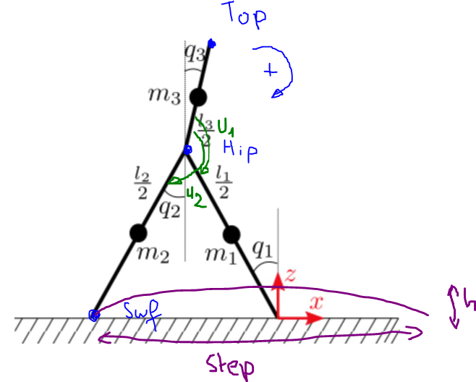
Task projection
- Hip Task
Control in speed in X axis
$$x_{hip}=l_{1}sin⁡(q_{1})$$
$$z_{hip}=l_{1}cos⁡(q_{1})$$
$$J_{hip}=\left[\begin{matrix}l_{1}cos⁡(q_{1}) & 0 & 0 \\ -l_{1}sin⁡(q_{1}) & 0 & 0\end{matrix}\right]$$
$$f_{hip}=\left[\begin{matrix}kdx_{hip}(v_{hipRef}-dx_{hip}) \\ 0\end{matrix}\right]$$
$$u_{hip}=B^{+}J_{hip}'f_{hip}$$

- Top Task
Control with damp between Hip and top:
$$x_{top}=l_{1}\sin\left(q_{1}\right)+l_{3}sin⁡(q_{3})$$
$$z_{top}=l_{1}\cos\left(q_{1}\right)+l_{3}cos⁡(q_{3})$$
$$J_{top}=\left[\begin{matrix}l_{1}cos⁡(q_{1}) & 0 & l_{3}cos⁡(q_{3}) \\ -l_{1}sin⁡(q_{1}) & 0 & -l_{3}sin⁡(q_{3})\end{matrix}\right]$$
$$f_{top}=\left[\begin{matrix}kpx_{top}(x_{hip}-x_{top}) \\ kdz_{top}(0-{dz}_{top})\end{matrix}\right]$$
$$u_{top}=B^{+}J_{top}'f_{top}$$

- Swing foot Task
Trajectory to follow:
$$z_{target}=h sin⁡(\frac{π}{stepLength}(x_{swf}-x0_{swf}))$$
Control position for z and speed for x:
$$x_{swf}=l_{1}\sin\left(q_{1}\right)-l_{2}sin⁡(q_{2})$$
$$z_{swf}=l_{1}\cos\left(q_{1}\right)-l_{2}cos⁡(q_{2})$$
$$J_{swf}=\left[\begin{matrix}l_{1}cos⁡(q_{1}) & -l_{2}cos⁡(q_{2}) & 0 \\ -l_{1}sin⁡(q_{1}) & l_{2}sin⁡(q_{2}) & 0\end{matrix}\right]$$
$$f_{top}=\left[\begin{matrix}kdx_{swf}(v_{swfRef}-{dx}_{swf}) \\ kpz_{swf}(z_{target}-z_{swf})\end{matrix}\right]$$
$$u_{swf}=B^{+}J_{swf}'f_{swf}$$

- Control total:
$$u=u_{hip}+u_{top}+u_{swf}$$

Optimization choices
To choose the different parameters, we chose to make use of the Global Optimization Toolbox.
A MultiStart problem is created with 200 starting points, different lower bounds and upper bounds are chosen for the initial position, initial velocity, $kdx_{hip}$,$kpx_{top}$, $kdz_{top}$, $h$, $steplength$, $kdx_{swf}$ and $kpz_{swf}$.

The objective function puts a penalty (~ +1000) when the mean velocity of the hip is negative, when the CoT is negative and when the mean height of the hip is lower than 0.3
It rewards a mean height of the hip when higher than 0.35 and a reward is created for the distance traveled by the robot

