## 中国版认知服务使用指导

认知服务为开发者提供了一组API和SDK，从而将微软公司不断演进的人工智能技术扩展到广大开发者手中。通过认知服务，你的应用可以轻松地获得智能。首批登陆[中国的API](https://www.azure.cn/documentation/services/cognitive-services/)包括人脸识别、情绪识别和计算机视觉。本文主要介绍认知服务的创建，控制台快速测试，多种语言的测试调用。本文以Face API的detect方法为例进行演示。

#### 认知服务的创建

1. 登陆到China Azure管理门户，登陆网址：<https://portal.azure.cn>
2. 新建Face API (新建 -> Data+Analytics -> 认知服务)：

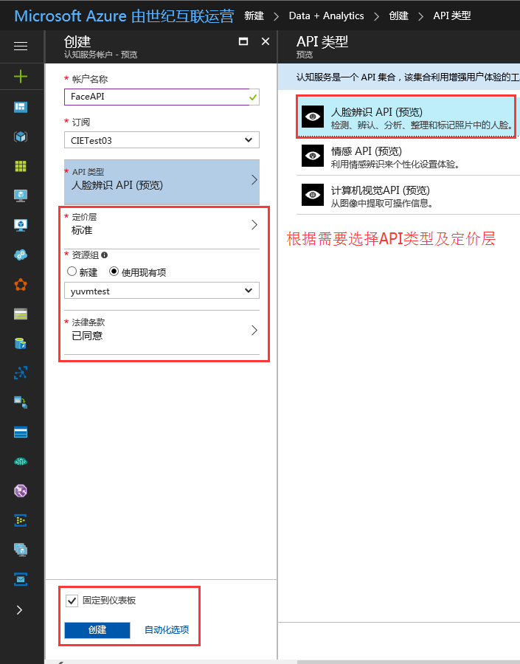

1. 获取服务的key：

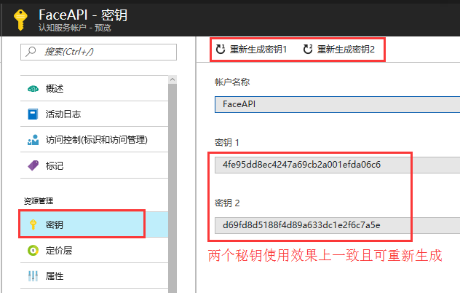

#### 控制台快速测试

1. 测试链接：<https://dev.cognitive.azure.cn/docs/services/563879b61984550e40cbbe8d/operations/563879b61984550f30395236>

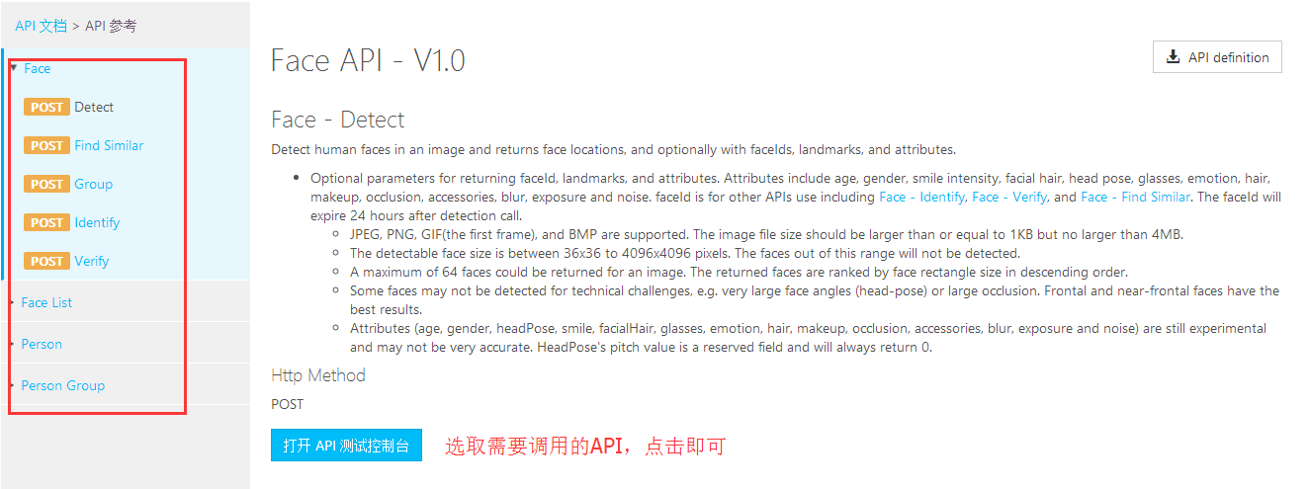

1. Detect控制台测试演示：<https://dev.cognitive.azure.cn/docs/services/563879b61984550e40cbbe8d/operations/563879b61984550f30395236/console>

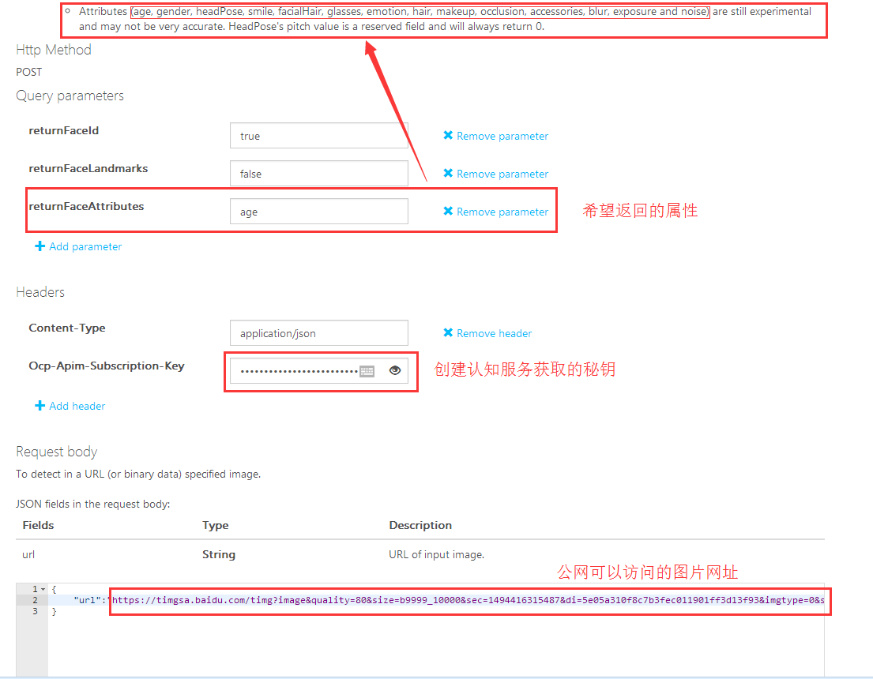

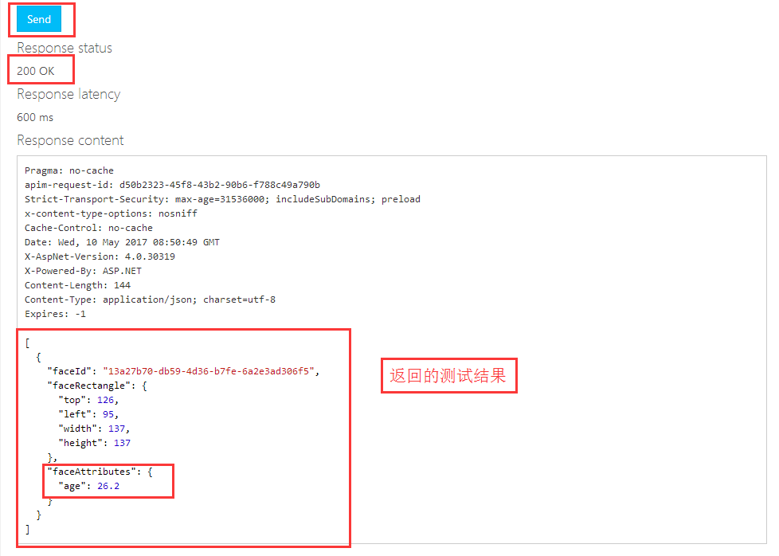

#### 程序调用示例

1. [C# Code Samples：](https://github.com/taroyutao/FaceAPI-CShip)

|  |
| --- |
| using System;  using System.IO;  using System.Net.Http;  using System.Text;  using System.Web;  namespace FaceAPI  {  class Program  {  static void Main(string[] args)  {  //UsePictureURL();  UseLocalPicture();  Console.WriteLine("Hit ENTER to exit...");  Console.ReadLine();  }  /// <summary>  /// use picture URL  /// </summary>  static async void UsePictureURL()  {  var client = new HttpClient();  var queryString = HttpUtility.ParseQueryString(string.Empty);  // Request headers  client.DefaultRequestHeaders.Add("Ocp-Apim-Subscription-Key", "4fe95dd8ec4247a69cb2a001efda06c6");//Face API key  // Request parameters  queryString["returnFaceId"] = "true";  queryString["returnFaceLandmarks"] = "false";  queryString["returnFaceAttributes"] = "age";  var uri = "https://api.cognitive.azure.cn/face/v1.0/detect?" + queryString;  HttpResponseMessage response;  // Request body  byte[] byteData = Encoding.UTF8.GetBytes("{\"url\":\"https://timgsa.baidu.com/timg?image&quality=80&size=b9999_10000&sec=1494416315487&di=5e05a310f8c7b3fec011901ff3d13f93&imgtype=0&src=http%3A%2F%2Fimgsrc.baidu.com%2Fbaike%2Fpic%2Fitem%2F4034970a304e251ff1e3819aa486c9177f3e53bf.jpg\"}");//Picture URL  using (var content = new ByteArrayContent(byteData))  {  response = await client.PostAsync(uri, content);  }  //response result  string result = await response.Content.ReadAsStringAsync();  Console.WriteLine("response:" + result);  }  /// <summary>  /// use local picture  /// </summary>  static async void UseLocalPicture()  {  var client = new HttpClient();    var queryString = HttpUtility.ParseQueryString(string.Empty);  // Request headers  client.DefaultRequestHeaders.Add("Ocp-Apim-Subscription-Key", "4fe95dd8ec4247a69cb2a001efda06c6");//Face API key  // Request parameters  queryString["returnFaceId"] = "true";  queryString["returnFaceLandmarks"] = "false";  queryString["returnFaceAttributes"] = "age";  var uri = "https://api.cognitive.azure.cn/face/v1.0/detect?" + queryString;  HttpResponseMessage response;  //read local picture to byte[]  string path = @"C:\Users\yuvmtest\Desktop\test.jpg";//local picture path  FileStream fs = File.OpenRead(path); //OpenRead  int filelength = 0;  filelength = (int)fs.Length;  byte[] image = new byte[filelength];  fs.Read(image, 0, filelength);  fs.Close();  using (var content = new ByteArrayContent(image))  {  content.Headers.Add("Content-Type", "application/octet-stream");//set content-type  response = await client.PostAsync(uri, content);  }  //response result  string result = await response.Content.ReadAsStringAsync();  Console.WriteLine("response:" + result);  }  }  } |

1. [Java Code Samples：](https://github.com/taroyutao/FaceAPI-Java)

|  |
| --- |
| **package** buct.edu.cn;  **import** java.io.FileInputStream;  **import** java.net.URI;  **import** org.apache.http.HttpEntity;  **import** org.apache.http.HttpResponse;  **import** org.apache.http.client.HttpClient;  **import** org.apache.http.client.methods.HttpPost;  **import** org.apache.http.client.utils.URIBuilder;  **import** org.apache.http.entity.ByteArrayEntity;  **import** org.apache.http.entity.StringEntity;  **import** org.apache.http.impl.client.HttpClients;  **import** org.apache.http.util.EntityUtils;  **public** **class** FaceAPI {  **public** **static** **void** main(String[] args) {    System.***out***.println("Begin FaceAPI Test.");    //UsePictureURL();  *UseLocalPicture*();  }  /**  * Use Picture URL  */  **public** **static** **void** UsePictureURL()  {  HttpClient httpclient = HttpClients.*createDefault*();  **try**  {  URIBuilder builder = **new** URIBuilder("https://api.cognitive.azure.cn/face/v1.0/detect");  builder.setParameter("returnFaceId", "true");  builder.setParameter("returnFaceLandmarks", "false");  builder.setParameter("returnFaceAttributes", "age");  URI uri = builder.build();  HttpPost request = **new** HttpPost(uri);  request.setHeader("Content-Type", "application/json");  request.setHeader("Ocp-Apim-Subscription-Key", "4fe95dd8ec4247a69cb2a001efda06c6");  // Request body  StringEntity reqEntity = **new** StringEntity("{\"url\":\"https://timgsa.baidu.com/timg?image&quality=80&size=b9999_10000&sec=1494416315487&di=5e05a310f8c7b3fec011901ff3d13f93&imgtype=0&src=http%3A%2F%2Fimgsrc.baidu.com%2Fbaike%2Fpic%2Fitem%2F4034970a304e251ff1e3819aa486c9177f3e53bf.jpg\"}"); //URL图片地址  request.setEntity(reqEntity);  HttpResponse response = httpclient.execute(request);  HttpEntity entity = response.getEntity();  **if** (entity != **null**)  {  System.***out***.println(EntityUtils.*toString*(entity));  }  }  **catch** (Exception e)  {  System.***out***.println(e.getMessage());  }  }    /**  * use local picture  */  **public** **static** **void** UseLocalPicture()  {  HttpClient httpclient = HttpClients.*createDefault*();  **try**  {  URIBuilder builder = **new** URIBuilder("https://api.cognitive.azure.cn/face/v1.0/detect");  builder.setParameter("returnFaceId", "true");  builder.setParameter("returnFaceLandmarks", "false");  builder.setParameter("returnFaceAttributes", "age");  URI uri = builder.build();  HttpPost request = **new** HttpPost(uri);  request.setHeader("Content-Type", "application/octet-stream");  request.setHeader("Ocp-Apim-Subscription-Key", "4fe95dd8ec4247a69cb2a001efda06c6");  // Request body  String pic_path = "C:\\Users\\yuvmtest\\Desktop\\test.jpg";    FileInputStream is = **new** FileInputStream(pic_path);  **int** i = is.available();  **byte** data[] = **new** **byte**[i];  is.read(data);  is.close();    ByteArrayEntity bae = **new** ByteArrayEntity(data);  request.setEntity(bae);  HttpResponse response = httpclient.execute(request);  HttpEntity entity = response.getEntity();  **if** (entity != **null**)  {  System.***out***.println(EntityUtils.*toString*(entity));  }  }  **catch** (Exception e)  {  System.***out***.println(e.getMessage());  }  }  } |

1. [PHP Code Samples:](https://github.com/taroyutao/FaceAPI-PHP)

|  |
| --- |
| **// User picture URL**  <?php  **use** GuzzleHttp\Psr7\Request;  **use** GuzzleHttp\Client;  **require_once** 'vendor\autoload.php';  $client = **new** Client();  $headers = ['Content-Type' => 'application/json','Ocp-Apim-Subscription-Key' => '4fe95dd8ec4247a69cb2a001efda06c6'];  $body = '{"url":"https://timgsa.baidu.com/timg?image&quality=80&size=b9999_10000&sec=1494416315487&di=5e05a310f8c7b3fec011901ff3d13f93&imgtype=0&src=http%3A%2F%2Fimgsrc.baidu.com%2Fbaike%2Fpic%2Fitem%2F4034970a304e251ff1e3819aa486c9177f3e53bf.jpg"}';  $request = **new** Request('POST','https://api.cognitive.azure.cn/face/v1.0/detect?returnFaceId=true&returnFaceLandmarks=false&returnFaceAttributes=age', $headers , $body);  $response = $client->send($request);  **echo** $response->getBody();  ?>  <?php  **use** GuzzleHttp\Psr7\Request;  **use** GuzzleHttp\Client;  **require_once** 'vendor\autoload.php';  $client = **new** Client();  $headers = ['Content-Type' => 'application/octet-stream','Ocp-Apim-Subscription-Key' => 'bd8e4ce12f444c639ac9c214d70ac72c'];  //读取本地图片，测试图片放在项目目录下  $myfile = *fopen*("tt.jpg", "r") or *die*("Unable to open file!");  $request = **new** Request('POST','https://api.cognitive.azure.cn/face/v1.0/detect?returnFaceId=true&returnFaceLandmarks=false&returnFaceAttributes=age', $headers , $myfile);  $response = $client->send($request);  **echo** $response->getBody();  *fclose*($myfile);  ?> |

1. [Python Code Samples(Python3.3):](https://github.com/taroyutao/FaceAPI-Python)

|  |
| --- |
| **# User Picture URL**  **import** http.client, urllib.request, urllib.parse, urllib.error, base64  headers = {  *# Request headers* **'Content-Type'**: **'application/json'**,  **'Ocp-Apim-Subscription-Key'**: **'4fe95dd8ec4247a69cb2a001efda06c6'**, }  params = urllib.parse.urlencode({  *# Request parameters* **'returnFaceId'**: **'true'**,  **'returnFaceLandmarks'**: **'false'**,  **'returnFaceAttributes'**: **'age'**, })  **try**:  conn = http.client.HTTPSConnection(**'api.cognitive.azure.cn'**)  conn.request(**"POST"**, **"/face/v1.0/detect?%s"** % params, **"{'url':'https://timgsa.baidu.com/timg?image&quality=80&size=b9999_10000&sec=1494416315487&di=5e05a310f8c7b3fec011901ff3d13f93&imgtype=0&src=http%3A%2F%2Fimgsrc.baidu.com%2Fbaike%2Fpic%2Fitem%2F4034970a304e251ff1e3819aa486c9177f3e53bf.jpg'}"**, headers)  response = conn.getresponse()  data = response.read()  print(data)  conn.close() **except** Exception **as** e:  print(**"[Errno {0}] {1}"**.format(e.errno, e.strerror))  **# User Local Picture**  **import** http.client, urllib.error  headers = {  *# Request headers* **'Content-Type'**: **'application/octet-stream'**,  **'Ocp-Apim-Subscription-Key'**: **'bd8e4ce12f444c639ac9c214d70ac72c'**, }  params = urllib.parse.urlencode({  *# Request parameters* **'returnFaceId'**: **'true'**,  **'returnFaceLandmarks'**: **'false'**,  **'returnFaceAttributes'**: **'age'**, })  **try**:  *# 读取本地图片* filenamePath=**"tt.jpg"** *# 测试图片存放在项目目录下* picturesdata = open(filenamePath, **'rb'**)   conn = http.client.HTTPSConnection(**'api.cognitive.azure.cn'**)  conn.request(**"POST"**, **"/face/v1.0/detect?%s"** % params, picturesdata, headers)  response = conn.getresponse()  data = response.read()  print(data)   picturesdata.closed  conn.close() **except** Exception **as** e:  print(**"[Errno {0}] {1}"**.format(e.errno, e.strerror)) |

1. Code测试结果：

|  |
| --- |
| [{"faceId":"13a27b70-db59-4d36-b7fe-6a2e3ad306f5","faceRectangle":{"top":126,"left":95,"width":137,"height":137},"faceAttributes":{"age":26.2}}] |

#### 更多信息参考：

认知服务价格详情：<https://www.azure.cn/pricing/details/cognitive-services/>

Cognitive-Samples-IntelligentKiosk：<https://github.com/Microsoft/Cognitive-Samples-IntelligentKiosk>

PHP使用Face API：<http://azurecloudapi.cn/?p=366>

CognitiveServices SDK：<https://github.com/Azure/azure-sdk-for-net/tree/vs17Dev/src/SDKs/CognitiveServices>