-- Представление "Ассистенты читающие лекции".
create view assistent as
select t.name_teacher, t.position, l.type_load
from teachers t
join loads l on t.personnel_number = l.personnel_number
where l.type_load = "лекция" and t.position = "ассистент";

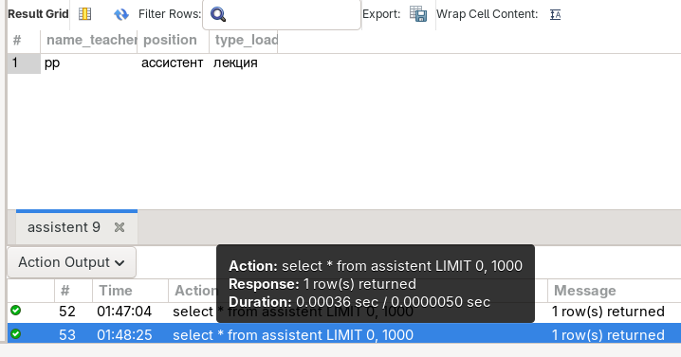
select * from assistent;
update assistent
set name_teacher = "pp"
where type_load = "лекция";
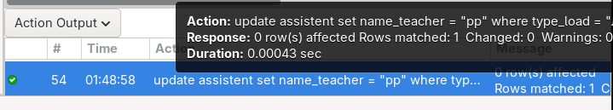

-- Второе

create view second as
select
d.name_discipline,
d.quantity_lectures,
lect.name_teacher as лектор,
case when d.number_of_seminars > 0 then d.number_of_seminars else null end,
sem.name_teacher as семинарник,
case when d.number_of_practical > 0 then d.number_of_practical else null end,
pract.name_teacher as практикант
from discipline d

left join loads l_lect on d.code_discipline = l_lect.code_discipline
and l_lect.type_load = "лекция"
left join teachers lect on l_lect.personnel_number = lect.personnel_number

left join loads l_sem on d.code_discipline = l_sem.code_discipline
and l_sem.type_load = "семинар"
left join teachers sem on l_sem.personnel_number = sem.personnel_number

left join loads l_pract on d.code_discipline = l_pract.code_discipline
and l_pract.type_load = "практические занятия"
left join teachers pract on l_pract.personnel_number = pract.personnel_number;

select * from second;
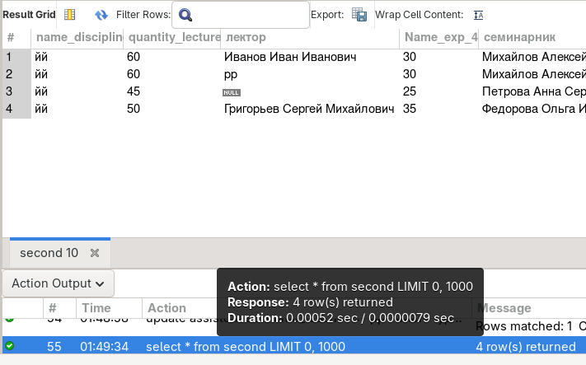

update second
set name_discipline = "йй";
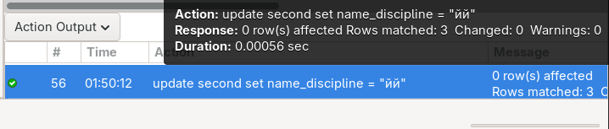

-- Третье

create view teacher_work as
select
t.name_teacher as фио_преподавателя,
d.name_discipline as дисциплина,

case
when l.type_load = 'лекция' then d.quantity_lectures * 2
else 0
end as количество_лекционных_часов,

case
when l.type_load = 'семинар' then d.number_of_seminars
else 0
end as количество_семинаров,

case
when l.type_load = 'практические занятия' then d.number_of_practical
else 0
end as количество_практических,

case
when l.type_load = 'лекция' then d.quantity_lectures * 2
else 0
end +
case
when l.type_load = 'семинар' then d.number_of_seminars
else 0
end +
case
when l.type_load = 'практические занятия' then d.number_of_practical
else 0
end as общее_количество_часов

from teachers t
join loads l on t.personnel_number = l.personnel_number
join discipline d on l.code_discipline = d.code_discipline
order by t.name_teacher, d.name_discipline;

select * from teacher_work;
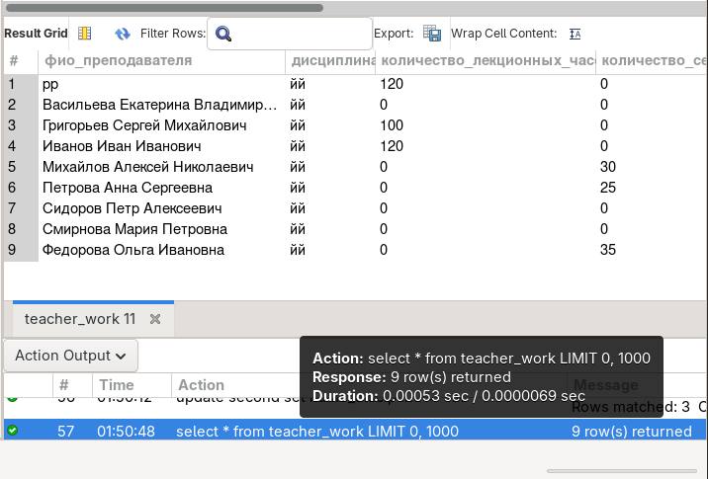

update teacher_work
set количество_лекционных_часов = 999
where фио_преподавателя = 'Иванов Иван Иванович';
