**Scenario 1:**

1. **The Build should trigger as soon as anyone in the dev team checks code in the master branch**

* Initially, click on Pipelines and select **Pipelines**

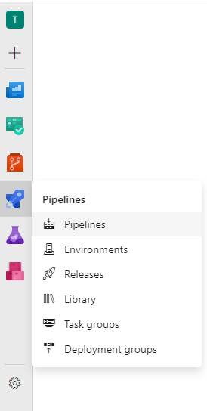

* Now, select **Create pipeline.**

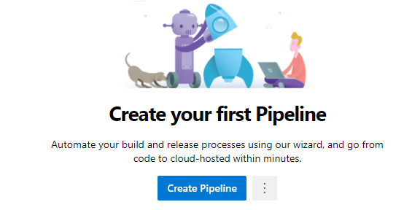

* Choose Use **classic editor without YAML**

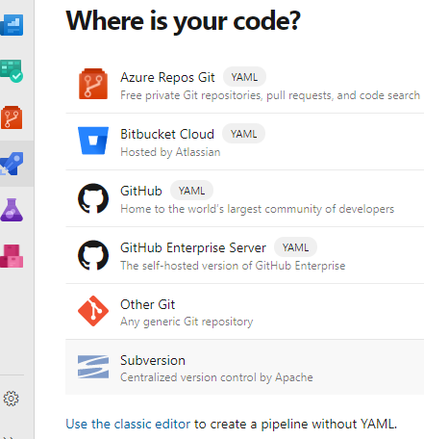

* After that, select your repository, default branch, and click on **Continue.**

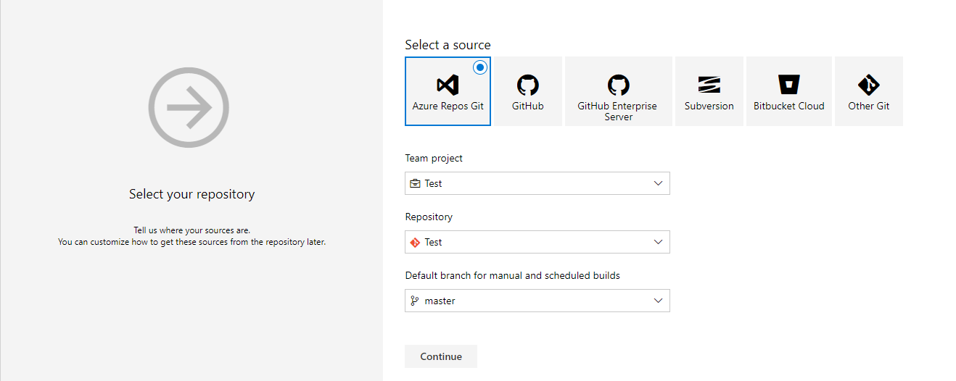

* Now, select the template ASP .NET

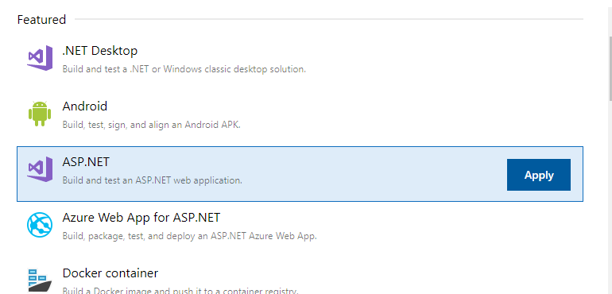

* Select **Triggers** option on top.

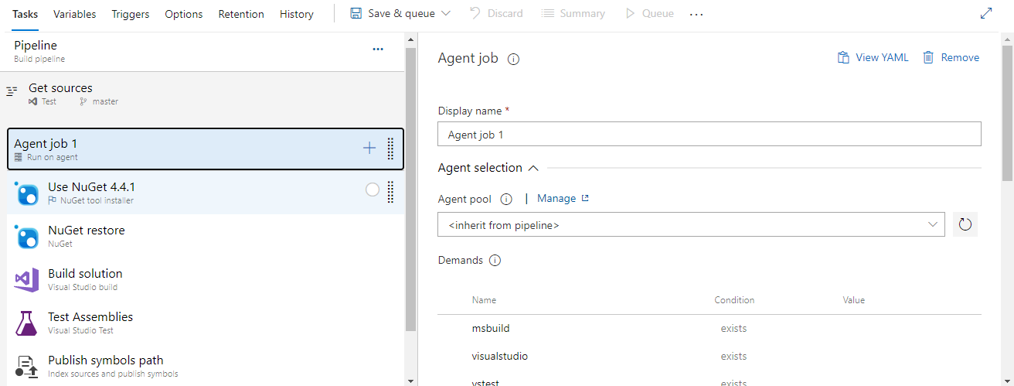

* Check-in the box of **Enable continuous Integration** and select the branch **master.**  So, whenever a developer checks in a commit to master branch, automatically **Build** triggers.

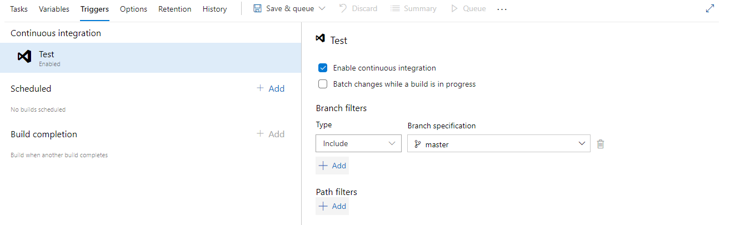

* Click on **Save and Queue** to run the pipeline now.

1. **There will be test projects which will create and maintained in the solution along the Web and API. The trigger should build all the 3 projects - Web, API, and test.**

* Now, we are maintaining Web, API, and test in the single solution and we are building the solution in the build pipeline. So, if any project fails while build, automatically whole Build pipeline fails in Azure DevOps.

1. **The deployment of code and artifacts should be automated to Dev environment.**

* Now, click on **Releases** and choose **New Pipeline**.

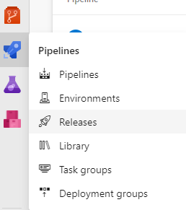

* Select the template **Azure App service Deployment.**

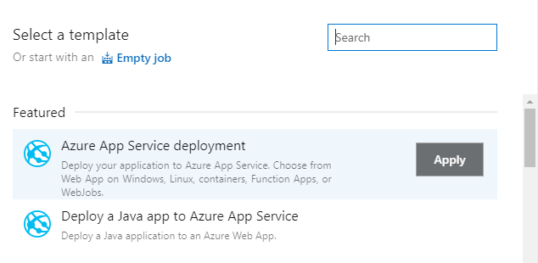

* Similarly, create the stages and name it QA and production.

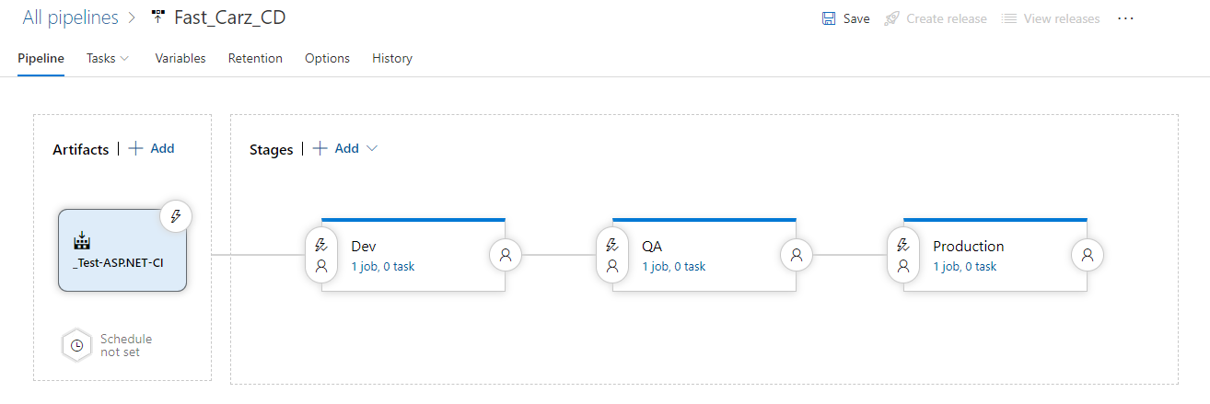

* So, whenever build is triggered, and it is successful then the release to Dev environment happens automatically.

1. **Upon successful deployment to the Dev environment, deployment should be easily promoted to QA and Prod through automated process.**



* As shown in the above picture, when deployment to Dev environment is successful, then deployment to QA and Production will go on.

1. **The deployments to QA and Prod should be enabled with Approvals from approvers only.**

* Deployments to QA and Production can be done by setting approvals. We will be enabling the Pre-deployment approvals to each environment (QA and production).
* So, deployment to that environment can be done only when the approval approves the request. Also, the approver will be notified with an email mentioning the approval details and link to navigate Azure DevOps release pipeline. Please refer the below image.

