Lam, Nghia 1001699317

1.a.i) The output given was 23 - -84

1.a.ii) The output given was 107

1.a.iii) The reason why the two lines of code gave different output is because [printf("%d\n", 23 - -84);] is doing 23 + 84, while [printf("%d - %d\n",23,-84)]; is only printing them out and not doing any math. By replacing the comma with a subtraction sign, the function does math.

1.b.i)

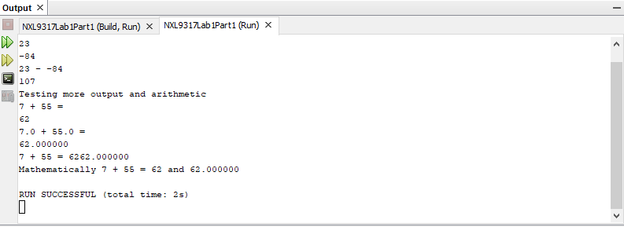

1.b.ii) It is printed differently because one of them is printed as an int and the other one is printed as a float variable.

1.b.iii) It is because [printf("%d", 7 + 55);] did not have a [\n] after the [%d], thus the next printf went on the same line as that one, Therefore, creating 6262.000000.

1.b.iv) The difference between the two lines that one of them has a [\n] and the other does not. If the one that does not have a [\n] gets a printf command after it, that printf command will print on the same line as that one. For the one that does have the [\n] the printf command will print on a new line. That is the only difference between those two commands.

1.b.v)

1. The first plus sign causes no mathematic purpose, it is just printed.
2. The second plus sign causes it to print out a 62 as it adds the two int variables.
3. The third plus sign causes it to print out 62.000000 as it adds two float variables.

2.a) When I tried to execute this program the program prints out all the numbers of age1 though age 4, because age 2 was not defined at first it was given a value of -12816 by the program I believe.

2.b) NetBeans prints out the int number of age 3, while [printf(age3);] did not show up on the console because it was seen as an error.

2.c) Sum of age1 & age2 = 33

2.d) The symbol ‘\*’ causes the two int numbers to be multiplied by each other.

The symbol ‘/’ between two integer numbers causes the first int to be divided by the second int

2.e) “=” is an assignment that assign the left variable to the right one, it is an equality operator

2.f)

2.g) The command “printf” prints out the values that are in-between its parentheses.

2.h) 5 variables were declared in this program age1 = int, age2 = int, age3 = int, age4 = int, age 5 = double. Thus 4 variables were declared int and 1 was declared a double.

2.i) The reason why is because age2 was cast (changed) into a double on one of them while in the other one age2 was still an int, thus giving one of them 2.000000 and the other one 2.666667

3.a)

3.b) The line with the error is line number: 39

3.c)

39 |fractionSum = (num1st + num2nd)/ (double) denom;

unable to resolve identifier fractionSum. Error: ‘fractionSum’ undeclared

43 |printf("The sum of the two fractions is ", fractionSum); unable to resolve identifier factionSum. Wrong number of arguments [I don’t know if this problem was an intentional one in the code]

3.d) The grader should look for Lab1Part3 for this problem

3.e) The code above did not work because on line 34 fractionSum was not declared as any type of data type, thus causing an error to exsist.

3.f)

