Original Task Flow

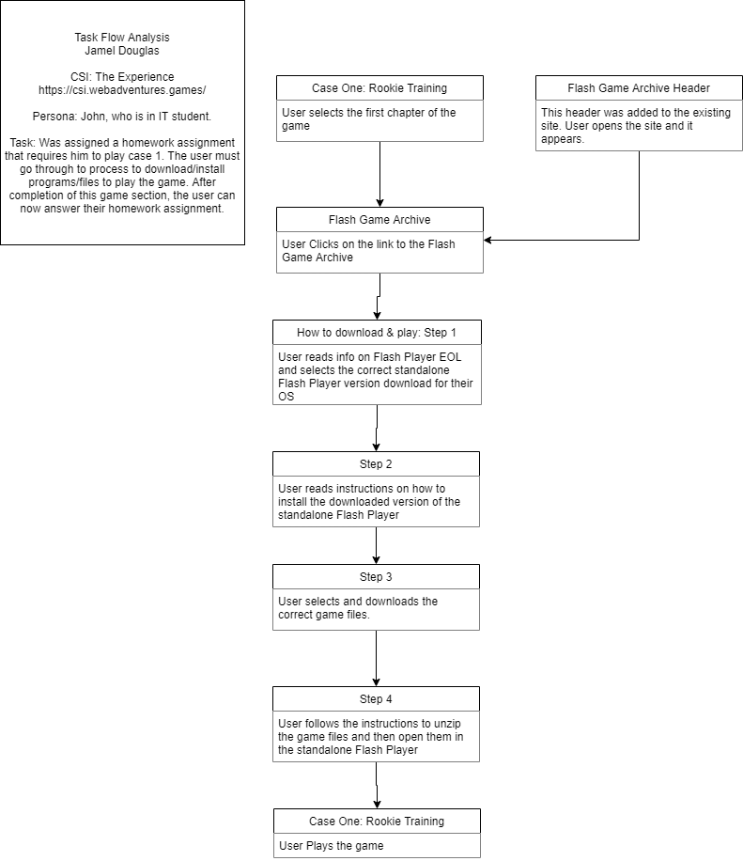

Redesigned Task Flow

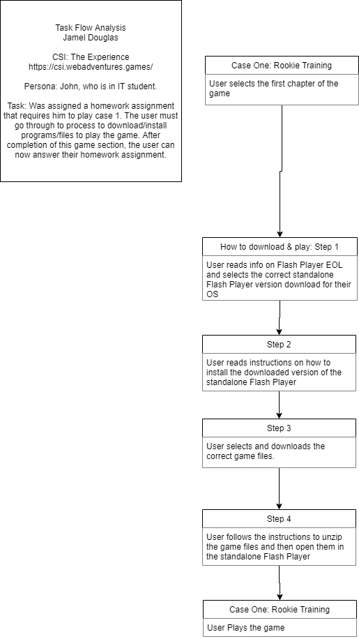

Advantages of recommended solution.

The removal of repeated information about Flash Player’s EOL would streamline the steps a user has to take to download and play the game offered on the site.