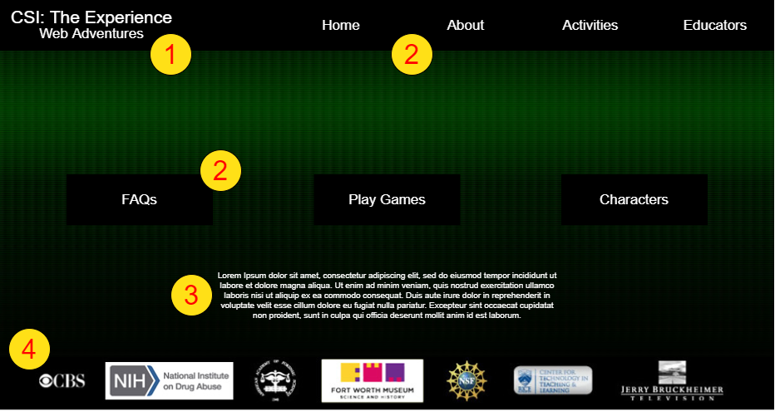

Notes

1 – Site Title, Part of navigation bar.

2 – Navigation Buttons. Buttons in navigation bar leads the user to general site tasks. Buttons in the center of the page lead the user to the main tasks of the site.

3 – Placeholder for general site information

4 – Footer. Contains site sponsor information.

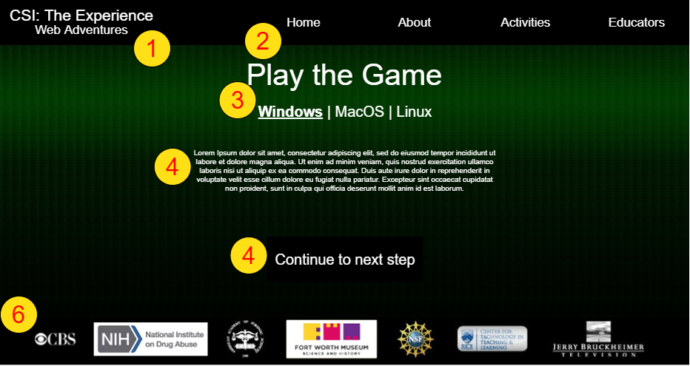

Notes

1 – Site Title, Part of navigation bar.

2 – Navigation Buttons. Buttons in navigation bar leads the user to general site tasks.

3 – Page Title. Navigation bar to switch between instructions based on the users operating system.

4 – Placeholder text for information regarding the step to play the game.

4-2 – Navigation button that takes user to the next step.

6 – Footer. Contains site sponsor information.

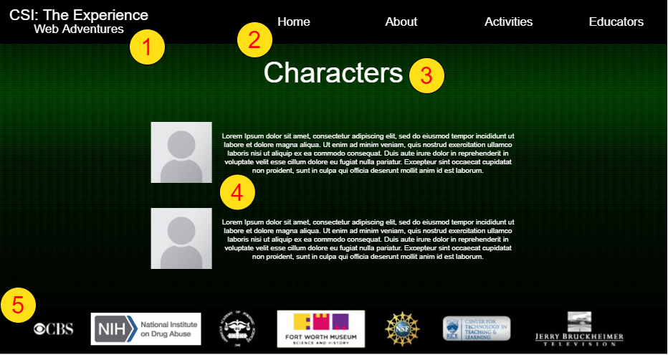

Notes

1 – Site Title, Part of navigation bar.

2 – Navigation Buttons. Buttons in navigation bar leads the user to general site tasks.

3 – Page title.

4 – Placeholders for information about characters. Includes picture of the character and text description

5 – Footer. Contains site sponsor information.

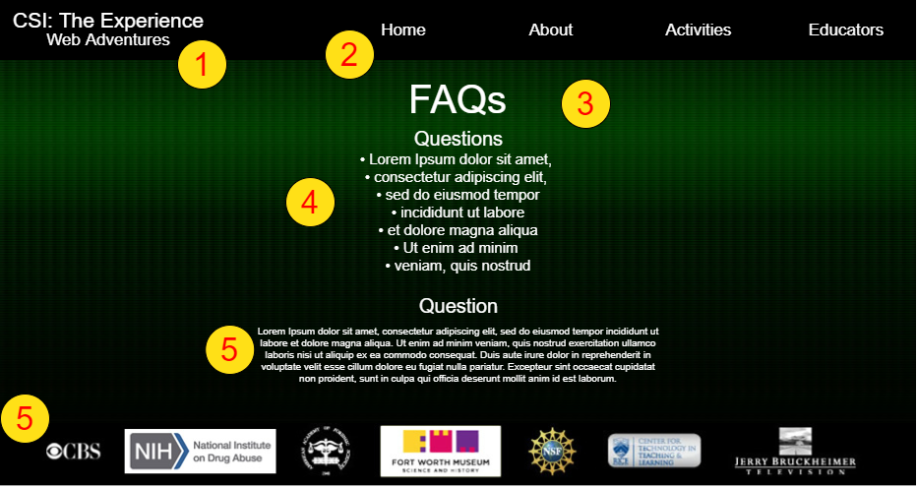

Notes

1 – Site Title, Part of navigation bar.

2 – Navigation Buttons. Buttons in navigation bar leads the user to general site tasks.

3 – Page title.

4 – Question list. Allows user to select a specific question which will navigate them directly to that question

5 – Placeholder for a question and an answer. “Question” would be replace with the question and the text below would be the answer

5-2 – Footer. Contains site sponsor information.