1.2 IP Config

Step 8

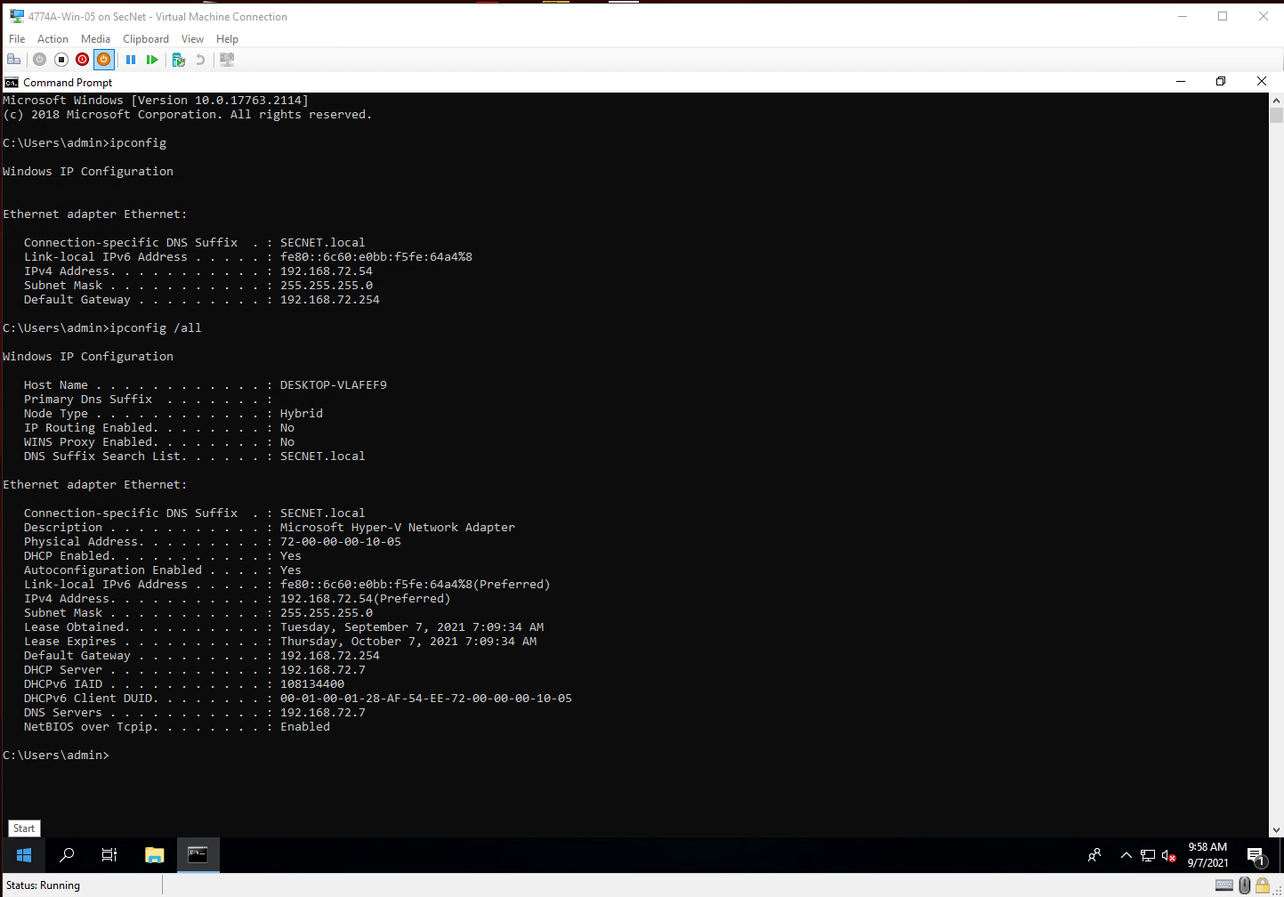

Step 16

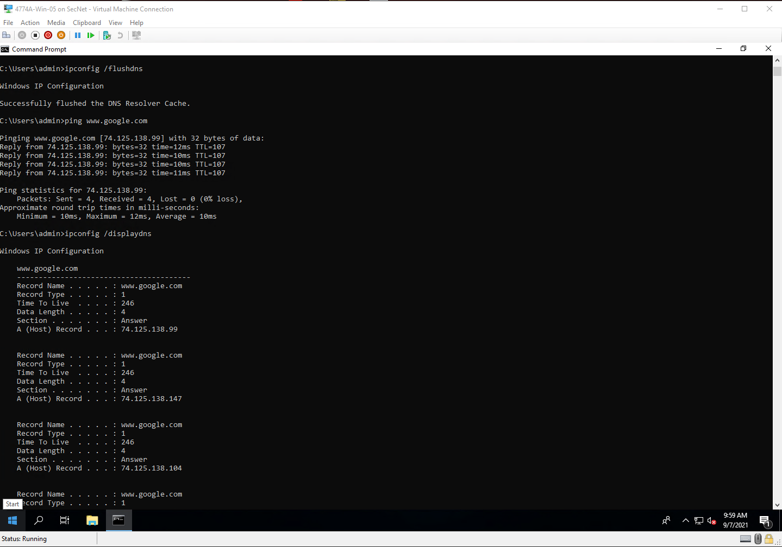

Step 19

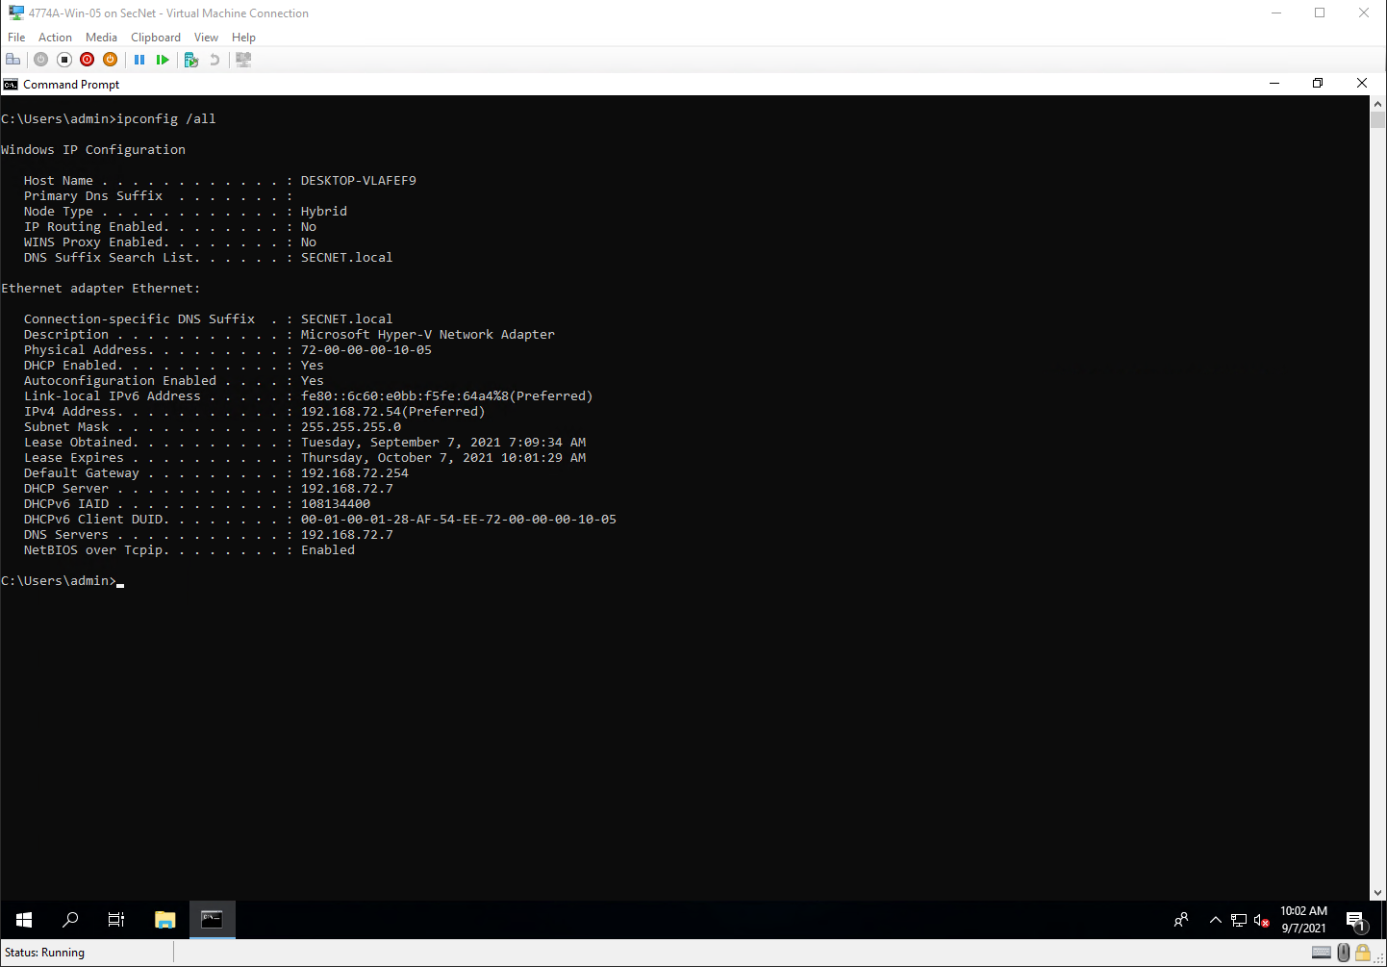

Step 24

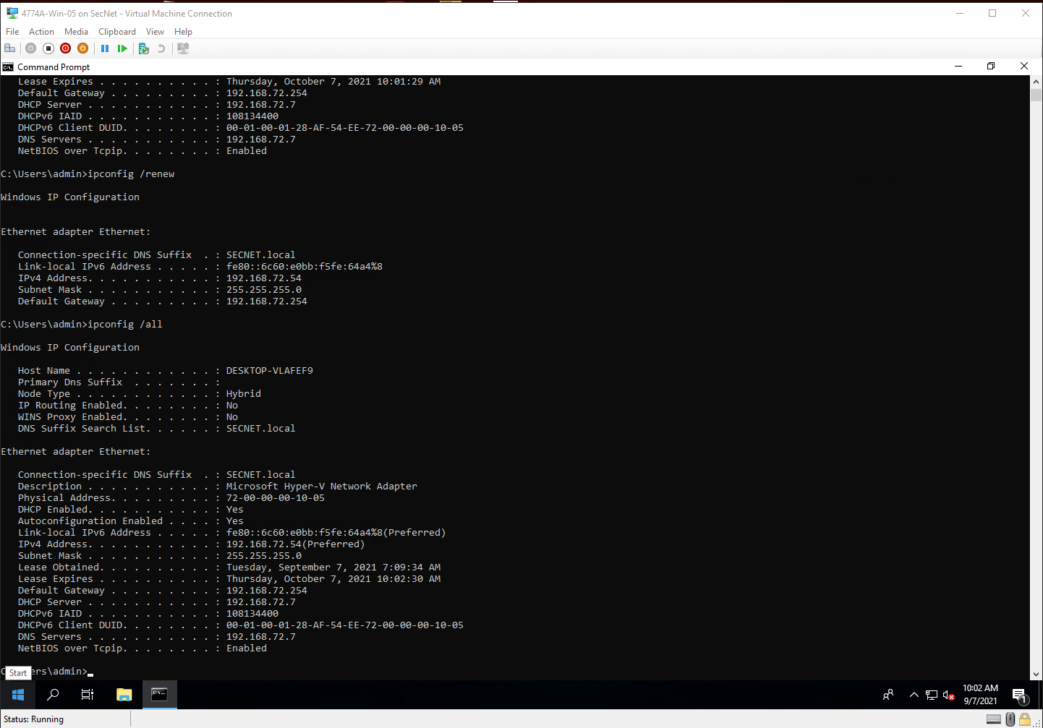

Step 28

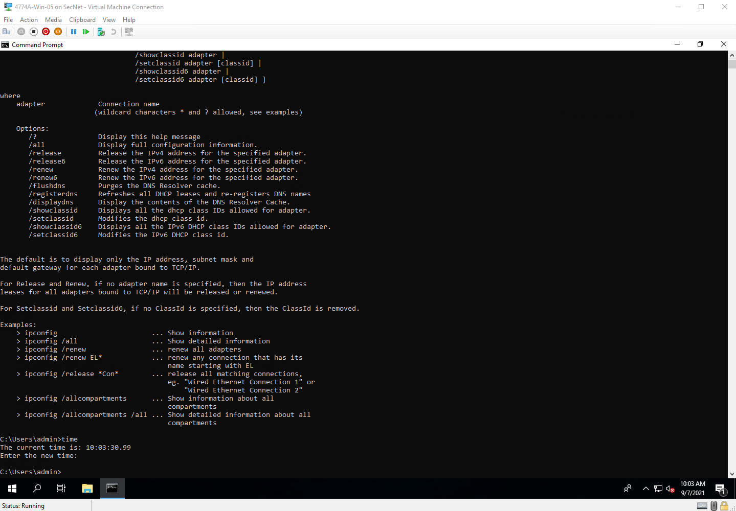

Project Questions

1. My IP address is 192.168.72.54
2. My MAC address is 72:00:00:00:10:05
3. My default gateway is at 192.168.72.254
4. My subnet mask is 255.255.255.0 or /24

Thought Questions

1. The MAC addresses are specific to the device and doesn’t change. IP addresses are network specific meaning that they can vary depending on what network the device is on.
2. The default gateway is how devices on this network connect to devices outside this network
3. DNS servers translate domain names into IP addresses.
4. Subnet mask defines how a network is divided.

1.3 Ping

Step 8

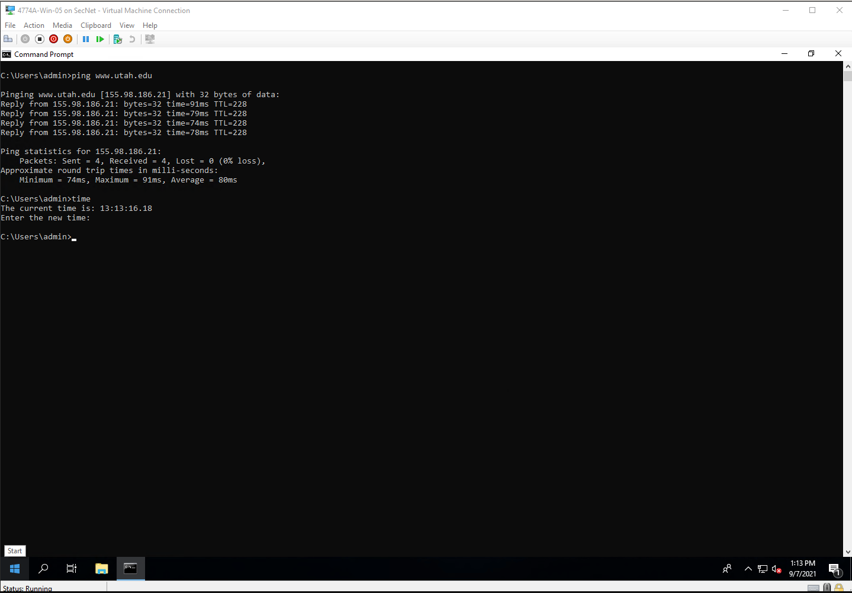

Step 16

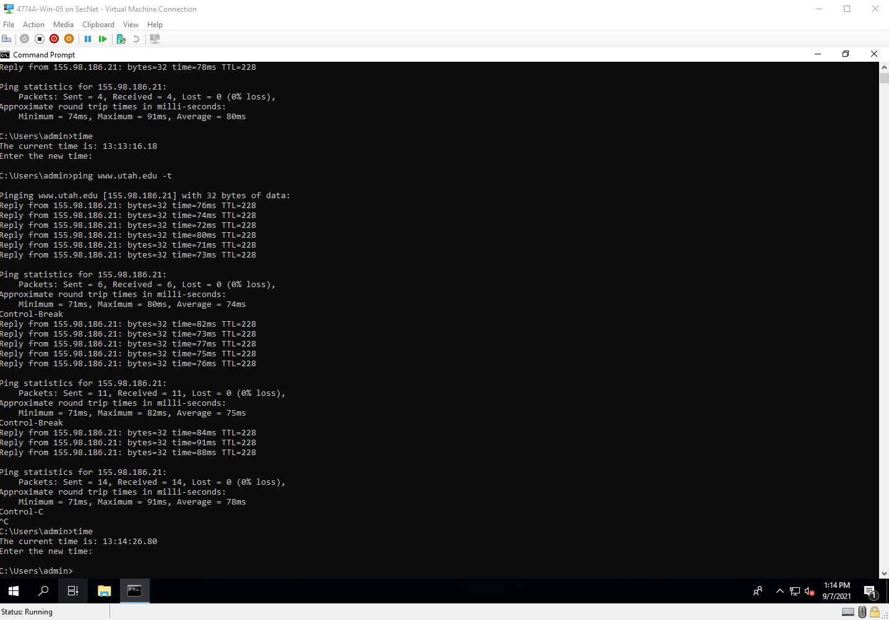

Step 25

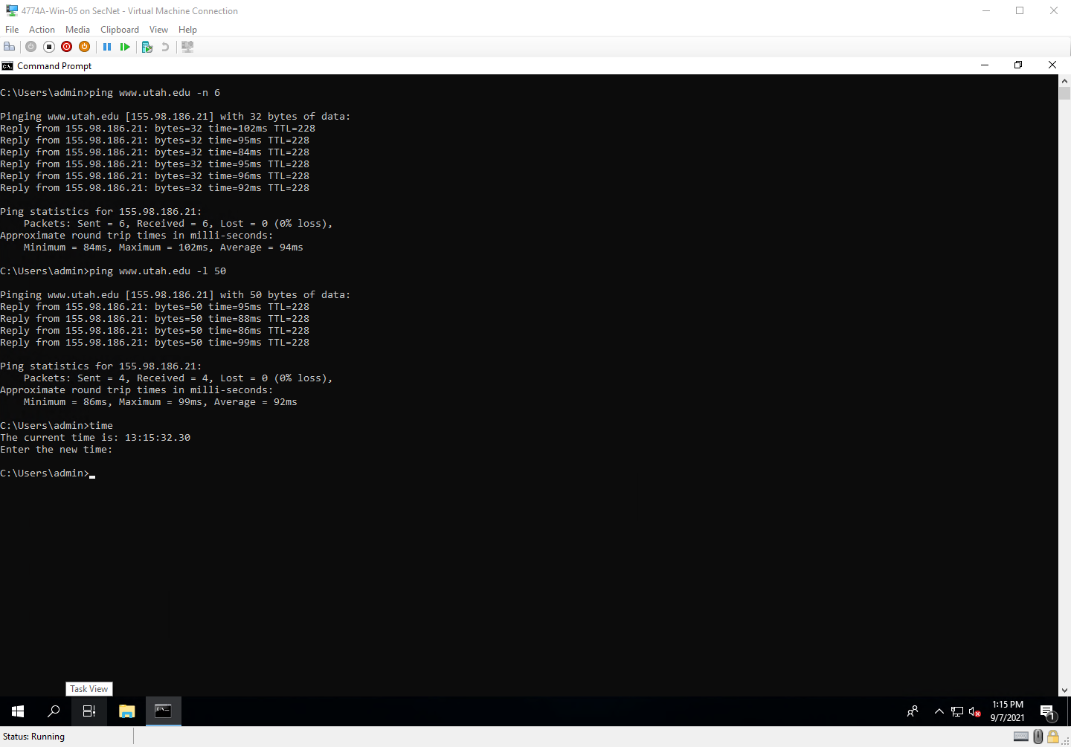

Project Questions

1. I pinged [www.utah.edu](http://www.utah.edu)
2. The IP address was 155.98.186.21
3. The ping was 95 ms long
4. It had 228 TTL value

Thought Questions

1. You can change the number of packets sent with the -n flag
2. The -l option changes the size of the packets sent. The -n option changes the number of packets sent. The -t option pings the host until interrupted by user.
3. Packet loss is typically experienced due to network connectivity issues.
4. Sending larger files allow for the user to test the throughput.

1.4 TraceRT

Step 10

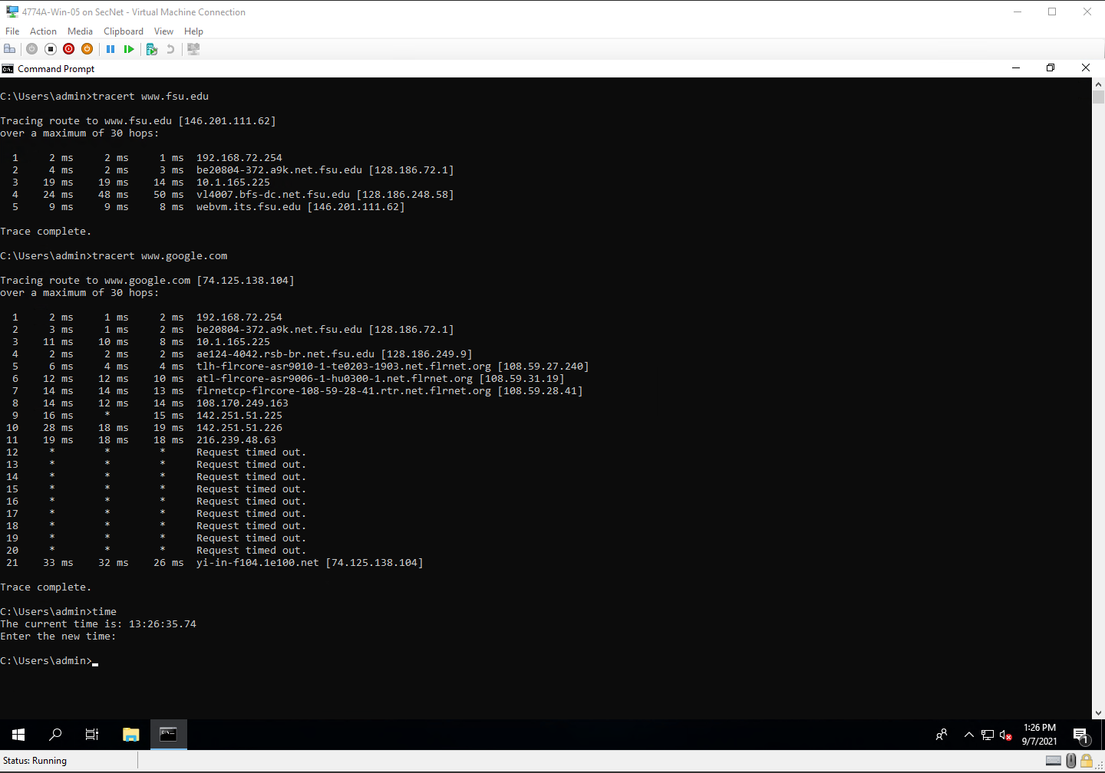

Step 17

Step 22

Step 27

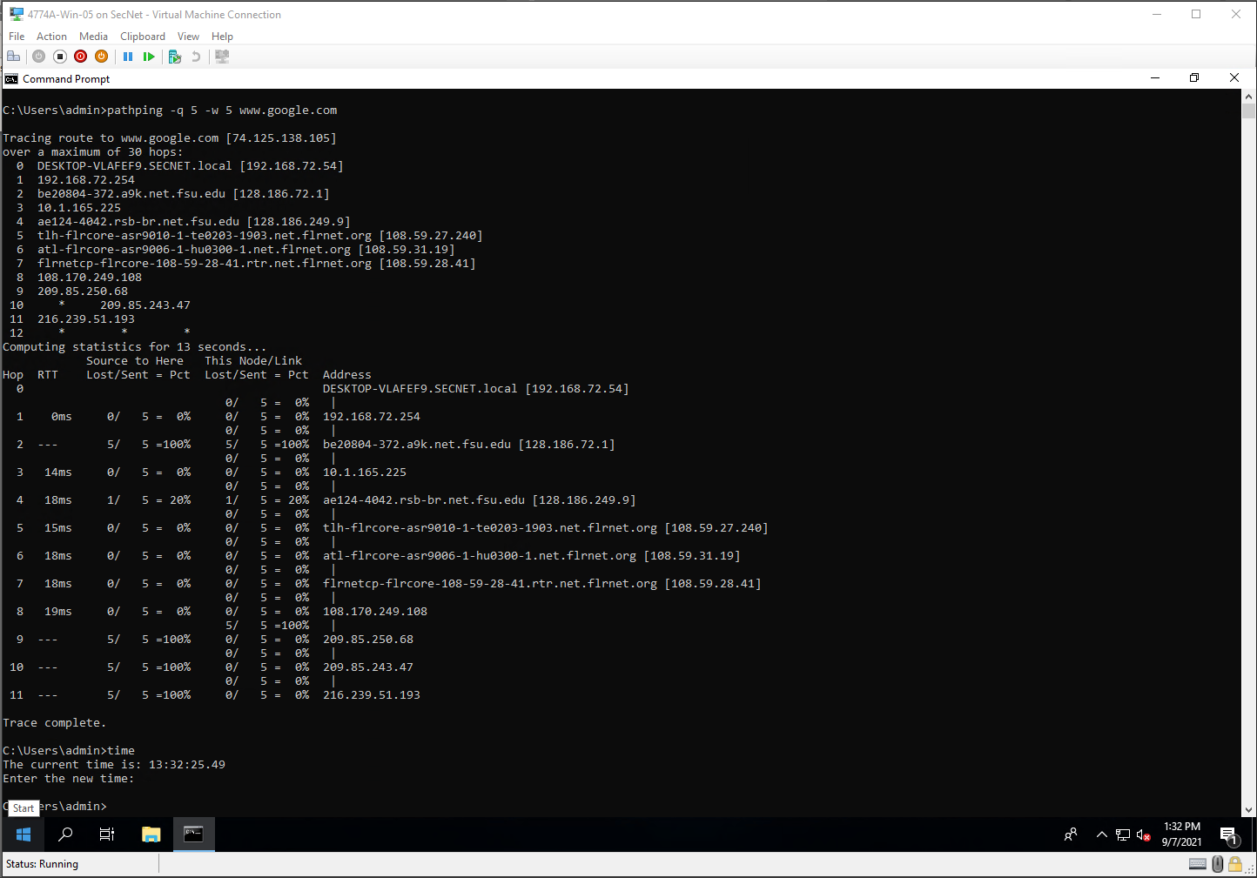

Project Questions

1. There were 5 entries between me and [www.fsu.edu](http://www.fsu.edu)
2. There were 21 entries between me and [www.google.com](http://www.google.com)
3. The computer after me is 192.168.72.254 (default gateway)
4. Pathpings longest wait for results was round 20 seconds

Thought Questions

1. You would use the -d option when you don’t want IP addresses resolved to hostnames.
2. The -w option sets the timeout limit. If a host takes longer than the timeout period to respond, the services skip over it.
3. A network administrator may want to see how traffic is being routed through the networks they have control over.
4. The -q option defines how many queries are made per hop in pathpin. If it is not specified, pathping will just use its default value.

1.5 NETSTAT

Step 8

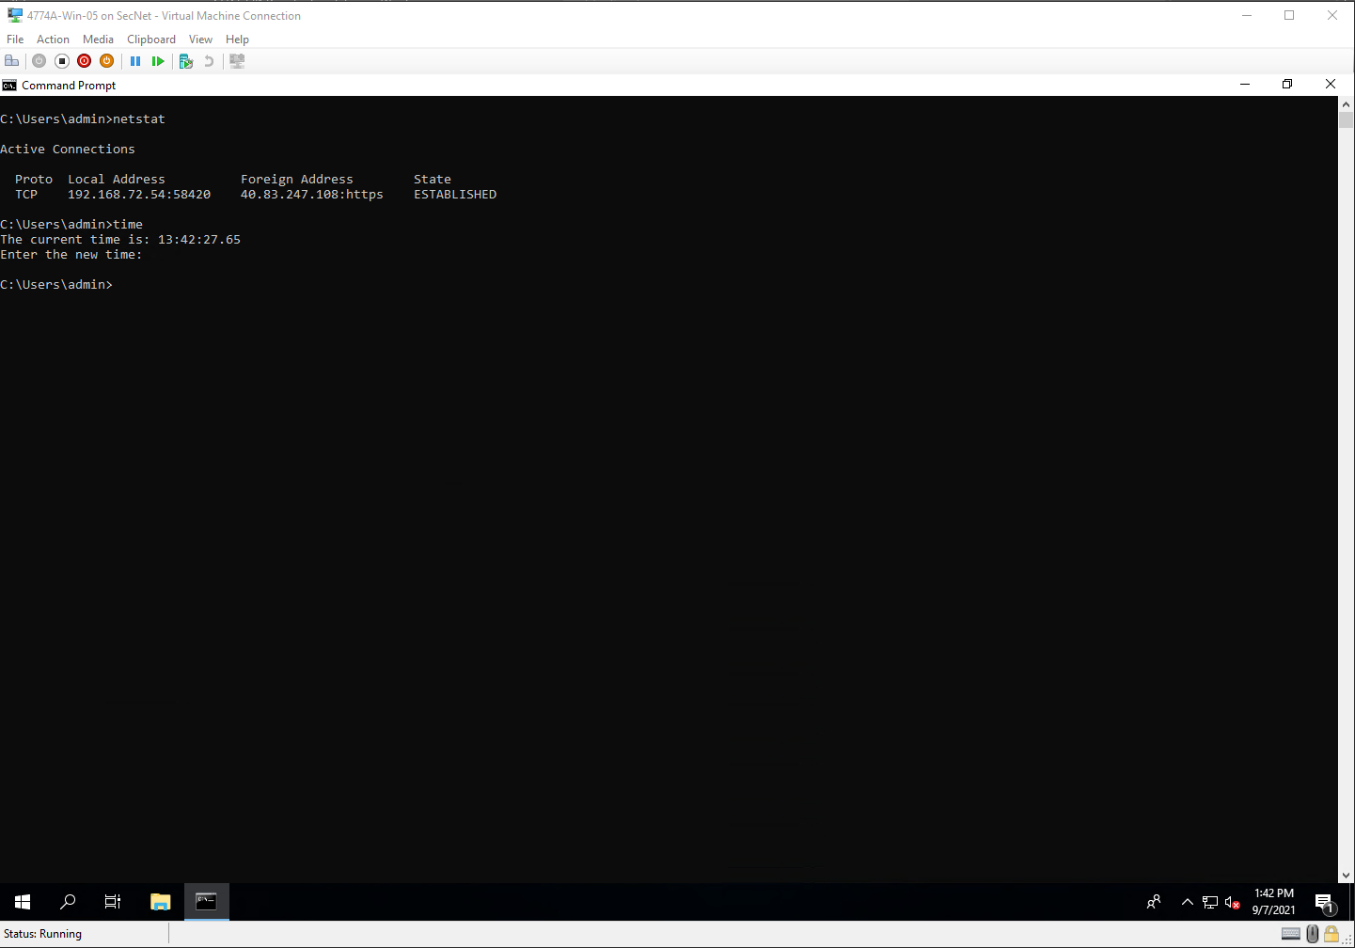

Step 13

Step 16

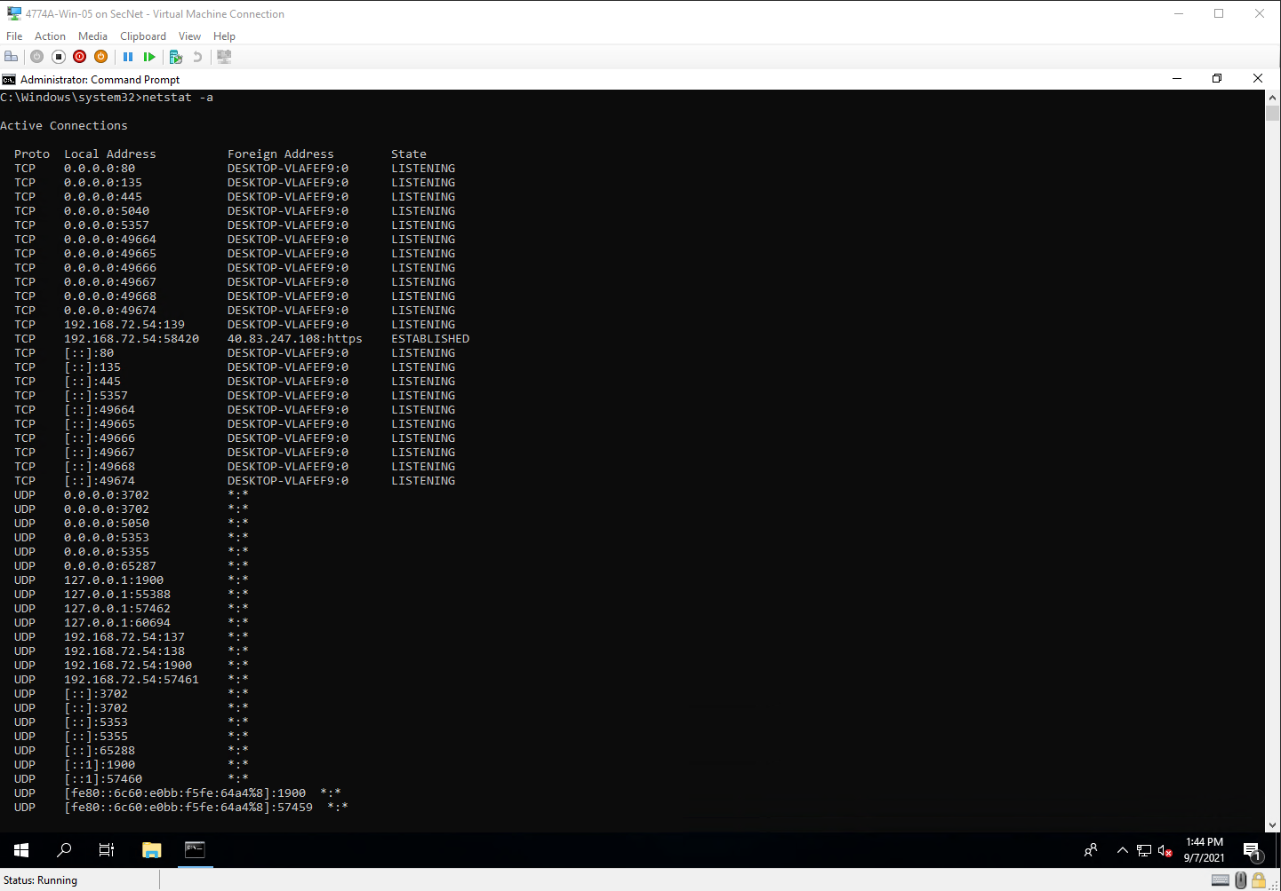

Step 21

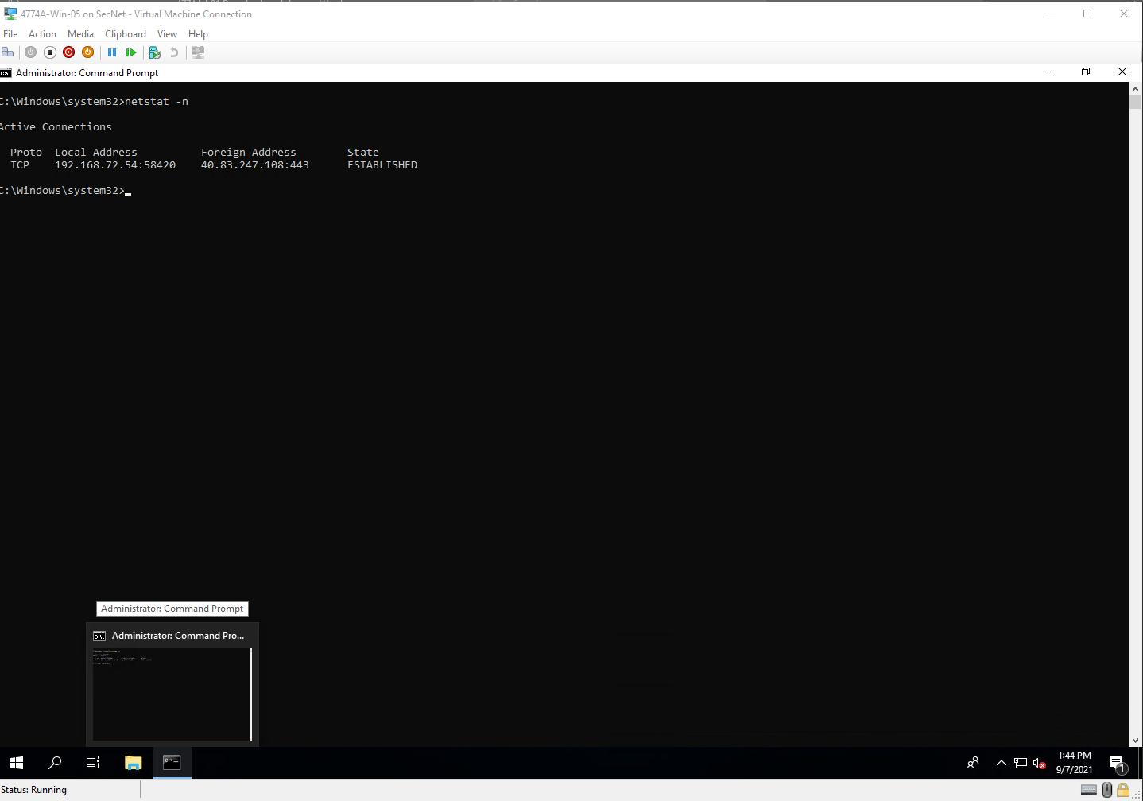

Step 24

Step 33

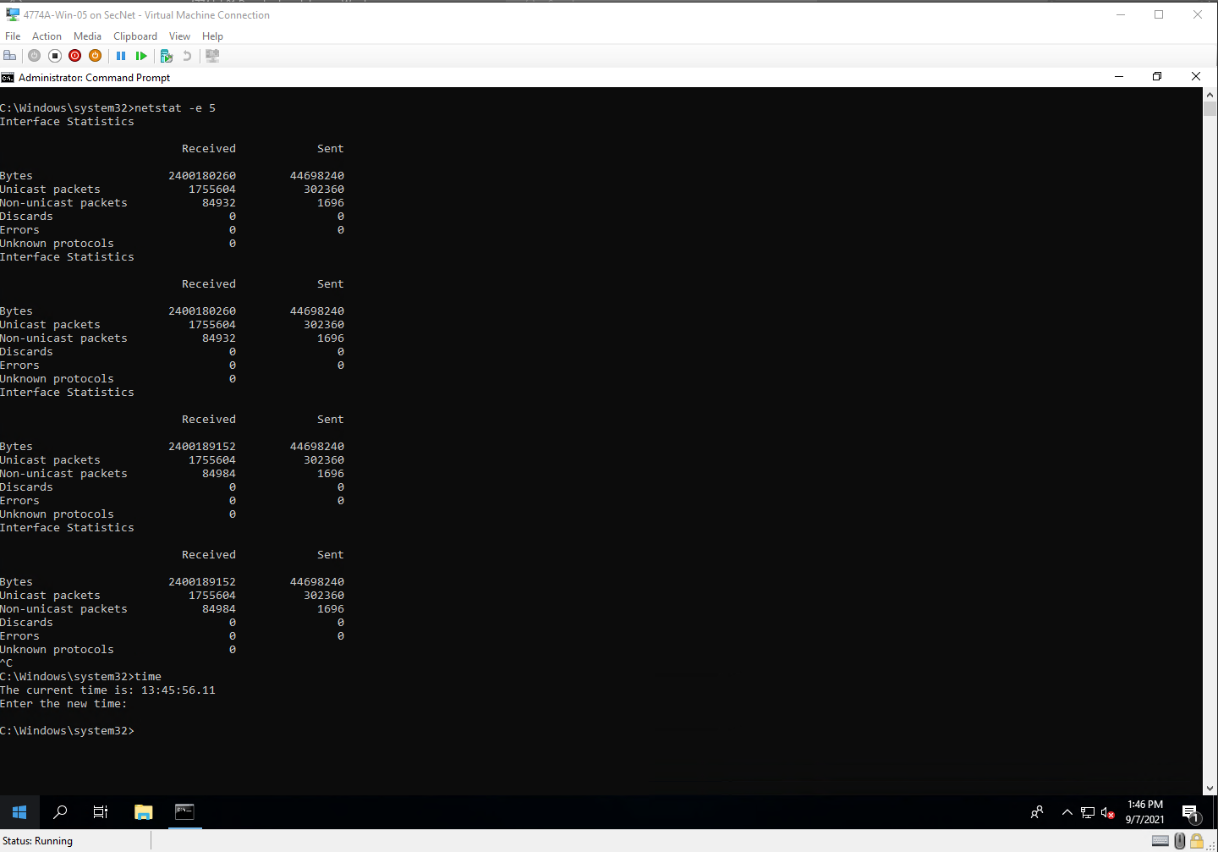

Step 36

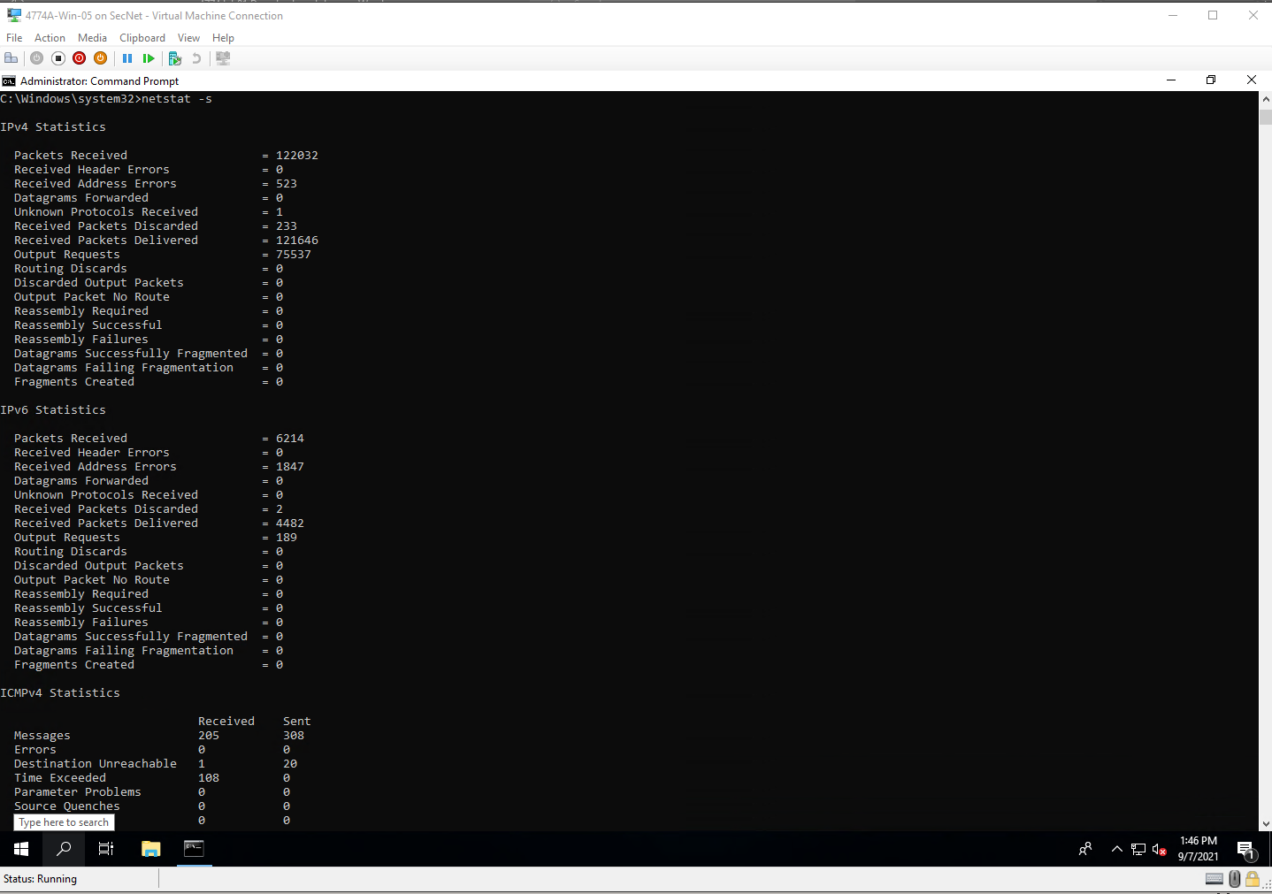

Project Questions

1. The first local port was 58420
2. I had 23 TCP connections
3. I sent out 44698240 bytes
4. I have 94 echo replies

Thought Questions

1. .

1.6 NSLOOKUP

Step 1

Project Questions

1. .

Thought Questions

1. .