16.6 CrypTool V2

Screenshots

Step 14

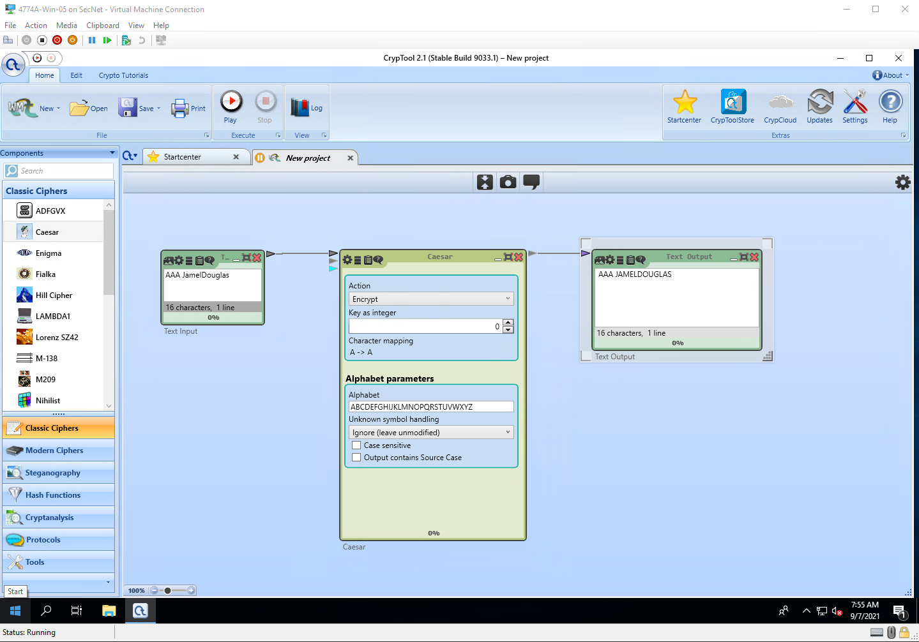

Step 17

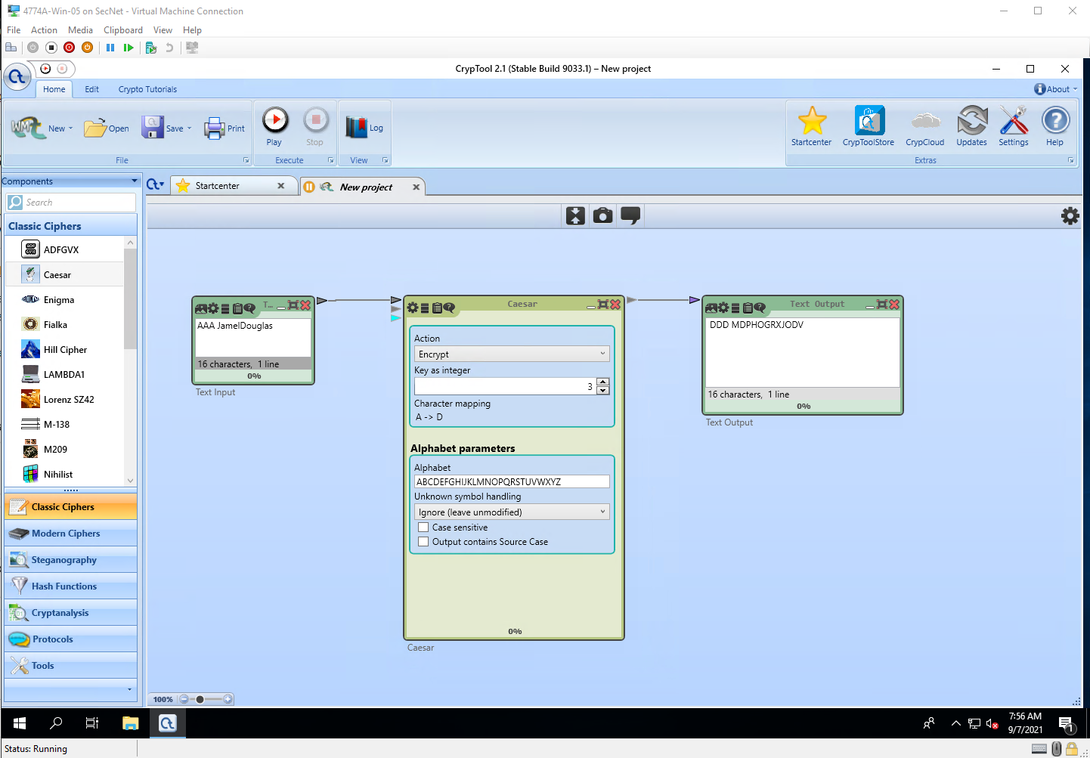

Step 25

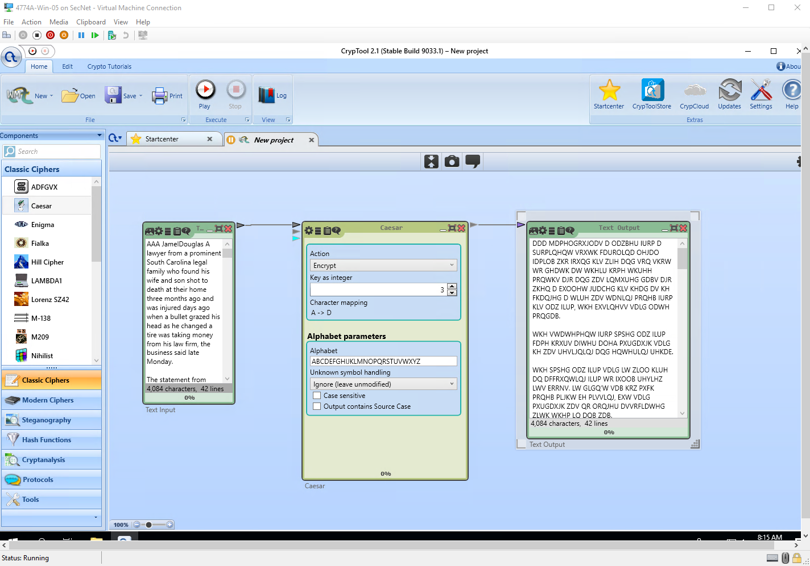

Step 40

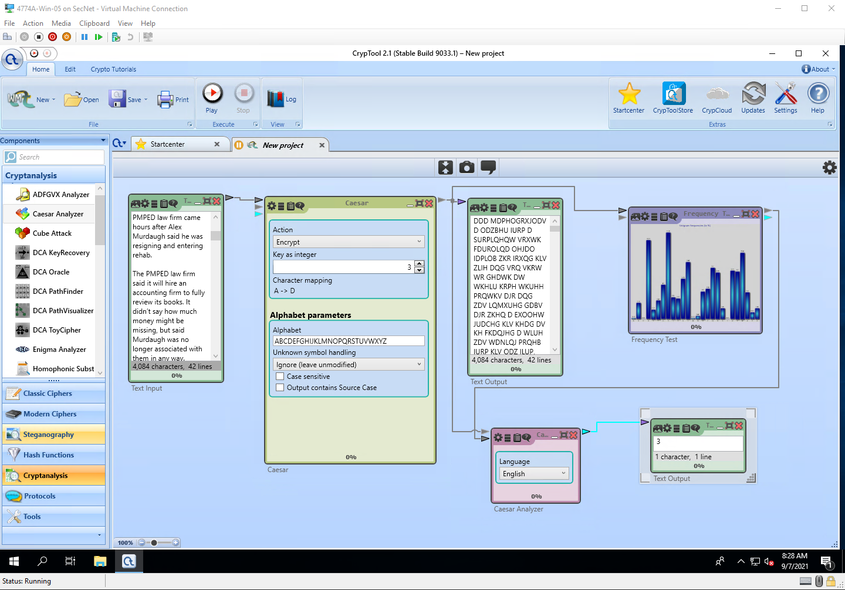

Step 52

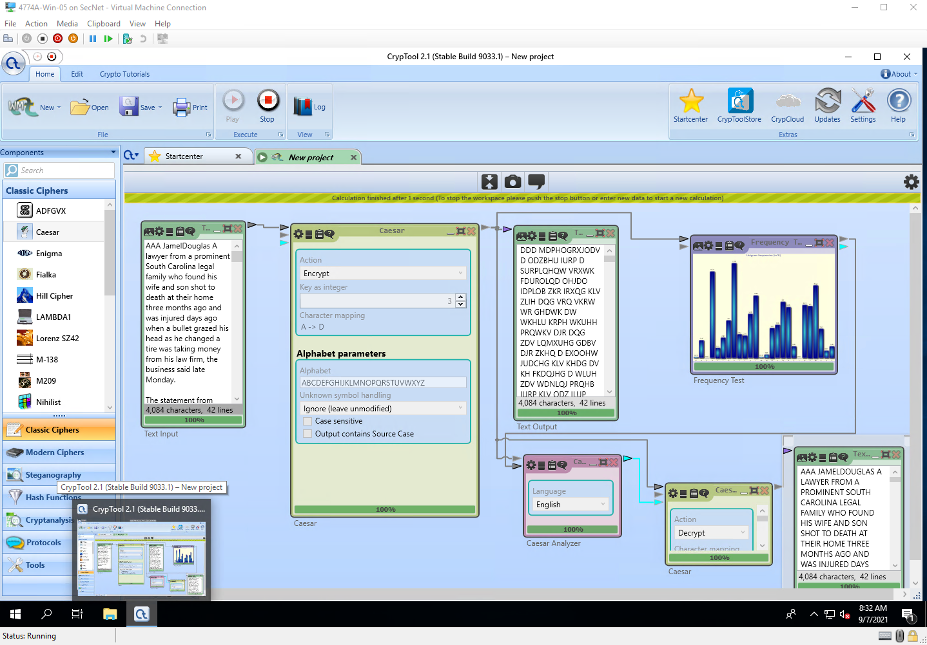

Step 57

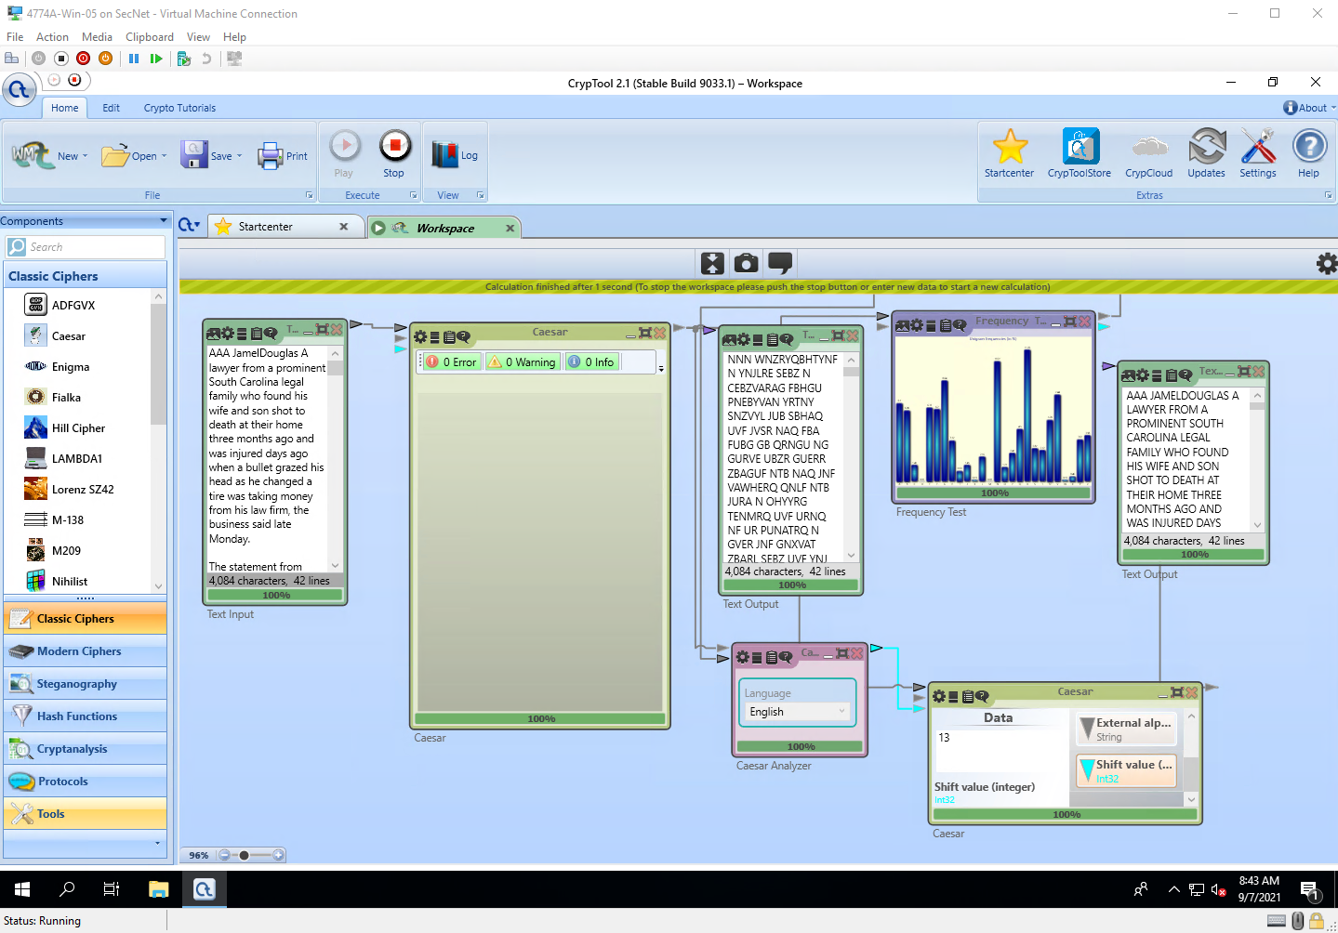

Project Questions

1. My random key value was 13
2. My name shifted 3 times is MDPHO GPXJODV
3. The percent frequency for the letter H was 3.52%
4. The lowest percent frequency on my chart was 0.03. This correlated with letters D and M

Thought Questions

1. Caesar shift only shifts the “value” by a certain amount. If you match up the frequencies of letters in the ciphertext to frequencies of how letters are used, you can somewhat visualize the shift.
2. I think that A, I, O, U, and Y are other letters that are common in the English language. These letters are vowels
3. Caesar shift would not be considered a secure method of encryption because it can be easily cracked with a frequency analysis, as proven in this lab.
4. It is possible to try all the Caesar shifts in English because there are only 25 different ways the alphabet can be shifted.