3 Tracking

Screenshots

Step 10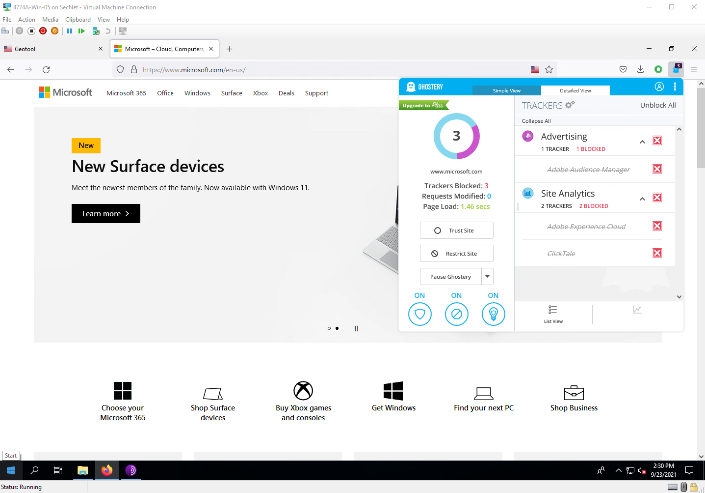

Step 12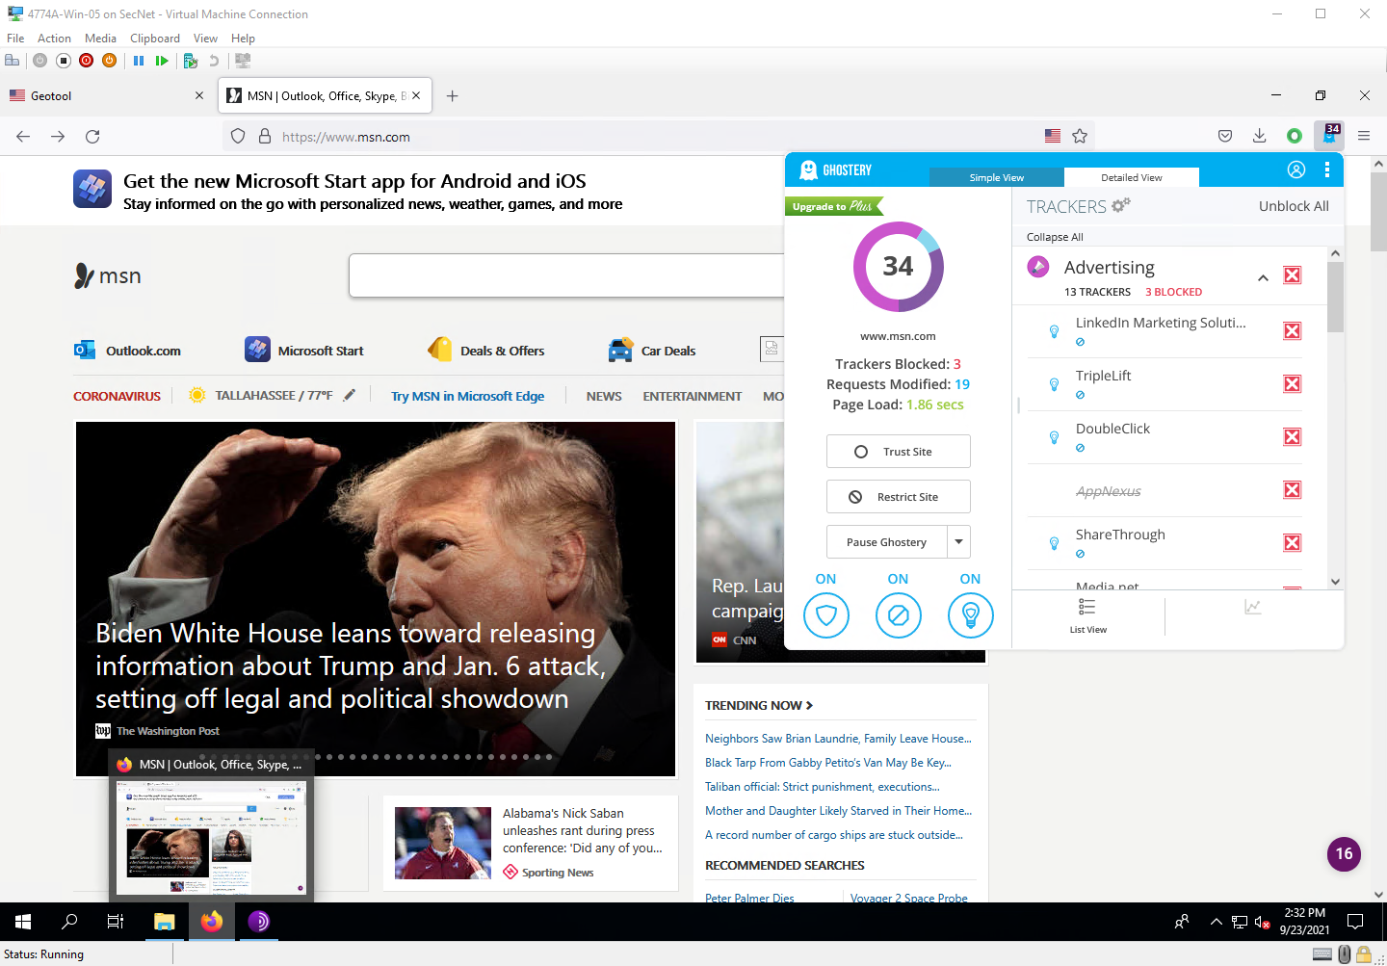

Step 16

Project Questions

1. msn.com had the most trackers with a total of 22.
2. Yes, FSU is using some trackers. They are using DoubleClick and Adobe Typekit trackers, and some others.
3. I got 3 trackers on Microsoft.com
4. I saw the DoubleClick tracker on multiple websites.

Thought Questions

1. Ad networks are company that sell ad space on the internet. An example is Google Adsense.
2. To help create a uniform advertisement experience.
3. A whitelist is a list of approves sources that can bypass the filter.
4. Sites track users so that they can cater ads to me based on the users behavior.

5 Web Proxy

Screenshots

Step 6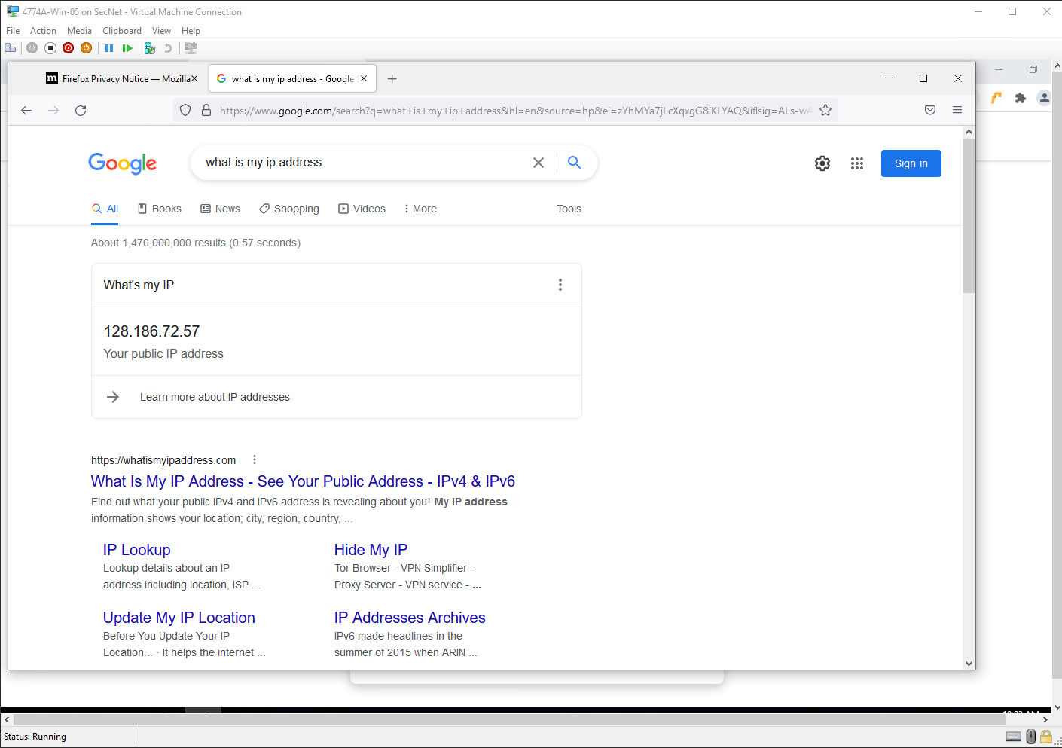

Step 13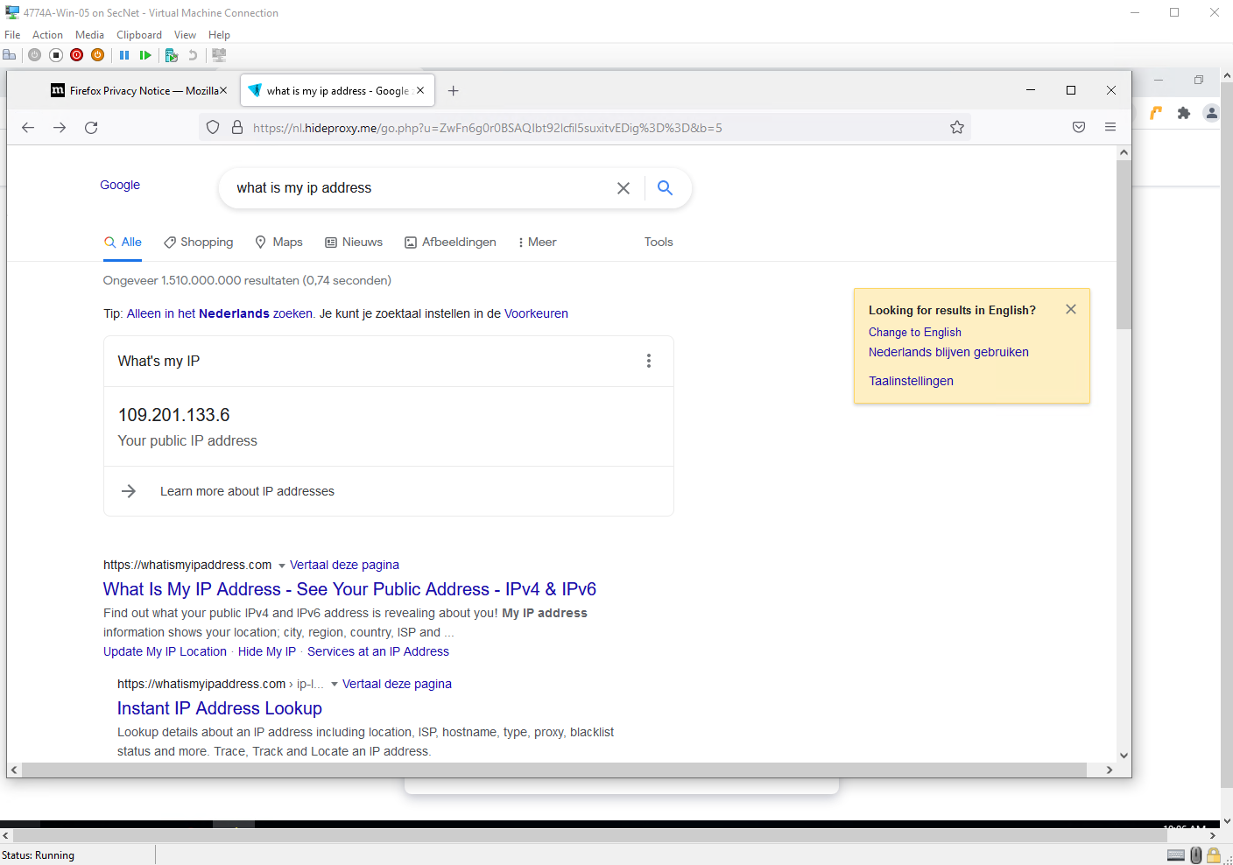

Project Questions

1. My IP address without the proxy was 128.18672.57
2. I used the BLANK web proxy.
3. Yes, a proxy can handle HTTPS traffic. However, the owner of the proxy server would still be able to see the traffic between the proxy server and your computer
4. My IP address with the proxy was 109.201.133.6

Thought Questions

1. It does do somethings to hide your identity, like changing you IP address. However, it does not prevent tracking through cookies or other ways.
2. Yes, it is possible for a company to block access to unauthorized proxy servers.
3. Rather than connecting to each individual server on their local network, users can connect to the proxy server, which will make the connection to the servers on the local network.
4. It is possible that an employer may get suspicious if you were to use a proxy server.

7 HTTPS Everywhere

Step 11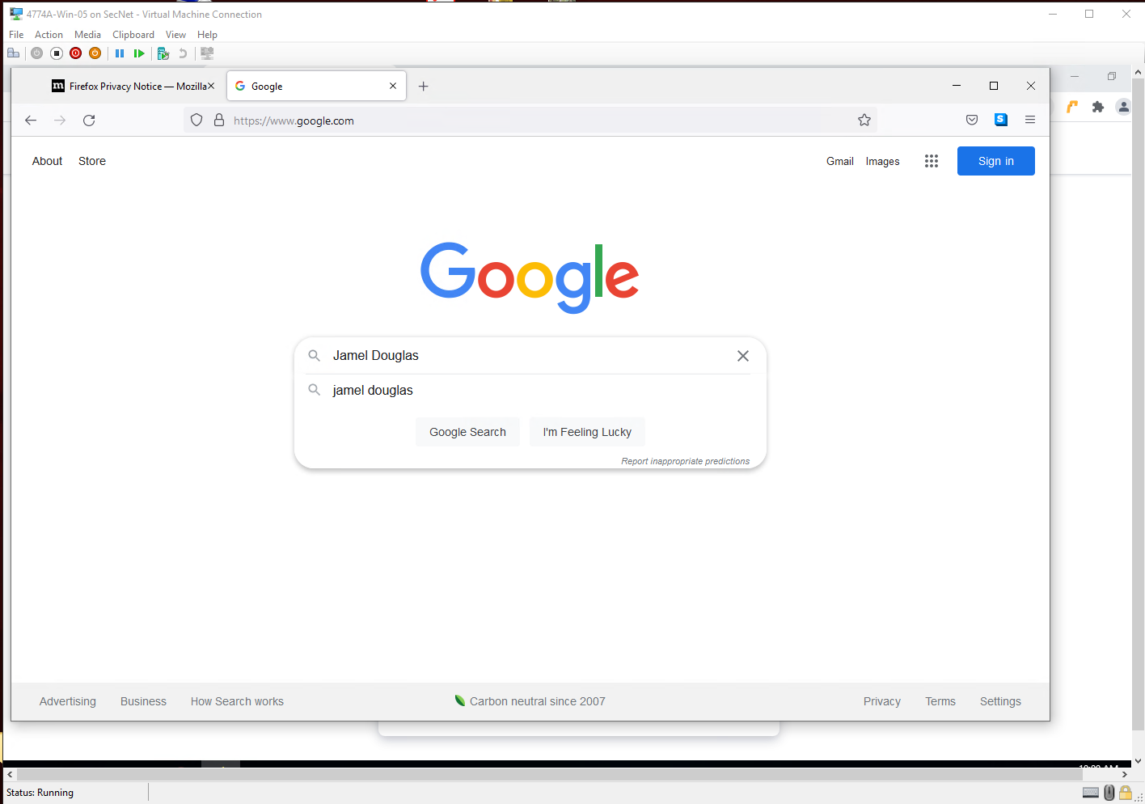

Project Questions

1. The first website listed when I looked my name was an Instagram page for the user @jameldouglas.
2. The top 5 search results had sites that used encrypted connections (HTTPS)
3. One of the sites that I visit on a daily basis, is FSU’s canvas site, and yes it does offer HTTPS.
4. No, I believe that another encrypted protocol is used for email.

Thought Questions

1. Not all sites offer HTTPS because it is a process to setup. However, HTTPS is slowly becoming the industry standard.
2. I’m pretty sure that employers would rather use HTTPS as it is more secure
3. In order to start offering HTTPS, the website owner must first get an SSL certificate that is signed by a reputable certificate authority.
4. Currently, using an HTTPS connection has become the industry standard. So that means the most basic sites are using encrypted connections

9 Web of Trust

Step 9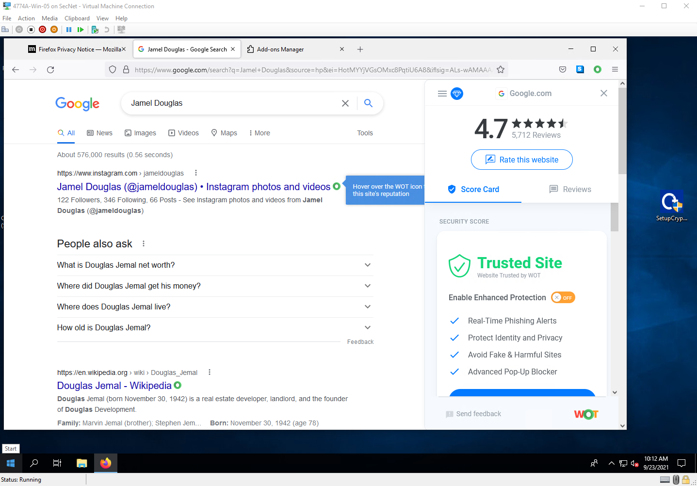

Step 14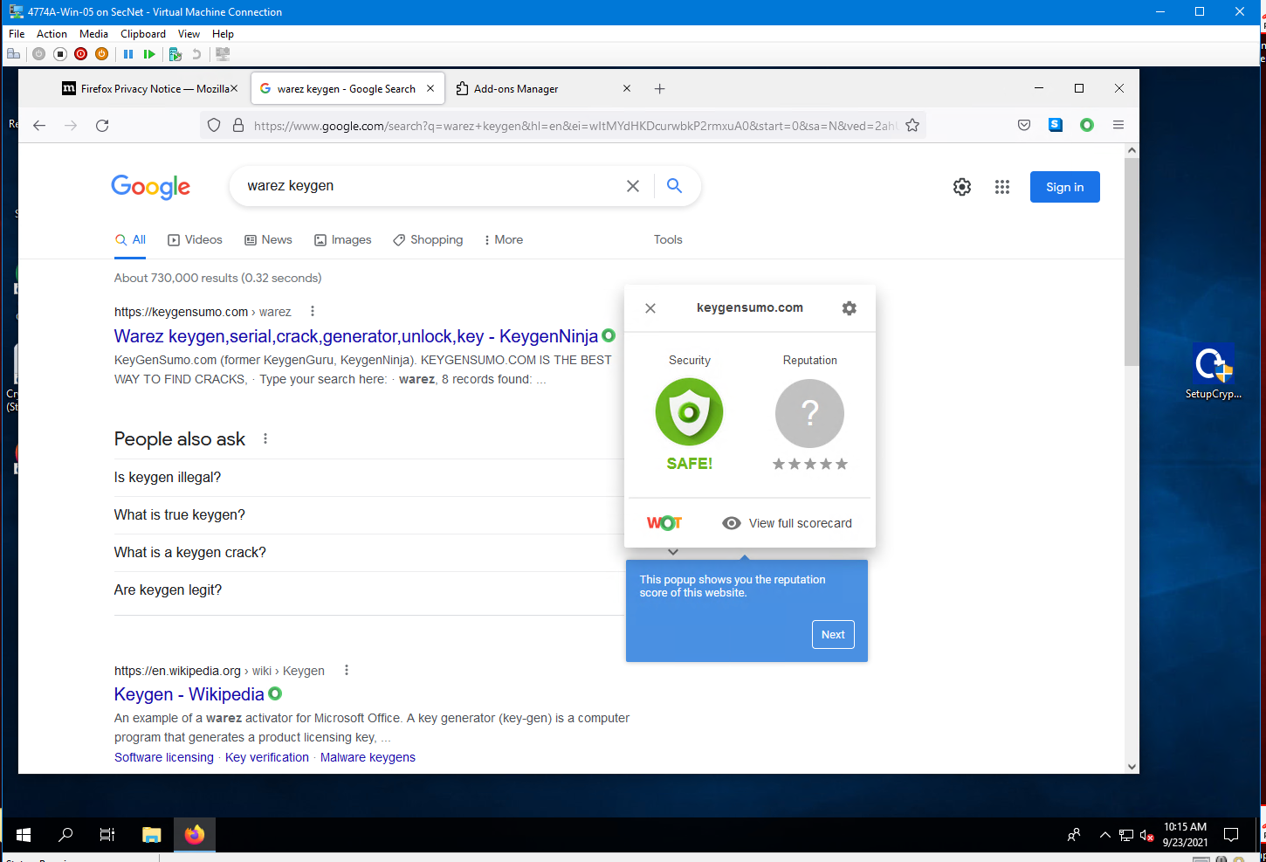

Project Questions

1. I chose Google as the site that I frequently visit.
2. Google did have a good scorecard. It was listed at 4.7 stars.
3. I did not come across any bad reports when I looked up my name.
4. I couldn’t find a page with a bad scorecard when I looked up warez keygen

Thought Questions

1. I believe WOT gets their scorecard values from users of the service. Users submit “reviews” of the site.
2. Yes, I could leave a “review” of the site using WOT
3. Service provider is Amazon, and it is located in Oregon
4. I would get to see which sites have a good or bad score attached to them and based on that I would decide if it is safe or not to visit the site

10 Onion Routing

Step 6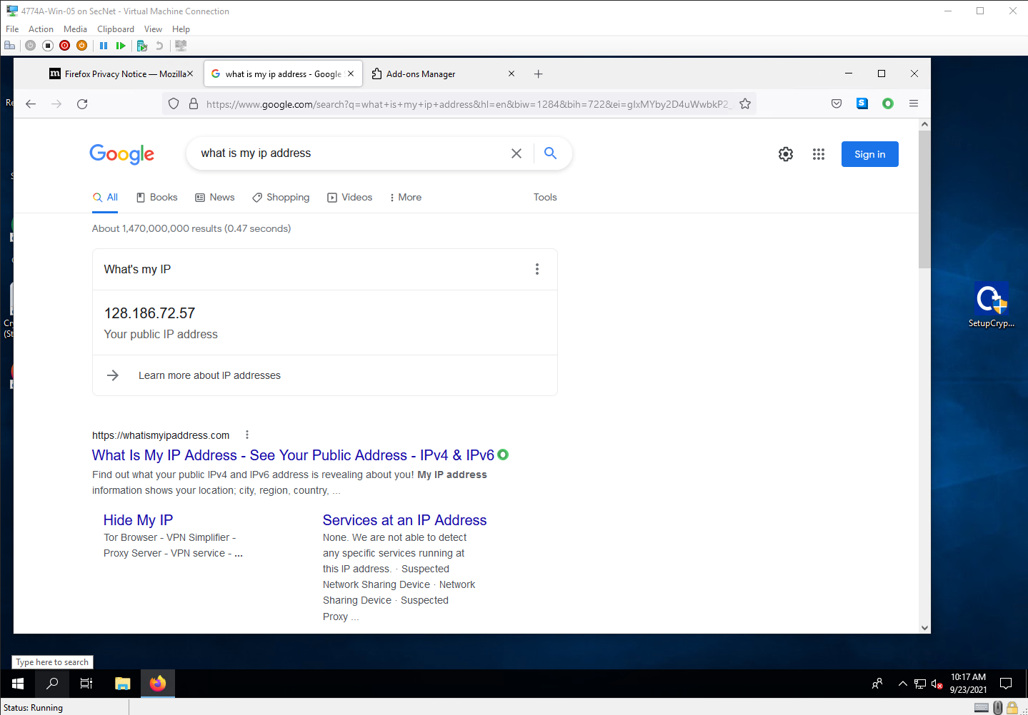

Step 20

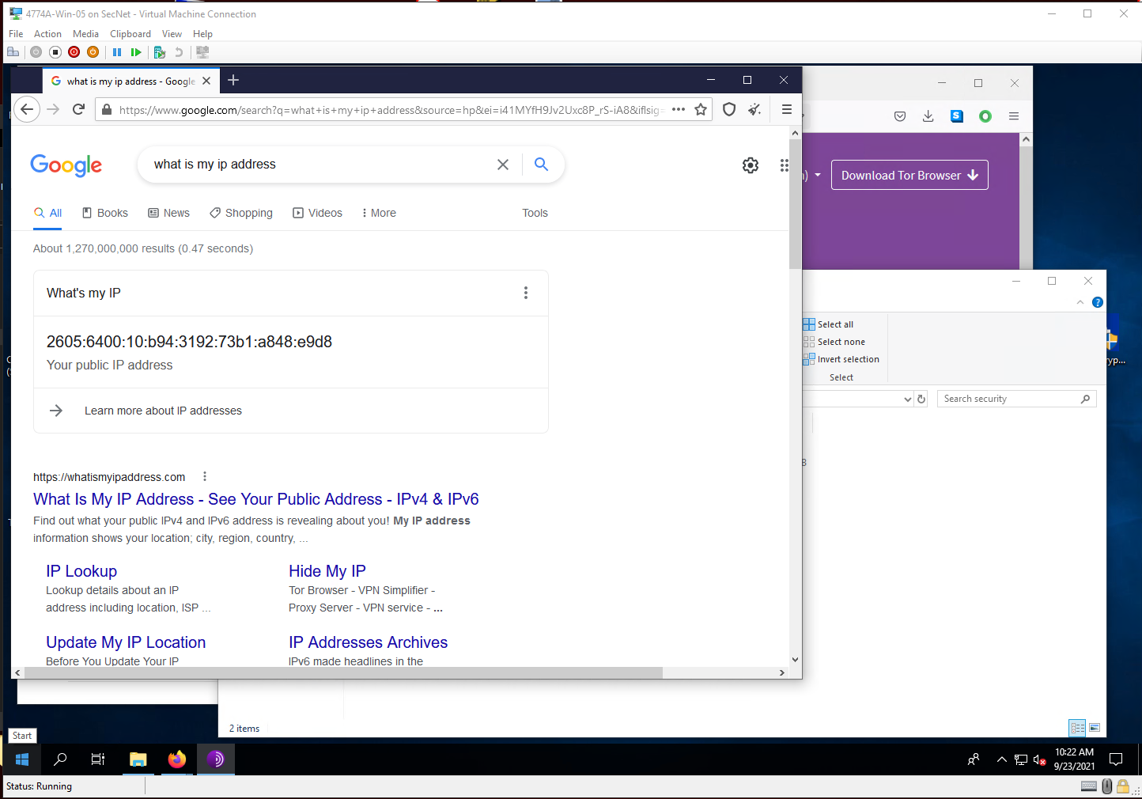

Step 24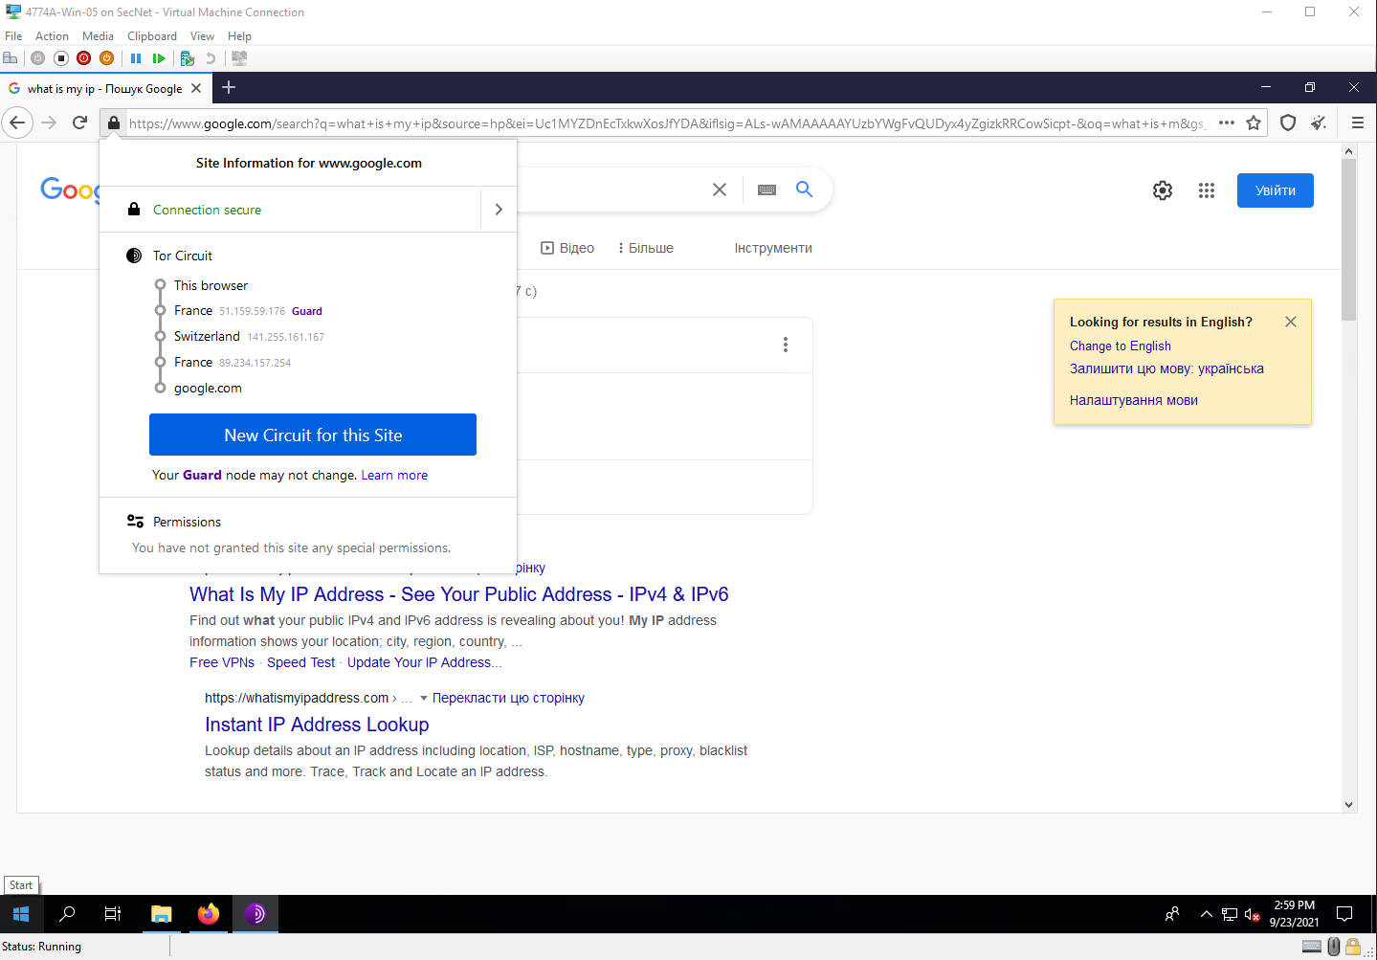

Step 28

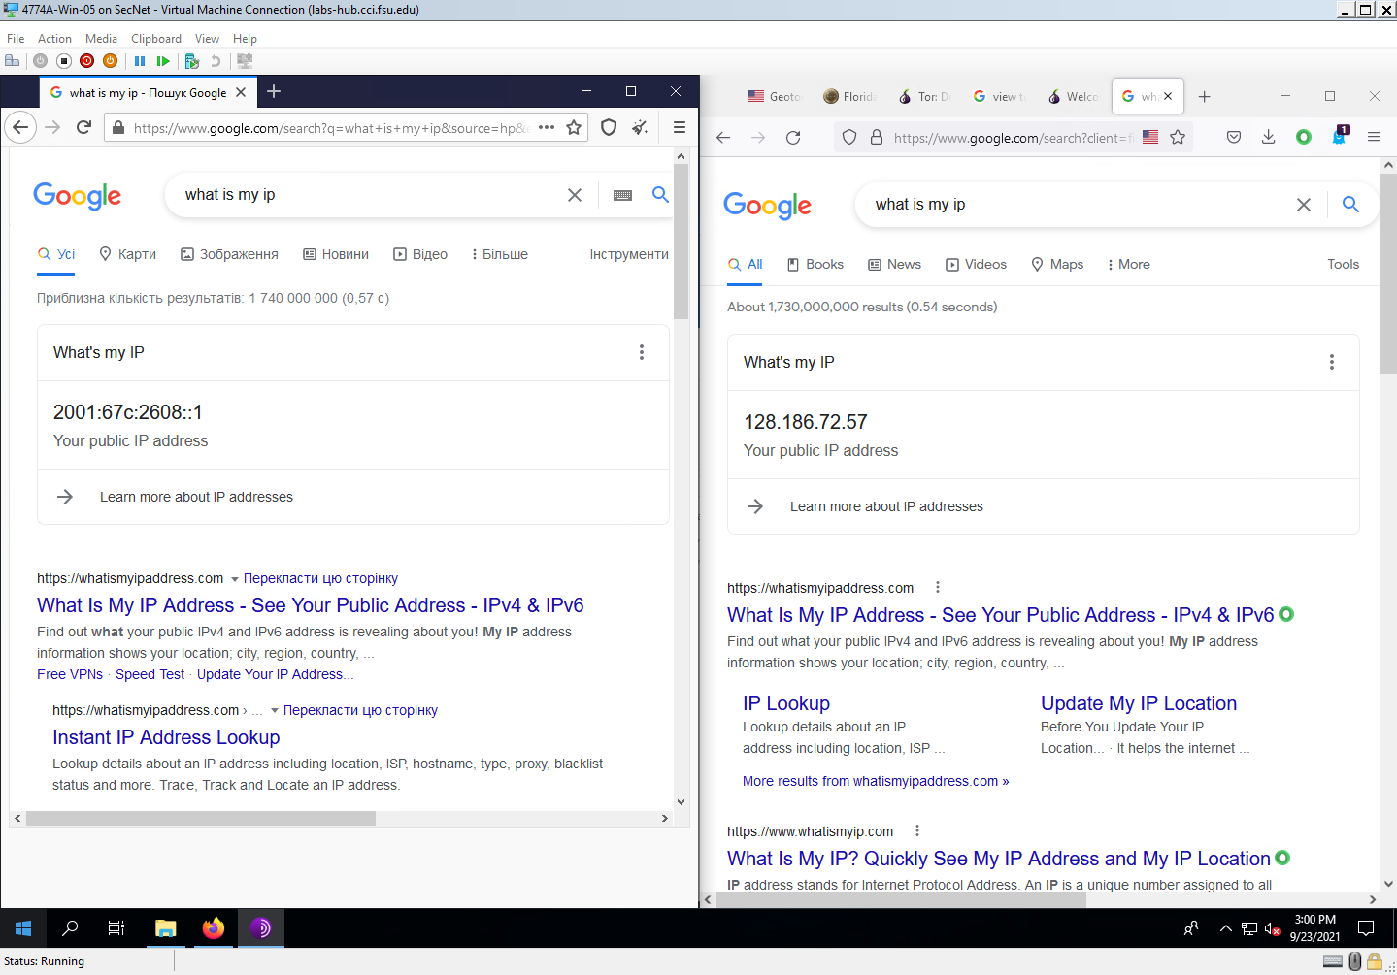

Project Questions

1. Real IP address was 128.186.72.57
2. Tor IP address was 2001:67c:2608::1
3. First relay server from France.
4. Browser is US based, through France, to Switzerland, back to France, then on to the site.

Thought Questions

1. Relay server essentially pass traffic along to other relay servers or to the exit node.
2. Yes, it is possible to act as a relay server by just following the instructions on their site.
3. If the traffic is not encrypted, then relay servers could read the traffic sent through them.
4. HTTPS is still needed because each relay server would see in plaintext whatever you were accessing on the internet