1 Tracking

Screenshots

Step 22

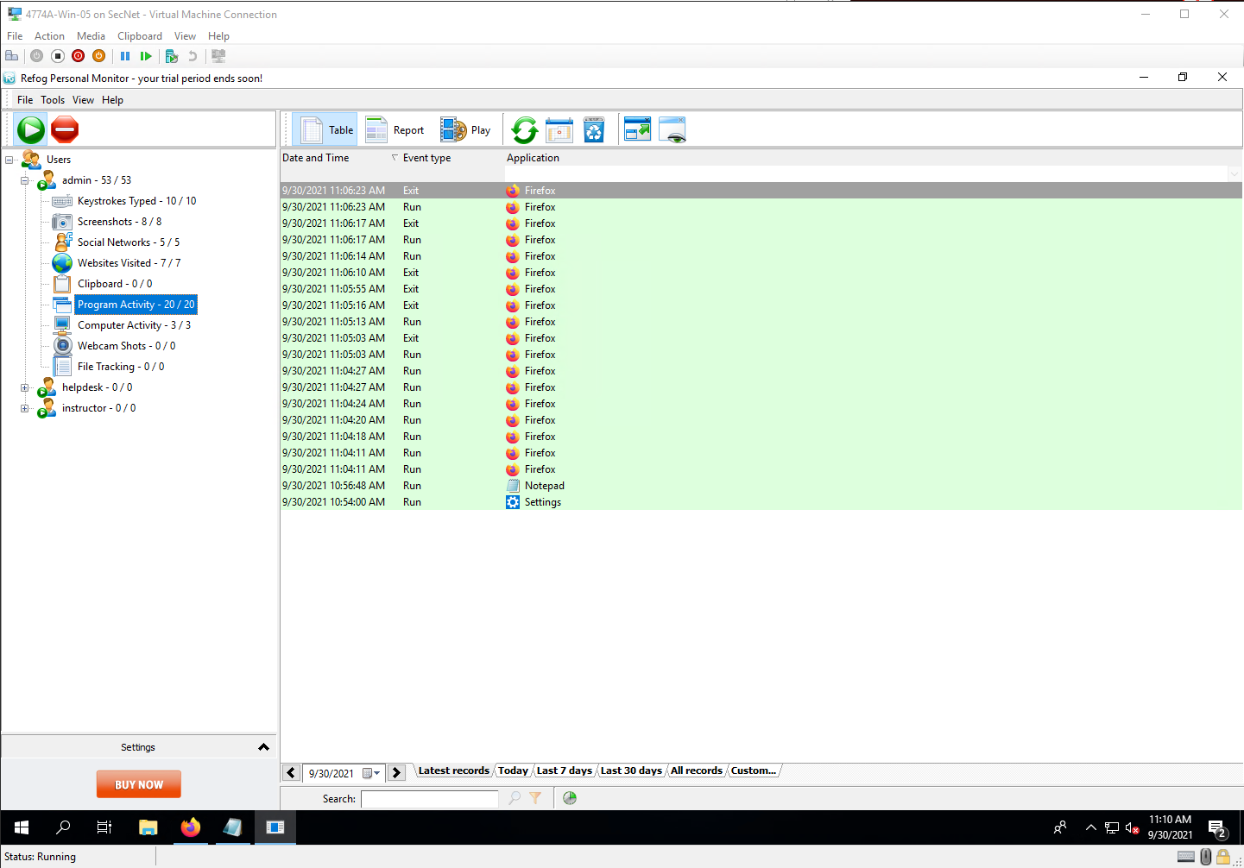

Step 24

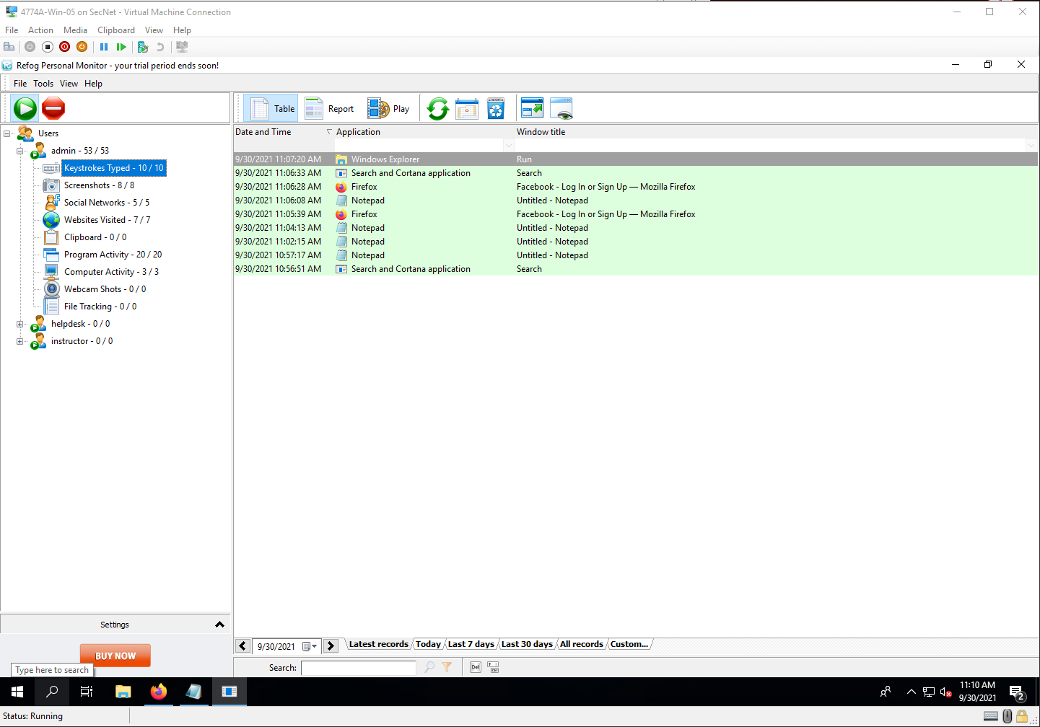

Step 27

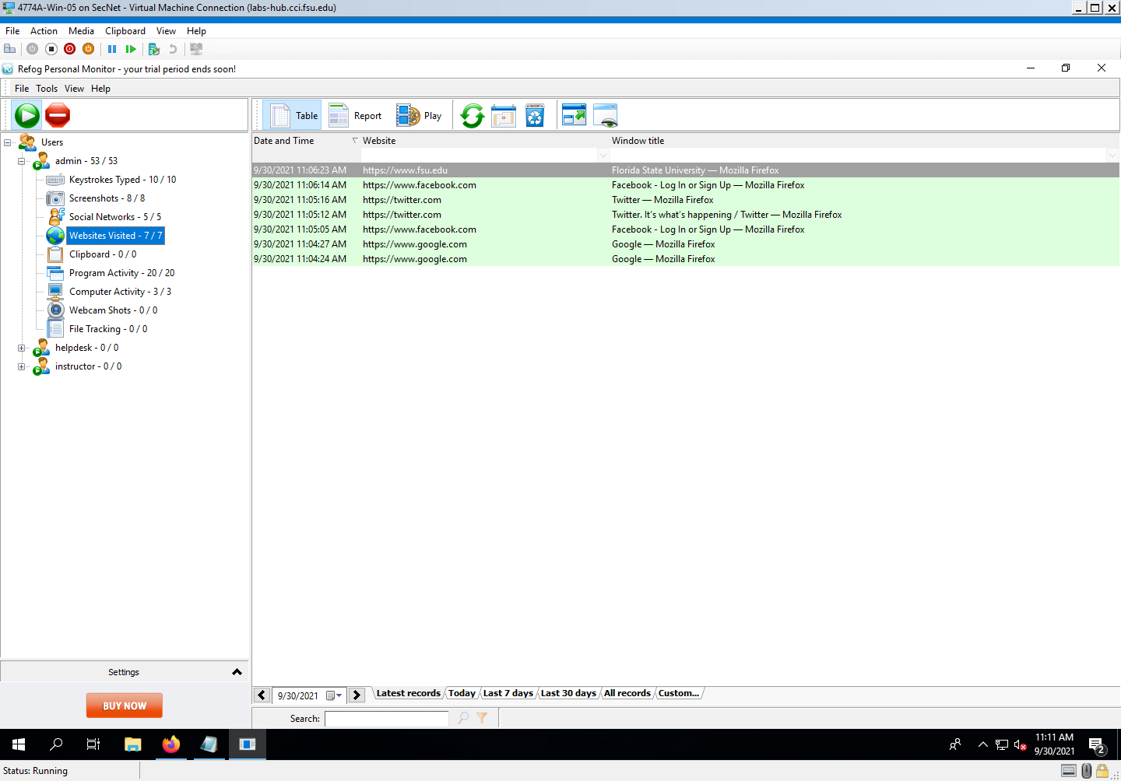

Step 29

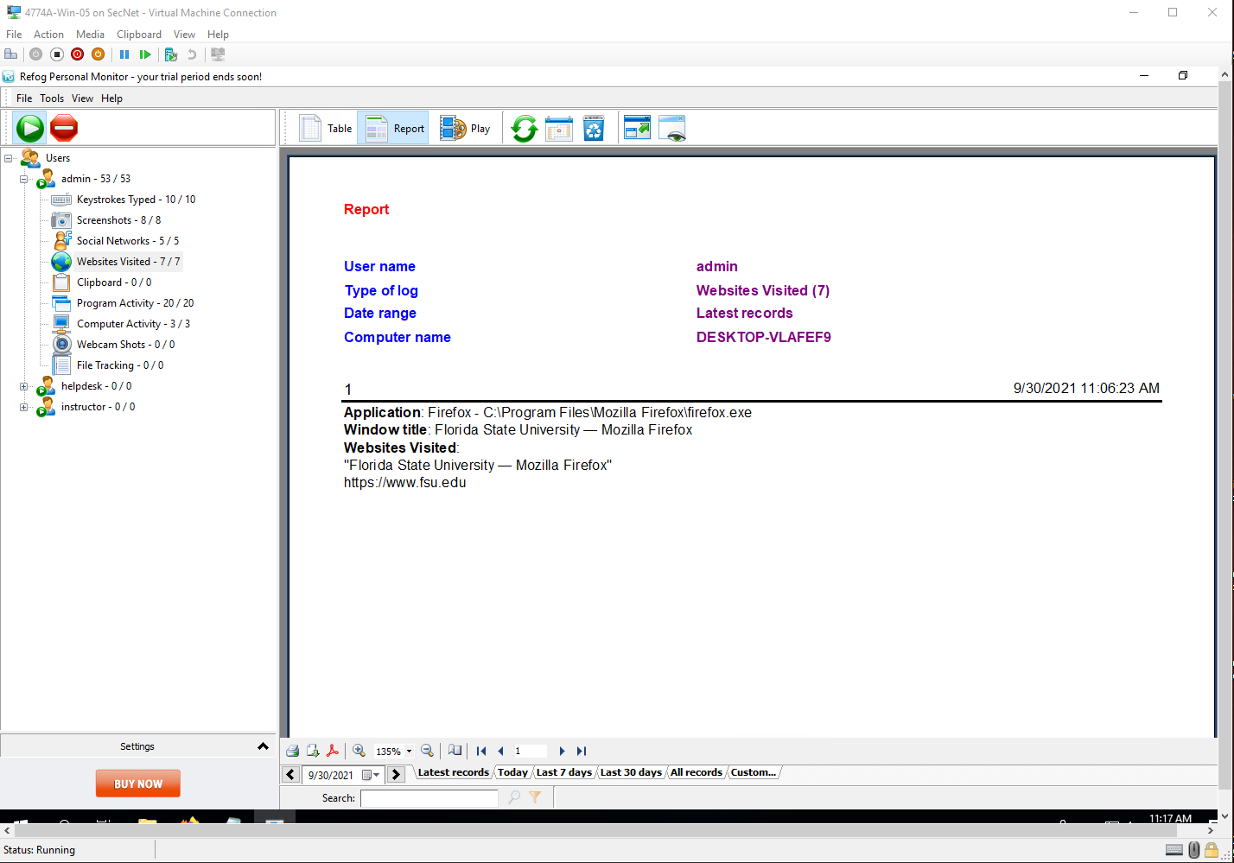

Project Questions

1. I entered my own name, Jamel Douglas.
2. I visited the FSU website, fsu.edu
3. I had notepad and Firefox listed under Program Activity.
4. My last keystrokes were at 9/30/2021 11:06:33 AM.

Thought Questions

1. Nobody monitors my activities with a key logger. I am about 90% sure because I was the one who installed the OS and I always lock my screen when I leave my computer.
2. If I used a keylogger to monitor somebody else’s activity and were caught, I feel like nothing good would come from that.
3. The only reason I would think that someone would install a keylogger on their own computer is to capture the information of some other person who uses that computer.
4. Most anti-virus programs should be able to detect the presence of a keylogger and then remove it. In fact, windows defender deleted the file from my VM immediately after I downloaded it.

4 Prey

Screenshots

Step 10

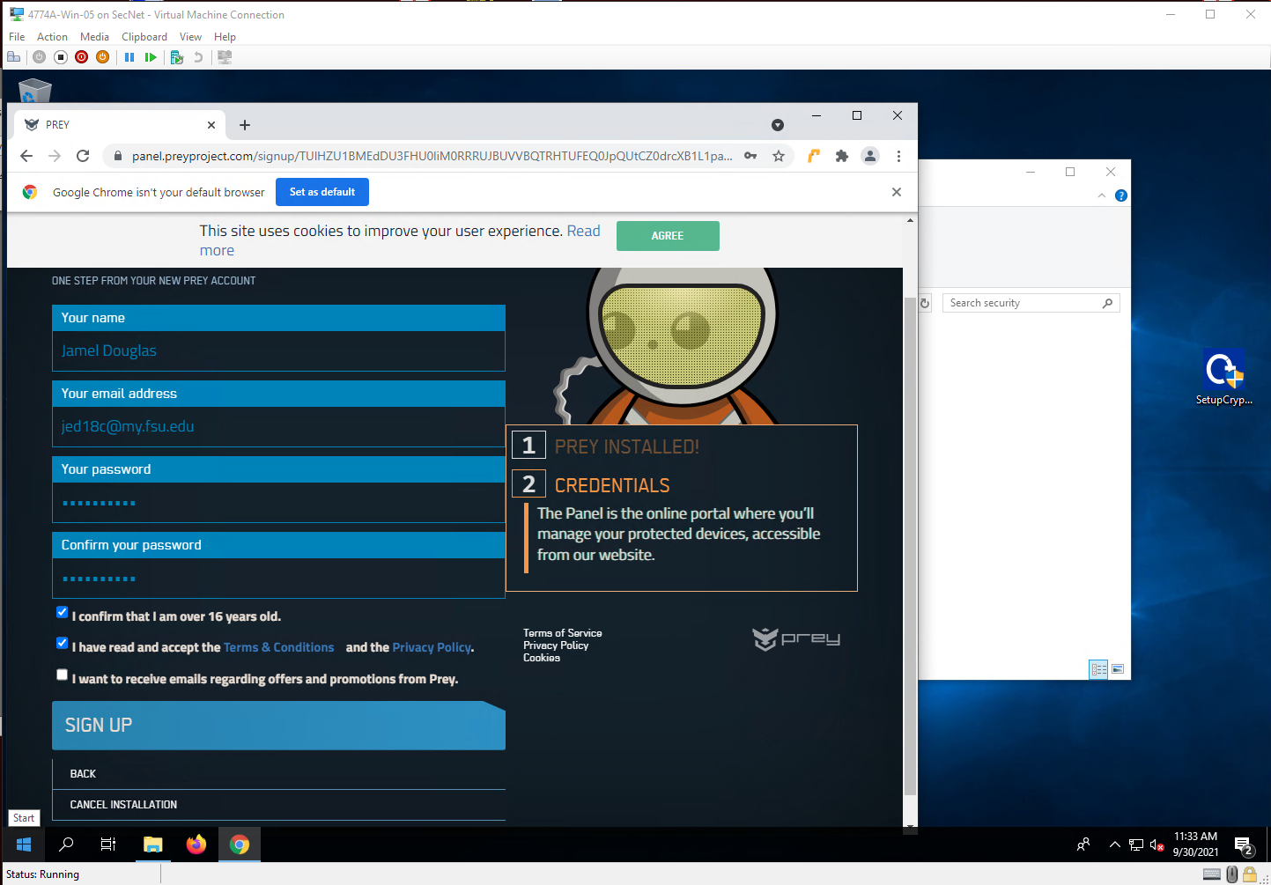

Step 22

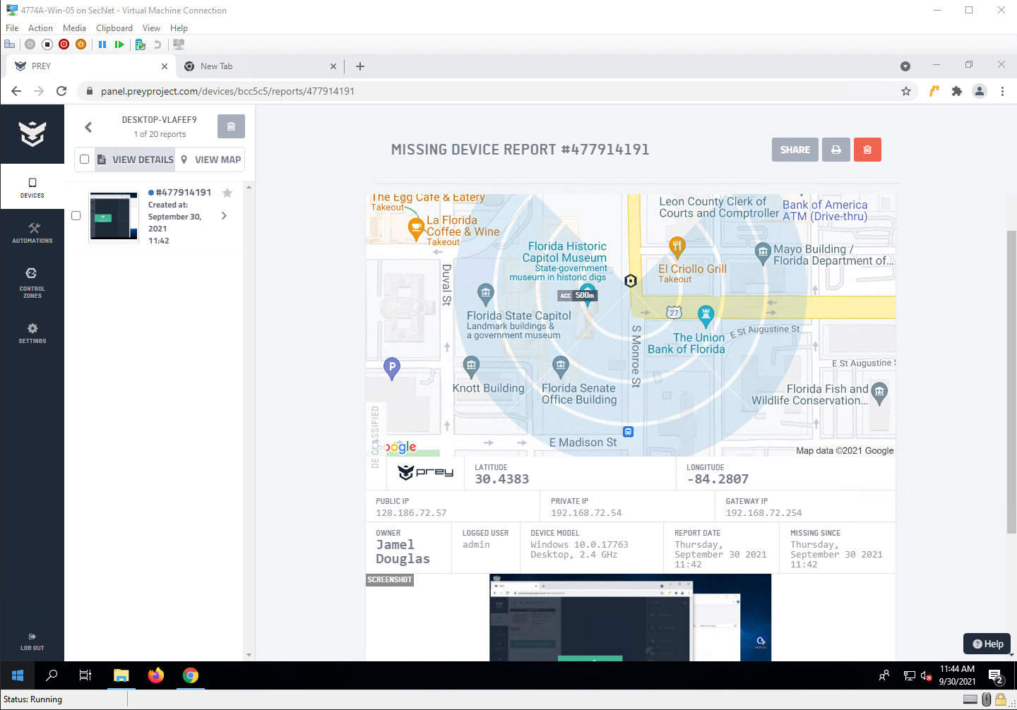

Project Questions

1. The location was mapped at (30.4383, -84.2807), the Florida state capitol.
2. The report was generated on 9/30/2021 11:42 AM.
3. A picture of my desktop was in the screenshot
4. My public IP address was 128.186.72.57. My private IP address was 192.168.72.54

Thought Questions

1. I business can use prey to locate mobile devices in the case that they are lost or stolen. For example, control zones can be setup and if a device is located outside of that zone a report is generated.
2. Yes, prey collects information about the computer like its hardware specifications, location, IP address, logged in user, and more.
3. Theoretically, yes, a prey report could be used as evidence in court
4. With the paid versions, prey can wipe files if a device is set to missing.