1 HoneyBot

Screenshots

Step 14



Step 27

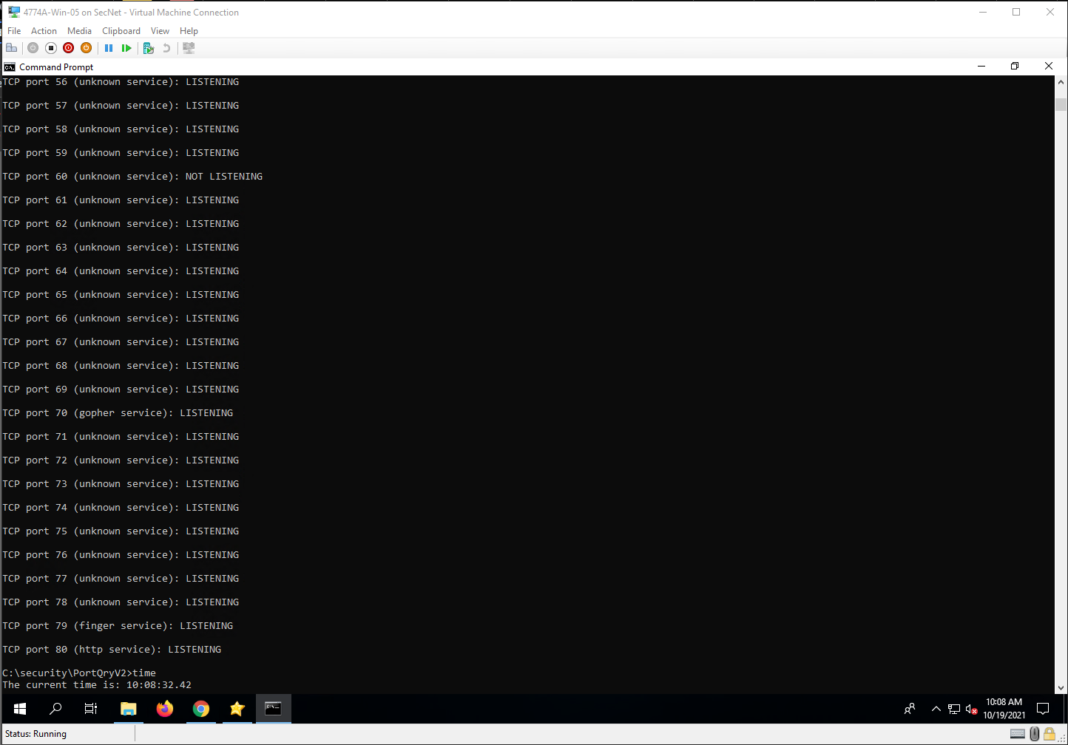

Step 29

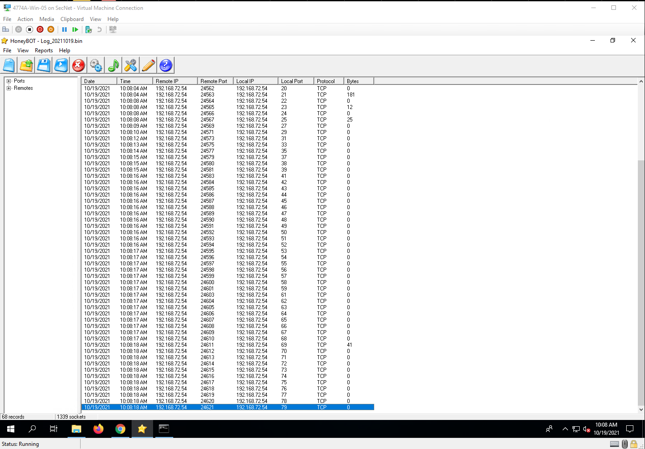

Step 34

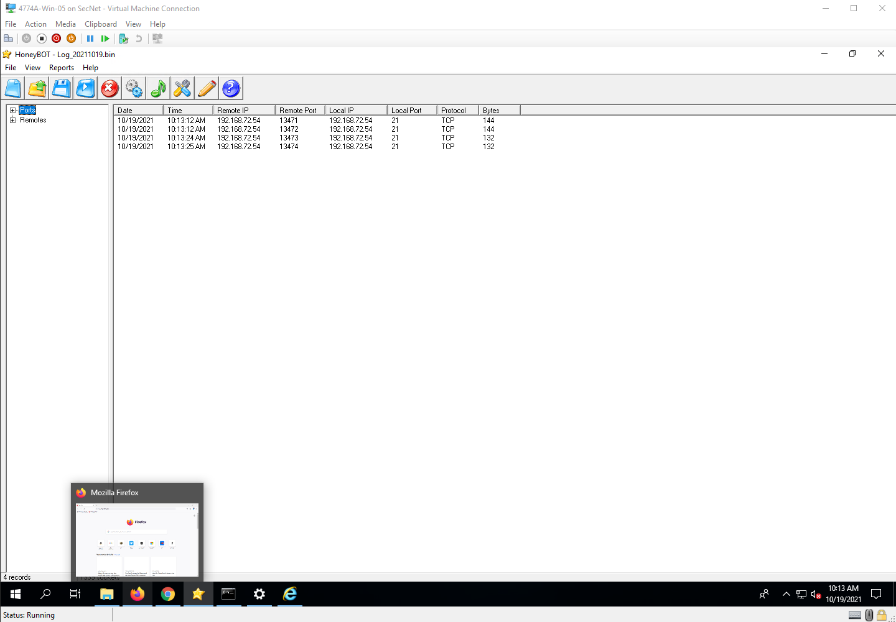

Step 36

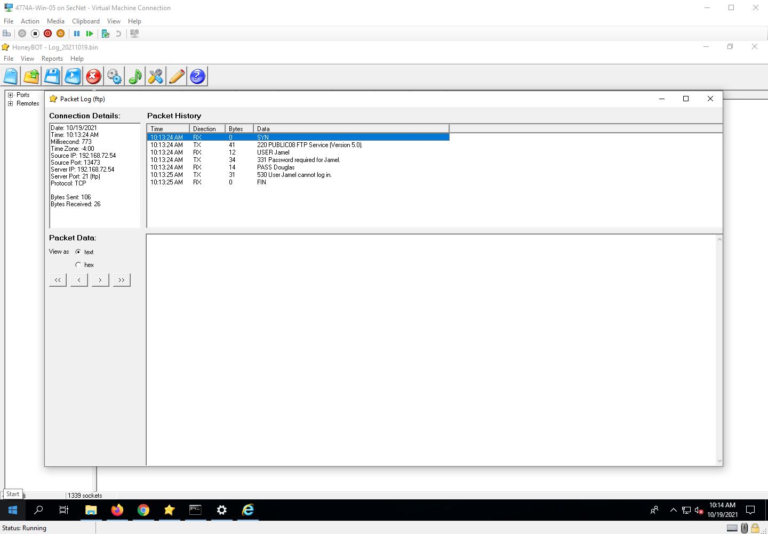

Step 41

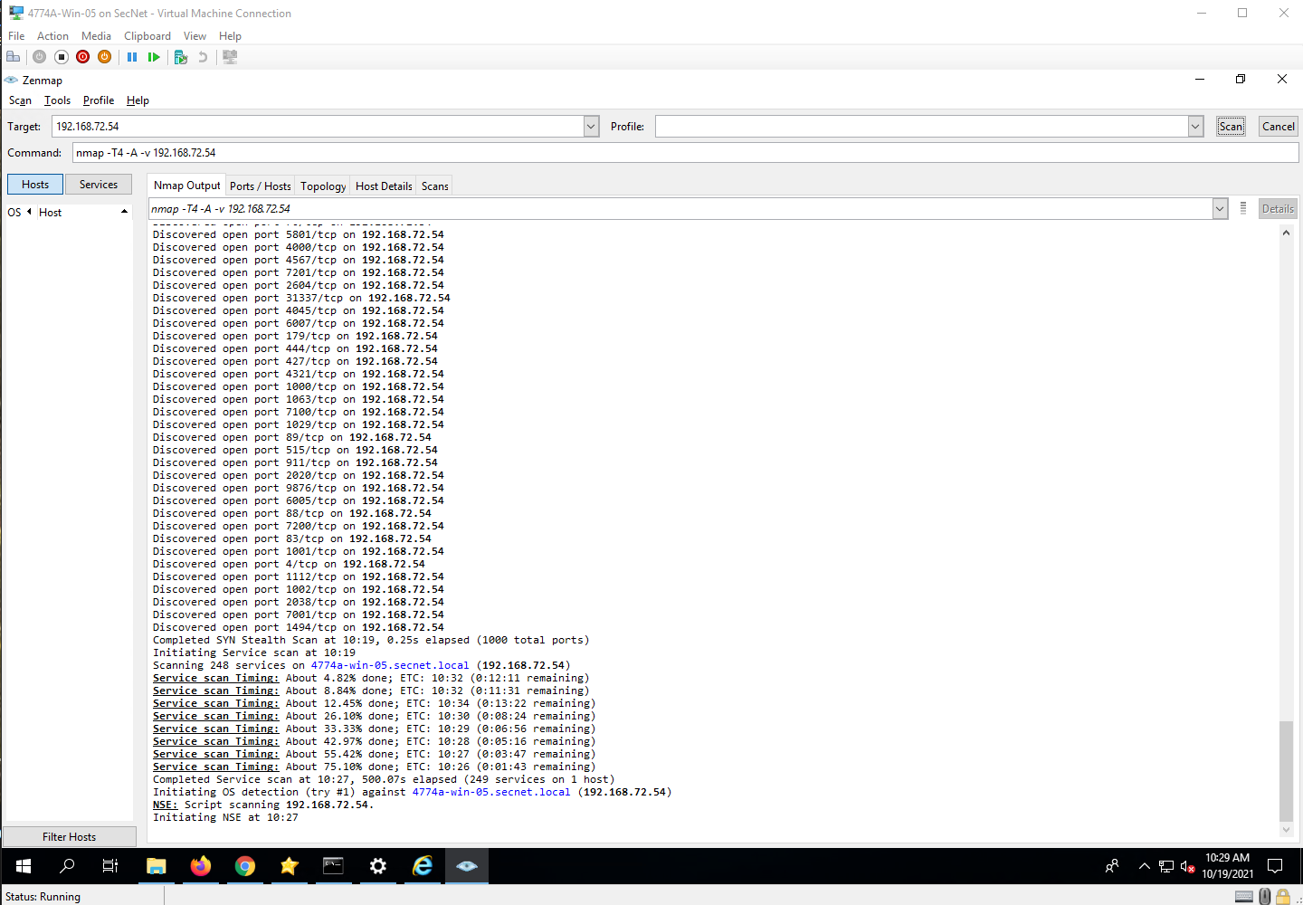

Step 43

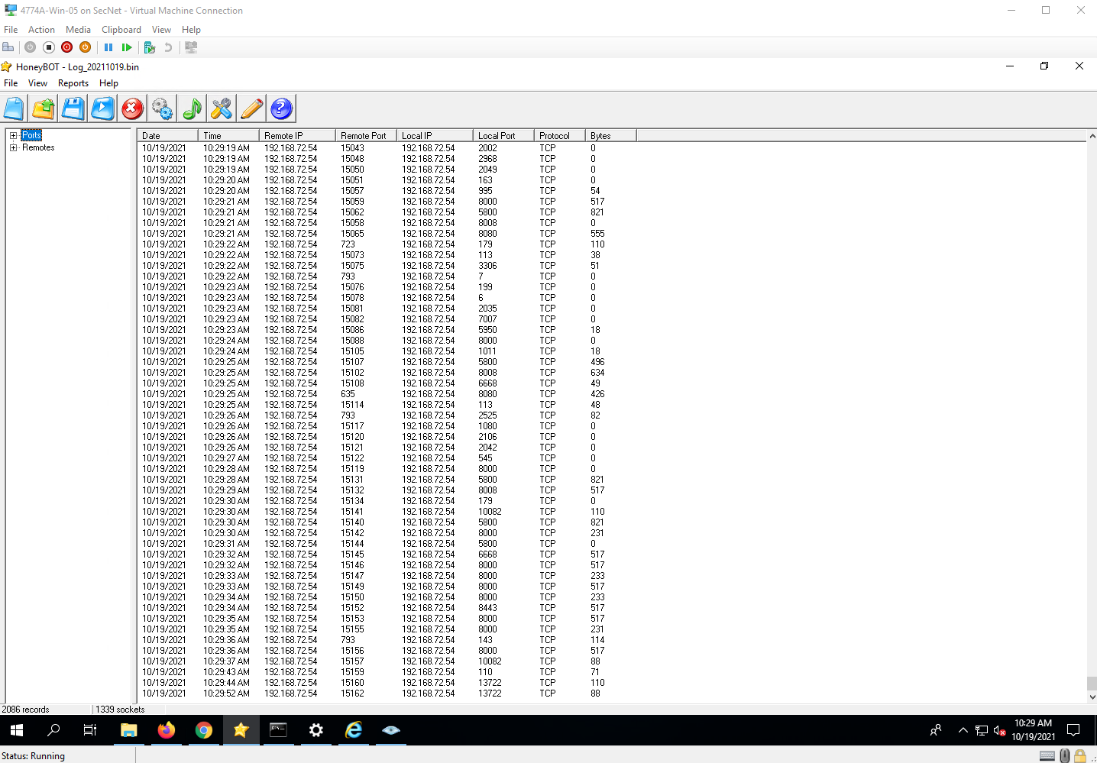

Step 54

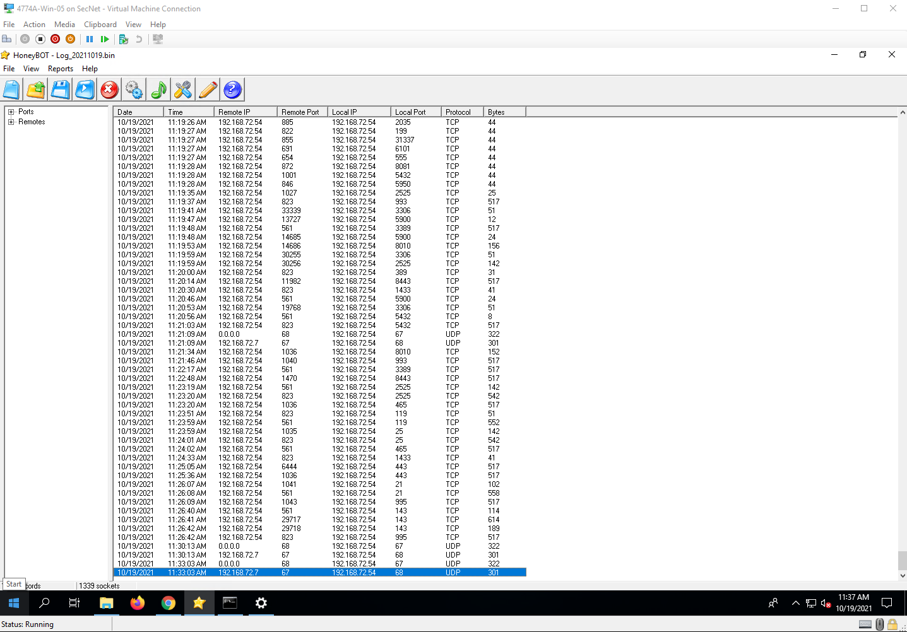

Step 61

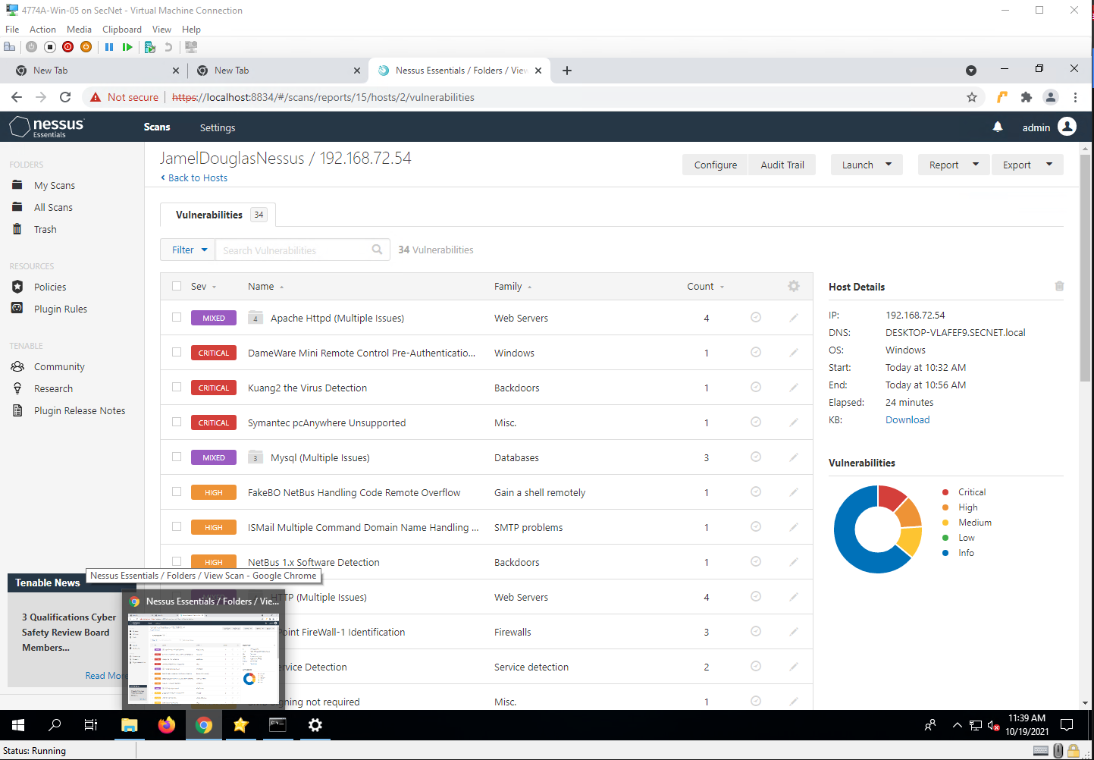

Project Questions

1. My IP address is 192.168.72.54.
2. Honey bot recorded 2086 events for the IP scan.
3. Honey bot recorded 1262 events for the Nessus scan.
4. I don’t think that HoneyBot recorded any other IP addresses throughout my scans.

Thought Questions

1. Ports need to be open in order for them to be enticing to hackers, closed ports don’t allow access, but open ports do.
2. It depends on the skill level of person who setup the honeypot, and the skills of the hacker accessing the honeypot. An experienced hacker probably would be able to tell if a basic or even intermediate honeypot is on the system.
3. I’m sure that there is some kind of honeypot that caters to blocking the harvesting of email addresses from sites
4. It I very much possible that law enforcement agencies in the US would use honeypots to track criminal behavior.