Jamel Douglas

June 25, 2021

LIS4910

IT Project

Professor Baeg

Midterm Exam

1. List the system you are evaluating.
   1. **Apple CarPlay**
2. Write 2 testable statements describing an important feature of the system. E.g., If my car was connected to my iPhone through Apple CarPlay, I would be able to communicate by text without typing, and this would make my driving safer.
   1. **If my car is connected to my phone with CarPlay, I would be able to place and pick up phone calls without interacting with my phone.**
   2. **If my car is connected to my phone with CarPlay, I would be able to control my music or other media without interacting with my phone.**
3. List the assumptions of each statement. E.g. The design idea assumes that keyboard texting while driving is dangerous, but we need to know whether non-keyboard texting is safer.
   1. **This design idea assumes that interacting with your phone for phone calls can be dangerous while driving because it takes your attention off the road.**
   2. **This design idea assumes that interacting with your phone for music or other media purposes can be dangerous while driving because it takes your attention off the road.**
4. Describe 3 features in each category. Include a brief description of each feature.
   1. Must have
      1. **Hands-Free* Phone – User can make and receive phone calls with minimal interaction with interface. Commands can be placed through voice control.**
      2. **Hands-Free* Messaging – User can send and text messages with minimal interaction with interface. Commands and messages can be placed through voice control.**
      3. **Radio – Needs to interface with AM/FM radio at minimum but could also interface with satellite radio.**
   2. Performance benefit
      1. **Wireless Connection – Rather than using USB to connect phone to interface, user can use Bluetooth connect their phone wirelessly.**
      2. **Maps and Navigation – User can select their choice of a navigation app, and it can integrate with the system. This allows the phone to also server as a GPS navigation device.**
      3. **Music – User can select their choice of a music app, and they can also choose and control their music.**
   3. Delighter
      1. **Car Keys – Unlock and start your car with iPhone (Select 2021 Models). Share your key with family and friends.**
      2. **Spoken Notifications – Most notifications that the user receives on their phone can be read out to them when it is connected to CarPlay, allowing them to keep their eyes on the road.**
      3. **Siri – Once phone is connected, user has access to Siri which is Apples virtual assistant.**
5. Write a user story about one of your performance benefits and one of your delighters.
   1. **Spoken Notifications – I have some family that lives outside of the US and to keep in contact we use a WhatsApp group chat. Though this app isn’t the generic text message app, the CarPlay system still has the ability to read out notifications, and thus messages, to me while I am driving.**
   2. **Maps and Navigation** **– When traveling to an unfamiliar area, I often used Google Maps on my phone to find my way around. With CarPlay, Google Maps integrates into the dashboard system allowing me to see directions on the screen in front of me and to also control my navigating without having to fumble around with my phone while I am driving.**
6. Create a user persona based on yourself and how you would use the system.
   1. 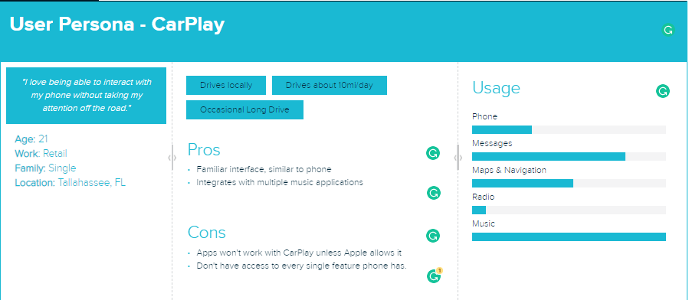
7. Describe 3 hardware features of a dashboard system that are required to support your selected system.
   1. **Touch Screen – Main user control interface. This the main way the user interacts with the system.**
   2. **Microphone – Voice control, Voice-to-text. Secondary method of interacting with the system.**
   3. **USB Port – CarPlay needs a USB port to connect the phone to the dashboard system.**
8. Research how Ford and Toyota are responding to these systems.
   1. List 3 benefits of the SmartDeviceLink open-source platform for auto manufacturers and for consumers.
      1. **App developers can integrate their app functions with in-vehicle technology, across all manufacturers.**
      2. **Automakers who adopt this standard can focus on their user experience throughout the vehicle.**
      3. **Gives drivers easy access to their smartphone apps with voice control and in-vehicle screens.**
   2. List 3 challenges that face SmartDeviceLink promoters as they try to make their system successful.
      1. **It is competing with Android Auto which has partnered with Fiat Chrysler.**
      2. **Apple is known for locking things down to keep their ecosystem consistent, they may block iPhones from interacting with SDL.**
      3. **Only works if more manufacturers join on, some manufactures, like Volkswagen and Honda, use another technology named MirrorLink.**