CS-440 Data Communications
Exam 1
Problems (do any three problems)
- Approximate the following pulse using a fundamental frequency and harmonic frequencies of a sinusoid up to a total of five harmonics (including the fundamental frequency). Use appropriate amplitude and frequency values for a better result.
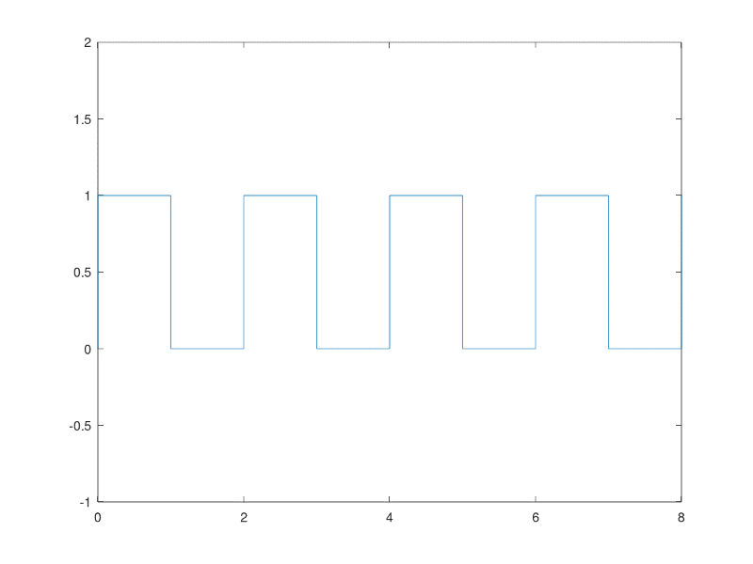
- Generate a composite signal of 8000 samples using three sinusoids of equal amplitudes and frequency values of 400 Hz, 900 Hz, and 1200 Hz, respectively. Plot the signal in the frequency domain. Submit the Octave code as well as the signal plot.
- Your cellphone is capable of taking 48-megapixel photos (uncompressed). Over time you stored 1,000 of these photos in the cellphone’s internal storage. You decided to share these photos with 6 of your friends simultaneously. What data rate is required to complete the transmission in 10 minutes?
- The bandwidth of a communications channel is 1 MHz. Due to parasitic effects, the channel is affected by a noise level of 100 nW. What should be the power in mW of a signal that travels through the communications channel so that the channel can reach a capacity of 10 Mbps?
- A 30 mW signal travels over three links. The first link causes the signal to lose a fifth of its power. The second link amplifies the signal by a rate equivalent to 6 dB. The third link causes the signal to lose 60% of its power. What is the power of the signal in mW at the end of the third link?
- You are asked to design a cluster of 64 high speed computers by connecting them to each other directly. Half of the computers have network cards with 8 ports (a maximum of 8 connections are allowed per computer) while the rest have network cards with 4 ports (a maximum of 4 connections are allowed per computer). Compute the number of network cables needed.
Note: Show your work in detail. Work not shown will only receive partial credit.

