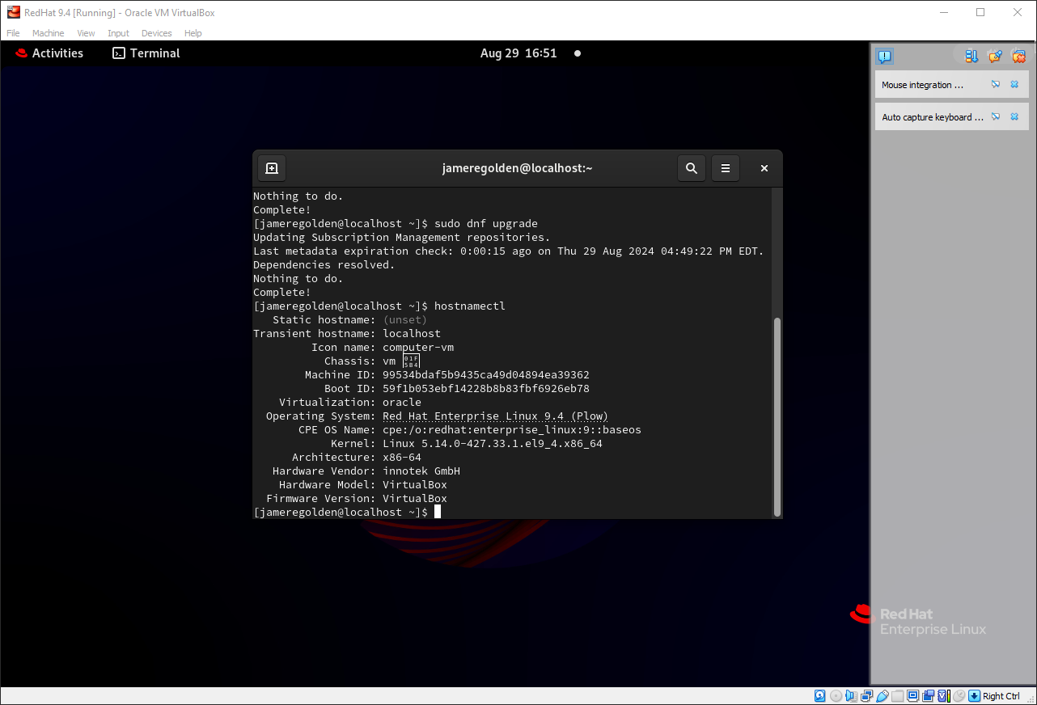

 | Host Machine Resource Info.
Disk  size | Used  Space | Available  Space | Ram  Amount | Disk  Controller | #CPU  Cores | Architecture | Graphics | Filesystem
475GB | 237GB | 238GB | 16GB | Nvme/Sata | 8 | X64 | Rtx360ti | ntfs
 | Virtual Machine for your Fedora Workstation
Disk  Size | Ram  Amount | Disk Controller | #CPU  (Cores) | Filesystems  Compatible With Linux
60Gb | 5GB | Sata/ Ide | 4 | Ext  Ext2  JFS  Xiafs  VFAT

