FishLedger: A Progressive Web App Fish Market Monitoring System with Retailer Information, Supply Source Identification, Automated Report Generation, and Predictive Analytics for Lucena Fish Port Complex

______________________________

______________________________

By
Garay, Martin Ryan
Mora, Jhun Albert M.
Viñas, Edwin

CHAPTER I

INTRODUCTION
This chapter will present the background and context of the study, highlighting the existing challenges and opportunities within fish market monitoring and management. It will discuss the significance of adopting digital technologies to improve operational efficiency, data management, reporting processes, and decision-making in fish port operations. The chapter will also introduce the research problem and explain the rationale behind the development of the proposed system.

Project Context

Fish ports remain critical economic centers that link fishermen, traders, retailers, and consumers within the marine supply chain. They play a vital role in ensuring national food security and supporting the livelihood of Filipino fishermen along the coasts. However, the majority of public fish ports still rely on manual monitoring systems, traditional handwritten documentation, and fragmented reporting processes all of which contribute to operational inefficiencies and limited data visibility.
Among these is the Lucena Fish Port Complex that will be developed into a regional fish trading center in Southern Luzon. The port will receive daily fish landings from its fleet as well as other fishing activities, and it will serve as a platform for fish products to be transported to retailers and local markets. Although essential for their operation, the identification of fish
arrivals, the retailer information, sourcing, supply and reporting will be largely manual or semi-paperless.
Manual logbooks and spreadsheet monitoring can negatively impact operations through late reporting, incomplete data entries, challenges in tracing the origin of the fish supply, or generally making market activities invisible. In addition, administrators may have difficulty in predicting fish availability, the days the session will be busiest, and demand patterns in the absence of foresight.
Recent studies emphasize that incorporating digital tracking systems and standardized data protocols into fisheries supply chains significantly improves transparency, ensures product legitimacy, and streamlines coordination among market players (Pembayun et al., 2024). The adoption of digitally secured monitoring systems across fisheries networks has led to a decrease in manual administrative errors, increasing supply chain accountability and facilitating efficient regulatory compliance (Pratiwi et al., 2024). The continuous flow of real-time supply chain data, when unified under digital monitoring frameworks, provides stakeholders with enhanced visibility that is crucial for managing the safety and quality of perishable food products (Tsolakis et al., 2022).
Predictive analytics and machine learning methodologies have proven highly effective in accurately forecasting market fluctuations and seasonal dynamics, enabling stakeholders to adapt to rapid changes in the fisheries supply chain while optimizing resource allocation (Wu et al., 2024). Furthermore, recent studies demonstrate that integrating data-driven predictive modeling specifically for perishable foods significantly improves supply chain planning, preventing waste by resolving overstocking and understocking issues that frequently occur due to inaccurate demand sensing (Birkmaier et al., 2024). Automating the analysis of complex fisheries data through advanced predictive analytics not only streamlines operations but also provides administrators with the foresight necessary to navigate the unique challenges of the seafood market (Kühn et al., 2024).
The aforementioned studies back the advancement of FishLedger as the digital monitoring and predictive analytics solution enhancing the operational capabilities, transparency, and decisions of those within the LFP. With this, the researchers will develop FishLedger, a progressive web app fish market monitoring system catered for the Lucena Fish Port complex. The system will combine retailer information management, supply source identification, automated reporting, and predictive analytics on a single digital platform. In this way, fish port managers can keep a pulse on routine activity, prepare accurate reports, and predict future supply patterns for improved planning and administration.

Statement of Objectives
The general objective of this study will be to enhance the operational efficiency and monitoring capabilities of the Lucena Fish Port Complex by developing a progressive web-based fish market monitoring system with predictive analytics.

Specific Objectives

This study will aim to:
- Design and develop a fish market monitoring system for the Lucena Fish Port Complex that will:
  - Manage retailer information and stall records;
  - Record and monitor fish arrivals, species, volume, and market prices;
  - Identify fish supply sources
  - Generate daily, weekly, monthly and annual operational reports
  - Provide dashboard-based monitoring and data visualization for decision-making.
- Design and develop retailer registration, account management, admin verification and role-based access modules within FishLedger, specifically catering to:
  - Retailer Account Registration
  - A structured account application and verification module for onboarding new retailers and suppliers.
  - Consumer Access to Statistical Analysis, Predictive Insights, and Monitoring Dashboards through a View-Only Interface
- Design and develop data analytics features to provide insights and foresight for port operations, including:
  - Daily fish supply volume
  - Expected availability of fish species
  - Historical fish arrival trends
  - Seasonal fish supply patterns
  - Price trends of fish products
- Evaluate the developed system based on the ISO/IEC 25010 Software Quality Standards in terms of:
  - Functional Suitability
  - Performance Efficiency
  - Compatibility
  - Usability
  - Reliability
  - Security
Scope and Limitations
This research is the design and development of FishLedger, a progressive web app fish monitoring system developed for Lucena Fish Port Complex. The system facilitates fish port boards to track fish market activities and fish port operation information.
The proposed system incorporates retailer data management, fish supply identification, retail supply source tracing, fish report automation and predictive analytics. These functionalities are designed to strengthen monitoring procedures and provide insight information on the trends of fish supplies and retailers in the fish port.
FishLedger is a web-based fish monitoring software developed for Lucena Fish Port Complex. portrays the functional core of the system in terms of operational data such as fish supplies, retailer information and market monitoring.
Yet there are certain constraints to the system. The system is tailor-made for the Lucena Fish Port Complex and is not applicable to any other fish market in the country which has a different mode of operations. Since it is a web-based system, its effectiveness depends on the accuracy of data encoded by fish port administrators and the consistent participation of fish vendors in the system. Furthermore, the predicted analytics analysis, which is based on patterns of historical data, does not take into consideration
the impact of unexpected events such as extreme weather, sudden interruptions of supply or other external factors that might have an influence on the fish market activities.

Purpose and Description
The purpose of this study will be to design and develop FishLedger, a progressive web-based monitoring system that will enhance the operational efficiency of the Lucena Fish Port Complex. The system will centralize fish market data into a single digital platform that will promote transparency, traceability, and data-driven decision-making.
FishLedger will record fish arrivals and quantities, manage retailer registration and profiles, track supply sources from fishing vessels, and generate daily, weekly, and monthly reports. Through predictive analytics, the system will forecast fish supply and demand patterns to assist administrators and stakeholders in planning operations more effectively.
The system will benefit fish port administrators and officers by providing a dashboard of fish volume, supplier activity, and retailer transactions, enabling faster monitoring, accurate reporting, and improved operational planning. It will benefit retailers and vendors by providing structured registration, proper documentation, and organized transaction records that will simplify compliance and daily transactions. Fishermen and suppliers will also benefit from the system through proper identification and traceability of fish supplies delivered to the port, which will improve coordination and record accuracy. Decision-makers and managers will gain predictive insights into seasonality, high-demand species, and supply variations that will support better resource allocation, storage preparation, and workforce planning. Future researchers and system developers will also benefit as the study will serve as a reference model for implementing digital monitoring and predictive analytics systems in similar market environments.
Automated reports will eliminate manual data compilation, reducing errors and saving time for personnel. During peak fishing seasons, FishLedger will predict increased supply volumes and will help managers prepare storage space and workforce allocation. During low-supply periods, the system will assist in adjusting operational strategies.
FishLedger will aim to modernize fish port operations by transforming labor-intensive processes into a structured, intelligent, and data-driven system that will promote efficiency, accountability, and sustainability for all stakeholders involved in the fish market ecosystem.
The study will benefit the following:
- Fish Port Administrators and Personnel – The system will help administrators monitor fish arrivals, retailer activities, and supply movements through a dashboard and automated reports. It will improve operational efficiency, reduce manual recording tasks, and support faster and more accurate decision-making.
- Retailers and Vendors – FishLedger will provide retailers and vendors with a structured registration and monitoring system that will help organize transaction records, retailer information, and market activities. This will simplify documentation processes and improve transaction management within the fish port.
- Fishermen and Fish Suppliers – The system will assist fishermen and suppliers through proper identification and traceability of fish supplies delivered to the fish port. This will improve coordination, supply documentation, and monitoring of fish deliveries.
- Fish Port Management and Decision-Makers – The predictive analytics feature of the system will provide insights into fish supply trends, seasonal demand patterns, and market activities. These insights will support better planning, resource allocation, workforce preparation, and storage management.
- Consumers and Local Markets – By improving the monitoring and management of fish supplies, the system will contribute to a more organized and efficient distribution of fish products, which may support consistent market availability and supply transparency.
- Future Researchers and System Developers – This study will serve as a reference for future studies related to fish market monitoring systems, predictive analytics, and web-based management systems. Future researchers and developers may use the findings and system design as a basis for improving or developing similar technologies in related industries.
Theoretical Framework
The study is underpinned by related IS, data management, and predictive analytics theories which posit that technology can facilitate enhanced operational monitoring and decision making.
The Information Systems Theory describes the role that computer-based systems play in an organization to efficiently gather, process, store and distribute information. Here, the FishLedger system is treated as the information system of a fish market.
Related to this is Data Analytics Theory that emphasizes the application of data analytical methods to detect patterns and to inform strategic decisions. A branch of data analytics, predictive analytics models historical data to predict what might happen in the future. In this research, predictive analytics is applied to fish supply history records to predict possible supply trends and market activities.
By combining these notions, the FishLedger will focus on delivering a digital product that increases the monitoring process and decisions making within the fish port environment.
Conceptual framework

INPUT

Fish arrival details (species, volume, time and date of arrival)
Retailer profiles and transaction records
Supply source details (fishing vessels, fishing areas, suppliers)
Daily market operation records (sales and inventory data)
Historical fish supply data for trend analysis
Encoded data from fish port administrators and personnel

PROCESS

FishLedger: A Progressive Web App Fish Market Monitoring System with Retailer Information, Supply Source Identification, Automated Report Generation, and Predictive Analytics for Lucena Fish Port Complex

OUTPUT
Up-to-date monitoring dashboard of fish market activities
Organized retailer information and records
Supply source identification
Automated reports (daily, weekly, and monthly)
Graphs and data visualizations of market data
Predictive analytics for fish supply and demand trends
Improved decision-making and operational efficiency

“The study uses the Input–Process–Output (IPO) model to illustrate how the identified problems and system requirements (input) are processed through system design and development (process) to produce the FishLedger monitoring system with predictive analytics (output).”
The inputs of the study were the operational issues in the monitoring of fish markets at the Lucena Fish Port Complex which were identified during the initial stage of the research. These inputs included data gathered from interviews, observations, and the analysis of various documents related to fish supply monitoring, retailer records, and
existing reporting mechanisms. System requirements and relevant literature were also considered as essential inputs in the design and development of the proposed system.
The processing stage will involve the development of the FishLedger system. This stage will include defining the system features and functionalities, designing the system architecture and database structure, developing the web-based platform, and conducting system testing. The development process will also incorporate predictive analytics capabilities to analyze fish supply trends and support data-driven decision-making.
The output of this study will be the successful design of a web-based fish market monitoring system for the Lucena Fish Port Complex called FishLedger. The system will provide features such as automated report, monitoring dashboards, supply source identification, and predictive analytics that will help improve operational efficiency and monitoring within the fish port.

Definition of Terms
For this study, certain terms will be defined to convey specific meanings as used in the research. These definitions aim to reduce ambiguity and help readers better understand the concepts and system features presented.

Technical Terms
Automated Report Generation – A system feature that will generate summarized reports of fish market activities using recorded data. In this study, it will produce daily, weekly, monthly and annual reports on fish supply transactions, retailer activities, and market operations at the Lucena Fish Port Complex.
Fish Market Monitoring – The process of observing, recording, and tracking fish trading activities, supply movements, and retailer transactions within the fish port. In this study, FishLedger will facilitate this through a centralized digital system.
Predictive Analytics – A branch of data analytics that will use historical data and statistical techniques to forecast future trends or outcomes. In this study, it will be used to predict fish supply and demand patterns.
Retailer Information Management – The process of recording, storing, and maintaining information about fish retailers operating within the fish port, including their profiles, registration details, and transaction records.
Supply Source Identification – The process of identifying and recording the origin of fish supplies delivered to the fish port. The system will track fish supplies from fishing vessels and other sources for proper documentation and traceability.
Dashboard and Data Visualization – A system interface that will present fish market data in graphical and visual formats such as charts and summaries for easier understanding and monitoring.

Operational Terms
Fish Arrival Data – Information recorded in the system regarding the species, volume, and arrival time of fish delivered to the port.
Historical Data – Previously recorded fish supply and market data that will be used by the system for analysis and prediction.
Retailer Transaction Records – Data related to the buying activities of registered retailers within the fish port.
User – Refers to fish port administrators, personnel, and authorized individuals who will encode, manage, and monitor data using the system.
Web-Based System – A software application that will operate through a web browser and require internet connectivity to access its features.

CHAPTER II
REVIEW OF RELATED LITERATURE AND SYSTEMS
This chapter will discuss the related concepts and findings from various literature and studies gathered from books, journals, and online resources to support the necessity of investigating and determining the impact of developing a progressive web application fish market monitoring system for Lucena Fish Port Complex.

Fish Diversity, Conservation Status, and Market Dynamics
Fish diversity serves as an important indicator of fisheries sustainability and market activity. According to Solante-Catiwalaan and Funesto (2025), public fish markets provide valuable information regarding fish species availability, market demand, conservation status, and economic value. Their study conducted in selected public markets in Cebu City recorded a total of 109 fish species belonging to 35 families, demonstrating the rich diversity of fish species being traded in local markets. The researchers emphasized that monitoring fish species composition is essential for understanding fisheries trends and supporting sustainable fisheries management.
The study revealed that reef-associated fishes accounted for seventy-nine percent (79%) of the species observed in the surveyed markets, while pelagic-neritic, pelagic-oceanic, demersal, and benthopelagic species comprised the remaining portion. This finding highlights the significant contribution of coral reef ecosystems to the fisheries industry and local seafood markets. The researchers noted that the abundance of reef-associated species reflects the importance of marine biodiversity in sustaining fish supply and market operations.
Furthermore, the study identified several commercially important fish families, including Scombridae, Carangidae, Chanidae, Lutjanidae, and Serranidae. Results showed that Scombridae, Carangidae, and Chanidae accounted for approximately 67.7 percent of the total fish volume sold in the surveyed markets. These families play a significant role in supporting the fisheries economy and meeting consumer demand for seafood products.
The researchers also documented fish species with conservation concerns, including the endangered Humphead Wrasse (Cheilinus undulatus), the vulnerable Brown-Marbled Grouper (Epinephelus fuscoguttatus), and several near-threatened species. Their presence in public markets highlights the need for effective monitoring and documentation systems to support fisheries management, species conservation, and regulatory compliance. Accurate monitoring of fish species can assist authorities in identifying potential threats to marine biodiversity and implementing appropriate conservation measures.
In addition, the study found significant variations in fish prices among different habitat-associated groups. Reef-associated fishes were observed to have higher market values compared to other fish groups because of their commercial importance and consumer demand. The researchers concluded that information regarding fish species composition, conservation status, market prices, and supply sources provides valuable insights for fisheries management and decision-making.
These findings support the proposed FishLedger system by emphasizing the importance of collecting and managing fish-related information in a centralized platform. Through digital monitoring, supply source identification, automated reporting, and predictive analytics, the system can contribute to improved fish market management, enhanced transparency, and data-driven decision-making within the Lucena Fish Port Complex.

Fish Market Monitoring Systems in the Modern Day
Modern fish markets are gradually transitioning from traditional manual processes to digital monitoring systems. According to Cruz (2022), fish market monitoring systems are digital platforms designed to track fish transactions, inventory, and pricing, improving transparency and operational efficiency. In his study on “Digital Transformation in Coastal Market Systems,” it was revealed that manual recording methods in fish ports often lead to data inconsistencies, delays, and lack of transparency.
Similarly, Santos et al. (2023) found that the implementation of digital monitoring systems in fish ports increased operational efficiency by reducing reporting time and improving data accuracy. Their study highlighted that over seventy percent (70%) of fish market stakeholders preferred digital systems due to faster transaction recording and monitoring capabilities.
These findings support the goal of the present study, which aims to develop a centralized monitoring system for the Lucena Fish Port Complex. The system is expected to improve transaction identification, enhance transparency, and provide data access for stakeholders.

Progressive Web Applications in Information Systems
Progressive Web Applications (PWA) have emerged as a modern solution for delivering reliable, efficient, and accessible web-based systems. According to Sharma (2021), PWAs combine the functionality of both web and mobile applications, enabling users to access systems offline, receive updates, and experience improved performance across various devices. This hybrid capability makes PWAs highly suitable for environments where consistent internet connectivity may not always be available.
Garcia and Lee (2022), in their study “Adoption of Progressive Web Applications in Enterprise Systems,” revealed that PWAs significantly reduce development and maintenance costs while maintaining high performance and accessibility. Their findings showed that organizations adopting PWAs experienced improved user engagement, faster loading times, and enhanced system reliability. Additionally, PWAs eliminate the need for separate mobile applications, allowing businesses to streamline their digital infrastructure while still providing a mobile-friendly experience.
Furthermore, a report by Tech Insights (2023) indicated that more than sixty percent (60%) of businesses have shifted toward PWA-based systems due to their scalability, cross-platform compatibility, and ease of deployment. The report also emphasized that PWAs contribute to increased operational efficiency by simplifying updates and reducing dependency on platform-specific development.
These studies collectively justify the use of a Progressive Web Application in the FishLedger system, as it ensures accessibility, flexibility, and efficiency for fish vendors, administrators, and stakeholders. By leveraging PWA technology, the system can
function effectively even in areas with limited internet connectivity, while still providing a responsive and user-friendly experience.

Fish Supply Chain Identification and Traceability Systems

Traceability systems play a critical role in ensuring food safety, quality assurance, and transparency in the fisheries sector. According to Reyes (2024), fish supply chain identification systems enable stakeholders to monitor the movement of fish products from the point of catch to the final market destination, ensuring accountability and reducing the risk of fraud and mislabeling. These systems are essential in maintaining accurate records and promoting trust among consumers, suppliers, and regulatory agencies.
In a related study, Villanueva et al. (2022) developed a traceability system utilizing QR codes and mobile technology, allowing users to access detailed information
about fish origin, handling processes, and distribution channels. The study revealed that such systems significantly improved consumer trust, strengthened regulatory compliance, and enhanced transparency within the supply chain. It also highlighted that digital traceability minimizes manual errors and simplifies data verification processes.
Additionally, a global review by Ahmed (2023) emphasized that traceability technologies, including Internet of Things (IoT) devices and digital databases, greatly enhance supply chain visibility and operational efficiency. The study pointed out that integrating these technologies allows data collection and monitoring, which supports better decision-making and more efficient resource management within the fisheries sector.
These findings support the inclusion of a supply source identification feature in the FishLedger system, which aims to provide accurate, reliable, and transparent
information about fish products within the Lucena Fish Port Complex. By integrating traceability functionalities, the system can improve accountability, strengthen stakeholder confidence, and ensure better management of fish supply chains.

Automated Report Generation Systems
Automated report generation systems are essential components of modern information systems because they improve efficiency, accuracy, and accessibility of operational data. According to Martinez (2022), automated reporting systems are designed to collect, process, and generate reports without requiring extensive manual intervention. These systems reduce human errors, minimize delays in report preparation, and ensure that stakeholders receive organized and accurate information for decision-making purposes.
In a related study, Torres and Ramirez (2023) emphasized that automated reporting significantly improves operational workflows by allowing organizations to generate daily, weekly, monthly and annual summaries in real time. Their findings revealed that businesses using automated reporting systems experienced faster report preparation, improved data consistency, and better monitoring of organizational performance. The study also highlighted that automated systems reduce paperwork and simplify record management processes.
Furthermore, Johnson (2024) stated that integrating automated report generation with centralized databases enhances data accessibility and transparency. By automatically consolidating transaction records and operational information, organizations can quickly analyze trends and monitor performance indicators. The study further explained that automated reporting systems support better strategic planning by providing timely and reliable reports for management and stakeholders.
These studies support the inclusion of automated report generation in the FishLedger system. Through automated reporting, the system can efficiently generate summaries of fish transactions, retailer activities, and supply monitoring records within the Lucena Fish Port Complex. This functionality can help administrators reduce manual workload, improve record accuracy, and enhance operational monitoring.

Philippine Fisheries Digitalization and BFAR Initiatives
The fisheries sector in the Philippines continues to face challenges related to manual monitoring systems, inconsistent data recording, and limited technological integration in municipal fish ports. According to the Bureau of Fisheries and Aquatic Resources (BFAR) (2023), digital transformation initiatives are necessary to improve fisheries management, strengthen data collection, and enhance transparency in fishery operations. BFAR emphasized that accurate and timely fisheries data are essential in supporting sustainable fishery practices and effective resource management.
In a report by the Philippine Fisheries Development Authority (PFDA) (2022), many fish ports in the country still rely on manual processes for recording fish transactions, monitoring supply distribution, and generating operational reports. The report highlighted that manual systems often result in delayed reporting, data inconsistencies, and difficulty in tracking fish supply movement. It further recommended the adoption of digital monitoring systems to improve operational efficiency and data reliability in fish port facilities.
Similarly, Dela Cruz et al. (2024) examined the implementation of digital technologies in selected municipal fish ports in the Philippines. Their study found that the use of web-based monitoring systems improved transaction recording, increased transparency, and enhanced communication among stakeholders. However, the researchers noted that several local fish ports still lack integrated systems capable of combining monitoring, traceability, reporting, and analytics functionalities.
These studies strengthen the relevance of the proposed FishLedger system for the Lucena Fish Port Complex. By incorporating digital monitoring, automated reporting, and predictive analytics, the system aligns with the ongoing digitalization efforts promoted by BFAR and other fisheries-related agencies in the Philippines. The proposed system aims to address the operational gaps in local fish port management by providing a centralized, efficient, and accessible platform for stakeholders.

The Use of Predictive Analytics for Market and Business Optimization
Predictive analytics is widely used to forecast trends and improve decision-making across various industries. According to Kumar (2023), predictive analytics utilizes historical data, statistical techniques, and machine learning algorithms to anticipate future outcomes and optimize business processes. By analyzing past patterns and behaviors, organizations can make informed decisions, reduce uncertainties, and improve overall operational efficiency.
Lee et al. (2022), in their study on decision tree models, revealed that predictive analytics significantly improves forecasting accuracy and supports data-driven decision-making. Their research demonstrated that decision trees are particularly effective in identifying patterns, classifying data, and predicting potential outcomes in business environments. The study further emphasized that these models are widely adopted due to their simplicity, interpretability, and reliability in handling complex datasets.
Meanwhile, Gonzales et al. (2024) examined the application of machine learning algorithms such as Random Forest and Logistic Regression in predicting market demand. Their findings showed that these models greatly enhance forecasting accuracy by analyzing large volumes of data and identifying hidden trends. As a result, businesses are able to optimize inventory management, improve resource allocation, and respond more effectively to market fluctuations.
These studies collectively prove that predictive analytics can significantly enhance the FishLedger system by enabling accurate demand forecasting, improving supply planning, and supporting data-driven decision-making within the Lucena Fish Port Complex. By incorporating predictive capabilities, the system can assist stakeholders in anticipating market trends, minimizing losses, and maximizing operational efficiency.

Synthesis
The related literature and studies that were reviewed highlighted the growing importance of fish market monitoring systems, the effectiveness of progressive web applications (PWA), the role of supply chain traceability, the efficiency of automated reporting systems, and the increasing significance of predictive analytics in enhancing market operations and decision-making processes.
Fish market monitoring systems play a crucial role in improving transparency, efficiency, and accuracy in market operations by replacing traditional manual processes with digital solutions. These systems enable identification of transactions, pricing, and inventory, which are essential in maintaining reliable market data. However, challenges such as limited technological infrastructure, resistance to digital adoption among stakeholders, inconsistent data recording practices, and lack of centralized systems continue to hinder the full implementation of digital monitoring in fish ports. These issues are further compounded by operational inefficiencies, including delayed reporting, data redundancy, and difficulty in accessing historical records. To address these
challenges, the integration of a centralized and user-friendly monitoring system is necessary to streamline operations and ensure data accuracy within fish market environments.
The reviewed literature also supports the use of Progressive Web Applications (PWA) as an effective platform for delivering accessible and scalable information systems. PWAs provide advantages such as offline functionality, cross-platform compatibility, and improved system performance, making them suitable for environments with unstable internet connectivity. Despite these benefits, some limitations remain, including low awareness among users, initial adaptation challenges, and the need for proper system design to ensure usability. Nevertheless, PWAs offer a practical solution for implementing digital systems in fish port operations, as they allow stakeholders to access information anytime and anywhere while maintaining system efficiency and reliability.
Supply chain identification and traceability systems were also identified as essential components in modern fish market operations. These systems enhance transparency by allowing stakeholders to track the origin and movement of fish products from source to market. They also improve accountability, food safety, and consumer trust. However, challenges such as fragmented data systems, lack of integration among stakeholders, and limited technological resources affect the effectiveness of traceability systems. Addressing these issues requires the development of an integrated platform that combines monitoring and identification functionalities to provide comprehensive and accurate supply chain information.
Predictive analytics was identified as a key driver in optimizing market strategies and improving decision-making. Studies have shown that predictive models using machine learning algorithms such as Decision Tree, Random Forest, and Logistic Regression can effectively forecast demand, identify trends, and optimize resource allocation. These tools enable proactive planning and help organizations respond to potential challenges before they occur. This highlights the need for systems that incorporate predictive capabilities to maximize the value of collected data.
The foreign and local studies gathered by the researchers have been instrumental in building the foundation for the proposed study entitled “FishLedger: A Progressive Web Application Fish Market Monitoring System with Retailer Information, Supply Source Identification , Automated Reports, and Predictive Analytics for Lucena Fish Port Complex.” The proponents utilized the reviewed literature to conceptualize a solution that addresses the existing gaps in fish market operations, particularly the lack of integration among monitoring, identification , reporting, and analytics systems. These insights significantly influenced the design and development of a comprehensive platform that aims to improve efficiency, enhance transparency, and support data-driven decision-making within the Lucena Fish Port Complex.

CHAPTER III
METHODOLOGY
This chapter explains the methods and tools used to conduct the study and collect the necessary data. It also describes the research design applied in developing and evaluating the FishLedger system. The study focuses on creating a system that helps monitor market prices, track supply sources, and generate predictive analytics for the Lucena Fish Port Complex, improving data management, reporting, and operational transparency.
Research Design
The researchers utilized a descriptive and developmental research design. This approach was selected to first accurately describe the existing manual price recording and supply monitoring processes at the Lucena Fish Port Complex (Descriptive), and subsequently design, build, and evaluate a digital solution in the form of a Progressive Web Application.
Software Development Lifecycle
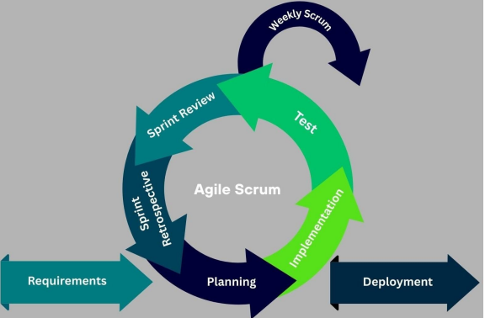
Figure 1. Agile Scrum Model for Fishledger
The study will utilize the Agile Scrum Software Development Life Cycle (SDLC) in developing FishLedger. Agile Scrum is an iterative and incremental software development framework that emphasizes collaboration, adaptability, continuous improvement, and regular feedback from stakeholders throughout the development process.

The Agile Scrum process consists of the following phases:

Requirements. In this phase, the researchers will gather and identify the system requirements for FishLedger. Information will be collected through interviews, observations, and document analysis conducted at the Lucena Fish Port Complex. The gathered requirements will serve as the foundation for the features and functionalities of the proposed system, including retailer information management, fish arrival monitoring, supply source identification, automated report generation, dashboard visualization, and predictive analytics. The needs of the intended users will be analyzed to ensure that the system effectively addresses existing operational challenges.

Planning. In this phase, the researchers will plan the overall objectives, scope, and major functionalities of the system. Meetings and consultations with fish port administrators, personnel, retailers, and other stakeholders will be conducted to identify operational issues and determine the most appropriate solutions. The system architecture, database structure, user interface design, and sprint schedules will also be prepared during this phase.

Implementation. In this phase, the researchers will develop the FishLedger system based on the identified requirements and project plan. The selected features and modules will be coded, integrated, and developed incrementally throughout the sprint cycles. Core functionalities such as retailer registration, fish arrival monitoring, supply source identification, automated reporting, dashboard visualization, and predictive analytics will be implemented during this stage.

Test. In this phase, the researchers will conduct various testing procedures to evaluate the functionality, reliability, performance, and accuracy of the system. Unit testing, integration testing, and system testing will be performed to identify bugs, errors, or inconsistencies. Any issues discovered during testing will be corrected and improved before proceeding to deployment.

Weekly Scrum. In this phase, the researchers will conduct weekly Scrum meetings to monitor project progress, discuss completed tasks, identify challenges encountered during development, and plan upcoming activities. These meetings will ensure continuous communication among team members and maintain alignment with the project objectives.

Sprint Review. In this phase, the researchers will evaluate the completed functionalities developed during each sprint. The developed features will be demonstrated to stakeholders to gather feedback and determine whether the sprint goals have been achieved. Suggestions and recommendations obtained during this phase will be considered for future improvements and succeeding sprint cycles.

Sprint Retrospective. In this phase, the researchers will assess the overall performance of the completed sprint. The team will identify successful practices, challenges encountered, and areas requiring improvement. Lessons learned during the sprint will be documented and used to enhance the efficiency and effectiveness of future development activities.

Deployment. Once the system has successfully passed the testing, review, and evaluation phases, it will be deployed for implementation at the Lucena Fish Port Complex. The developed system will be made available to authorized users, including fish port administrators, personnel, and stakeholders. Continuous enhancements, maintenance, and feature improvements may be implemented through future sprint iterations to ensure the system remains effective and responsive to user needs.
Requirements Analysis
Requirements analysis involves identifying and defining the functionalities and quality attributes needed to address the monitoring, reporting, and operational requirements of the Lucena Fish Port Complex. The identified requirements served as the basis for the design and development of FishLedger.

Functional Requirements
Functional requirements describe the specific features, capabilities, and behaviors that the FishLedger system shall provide. These requirements define how the system responds to user interactions, processes data, and supports the operational needs of the Lucena Fish Port Complex.

User Authentication and Access Control
- The system shall allow users to register and log in using authorized credentials.
- The system shall authenticate users before granting access.
- The system shall assign role-based access permissions for Administrators, Fish Port Personnel, Retailers, and Public Consumers.
- The system shall allow administrators to manage user accounts, roles, and account verification.

Retailer Information Management
- The system shall allow retailers to register and submit business information.
- The system shall allow administrators to approve, reject, update, or deactivate retailer accounts.
- The system shall maintain retailer profiles, business information, stall assignments, and verification status.

Fish Information Management
- The system shall maintain a centralized catalog of fish species.
- The system shall allow administrators to create, update, and delete fish records.
- The system shall store fish names, scientific names, categories, and reference information.

Fish Arrival and Market Monitoring
- The system shall record fish arrivals, quantities, market prices, and arrival dates.
- The system shall allow authorized personnel to update market records.
- The system shall display current fish availability and market prices.
- The system shall maintain historical market records for analysis.

Supply Source Identification
- The system shall record fishing vessels, fishing locations, and supply origins.
- The system shall associate fish arrivals with their corresponding supply sources.
- The system shall display supply source information for monitoring and traceability.

Dashboard and Data Visualization
- The system shall display real-time dashboards summarizing fish arrivals, market prices, retailer activities, and supply information.
- The system shall present statistical data using charts, graphs, and summary cards.
- The system shall provide visual monitoring of fish market operations.

Predictive Analytics
- The system shall analyze historical market data to generate fish supply forecasts.
- The system shall provide predicted fish availability and seasonal supply trends.
- The system shall display historical and predicted data for comparison.
- The system shall present market trend analysis to support decision-making.

Report Generation
- The system shall automatically generate daily, weekly, monthly, and annual reports.
- The system shall allow authorized users to export reports in printable format.
- The system shall generate statistical summaries of fish arrivals, market prices, retailer activities, and supply sources.

Public Information Access
- The system shall provide a public view of fish prices, fish availability, and market statistics.
- The system shall allow public users to view dashboards and predictive insights without modifying system data.
- The system shall allow users to download public reports and market summaries.

Announcements and Notifications
- The system shall allow administrators to publish announcements and market advisories.
- The system shall display announcements on the dashboard.
- The system shall notify users of important market updates and system announcements.

Data Management
- The system shall store, update, retrieve, and archive operational records.
- The system shall maintain historical data for reporting and predictive analytics.
- The system shall ensure data consistency and integrity throughout system operations.

Audit and Activity Logging
- The system shall record significant user activities, including logins, data updates, and administrative actions.
- The system shall allow administrators to review system activity logs for monitoring and accountability.
Non-Functional Requirements
The non-functional requirements define the quality standards and performance expectations of FishLedger.
Performance Efficiency
- The system shall provide acceptable response times during data entry, retrieval, and report generation.
- The system shall support multiple users simultaneously without significant performance degradation.
Compatibility
- The system shall be accessible through commonly used web browsers.
- The system shall function properly on desktop computers, tablets, and mobile devices as a Progressive Web Application (PWA).
Usability
- The system shall provide a user-friendly and intuitive interface.
- The system shall be easy to learn and navigate for administrators, fish port personnel and retailers.
Reliability
- The system shall perform its intended functions consistently and accurately.
- The system shall minimize system downtime and ensure continuous access to monitoring records and reports.
Security
- The system shall implement user authentication and role-based access control mechanisms.
- The system shall restrict access to sensitive information based on authorized user roles.
- The system shall protect fish port records and retailer information from unauthorized access or modification.
Data Gathering Procedure
The researchers gathered data through interviews with fish port administrators to understand current workflows and identify existing challenges. Direct observation was also conducted to examine the manual process of recording fish prices and distributing bulletins. In addition, relevant documents, such as historical fish delivery records and price bulletins, were reviewed to support the development of the system database and AI forecasting model.
Respondents of the Study
The respondents of the study consisted of ten (10) market administrators, twenty (20) retailers, and fifteen (15) frequent port consumers. The market administrators evaluated the system's management and reporting features, while the retailers assessed the price entry and inventory management functions. Frequent port consumers were included to evaluate the accuracy, accessibility, and usefulness of the price forecasts and market bulletins.
Statistical Treatment
The collected data will be analyzed using appropriate statistical tools and techniques. The Weighted Mean will be used to determine the overall evaluation and acceptability of the FishLedger system based on the responses gathered from the fish port administrators, fish port personnel, and retailers using the ISO/IEC 25010 Software Quality Evaluation questionnaire.
The weighted mean formula is:
X̄ = Σfx / N
Where:
- X̄ = Weighted Mean
- Σfx = Sum of weighted responses
- N = Total number of respondents
Weighted Point | Range Interval | Verbal Interpretation
5 | 4.20-5.00 | Strongly Agree
4 | 3.40-4.19 | Agree
3 | 2.60 – 3.39 | Neutral
2 | 1.80 – 2.59 | Disagree
1 | 1.00 – 1.79 | Strongly Disagree

In addition, the predictive analytics component of FishLedger, which utilizes a Random Forest Regression model, will be evaluated using the following accuracy metrics:
Mean Absolute Error (MAE)
MAE measures the average absolute difference between the predicted fish supply values and the actual observed values. Lower MAE values indicate better prediction accuracy.
[
MAE = \frac{\sum |y_i - \hat{y_i}|}{n}
]

Where:
- yᵢ = Actual value
- ŷᵢ = Predicted value
- n = Total number of observations
Root Mean Square Error (RMSE)
RMSE measures the square root of the average squared differences between predicted and actual values. It provides an indication of how concentrated the prediction errors are.
[
RMSE = \sqrt{\frac{\sum (y_i - \hat{y_i})^2}{n}}
]
Where:
- yᵢ = Actual value
- ŷᵢ = Predicted value
- n = Total number of observations
Coefficient of Determination (R² Score)
The R² Score measures how well the Random Forest Regression model explains the variability of the fish supply data. Values closer to 1 indicate better model performance and predictive capability.
[
R^2 = 1 - \frac{\sum (y_i - \hat{y_i})^2}{\sum (y_i - \bar{y})^2}
]
Where:
- yᵢ = Actual value
- ŷᵢ = Predicted value
- ȳ = Mean of actual values
These statistical measures will be used to assess the forecasting performance of the predictive analytics module and determine the effectiveness of the Random Forest Regression model in predicting fish supply trends within the Lucena Fish Port Complex.
Ethical Considerations
The researchers observed ethical standards throughout the study in accordance with Republic Act No. 10173, also known as the Data Privacy Act of 2012. All participants were informed about the purpose of the study and voluntarily provided their consent before participating. Personal information collected during the study was kept confidential and protected through appropriate security measures. The researchers also maintained objectivity and impartiality during data collection, analysis, and interpretation of the results.
Design of Software, System, Product, and/or Processes
This section discusses the design of the proposed FishLedger system. It presents the software architecture, product features, and operational processes used to automate fish port activities. The diagrams and models in this section illustrate how the system
functions and interacts with its users.
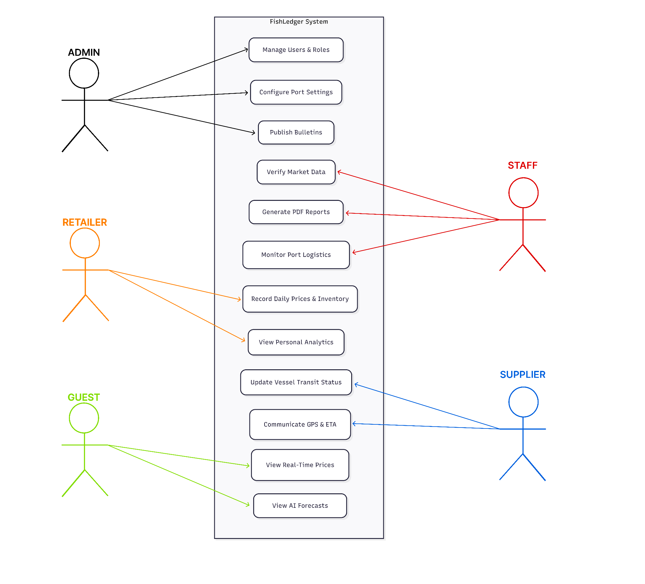
Figure 2. Use Case Diagram for Fishledger
The diagram will illustrate the four primary actors of the proposed system: the Admin, Staff, Retailer, and Consumer. The Admin will be responsible for managing users, roles, fish catalogs, and configuring system settings. The Staff will record fish prices, track supply and delivery, manage inventory, and assist in generating market reports. The Retailer will access fish price records, inventory information, supply tracking, market bulletins, and analytics to support business decisions. The Consumer will be able to view analytics and AI-generated forecasts, allowing them to monitor fish market trends, predicted price changes, and supply availability to make informed purchasing decisions.

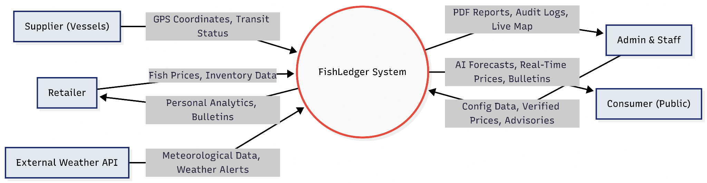
Figure 3. Context Diagram
The diagram illustrates the FishLedger system as the central component that receives data from various external entities, including retailers, suppliers, and a weather API. The system processes the collected information and generates outputs such as price forecasts, PDF market bulletins, and map visualizations. These outputs are then provided to users to support monitoring, decision making, and access to real-time fish port information.

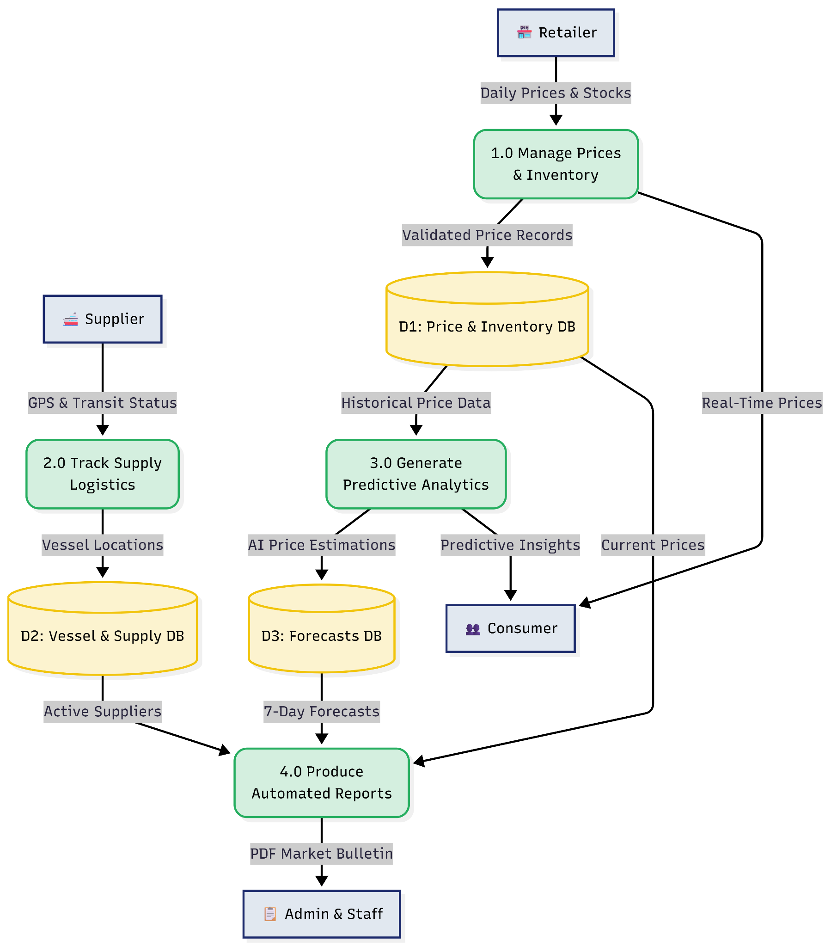

Figure 4. Data Flow Diagram
The Data Flow Diagram illustrates how data moves throughout the FishLedger system. It shows how information entered by users, such as fish prices and inventory records, is processed by the system and stored in the database. The data is then utilized by the forecasting module to generate price predictions and by the reporting module to produce market bulletins and other reports.
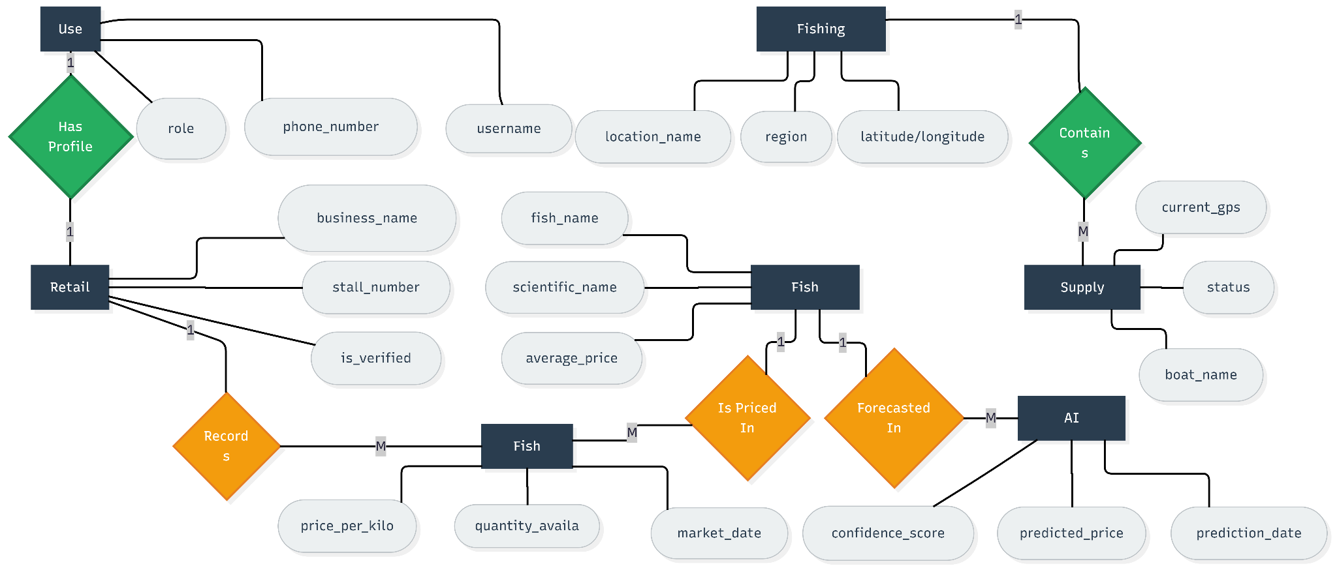
Figure 5. Entity Relationship Diagram
The Entity Relationship Diagram illustrates the relationships among the major entities of the FishLedger system, including Users, Fish, Retailers, Fish Prices, Supply Sources, Fishing Locations, and Predictions. It defines how data is organized and connected within the database, ensuring data integrity, consistency, and efficient data management. The ERD also supports accurate reporting, forecasting, and analytical processes within the system.
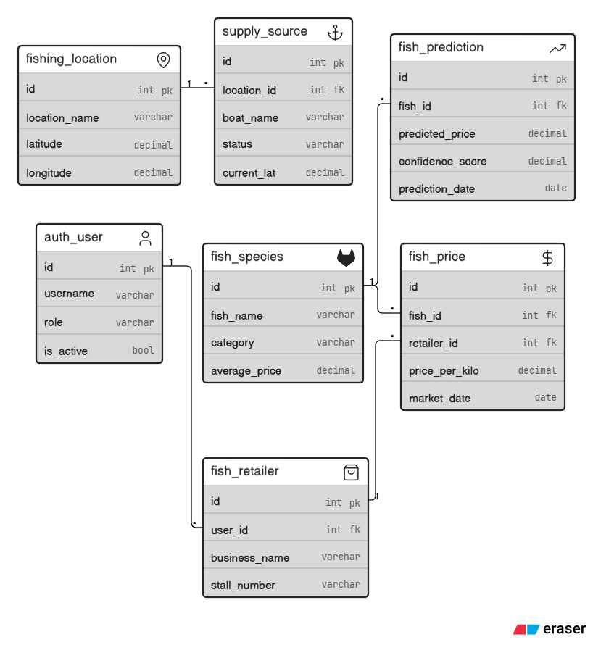
Figure 6. Database Schema
This figure illustrates the Database Schema of the FishLedger system. It defines the relationships among the database tables and ensures organized, accurate, and consistent data storage. The schema is designed to support fish price monitoring, vessel tracking, reporting, and AI-based forecasting while remaining scalable for future data growth.
3.1 Table 1: auth_user (User)
The auth_user table stores user credentials, personal details, and roles to manage secure authentication and access permissions within the system.

Field Name | Data Type | Constraints | Description
id | Integer | PK, NOT NULL, Auto-Increment | Unique identifier for each user record (Django default primary key).
username | Varchar(150) | NOT NULL, Unique | Unique username used for authentication and system identification.
password | Varchar(128) | NOT NULL | Hashed password string managed by Django's authentication framework.
email | Varchar(254) | NOT NULL, Unique | User's registered email address used for account verification and communication.
role | Varchar(50) | NOT NULL | Designates the user's role within the system (e.g., 'Admin', 'Retailer', 'Viewer').
phone_number | Varchar(20) | Nullable | Contact phone number of the user; optional field for secondary communication.
first_name | Varchar(150) | NOT NULL | User's given name as registered in the system.
last_name | Varchar(150) | NOT NULL | User's family or surname as registered in the system.
is_active | Boolean | NOT NULL, Default: TRUE | Indicates whether the user account is currently active.
is_staff | Boolean | NOT NULL, Default: FALSE | Grants access to the Django administrative interface if set to TRUE.
date_joined | DateTime | NOT NULL, Auto-set on create | Timestamp recording when the user account was initially created.
last_login | DateTime | Nullable | Timestamp of the user's most recent successful login session.

3.2 Table 2: fish(Fish)
The fish table serves as a central catalog that stores detailed profiles, habitat classifications, and baseline pricing information for various fish species managed within the system.
Field Name | Data Type | Constraints | Description
id | Integer | PK, NOT NULL, Auto-Increment | Unique identifier for each fish species record.
fish_name | Varchar(100) | NOT NULL | Common trade name of the fish species as used in local market transactions.
category | Varchar(20) | NOT NULL | Habitat classification of the species; restricted to 'Freshwater' or 'Saltwater'.
scientific_name | Varchar(150) | Nullable, Unique | Binomial scientific nomenclature (genus and species) of the fish.
average_price | Decimal(10,2) | NOT NULL | Baseline reference price per kilogram derived from historical market data.
description | TextField | Nullable | Supplementary narrative information about the fish species, habitat, or usage.
created_at | DateTime | NOT NULL, Auto-set on create | Timestamp indicating when the fish record was first entered into the system.
updated_at | DateTime | NOT NULL, Auto-updated | Timestamp reflecting the most recent modification to the fish record.

3.3 Table 3: fishdealer (Retailer)
The fish dealer table stores business profiles, stall locations, and verification statuses for retailers, linking each record back to their system user account via a foreign key.
Field Name | Data Type | Constraints | Description
id | Integer | PK, NOT NULL, Auto-Increment | Unique identifier for each retailer record.
user_id | Integer | FK → auth_user(id), NOT NULL | Foreign key linking the retailer profile to the corresponding system user account.
business_name | Varchar(200) | NOT NULL | Registered or operating trade name of the retailer's business or stall.
stall_number | Varchar(20) | NOT NULL, Unique | Unique stall or booth identifier assigned within the fish market.
contact_number | Varchar(20) | NOT NULL | Primary contact telephone number for the retailer's business operations.
address | TextField | Nullable | Physical or mailing address of the retailer's place of business.
is_verified | Boolean | NOT NULL, Default: FALSE | Indicates whether the retailer's credentials have been validated by administrators.
created_at | DateTime | NOT NULL, Auto-set on create | Timestamp recording when the retailer profile was first registered in the system.

3.4 Table 4: fishprice(FishPrice)
The fish price table tracks the daily market prices and stock levels of specific fish species offered by individual retailers.
Field Name | Data Type | Constraints | Description
id | Integer | PK, NOT NULL, Auto-Increment | Unique identifier for each fish price entry.
fish_id | Integer | FK → fish_fish(id), NOT NULL | Foreign key referencing the specific fish species associated with this price record.
retailer_id | Integer | FK → fish_retailer(id), NOT NULL | Foreign key referencing the retailer who submitted or owns this price entry.
price_per_kilo | Decimal(10,2) | NOT NULL | Selling price per kilogram of the specified fish species on the given market date.
quantity_available | Decimal(10,2) | NOT NULL | Total stock available in kilograms at the time of price entry submission.
market_date | Date | NOT NULL | The calendar date on which the recorded price and quantity data is applicable.
is_active | Boolean | NOT NULL, Default: TRUE | Flags whether this price listing is currently active and visible to system users.
created_at | DateTime | NOT NULL, Auto-set on create | Timestamp recording when the price entry was first submitted into the system.
updated_at | DateTime | NOT NULL, Auto-updated | Timestamp reflecting the last modification to the price or quantity information.

3.5 Table 5: fishsupplysource (SupplySource)
The fish supply source table identifies the source or origin of the incoming fish supplies by maintaining records of the registered fishing vessels that caught and delivered them.
Field Name | Data Type | Constraints | Description
id | Integer | PK, NOT NULL, Auto-Increment | Unique identifier for each supply source (vessel) record.
boat_name | Varchar(100) | NOT NULL | Registered name or call sign of the fishing vessel.
owner_name | Varchar(150) | Nullable | Name of the registered owner or operator of the fishing vessel.
status | Varchar(20) | NOT NULL | Current operational status; constrained to 'At Sea', 'In Transit', or 'Docked'.
latitude | Decimal(9,6) | Nullable | GPS latitude coordinate of the vessel's current or last known position.
longitude | Decimal(9,6) | Nullable | GPS longitude coordinate of the vessel's current or last known position.
last_updated | DateTime | NOT NULL, Auto-updated | Timestamp of the most recent positional or status update for the vessel.
created_at | DateTime | NOT NULL, Auto-set on create | Timestamp indicating when the vessel record was first registered in the system.

3.6 Table 6: fishprediction (Prediction)
The fish prediction table stores forecasted prices and market trends generated by machine learning models for specific fish species and dates.
Field Name | Data Type | Constraints | Description
id | Integer | PK, NOT NULL, Auto-Increment | Unique identifier for each prediction record.
fish_id | Integer | FK → fish_fish(id), NOT NULL | Foreign key referencing the fish species for which the prediction is generated.
retailer_id | Integer | FK → fish_retailer(id), Nullable | Optional foreign key associating the prediction with a specific retailer's data.
predicted_price | Decimal(10,2) | NOT NULL | The model-generated forecasted price per kilogram for the target fish species.
confidence_score | Decimal(5,4) | NOT NULL | A normalized probability score (0.0000–1.0000) expressing the model's prediction certainty.
trend_status | Varchar(20) | NOT NULL | Qualitative market trend label; one of 'Rising', 'Stable', or 'Declining'.
prediction_date | Date | NOT NULL | The specific future date for which the price prediction is projected.
model_version | Varchar(50) | Nullable | Identifier string for the machine learning model version used to generate the prediction.
created_at | DateTime | NOT NULL, Auto-set on create | Timestamp recording when the prediction record was generated and stored.

3.7 Table 7: fishinglocation (FishingLocation)
The fishing location table catalogs the names, administrative regions, and geographic coordinates of the distinct coastal areas or fishing zones handled by the system.
Field Name | Data Type | Constraints | Description
id | Integer | PK, NOT NULL, Auto-Increment | Unique identifier for each fishing location record.
location_name | Varchar(150) | NOT NULL, Unique | Descriptive name of the fishing zone, bay, or coastal area.
region | Varchar(100) | NOT NULL | Broad regional designation (e.g., MIMAROPA, Calabarzon) containing the location.
province | Varchar(100) | NOT NULL | Province-level administrative division where the fishing location is situated.
municipality | Varchar(100) | Nullable | Municipality or city within the province associated with the fishing location.
latitude | Decimal(9,6) | Nullable | Central GPS latitude coordinate representing the geographic centroid of the location.
longitude | Decimal(9,6) | Nullable | Central GPS longitude coordinate representing the geographic centroid of the location.
is_active | Boolean | NOT NULL, Default: TRUE | Indicates whether the location is currently in use for supply tracking or analysis.
created_at | DateTime | NOT NULL, Auto-set on create | Timestamp recording when the fishing location was first added to the system.

The Data Dictionary provides a detailed description of the database tables, including their fields, data types, and purposes within the FishLedger system. It serves as a reference for understanding how data is stored, organized, and managed. This helps ensure consistency, accuracy, and integrity throughout the development and operation of the system. The following tables represent the primary database entities used in the study.
Development and Testing
The FishLedger system will be developed using Django REST Framework for the backend and React for the frontend. APIs will be utilized to facilitate communication between system components and provide real-time data updates. To ensure system quality, Unit Testing, Integration Testing, and User Acceptance Testing (UAT) will be conducted to evaluate functionality, performance, and user satisfaction based on ISO/IEC 25010 standards.

Description of the Prototype
This figure illustrates the proposed prototype of the FishLedger system, a Progressive Web Application (PWA) designed for both mobile and desktop users. The system will feature a centralized dashboard that provides real-time information on fish prices, market trends, and supply monitoring. It will also include an interactive map for tracking fishing vessels and their arrival status. The interface will adapt according to user roles, enabling retailers, administrators, and staff to access functionalities relevant to their responsibilities. Furthermore, the system will employ a responsive design approach to ensure accessibility and usability across various devices and operating environments.

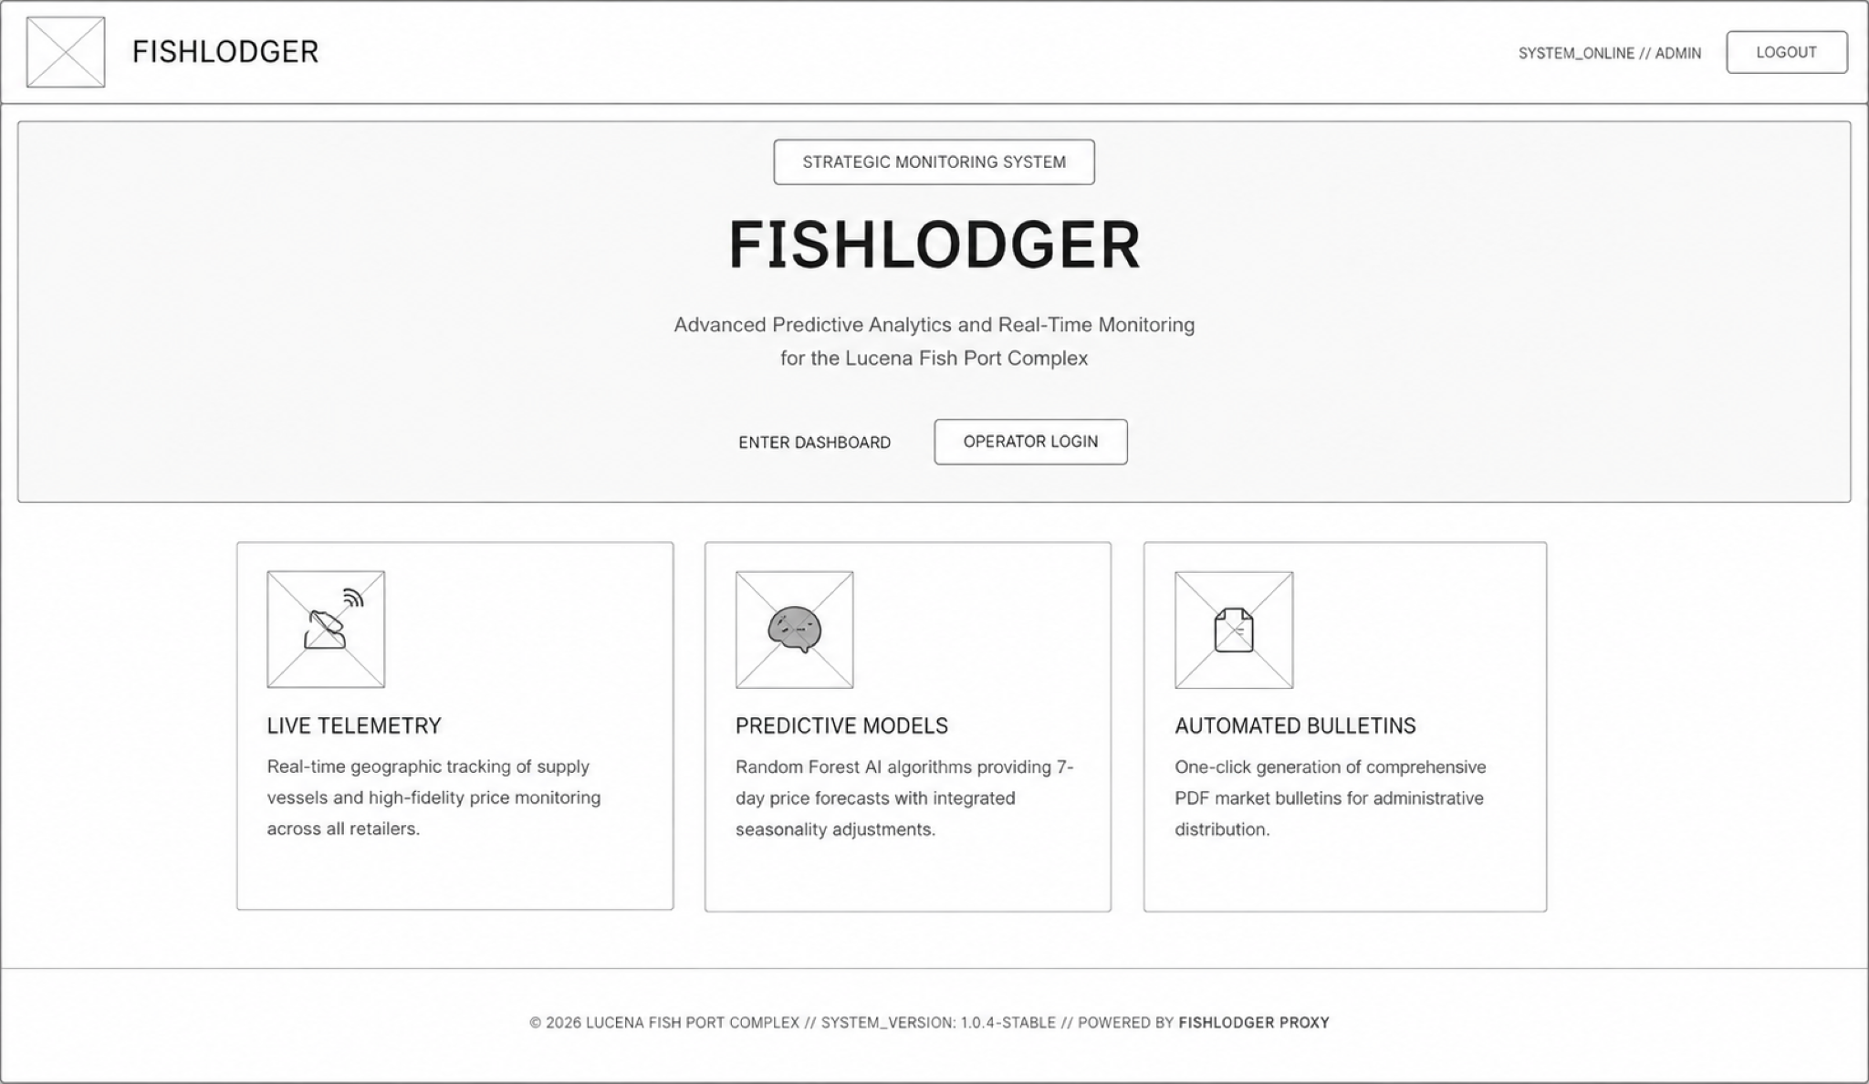
Figure 7. Prototype: Landing Page
The system’s public introduction will feature a centralized landing page designed around a "Strategic Monitoring" theme. Serving as the primary entry point for guests and operators, this page will highlight FishLedger's core capabilities, including live telemetry for vessel tracking, AI-driven predictive forecasting models, and automated PDF market bulletins. This interface will ensure a clear, informative onboarding experience before users log into deeper operational layers.

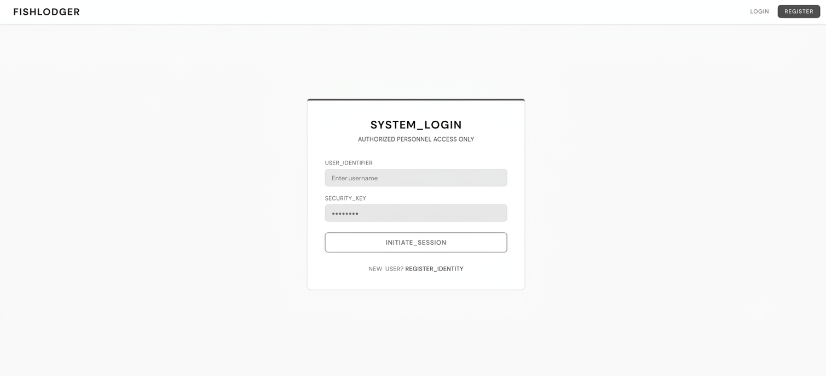
Figure 8. Prototype: Login Page
The login page will provide secure, JWT-based authentication for network entry. It will incorporate an HTTP interceptor that automatically detects expired user sessions and redirects individuals back to this interface with a re-authentication prompt. The page will display a standard credential input form paired with specialized status messages tailored for "Authorized Personnel Access" to guide users through the authentication workflow.
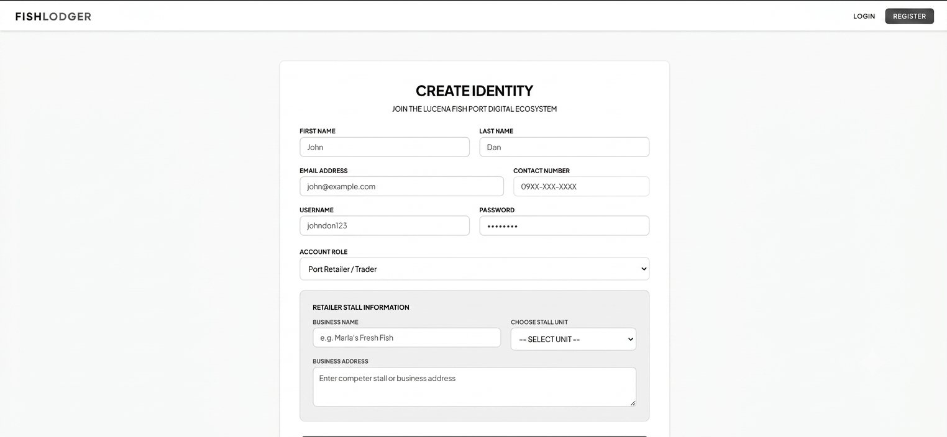
Figure 9. Prototype: Register Page
The registration page will handle identity onboarding for the digital network. This interface will collect the user's personal details and require a mandatory role selection categorized into Guest, Retailer, or Administrative Staff which will automatically determine and enforce their specific access permission levels across the application.
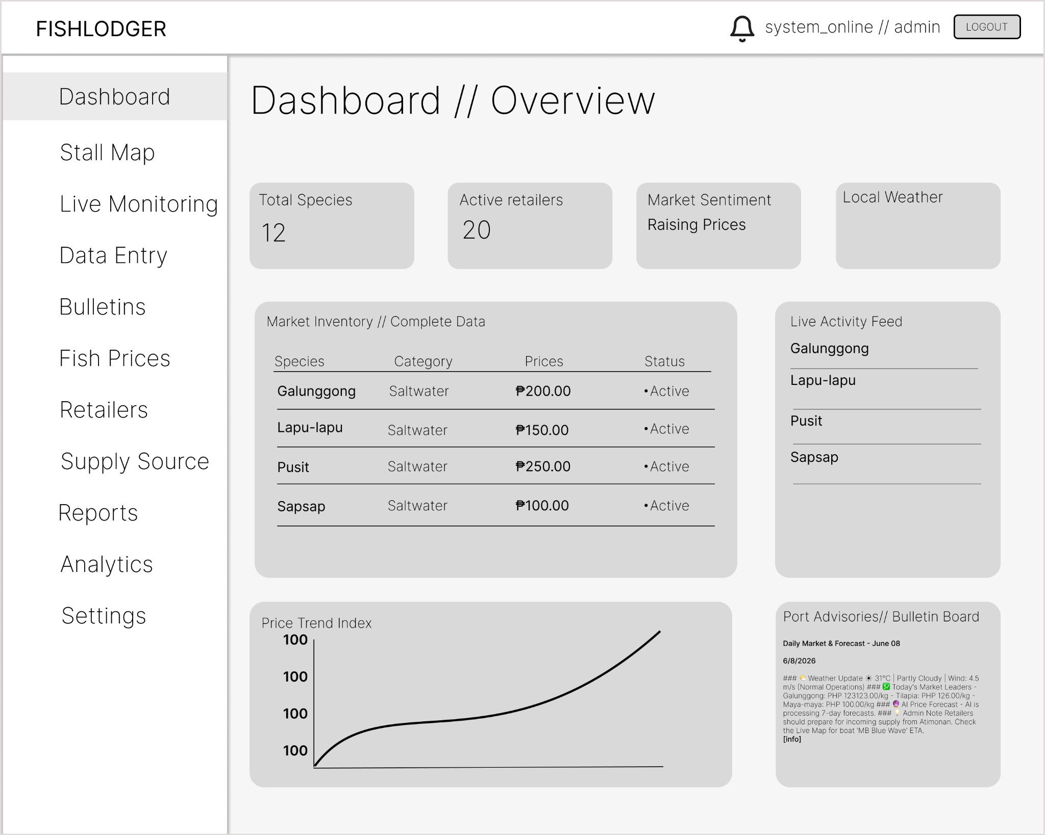
Figure 10. Prototype: Dashboard Page
Serving as the central command center, the overview dashboard will use WebSockets to provide real-time data and instant price updates without manual page refreshes. The interface will feature a "Quick Stats" section showing live species counts, active retailers, and an AI-generated market sentiment tracker. It will also integrate the OpenWeather API to display current weather conditions calibrated for Lucena City. Finally, users will be able to monitor rapid market shifts through a rolling live activity feed of recent changes alongside an inventory snapshot table tracking current fish prices and categories.

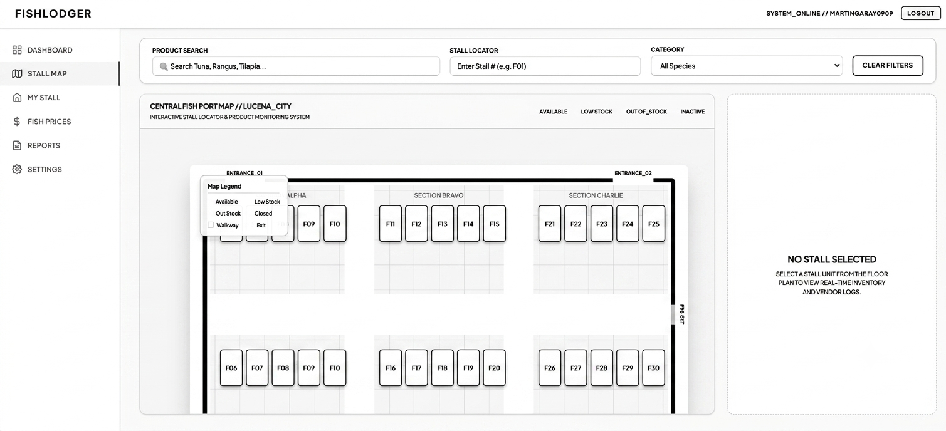
Figure 11. Prototype: Stall Map
The stall map page will feature an interactive architectural floor plan of the Fish Port Complex. This interface will display over 30 stalls using a color-coded status legend to track inventory availability, categorizing sections by available, low stock, out of stock, or closed indicators. Selecting any specific stall card from the grid will dynamically open a side panel showing the vendor's contact information alongside a detailed inventory log that details fish names, current stock weights in kilograms, and pricing.
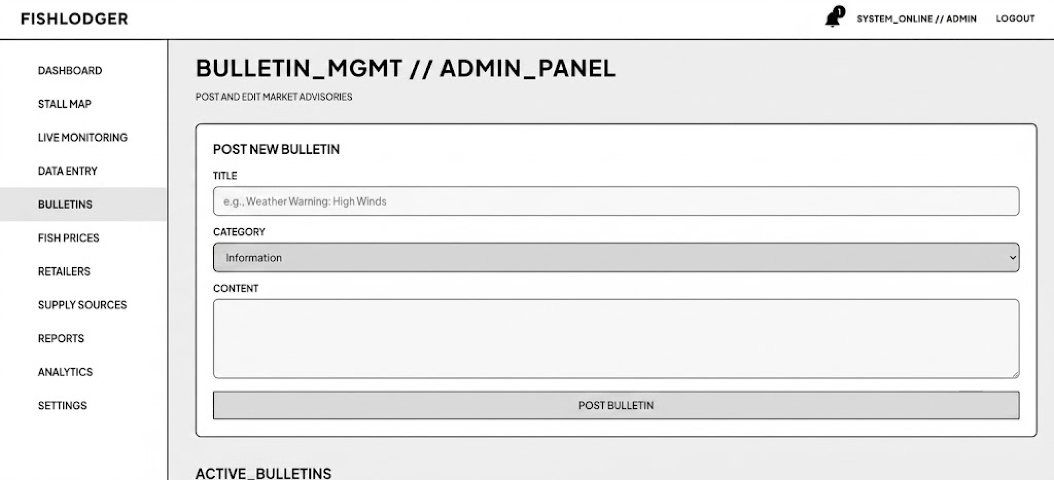
Figure 12. Prototype: Bulletin
The bulletins module will serve as an essential administrative tool for the rapid deployment of port-wide advisories. This interface will empower authorized personnel to create, manage, and categorize critical announcements including general Information, Urgent market alerts, or imperative Weather Warnings via a structured input form. Once published, these structured advisories will automatically and instantly synchronize to the central Dashboard's Bulletin Board widget, ensuring that all active port users receive timely updates without manual redistribution.

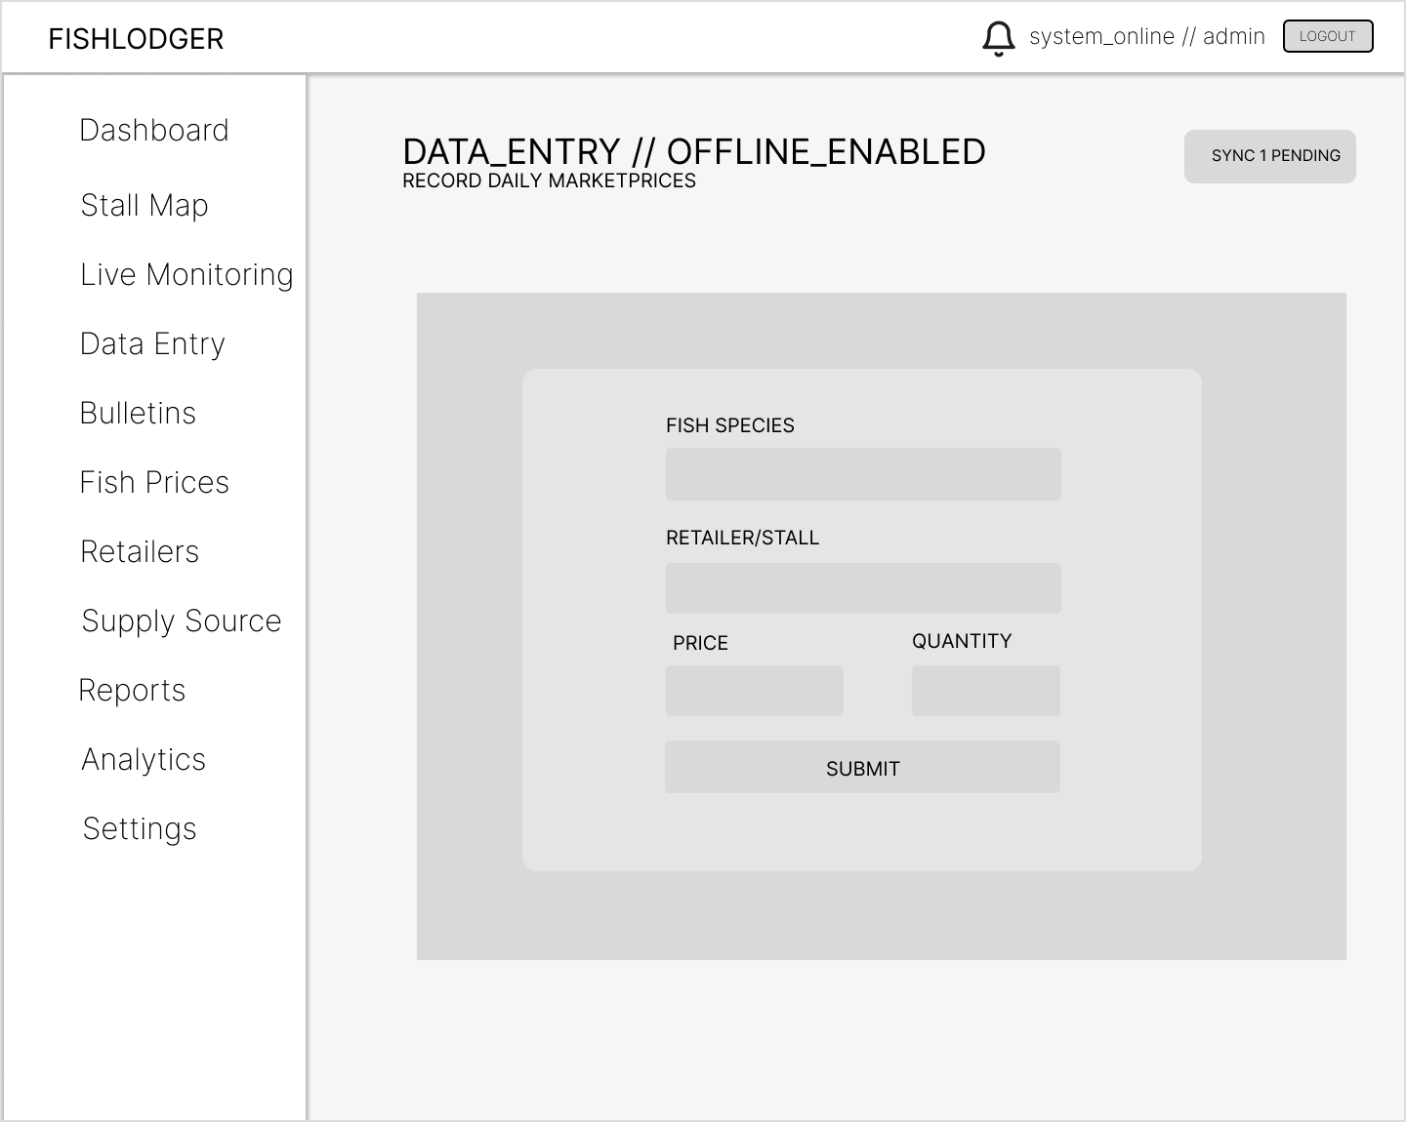
Figure 13. Prototype: Data Entry
The data entry page will be a specialized tool for field staff that works even without an internet connection. If the network drops, the system will save all data locally on the device using IndexedDB and will show a sync button to upload everything once the connection returns. The interface will feature simple forms so workers can quickly log fish species, retailer names, current prices, and quantities.

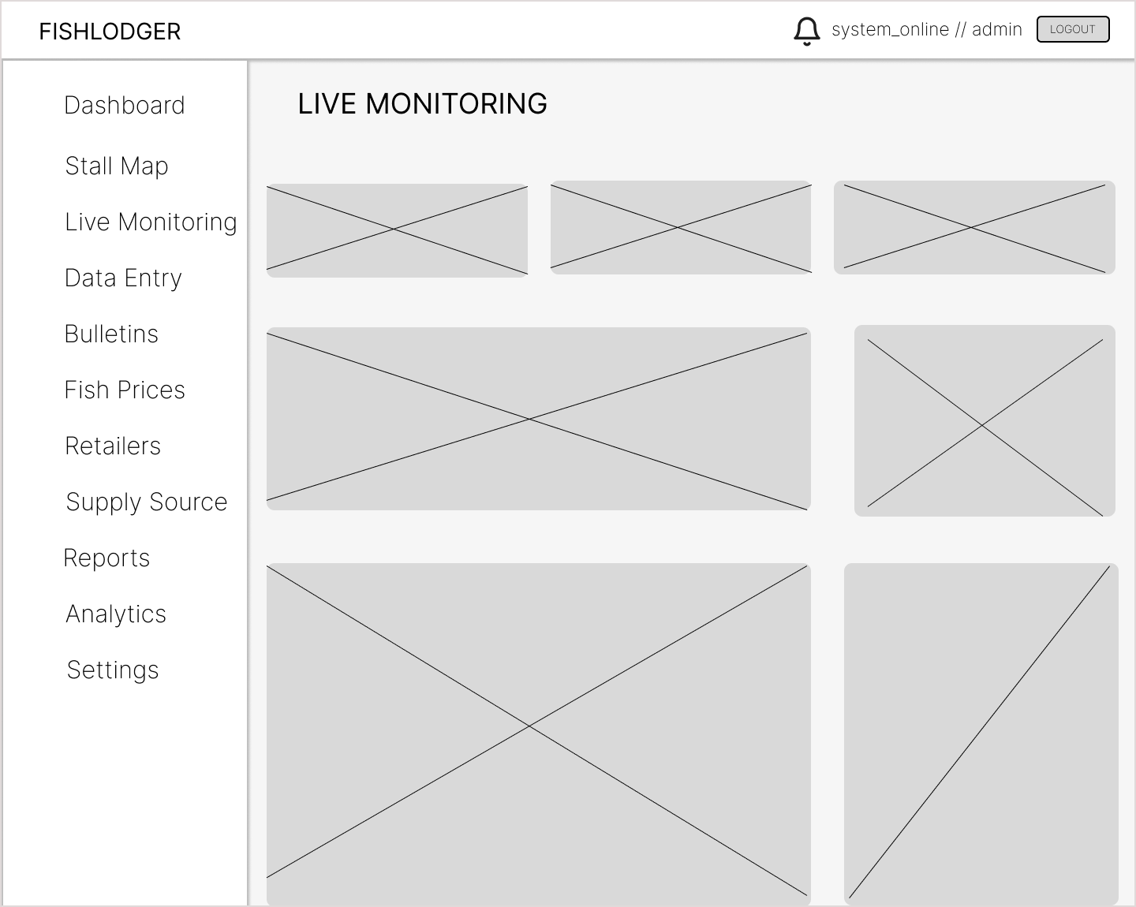

Figure 14. Prototype: Live Monitoring
The live monitoring page will track the geographic supply chain in real-time using Leaflet Maps to follow the movement of supply vessels. The main map will show fishing grounds using circles sized by volume, alongside active boat icons that show if a vessel is in transit or has arrived. The interface will also feature market alerts to flag unusual data like sudden drops in supply or price spikes. Finally, it will track import volume to display the total kilograms of fish arriving at the port each day.
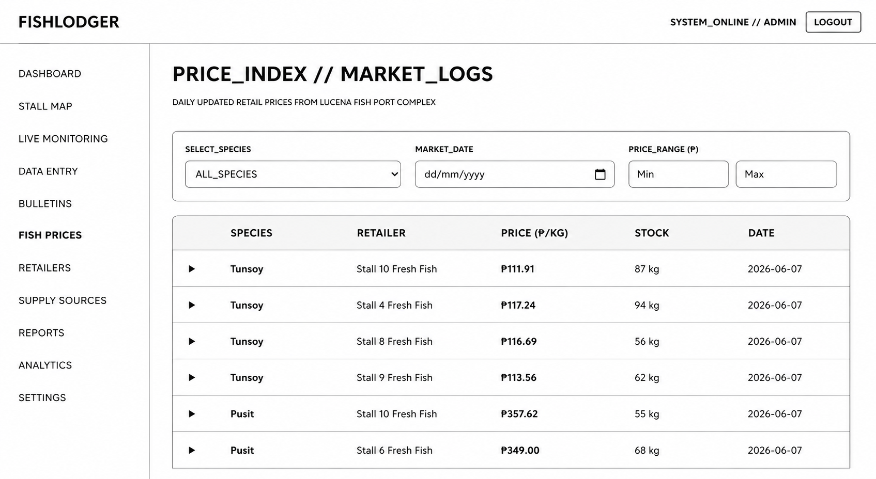
Figure 15. Prototype: Fish Prices
The price index page will feature a searchable archive of all historical market price logs to help users track long-term pricing trends across different retailers. This interface will include filtering controls so users can quickly sort through records by specific fish species, exact calendar dates, and minimum-to-maximum price ranges. The data will be organized in a main table where rows are expandable, allowing users to click a record to reveal deeper details about the retailer and specific stock remarks.
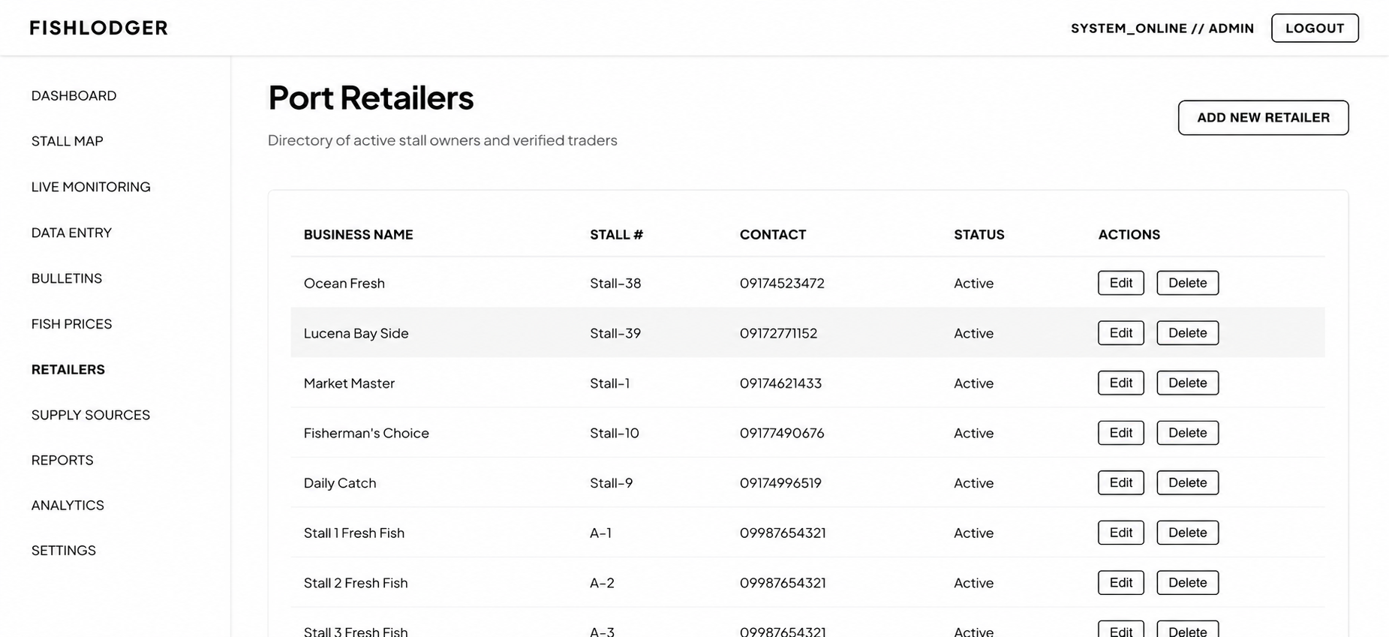
Figure 16. Prototype: Retailers
The prototype will feature a comprehensive port retailers management interface designed to act as a directory of active stall owners and verified traders. It will include an "Add New Retailer" action button at the top right to facilitate administrative onboarding workflows. The primary data table will systematically organize retailer profiles, detailing their official business name, assigned stall number, contact information, and current operational status. Additionally, the interface will provide inline management actions for each entry, allowing administrators to directly edit profile credentials or delete obsolete merchant records from the active system database.
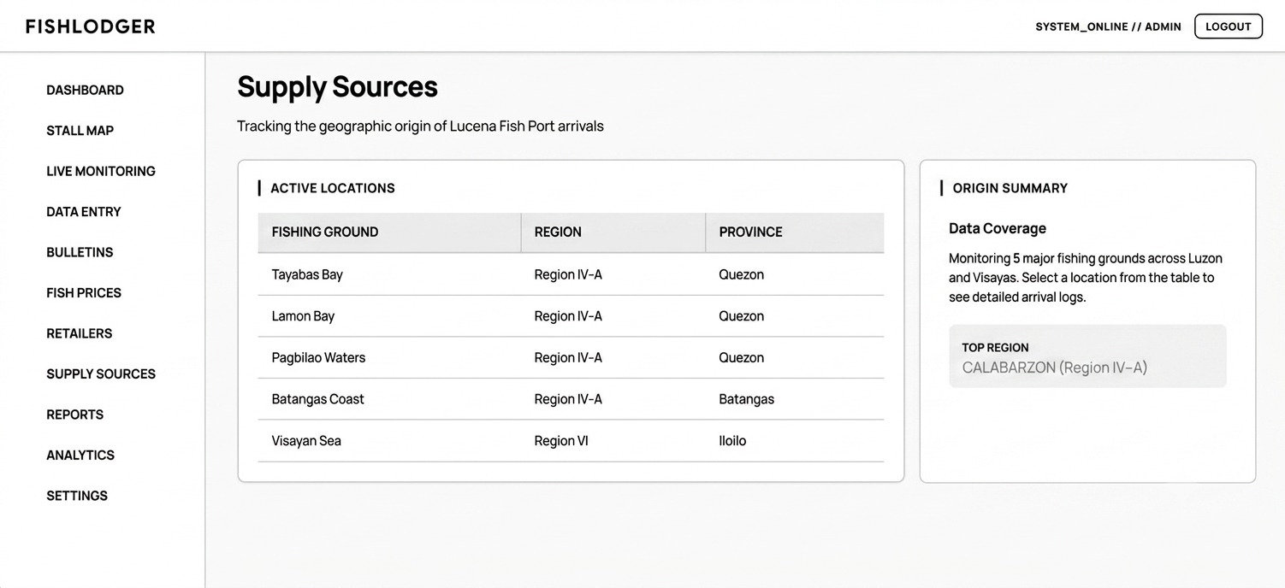
Figure 17. Prototype: Supply Source
The supply sources page will track the geographic origins of all commercial fish entering the port complex. The interface will list primary fishing grounds—such as Ragay Gulf and Tayabas Bay—alongside their respective regions and provinces. This centralized list will help administrators and traders map exactly where incoming supply is being harvested to better understand regional distribution.
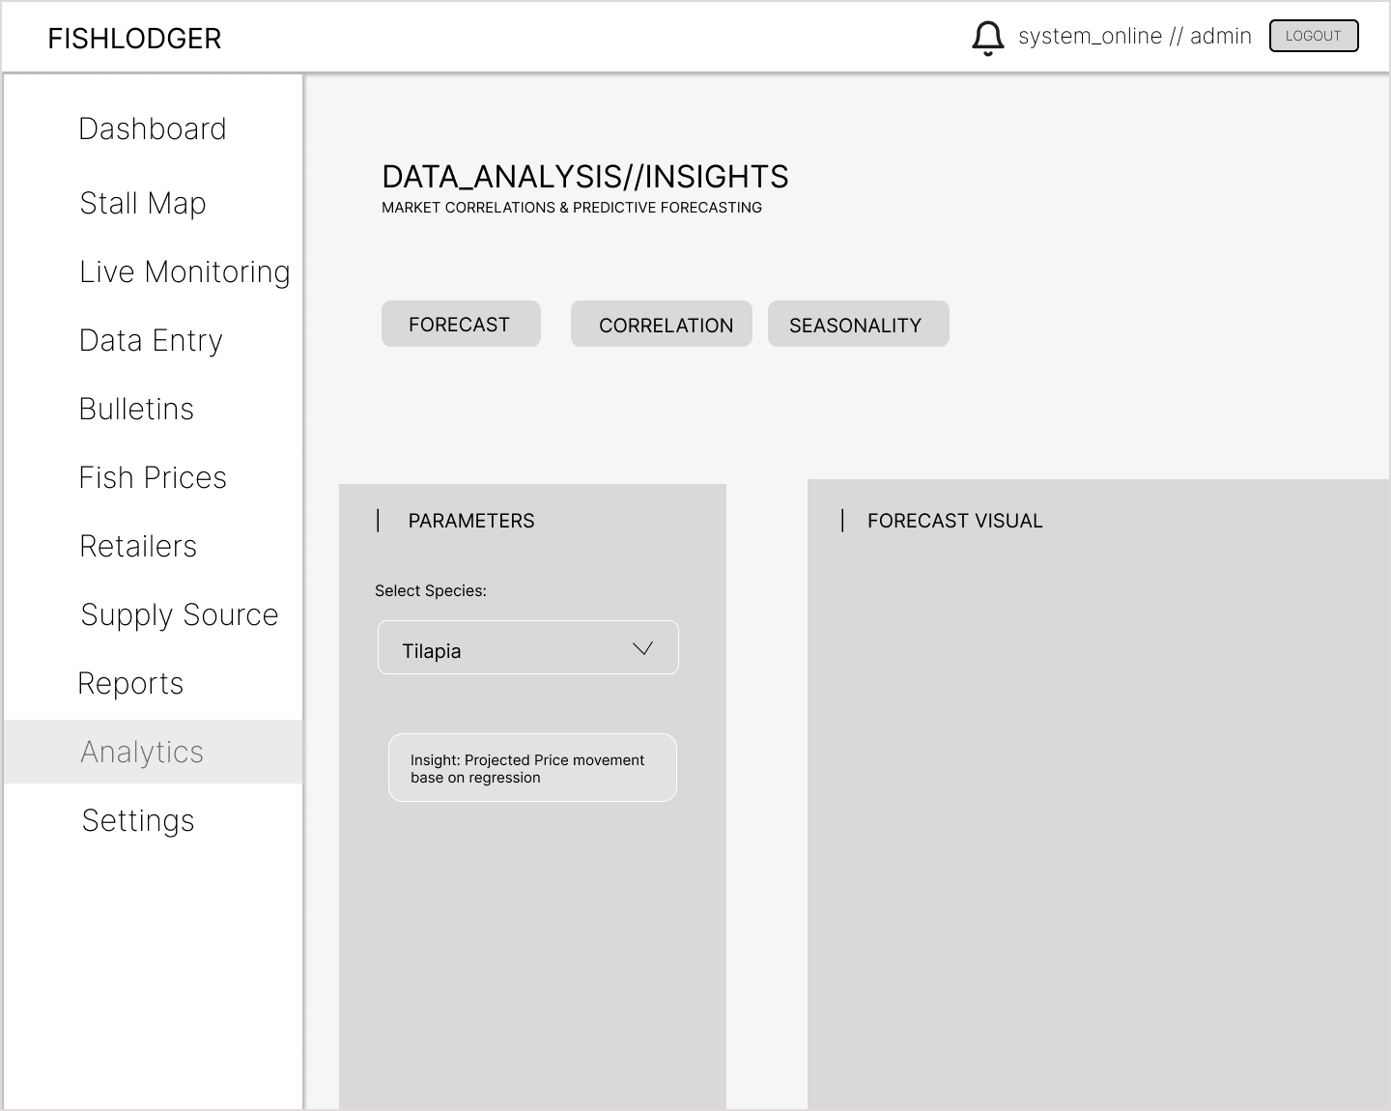
Figure 18. Prototype: Analytics Page
The Analytics Page will serve as the system's predictive analytics module, utilizing a Random Forest Regression model to forecast fish supply trends based on historical data. It will display a 7-day forecast, seasonal trend analyses, and visualizations of fish supply patterns. Users will also be able to compare historical and predicted supply trends across different fish species to support planning and decision-making within the Lucena Fish Port Complex.
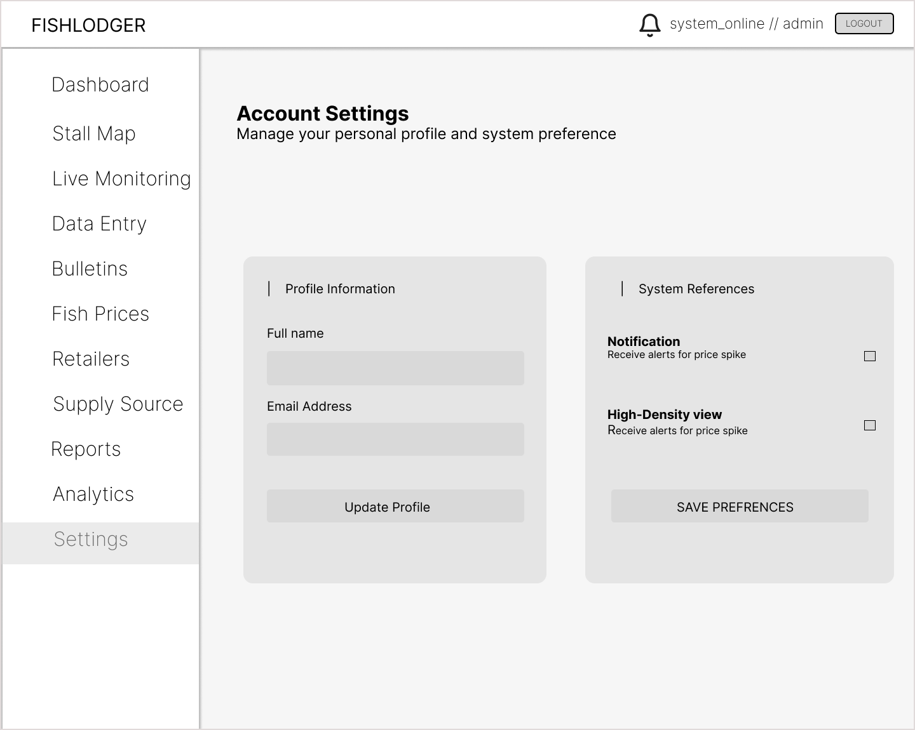
Figure 19. Prototype: Settings Page
The settings page will handle user profile updates and system preference management. This interface will allow users to customize their application experience through toggles for system notification alerts, such as immediate price changes, and options to adjust the user interface layout density to fit their workflow needs.
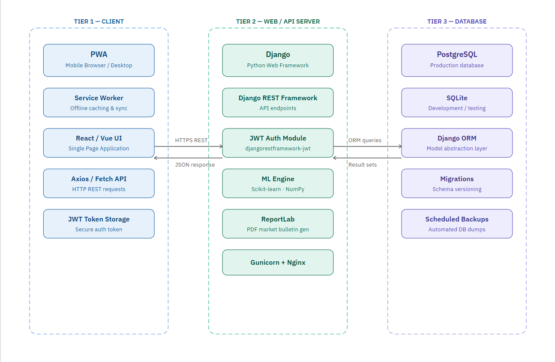
Figure 20. Deployment Diagram
The Deployment Diagram illustrates how the FishLedger system is implemented and accessed by users. It shows the cloud server, which hosts the application, database, and system services, as the central component of the architecture. Users can access the system through various devices, including smartphones, tablets, and desktop computers, using the Progressive Web Application (PWA). This setup enables real-time data access, efficient communication between system components, and reliable operation across different platforms.
ISO/IEC 25010 Software Quality Evaluation
The developed FishLedger system will be evaluated using the ISO/IEC 25010 Software Quality Model, an internationally recognized standard for assessing software quality. This model provides a comprehensive framework for measuring the quality and effectiveness of software systems based on specific quality characteristics. The evaluation will be conducted through a survey questionnaire administered to fish port administrators, personnel, and retailers who will use the system.
The evaluation will focus on the following quality characteristics:

1. Functional Suitability
Functional Suitability refers to the degree to which the system provides functions that meet the stated and implied needs of users when used under specified conditions.
- Functional Completeness – The system provides all necessary functions required for fish market monitoring, retailer management, supply source identification, automated reporting, and predictive analytics.
- Functional Correctness – The system produces accurate and correct results based on user inputs and stored data.
- Functional Appropriateness – The functions of the system effectively support users in accomplishing their tasks efficiently.
2. Performance Efficiency
Performance Efficiency refers to the capability of the system to provide appropriate performance relative to the amount of resources used under stated conditions.
- Time Behavior – The system responds quickly during data entry, retrieval, report generation, and dashboard loading.
- Resource Utilization – The system efficiently uses available resources such as memory, processing power, and network connectivity.
- Capacity – The system can handle multiple users and large volumes of fishmarket records without performance degradation.

3. Compatibility
Compatibility refers to the degree to which the system can operate effectively while sharing resources and exchanging information with other systems.
- Co-existence – The system can operate alongside other software applications without conflicts.
- Interoperability – The system can exchange and utilize information with external services and integrated technologies when necessary.
4. Usability
Usability refers to the degree to which the system can be used by specified users to achieve specified goals effectively, efficiently, and satisfactorily.
- Appropriateness Recognizability – Users can easily recognize how the system can help them accomplish their tasks.
- Learnability – The system is easy to learn, even for first-time users.
- Operability – Users can easily navigate and control the system functions.
- User Interface Aesthetics – The interface is visually appealing, organized, and understandable.
- Accessibility – The system can be accessed and used across different devices and user environments.

5. Reliability
Reliability refers to the ability of the system to perform specified functions consistently under specified conditions for a specified period.
- Maturity – The system performs consistently with minimal failures during operation.
- Availability – The system remains accessible whenever needed by users.
- Fault Tolerance – The system continues to function properly despite minor errors or unexpected conditions.
- Recoverability – The system can restore data and resume operations after interruptions or failures.

6. Security
Security refers to the degree to which the system protects information and data so that users have appropriate access according to their authorization levels.
- Confidentiality – Sensitive information is protected from unauthorized access.
- Integrity – Data remains accurate, complete, and protected from unauthorized modification.
- Accountability – User activities can be traced through system logs and records.
- Authenticity – The system verifies the identity of users before granting access.

