Using the “EXPLAIN" keyword in MySQL Workbench for the following query:  
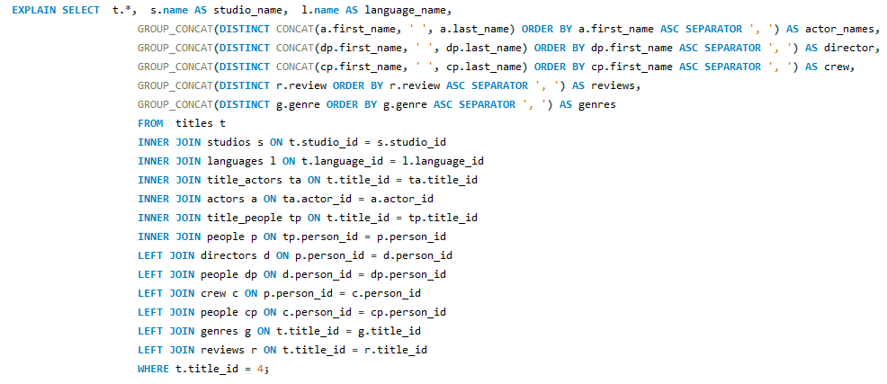  
Produced the following result:  
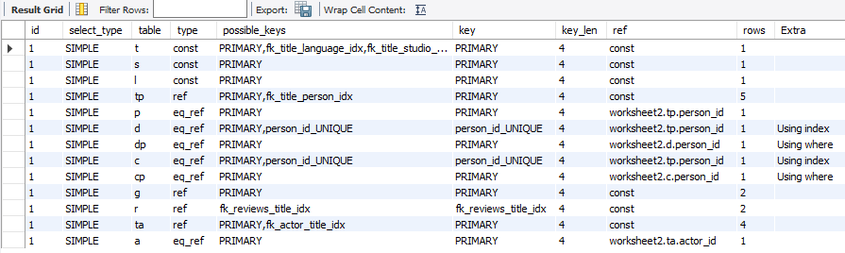

As visible in the ‘table’ column, the RDBMS must perform an operation on a different table for every join statement in the query. Even though few rows are scanned in every table, the efficiency of this query can still be increased by removing any unnecessary join statements. Since this query is used multiple times in the API, it often retrieves data from many table that is not always required.   
  
For example, only retrieving additional info from the “studio” and “genre” tables produces the following result with less table operations:  
  
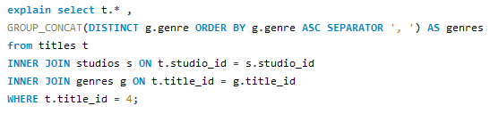  
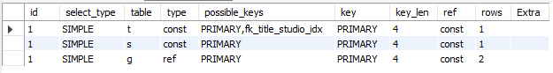  
  
The best way to improve the efficiency and performance of the query would be to have a “result” parameter in the API which specifies which data is required. The API would then dynamically build SQL queries with only the required number of joins instead of using all available joins every single time.