Position Control of Multiple Servos and Stepper Motors

with an Arduino

Control of multiple servos and stepper motors by a single Arduino is demonstrated with a 16 channel I2C device incorporating a PCA9685 IC.

Applications include, for example, robotics.

Documentation for the demonstration equipment is stored in GitHub repository: <https://github.com/James-Canova/PWM_motors.git>

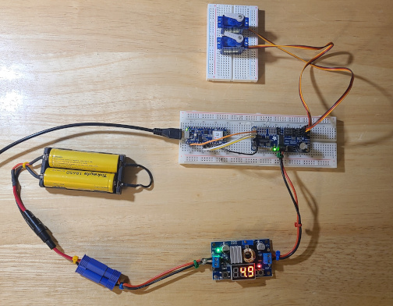

Figure 1 – Servo control demonstration equipment

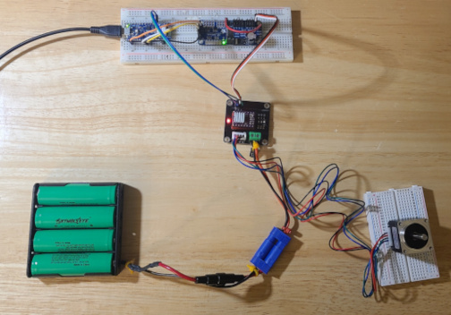

Figure 2 – Stepper motor control demonstration equipment