IPFS

Content
- Since IPFS locates data based on content, any content added to the IPFS network is hashed with an immutable ID called CID. This CID is used to locate and identify content in the network, as opposed to just looking for the IP address only.
- CID is like the domain name/URL, but it’s not based on IP address but the content itself.
- Content-address first as opposed to location-address first.
Routing (how to know where to connect to find the content?)
- Distributed Hash Tables – they hash CID with peer (IP) address, because you still have to know the location of the machine that hosts the content you’re looking for, in order to actually retrieve it from that machine.
- DHT/IPFS server/node hosts DHT
- DHT/IPFS client connects to the DHT server via IPFS protocol to find content.
Publishing Content
- 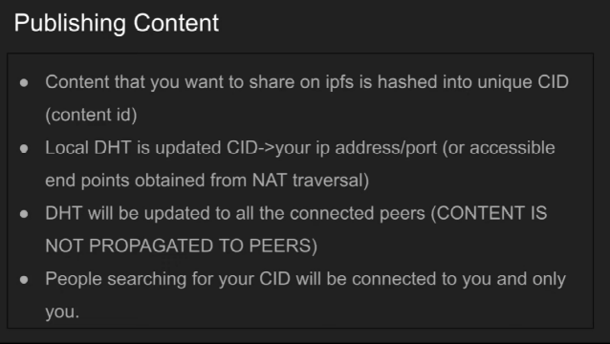
- When you add a content to your IPFS node (or somebody else’s), the local DHT (of the IPFS node) will update and map the IP address of the IPFS node with the content: CID -> IP address.
- Updated DHT is propagated across “all the connected peers” (??? – private network of peers possible?).
- Other peers can only host the actual content when they explicitly download it from your IPFS node.
Consuming Content
- 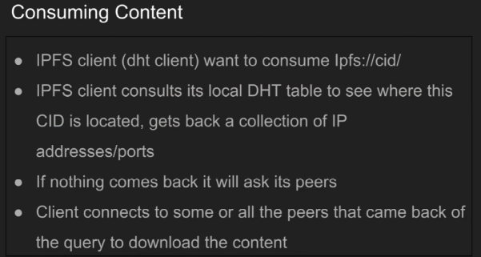
- 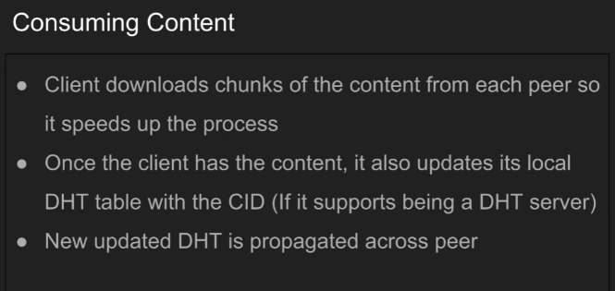
- The client can actually opt to not host the content after they download it by not updating its own local DHT, which will not update other peers’ DHT tables.
- If the client downloads the content from other peers and updates its own local DHT tables to map the content with the client’s IP address, this means the client is hosting the content and is now effectively a DHT server (or an IPFS server/node hosting an updated DHT), and other peers will know that the client is also a DHT server hosting that content.

