COMP 3322 Software Engineering · Fall 2026

Repo & Git Guide
Course Project: Panther Parking · how to get your repo and work in it
This guide covers the hands-on GitHub and git steps for the project. The Project guide says what to build and when; this one says how to do it in the repo. Keep it open while you work.
Part | When you need it
1. Get your team repo | Week 0, one member
2. Install and run the starter | Week 0, everyone
3. Your first pull request | Week 0, everyone
4. The everyday loop | Every story
5. Tag the final version | Sun Nov 22
6. When something goes wrong | Whenever

1. Get your team repo
One member, the repo owner, does this once for the whole team.
- Open the starter template (link on Canvas). Click Use this template → Create a new repository. Do not fork it.
- Name it panther-parking-<team-name>, choose Public, and click Create repository.
- Settings → Collaborators → Add people: add your three teammates and me.
- Open the Actions tab and wait for the first run to finish with a green check. This creates the test check used in the next step.
- Settings → Branches → Add branch protection rule (or Add classic branch protection rule). Branch name pattern: main. Turn on:
  - Require a pull request before merging, with 1 required approval
  - Require status checks to pass before merging, and select test
  - Do not allow bypassing the above settings
- Click Create, then submit the repo link on Canvas.
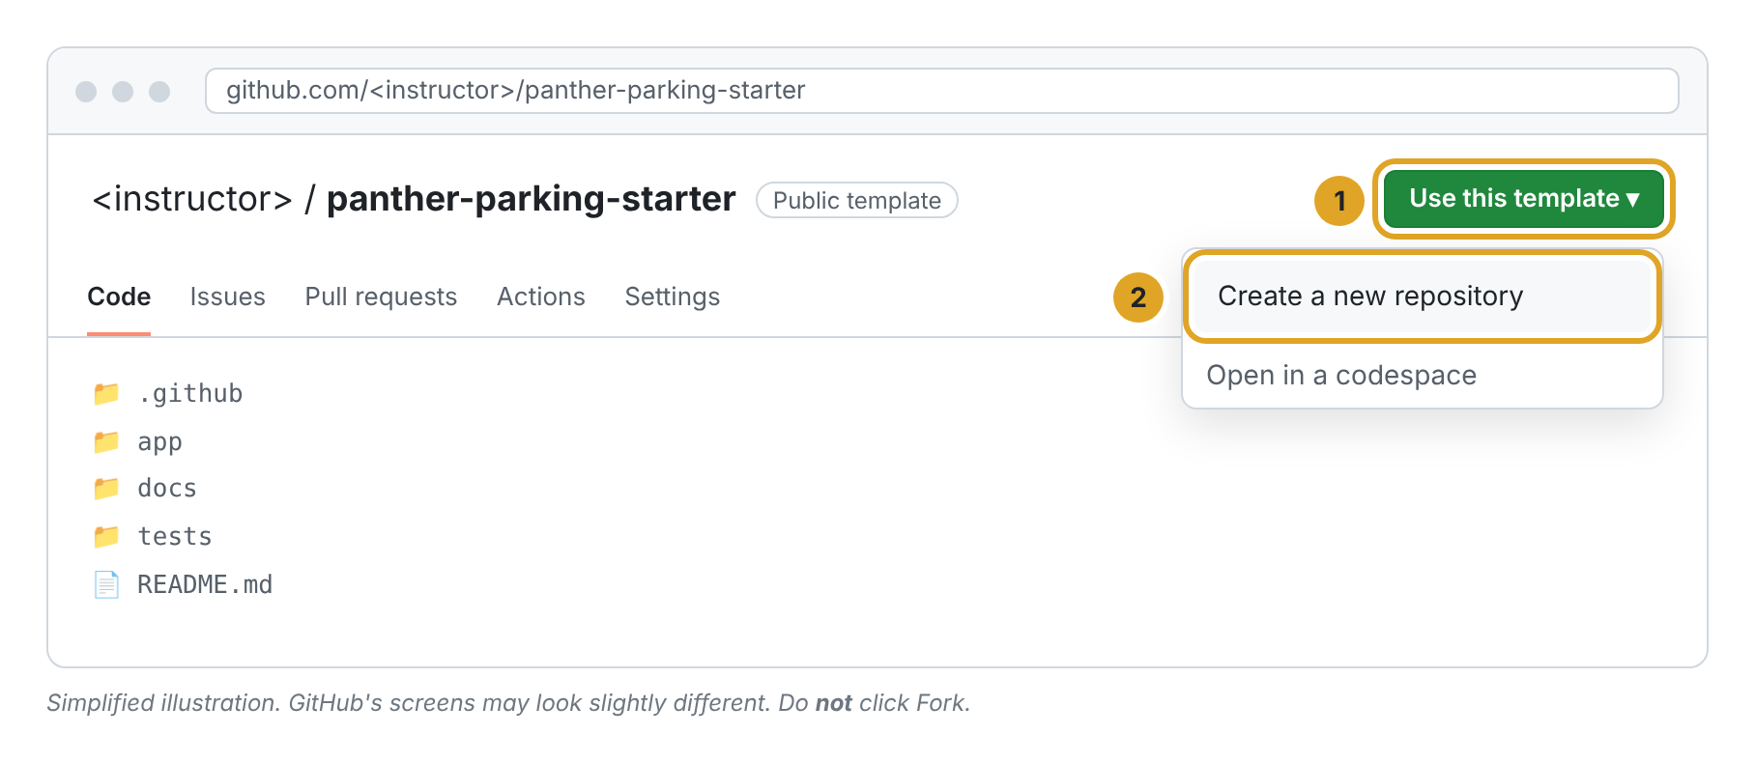
Step 1: Use this template, then Create a new repository.
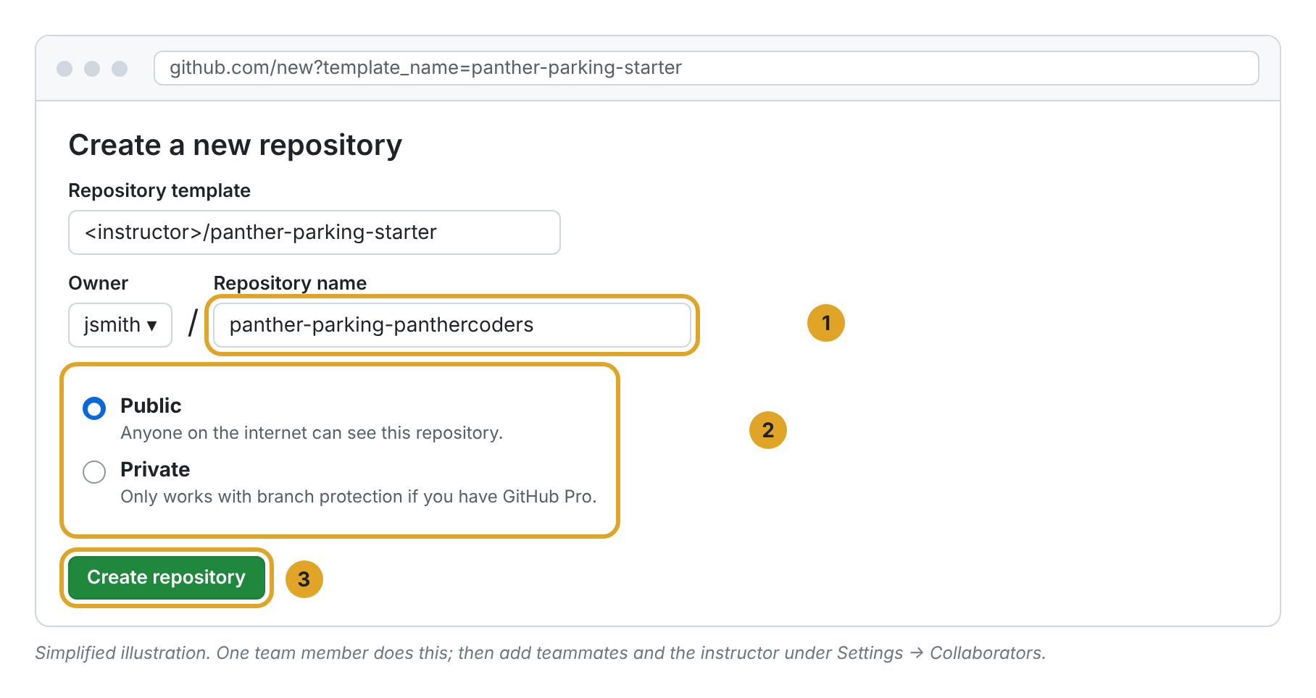
Step 2: name the repo and make it Public.
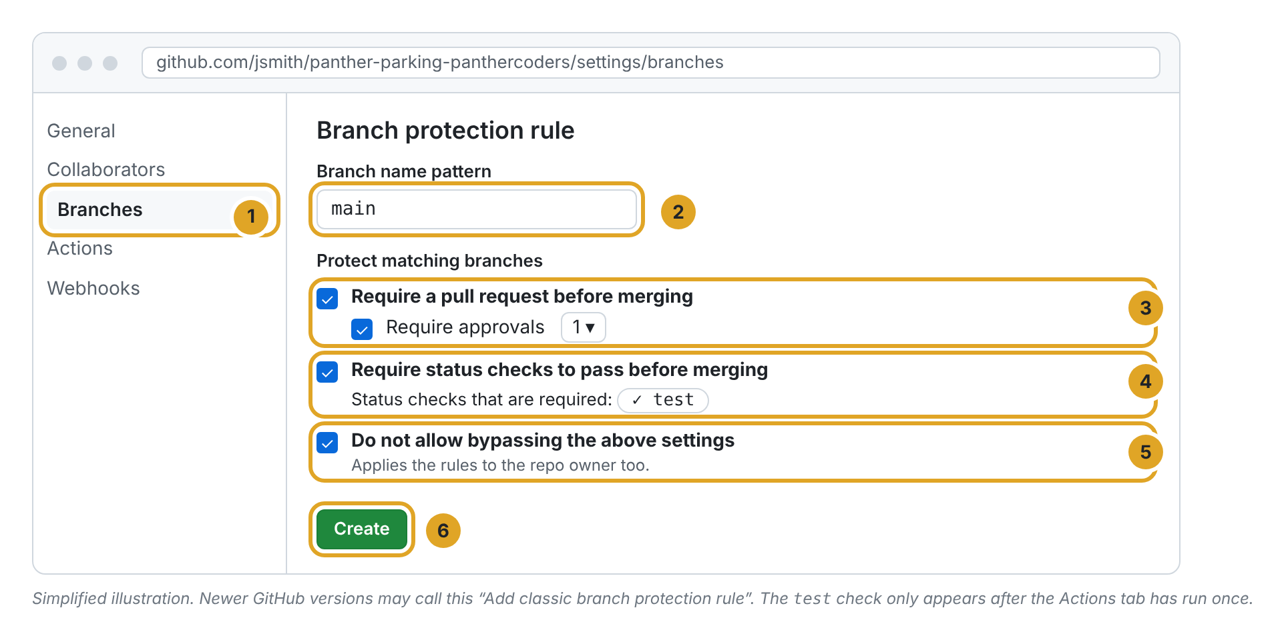
Step 5: protect main.
Your repo is public
Other teams can see your code. Reading it to learn is fine; copying it is an academic integrity violation, and the repo history and code walkthrough make copying easy to spot.

2. Install and run the starter
Every member does this on their own computer. You need Python 3.12 or newer (python.org; on Windows, tick "Add python.exe to PATH"), Git (git-scm.com), a GitHub account, and a code editor such as VS Code.
In a terminal (PowerShell or the VS Code terminal on Windows):
git clone https://github.com/<owner>/panther-parking-<team-name>.git
cd panther-parking-<team-name>
python -m venv .venv
.venv\Scripts\activate # Windows
# source .venv/bin/activate # Mac / Linux
pip install -r requirements.txt
flask --app app init-db
flask --app app run --debug
Open http://127.0.0.1:5000 to see the app. Stop it with Ctrl+C, then run the tests:
pytest -v
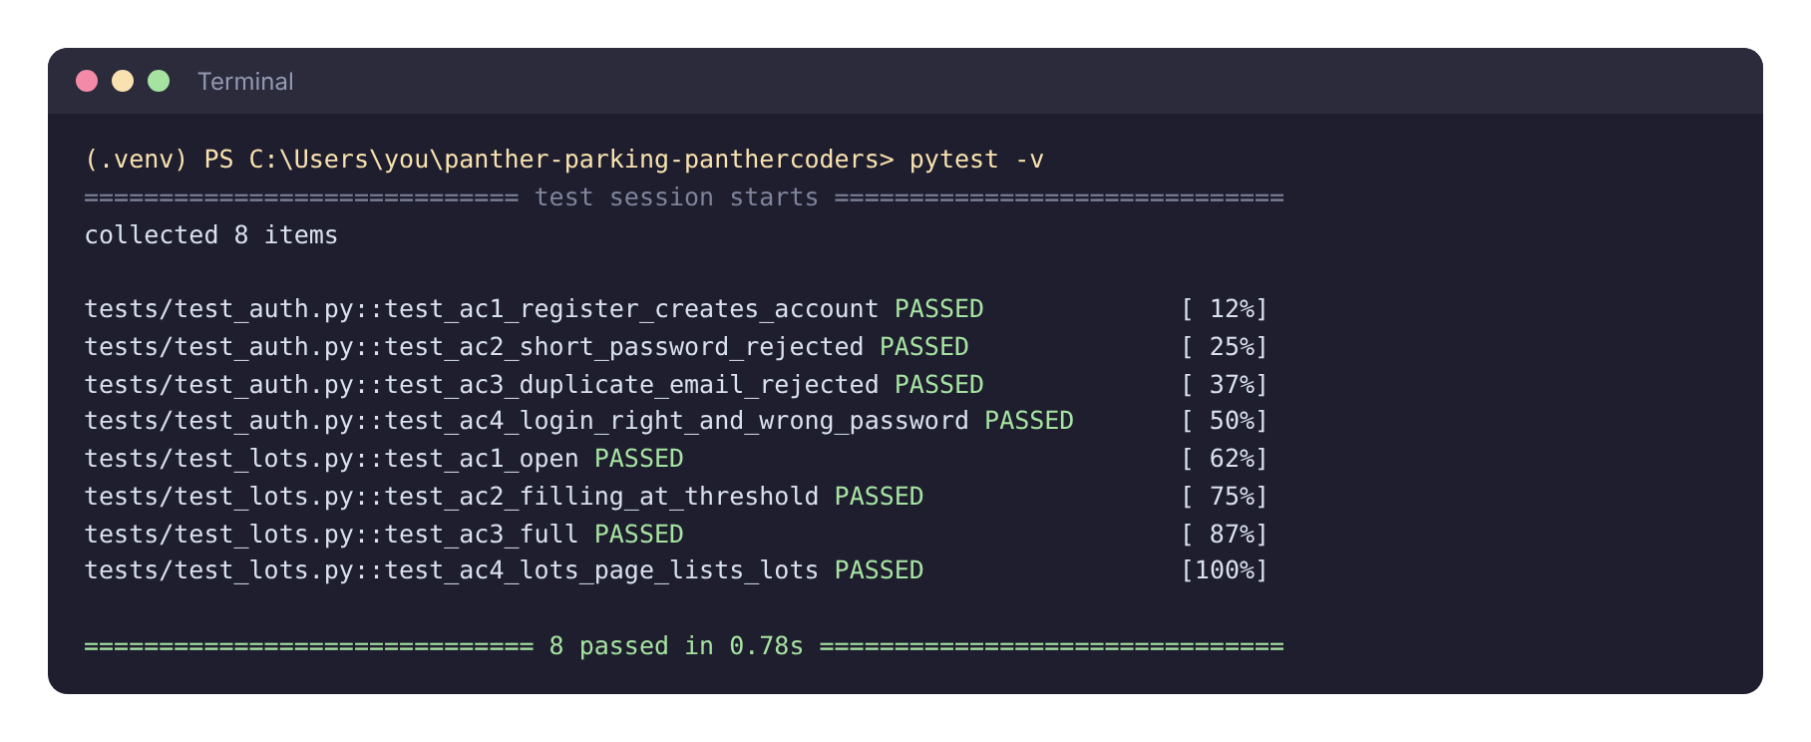
Expected: 8 passed. If not, ask your team or me before going further.
Each time you open a new terminal, cd into the folder and run the activate line again.

3. Your first pull request
Every member does this once in week 0. It is a small change (your name in the README) that walks you through the whole workflow.
git checkout -b add-<your-name>
# edit README.md: add your row to the team table
git add README.md
git commit -m "Add <your name> to team table"
git push -u origin add-<your-name>
- On GitHub click Compare & pull request, fill in the template (the AI line can say "None"), and create it.
- A teammate opens Files changed → Review changes, leaves a comment and approves.
- When the check is green and the review approved, click Merge pull request.
- Back on your computer: git checkout main, then git pull.
Four people editing the same table will probably cause a merge conflict. That's useful practice; part 6 shows how to fix it.

4. The everyday loop
Every story lives on its own branch until its pull request is approved and passing.
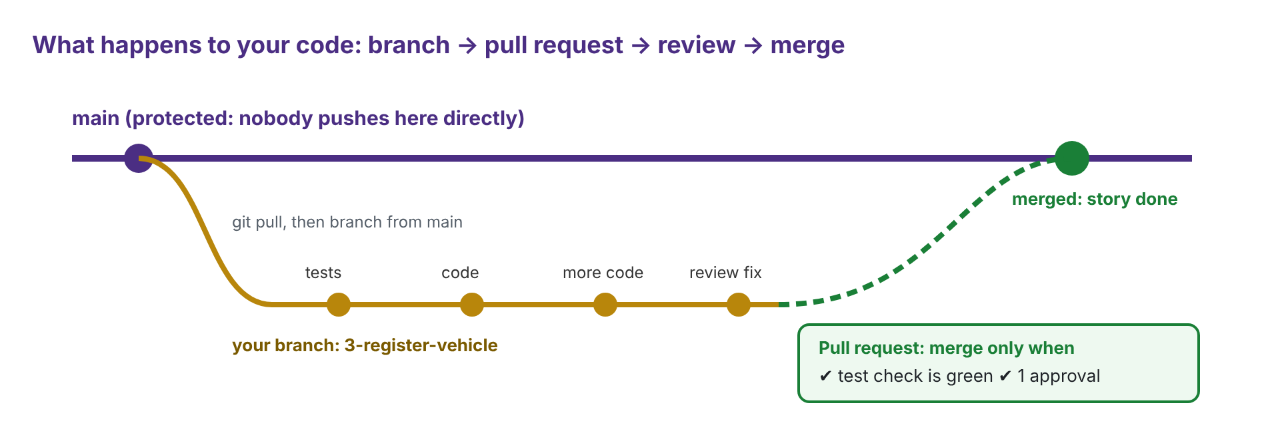
- Start from the latest code and make a branch named for the issue:
git checkout main
git pull
git checkout -b 3-register-vehicle
- Write the tests, run pytest (they should fail), write the code, run pytest again until everything passes. If you changed app/schema.sql, run flask --app app init-db again.
- Commit small and often with clear messages, and push:
git add .
git commit -m "Add plate validation and tests for AC2, AC3"
git push -u origin 3-register-vehicle
- Open a pull request. Write Closes #3 in the description so the issue closes on merge.
- Fix what your reviewer finds by pushing more commits to the same branch.
- Merge when the check is green and the review is approved, then delete the branch.
Pair programming? End the commit message with a line Co-authored-by: Name <email> so both of you get credit.

5. Tag the final version (by Sun Nov 22, 11:59 pm)
On GitHub: Releases → Create a new release. Type v1.0 as the tag, choose main as the target, and click Publish release. I grade the code at that tag; later commits are not graded.

6. When something goes wrong
Problem | Fix
Red ✖ on your pull request | Click Details to see which test failed. Run pytest -v locally, fix it, and push again.
Merge conflict | git checkout main, git pull, git checkout <your-branch>, git merge main. In each conflicted file keep the right lines and delete the <<<<<<<, =======, >>>>>>> markers. Then commit and push.
Errors about missing tables or columns | You changed schema.sql. Run flask --app app init-db again (this wipes your local data).
flask or pytest not found | Your virtual environment isn't active. Run the activate line from part 2.
Can't merge: "Review required" | A teammate has to approve. You can't approve your own pull request.
Stuck for more than an hour | Say so at the Monday check-in or post on the Canvas discussion. Being stuck is normal; staying stuck quietly is the problem.

