COMP 3322 Software Engineering · Fall 2026

Course Project: Panther Parking
Team project · 25 points · Oct 19 – Nov 23, 2026

1. The app
Parking at PVAMU is a daily headache. Students circle full lots looking for a space. Permits are handled by paper and email. Nobody knows about a citation until a hold appears on their account.
Panther Parking is a web app that fixes the basics. Drivers see which lots have space, register their cars and apply for permits. Parking Office staff manage the lots and approve the permits.
Who uses it | What they need
Drivers (students, faculty, staff) | See which lots have space; register vehicles; apply for a permit and see whether it was approved
Parking Office staff (admins) | Keep the list of lots up to date; approve or reject permit applications

Every team builds the same app. That way you can compare designs and learn from how other teams solved the same problem.

2. What you get
You don't start from a blank page. On day one your team gets a starter app that already runs. A driver can create an account, log in and see every lot with its free spaces and status.
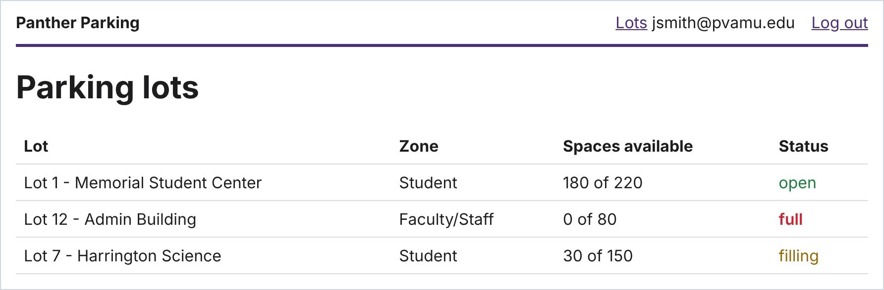
The starter on its first run: three sample lots, one of them full.
Two features are already built, and they are your worked examples. Read them before you write anything:
- Story 1: accounts. As a driver, I want to create an account and log in, so that my vehicles and permits are saved.
- Story 5: lot status. As a driver, I want to see each lot's capacity and status, so that I don't circle full lots.
The code is split into three layers. Each layer has one job and only calls the layer below it. Every new feature you add follows the same path.
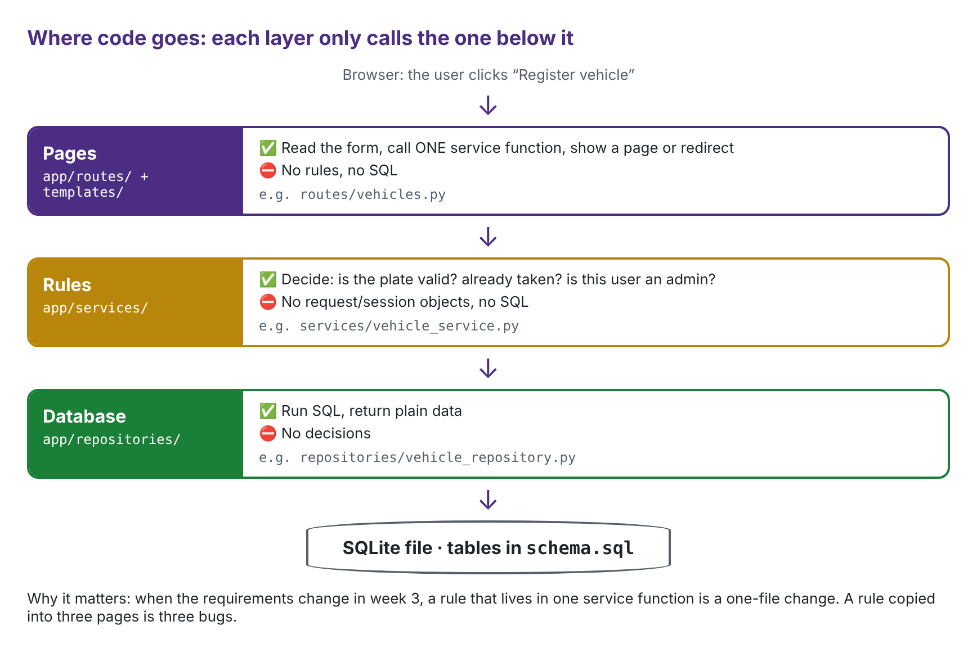
Where code goes. The example uses the vehicle feature you will build in week 1.
The starter also comes with 8 automated tests, one for each acceptance criterion of stories 1 and 5, and they run automatically every time you push code. Some things are deliberately missing: there are no vehicle or permit tables, and there is no way to make someone an admin. Deciding how to add them is part of your work.

3. The goal

What the finished app must do
By Mon Nov 23 your app must support four more user stories. The screenshots come from a working version. Yours doesn't have to look like this (plain pages are fine), but it must do the same things.
Story 2 · Register a vehicle  As a driver, I want to register a vehicle (plate, make, model, color), so that it can be linked to a permit.  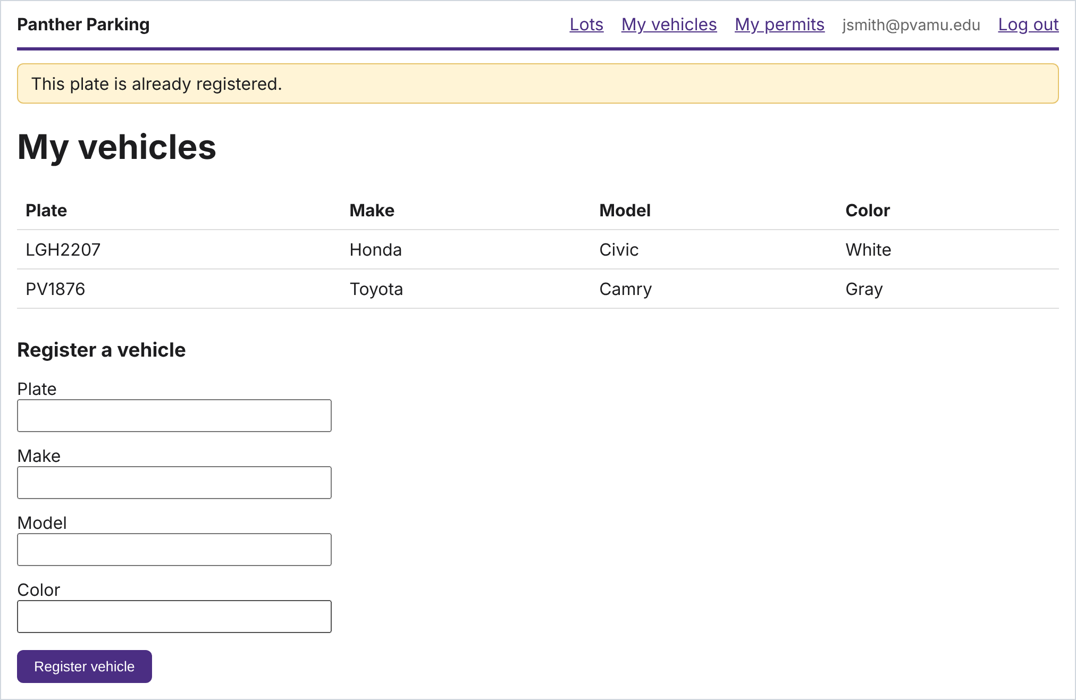 | Story 6 · Manage lots  As a Parking Office admin, I want to create and edit lots (name, zone, capacity), so that the system matches campus.  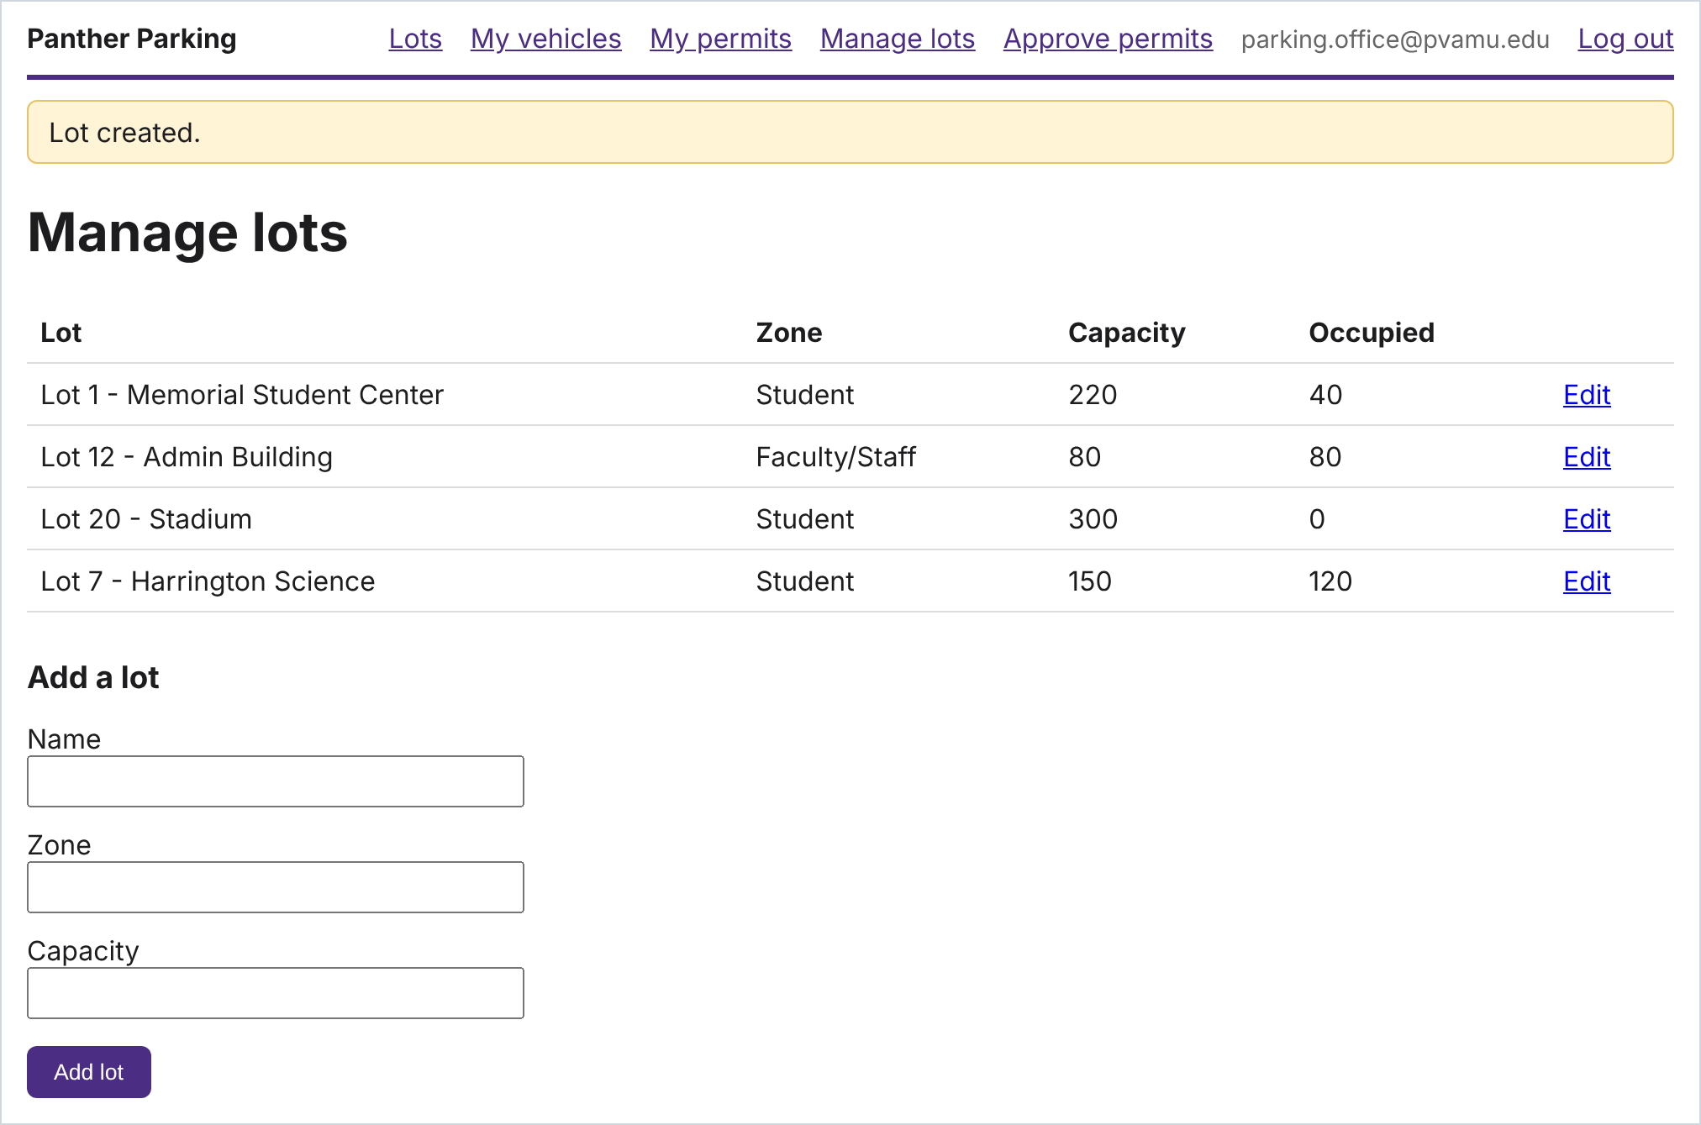
Story 3 · Apply for a permit  As a student, I want to apply for a permit for a lot zone, so that I can park legally.  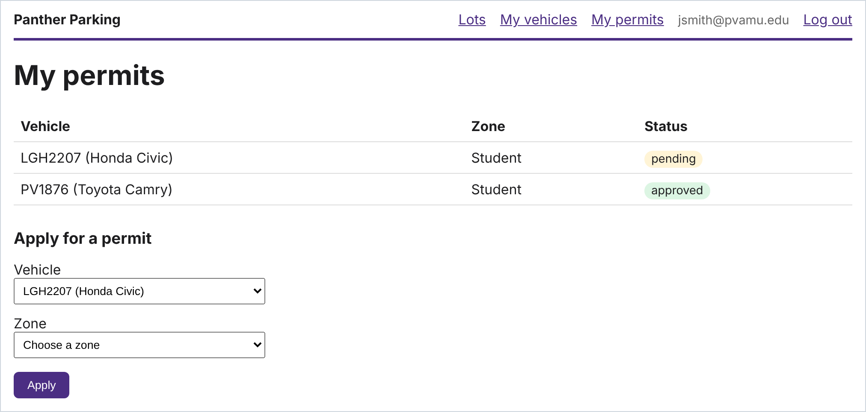 | Story 4 · Approve permits  As an admin, I want to approve or reject permit applications, so that only eligible drivers get permits.  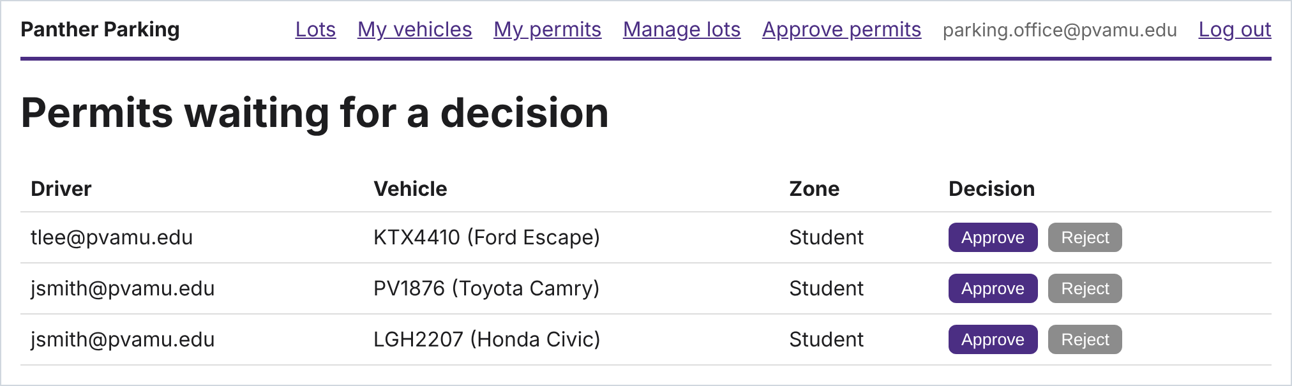

Extra credit (up to 1 point), only after everything else is done: issue citations (story 7), view and appeal citations (8), one-day visitor passes (9), or let drivers report a full lot (10).

How you will build it: three habits
The point of the project is not just that the features work. It is how you build them. You will repeat the same three habits for every story:
- Write testable acceptance criteria. Each story gets 3 to 5 specific, checkable statements of what must be true when it is done.
- Write a test for every acceptance criterion, before the code, and keep every test passing.
- Merge only through a reviewed pull request. Nobody changes the main code directly. A teammate reviews every change first.
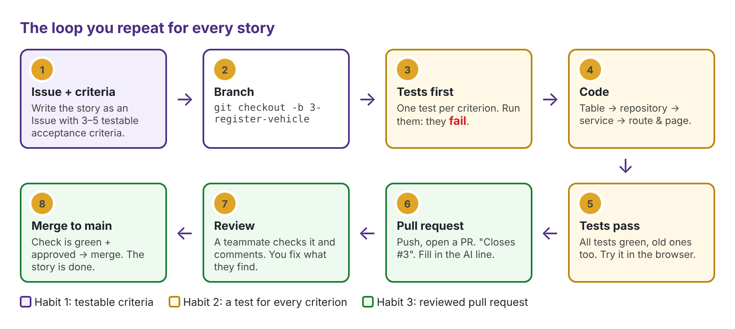
The loop you will repeat for every story.
What makes an acceptance criterion testable? You can imagine the test for it:
Not testable | Testable
Plates are validated. | A plate longer than 8 characters, or with anything other than letters and digits, is rejected with a message.
Duplicate vehicles are handled. | A plate already registered to another driver is rejected with "This plate is already registered."
Only admins can approve. | A driver who opens the approval page is redirected, and the permit stays pending.

A story is done only when every acceptance criterion has a passing test, a teammate has reviewed and approved the change, it is merged into the team's main code, and it works on a fresh copy of the repo.

Then the requirements change
In week 3 the "Parking Office" will hand every team the same new requirement. You won't know it in advance, just as real teams don't. Teams that kept each rule in one place in the service layer will absorb it in a day or two. Teams that scattered logic across pages will feel it. That difference is what software design is for.

4. What you do, week by week
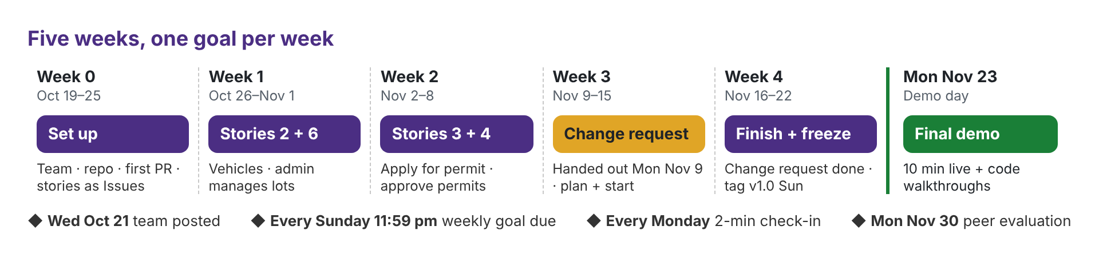
Each week's goal is due Sunday at 11:59 pm. Every Monday, each team takes 2 minutes in class to show what is merged and what is next. Check-ins aren't graded, but they are where I find teams that are stuck.

Week 0 · Oct 19 – 25 · Get set up
- Form a team of four and post it on the Canvas project discussion by Wed Oct 21.
- Get your team repo and run the starter on every member's computer. Follow the Repo & Git Guide, parts 1 and 2.
- Every member merges one small pull request (adding your name to the README). This proves the whole team can use the workflow. See Repo & Git Guide, part 3.
- Write the four required stories as Issues, each with 3 to 5 testable acceptance criteria and one owner. Every member owns at least one story.
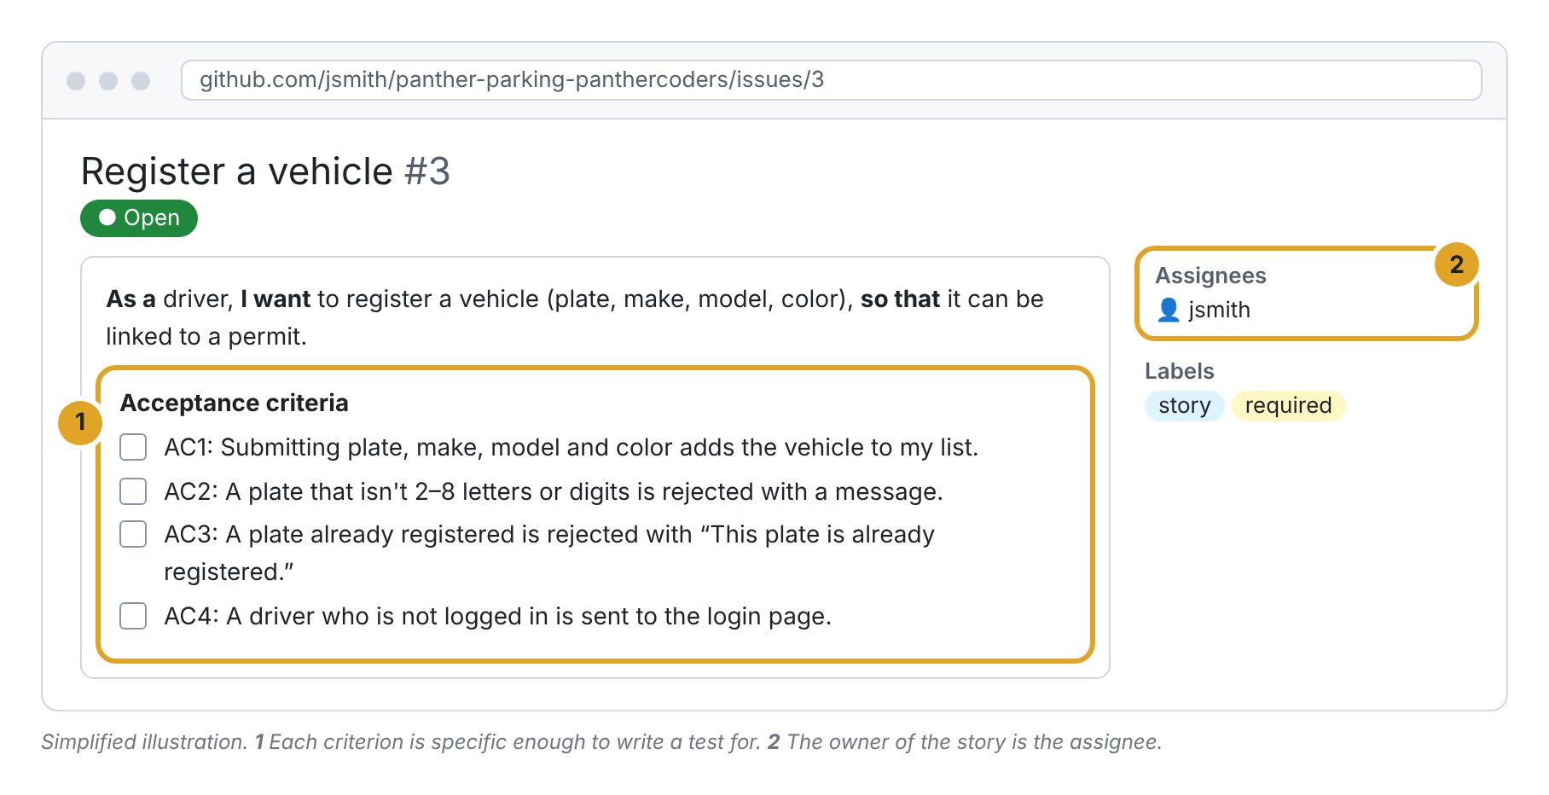
A good story issue: specific acceptance criteria and an owner.

Week 1 · Oct 26 – Nov 1 · Stories 2 and 6
Your first real pass through the loop. Story 2 (vehicles) and story 6 (manage lots) don't depend on each other, so two pairs can work in parallel.
- Tests first. Turn each acceptance criterion into a test, named after it (copy tests/test_lots.py). Run them and watch them fail: a test that has never failed hasn't proven anything.
- Then the code, layer by layer: the table, the database functions, the rule in the service, then the page.
- Open a pull request that links the issue, says how you tested it, and fills in the AI-use line (section 5).
- Get a real review. The reviewer says what they checked, asks a question or suggests a change. "LGTM" alone doesn't count.
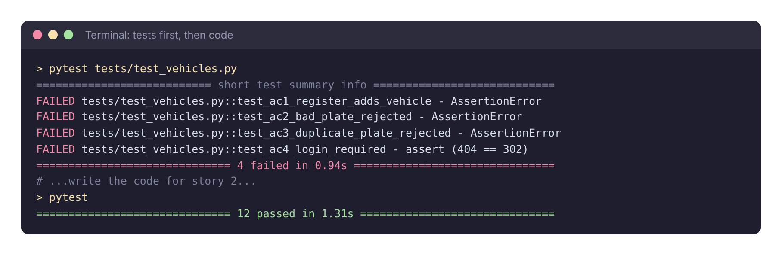
Tests first: before story 2 exists, its four tests fail. After the code, everything passes.
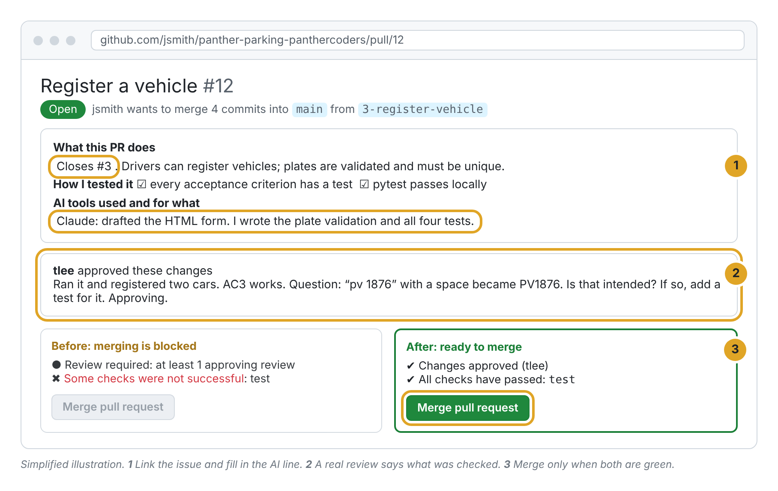
A pull request ready to merge: linked issue, AI line, a real review, and passing tests.

Week 2 · Nov 2 – 8 · Stories 3 and 4
Permits. A permit needs a vehicle, and an approval needs a permit, so story 3 depends on story 2 and story 4 depends on story 3. If story 2 slipped, pair on it first.
Story 4 needs admins, and the starter has no way to make one. Decide as a team how an account becomes an admin (for example, a command the Parking Office runs), and remember that a driver trying to approve a permit is an acceptance criterion too.

Week 3 · Nov 9 – 15 · The change request
The new requirement is handed out in class on Mon Nov 9. You have two weeks. Treat it like any other story:
- Write it as an Issue with acceptance criteria
- Implement it with a test for each criterion, keeping every earlier test passing (if you must change an old test, explain why in the pull request)
- Fill in docs/change-request.md (about half a page): what you changed, what made it easy or hard, and what you'd design differently

Week 4 · Nov 16 – 22 · Finish and freeze
Finish the change request, then check that every story meets the done rule on a fresh copy of the repo. Code freeze is Sun Nov 22 at 11:59 pm. Mark the final version as v1.0 (Repo & Git Guide, part 5). I grade the code at that tag.

Mon Nov 23 · Final demo
Each team has 10 minutes, live, from v1.0. Attendance is required.
- Walk through the four stories as real users: a student registers a car and applies for a permit; an admin adds a lot and approves the permit.
- Show one error case on purpose, such as a duplicate plate or a driver trying to approve.
- Show the change request working.
- Tell us one thing that went wrong during the project and what you did about it.
Then each member does a 2-minute code walkthrough with me (section 5). Peer evaluations are due Mon Nov 30, which is also the makeup day for documented absences only.

5. How you're graded
25 points: 15 team, 10 individual. I grade from your repo at v1.0 and from the demo.
Item | Pts | Full credit | Partial credit
Team | 15
Acceptance criteria | 3 | Every required story and the change request have 3–5 criteria, each specific enough to test | Some criteria vague ("works correctly") or missing
Required stories working | 5 | Stories 2, 3, 4 and 6 are done and work in the demo | Some stories done, or they work only with a workaround
Tests | 3 | Each acceptance criterion has a test that checks behavior; all pass at v1.0 | Only happy-path tests, or some fail at the tag
Change request | 4 | Done and tested; no earlier test broken without reason; thoughtful change-request.md | Partly done, or the note is missing or generic
Individual | 10
Story ownership | 4 | Owned a required story end to end; your merged pull requests are spread across the weeks | Owned a story, but the work came in one late burst
Code reviews | 2 | At least 3 reviews that ask, suggest or say what was checked | Reviews mostly "LGTM"
Code walkthrough | 4 | Explains your own code clearly and makes a requested change live | Explains it but needs heavy help to change it

No credit on an item means it is missing, wasn't attempted, or doesn't run.

AI use and the code walkthrough
You may use AI coding tools, as working engineers do. You may not submit code you can't explain. If your name is on it, you own it. Every pull request says which AI tools were used and for what ("None" is fine). Honest disclosure is never penalized; undisclosed use is handled under the syllabus integrity policy.
At the demo I will open code from one of your pull requests and ask you to explain it or make a small change live, such as adding a validation rule. It takes about 2 minutes, and if you wrote and understood your code you won't need to prepare. A student who can't explain their own code also has their story-ownership points reviewed.

Peer evaluation (due Mon Nov 30)
You rate each teammate from 1 to 5 on two questions: delivered what they committed to, and was a useful reviewer and teammate. Your average sets your share of the 15 team points. If the repo history clearly contradicts a rating, in either direction, the history wins. Not submitting costs you 1 point.
Peer score | 70% or higher | 60–69% | 50–59% | Below 50%
Team points you receive | 100% | 90% | 80% | 60%, and we talk

Questions
Can we use a different language or framework? No. Everyone uses the starter, so you can help each other and compare designs.
Does it need to look nice? No. Working, tested features earn the points; styling earns none.
A teammate isn't doing anything. What do I do? Tell me early, at a check-in or by email. Don't wait for the peer evaluation.
We finished early. Now what? Make your tests better, then try an extra-credit story.

