Joint analysis of climate mitigation, adaptation in Kenya’s beef sector by breed, farmtype, and agroecology

  - Authors:
  - James Hawkins¹
Rebecca Emiru
Jos Creemers
Chris Jones
Jaber Rahimi
Endale Gurmu¹
Sonja M. Leitner¹
Chloe Stull-lane
  - Claudia Arndt¹

¹ Mazingira Centre for Environmental Research and Education, International Livestock Research Institute (ILRI), Naivasha Rd, PO 30709, 00100 Nairobi, Kenya
[others to be added]

Target journals
Food systems research letters
Environmental Research Letters
Regional Environmental Change

1 Introduction
Africa’s livestock sector emits the highest quantity of greenhouse gas emissions per unit product (greenhouse gas emissions intensity or GHG-ei) among world regions (Bai et al. 2024). Extrapolations of historical data suggests this trend will continue – attributed to high population growth, and insufficient uptake of improved breed and forage production practices, among others (Jayne et al. 2021). Since 2000, livestock production in Africa has grown more than any other world region, and ~50% faster than the world mean growth rate (FAO 2025a). This production growth has mainly been through increases in meat and milk producing animals -- for which population growth rates are also highest among world regions -- 3.6x the global average (authors’ calculations from FAO 2025a). Climate change however introduces significant uncertainty in the future of African livestock production – and continental sub-regions will be unevenly affected. While the Sahel is projected to undergo declining precipitation, posing risks for grassland based ruminant production, East and South Africa will experience higher mean precipitation and, with the fertilization effect of higher CO₂, the viability of grassland-based systems will grow relative to alternatives such as mixed crop-livestock or semi-intensive systems (Yu et al. 2025, Weindl et al. 2015). Due to Africa’s abundant endowment of grazing resources making pastoral-based animal production affordable relative to world standards, sourcing a greater share of meat production from the continent is predicted to ease climate adaptation costs globally (Castonguay et al. 2025). Such production growth, however, must be enabled by GHG-ei reducing practices to be truly ‘climate-smart’.
The rate of animal liveweight gain (LWG) determines as much as 90% of GHG-ei variability in beef production across systems and agro-ecologies (Heo et al. 2025). As LWG is also a key economic indicator of beef production, production strategies which increase liveweight gain have significant potential to reduce GHG-ei while improving economic performance and potentially climate resilience in beef production. LWG is largely determined by genetics and feeding – implying breed selection and diet composition represent key levers for reducing GHG-ei in beef systems. In Africa, this implies selection for breeds combining high feed conversion efficiency with resilience to disease, heat and drought (i.e. forage scarcity), and (ii) substituting low quality native grasses & crop residues with higher quality forages and silages grown according to best agronomic practices (Mushi et al. 2015). Lesser but not insignificant reductions can be achieved via improved health management to mitigate disease-driven declines in LWG and milk yield. Results from studies have demonstrated mitigation potentials ranging from 8-260% (Renand et al. 2019, Duthie et al. 2017) for breed optimisation, 10-70% (Stifkens et al. 2019, Macleod et al. 2018, Kearney et al. 2023) for diet optimization, and 8-13% (McAtee et al. 2025, Macleod et al. 2018) for improved health management. Modelling studies moreover have documented synergies when such strategies are adopted concurrently, including in European (Jebari et al. 2025, Samsonstuen et al. 2020, Kearney et al. 2011), South-Asian (Chen et al. 2023), North (Beauchemin et al. 2011) and Latin American (D’Aurea et al. 2017) beef systems. Few studies, if any, have considered multiple productivity/mitigation factors in the context of climate impacts and adaptation for Africa’s beef sector.
This study quantified GHG and productivity outcomes under future development pathways in Kenya’s beef sector based on the combined outcomes of productivity enhancing practice/technology adoption and projected climate impacts to 2050. The study considered four intervention areas with potential impacts on GHG and resilience in Kenya’s beef sector: (1) animal genetics, (2) diet composition, (3) veterinary inputs/services and disease prevalence, and (4) ‘intensive finishing’ (finishing animals under feedlot or intensive ranching conditions). The cumulative effects are evaluated across three scenarios ranging from the predicted lowest highest GHG-ei outcomes to highest productivity and lowest GHG-ei outcomes, defined respectively as: Worst-case, Baseline, and Best-case. Climate impacts on productivity and GHGs were accounted for via heat stress and forage scarcity impacts, and were projected at sub-region level consistent with ‘Middle of the road’ and ‘High emissions’ narratives of the Representative concentration pathways (RCPs) 4.5 (‘Middle of the road’) and 8.5 (‘Accelerated warming’) respectively (Van Vuuren et al. 2011). This analysis informs of the expected GHG emissions observable across the most ‘pessimistic’ to most ‘optimistic’ development pathways in Kenya’s beef sector from the vantage of productivity and GHG mitigation potentials, as well as the regional-disaggregation of future production and GHG emissions.

2 Methods

2.1 Multi-chain simulation process
The analytic framework merged farm-level and spatially derived data in a multi-stage model process involving pre- and post-model parameter modification for climate and disease impacts (Figure 1). Doing so, the impacts of the scenario interventions on feed conversion efficiency (an indicator of genotype + feeding efficiency) and GHG emissions at sub-region and finally national level were estimated. The model framework consisted of three main stages, namely: (i) simulation of liveweight gain (LWG) and milk yield (MY) over beef cattle production cycles using the Rumen8 feed-formulation model,, (ii) climate- and disease-accounting on post-Rumen8 outputs, considering impacts of heat stress and forage scarcity on key production parameters of LWG, MY and dry matter intake (DMI) and (iii) GHG emission budgeting based on modified Rumen-8 outputs plus other system descriptors using the online interactive tool of the Global Livestock Environmental Assessment Model (GLEAM-i) (Macleod et al. 2018). Climate and disease accounting were performed under both pre- and post-feeding simulations (described below) using technical coefficients from literature combined with epidemiologic data on disease, treatment prevalence and projected climate-impacts across Kenya’s major beef systems. In doing so, the results of the model (GLEAM-i, Rumen8) outputs took into account disease and climate impacts in the estimation of key GHG and productivity determinants.

Kenyan beef production systems
Model disaggregation according to beef systems accounted for key sources of heterogeneity, specifically (i) agro-ecology, leading to differences in feed baskets and nutrient composition of natural grasslands across regions, (ii) cattle genotype, via distinctions in genetic composition of common meat-producing breeds; and (iii) farm-type classifications, and the associated production characteristics (breeds, herd structures, feeding) specific to each.

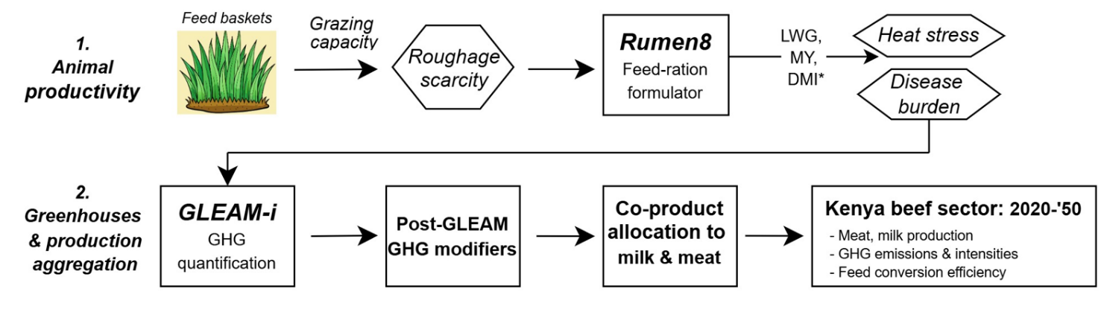
Figure 1: Model and data workflow.

Agro-ecological de-lineation discerned key productivity gradients driven by temperature and rainfall variability, given the well established temperature (Bunning and Wall 2022) and forage nutrient quality variability driven by such factors. Agro-ecological de-lineation extended a pre-existing FAO classification system (FAO 1996) and was adapted particularly to better reflect temperature gradients. The classification system resulting involved two low elevation, low precipitation systems: arid (A) and semi-arid (SA), and two medium-high producing systems: humid/sub-humid (HSH) (lowland altitude) and humid/sub-humid, mid- and highlands (HMH) (midlands & highlands). A further < 0.1% of area fell under arid, mid and highlands, and this group was added to SA leading to four agro-ecological zones: A, SA, HSH, HMH (Fig. 2a). The resulting agro-ecological zones were used to classify the predominant farming systems across regions (described below) and to discern variability in forage nutrient properties. Based on the 4 zones, 3 distinct sub-regions were de-lineated with respect to forage nutrient properties: arid (arid zones), semi-arid (semi-arid zone), and humid/sub-humid (the spatial aggregation of humid/sub-humid and humid, mid- and highland zones).
Beef genotype de-lineation acknowledged three distinct meat-producing breeds observable across Kenyan systems: East African Shorthorn Zebu (B. indicus) (hereafter Zebu), Boran (mixed genotype: ~65% African B. indicus, 24% and 12% European and African B. taurus, respectively, Hanotte et al. 2013) (since this breed is mainly of African lineage, it will be considered grouped with Zebu as Bos-indicus for the remainder of this study), and Exotic (~50% B. indicus, ~50% European B. taurus), representing crosses of Zebu x Angus or Zebu x Hereford, as commonly reported on Kenyan commercial beef farms (APRI 2025, Mwangi et al. 2020).
Farm-type classification extended previous classifications for Kenyan beef by FAO (2018) and Ngetich et al. (2023) into a spatially explicitly de-lineated farm-type classification (Table 1) differentiating farms by main breeds reared, feed-basket, and herd structure. This led to five main farm-types: (1) Pastoral: subsistence/semi-subsistence based predominantly on grazed grasslands with minimal external inputs or feeding (arid & semi-arid agroecological zones); (2) Agropastoral: subsistence/semi-subsistence based on the combination of grazing with some feeding of stover, supplements, and cultivated forages (semi-arid & humid/sub-humid), (3) Mixed: semi-confinement feeding mainly native grasses and crop stover with some sown forages and supplement (humid/sub-humid), (4) Cow-calf ops: variable intensity/feed mixes depending on region, oriented towards rearing cow- and bull-calves from birth to slaughter or sale (i.e. for finishing) (all agroecologies), and (5) Finishing ops, specialized in purchase of

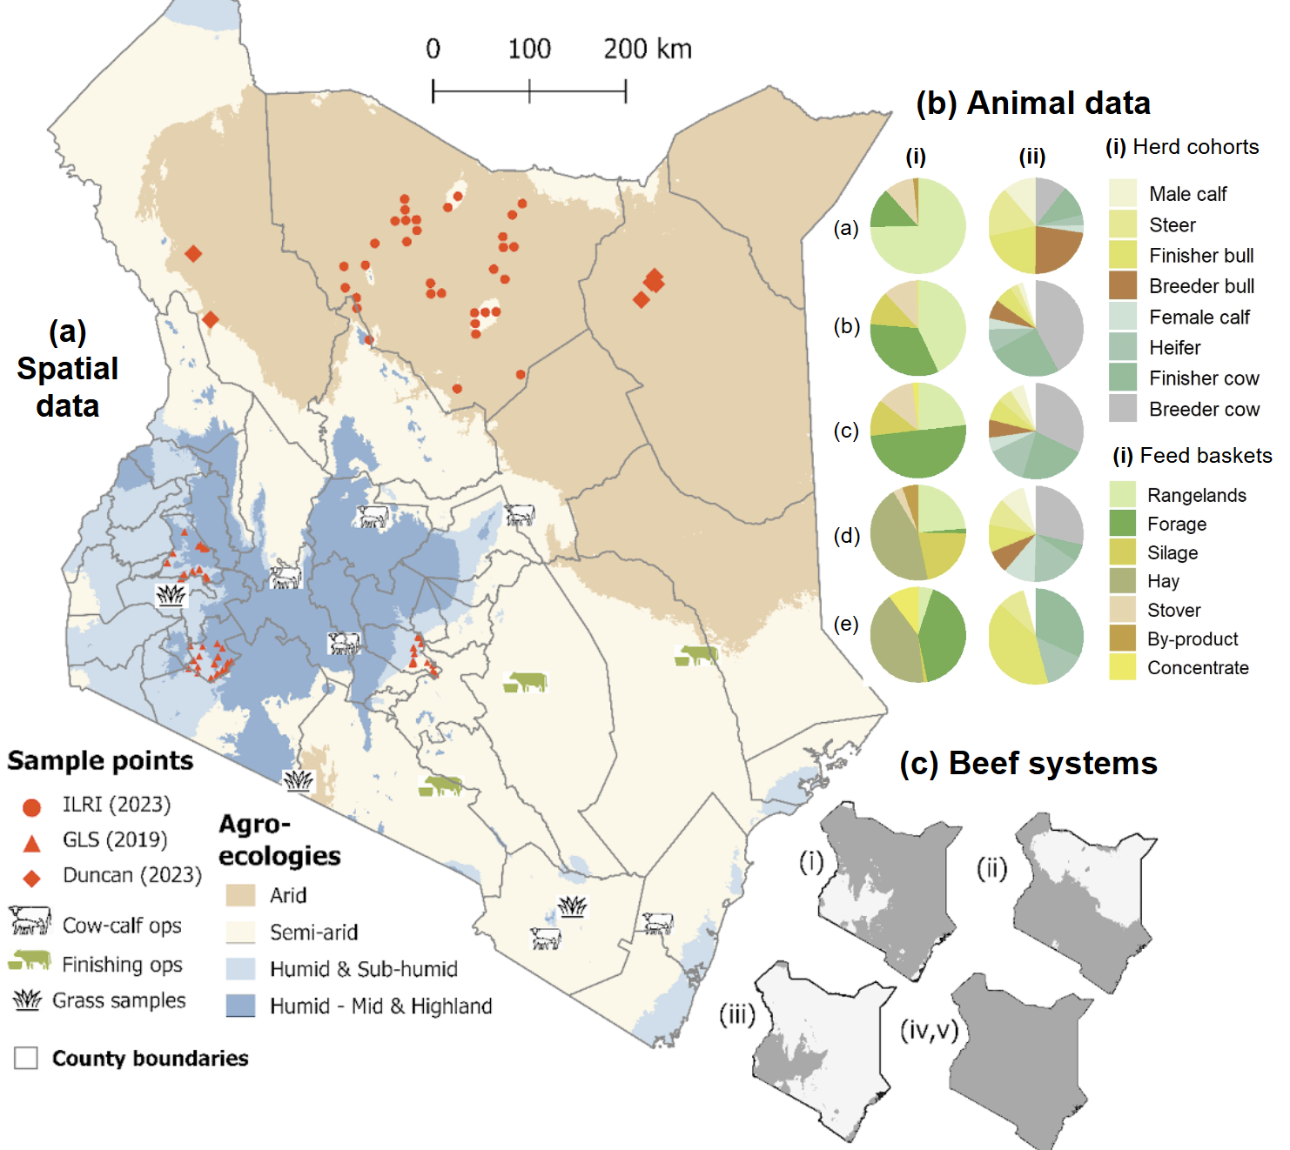
Figure 2: Spatial overview of (a) data collection sites and agro-ecological zones across Kenya (Spatial data), (b) herd structures (% decomposition of herd) and feed compositions (decomposition of diets, DM basis) (a: Pastoral; b: Agro-pastoal, c: Mixed, d: Cow-calf ops, e: Finisher ops) (Animal data), and (c) extent of 5 beef production systems (i: Pastoral; ii: Agro-pastoal, iii: Mixed, iv: Cow-calf ops, v: Finisher ops) (Beef systems).

juvenile cattle for finishing, with relatively high supplement feeding, forage production and conservation (all agroecologies). Consistent with most common breed observance across Kenya’s diverse farm-types/systems, the former three were assumed to raise exclusively Zebu & Boran; the latter two reared exclusively Boran and Exotic (Ngetich et al. 2023, KMT 2025). Subsequent modelling stages (Rumen8, GLEAM-i) and the outcomes of the simulations were the result of the aggregated five farm-types and three breeds, leading to 10 total ‘simulation units’ as follows: (1) Pastoral - Zebu, (2) Pastoral - Boran, (3) Agropastoral - Zebu, (4) Agropastoral - Boran, (5) Mixed - Zebu, (6) Mixed - Boran, (7) Cow calf ops -Boran, (8) Cow calf ops – Exotic beef, (9) Finisher ops - Boran, (10) Finisher ops – Exotic beef.
Farm data: surveys and focus group discussions
Model inputs for feeding and herd structures across systems were drawn from four farm surveys and two focus group discussions, aligning the data sources spatially with the systems which their data drew from (exhaustive breakdown under Table 1 – Agroecological zone). The sources (references cited for the remainder of this study) were: (1) a survey of 340 pastoralist/agro-pastoralist beef farmers in Marsabit county (ILRI 2023), (2) a survey of 121 mixed crop-livestock and semi-intensive beef farmers across semi-arid and humid/sub-humid production systems in west & central Kenya (GLS 2019), a survey of nine commercial beef ranches distributed across all Kenyan agro-ecologies and production systems (APRI 2025), and a second survey of 20 commercial beef finishing operations, distributed across all Kenyan agro-ecologies (KMT 2020). Of the nine beef ranches, six were categorized as Cow-calf ops and three as Finisher ops, parameterizing the same farm-types modelled herein. The focus group discussions (Otieno et al. 2016, Turkana et al. 2016) were conducted in pastoral/agro-pastoral arid & semi-arid regions of north Kenya, using the ‘Feed Assessment Tool’ (FEAST) (Duncan et al. 2023) questionnaire and including a total of 45 farms owning ~114 cattle. The surveys and FGDs informed feed baskets and herd structures per region (Figure 2b and Tables S3 and S4) and were used to interpolate the herd structures from census data (details below).
Cattle populations, cross-border & inter-farm flows
Beef cattle populations were derived from Kenya government census data (KNBS 2025a) at county level for year one of the model simulation (2020). The decomposition according to genotype was derived from census estimates as 36%, 61% and 3% for Zebu, Boran, and Exotic beef, respectively (KNBS 2022) and no adjustments for regional variation were made due to the documented presence of all breed classes in all Kenya’s agro-ecologies (Mwangi et al. 2020, GLS 2019, APRI 2025). Based on total cattle population for respective breeds, quantities assigned per farm type were based on survey/literature figures estimates of percentage of farms corresponding to each of the five types (Table 1). For this, GLS (2019) was used to estimate the proportion of Pastoral and Agro-pastoral farms in humid/sub-humid and humid mid- & highland AEZs; Mwangi et al. (2023) for Pastoral and Agropastoral farms in semi-arid and arid AEZs, and APRI (2025) for Cow-calf ops and Finishing ops across all agro-ecologies. Beef herd population for Baseline were projected per farm-type to 2050 consistent with the system de-lineation and under a ‘middle of the road’ trajectory by FAO (FAO 2019). Reported as the total change relative to base year of 2020, cattle population changes were as follows: -12.6% for Pastoral-Zebu/Boran, +58.7 for Agropastoral-Zebu/Boran and Mixed-Zebu/Boran, whereas for commercial systems, explosive growth rates of +425.7% and +10,109.1% were projected for Cowcalf-Boran/Exotic and Finisher-Boran/Exotic, respectively. Such growth rates based on FAO (FAO 2019) reflect ongoing structural shifts in Kenyan beef production; namely climate-driven animal number declines in pastoral systems (Bogale & Erena, 2022, Yosef et al. 2013), and explosive commercial export and urban-demand driven growth in commercial systems (Mwacalimba et al. 2025).
[herd figure here]

Inter-farm and cross-border flows of animals were accounted for assuming that the balance of domestic sales/purchases plus net imports sum to zero (SM 1.1, Equation S1). Domestic inter-farm flows, representing animals sold pre-culling by Pastoral, Agropastoral, Mixed, or Cow-calf ops (selling farms/pastoralists) to Finisher ops (purchasing farms), were assumed strictly to consist of Boran and Exotic, which represent the predominant breeds finished in Kenyan feedlots or semi-/intensive ranches (KMT 2020). The proportion sold were derived from literature estimates on marketing decisions by respective farm-types, estimated as 26.8%, 12.0%, and 22.7 % for Pastoral and Agro-pastoral (Mwanyumba et al. 2015), Mixed (Bebe et al. 2008), and Cow-calf ops (Otieno et al. 2014), respectively. For cross border flows, net imports of beef animals were assumed to be consistent with the national decomposition (described above) while imports were acquired by any of the Finisher ops (for Boran, Exotic) or non-finishing farms/pastoralists (for Zebu). Net animal imports as a percentage of the total Kenyan beef herd, moreover, were assumed fixed at the base year level, estimated from FAO trade data as 0.35% (FAO 2025d). Under the scenarios, counterfactual figures for the proportion of Boran and Exotic finished on Finisher ops were considered (see 2.3 Scenarios). The disaggregation of beef cattle by main breeds per system and as a fraction of the national beef herd for each scenario are shown in Figure 3.

Feed baskets
Feed baskets, representing the relative proportion of DMI and feeding into Rumen8 and GLEAM-i as described below, were determined jointly from land allocation and feed purchases in the surveys, applying rules governing sub-annual allocation of feeds based on common conservation and seasonal-based practices among Kenya’s beef farmers/pastoralists (see SM 2). The composition of diets across systems were discerned from a combination of surveys (GLS 2019, APRI 2025) and literature (KMT 2020, Mwangi et al. 2020). Five broad feed categories were discerned, in each group assigning species based on the most common type in that group. The groups (bold) and feeds therein (italic) were as follows. Grasslands: perennial tropical grass mixtures representing native Kenyan savannah rangelands (‘Native grass’) (1) (assumed grazed only, not harvested) (1), and a sown, moderately improved but unmanaged grass: ‘Buffel grass‘ (Cenchrus ciliaris) (2); Improved forage: a perennial high quality forage: ‘Kikuyu grass’ (Cenchrus clandestinus) (assumed harvested only, not grazed) (3); Silage: ‘Maize silage’ (Zea Mays) (4); Stover: ‘Maize stover’, either harvested or grazed (5), and Supplements: ‘Maize bran’ (6) and ‘Cottonseed cake’ (Gossypium hirsutum) (7). Nutrient properties of Native grass were sub-divided according to arid, semi-arid, and humid/sub-humid agro-ecologies with parameters derived from field samples collected across Kenya by ILRI-Mazingira (ILRI 2025) (Fig. 2 – Feed sample collection points). Other feed nutrient properties were derived from various sources as summarized in Table S2.
Dry matter intake estimation
As grazed feed intake was not recorded in surveys, residual biomass intake (i.e. other than feed provided/on-offer) was inferred using the neutral detergent fibre (NDF) method (Mertens et al. 1987), based jointly on NDF concentration of the diet (kg kg⁻¹ DM) and bodyweight (BW) (kg) as follows: DMI (kg head⁻¹ day⁻¹) = NDF_Frac_BW x BW / NDF. While Mertens et al. (1987) proposed 1.2% of bodyweight as NDF (i.e. NDF_Frac_BW 0.012), recent work has suggested higher values of 1.35% (Bateki and Dickhoefer, 2019) or higher (Beltrame et al. 2021) better reflect the fibre-intake capacity of African (B. indicus) breeds, as shown by experimental studies (e.g. Siddique et al. 2015). A value of 0.015 was thus used for the predominantly B. indicus Zebu and Boran breeds in this study and a value of 0.014 was used Exotic beef. These values are justified by the good fit observed between literature reported and Rumen8-simulated LWGs reported in the results. From this estimated DMI representing unrestricted (ad libitum) intake, actual feed provided in Rumen8 was scaled downwards to be consistent with projected scarcity of grazed/browsed feed intake per climate scenario (RCPs 4.5 vs. 8.5) based on the coefficients and procedure described below (section 2.4 – Roughage scarcity) (this did not apply to market purchased feeds - maize bran and cottonseed cake, or whole crop silages - maize silage, which are generally not grazed and less subject to localized animal over-population).

2.2.1 Rumen8 software: liveweight gain
Rumen8 is a free and publically available (https://www.rumen8.com.au/) application enabling liveweight prediction and enteric methane estimation (among others) of large ruminants, based on animal genotype and feed mixes from a selection of bulit-in or user specified feed and breed libraries (Morris and Staines and 2022). The software has been tested and applied extensively in East African livestock -- especially dairy systems (SNV 2019). The model was used to simulate liveweight gain and methane production per individual animal, extending from weaning (the model does not include calf/pre-weaning periods) to culling, for each simulation unit, with further disaggregation according to animal cohort and agro-ecology (for which the only distinction is quality of native grasslands). Animal cohorts were defined, for each breed, distinguishing males from females, growing from mature, and for cows, breeding (i.e. animals retained solely for reproduction) vs. finishing (culled upon reaching mature weight). Thus a total of seven animal categories were distinguished. For males: male calves, steers, bulls, and, for females: female calves, heifers, finisher cows, and breeding cows.
Conditions specifying transitions across life stages were based on weaning weights, growth rates, and age at first calving (for cows) as reported in literature and summarized in Table S1. The herd decomposition according to cohorts were derived jointly from surveys (APRI 2025, GLS 2019, ILRI 2023), and literature for respective systems: pastoral/agro-pastoral (Mwanyumba et al. 2015), mixed (Wanjala et al. 2014), and commercial systems (APRI 2025) (data summarized in Table S2).
Rumen8 liveweight gain estimates were first adjusted according to technical coefficients representing disease and heat stress modifiers (as described further under 2.3, 2.4), taking into account heat stress and disease severity. For heat stress, all beef cattle per region were assumed subject to similar heat and humidity parameters; for disease, production parameters were modified based on weighted averages of infected vs. uninfected animals, based on disease prevalence estimates described below. Post-processed LWG, average liveweight, and milk yield per animal category were then fed into GLEAM-i for each cohort and simulation unit and scenario. In order to highlight regional variability of feeding and genotype efficiency, feed conversion efficiency was reported as FCE (kg LWG kg⁻¹ DMI) = Lifetime average liveweight gain (kg hd⁻¹) / Lifetime total DMI (kg).
    - GLEAM-i: Greenhouse gas estimation
GLEAM-i is an interactive online software tool, designed by FAO, to compute regional GHG budgets from livestock production (Macleod et al. 2018a). The tool has been applied in East African dairy (Mottet et al. 2018) and beef systems (Macleod et al. 2018b). GHG emissions are computed in accordance with the Intergovernmental Panel on Climate Change methodology Tier 2 methodology (IPCC 2019). The model however has been adapted to include ‘pre-farm‘ (i.e. feed and fertilizer inputs) emissions not typically considered by IPCC, but included under life cycle assessment (LCA) methodology. In this analysis, total beef system GHG emissions were derived from GLEAM-i and converted to emissions intensities, considering co-product allocation, following LCA guidelines. The LCA scope was ‘cradle-to-slaughterhouse’, reflecting the substantial portion of Kenyan beef cattle slaughtered off-farm, in public or private abattoirs (Alarcon et al. 2017). Emissions associated with transport and processing post-slaughter were excluded. Land use change emissions were omitted, justified given that <10% of Kenyan land cover throughout the ASAL is classified under forest (GOK 2022), suggesting beef contributes negligible deforestation-GHGs. While deforestation is concerning in humid/sub-humid regions of Kenya (Jebiwot et al. 2022), grazing and crop cultivation have been identified as secondary to charcoal and logging as key drivers (Jebiwot et al. 2022, Njora & Yilmaz et al. 2022), justifying the focus on direct GHG emissions only.
Emissions estimates were reported based on groupings as defined in GLEAM-i, but merging energy related CO₂ emissions (including emissions embodied in production, manufacturing, and transport of capital and other farm inputs), given their low relative impact in the Africa context. This resulted in the following six emission groups: enteric fermentation CH₄ (Enteric CH₄), CH₄ from managed or excreted manure (Manure CH₄), N₂O from manure storage systems (Manure N₂O), N₂O from manure excreted on grassland (Grassland N₂O), N₂O from manufacture of fertilizer (Fertilizer N₂O), and Fossil Energy CO₂. Emissions were reported in global warming potentials (kg CO₂ equivalents kg⁻¹ CH₄ and N₂O) following IPCC’s 6th Assessment Report (IPCC 2023), as 27.0, and 273.0 kg CO₂eq kg⁻¹ for CH₄ of non-fossil origin and N₂O respectively. Feed baskets (reported as % total DMI from individual feeds) and herd structures (% of individual cohorts to total herd sizes) are summarized across simulation units in Fig. 2b. An exhaustive summary of animal parameters provided to GLEAM-i (and Rumen8) are included in Table S1.
Mortality rates were derived from a variety of empirical sources representative of modelled breeds across Kenyan systems which, ordered as calves (0-6 months), weaners (post-weaning to maturity) and mature yielded the following values: 16.0, 11.0, 10.0% for Zebu (Rowlands et al. 1994), 6.3, 2.7, and 2.0% for Boran (Ndung’u et al. 2024), and 24.0, 14.0, and 9.0% for Beef c.bred (Maloo et al. 2001). Manure emissions were computed based on weighted average emission factors for respective management systems, following the IPCC (2019a) classification. In Kenyan beef, relevant manure systems are one of either (i) ‘Pasture, range, and paddock’ (PRP) for manure excreted during grazing, (ii) ‘Solid storage’ for manure stored in storage facilities, or (iii) ‘Drylot’ for both feedlot systems as well as manure excreted in bomas, which exhibit comparable emission factors as industrial feedlots (Leitner et al. 2024). For Pastoral & Agro-pastoral systems, a ratio of 50:50 Drylot to PRP was used, given comparable excretion amounts between bomas and grazing in extensive Kenyan livestock systems (Carbonell et al. 2021). For Mixed systems, ratio of 80:20 Solid storage to PRP is used based on estimated grazing (vs. confinement) time from the survey of mixed farming systems (GLS 2019). For Cow-calf ops a ratio of 25:75 Solid storage to PRP was used, reflecting the predominantly grazing based feeding systems of the sample of commercial ranches (APRI 2025). Finally for Finisher ops a ratio of 90:10 Drylot to PRP was used, given the highly intensive nature of most Kenyan finishing operations (APRI 2025, KMT 2020).
    - Co-product allocation, inter-sectoral impacts
GHG estimates from GLEAM were reported using an LCA, considering meat and milk output of the beef herd as sole co-products, defined as kg edible carcass weight (CW) and kg fat and protein-corrected milk (FPCM) respectively. Edible carcass weight was as slaughter weight x dressing percentage, ranging from 0.47-0.50 (Baltussen et al. 2020, Mushi et al. 2020), then multiplied by 0.85 reflecting the fraction of carcass weight as edible meat (N’dungu et al. 2022). FPCM was calculated according to the International Dairy Federation equation (IDF 2015) taking milk composition for respective breeds from the literature (Rege et al. 2001, Kiwuwa et al. 1971). A mass allocation procedure was used, with equal weights to respective co-products, implying allocation factors for meat and milk as kg CW (kg CW + kg FPCM)⁻¹ and kg FPCM (kg CW + kg FPCM)⁻¹ respectively. In addition to this attributional C footprint, GHG emissions from dairy-beef and import substitution were reported, based on the procedure described below.

Table 1: Summary of system de-lineation of Kenya’s beef sector. Agroecological zones (see Figure 2): A = Arid, SA = Semi-arid, HSH = Humid/sub-humid, Arid – Mid & Highland = AMH, Humid – Mid & Highland = HMH. Uses of farm surveys: Feed = feeding practices and dietary composition, Herd = herd structure.
Farm type | Cattle population  (Million head) |  |  | Agro-ecological zones | Data source
 | Breed¹ | Animals - 2020 ² | Animals - 2050³
 |  |  |  |  | Source | Total cattle | Uses
Pastoral | Zebu | 1.27 | 4.23 | A, SA | ILRI (2023),  Duncan et al. (2013) | 79,424 | Feed, Herd
 | Boran | 2.50 | 8.36 |  |  | 114 | Feed
Agro-pastoral | Zebu | 1.27 | 4.23 | SA, HSH, HMH | ILRI (2023),  ,GLS (2019),  Duncan et al. (2013) | -- | Feed, Herd
 | Boran | 3.07 | 7.15 |  | GLS (2019) | 561 | Feed, Herd
Mixed | Zebu | 2.14 | 7.15 | HSH, HMH |  | 121 | Feed, Herd
 | Boran | 0.56 | 1.88
Cow-calf ops⁴ | Boran | 4.10 | 13.68 | All | APRI (2025) | 3,379 | Feed, Herd
 | Exotic beef | 0.98 | 3.28
Finisher ops⁴ | Boran | 1.28 | 4.27 |  |  | 1053
 | Exotic beef | 0.31 | 1.02
1 Predominant breeds pertaining to each sub-sector based on data from Mwangi et al. (2020) and FAO (2018). 2 Based on Kenyan government census cattle populations and assuming (a) that the composition of Zebu to Boran to Beef cross breeds is consistent with national level value of Kenyan census data (KNBS 2022). The disaggregation between farm types was based on GLS (2019) for semi-/subsistence and APRI (2025) for large-scale commercial farms, as described in text. This resulted in 78% and 23% of cattle being categorized under agro-pastoral and Mixed farm types, respectively, in humid agro-ecologies (HSH and HMH) and 85% and 15% as Pastoral and Agro-pastoral, respectively, in the semi-arid agro-ecology (GLS 2019). For large-scale commercial farms, 76% of animals were categorized as Cow-calf ops and 24% as Finishing ops based on cattle populations within respective farm groups (APRI 2025). 3 Based on system-specific trends as described in text. 4 Rear exclusively improved breeds (Boran and Exotic beef) consistent with farm survey (KMT 2020).

Scenarios
Scenario designed explored the range of potential trajectories of GHG-ei, adaptation and productivity determinants in Kenya’s beef systems. As data limitations prevented establishing credible trendlines for some variables, scenarios were narrative-driven, taking account available empirical sources plus authors’ understanding of key moderating (driving /constraining) factors per intervention area. All projections assumed linear trendlines, based on the 2020 (base year) plus the annual increment, summarize as:
Y_{t} = Y_{o} + G $×$t -- Equation (1)
with Y_{o} is the initial period (2020) value of any given intervention-determinant (described below), G as the annualized growth rate, and t as year of the simulation (since 2020). When data gaps prevented credible trendline establishment, base year values were extrapolated to 2050 (for Baseline); scenarios Worst- and Best-case involved respectively pessimistic and optimistic counter-factuals. Baseline growth rates and sources are shown in Table 1; the following sections summarizes the rationale for trendline establishment under Best- and Worst-case.
Breeds: Breed scenarios simulated higher (lower) proportions of Boran in the herd for Best- and Worst-case respectively. Boran breeds could be a key level for climate mitigation & adaptation in Kenya’s beef sector, due to superior thermal and disease resilience over exotics (Asizua et al. 2017) combined with feed conversion efficiency comparable to Bos taurus crossbreds (Asizua et al. 2017). Under Baseline, Boran comprised between -% of the herd across systems by the year 2050 (Fig ). Under Best- and Worst-case, growth rates were upward (downward) revised by 25% and Boran substituted Zebu (in semi-subsistence systems) and Exotic (commercial systems). The resulting final breed proportions were […] across systems (Figure ).
Feeding: As described in introduction, nutrient dense diets promote higher LWG and can reduce CH₄ intensity via ___. Dietary factors relevance for climate-smart beef thus depend on the proportion of supplement feeds and cultivated and conserved forages (i.e. grasses fed as hay; whole plant maize fed as silage). Taking into account forage to system mappings defined above, diet ingredients modified in scenarios included, for forages, Buffel grass in Pastoral & Agro-pastoral systems, Kikuyu grass for Cow-calf ops, Finisher ops in arid/semi-arid agro-ecologies, and Maize silage for Mixed, Cow-calf ops, and Finisher ops in humid/sub-humid systems respectively (recall: concentrates and byproducts of maize bran and cottonseed cake are fed across all agroecologies/systems in Kenya). Increases/decreases in these feeds replaced on a 1:1 basis, lower quality feeds (i.e. stovers and native grasses) depending on the system. Diet projections under Baseline involved a modest 1.5-2.0% annual growth rate in concentrate feeding; a reflection of the contrasting effects of low barriers to adoption (Amuge et al. 2017), but constraints including population pressures and food-crop competition. This modest growth rate is consistent with longitudinal reports of small but significant growth trends in supplement feeding (KDB 2024, Kimenju et al. ) in Kenya. For cultivated forages Baseline assumes no trend as field-reports consistently demonstrate uptake of improved forages and whole plant silages remains negligible in Kenya (Mwenia et al. , Ndah et al, ILRI 2025), due to labour scarcity and mechanization constraints in addition to land competition and degradation (Flores et al. 2024).
Preventive health: Consistent with epidemiology, ECF and FMD among infected cattle were assumed to result in declines in liveweight gain, milk yield, and dry matter intake; percentage declines under each disease were derived from experimental reports (see below). Animal mortality and indirect impacts on fertility were omitted, which was justified as mortality from such diseases is in general <10% in infected cattle (Ngetich et al. 2025, Nthiwa et al. 2019, Bijari et al. 2025). Any reproductive effects moreover are likely to be minor in beef production systems. Intake and productivity impacts, expressed as % differences between infected and uninfected cattle, are summarized in Table , as tabulated from epidemiologic data on East coast fever (Okello-Onen et al. 2003, Dolan 1986, Surve et al. 2023) and foot-and-mouth disease (Senturk et al. 2009, Bijari et al. 2025) in Kenyan or comparable East Africa systems. Treatment interventions involved, for ECF, acaricide (anti-tick treatment) applied once or more weekly and, for FMD, vaccine administration, assumed post-infection (i.e. prophylactic) which represent most plausible and currently used treatments for respective diseases in Kenya (Okello-Onen et al. 2003, Gachohi et al. 2012, Dolan 1986, Senturk et al. 2009). The prevalence of respective diseases were aggregated to respective agro-ecological zones: humid/subhumid and arid/semi-arid and were computed from survey data across sites in Kenya combined with a simple infectious disease accounting model to account for treatment impacts on disease prevalence, described fully in SM __.
Intensive finishing: Finally, the quantity of animals sold for intensive finishing under Baseline were assumed constant at 2020 values (as described above). Under Baseline, 2050 values were assumed same as 2020; Low-end and High-end examined deviations of -/+ 75% (i.e. consistent with other parameters), respectively (Table 2).

Table 2: Methods and sources used in baseline estimates and scenario values for beef system productivity determinants. Agro-ecologies: A = Arid, SA = Semi-arid, H/SH = Humid/sub-humid. Breeds: Z = Zebu, B = Boran, BC = Exotic beef. Farm-types: P = Pastoral, AP = Agro-pastoral, M = Mixed, CC = Cow-calf ops, F = Finisher ops.
Category | Parameter modified (unit) | Agro-ecology | Breed | Farm-type | Baseline trend |  | Parameter value: 2050 vs. 2020
 |  |  |  |  |  |  | Low-end | Baseline | High-end
 |  |  |  |  | Estimation method | Trend (annual)
Secondary finishing | Fraction sold to finishers (%) | All | Z | P, AP, M | Fixed at 2020 | - | 0% | 0% | 0%
 |  | A,SA | B | P, AP |  | - | 7% | 27%¹ | 47%
 |  |  | B, BC | CC |  | - | 6% | 23%² | 40%
 |  | H/SH | B | M |  | - | 3% | 12%³ | 21%
 |  |  | B, BC | CC |  | - | 6% | 23%² | 40%
Genetics | Cattle population (head) | A,SA | Z | All | Breed, system specific estimate (2000-2010)⁴ | 6.8% | -- | -- | --
 |  |  | B, BC |  |  | 13.6% | -- | -- | --
 |  | H/SH | Z |  |  | 7.1% | -- | -- | --
 |  |  | B, BC |  |  | 9.6% | -- | -- | --
Feeding | Concentrates (% DMI) | All | All | All | FAO historical⁵  (2010-2020) | 7.1%^{b} | +110% | +210% | +320%
 | Improved foragesª + conservation (% DMI) |  |  |  | Qualitative inference, expert opinion^{6,7,8,9} | 4.0% | +60% | +120% | +180%
Preventive health | Acaricide  (% treated) | A,SA | All | All | Literature | 1.8% | +30% | +60% | +80%
 |  | H/SH
 | FMD vaccine (% treated) | A,SA | All | All
 |  | H/SH
1 Mwanyumba et al. (2015) 2 Otien et al. (2014) 3 Bebe et al. (2008) 4 Wambugu et al. (2011) 5 FAO (2025a,c) 6 Florez et al. (2024), 7 Creemers (2025), 8 Jones (2025), 9 Katothya et al. (2020).
a Buffel grass, Kikuyu grass, Maize silage.

Table 3 : Coefficients, methods used to account for East coast fever, Foot-and-mouth-disease on beef production for Zebu, Boran and Beef crossbred cattle in Kenya. Breeds: B = Boran, Z = Zebu, BCb = Exotic beef. Scenarios: LE = Low-end, BL = Baseline, HE = High-end.
Disease | Variable impacted | Unit | Impact relative to uninfected  (breed affected) | Scenario | % impact by breed, agro-ecology
 |  |  |  |  | Zebu, Boran |  | Beef c. bred
 |  |  |  |  | A/SA | H/SH | A/SA | H/SH
East coast fever | Dry matter intake | kg hd⁻¹ yr⁻¹ | XX | LE  BL  HE | -26.7  -15.5  -13.9 | -23.8  -11.6  -11.0 | -20.2  -155  -10.8 | -16.3  -11.6  -6.9
 | Liveweight gain |  | -6.3%¹ (B+Z)  -29.1%² (BCb) | LE  BL  HE | -4.1  -2.9  -1.7 | -5.1  -3.9  -2.7 | -19.0  -13.5  -18.1 | -23.5  -18.0  -12.6
 | Milk yield |  | -25.0%³ (All) | LE  BL  HE | -20.2  -15.5  -10.8 | -16.3  -11.6  -6.9 | -20.2  -15.5  -10.8 | -11.6  -16.3  -6.9
Foot-and-mouth-disease | Dry matter intake |  | -3.7%⁴ (All) | LE  BL  HE | -6.5  -4.8  -3.1 | -7.5  -5.8  -4.1 | -7.5  -5.8  -4.1 | -6.5  -4.8  -3.1
 | Liveweight gain |  | -15.0%⁵ (B+Z)  -20.0%⁵ (BCb) | LE  BL  HE | -10.7  -7.9  -5.1 | -12.3  -9.5  -6.7 | -14.3  -10.5  -6.8 | -16.5  -12.7  -9.0
 | Milk yield |  | -9.1%⁴ (All) | LE  BL  HE | -6.5  -4.8  -3.1 | -7.5  -5.8  4.1 | -6.5  -4.8  -3.1 | -7.5  -5.8  -4.1
1 Okello-Onen et al. (2003), 2 Dolan (1986), 3 Surve et al. 2023, 4 Rangga et al. (2026), 5 Senturk et al. (2009), 6 Bijari et al. (2025),

Table 4 : Coefficients, methods used to account for climate impacts (reductions in grazing capacity and heat stress) on production for Kenyan Zebu, Boran and Beef crossbred cattle. Values linked to THI calculated based on every unit above thermal thresholds of 79 and 76, following experimental evidence for Zebu/Boran (Bos indicus) and crossbred cattle, respectively.
Climate impact | Variable(s) impacted | Unit | Estimation method | RCP | % impact by farm-type & breed
 |  |  |  |  | Pastoral | Agro-pastoral | Mixed | Cow-calf ops,  Finisher ops
 |  |  |  |  | Zebu, Boran |  |  | Boran | Beef c. bred
Grazing capacity | Forages, liveweight gain, milk yield, enteric CH₄ | Various | Rumen8 | 4.5 | unreported
 |  |  |  | 8.5
Heat stress | Dry matter intake |  | -2.9%¹ THI⁻¹ | 4.5 | -0.9 | -0.6 | -0.1 | -0.1 | -3.0
 |  |  |  | 8.5 | -4.1 | -1.8 | -0.4 | -3.5 | -7.2
 | Liveweight gainª |  | -8.8%² THI⁻¹ | 4.5 | -2.7 | -1.7 | -0.3 | -2.3 | -9.1
 |  |  |  | 8.5 | -12.6 | -5.3 | -1.4 | -10.5 | -21.8
 | Milk yieldª |  | -0.5%² THI⁻¹ | 4.5 | <-0.0 | <-0.0 | <-0.0 | -0.01 | -0.1
 |  |  |  | 8.5 | -0.7 | -0.3 | -0.1 | -0.01 | -1.2
1 Martel et al. (2021), 2 Hasan et al. (2026)
ª Cumulative impacts over 14- and 5-day periods for liveweight gain and milk yield, respectively, as reported by Hasan et al. (2026)

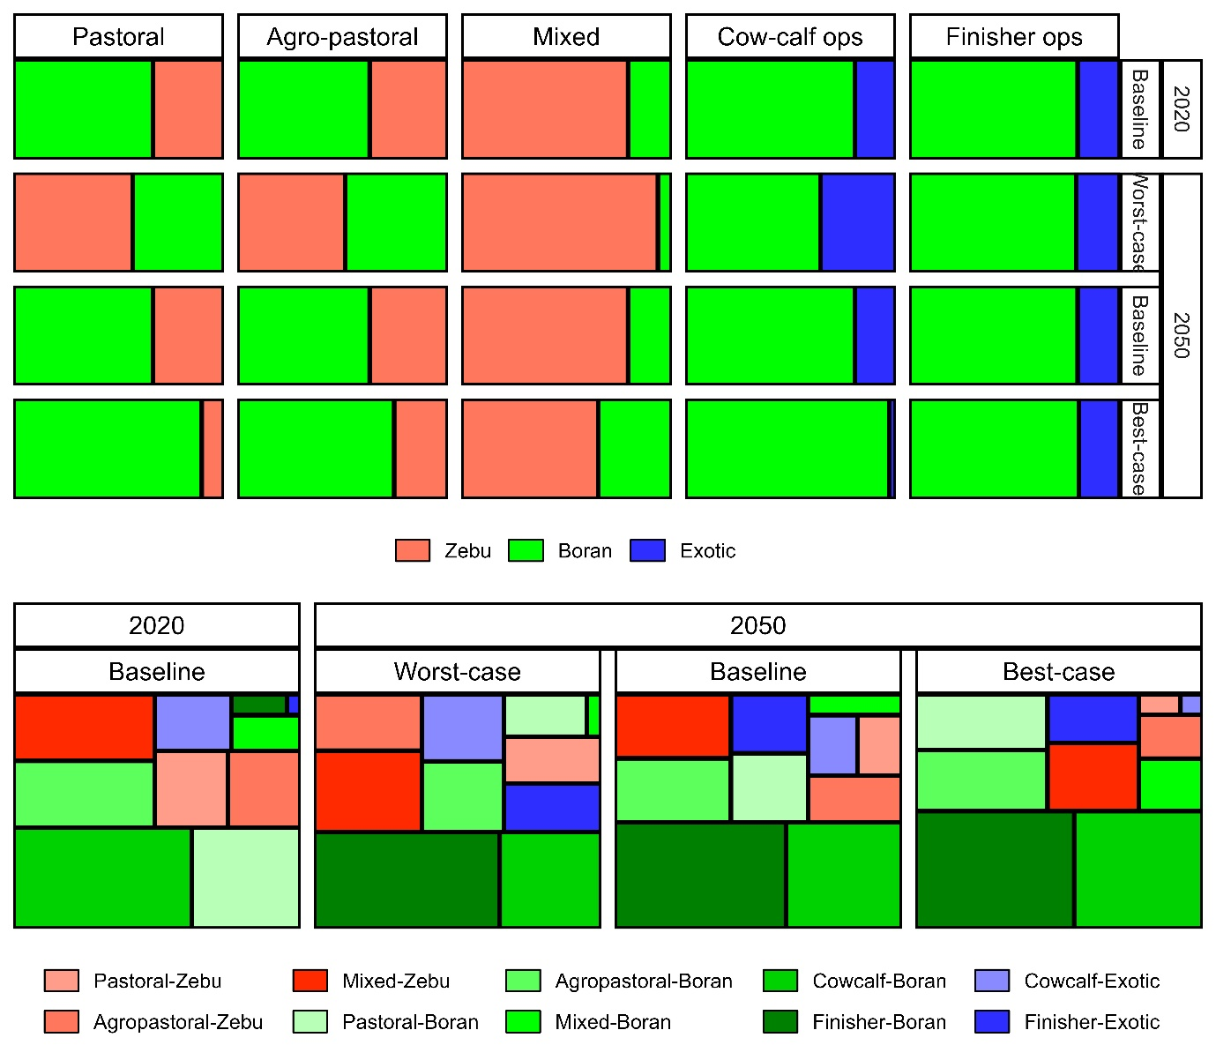

Figure 3:
2.4 Roughage scarcity and heat stress: climate impacts
Heat stress and grazing capacity-driven declines in roughage availability represent two ongoing climate-impacts in African livestock production with regionally-varying severity, expected to worsen in coming years. Increases in heat and humidity above ‘thermal thresholds’ specific per breed affect feed intake, liveweight gain, and milk yield (Angel et al. 2018) (among others); climate-driven declines in rangeland productivity may lead to deficits in roughage biomass, impacting all major productive and environmental outcomes. Given the documented current and predicted impacts of such in Kenya (Duku et al. 2021) and East Africa generally (Rahimi et al. 2021), roughage scarcity (RS) and heat stress (HS) were accounted for by applying technical coefficients from literature to model inputs/outputs pre- and post- Rumen8 simulations respectively.
Roughage scarcity
Roughage availability pre-feeding simulation was modified to reflect estimated shortages driven by future declines in livestock carrying capacity. RS was estimated at grid-cell level using projected biomass yield data and cattle population density projections consistent with projections described above (extended description in SM 1.3 – Roughage scarcity). Based on this, RS, reported as total supply of roughage biomass to animal requirements per agro-ecology and under respective RCPs were as follows: arid: >1 for both RCPs 4.5 & 8.5; semi-arid: 0.965 for RCP 4.5, 0.969 for RCP 8.5; humid/sub-humid: 0.994 for RCP 4.5, 0.821 for RCP 8.5. Note that a RS > 1 implies roughage availability exceeds demand by cattle, implying no limitation. Roughage availability under Rumen8 simulations were implemented by a decline in roughage proportional to the RS coefficient; because the outputs are embedded in the Rumen8 simulations, the magnitude of the impacts are unreported (there is no baseline for comparison).
Heat stress
Similar to disease impacts as described above, DMI, MY, and LWG were modified post-feeding simulation, applying technical coefficients per respective genotype -- Bos indicus (Zebu, Boran) or crosses (Exotic beef) (Table 4 – Estimation method). The coefficients represented impacts of heat and humidity stress on DMI following experimental estimates by Martel et al. (2021) for DMI and Hasan et al. (2026) for MY and LWG. Declines in each variable were then estimated per breed/farm-type sub-aggregation from Temperature and Humidity (THI) index values estimated at gridcell level from ‘Coupled model intercomparison’ 6 (CCCS 2023) projections under RCPs 4.5 and 8.5 respectively (extended description under SM 1.4 – Heat stress). The results, expressed as % declines in DMI, LWG, and MY per breed/farm-type sub-aggregation are summarized in Table 4.

Uncertainty
Estimation error
For the main model outputs: total and intensity of GHG emissions and feed conversion efficiency (the latter, depending jointly on DMI and LWG), uncertainty was reported according to IPCC protocols as 95% confidence intervals, based on input-parameter uncertainty expressed as coefficient of variation (%) (CV) (IPCC 2019a). As raw GHGs were estimated jointly from GLEAM-i and Rumen8, themselves relying on default IPCC emission factors, CVs for each source were assigned based on the ‘Tier’ of the estimation procedure, assumed to take values of 30, 20, and 10% for Tiers 1, 2, and 3 respectively. Thus, enteric fermentation - estimated by Rumen8 using mechanistic physiology models based region-specific breed and feed data -- took a CV of 10%. Other GLEAM-I derived GHGs took either 20% (Tier 2) or 30% (Tier 1) CVs.
Outputs depending on multiple variables (GHG-ei, FCE) were accounted following IPCC guidelines for error propagation (IPCC 2019b). Under this, the ‘arithmetic’ rule of error propagation computes total uncertainty as the sum of uncertainty of sub-components. Non-GHG outputs of meat (computed from liveweight gain), milk, LWG, were assumed to have CVs of 10% consistent with Tier 3 estimation methods of IPCC (i.e. given these either inputs/outputs of Rumen8, which runs on breed and feed libraries specific to the study area). DMI CVs were set as 20%, a conservative value derived from the reported mean squared percent prediction error of 29% (Bateki and Dickhoefer, 2019) for which our DMI intake estimation method was based.

Parameter sensitivity
- Main categories of parameters to target summarized in table
- All parameter sensitivity involves changing one variable while holding all others constant. Exceptions to this are parameters defined as ratios; in these cases, the percentage increase/decrease in one parameter involves an equivalent decrease/increase in another parameter (this extends to ‘Breeds’, ‘Herd’, and ‘Farm-types’ in the table)
- Because all parameters under Baseline are estimated from survey/census/literature, the sensitivity analysis assumes relatively small (20-30%) changes. Two exceptions to this are ‘Farm machinery’ and ‘Manure’ for which GLEAM estimates/emission factors may differ widely from the situation on farm
- Sensitivity scenarios are implemented only for the ‘Baseline’ (i.e. we do not test the impacts of sensitivity on outcome parameters under Worst-case or Best-case scenarios – this would lead to a proliferation of outcomes to test)

Table: Summary of implementation methods for sensitivity analysis.
Category | Description/parameter(s) impacted | Impactª
 | Populations & demographics
Herd size | Total beef cattle population. | +/- 20%
Breeds | Ratio of given breed within herd (Zebu, Boran, Beef c.bred) | +/- 20%
Herd | Ratio of finishing to reproductive animals. | +/- 20%
Farm-types | Ratio of given farm-type among population. | +/- 20%
 | Animal productivity/ constraints
Feed conversion efficiency | Feed conversion efficiency (per breed). | +/- 20%
Lifecycle duration | Time from birth to slaughter. | +/- 30%
Disease burden | Declines in Liveweight gain, milk yield, dry matter intake | +/- 20%
Heat stress |  | +/- 20%
 | Management
Farm machinery | Quantity of machinery on-farm. | +/- 200%
Manure system | Percent managed per system | +/- 50%
ª Relative to Baseline scenario. ^{b} One simulation each for + and -

3.0 Results

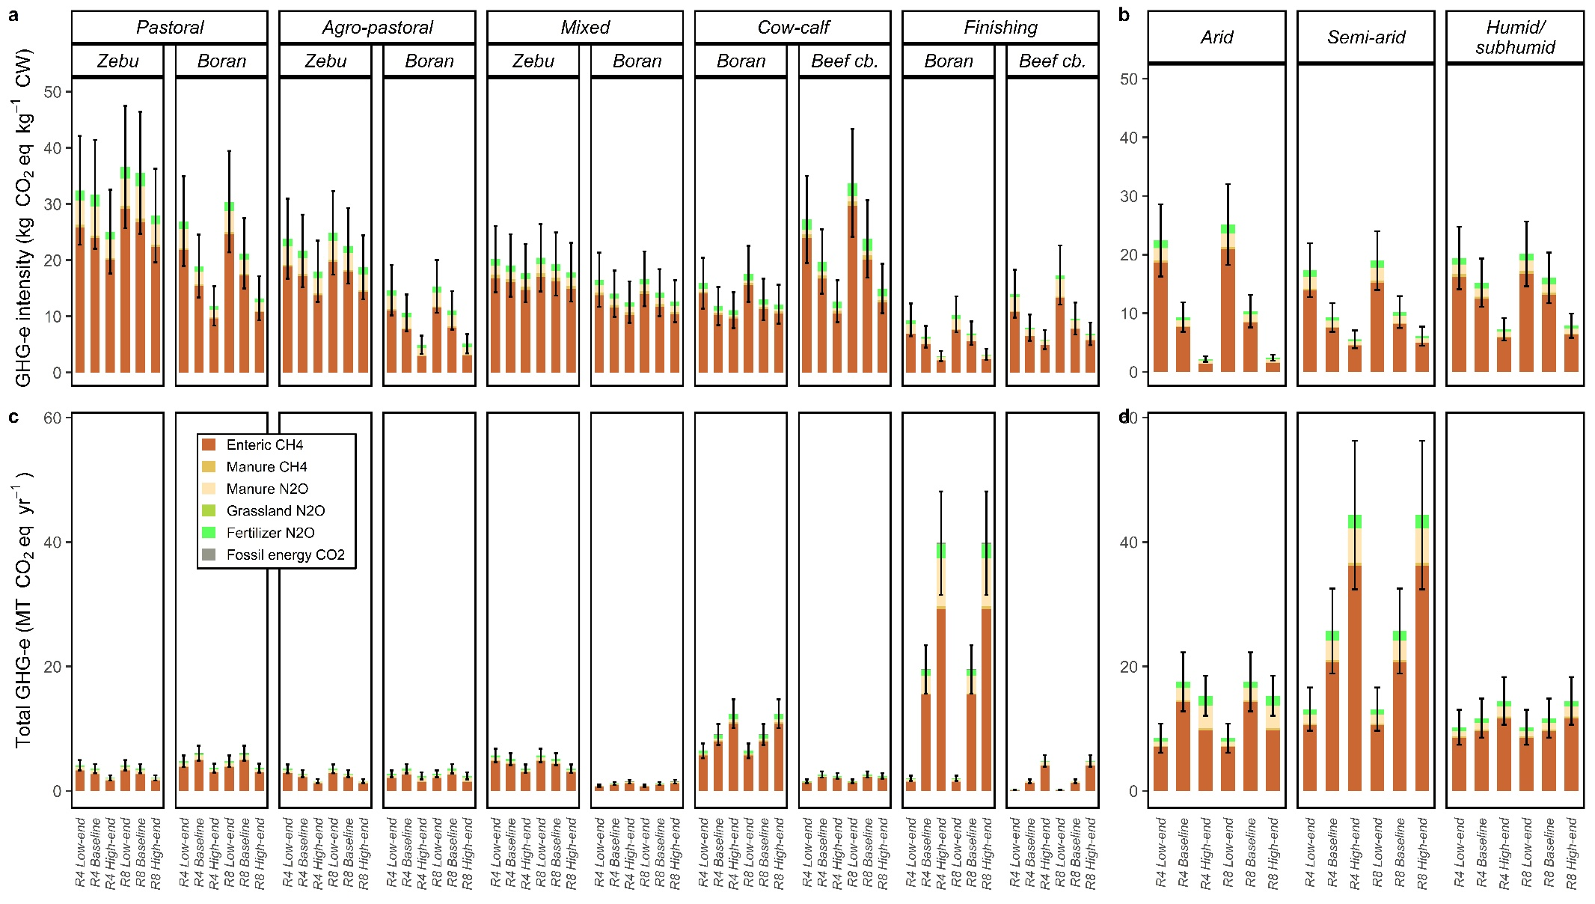

Figure 3: Greenhouse gases as intensities (a,b) in kg CO₂eq kg⁻¹ CW and total (c,d) in MT CO₂eq yr⁻¹ for Kenya’s main beef production systems under RCP 4.5 (‘Middle of the road’) climate future. GHGs disaggregated respectively by farm types plus breed (a,c) and agro-ecology (b,d). Error bars represent 95% confidence interval on estimated emissions.

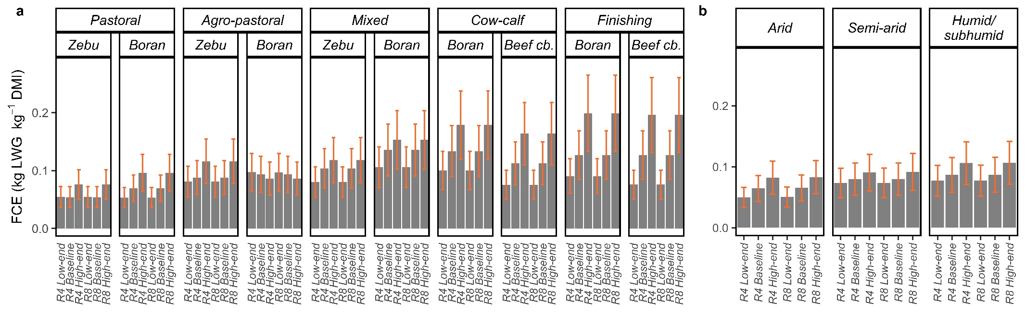

Figure 4: Feed conversion efficiency (FCE) estimates as kg liveweight gain per kg dry matter intake for Kenyan beef production systems under RCP-4.5 (‘Middle of the road’) climate future. FCE indicators disaggregated respectively by farm types plus breed (a), agro-ecology (b), and country (c). Error bars represent 95% confidence interval based on error margins for dry matter intake and animal liveweight gain.

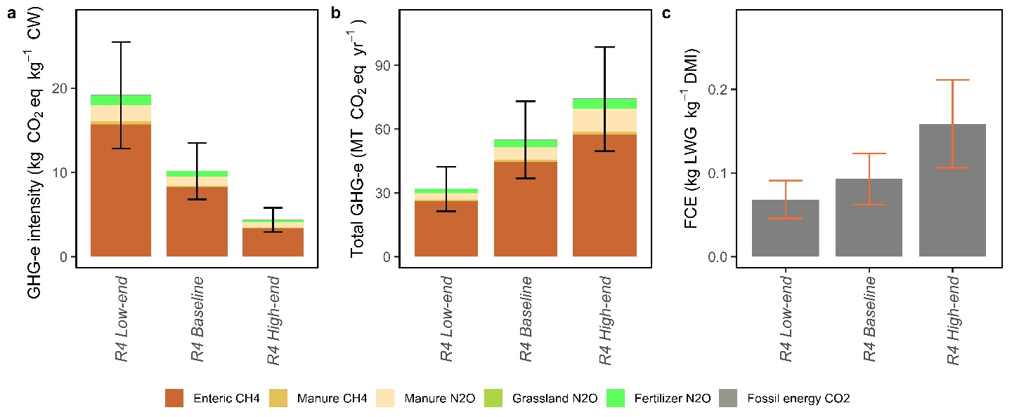
Figure: National level results. Panels show greenhouse gases as intensities (a) in kg CO₂eq kg⁻¹ CW and total in MT CO₂eq yr⁻¹ (b) and feed conversion efficiency (c) as kg LWG kg⁻¹ DMI under RCP 4.5 (‘Middle of the road’) climate future. Error bars represent 95% confidence intervals.

References
Abong’o, D. A., Welimo, M. J., & Wandiga, S. O. (2022). Types and Classification of Acaricides used and Challenges faced by livestock farmers in Kajiado West Sub County, Kajiado, Kenya. Int. J. Sci. Res. Sci. Eng. Technol., 4099, 189–201.
Alarcon, P., Fèvre, E. M., Murungi, M. K., Muinde, P., Akoko, J., Dominguez-Salas, P., Kiambi, S., Ahmed, S., Häsler, B., & Rushton, J. (2017). Mapping of beef, sheep and goat food systems in Nairobi — A framework for policy making and the identification of structural vulnerabilities and deficiencies. Ag. Sys. 152, 1–17.
Angel, S. P., Amitha, J. P., Rashamol, V. P., Vandana, G. D., & Savitha, S. T. (2018). Climate Change and Cattle Production: Impact and Adaptation. Journal of Veterinary Medicine and Research, 5(4).

MacLeod, M., Eory, V., Wint, W., Shaw, A., Gerber, P. J., Cecchi, G., Mattioli, R., Sykes, A., & Robinson, T. (2018). Assessing the Greenhouse Gas Mitigation effect of removing bovine trypanosomiasis in Eastern Africa. Sustainability (Switzerland), 10(5).

CABI. (2019). Boran cattle. CABI Digital Library. doi: https://www.cabidigitallibrary.org/doi/full/10.1079/cabicompendium.91611

APRI (Agro-pastoral Resilience Initiative). (2025). Survey of Kenyan Beef ranches. 2025.
Asizua, D., Mpairwe, D., Kabi, F., Mutetikka, D., Hvelplund, T., Weisbjerg, M. R., & Madsen, J. (2017). Effects of grazing and feedlot finishing duration on the performance of three beef cattle genotypes in Uganda. Livestock Science, 199, 25–30.
Baltussen, W., van Berkum, S., Dijkxhoorn, Y., Helmes, R., Özkan Gülzari, Ş., Vellinga, T., Massawe, G. D., Galgani, P., Borniotto, D., van den Elzen, F., & Smith, T. (2007). Traditional livestock systems in Tanzania: An application of the TEEB framework. UN Environment Programme. 97 pp.
Bateki, C. A., & Dickhoefer, U. (2019). Predicting dry matter intake using conceptual models for cattle kept under tropical and subtropical conditions. J. An.Sci. 97(9), 3727–3740.
Beauchemin, K. A., Janzen, H. H., Little, S. M., McAllister, T. A., & McGinn, S. M. (2011). Mitigation of greenhouse gas emissions from beef production in western Canada - Evaluation using farm-based life cycle assessment. Animal Feed Science and Technology, 166–167, 663–677.
Bebe, B. O. (2008). Assessing potential for producing dairy replacements under increasing intensification of smallholder dairy systems in the Kenya highlands. Livestock Research for Rural Development, 20(2).
Beltrame, R. J. A., Bateki, C. A., & Dickhoefer, U. (2021). Predicting voluntary dry matter intake of Bos indicus cattle: a case for conceptual models. 2021 Tropentag conference report.
Bijari, M., Sadeghi-Sefidmazgi, A., Ansari-Lari, M., & Ghaffari, M. H. (2025). Productivity, reproduction and economic losses due to foot-and-mouth disease (FMD) in Iranian Holstein cows. Prev. Vet. Med., 238, 106471.
Bronsvoort, de Clare B. M., Thumbi, S. M., Poole, E. J., Kiara, H., Auguet, O. T., Handel, I. G., Jennings, A., Conradie, I., Mbole-Kariuki, M. N., Toye, P. G., Hanotte, O., Coetzer, J. A. W., & Woolhouse, M. E. J. (2013). Design and descriptive epidemiology of the Infectious Diseases of East African Livestock (IDEAL) project, a longitudinal calf cohort study in western Kenya. BMC Vet. Res. 9.
Bunning, H., & Wall, E. (2022). The effects of weather on beef carcass and growth traits. Animal 16(11).
Carbonell, V., Merbold, L., Díaz-Pinés, E., Dowling, T. P. F., & Butterbach-Bahl, K. (2021). Nitrogen cycling in pastoral livestock systems in Sub-Saharan Africa: knowns and unknowns. Ecol. App. 31(6).
Castonguay, A. C., Polasky, S., H. Holden, M., Herrero, M., Mason-D’Croz, D., Godde, C., Chang, J., Gerber, J., Witt, G. B., Game, E. T., A. Bryan, B., Wintle, B., Lee, K., Bal, P., & McDonald-Madden, E. (2023). Navigating sustainability trade-offs in global beef production. Nat. Sustain. 6(3), 284–294.
Chang-Fung-Martel, J., Harrison, M. T., Brown, J. N., Rawnsley, R., Smith, A. P., & Meinke, H. (2021). Negative relationship between dry matter intake and the temperature-humidity index with increasing heat stress in cattle: a global meta-analysis. International Journal of Biometeorology, 65(12).
Chen, X., Tao, T., Zhou, J., Yu, H., Guo, H., & Chen, H. (2023). Simulation and Prediction of Greenhouse Gas Emissions from Beef Cattle. Sustainability (Switzerland), 15(15).
Chimbevo, L. M., Atego, N. A., Oshule, P. S., Mapesa, J., Essuman, S., Nderitu, J. H., Asamba, M. N., & Ngeny, C. (2021). The Role and Sustainability of Community-based County Government Funded Agricultural Infrastructure Projects: A Case of Community Cattle Dips and Acaricides Use in Kilifi, Kajiado and Nakuru Counties. J. Agric. Ecol. Res. Int., 22, 26–36.
Copernicus Climate Change Service (C3S) (2023): Gridded monthly climate projection dataset underpinning the IPCC AR6 Interactive Atlas. Copernicus Climate Change Service (C3S) Climate Data Store (CDS).
CRPK (Climate Risk Profile: Kenya). (2021). The World Bank Group. Washington, DC. 32 pp.
D’aurea, A. P., da Silva Cardoso, A., Guimarães, Y. S. R., Fernandes, L. B., Ferreira, L. E., & Reis, R. A. (2021). Mitigating greenhouse gas emissions from beef cattle production in brazil through animal management. Sustainability (Switzerland), 13(13).
Dabasso, B. H., Wasonga, O. V., Irungu, P., & Kaufmann, B. (2019). Stratified Livestock Production adds value to pastoral cattle: evidence from the drylands of Kenya. Bull. Anim. Health Prod. Af. 67(1), 101–114.
Dolan, T. T. (1986). Chemotherapy of East Coast fever: The long term weight changes, carrier state and disease manifestations of parvaquone treated cattle. J. Comp. Pathol., 96(2), 137–146.
Duku, C., Diro, G. T., Demissie, T., & Dawit, S. (2025). Climate change impacts livestock carrying capacity in East Africa. Regional Environmental Change, 25(3).
Duncan, A. J., Lukuyu, B., Mutoni, G., Lema, Z., & Fraval, S. (2023). Supporting participatory livestock feed improvement using the Feed Assessment Tool (FEAST). Ag. Sust. Dev. 43(2).
Duthie, C. A., Haskell, M., Hyslop, J. J., Waterhouse, A., Wallace, R. J., Roehe, R., & Rooke, J. A. (2017). The impact of divergent breed types and diets on methane emissions, rumen characteristics and performance of finishing beef cattle. Animal 11(10), 1762–1771.
FAO & New Zealand. (2017). Options for low-emission development in the Kenya dairy sector: reducing enteric methane for food security and livelihoods. FAO & New Zealand Agricultural Gas Research Centre. 43 pp.
FAO (1996). FAO Soils Bulletin 73. AGRO-ECOLOGICAL ZONING.
FAO (Food and Agriculture Organization of the United Nations). (2025a). FAOSTAT Production: Crops and Livestock Products. Accessed at [https://www.fao.org/faostat/en/#data/QCL]. Accessed September 2025.
FAO. (2018). Kenya cattle and poultry sectors. Africa Sustainable Livestock 2050: Cattle and Poultry Sectors. 13 pp.
FAO. (2025a). FAOSTAT Production data: Crops and Livestock Products. [https://www.fao.org/faostat/en/#data/QCL]. Accessed September 2025.
FAO. (2025a). FAOSTAT Production data: Crops and Livestock Products. [https://www.fao.org/faostat/en/#data/QCL]. Accessed September 2025.
FAO. (2025b). FAOSTAT Trade: Crops and Livestock Products. Accessed at [https://www.fao.org/faostat/en/#data/TCL]. Accessed September 2025.
FAO. (2025c). FAOSTAT Trade: Crops and Livestock Products. Accessed at [https://www.fao.org/faostat/en/#data/FBS]. Accessed December 2025.
FAO. (2025d). FAOSTAT Trade: Crops and Livestock Products. Accessed at [https://www.fao.org/faostat/en/#data/FBS]. Accessed December 2025.
Florez, J. F., Karimi, P., Paredes, J. J. J., Ángel, N. T., & Burkart, S. (2024). Developments, bottlenecks, and opportunities in seed markets for improved forages in East Africa: The case of Kenya. Grassland Research, 3(1).
Gachohi, J., Skilton, R., Hansen, F., Ngumi, P., & Kitala, P. (2012). Epidemiology of East Coast fever (Theileria parva infection) in Kenya: Past, present and the future. Parasites and Vectors, 5(1), 1.
GLS (Greening Livestock Survey) (2019). International Livestock Research Institute. [Accessible at https://data.ilri.org/portal/dataset/ greeninglivestock]
GOK (Government of Kenya). (2022). County Integrated Development Plans 2023-2037. [Accesed at https://maarifa.cog.go.ke/taxonomy/term/22]
GOK (Government of Kenya.) (2017). Kenya Climate Smart Agriculture Strategy: 2017-2026. 53 pp.
Hasan, F. M., Chlingaryan, A., Thomson, P. C., Clark, C. E. F., Islam, M. R., & Lomax, S. (2026). Impact of heat stress on cattle systems: Responses of production metrics to thermal stress. Computers and Electronics in Agriculture, 240.
Heo, J., Bugenyi, A. W., Song, K., Shin, D., & Lee, H. (2025). Coupling emission intensity with production efficiency in global beef production. J. Clean. Prod. 523 (140632).
Herrero, M., Havlík, P., Valin, H., Notenbaert, A., Ru, M. C., & Thornton, P. K. (2013). greenhouse gas emissions from global livestock systems. Proc. Natl. Acad. Sci. 110 (52).
IDF (International Dairy Federation) (2015). A Common Carbon Footprint Approach for the Dairy Sector: The IDF Guide to Standard Life Cycle Methodology.
ILRI (International Livestock Research Institute). (2023). Index Based Livestock Insurance (IBLI) Marsabit Household Survey Data: Rounds 1-7. ILRI
IPCC. (2019). Chapter 3: Uncertainties. In: 2019 Refinement to the 2006 IPCC Guidelines for National Greenhouse Gas Inventories [Eggleston, H.S., L. Buendia, K. Miwa, T. Ngara, and K. Tanabe (eds.)]. IPCC, Geneva, Switzerland.
IPCC. (2019).Refinement to the 2006 IPCC Guidelines for National Greenhouse Gas Inventories, Calvo Buendia, E., Tanabe, K., Kranjc, A., Baasansuren, J., Fukuda, M., Ngarize S., Osako, A., Pyrozhenko, Y., Shermanau, P. and Federici, S. (eds). Published: IPCC, Switzerland
IPCC. (2023). Climate Change 2023: Synthesis Report. Contribution of Working Groups I, II and III to the Sixth Assessment Report of the Intergovernmental Panel on Climate Change [Core Writing Team, H. Lee and J. Romero (eds.)]. IPCC, Geneva, Switzerland, pp. 35-115,
Jayne, T. S., & Sanchez, P. A. (2021). Agricultural productivity must improve in sub-Saharan Africa. Science 372(6546), 1045–1047.
Jebari, A., Takahashi, T., Lee, M. R. F., Collins, A. L., Coleman, K., Carswell, A., Segura, C., Cardenas, L., & McAuliffe, G. A. (2025). Carbon footprints of greenhouse gas mitigation measures for a grass-based beef cattle finishing system in the UK. International Journal of Life Cycle Assessment, 30(4), 654–667.
Jeelani, R., Konwar, D., Khan, A., Kumar, D., Chakraborty, D., & Brahma, B. (2019). Reassessment of temperature-humidity index for measuring heat stress in crossbred dairy cattle of a sub-tropical region. J. Therm. Bio. 82, 99–106.
Jiyana, S. T., Ratsaka, M. M., Leeuw, K. J., & Mbatha, K. R. (2022). Impacts of graded dietary fiber levels on feed efficiency and carbon footprint of two beef breeds. Lives. Sci.258.
Katothya, G. M., Kilelu, C. W., Sikumba, G., & van der Lee, J. (2020). Emerging private extension and advisory services models in the Kenyan agrifood sector: Selected case studies. Wageningen University and Research. Kenya Report. Wageningen. 1-66 pp.
Kearney, M., O’Riordan, E. G., Byrne, N., Breen, J., & Crosson, P. (2023). Mitigation of greenhouse gas emissions in pasture-based dairy-beef production systems. Ag. Sys. 211.
Kibore, B., Gitao, C. G., Sangula, A., & Kitala, P. (2013). Foot and mouth disease sero-prevalence in cattle in Kenya. J. Vet. Med. Anim. Heal., 5(9), 262–268.
Mugambi, J. M., Wesonga, F. D., & Ndungu, S. G. (2012). Ticks and tick-borne disease control in a pastoral and an agro-pastoral farming systems in Kenya. Livest. Res. Rural Dev., 24(5).
Kidake, B. K., Manyeki, J. K., Kubasu, D., & Mnene, W. N. (2016). Promotion of range pasture and fodder production among the pastoral and agro-pastoral communities in Kenyan rangelands: Experiences and lessons learnt. Lives. Res. Rur. Dev. 8(28).
Kiggundu, N., Ddungu, S. P., Wanyama, J., Cherotich, S., Mpairwe, D., Zziwa, E., Mutebi, F., & Falcucci, A. (2019). Greenhouse gas emissions from Uganda’s cattle corridor farming systems. Ag. Sys. 176.
Kiplagat, M. D. (2025). Evaluation of breed suitability, productivity, and profitability of smallholder dairy cattle production system in Kenya. Doctoral Thesis. Jomo Kenyatta University of Agriculture and Technology. 131 pp.
Kiwuwa, G. H., & Kyomo, M. L. (1971). Milk Composition and Yield Characteristics of Mpwapwa Cattle. E. Af. Agri. For. J. 36(3), 290–295.
KMT (Kenya Markets Trust). (2020). A mapping and analysis of livestock fattening and finishing enterprises and business models in Kenya. Survey Report. 62 pp.
KNBS (2022). Census of commercial and institutional farms and specialty crops. Kenya Ministry of Agriculture, Livestock, and Fisheries. 134 pp.
KNBS (Kenya National Bureau of Statistics). (2025a). Livestock statistics 2020. [Accessed at https://nipfn.knbs.or.ke/download/livestock-statistics-2020/] [Accessed June 15 2025].
KNBS (2025b). Livestock statistics 2018-2021. [https://nipfn.knbs.or.ke/download/livestock-statistic-2018-2021/] [Accessed September 24 2025].
Leitner, S. M., Carbonell, V., Mhindu, R. L., Zhu, Y., Mutuo, P., Butterbach-Bahl, K., & Merbold, L. (2024). Greenhouse gas emissions from cattle enclosures in semi-arid sub-Saharan Africa: The case of a rangeland in South-Central Kenya. Ag. Ecosys. & Environ. 367.
MacLeod, M. J., Vellinga, T., Opio, C., Falcucci, A., Tempio, G., Henderson, B., Makkar, H., Mottet, A., Robinson, T., Steinfeld, H., & Gerber, P. J. (2018). Invited review: A position on the Global Livestock Environmental Assessment Model (GLEAM). Animal 12, 2, 383–397.
Maichomo, M., Wachira, A., Olum, M., Gathumbi, J., Mutua, J., Waiguru, S., Jesang, A., & Wesonga, H. (2024). Status on use and delivery of foot and mouth and newcastle vaccines in Kenya. East African Journal of Science, Technology, and Innovation, 5(2), 1–15.
MALF (Ministry of Agriculture Livestock and Fisheries). (2023). Strategic Plan 2018-2022. Kenya State Department for Livestock. 108 pp.
Maloo, S. H., Rowlands, G. J., Thorpe, W., Gettinby, G., & Perry, B. D. (2001). A longitudinal study of disease incidence and case-fatality risks on small-holder dairy farms in coastal Kenya. Preventive Veterinary Medicine, 17–29.
McAtee, T. B., Renter, D. G., Betts, N. B., & Cernicchiaro, N. (2025). Pens of commercial feedlot cattle with better health and performance have lower estimated greenhouse gas emissions intensity. TAS 9.
Mchau, K. W., Syrstad, O., & Kifaro, G. C. (2006). Performance of Boran and Crossbred Cattle for Beef Production Under Ranch Conditions in Tanzania: 1.Gestation Length and Growth to 36 Months. Tanz. J. Agri. Sci. 7(2), 67–76.
Melaku, M. (2019). Beef cattle fattening practices, constraints, and future potentials in Ethiopia: a review. Anim. Res. Int. 16(2), 3401–3411.
Mertens, D. R. (1987). Predicting intake and digestibility using mathematical models of ruminal digestion. J. Ani. Sci. 64, 1548–1558.
Morris, R., & Staines, M. (2023). Rumen8 User Guide. Rumen8 Nutrition Pty Ltd. 247 pp.
Mugambi, J. M., Wesonga, F. D., & Ndungu, S. G. (2012). Ticks and tick-borne disease control in a pastoral and an agro-pastoral farming systems in Kenya. Livestock Research for Rural Development, 24(5).
Mushi, D. E., Eik, L. O., Bernués, A., Ripoll-Bosch, R., Sundstøl, F., & Mo, M. (2014). Reducing GHG Emissions from Traditional Livestock Systems to Mitigate Changing Climate and Biodiversity. In Sustainable Intensification to Advance Food Security and Enhance Climate Resilience in Africa. Springer. 343-365 pp.
Mwangi, V., Owuor, S., Kiteme, B., & Giger, M. (2020). Beef production in the rangelands: A comparative assessment between pastoralism and large-scale ranching in Laikipia county, Kenya. Agriculture 10(9), 1–15.
Mwanyumba, P. M., Wahome, R. W., MacOpiyo, L., & Kanyari, P. (2015). Livestock herd structures and dynamics in Garissa County, Kenya. Past. 5(1).
Mwilawa, A. J., Gurmu, E. B., Weisbjerg, M. R., Laswai, G. H., Poole, J., & Arndt, C. (2025). Animal performance and methane emissions in feedlot vs, traditional pastoral systems with concentrate supplementation for Tanzanian Short Horn Zebu and Boran cattle. Past. 15.
Ndung’u, C., Tura, I., Muema, L., Kemboi, F., Mwangi, P., Kamau, P., Tarus, P., Owiro, E., & Mghanga, S. (2024). Mortality rates among improved boran beef cattle and their crosses from birth to two years under ranching conditions in Kenya. Int. J. Vet. Sci. Anim. Husb. (3), 321–331.
Ndung’u, P. W., Takahashi, T., du Toit, C. J. L., Robertson-Dean, M., Butterbach-Bahl, K., McAuliffe, G. A., Merbold, L., & Goopy, J. P. (2022). Farm-level emission intensities of smallholder cattle (Bos indicus; B. indicus–B. taurus crosses) production systems in highlands and semi-arid regions. Animal 16(1).
Ngetich, W., Gitau, G. K., Okumu, T. A., Aboge, G. O., & Muasya, D. (2025). Morbidity, mortality, and risk factors associated with Theileria parva seropositivity in a longitudinal calf study, Narok, Kenya. Vet. Anim. Sci., 29.
Njalale, S., Lolem, E., Mwangi, P., Lukuyu, B., & Kinyua, C. (2016). Characterization of livestock production systems and the potential of feed-based interventions to improve livestock productivity in Lokapel-Katilu, Turkana South sub-county, Turkana, Kenya. ILRI FEAST Assessment. Nairobi. 12 pp.
Njarui, D. M. G., Gichangi, E. M., Gatheru, M., Nyambati, E. M., Ondiko, C. N., Njunie, M. N., Ndungu-Magiroi, K. W., Kiiya, W. W., Kute, C. A. O., & Ayako, W. (2016). A comparative analysis of livestock farming in smallholder mixed crop-livestock systems in Kenya: 2. Feed utilization, availability and mitigation strategies to feed scarcity. Liv. Res. Rur. Dev. 28(4).
Njora, B., & Yilmaz, H. (2022). Analysis of the effects of deforestation on the environment and agriculture in Kenya. International Journal of Water Management and Diplomacy, 4.
Nthiwa, D., Alonso, S., Odongo, D., Kenya, E., & Bett, B. (2019). A participatory epidemiological study of major cattle diseases amongst Maasai pastoralists living in wildlife-livestock interfaces in Maasai Mara, Kenya. Tropical Animal Health and Production, 51(5),
Nyaguthii, D. M., Armson, B., Kitala, P. M., Sanz-Bernardo, B., di Nardo, A., & Lyons, N. A. (2019). Knowledge and risk factors for foot-and-mouth disease among small-scale dairy farmers in an endemic setting. Veterinary Research, 50(1).
Okello-Onen, J., Tukahirwa, E. M., Perry, B. D., Rowlands, G. J., Nagda, S. N., Musisi, G., Bode, E., Heinonen, R., Mwayi, W., & Opuda-Asibo, J. (2003). The Impact of Tick Control on the Productivity of Indigenous Cattle under Ranch Conditions in Uganda. Tropical Animal Health and Production, 35, 237–247.
Onono, J. O., Wieland, B., & Rushton, J. (2013). Constraints to cattle production in a semiarid pastoral system in Kenya. Trop. Anim. Health. Pro. 45(6), 1415–1422.
Otieno, B., Lwevo, E., Kassim, Y., & Osman, A. B. (2016). Characterization of livestock production systems and the potential of feed-based interventions to improve livestock productivity in Eldas ward of Wajir county, Kenya. ILRI FEAST Assessment. Nairobi. 14 pp.
Rahimi, J., Mutua, J. Y., Notenbaert, A. M. O., Marshall, K., & Butterbach-Bahl, K. (2021). Heat stress will detrimentally impact future livestock production in East Africa. Nature Food 2(2), 88–96.
Rangga, P., MacPhillamy, I., Handaru, S., Matsumoto, N., Zalcman, E., & Madin, B. (2026). A case report of the 2022 foot and mouth disease outbreaks in a sample of Indonesian feedlots. Preventive Veterinary Medicine, 246.
Rege, J. E. O., Kahi, A., Okomo-Adhiambo, M., Mwacharo, J., & Hanotte, O. (2001). Zebu cattle of Kenya: Uses, performance, farmer preferences and measures of genetic diversity. ILRI (International Livestock Research Institute), Kenya. 103 pp.
Renand, G., Vinet, A., Decruyenaere, V., Maupetit, D., & Dozias, D. (2019). Methane and carbon dioxide emission of beef heifers in relation with growth and feed efficiency. Animals 9(12).
Rowlands, G. J., Mulatu, W., Authi, E., d’Ieteren, G. D. M., Leak, S. G. A., & Nagda, S. M. (1994). Effects of trypanosomiasis on growth and mortality of young East African Zebu cattle exposed to drug-resistant trypanosomes. Prev. Vet. Med. 21, 87–101.
Samsonstuen, S., Åby, B. A., Crosson, P., Beauchemin, K. A., & Aass, L. (2020). Mitigation of greenhouse gas emissions from beef cattle production systems. Acta Agriculturae Scandinavica A: Animal Sciences, 69(4), 220–232.
Schlatter, T.W. (1987). Temperature-humidity index . In: Climatology. Encyclopedia of Earth Science. Springer, Boston, MA
Senturk, B., & Yalçın, C. (2009). Production losses due to endemic foot and mouth disease in cattle in Turkey. Proc. of 2nd Animal Wealth Research Conference in the Middle East & North Africa. Cairo, Egypt. 155-163 pp.
Siddique, M. A. B., Sarkar, N. R., Hamid, M. A., Amin, M. N., & Sultana, M. (2015). Growth Performance, Feed Conversion Ratio and Economics of Production of Native and Crossbred (Local × Holstein Friesian) Bulls for Fattening under Different Improved Feeding. J. agric. sci. technol. 5(9), 770–780.
Snijders, P., Onduru, D., Wouters, B., Gachimbi, L., Zake, J., Ebanyat, P., Ergano, K., Abduke, M., & van Keulen, H. (2009). Cattle manure management in East Africa: Review of manure quality and nutrient losses and scenarios for cattle and manure management. Wageningen Univesity & Research (WUR). 39pp.
SNV (Netherlands Development Organisation). (2019). Rumen8: Dairy cattle ration formulation software. Piloting approach in Sub-Saharan Africa: a case of Kenya. Project Report. 54 pp.
Stifkens, A., Matthews, E. M., McSweeney, C. S., & Charmley, E. (2022). Increasing the proportion of Leucaena leucocephala in hay-fed beef steers reduces methane yield. Anim. Prod. Sci. 62(7).
Surve, A. A., Hwang, J. Y., Manian, S., Onono, J. O., & Yoder, J. (2023). Economics of East Coast fever: a literature review. Front. Vet. Sci., 10(9).
Tenny, S., Hoffman, MR. (2023). Prevalence. In: StatPearls [Internet]. Treasure Island (FL): StatPearls Publishing; 2025 Jan-. Accessed at [ https://www.ncbi.nlm.nih.gov/books/NBK430867/]
Thorpe, W., Morris, C. A., & Kang’ethe, P. (1994). Crossbreeding of Ayrshire, Brown Swiss, and Sahiwal Cattle for Annual and Lifetime Milk Yield in the Lowland Tropics of Kenya. J. dairy sci. 77(8), 2415–2427.
Tura, I., Mwangi, P., Kemboi, F., Kashongwe, O., Ndung’u, C., Metto, V., Kaburu, P., & Kiprop, J. (2024). Performance of improved Boran, improved Boran x Sahiwal and Small East African Zebu cattle finished on silage and grass-based rations in Kenya. Lives. Res. for Rur. Dev. 36(4).
Turkana, K., Njalale, S., Lolem, E., Mwangi, P., Lukuyu, B., & Kinyua, C. (2016). Characterization of livestock production systems and the potential of feed-based interventions to improve livestock productivity in Kodopa/Napeikar, Loima sub-county. ILRI FEAST Assessment. Nairobi. 1-14 pp.
van Vuuren, D. P., Edmonds, J., Kainuma, M., Riahi, K., Thomson, A., Hibbard, K., Hurtt, G. C., Kram, T., Krey, V., Lamarque, J. F., Masui, T., Meinshausen, M., Nakicenovic, N., Smith, S. J., & Rose, S. K. (2011). The representative concentration pathways: An overview. Clim. Change 109(1), 5–31.
Wambugu, S., Kirimi, L., & Opiyo, J. (2011). Productivity trends and performance of dairy farming in Kenya. Tegemeo Institute of Agricultural Policy and Development. Egerton University. Njoro, Kenya. 45 pp.
Wanjala, S. P. O., & Njehia, B. (2014). Herd Characteristics on Smallholder Dairy Farms in Western Kenya. J. Anim. Sci. Adv. 4(8), 996.
Weindl, I., Lotze-Campen, H., Popp, A., Müller, C., Havlík, P., Herrero, M., Schmitz, C., & Rolinski, S. (2015). Livestock in a changing climate: Production system transitions as an adaptation strategy for agriculture. Env. Res. Lett. 10(9).
Wilkes, A., Wassie, S., Odhong’, C., Fraval, S., & van Dijk, S. (2020). Variation in the carbon footprint of milk production on smallholder dairy farms in central Kenya. J. Clean. Prod. 265.
Yadav, B., Srivastava, A., Yadav, P., Swain, D. K., Anand, M., Yadav, S., & Madan, A. K. (2025). Identification of Thermoneutral Zone in Sahiwal Zebu Calves in Subtropical Climate of India. Animals 15(13).
Yu, S., Zhang, X., Liu, Y., Yan, N., Zhu, W., Liu, Y., Cheng, Y., Yu, X., Chen, M., Zhang, C., & Jiang, Y. (2025). Assessment of African grassland sustainability for livestock use by constructing a carrying capacity alert index. Nature Communications.
Zanaga, D., Van De Kerchove, R., De Keersmaecker, W., Souverijns, N., Brockmann, C., Quast, R., Wevers, J., Grosu, A., Paccini, A., Vergnaud, S., Cartus, O., Santoro, M., Fritz, S., Georgieva, I., Lesiv, M., Carter, S., Herold, M., Li, Linlin, Tsendbazar, N.E., Ramoino, F., Arino, O., 2021. ESA WorldCover 10 m 2020 v100.

Supplementary material

1 Supplementary model methods

1.1 Animal flow accounting
Inter-farm and cross border flows of beef cattle of breed ‘b’)and agro-ecology ‘a’ were accounted for as follows:
Domestic purchases_{b,a} = Domestic sales_{b,a} + $\sum_{a=1}^{A}{{Net imports}_{b} x {FRAC_AEZ}_{b,a} }$ -- Eqn. (S1)
With ‘Domestic purchases_{b,a}‘ and ‘Domestic purchases_{b,a}‘ as total domestic purchases and sales (head yr⁻¹), respectively, ‘Net imports_{b}’ as net imports of a given breed, and ‘FRAC_AEZ_{b,a}’ as the fraction of total imports in a given breed ‘b’ assumed purchased by farms/pastoralists in agro-ecology ‘a’. Net imports in live beef cattle were assumed constant in relation to the national beef cattle population in 2020. The latter was derived via FAO statistics showing 5-year (2018-2022) net imports averaging 58,174 head yr⁻¹ (FAO 2025) (based on statistics per major trading partner, and the predominant cattle type traded per respective partner as reported by Makokha et al. 2013) which, when expressed as a percentage of Kenya’s beef cattle population yielded, 0.35%. This value was assumed constant throughout the simulation period and the decomposition according to predominant breeds was similarly assumed equal to the national-level beef cattle decomposition summarized in the text.
Live animal imports were assumed purchased by domestic beef farms/pastoralists. The proportion of total imports flowing to respective farm-types/agro-ecologies/cohorts was simply assumed the same as the national-level decomposition according to breed and agro-ecology.

1.2 Disease prevalence
Disease prevalence (% of cattle infected among total population in a given system) for respective diseases were modelled according to a modified version of the steady-state infectious disease prevalence formula (Tenny & Hoffman, 2025). Using this formula, prevalence is jointly computed from disease incidence (% of cattle infected at any time in their lifecycle) and treatment uptake (% of cattle treated) for each of east coast fever and foot-and-mouth-disease. Because on-farm/in-the-field data reports only prevalence, disease incidence was inferred based jointly on prevalence and treatment uptake reported among literature and surveys, for strata of agro-ecological systems, as summarized below and reported in Table 3 (full description including formula in SM 1.2).
Following the simple one-period model of infectious disease (Tenny and Hoffman, 2023), prevalence was computed for respective diseases (east coast fever, foot-and-mouth-disease) among breeds and agro-ecological strata as:
Period prevalence_{b,a} (%) = Incidence rate_{b,a} (%) x [100 – Treatment prevalence_{b,a} (%)] / 100 - Eqn. (S2)
where ‘Period prevelance_{b,a} (%)’ is the percentage of cattle of a given breed and agro-ecological strata infected at a given period, ‘Incidence rate_{b,a} (%)’ is the percentage of cattle of a given breed and agro-ecological strata infected at any point, and ‘Treatment prevalence_{b,a} (%)’ is the percentage of cattle receiving preventive treatments for ECF (acaricide) or FMD (FMD vaccine). Subscripts ‘b’ and ‘a’ represent respectively modelled beef breeds (Zebu, Boran, Exotic) and sub-strata of Kenyan agro-ecological zones, namely arid/semi-arid and humid/sub-humid (as data limitations prevented reporting higher levels of disaggregation).
Because the statistical data gathered reports prevalence (i.e. animals infected at the time of sampling) but not incidence (animals infected at any point in time, including recovered/treated), the incidence was computed by re-arranging equation S1 for incidence rate. Under the forward looking scenarios, this same incidence rate was used and the updated disease prevalence was computed based on the modified treatment prevalence, as defined for each scenario (see main text).
Prevalence and treatment data
Under Baseline, prevalence of ECF was computed as averages of sampling points across counties of Uasin Gishu, Murang’a, and Busia (predominantly humid/sub-humid) and Kilifi, Mbeere, Machakos, and Narok (predominantly arid and semi-arid) leading to prevalences of 46.5 and 62.0% respectively (Gachohi et al. 2012). Prevalence of FMD was based on samples from 39 Kenyan counties documenting 63.5% and 52.7% for predominantly humid/sub-humid and arid/semi-arid counties, respectively (Kibore et al. 2013). Similarly, for treatment uptake, data representing observed acaricide (Mugambi et al. 2012, Abongo et al. 2022, Chimbevo et al. 2021, GLS 2019) and vaccine uptake (Nyaguthi et al. 2019, Maichomo et al. 2024, GLS 2019) were used leading to Baseline values of 28.0% and 60.3% for acaricide in arid/semi-arid systems and humid/sub-humid respectively; for FMD, Baseline values of 61.3% and 33.0% for vaccine uptake in arid/semi-arid systems and humid/sub-humid systems were used, respectively. Under Baseline, treatment uptake for both acaricide and FMD vaccines was consistent with farm-reports of annual uptake of new veterinary treatments in Kenya (Katothya et al. 2020). Low-end and High-end considered, like other scenarios, increments of +/- 75% respectively (Table 2). The impact of respective diseases on LWG, MY, and DMI at the population level (i.e. pooling infected and uninfected cattle for respective breeds in each agro-ecological strata) are summarized, for each scenario (i.e. differing in treatment prevalence) in Table 3.

1.3 Roughage scarcity
Roughage scarcity was computed as the ratio of roughage supply to demand. A value <1 implies insufficient roughage availability and hence intake is less than ‘voluntary’ intake. This was computed as the simple average of 2020 (actual) and 2050 (projected) under RCPs 4.5 and 8.5, respectively, representing the mean simulation period values for respective scenarios.
Roughage supply
Supply of roughage biomass was computed consistent with the approach conducted in the Sahel region of Africa by Rahimi et al. (2021), which accounted for grazed, browsed, and fed (i.e. stover or cultivated forages in mixed systems) biomass sources. Total biomass at pixel level was computed from MODIS satellite data (Running et al. 2015) as net primary productivity for 2020. The 2050 values were then estimated based on projections reported for respective agro-ecologies by Duku et al. (2025), for RCPs 4.5 and 8.5 respectively. Roughage biomass was computed from NPP in all pixels whereby 2020 land use was categorized as one of crop, grass or shrubland, based on Worldcover (Zanaga et al. 2021) satellite data (i.e. forest and other land categories were excluded). As herbaceous biomass (i.e. not woody biomass) was assumed consumed, forest and other land-types were omitted. Because of the well documented classification error in Worldcover data, it was assumed specific fractions of total land cover (and NPP) were mis-categorized: specifically, for croplands it was assumed 66% as cropland and the remainder as savannah (grass and/or shrubland), consistent with the predicted classification error between croplands with grass and shrublands for Kenyan Worldcover data as reported by (Lesiv et al. 2019). Shrublands too can be expected to include both woody and herbaceous biomass – the actual ratio between highly variable – with some studies showing herbaceous cover as low as 5% (Gessner et al. 2012) and others as high as 70% (D’Onofrio et al. 2019). An approximate mid-range value of 40% was used for this study. 100% of grasslands were assumed as herbaceous biomass due to the low reported error (<2%) (Lesiv et al. 2019) of such with other land-types.
Total grass biomass supply was estimated similar to previous methods (Duku et al. 2026) at gridcell-level as follows:
Grass biomass (kg ha⁻¹ y⁻¹) = NPP x NPP_grass_frac x C_frac_grass⁻¹ x AGBR_grass x PUF_grass -- Eqn. (S3)
Where NPP is MODIS-estimated net primary productivity (kg ha⁻¹ y⁻¹); NPP_grass_frac is the fraction of total NPP categorized as herbaceous biomass (1.0 for grassland, 0.34 for cropland, 0.40 for shrubland, as summarized above); C_frac_grass is the carbon fraction of grass biomass, assumed to be 0.48 based on IPCC default values for grass biomass in tropical systems (IPCC 2019); AGBR is the ratio of above ground to total biomass, taking a value of 0.44 based on global average estimates for tropical shrub/grassland and savannah (Sun et al. 2021); and PUF_grass is the proper use fraction of grassland biomass – representing the fraction of available biomass consumed (i.e. excluding trampled, overgrowth, etc.) and assumed to take a value of 0.30 consistent with other studies for Kenyan systems (Duku et al. 2025).
Total available cropland biomass (as stover) was similarly estimated as:
Stover biomass (kg ha⁻¹ y⁻¹) = NPP x NPP_crop_frac x C_frac_crop⁻¹ x (1 – Crop_HI) x PUF_stover -- Eqn. S3
Where NPP_crop_frac is the fraction of NPP per pixel classified as cropland which is actually crop biomass (0.66 as summarized above); C_frac_crop is the carbon fraction of crop biomass (unitless) assumed to be 0.40 which is an aggregated estimate for all crop stover (Stewart 1993); and CROP_HI (unitless) is the harvest index of crop biomass, assumed to take a value of 0.50 consistent with most grain crops in Kenyan agriculture (Jindo et al. 2025). PUF_stover was set as 0.50 following evidence from Jaleta et al. (2015) on the typical fraction of stover biomass used as livestock feed in Kenya. Total roughage biomass supply available as livestock feed in a given pixel was then calculated as the sum of grass and stover biomass.
Roughage demand
Following previous carrying capacity estimation methods (Rahimi et al. 2021, Duku et al. 2026), demand for roughage biomass was estimated from cattle population densities, distinguishing beef and dairy sub-populations (values for 2020 and 2050 reported in main text), the weighted mean animal liveweight per cattle sub-population, and assuming an intake of 0.025 kg DM kg⁻¹ BW d⁻¹. Weighted mean cattle liveweights were derived from herd structures and animal liveweights per cohort (young, growing, mature) as derived from Mwanyumba et al. (2015) for beef and Onono et al. (2012) for dairy, leading to values of 167 and 201 kg hd⁻¹ for respective systems.
Total demand for roughage biomass per gridcell in a given year was then estimated as:
Roughage demand (kg ha⁻¹ y⁻¹) = 365 * (Avg_LW_Beef x Beef_density + Avg_LW_Dairy Dairy_density ) x (1 – Fed_frac) x 0.025
Where ‘Avg_LW_Beef’ and ‘Avg_LW_dairy’ are herd averaged liveweights for beef and dairy cattle respectively (kg) (reported above), ‘Beef_density’ and ‘Dairy_density’ are actual or projected density (hd ha⁻¹) of beef and dairy cattle, respectively per gridcell in a given year, ‘Fed_frac’ is the fraction of biomass assumed fed and not grazed/browsed, and 0.025 is the total feed consumption per unit bodyweight (units as kg DM kg⁻¹ BW d⁻¹). ‘Fed_frac’ was assumed to take a value of 0.02 which was the weighted average fraction of total DMI obtained from non-grazed feeds in the survey data (which included supplements and whole plant silages).
Grazing capacity
From roughage supply and demand, roughage scarcity was computed as:
Roughage scarcity = (Grass biomass + Stover biomass) / Biomass Demand -- Eqn. S4
Gridcell results are summarized in Fig. S1 and the aggregate values per modelled beef system, as a system-wide average for the 2020-2050 period under RCPs 4.5 and 8.5, are reported under Section 2.4.

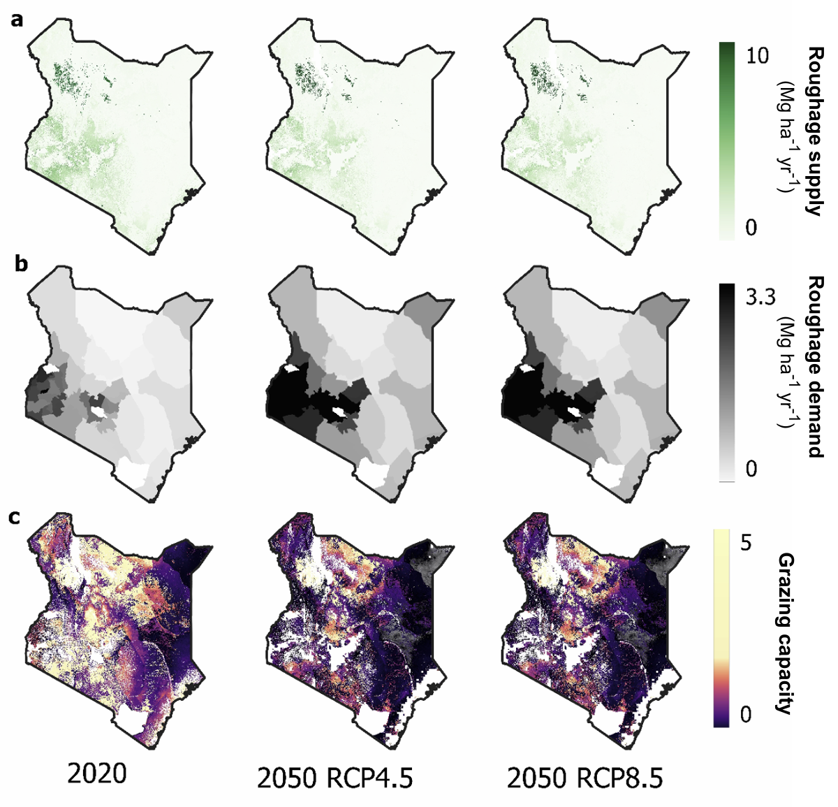
Figure S1: Estimated roughage biomass supply (a, 1st row), demand (b, 2nd row), and ratios thereof (Supply/Demand or ‘Roughage scarcity’ (c, 3rd row) for Kenya. Columns represent periods of 2020 (actual/historical) and 2050 under RCPs 4.5 (column 2) and 8.5 (column 3) climate narratives.

1.4 Heat stress
DMI and LWG impacts were computed from exceedance metrics of established thresholds defined in terms of temperature and humidity index (THI), as 79 for B. indicus and 76 for B. indicus x B. taurus crosses, following experimentally-derived values for respective breed genotypes (Volpi et al. 2004, Beatty et al. 2004, Ekine-Dzevu et al. 2020). THI was calculated using the equation THI = 0.8 x T + RH x (T – 14.4) + 46.4 with T and RH as temperature and relative humidity, respectively (Schlatter, 1987). Actual (2020) and projected (2050) THI per gridcell were based on ‘Coupled model intercomparison’ 6 (CMIP 6) projected maximum daily temperature and monthly mean humidity, for RCPs 4.5 and 8.5, respectively.
For each day above the threshold value, LWG was assumed to decline by 8.8% over a 14-day period and, for MY, -0.5% over 5-day period, following experimental inferences from a sample of mixed genetic (B. indicus, B. indicus x B. taurus) cattle in tropical/subtropical settings (Hasan et al. 2026). For DMI, a coefficient of -2.9 % DMI THI⁻¹ day⁻¹ was applied, similarly based on a pooled-breed coefficient reported by Martel et al. (2021).
Impacts on DMI, LWG, and MY were computed for each of 2020 and 2050 as summarized at gridcell level in Fig. S2. The simulation period averages per breed & farm-type sub-aggregation (based on spatial extent of farm-types) are summarized in Table 4 of the main text.

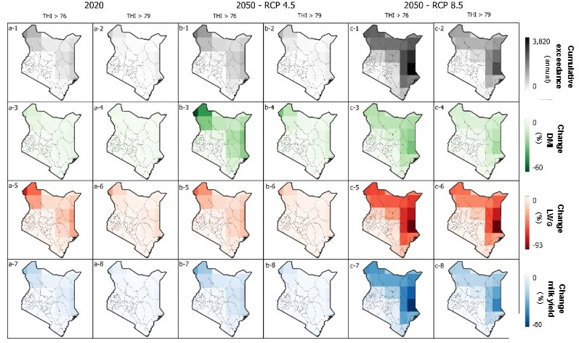
Figure S2: Heat stress impacts on Kenyan beef systems for 2020 (actual/historical) (a) and 2050 (projected) under RCPs 4.5 (b) and 8.5 (c) climate narratives. Rows represent respectively: (1) Accumulated THI values above threshold (unit = THI indices), (2) change in dry matter intake (DMI) (%), (3) change in liveweight gain (LWG) (%), and (4) change in milk yield (%). Columns represent, for each time period and RCP narrative, THI thresholds of 76 and 79, respectively.

2 Rumen8 simulations

Liveweight simulations: Rumen8
Rumen8 software was used to simulate liveweight across the production cycle for the eight cohorts of three breeds of ruminants. Seasonal variation in feed quantity was accounted for by running separate simulations for the two dry and two rainy seasons, with the trajectory of liveweight harmonized across each period (i.e. the beginning liveweight in any period is equal to the as the end liveweight of the previous period). The simulation start period for each animal was consistent with weaning period; the end-period corresponded with the culling period. The season corresponding to the beginning of the simulation was consistent with calving during the month of April, which is the recommended calving period to optimize nutrition of the cow during late gestation and early weaning, respectively (). For subsistence/semi-subsistence systems (Mixed, Pastoral, Agro-pastoral), the simulations were conducted for both calving during rainy and dry season and the average was reported – representing seasonal ‘obliviousness’ – as there is no evidence suggesting that subsistence/semi-subsistence Kenyan beef farmers time calving or finishing.
Cattle walking distances among Kenyan beef systems reportedly vary from <1 km d⁻¹ in semi-intensive to full confinement systems in central Kenya (Peter et al. 2015) to as high as 10 for pastoralists in arid systems (Raizman et al. 2013). These values however included transhumance farmers which are not representative of many beef farmers which may not practice transhumance. For pastoral systems, walking distances were set as 6 (rainy) and 8 km (dry), and slightly lower at 2.5 (rainy) and 4.0 km d⁻¹ for agro-pastoral systems values, while those for Mixed systems were assumed 0.5 kg d⁻¹ for both seasons. For Cow calf ops and Finisher ops values of 3.5 km d⁻¹ and 5.0 km d⁻¹ (Cow-calf ops) and 0.5 km d⁻¹ (Finisher ops) were assumed based on data representative of commercial Kenyan beef systems (Trail and Gregory 1981, Prodairy East Africa, 2023). All breed-specific parameters used in the simulations (used for both Rumen8 and GLEAM) are summarized in Table S1.

Feeding simulations
Since the survey sources do not explicitly account for feed seasonality, a rules-based system was used to account for sub-annual distribution of feed resources. This approach assumes feeding is homogeneous respectively within dry and rainy seasons, but the proportion of individual feed categories (stovers, forages, etc.) differ according to their availability (/feasibility) throughout the year (Fig. S3). The rules used were based qualitatively on common fead practices discerned from FEAST (Feed Assessment Tool) which suggest crop stovers, conserved hays and silages are fed mainly in the two dry seasons, and fresh forages and grassland are prioritized for rainy seasons (Otieno et al. 2016, Njalale et al. 2016a,b). In each period, feed on offer was set based on initial liveweight using the intake-prediction equation (Mertens et al. 1988). Based on the resulting feed available, the actual daily gain was then set so that nutrient availability (calories and protein) matched requirements. As a validation of this simulation framework, the resultant liveweight gains were validated to observed daily gains derived from available literature (reported in results).
Figure S3: Feed seasonality chart. Availability ( = available, -- = unavailable) and characteristics of (dry vs. fresh) major feed groups across Kenya’s four main production seasons (Short dry = Jan-Feb, Long rains = Mar-May, Long dry = Jun-Sep, Short rains = Oct-Dec).
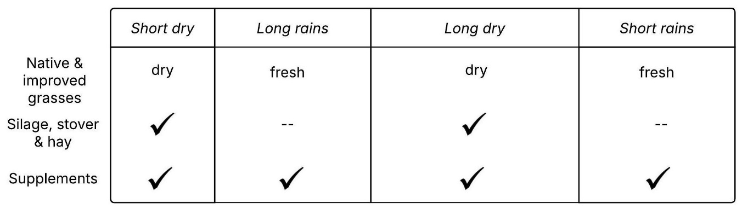

Table S1: Parameters used and their sources for estimating animal liveweight using Rumen8 software and for conducting GHG estimations using GLEAM-i. (Reproduction & lactation characteristics: ADG = Average daily gain; CI = calving interval, AFC = Age at first calving; GL = gestation length, LL = lactation length, MDMY = Mean daily milk yield, LMY = lactation milk yield, MP = milk protein content, MF = milk fat content).
Farm type | Breed | Walking distance  (km d⁻¹) | Liveweight & liveweight change |  |  |  |  | Reproduction & lactation
 |  |  | Weight (kg) |  |  |  | ADG  (kg d⁻¹) | CI  (m) | AFC  (m) | GL  (m) | LL  (m) | MDMY  (kg) | LMY  (kg) | MP²  (%) | MF²  (%)
 |  |  | Birth | Weaning | Start finish period | Slaughterª
Pastoral | Boran | Wet: 4.0-6.0 ¹  Dry: 6.0-8.0¹ | 24² | 240³ | -- | 350⁴ | 0.25⁴ | 14.7⁴ | 48⁴ | 9.3⁵ | 7.7⁴ | 2.0⁴ |  | 4.1 | 5.0
 | Zebu |  | 21² | 170² | -- | 250 | 0.30⁶ | 16.7⁷ | 60⁸ | 9.35 | 7.8⁸ | 1.6⁸ |  | 4.1 | 6.5
Agro-pastoral | Boran | Wet: 2.5 ¹  Dry: 4.0¹ | 24² | 240³ | -- | 400⁴ | 0.25⁴ | 14.5² | 46⁴ | 9.3⁵ | 7.7⁴ | 2.0⁴ |  | 4.1 | 5.0
 | Zebu |  | 21² | 170² | -- | 300⁴ | 0.30⁶ | 16.7⁷ | 60⁸ | 9.3⁵ | 7.8⁸ | 1.6⁸ |  | 4.1 | 6.5
Mixed | Boran | Wet & Dry: 0.5 | 24² | 240³ | -- | 400⁴ | 0.25⁴ | 14.5⁴ | 46⁴ | 9.3⁵ | 7.7⁴ | 2.0⁴ |  | 4.1 | 5.0
 | Zebu |  | 21² | 170² | -- | 350⁴ | 0.30⁶ | 16.7⁷ | 48⁸ | 9.3⁵ | 7.8⁸ | 1.6⁸ |  | 4.1 | 6.5
Cow-calf | Boran | Wet: 3.5⁹  Dry: 5.0⁹ | 24² | 240³ | -- | 400⁴ | 0.95¹⁰ | 14.0⁴ | 40⁴ | 9.3⁵ | 7.7⁴ | 2.0⁴ |  | 4.1 | 5.0
 | Exotic beef |  | 26¹¹ | 224² | -- |  | 0.80¹² | 13.4? | 34? | 10? | 7? | 3.8¹³ | 2019¹³ | 3.5 | 4.1
Finishing | Boran | 0.5¹⁴ | 24² | -- | 250¹⁶ | 525⁴ | 0.95¹⁰ | -- | -- | -- | -- | -- | -- | 4.1 | 5.0
 | Exotic beef |  | 26¹⁰ | -- | 250¹⁶ |  | 0.80¹² | -- | -- | -- | -- | -- | -- | 3.5 | 4.1
1 Butt (2010), 2 Rege et al. (2001), 3 Kenyan Breed Catalogue (2019), 4 Bayssa et al. (2021), 5 Mwatawala et al. (2009), 6 Ngesa (1978), 7 Kanuya et al. (2006), 8 Mwacharo and Rege (2002), 9 Trail & Gregory (1981), 10 Wasike et al. (2006), 12 Ali et al. (2015), 13 FAO (ND), 14 Rewe et al. (2015), 15 Prodairy East Africa (2023), 16 KMT (2020).
ª Minimum

Nutrient properties of feeds
Table S2 summarizes nutrient properties of feeds used in parameterizing Rumen8 based on ILRI (ILRI 2025) and FAO feed databases (FAO 2025). As not all feed properties were available from listed sources, digestibility and metabolizable energy were in select cases predicted from known properties based on published empirical equations. Specifically, these sources were based on Adams et al. (1988), Hales et al. (2022), Moran et al. (2005) for dry matter digestibility and metabolizable energy inference, respectively. In some instances, nutrient data only existed for one of the dry or rainy seasons; inferences were thus made based on the season with observed data. For this , ratios of nutrient parameters between rain and dry seasons were used, which took values of 1.20 and 0.98 for protein and fibre (ADF, NDF) respectively based on an analysis of East African semi-arid rangelands (Smit et al. 2025). A ratio of 1.18 for digestibility was used (Safari et al. 2011). Finally, to account for dry matter, protein, fibre and energy densities between fresh grass and hay, we used standardized coefficients calculated for perennial grasses from NRC (2001).
Table S2: Nutrient properties of feed sources used in beef cattle simulations using Rumen8 software. Agro-ecological zones: A = Arid, SA = Semi-arid, HSH = Humid/sub-humid, HMH = Humid – Mid & Highlands. Nutrient properties: DM = dry matter (%), DMD = dry matter digestibility (%), GE = gross energy (MJ kg DM⁻¹), ME = metabolisable energy (MJ kg DM⁻¹), CP = crude protein (% DM), CF = crude fat (% DM), NDF = neutral detergent fibre (% DM), ADF = acid detergent fibre (% DM), aN = immediately degradable nitrogen fraction (fraction), bN = potentially degradable nitrogen (fraction), cN = hourly degradation rate of particles for nitrogen (fraction). Phenology: F = Fresh (rainy season), D = Dehydrated (dry season), H = Hay, S = Silage (maize only), - = no distinction.

Feed (species) | AEZ | Phen-  ology | Feed property
 |  |  | DM | CP | CF | NDF | ADF | ME | aN | bN | cN
Native grassland^{1,3} (--) | A | F | 31.1 | 9.0 | 2.7 | 71.4 | 43.6 | 7.4 | 0.192 | 0.689 | 0.01
 |  | D | 92.3 | 7.1 | 1.8 | 70.0 | 42.7 | 7.1 | 0.192 | 0.689 | 0.01
 | SA | F | 31.1 | 10.9 | 2.7 | 71.1 | 40.1 | 8.6 | 0.192 | 0.689 | 0.01
 |  | D | 93.0 | 8.1 | 1.8 | 72.5 | 40.9 | 7.8 | 0.192 | 0.689 | 0.01
 | HSH, HMH | F | 31.1 | 10.5 | 1.6 | 68.5 | 37.2 | 7.9 | 0.192 | 0.689 | 0.01
 |  | D | 95.0 | 8.3 | 1.6 | 69.9 | 35.9 | 7.7 | 0.192 | 0.689 | 0.01
Buffel grass^{2,3,4,5} | All | F | 30.1 | 10.9 | 2.1 | 45.1 | 25.5 | 8.9 | 0.200 | 0.532 | 0.03
 |  | D | 90.0 | 9.0 | 1.9 | 69.1 | 39.6 | 8.1 | 0.200 | 0.532 | 0.03
Kikuyu grass^{2,3} | All | F | 20.1 | 15.1 | 2.7 | 65.3 | 35.1 | 9.7 | 0.200 | 0.532 | 0.03
 |  | D | 90.0 | 9.8 | 2.7 | 64.0 | 34.4 | 4.8 | 0.200 | 0.532 | 0.03
 |  | H | 90.0 | 11.3 | 0.8 | 70.4 | 41.1 | 8.0 | 0.200 | 0.532 | 0.03
Whole maize^{2,4} | All | F | 23.5 | 8.0 | 2.6 | 49.3 | 27.0 | 10.5 | 0.555 | 0.384 | 0.08
Maize stover² | All | F | 29.6 | 6.8 | 1.8 | 69.9 | 39.6 | 8.4 | 0.300 | 0.550 | 0.02
Maize bran² | All | - | 88.7 | 11.9 | 4.6 | 44.2 | 14.5 | 11.0 | 0.080 | 0.920 | 0.02
Cottonseed cake² | All | - | 90.9 | 47.3 | 3.0 | 27.0 | 17.8 | 13.5 | 0.370 | 0.610 | 0.08
Sources: 1 ILRI (2025), 2 FAO (2025), 3 Kabi et al. (2005), 4 Pirmohammadi et al. (2005), 5 Aden (2023), 6 Yigzaw (2019).
Scientific names: Buffel grass: Cenchrus ciliaris, Kikuyu grass: Pennisetum clandestinum, Maize: Zea mays, Cottonseed: Gossypium hirsutum.

Table S3: Feed baskets [will be inserted here - same data as reported in Figure 2]
Table S4: Herd structures (% decomposition of herd according to cohorts) used in model simulations.
Farm-type | Breeds | Herd structure (% of total herd)
 |  | Males |  |  |  | Females
 |  | Calves | Steers | Finisher bulls | Breeder bulls | Calves | Heifers | Finisher cows | Breeder cows
Pastoral^{1,2} | Zebu, Boran | 11.9 | 17.8 | 22.3 | 23.9 | 2.6 | 3.8 | 6.6 | 11.1
Agro-pastoral^{2,3} | Zebu, Boran | 2.0 | 2.8 | 6.3 | 6.7 | 4.0 | 8.0 | 26.0 | 44.0
Mixed³ | Zebu | 5.0 | 5.0 | 7.6 | 6.4 | 5.0 | 14.0 | 23.4 | 33.6
Cow-calf⁴ | Boran,  Exotic beef | 8.7 | 9.7 | 9.7 | 8.0 | 11.2 | 16.7 | 6.1 | 29.9
Finishing⁴ | Boran,  Exotic beef | - | 9.4 | 42.8 | - | - | 14.4 | 33.4 | -
1 ILRI (2023), 2 Mwanyumba et al. (2015), 3 GLS (2019), 4 APRI (2025).

SM References
Adnew, W., & Asmare, B. (2023). Agronomic Performance, Yield, and Nutritional Value of Grasses Affected by Agroecological Settings in Ethiopia. Advances in Agriculture, 9045341, 1–8.
Ali, I. E., Ishag, I. A., Ibrahim, F. H., Magzoob, A., & Ahmed, M.-K. A. (2015). Impact of Genetic and Non-Genetic Factors on Birth Weight of Crossbred Red Angus and Simmental with Local Cattle. American Journal of Agricultural Science, 2(3), 80–84.
Bayssa, M., Yigrem, S., Betsha, S., & Tolera, A. (2021). Production, reproduction and some adaptation characteristics of Boran cattle breed under changing climate: A systematic review and meta-analysis. In PLoS ONE (Vol. 16, Issue 5 May).
Behnke, R., & Muthami, D. (2011). The Contribution of Livestock to the Kenyan Economy. IGAD Working Paper 3. 62 pp.
Butt, B. (2010). Seasonal space-time dynamics of cattle behavior and mobility among Maasai pastoralists in semi-arid Kenya. Journal of Arid Environments, 74(3), 403–413.
FAO. (2025). Feedipedia. Rhodes grass (Chloris gayana) – Tables of Chemical Composition and nutritional value. Animal feed resources information system. [https://www.feedipedia.org/node/480].[Accessed July 30th 2025]
GOK. (2020). Inventory of GHG emissions from dairy cattle in Kenya: 1995-2017.pp 1-123.
Hales, K. E., Foote, A. P., Brown-Brandl, T. M., & Freetly, H. C. (2017). The effects of feeding increasing concentrations of corn oil on energy metabolism and nutrient balance in finishing beef steers. Journal of Animal Science, 95(2), 939–948.
ILRI (2025). ILRI Feed Nutrient Property Database. 2025.
Indah, A. S., Permana, I. G., & Despal. (2020). Determination dry matter digestibility of tropical forage using nutrient compisition. IOP Conference Series: Earth and Environmental Science, 484(1).
Jaleta, M., Kassie, M., & Erenstein, O. (2015). Determinants of maize stover utilization as feed, fuel and soil amendment in mixed crop-livestock systems, Ethiopia. Agricultural Systems, 134, 17–23.
Mertens, D. R. (1987). Predicting intake and digestibility using mathematical models of ruminal digestion. Journal of Animal Science, 64, 1548–1558.
Moran, J. (2005). What is in feeds? In: Tropical dairy farming: feeding management for small holder dairy farmers in the humid tropics. CSIRO.
Mwacharo, J. M., & Rege, J. E. O. (2002). On-farm characterization of the indigenous small East African Shorthorn Zebu cattle (SEAZ) in the Southeast rangelands of Kenya. Animal Genetic Resources, 32, 73–86.
Mwatawala, H. W., & Kifaro, G. C. (2009). Reproductive performance of artificially and naturally bred Boran heifers and cows under ranch conditions in Tanzania. In Journal of Animal & Plant Sciences (Vol. 4).
Ngesa, A. A. (1988). Factors affecting weigh-suckle-weigh milk yield estimates and calf performance of Zebu cattle. MSc. Thesis. University of Nairobi. 116 pp.
Pirmohammadi, R., Rouzbehan, Y., Rezayazdi, K., & Zahedifar, M. (2006). Chemical composition, digestibility and in situ degradability of dried and ensiled apple pomace and maize silage. Small Ruminant Research, 66(1–3), 150–155.
ProDairy East Africa (2022). Forage master plan for Kasigau Ranch, Taita Taveta County. 54 pp.
Running, S., Mu, Q., & Zhao, M. (2015). MOD17A2H MODIS/Terra Gross Primary Productivity 8-Day L4 Global 500m SIN Grid (Version 006) [Data set]. NASA Land Processes Distributed Active Archive Center (LP DAAC).
Smit, M., Malan, P., Smit, N., & Deacon, F. (2025). Drought impact on the nutrients of forage plants in a semi-arid rangeland and its potential implications for sustaining herbivores. Journal of Arid Environments, 227.
SNV (2024). Ex-tozi Rhodes (Chloris gayana) factsheet. Netherlands Development Organization (SNV). 2pp. Accessed at [https://livestock.africa/wp-content/uploads/2024/02/9.-Ex-Tozi-Rhodes-Factsheet_ICSIAPL-2022.pdf]
Trail, J. C. M., & Gregory, K. E. (1981). Sahiwal cattle: An evaluation of their potential contribution to milk and beef production in Africa. ILCA Monograph 3. 1-141 pp.
Wasike, C. B., Indetie, D., Irungu, K. R., Ojango, J. M., & Kahi, A. K. (2008). Environmental effects on variation in growth and reproductive performance of Boran cattle in ASAL of Kenya. Bulletin of Animal Health and Production in Africa, 54(3), 156–167.

