**CSCI 144 PROJECT REPORT**

**Time Graphs**

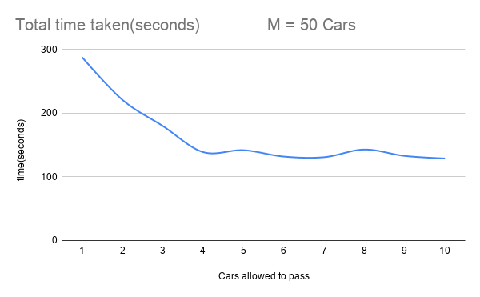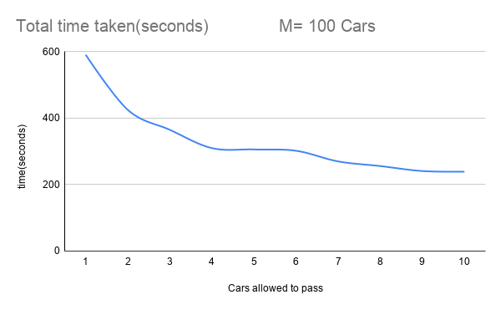

**Data Analysis**

For this program testing I ran two sets of 10 different runs with each set have two different consistent M’s while having the N’s being incremented from 1-10 for each run and measuring the total time taken for all cars to complete the simulation. In the graphs above there are two smooth line graphs to visualize the data I received while testing; one with M = 50 (top) and M = 100(bottom) and on these graphs I ran 10 different N’s for each M starting from 1 and ending at 10.

In both graphs ran with different M’s 50 and 100, the data came out similar with expected behavior of the program. With allowing 1 car to pass at a time of course gave the longest total time for completion but as N was being incremented to allow more cars to pass there was a drop-in total time making the simulation run faster than previous which was to be expected. However, with each increment in N through each run, the time was not dropped as significant as from 1 to 3 as you can see in the graphs below, but I do believe that would be expected behavior for such a simulation. There would have to exist a time for where the total time begins to slowly flatline given M not changing while N does. Based on my observations of the program, due to the randomness I believe I would have received better graphs/ data if I ran the iterations for example M = 50 and N = 5 a few more times and got an average it would turn the graph into a better fit example. I was going to include a third graph with M = 150 but since the behavior/ and results of the first two were shown as expected I felt that it would be unnecessary to make a third.