CALIFORNIA STATE UNIVERSITY, LONG BEACH
IS 445/545 – Internet Application Development

Spring 2026 Term – Section 01

Notes:
- You will create a web site using tutorial 4 lab 2 as a template
- Submission requirements (two files)
- Zipped file containing the following
  - The directory containing all your code
(these are the same files you push to GitHub)
Name the file as follows: yourLastNmaehw4.zip (e.g. asherhw4.zip)
- Solution to questions following the programming exercises (A Word or PDF file)

- Canvas submittal
  - In the comments section, include the links to your GitHub Repository and Netlify application. For example:
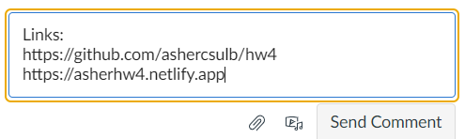

Programming Assignment
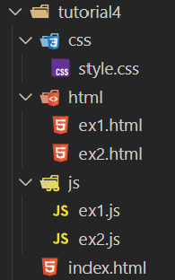
The programming assignment requires you to create solutions to several exercises below. Use tutorial 4 lab 2 as a template, that is (sample image for HW4)
- Create the directory structure as in tutorial 4 lab 2 (html, js, and css)
- Create an index.html file
  - It will have links to the solution for each exercise
- For each exercise, create two files
(replace # with the exercise number)
  - ex#.js (placed in js directory)
    - Contains JavaScript code
  - ex#.html (placed in html directory)
    - Runs the JavaScript code
    - Contains link back to index.html
- style.css (optional)
  - Optional style sheet
- Given the following HTML
<h1>CSULB IS Courses</h1>
<p>Fall Classes Taken:</p>
<ul>
<li>IS 300</li>
<li>IS 310</li>
<li>IS 340</li>
<li>IS 385</li>
</ul>
<p>Spring Classes Taken:</p>
<ul>
<li>IS 301</li>
<li>IS 320</li>
<li>IS 380</li>
<li>IS 445</li>
</ul>

Complete the code to display all body nodes (including text)
//Complete the following functions
//Displays all body nodes
const bodyNodes = () => {

}

bodyNodes();

Ouput
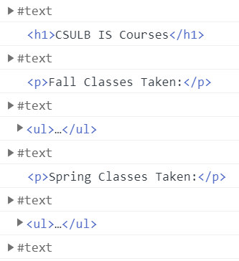

Use the following HTML for exercises 2 – 4
<h1>CSULB IS Courses</h1>
<p>Fall Classes Taken:</p>
<ul class="iscourses" id="fall">
<li class="300level">IS 300</li>
<li class="300level">IS 310</li>
<li class="300level">IS 340</li>
<li class="300level">IS 385</li>
</ul>
<p>Spring Classes Taken:</p>
<ul class="iscourses" id="spring">
<li class="300level">IS 320</li>
<li class="300level">IS 380</li>
<li class="400level">IS 445</li>
<li class="400level">IS 480</li>
</ul>
<h2>Links</h2>
<ul id="links">
<li id="csulb"><a href="http://www.csulb.edu">CSULB Home Page</a></li>
<li id="is"><a href="https://www.csulb.edu/college-of-business/information-systems">Information Systems</a></li>
</ul>

- Complete the code to display the text only (no HTML) for 400 level courses
//Complete the code for the following function
//Display text for 400 level courses
const displayText400 = () => {
}

displayText400();

Output
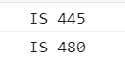

- Create and run a function to change all paragraph elements to bold with a yellow background. Output (partial) will be as follows:
Hint: Google what style to use for bold font.
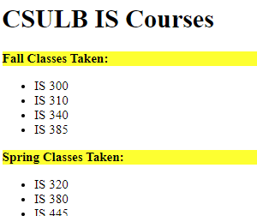

- Create and run a function to add a link to the College of Business between the CSULB link and the IS link.
Link: https://www.csulb.edu/college-of-business

Output (partial)

- Given the following HTML
<h2>Number Table</h2>
<div id="output"></div>

Write JavaScript code to display a table as shown below. Note the following:
- Table displays numbers 1 – 12 (a number on each row)
- Numbers divisible by 4 have a blue background
- Text is center aligned

Hint:
Use CSS. If the number is divisible by 4, add the appropriate class.

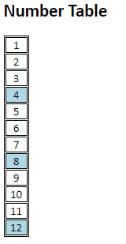

- Mini-dictionary (text exercise)
Here is the HTML code of a web page.
<h3>A mini-dictionary</h3>
<div id="content"></div>
Write a program that shows on the page a list of terms and definitions defined in a JavaScript array.
const words = [{
term: "Procrastination",
definition: "Avoidance of doing a task that needs to be accomplished"
}, {
term: "Tautology",
definition: "logical argument constructed in such a way that it is logically irrefutable"
}, {
term: "Oxymoron",
definition: "figure of speech that juxtaposes elements that appear to be contradictory"
}];

Use the HTML <dl> tag to create the list (more on this tag). Each term of the dictionary should be given more importance with a <strong> tag.
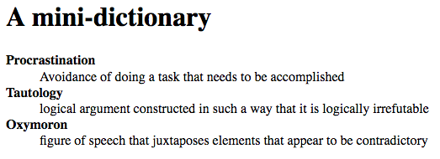

- User Input / Sum
Use the prompt to query the user for two Integers. Display the sum on the HTML Page.

Below is the starter HTML code

<h3>Sum of two Integers</h3>
<div id="content"></div>

Requirements
Correct input.
Display the sum as shown below. Note that the sum style is red and bold
Hint:
See hands on tutorial. May use the span element with style.color and style.fontWeight.

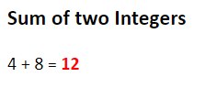
Invalid input
Display the error as shown below. Again, note the red and bold font.
Also note that the input values are shown in quotes.

Error – Alphanumeric input:

Error – Decimal input:


Answer the following

- What are the links to your web site (see notes on first page)?
  - GitHub URL:
  - Netlify URL:

- Given the HTML file in Exercise 1. What is the output of the following?
console.log(document.body.childNodes[0]);
console.log(document.body.childNodes[1]);
console.log(document.body.childNodes[20]);
console.log(document.body.childNodes[5].childNodes[0]);
console.log(document.body.childNodes[5].childNodes[1]);

