STAT 2450 Assignment 6

James MacPhee

Banner: B00768516

1. Plot a histogram of the bootstrap distribution of the estimated slope parameter for the hardwood data.

* a convenient way to incorporate a bootstrap sample from the pairs (), is as follows.
* lm(y~x,subset=sample(1:n,n,replace=T)
* then extract the estimated slope using coef(lm.out)[2]

rm(list=ls())  
set.seed(999123)  
x = c(1,1.5,2,3,4,4.5,5,5.5,6,6.5,7,8,9,10,11,12,13,14,15)  
y = c(6.3,11.1,20,24,26.1,30,33.8,34.0,38.1,39.9,42,46.1,53.1,52,52.5,48,42.8,27.8,21.9)  
Nboot=1000  
temp=NULL  
for (i in 1:Nboot){  
 lm.out = lm(y~x,subset=sample(1:19,19,replace=T))  
 slope = coef(lm.out)[2]   
 temp = c(temp,slope)  
}

* 1. make a histogram of the estimated slopes

hist(temp,breaks=200)

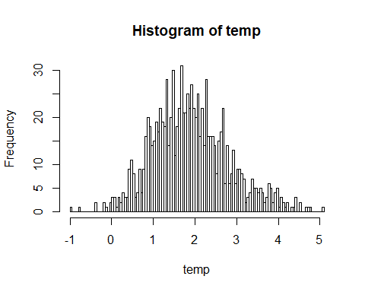

+ (b) use the quantile function to calculate a 90% percentile interval

tinterval=function(data,alpha=.1){  
 n=length(data)  
 t=qt(1-alpha/2,n-1)  
 xbar=mean(data)  
 s=sd(data)  
 tinterval=xbar+c(-1,1)*t*s/sqrt(n)  
 return(tinterval)  
}  
tinterval(temp)

## [1] 1.852580 1.948129

* 1. estimate the variance of .

summary(lm.out)$coefficients[2, 2]

## [1] 0.5816625

#I know it says variance but I realize that standard error is used to show variablity of a statistic inside a distribution  
#If it is truly variance that would be the square of the standard error multipled by the sample size or 19*(0.5816625^2)=6.4283

1. Explore the sensitivity of the bootstrap estimate of the standard error of the slope estimate using the “boot” procedure, using the hardwood data.

b1=function(data, index){  
 x=x[index]  
 y=y[index]  
 lm.out = lm(y~x)  
 return(coef(lm.out)[2])  
}  
#library(boot)

* Run the boot procedure 10 times with a bootstrap sample size of 10, 100, and 1000.

for(i in 1:10){  
 #boot(temp,b1,R=10)  
 #boot(temp,b1,R=100)  
 #boot(temp,b1,R=1000)  
}

How does the variability of the bootstrap estimate of standard error  
change as the number of bootstrap samples increases?

I can’t get my boot() function to work because I don’t have library() access defined on my PATH on this computer but this is the way I would do it and I hope this suffices. I had to comment out the calls to “boot()” so I could avoid errors and still be able to knit to a word document. If I was able to see the results I would suspect the variability to reduce as the sample size increases.