My contributions to the group project:

- Built the initial CSS layout that has since been contributed to by everybody else, with a map and inventory on the left, dialogue on the bottom and choices on the left, and iterated on this to improve it. The map was later on replaced with displaying the temperature and timer systems.

- Created the HTML template that is used in each location, ensuring the layout of the game was consistent throughout every area

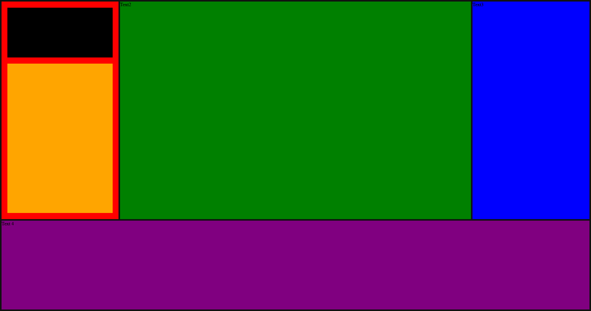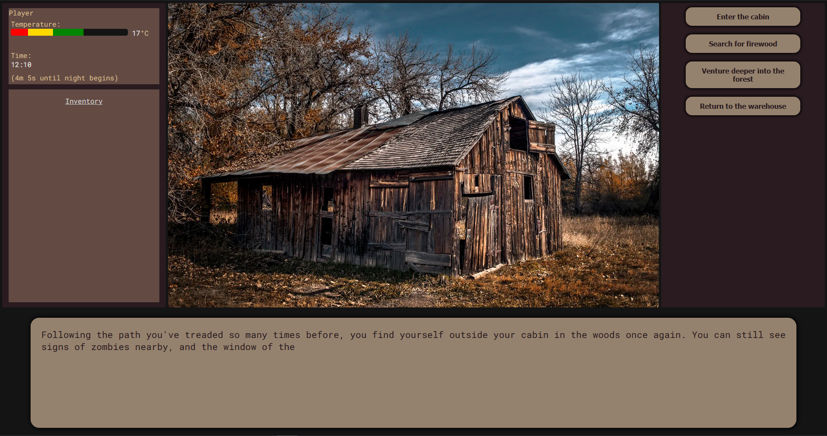 (Image showing initial testing of the layout CSS) (Image of the final CSS)

- Created the cabin location, containing a wide range of events, items and endings

- Took Andrew’s prototype typewriter system and rewrote it to be significantly more robust (allowing any HTML element tags, not breaking when the user choices too quickly, etc.) while still remaining fully compatible with code that expected Andrew’s version.

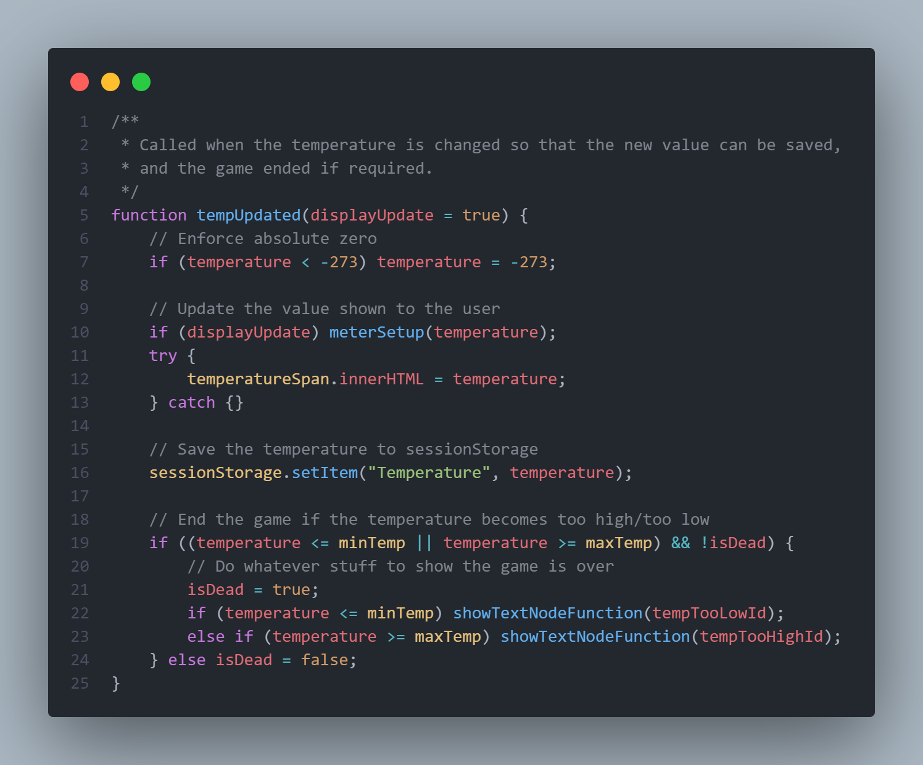 (The visual output of the temperature system)

(A small sample of the code used to create the temperature system)

- Implemented a system for cross-fading audio, allowing a smooth transition between audio effects in different scenes, as I found the abrupt transition that we were initially using to be extremely jarring- This audio system was also updated to support playing short, non-repeating sounds

- Later on, it was also updated to integrate with the volume slider Ryan had added

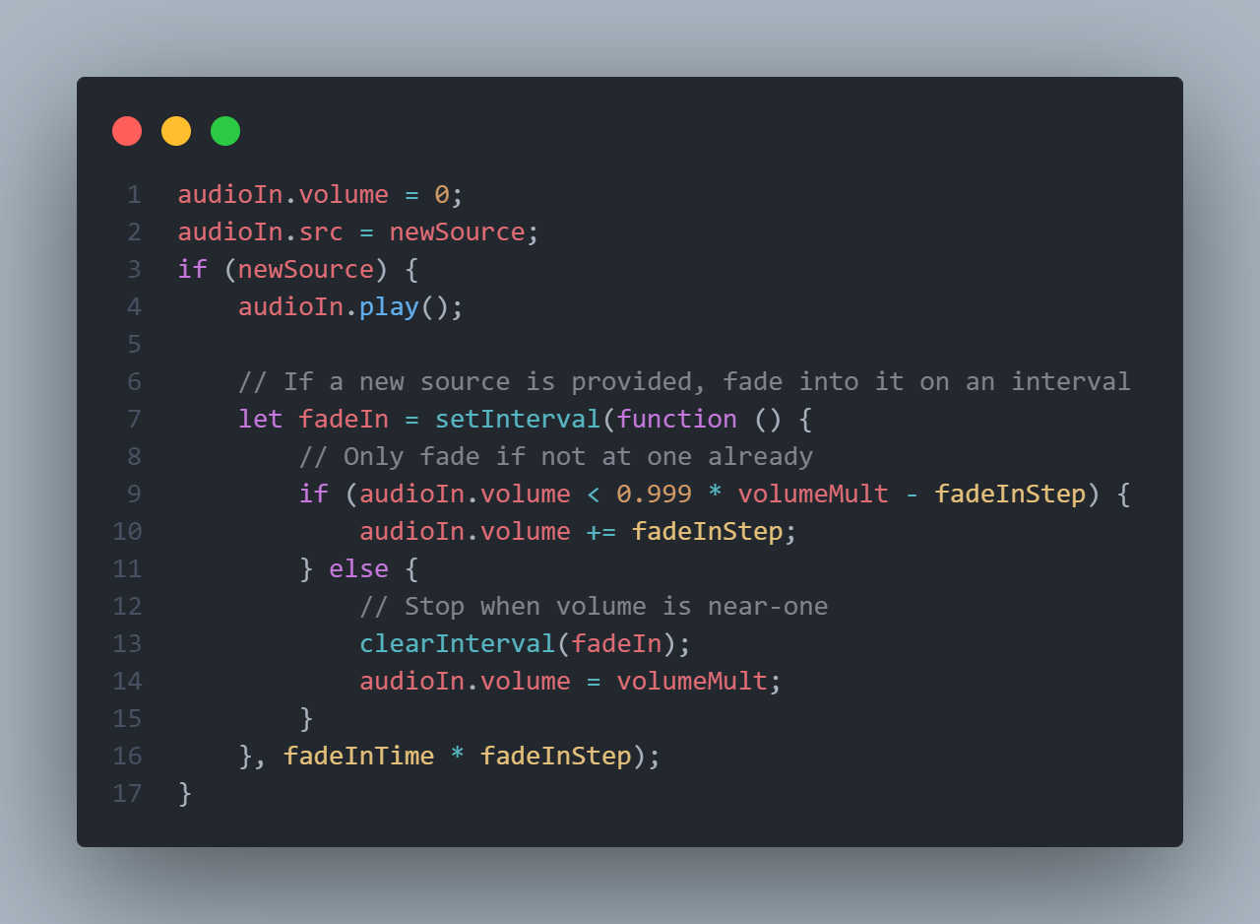 (A section of the code that controls cross-fading audio)

- Created a temperature system, compatible with Andrew’s initial prototype, that also allows each location to be more flexible with increasing and decreasing the temperature, made sure the temperature was saved to session storage so it would carry over between locations, allowing specific events to be called to end the game if the player gets too hot/cold, and displayed the temperature to the player both as a number and as a colour-coded bar that can be read easily at a glance

- Improved Andrew’s initial version of the timer by getting it to display the time remaining as part of the UI, and added functionality to run specific text nodes whenever the night started/ended, to make sure the time limit of 5 minutes was actually enforced

- Improved Ryan’s inventory system by moving it to its own file to allow everyone to integrate it more easily (same as all the other systems), and allowed it to save the state of the inventory to session storage to allow it to be carried between locations, and finally allowed the player to pick up multiple items of the same type (e.g. have 2 sets of wood planks)