# The Irish Economy

As a small open economy Ireland’s financial fortunes are dependent on international trade and influenced by global markets. The EU’s Single Market environment, together with decisions to introduce low corporate taxes and develop an Industrial Development Agency (IDA Ireland) to promote Ireland abroad, eventually enabled the new Irish economy to flourish.

The value added recorded in Ireland by multinationals is displayed in Figure 1. The gross value added (GVA) is used in the estimation of Gross Domestic Product (GDP)[1].  The gross value added (GVA) is a measure of output net of the inputs used for its production. Note, in 2015 GVA more than doubled in the economic sectors dominated by foreign owned multinationals[2]. Currently, multinationals account for 90 % of exports for five key sectors: computer programming, chemicals, computer consultancy, computer electronic and optical devices, and medical devices.

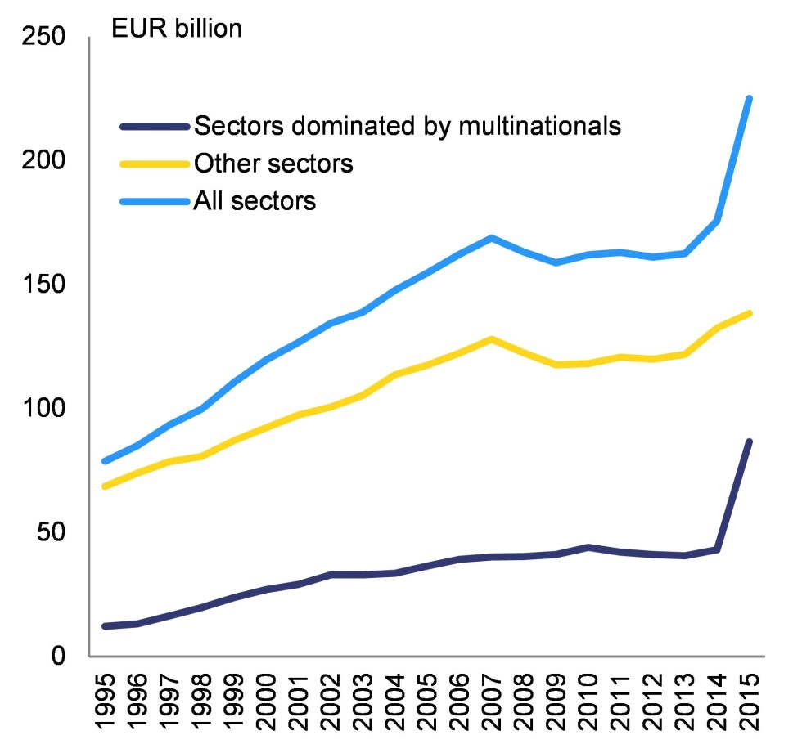

Figure 1 Gross value added from domestic production and foreign owned multinationals. Gross value added at constant basic prices (chain linked annually referenced to 2014). Source: Central Statistics Office of Ireland (CSO).

One of the difficulties with small open economies like Ireland’s is that they are vulnerable to global factors and Ireland’s strongest period of economic growth, from the mid ‘90s to the mid ‘00s, was followed by an unprecedented crash triggered by a worldwide financial meltdown. Figure 2 displays the year-on-year percentage change in GDP with robust growth up until the mid ‘00s and a decline between 2008 and 2012. The contribution of the building and construction sector to the overall GDP figure is also displayed. Figure 3 displays the ratio of the building and construction sector to GDP for both the UK and Ireland. While construction output remains historically low in both economies, the Irish construction sector remains close to all time lows.

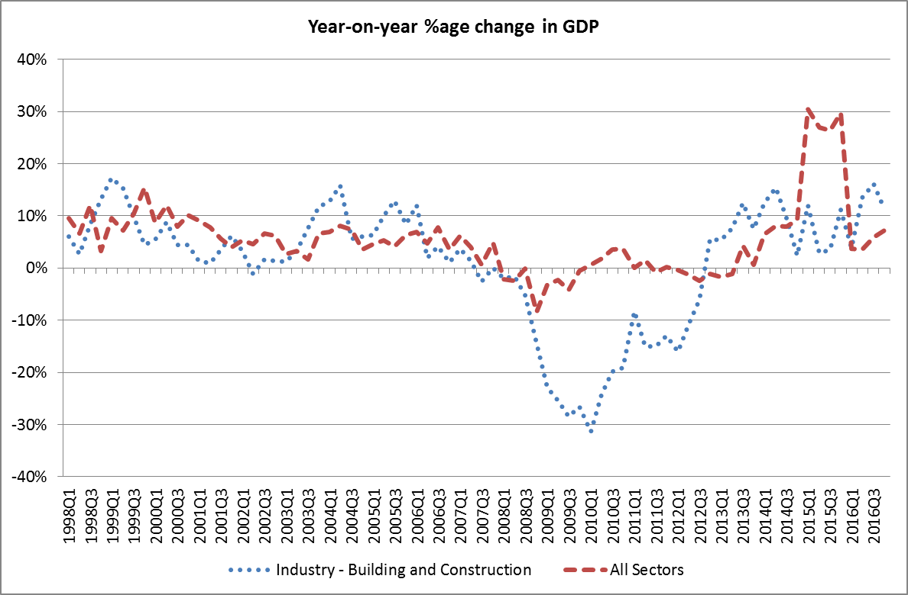

Figure 2 Gross Domestic Product at Constant Factor Cost (chain linked annually and referenced to 2014) (Seasonally Adjusted) (Euro Million) by Quarter and Sector. Source: CSO.

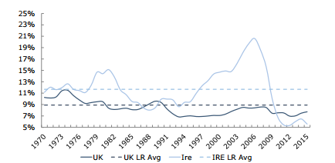

Figure 3 Comparison of Construction/GDP ratios for UK and Ireland. Source: Goodbody.

Ireland became a victim of the global economic downturn that climaxed following the 2008 collapse of Lehman Brothers - the fourth largest investment bank in US. Banks all around the world stopped lending to each other and credit dried up. Ireland was particularly vulnerable to the crisis because of a property bubble that had been inflating at an alarming rate for almost a decade, as per Figure 4.

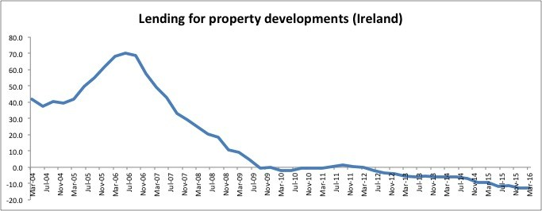

Figure 4 Year-on-year %age change in level of lending for property development in Ireland. Source: various

Figure 5 displays the lending to Irish households and covers developments in lending for house purchase, and lending for consumption and other purposes by banks within Ireland. The pace of expansion in lending to Irish households in the pre-crisis years was among the highest in the euro area. The subsequent decline was particularly large for consumer lending which started to show year-on-year declines in early 2009; meanwhile, both total and housing-related lending have been contracting on an annual basis since late 2009/early 2010. All three series continue to decline on an annual basis. The extent of the contraction in household lending in Ireland has been more pronounced than in the euro area as a whole.

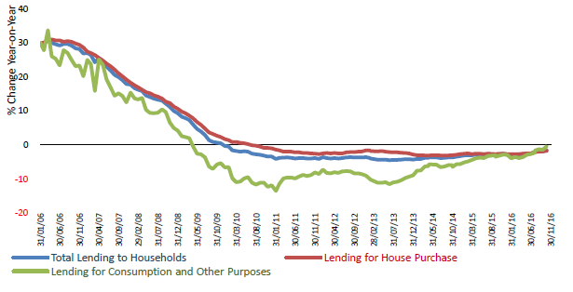

Figure 5 Lending to Irish Resident Households (%change year-on-year). Source: Central Bank Ireland

Irish banks had lent huge amounts, much of it to property developers, leaving our banking system exposed when funds could no longer be borrowed from the markets and the risks of non-repayment of the property loans made by the banks became suddenly larger. During the bubble, the balance sheets of Irish domestic banks had grown through property lending to four times Irish GDP, and the scale of the Irish banking crisis was correspondingly larger than in other countries. The amount in mortgage drawdowns by Irish banks is displayed in Figure 6. A historical series of housing completion and loan approvals is displayed in Figure 7.

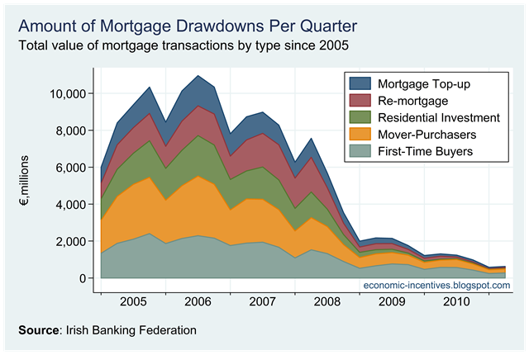

Figure 6 Reduction in the number of mortgage drawdowns by quarter

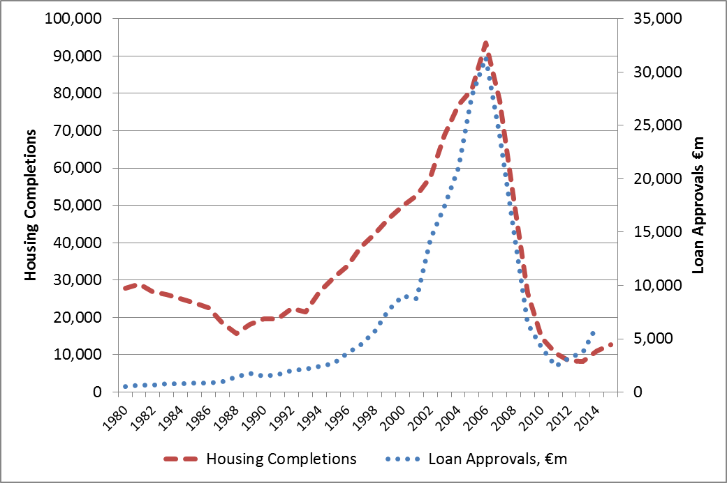

Figure 7 Housing completion and loan approvals 1980 - 2016. Source: Dept. of Housing, Planning, Community, and Local Government.

To prevent a run on the banks and protected the savings of ordinary citizens governments allocated funds to safeguard the liquidity of the banks. These funds had to be borrowed and by late 2009 the most exposed Eurozone Member States, including Ireland, began to have problems servicing the debt, as per Figure 8.

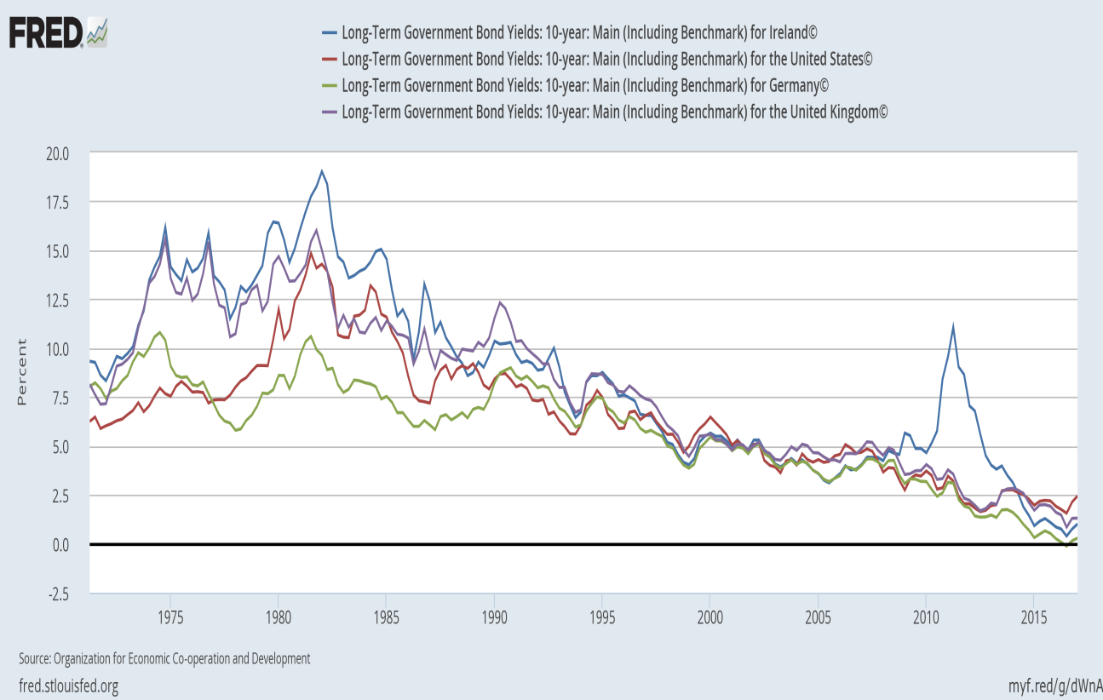

Figure 8 Ten year Long Term Government Bond yield curves. Source: St. Louis Federal Reserve.

The banking crises in Europe had now become a sovereign financial crisis and banks reduced their lending to businesses and private households, leading to unemployment and hardship (see Figure 9).

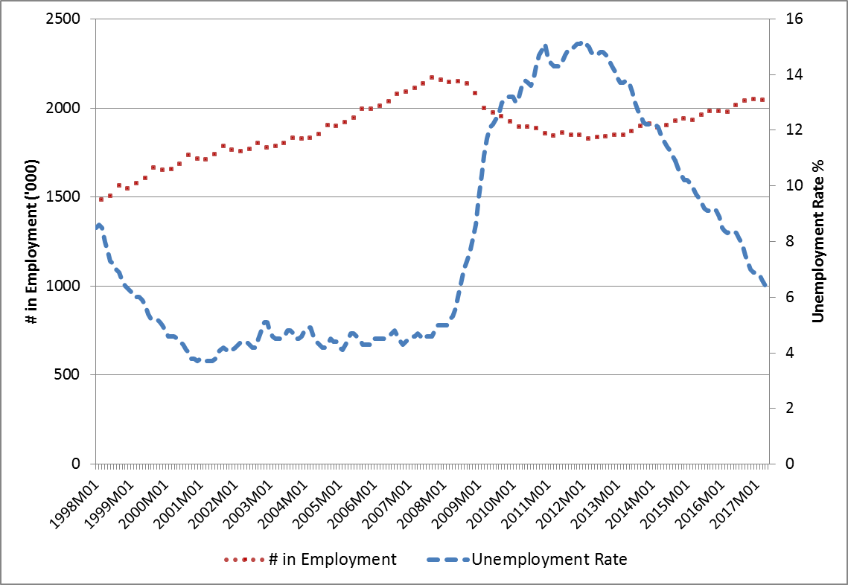

Figure 9 Unemployment rate (RHS) and numbers in employment (LHS).

When the numbers in employment is indexed to and re-based at the peak value the scale of the financial crisis on Irish employment is highlighted, particularly when compared with Ireland’s main trading partners (see Figure 10).

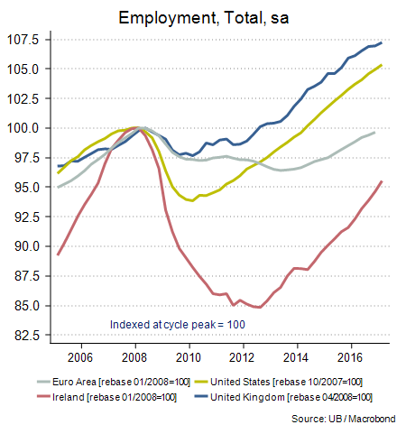

Figure 10 Rebasing and indexing of employment numbers for Ireland, EU, USA and UK. Figures are seasonally adjusted and re-based to the cycle peak.

In Ireland the sovereign debt was compounded by a blanket bank guarantee given by the State to alleviate fears of mass deposit withdrawals and collapse. To date, the cost of the blanket guarantee is €41 billion (note: this is exclusive of the billions put into the covered banks from the National Pension Reserve Fund).

In addition, the Irish State had become heavily dependent on property taxes, which had disappeared with the bursting of the property bubble, as per Figure 11 and Figure 12. The increasing deficits and spiralling debt meant the financial markets lost confidence in the country’s ability to pay back what was owed, making it difficult for the State to borrow money at sustainable rates.

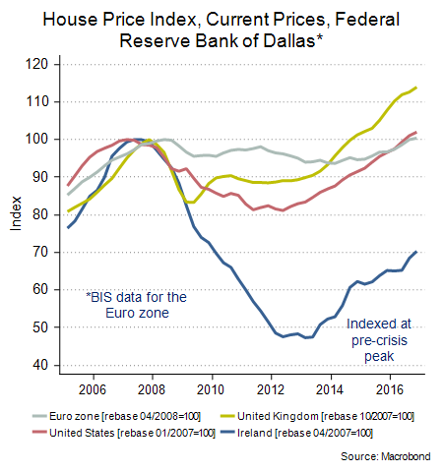

Figure 11 Rebasing and indexing of the house price index for Ireland, EU, USA and UK. Figures are seasonally adjusted and re-based to the cycle peak.

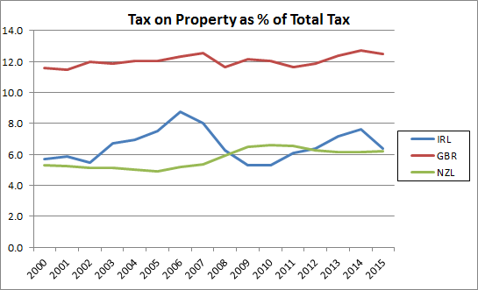

Figure 12 Tax on property is defined as recurrent and non-recurrent taxes on the use, ownership or transfer of property[3]

The strain finally became too much in 2010 and in November of that year the Irish Government officially requested international financial assistance, a move backed by the ECB and the European Commission.

Source: <http://ec.europa.eu/ireland/news/key-eu-policy-areas/economy_en>

In summary a timeline of the significant macroeconomic events described above is displayed in Table 1.

|  |  |
| --- | --- |
| 2007 | Ireland’s property market reaches its peak. |
| 2008 | Ireland’s property bubble starts to collapse as the country officially enters recession; the first Euro Area Member State to do so. Unemployment starts to rise sharply. Inter-bank lending collapses. The Irish Government acts to protect the country’s banking system and guarantees all deposits to try and prevent a run on Irish banks. |
| 2009 | Unemployment reaches its highest levels since records began. Protestors take to the streets and the Irish Stock Exchange hits a 14 year low. The Government injects billions of euro into Irish banks to prevent them from collapsing. The National Asset Management Agency (NAMA) is established and takes on the role of banker for bad property debt. |
| 2010 | The crisis deepens as more money is pumped into the ailing banks and the Irish Government officially requests financial assistance from the EU, the IFM and other Member States. A package worth €85 billion is negotiated, conditional on Ireland allowing its budget to be closely monitored by the Troika (European Commission, European Central Bank and the IMF) on a regular basis to ensure financial conditions are met. |
| 2011 | The Irish Government is heavily defeated in a general election held just three months after the package is agreed. Ireland’s debt rating is downgraded to junk status. |
| 2012 | Irish voters approve the European Union Fiscal Treaty by 60% at a referendum |
| 2013 | Ireland successfully raises €5bn by issuing a syndicated 10-year benchmark bond to the financial markets. It’s Ireland’s first sale of benchmark bonds since the banking collapse in 2010. |
| 2013 | Ireland successfully exits the Troika’s three year programme on December 15th 2013. |
| 2014 | Ireland again returns to the long term borrowing markets with a €3.75bn sovereign bond and receives a Moody’s upgrade in January 2014. |
| 2015 | According to EU forecasts, Irish GDP growth for 2015 as a whole was 6.9%. |
| 2016 | The European Commission’s winter 2016 European Economic Forecast expects a moderation in Irish economic growth for 2016 and 2017 to more sustainable rates of about 4% and 3% respectively. |

Table 1 Timeline of significant macroeconomic events.

## New Lending Rules

There are a number of initiatives the Irish Government and Central Bank introduced as a lever to help stimulate and exert some form of control on the housing market. Statutory Instrument 47 (SI 47 Rules) passed legislation in February 2015 and underwent revision in 2016. The regulations impose lending caps on borrowers based on the LTV, LTI and buyer type (mortgage type primary dwelling house and buy-to-let). Currently, the regulations stipulate:

* PDH mortgages for non-first time buyers are subject to a limit of 80 per cent LTV.
* For first time buyers of properties a maximum LTV of 90 per cent will apply.
* These LTV limits should not be exceeded by more than 20 per cent of the euro value of all housing loans for second and subsequent PDH purposes, and not be exceeded by more than 5 per cent of the euro value of all housing loans for first time buyers, during an annual period.
* BTL mortgages are subject to a limit of 70 per cent LTV. This limit can only be exceeded by no more than 10 per cent of the euro value of all housing loans for non PDH purposes during an annual period.

With respect to LTI:

* PDH mortgage loans are subject to a limit of 3.5 times loan to gross income.
* This limit should not be exceeded by more than 20 per cent of the euro value of all housing loans for PDH purposes during an annual period.

Other market measures include:

* Home Renovation Scheme (a tax rebate on home renovations priced up to €32000)
* Mortgage Interest Relief – Increasing from 75% to 80% in 2017.
* The Help-To-Buy scheme – First time buyers of a new home from July 2016 to 2019 are entitled to a tax rebate of up to €20,000 or 5% of the value of the house to first time buyers of new homes.
* Previous measures distorted the market e.g. Section 22 tax relief.

The house price to industrial earnings over time is displayed in Figure 13.

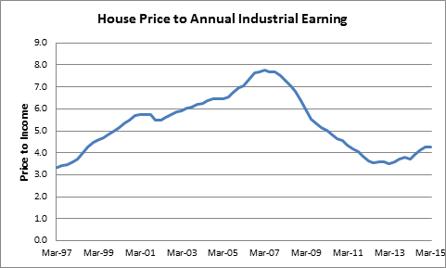

Figure 13 House price to annual industrial earnings. Source: CSO.

## Forbearance

Introduced in July 2013 by the CBI, the revised Code of Conduct on Mortgage Arrears (CCMA) has changed the way delinquent owner-occupied borrowers are managed. The changes are intended to reduce the minimum time before enforcement proceedings can begin and provide much needed clarification on the legality of enforcement. Alongside the CCMA, regulation such as the Mortgage Arrears Resolution Process (MARP), the Personal Insolvency Arrangement and the Land of Conveyancing Law Reform Act 2013 have reformed the repossession process. Figure 14 displays a timeline of strategies for non-performing loans and the effects on the balance of NPLs.

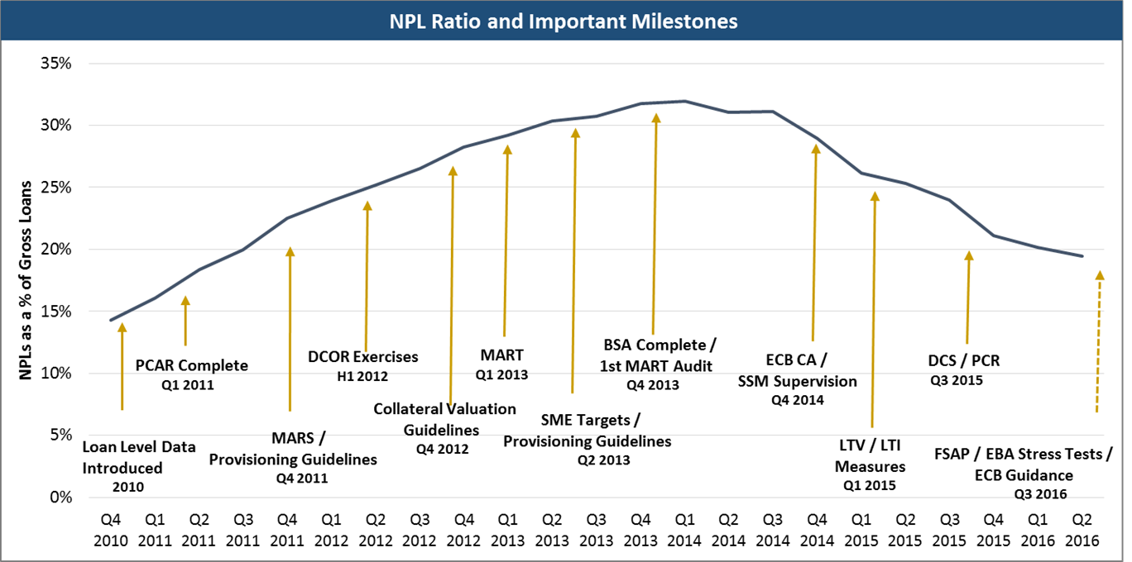

Figure 14 Timeline of CBI reviews, remediation requirements and the issuing of guidelines. Note: At Q3 2014 the EBA’s definition of non-performing was introduced

A servicer’s MARP outlines a prescriptive direction and exhaustive set of actions that servicers must take prior to repossession. The steps generally include borrower outreach, short-term forbearance, long-term forbearance, as well as alternatives such as voluntary surrender, private sale and mortgage to rent arrangements (Figure 15). MARP timelines vary significantly dependent on the responsiveness and cooperation of borrowers. The MARP can be reset at any point if a borrower makes any payments, which can extend the timeline to resolution if the payments are capricious.

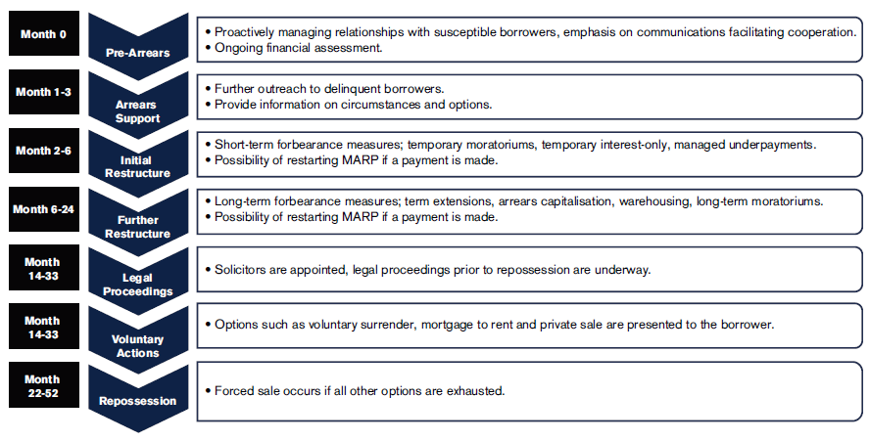

Figure 15 Example MARP structure.

The most common forbearance measures used in the Irish market are arrears capitalisation and reduced monthly payments. Typically, a resolution strategy will attempt to maximise the net present value (NPV) of a loan portfolio while also adhering to the appropriate laws and regulations, such as the Mortgage Arrears Resolution Process in accordance with the Central Banks CCMA.

## Legal uncertainties

The ability to undertake secured lending is ultimately dependent on the power to realise the security if needed. This is a cornerstone of secured lending and, by extension, an effectively functioning mortgage market. Relative to many other European jurisdictions, including those with lower levels of non-performing loans, the legal process through which lenders effect security is now substantially longer in Ireland.

The time taken to go through the court process for residential property repossessions will mean that there will continue to be a cohort of borrowers that remain in arrears, with limited restructuring activity taking place.

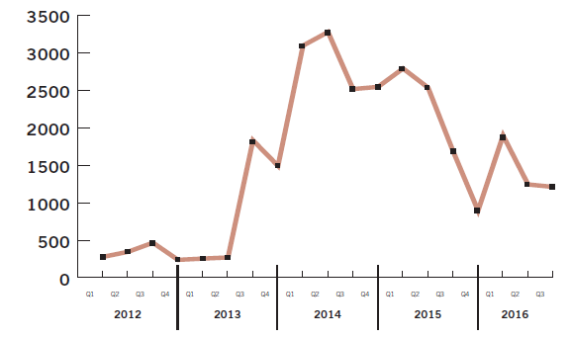

Figure 16 Number of proceedings issued in the Irish courts for enforcement of security in relation to PDH mortgages (Q3 release by the Central Bank of Ireland)

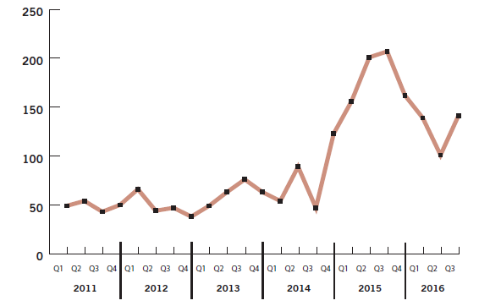

Figure 17 PDH mortgages actually repossessed on foot of a court order (Q3 release by the Central Bank of Ireland)

Dunne ruling effects the total population. During the LGD model build we had to move accounts from the litigation stock of accounts into the loss category.

1. **GVA + taxes on products - subsidies on products = GDP**
2. A small number of very large multinationals restructured their operations in 2015. This led to a bigger share of GVA from their global production chains being booked in Ireland but had a limited impact on domestic economic activity.
3. These include taxes on immovable property or net wealth, taxes on the change of ownership of property through inheritance or gift and taxes on financial and capital transactions. This indicator relates to government as a whole (all government levels).