

Data Technician

Name: Alaa Mostafa
Course Date: 16/12/24
Table of contents
Day 1: Task 1 2
Day 2: Task 1 2
Day 2: Task 2 3
Day 2: Task 3 4
Day 3: Task 1 4
Day 3: Task 2 5
Dataset: 5
Step 1: Create a Pivot Table 5
Step 2: Use the SWITCH Function 5
Submission: 6
Day 3: Task 3 6
Day 4: Task 1 7
Course Notes 9
Additional Information 10

Day 1: Task 1

Please complete the below boxes on commons laws and regulations that must be followed when working with customers data, use the below bulleted list to support your answers.

- What is it
- Why is it important
- Provide a real-world example of how you can follow it
- How does it impact working with data
- What could happen if you breached it

Data Protection Act | The Data protection app controls how personal information can be used and individuals rights to ask for information about themselves. It is important because it allows individuals to know what information is held about them and have access to it. An example is requesting your travel history from the Home Office using SAR. It impacts working with data as it allows people to restrict how their information is used. If breached you can be fined or criminally charged.
GDPR | GDPR is the General Data Protection Regulation. It is an UK and EU law that controls how organisations collect, store and use data. It is important as it gives people the right over the access, correction and deletion of their data. Impacting how other companies can use their data. I can ensure that companies can’t share my email for marketing purposes unless I opt into the list. Earlier this year, Capita Pensions Solutions limited were fined €6,880,000 for insufficient technical and organisational measures to ensure information security.
Freedom of Information Act | The Freedom of information Act 2000 gives the public a right to access recorded information held by most public authorities. It is important as it gives the public the right to access information held by these public authorities. An example would be asking a local council for total street lamp repair costs in a particular ward. It allows us to access data from public authorities to compare data. Organisations that change or block this data request can be fined up to £5000.
Computer Misuse Act | Introduced in 1990, the Computer Misuse Act is designed to protect people computers. It is illegal to access data or change data on a computer without permission. To access data that would be used for illegal activities. This is important as it protects people when their data is being misued. It impacts data analysis as it is important to ensure we are accessing data with their permission and ensuring they know exactly what they’re allowing us to collect. 2021 two people were sentenced after transferring personal data about road accidents to allow nuisance calls. They were sentenced to 8 months suspended sentence.

Day 2: Task 1

Please research and complete the following tasks within the retail-sales_dataset.xlsx document, paste a print screen into the provided boxes below:

- In the sheet ‘retail_sales_dataset’ add all available data between columns A –J into a ‘table’
- Using the ‘sort’ function, sort ‘Age’ to ‘largest to smallest’
- Using the ‘SUM’ function, show me the commission total in cell ‘L10’
- Using the ‘AVERAGE’ function, show me the average commission in cell ‘L11’

Print screen 1 | 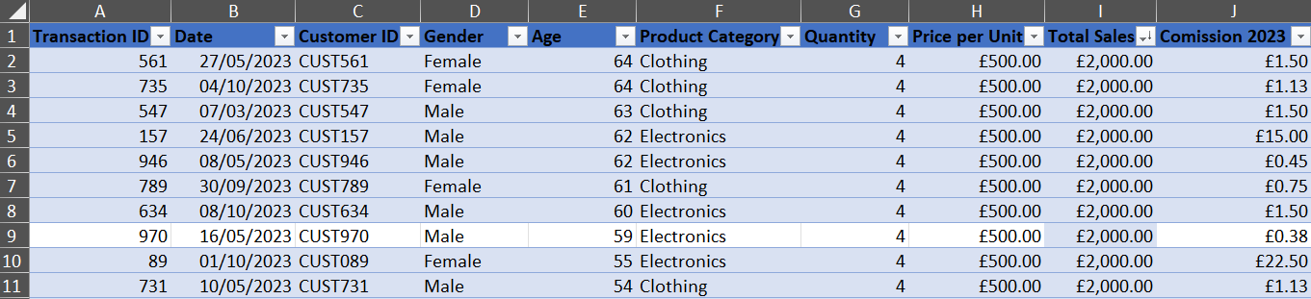
Print screen 2 | 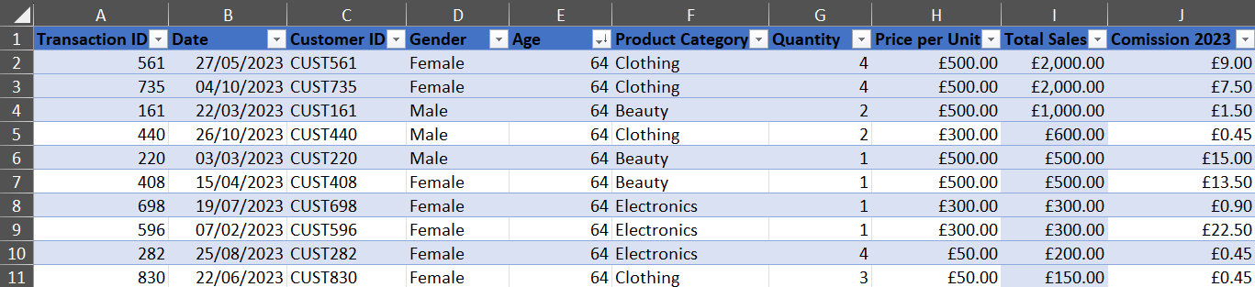
Print screen 3 | 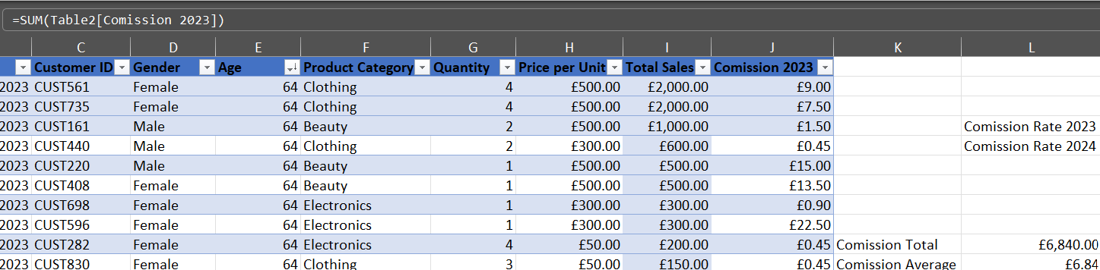
Print screen 4 | 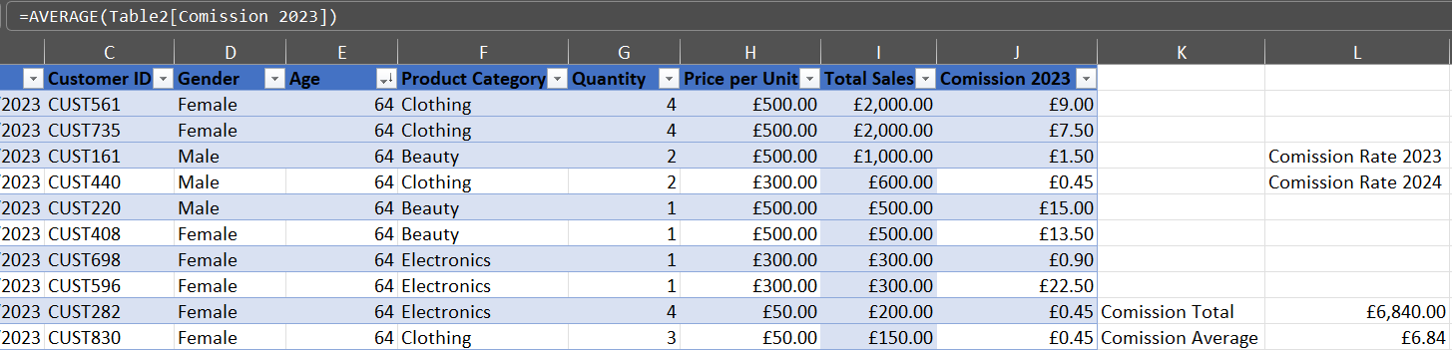

Day 2: Task 2

Please research and complete the following tasks within the retail-sales_dataset.xlsx document, paste print screens into the provided box below:

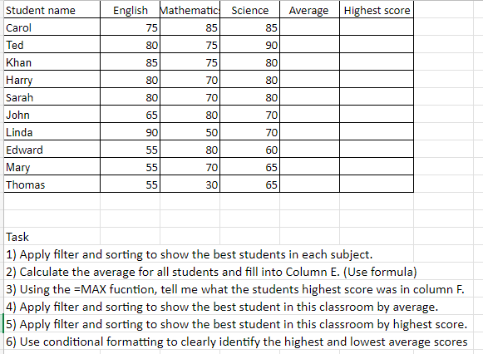

Print screen 1 | 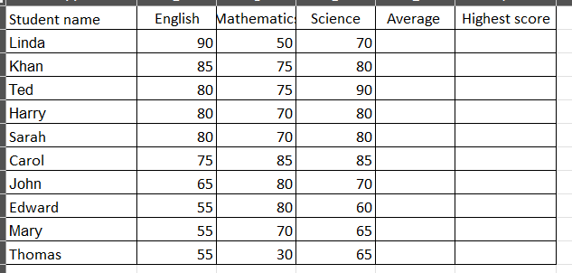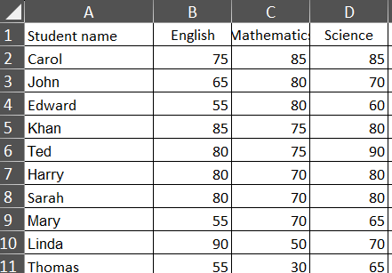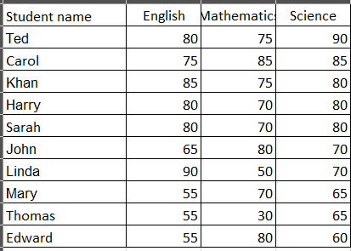  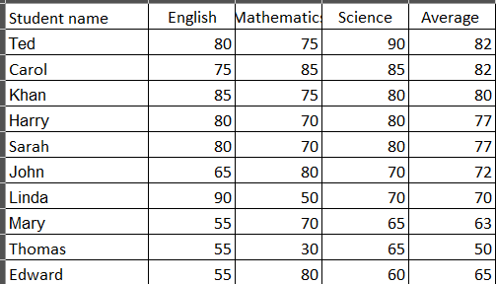  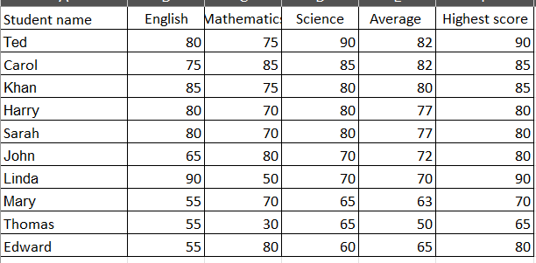  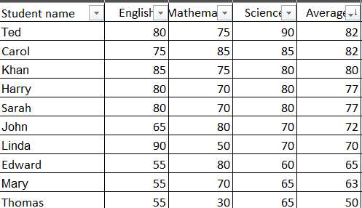  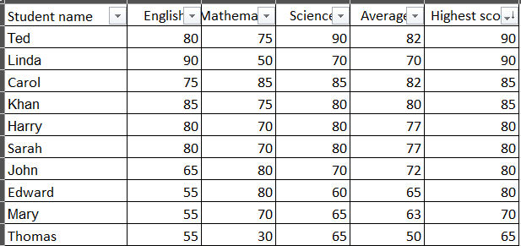  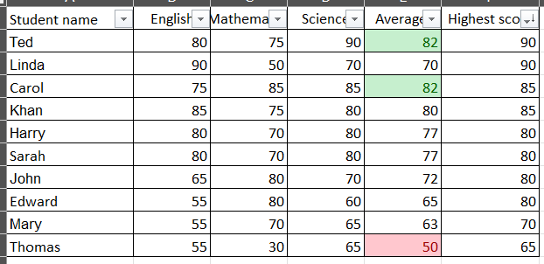

Day 2: Task 3

Using the skills developed today, have some fun with the data set you have imported. Paste your work below and enjoy!

Print screen 1 | I downloaded data about top rated IMDB movies  My first step was to convert the numbers columns into a number format, changing the decimals to make it easier to view.  I added a colour grading onto the vote average and added a data bar onto the vote counts to make it easier to compare how many votes each film has. 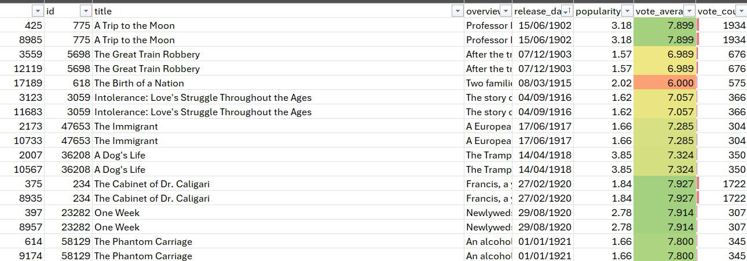  I then added an IFS function to grade the film based on how high the vote_average was  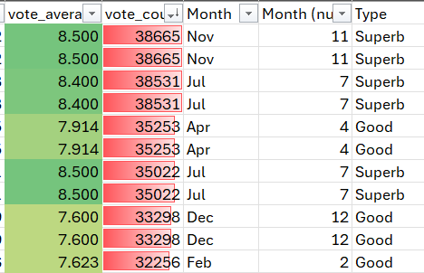  I then added countif statements to count up each new worded grade  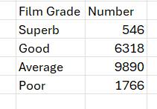  Finally I used xlookup so a person could type in a film name and receive its vote average and release date, I used the Date functions and concaternate functions to turn the number date into a written date  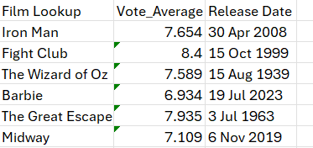

Day 3: Task 1

Please download the dataset ‘Day_3_Task_1_Bike_Sales_Pivot_Lab.xlsx’ and the lab instructions.

Do not worry if you do not complete the lab, just working with data and playing with the pivot table will be good experience.

Please paste your final pivot table below and complete the reflection questions:

Print screen 1 | 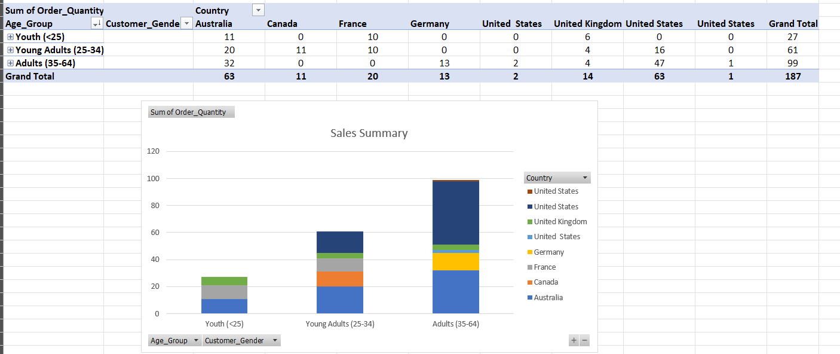
In which markets does Germany have customers? | Germany only has customers in the Adults (35-64) market, with both male and female customers in that Category.
What country has sales in all markets? | Australia is the country which has sales in all markets
What are the most profitable markets by country, age group, and gender? | Most profitable by Category:  - Country: United States  - Age Group: Adults (35-64)  - Gender: Female
Any other findings? | - No one under the age of 35 from Germany ordered a Bike from this company.  - Females outsold males in every Age group, only France and the UK saw males outsell females by country.

Day 3: Task 2

The dataset below tracks the sales performance of different products in various counties in England. Please paste the dataset into a blank Excel workbook. Your task is to:
- Create a Pivot Table to summarise the data by county and product.
- Use the SWITCH function to categorise products based on their sales volume.

Dataset:
County | Product | Sales Volume
Yorkshire | Laptops | 500
Yorkshire | Smartphones | 200
Cornwall | Laptops | 700
Cornwall | Printers | 400
Lancashire | Smartphones | 150
Lancashire | Laptops | 600
Essex | Printers | 800
Essex | Smartphones | 300
Durham | Laptops | 250
Durham | Printers | 300
Greater Manchester | Smartphones | 600
Greater Manchester | Laptops | 400

Step 1: Create a Pivot Table
- Select the dataset (columns A to C).
- Insert a Pivot Table to summarise the data by County in the rows and Products in the columns. Use Sales Volume as the value to be summarised.

Step 2: Use the SWITCH Function
In a new column next to your data, use the SWITCH function to categorise products based on Sales Volume as follows:
  - For sales greater than 600: "High"
  - For sales between 300 and 600: "Medium"
  - For sales less than 300: "Low"
SWITCH Function Example:
=SWITCH(TRUE, C2 > 600, "High", C2 >= 300, "Medium", "Low")
- Apply this formula to each row, and check if the products are categorised correctly.

Submission:
- A completed Pivot Table summarising sales by county and product.
- A new column in the dataset categorising products by sales volume using the SWITCH function.
  - Please paste your completed work below

Print screen 1 | 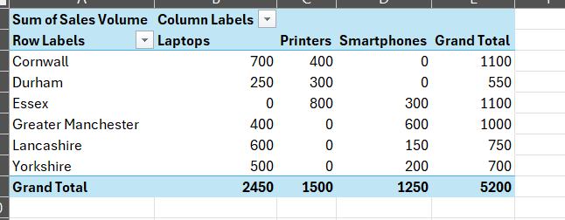  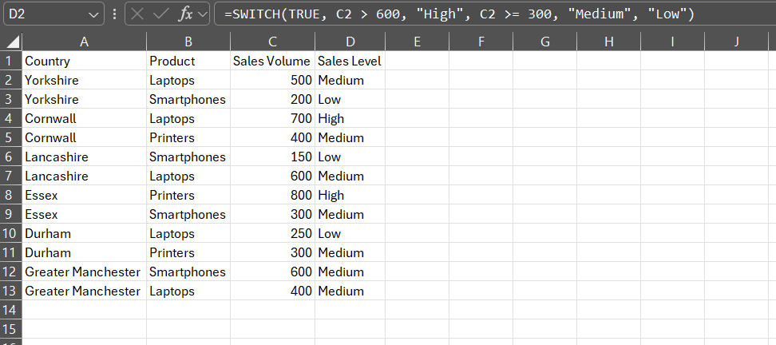

Day 3: Task 3

Please download the dataset ‘Day_3_Task_3_Bike_Sales_Visualisations_Lab.xlsx’ and the the lab instructions. Do not worry if you do not complete the lab, just working with data and playing with the charts will be good experience.

Please paste your results below:

Print screen 1 | 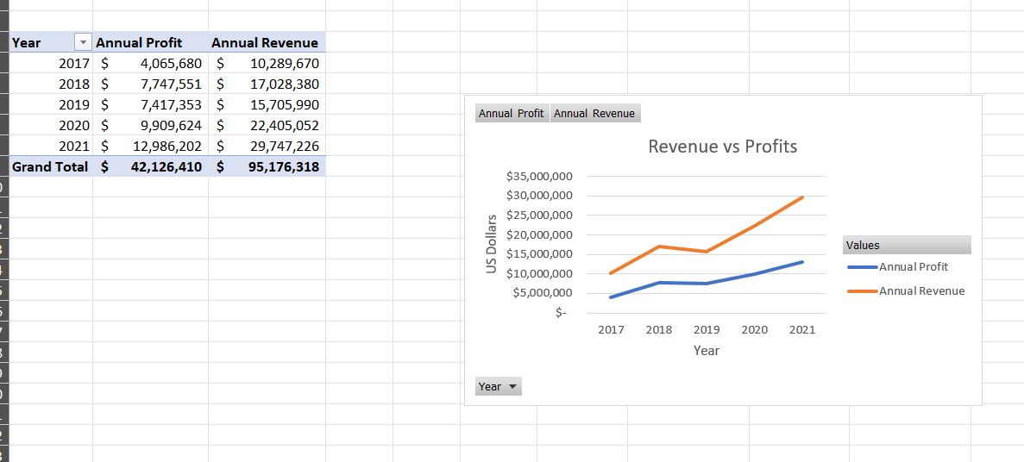  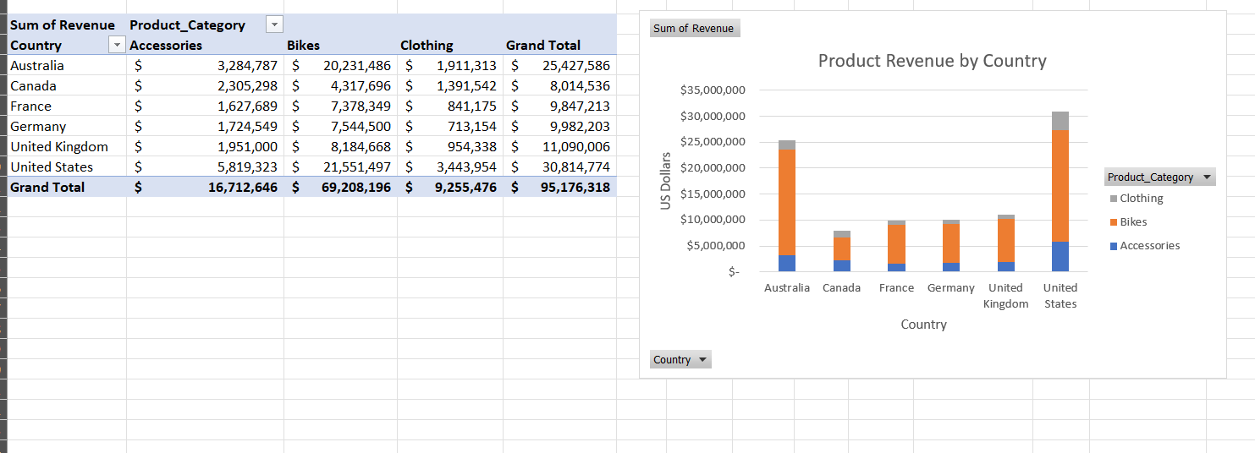  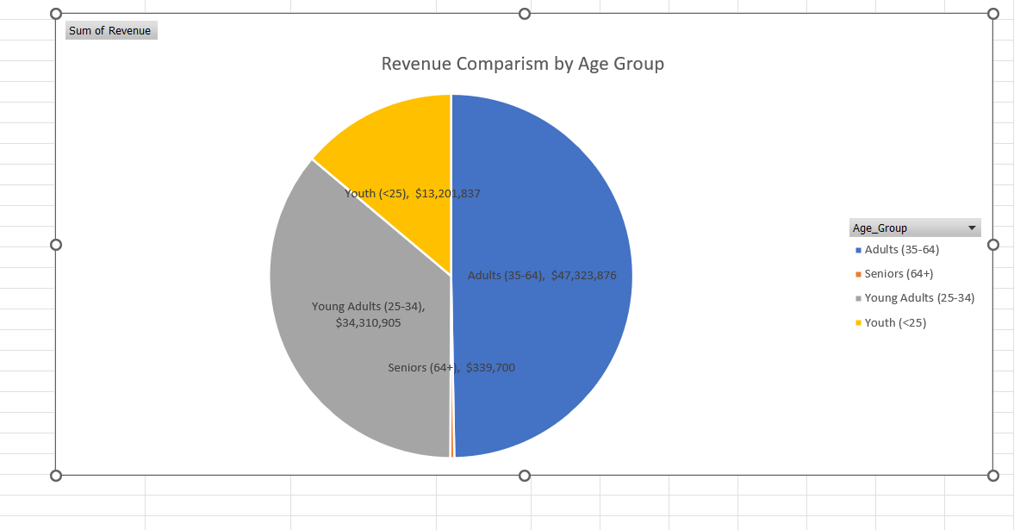

Day 4: Task 1

You have been asked to deliver your analysis findings to the board of directors, with your analysis you have identified that customers are leaving your company at the 12-month point, this is typically when they receive their renewal price.

Conduct research and complete the below questions:

How would you prepare for the delivery? | - I would compile the data into a graph ensuring they are easy to understand.  - I would make sure I have the renewal price on hand
What tools would you use for the delivery? | - A line chart to show how the customers leave peak after 12 months to ensure it is clear the12 month timeline is significant.
What is prospecting and why would you complete this before your delivery? | - Prospecting is a technique where you gather potential clients and make them aware of a product. This increases the number of sales as often they are unaware of different products.
Tell me best practices for public speaking and providing updates to senior leaders | - Practise the presentation to ensure you’re used to how the speech will go in terms of delivery and cadence.  - Time the speech to make sure it isn’t going on for too long.  - Ensure the material is well organised  - Come up with questions that are likely to be asked to increase the ability to deal with any worries  - For updates, ensure they are in the communication chain for regular updates.  - If they ask particular questions, ensure the next update answers that query in detail.
What will you show the board in your delivery? | - The chart showing how customers are leaving after 12 months  - Explain this is due to them receiving the renewal price.  - Give ideas for how we can reduce the drop off at the end of the year.
How will you articulate the changes that are needed? | - If the data shows that for the customers who stay on after 12 months keep renewing at a far higher rate than those who don’t. Suggest this shows that once a customer renews for the first time, they are far more likely to keep renewing, increasing the profits.  - Show how much profit were are missing out on from customers not renewing.
Provide a list of online resources and videos that will support your preparation for public speaking | Videos that help prep for public speaking  https://www.youtube.com/watch?v=5m-C5mwpmxU  https://www.youtube.com/watch?v=PiNN-HmHu7A  https://www.youtube.com/watch?v=-FOCpMAww28
Evaluate tools that provide visualisation.  Tell me what they are.  Tell me what you would choose when delivering your presentation and why | - Excel, a helpful tool that provides an easy method to convert data in graphs. However the graphs can be basic and difficult to transform and add detail.  - Datawrapper is a free online site where data from excel can be copied to. It allows far more control over how the data is visualised, especially for complicated sets. And has the ability to be imbedded in sites or linked to for ease of sharing data.  I would likely however use Excel for this presentation as the data isn’t too complicated, and the graph would likely be easier to view. Data wrapper is better for complicated data sets where Excel starts to get difficult. It would also be easy to add to a presentation PowerPoint.

Course Notes

It is recommended to take notes from the course, use the space below to do so, or use the revision guide shared with the class:

Additional Information

We have included a range of additional links to further resources and information that you may find useful, these can be found within your revision guide.

END OF WORKBOOK

Please check through your work thoroughly before submitting and update the table of contents if required.

Please send your completed work booklet to your trainer.

