

Data Technician

Name:
Course Date:
Table of contents
Day 1: Task 1 2
Day 1: Task 2 2
Day 2: Task 1 3
Day 2: Task 2 3
Day 3: Task 1 4
Day 3: Task 2 5
Day 4: Task 1 6
Day 4: Task 2 7
Course Notes 7
Additional Information 8

Day 1: Task 1

Please research the different versions of Tableau, compare and contrast them below and explain the limited functionality on ‘Tableau Public’.

Different Tableau versions | Desktop: Their main version, requires payment but can be used for creating, analysing and publishing visualizations.  Public: A free version which allows you create visualisations, however they are online and available to everyone which means you can’t use private data.  Cloud: A cloud hosted version that allows people to interact with data via web browsers.  Server: An online place to post dashboards, making it easier to share data from Desktop and can also allow them to interact with the data without requiring desktop.  Prep: A tool for prepping data for visualisations, including cleaning the data, combining or restructuring it.  Next; An AI tool designed to analyse the data

Day 1: Task 2

Using the EMSI_JobChange_UK dataset, create your own dashboard, I want to see a bar chart showing percentage change and a UK based map showing the key city locations impacted.

Paste your print screen here | 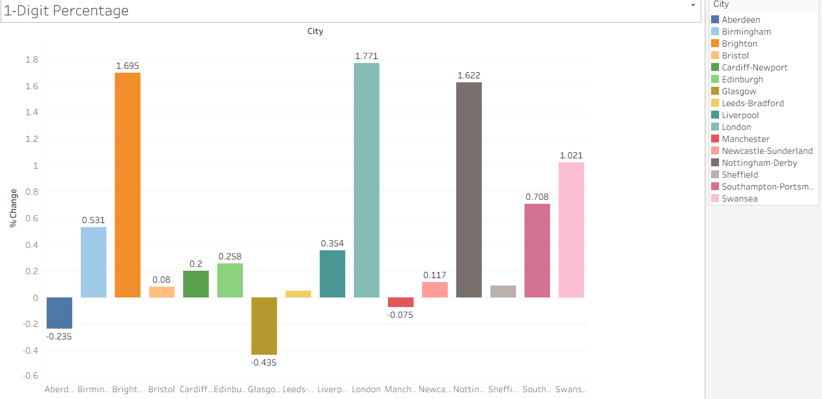  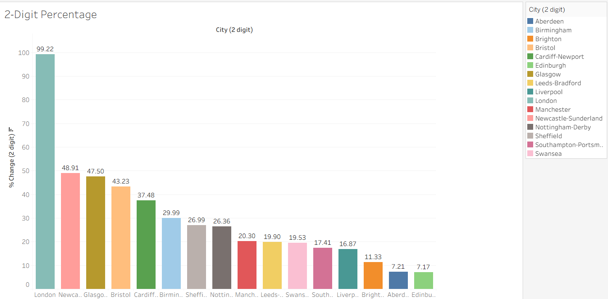  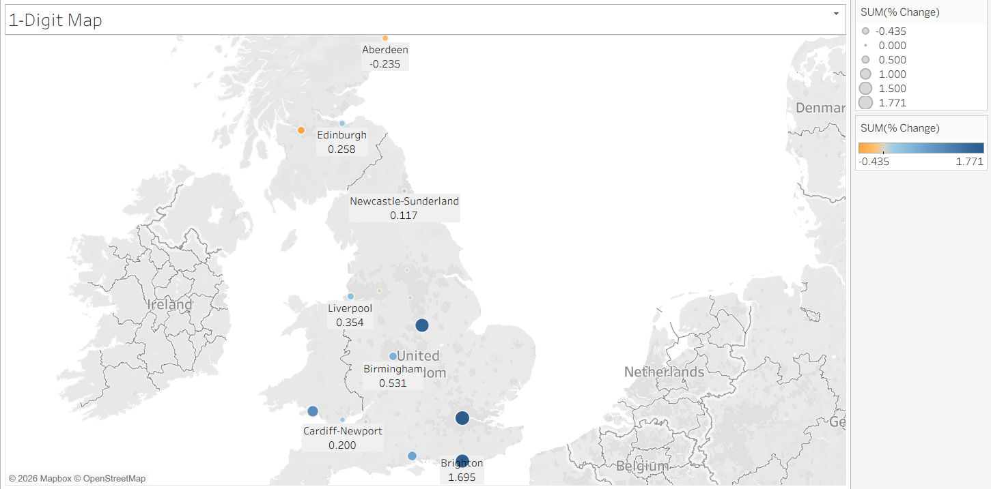

Day 2: Task 1

Using the Spotify data set, conduct an analysis to find trends and key information that could be used by an organisation for future projects.

There is no set scope for the analysis, simply to find trends and document them below:

Paste your print screens here | 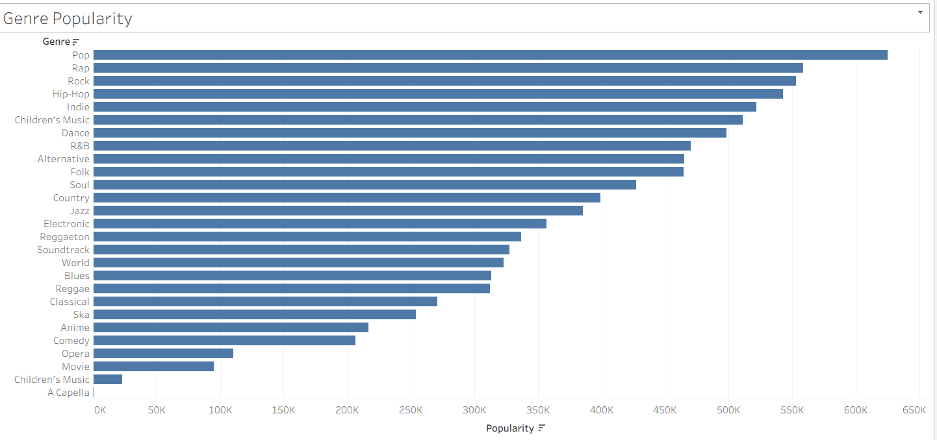  Figure 1  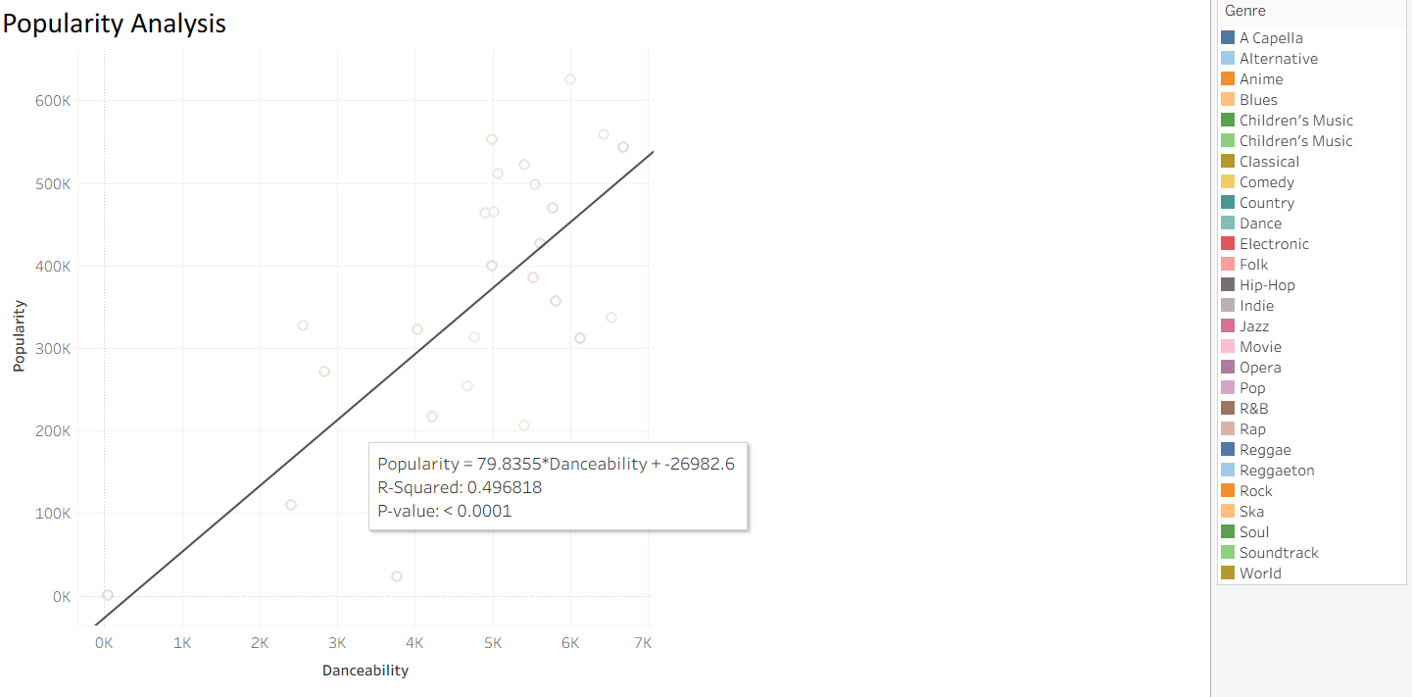  Figure 2  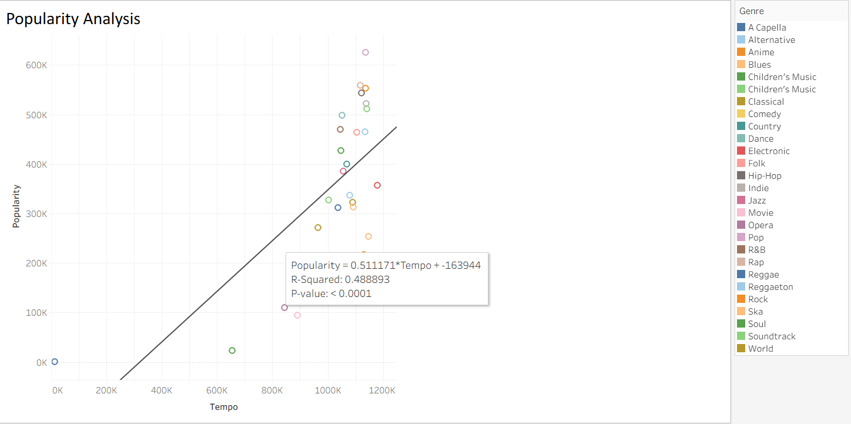  Figure 3  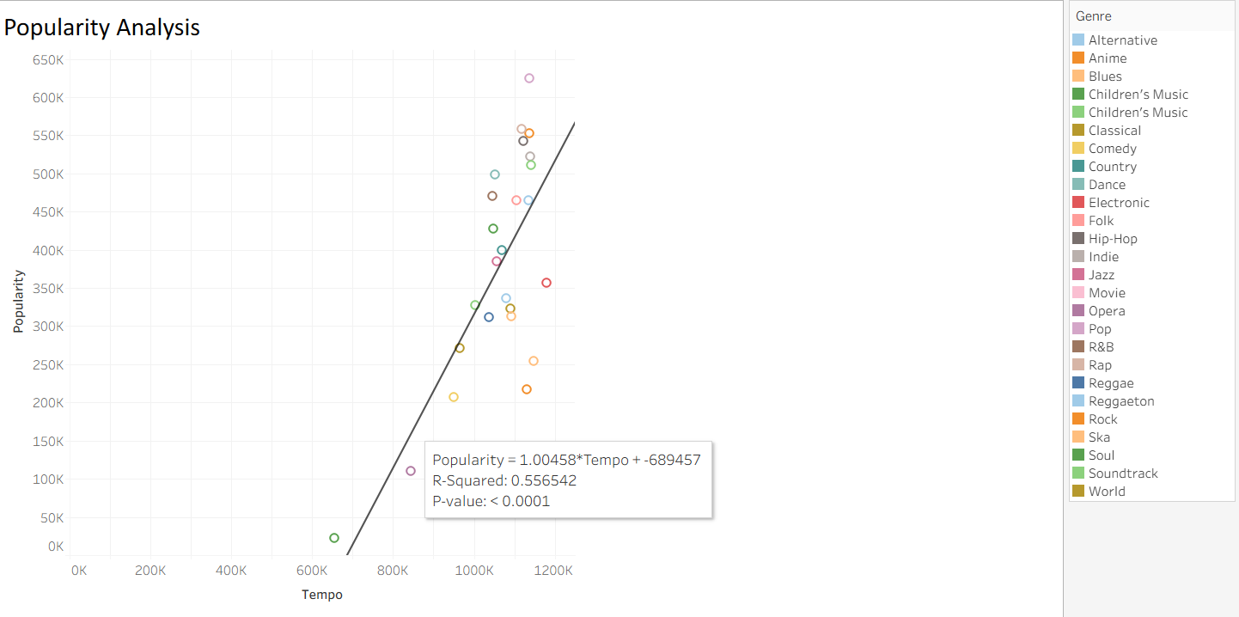  Figure 4  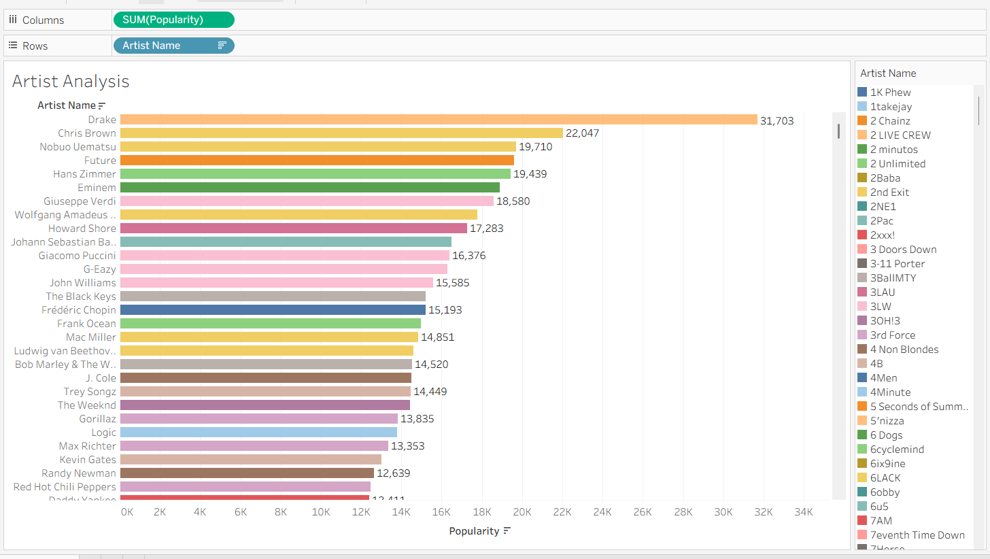  Figure 5  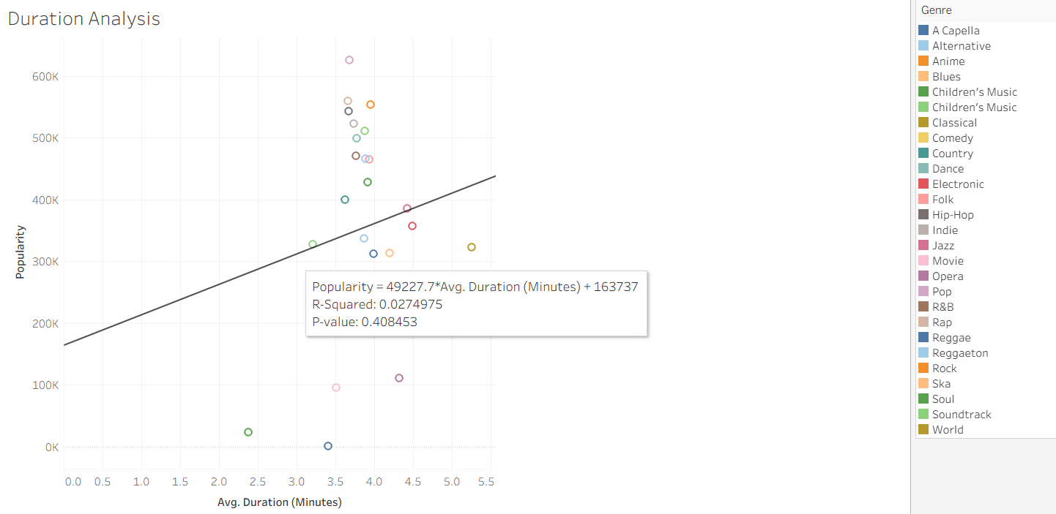  Figure 6  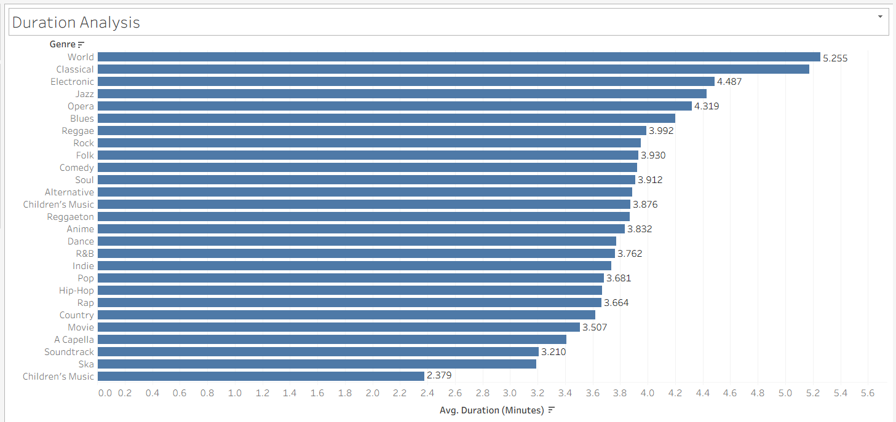  Figure 7

What did you find? | - We can see from fig (1) that Pop is the most popular genre of music on Spotify. While Acapella is the least popular.  - My next step was to see if there was any relationships between Popularity and different measurements. I started with danceability with an R² of 0.50, which shows a slight relationship.  - My next one was Tempo, however there I spotted an anomalous result which was Acapella. I assumed the Spotify method of measuring tempo was not effective for Acapella. After removing this the R² improve from 0.49 to 0.56 so if we assume the decision to remove Acapella is correct, this suggests a slightly stronger relationship for Tempo than there is for relationship.  - After that I chose to rank the Artists separately by popularity, showing that Drake is the most popular artist.  - After transforming the duration from milliseconds to minutes for easier viewing, I compared the average duration to popularity. This however showed a very weak R² of just 0.03 or effectively 0 relationship between how long a song is and how popular it is.  - I then decided to rank each Genre by average duration time to see that World and Classical music where by far the longest. While Children’s Music was the shortest comfortably.

Day 2: Task 2

Using the Health, conduct an analysis to find trends and key information that could be used by an organisation for future support.

There is no set scope for the analysis, simply to find trends and document them below.

- Data can be lifesaving and is being used more within the NHS, reflect on how this data could support decision making for the NHS.

Paste your print screens here | 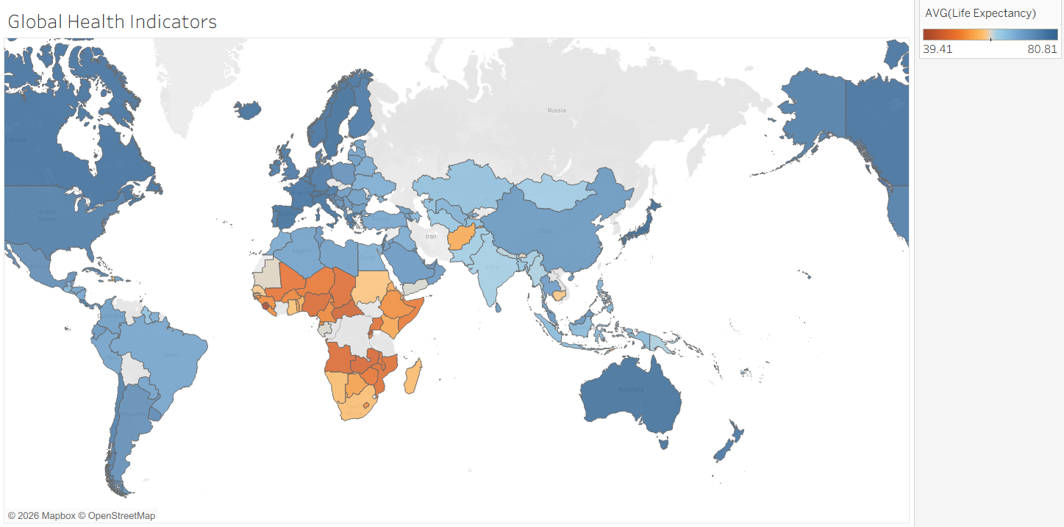  Figure 8  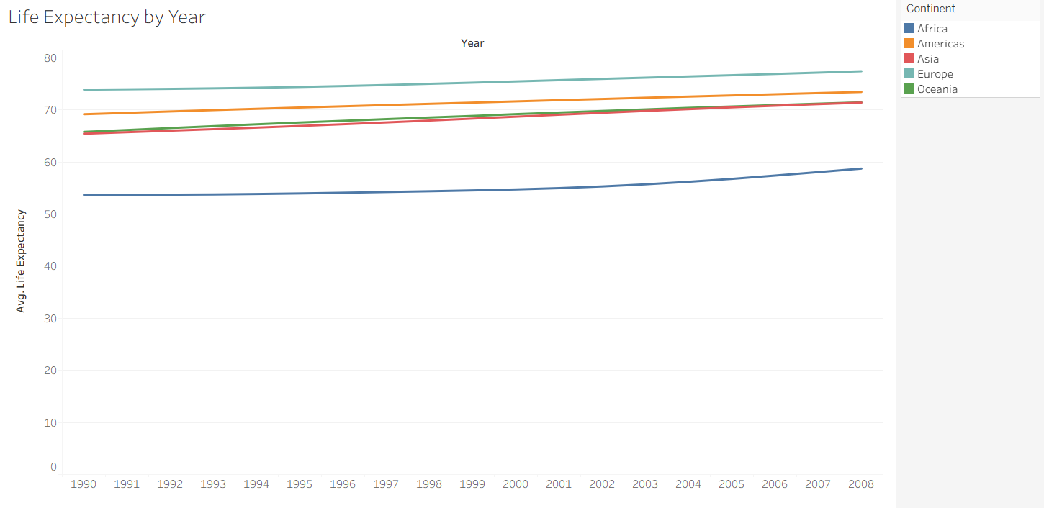  Figure 9  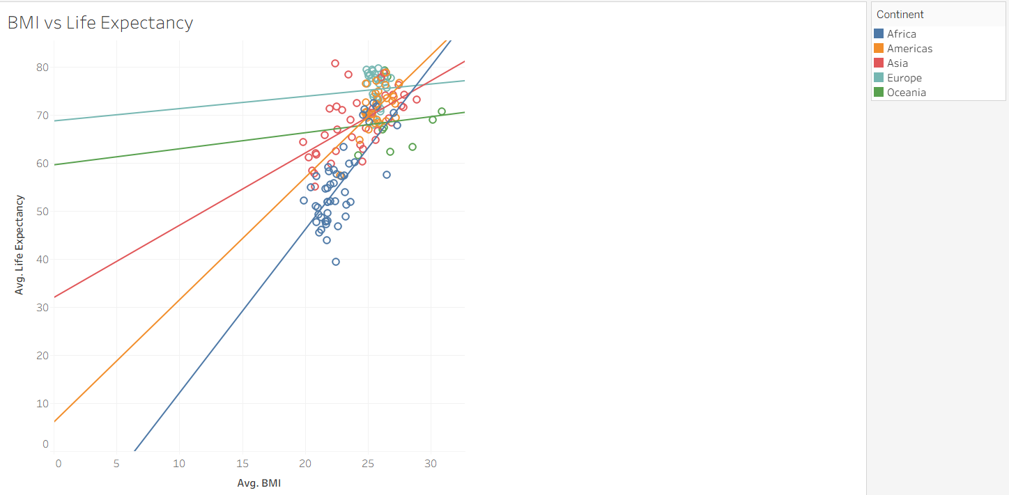  Figure 10  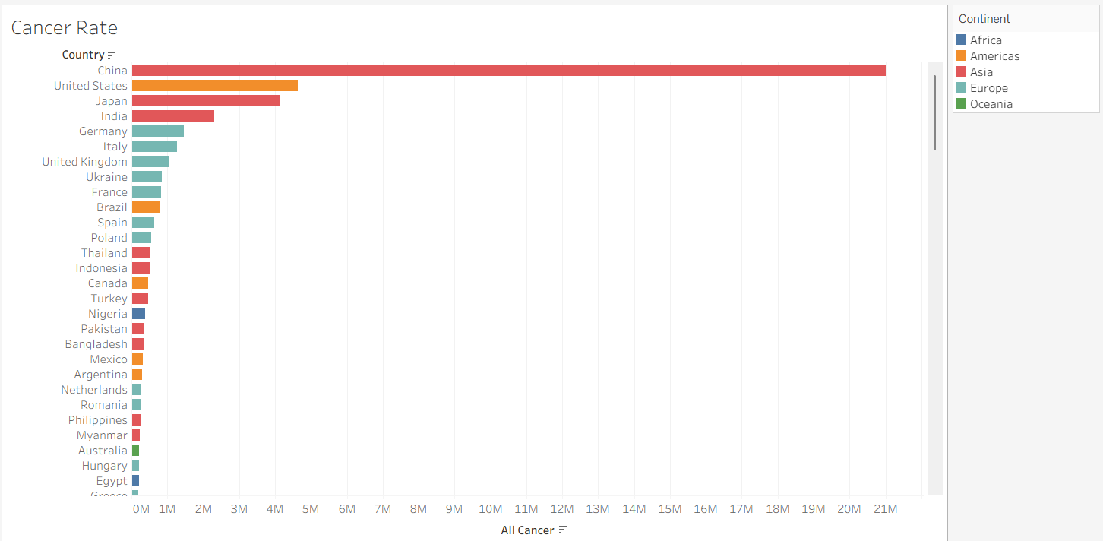  Figure 11  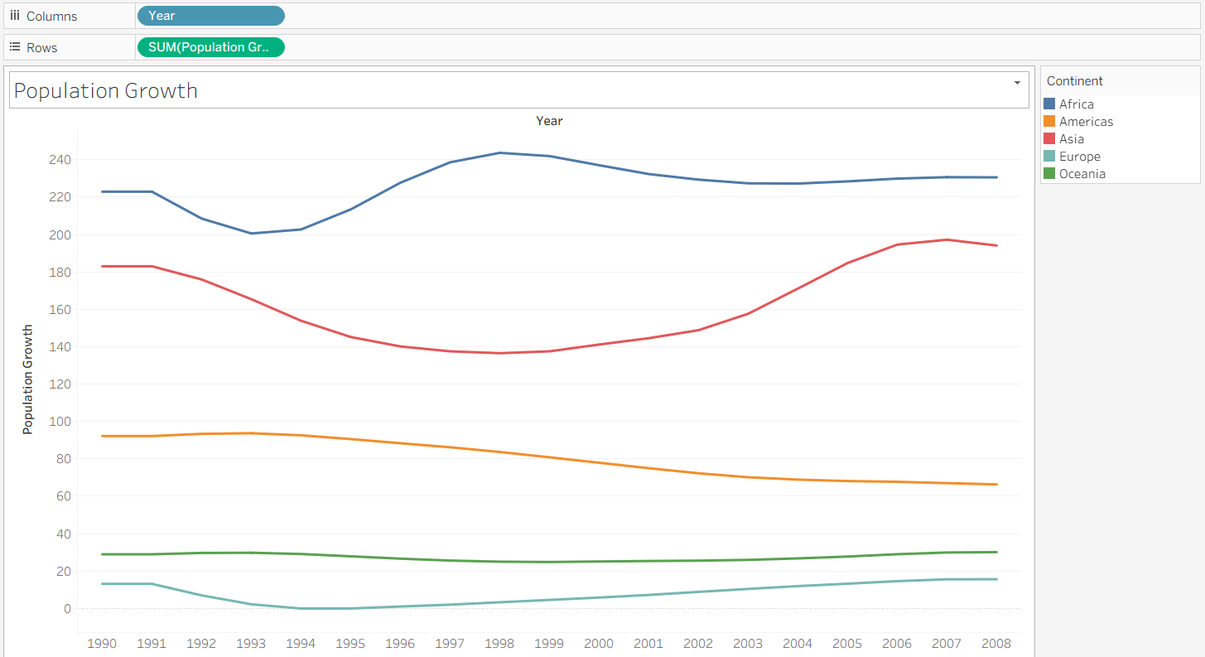  Figure 12  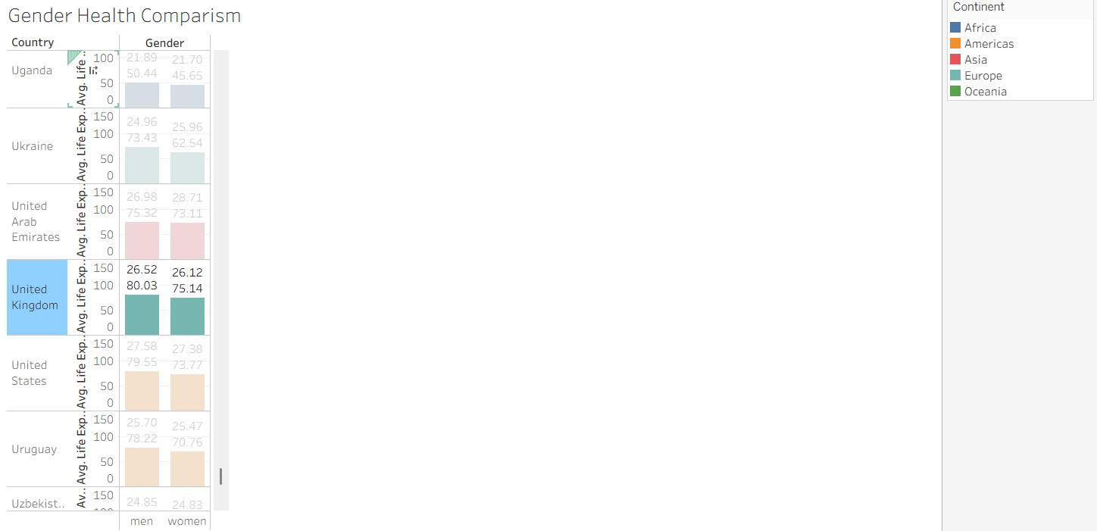  Figure 13  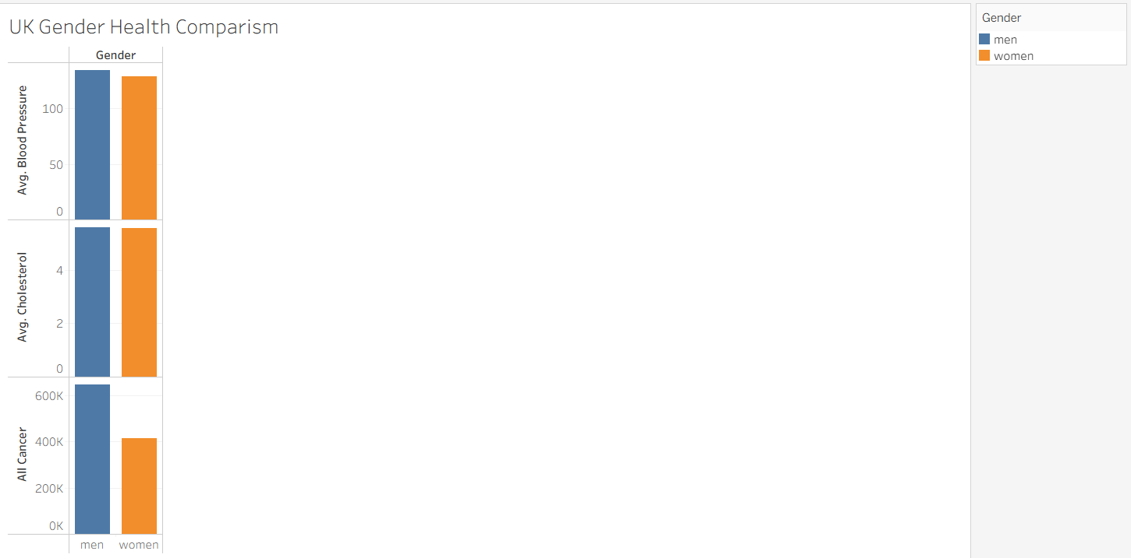  Figure 14  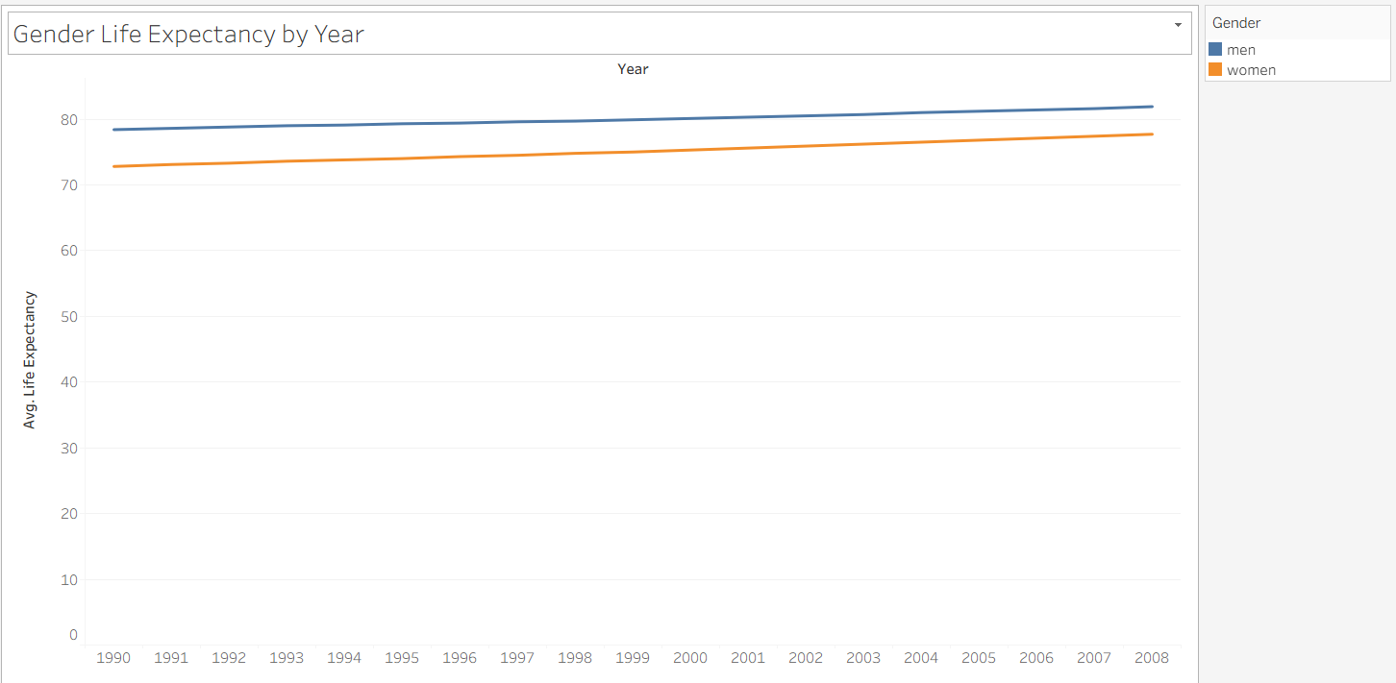  Figure 15
What did you find and any reflections on how the NHS could use this? | - Figure 8 shows that life expectancy is higher in the western world (High income countries) compared to lower income countries (Africa). And thus as the UK is high developed we can expect a lot of older patients.  - Figure 9 shows that life expectancy has grown over time suggesting that in the future the amount of older patients for the NHS will increase.  - Figure 10 is BMI vs Life Expectancy split by continent. Here we have a separation of trends. For Africa we have a strong R² of 0.5, while the Americas and Asia are a weaker 0.35. Finally Europe and Oceania have extremely weak R². What we can learn from this is that the richer the country, the more easily obesity health related issues can be treated, as for Europe there is effectively zero (0.001R²) relationship.  - For figure 11 we view all countries and their rates of cancer. Here China is by far the highest, which could be related to lack of safety issues during their rapid industrialisation which western countries had a hundred years earlier.  - In figure 12 we can see bar Asia all the other continents have seen a stagnation in population growth, however for Asia it has increased dramatically. This suggests the NHS will not have to deal with a rapid population increase.  - In figure 13 I split life expectancy and BMI by gender and focused on the United Kingdom. As expected from Figure 10, as a high income country there is no relationship to BMI. However the gap of 5 years suggests the NHS is not treating female patients as effectively as they could. This could be due to lack of studies for female patients in terms of symptoms and a lack of female doctors.  - To further investigate this, first I compare basic health issues by Gender in figure 14. Then in figure 15 I looked at how life expectancy had changed over time for both genders. Both figures focused on the UK. For Cholesterol and blood pressure there were no differences. While for cancer numbers women saw significantly less cases. That could be slightly explained by a lower life expectancy, but the data suggested the women were just as healthy as men. Figure 15 showed this gap in life expectancy goes back at least as far as 1990. The lack of data suggesting women are unhealthier and the length this goes back supports the theory the true issue lies in how the NHS deals with female patients.

Day 3: Task 1

Please complete Lab 1 ‘Get Data in Power Bi Desktop’. Once complete, paste a print screen below and in the collaboration board.

“Teaching is the best way to learn, so please listen out for support requests from the class and we’ll work through the challenges together”

Paste your completed lab here | 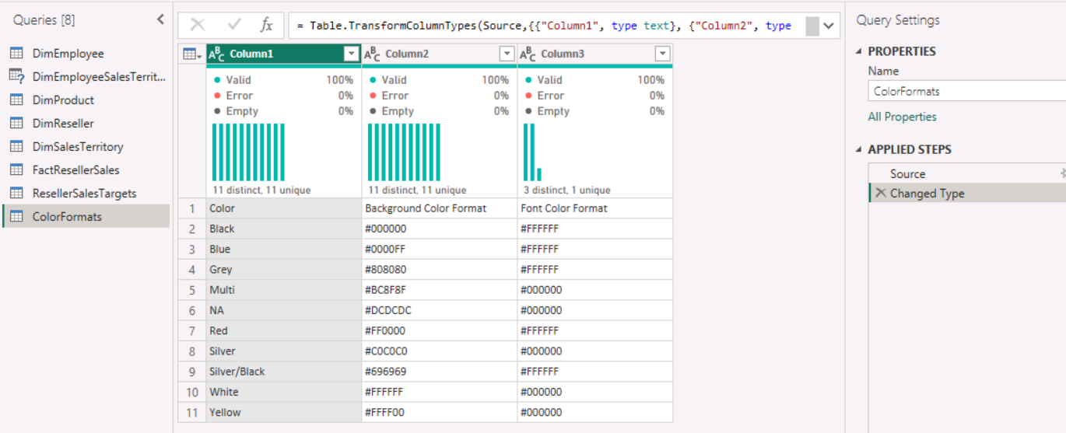

Day 3: Task 2

Please complete Lab 2 ‘Load Transformed Data in Power BI Desktop’. Once complete, paste a print screen below and in the collaboration board.

“Teaching is the best way to learn, so please listen out for support requests from the class and we’ll work through the challenges together”

Paste your completed lab here | 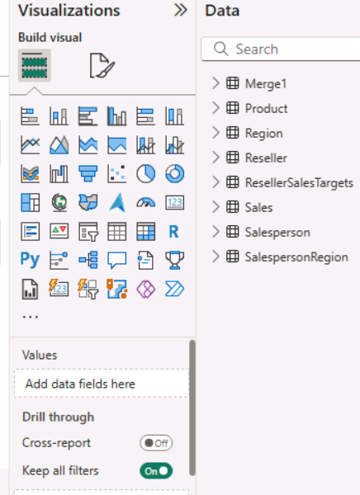

Day 4: Task 1

Please complete Lab 8 ‘Design a Report in Power BI Desktop’. Once complete, paste a print screen below and in the collaboration board.

“Teaching is the best way to learn, so please listen out for support requests from the class and we’ll work through the challenges together”

Paste your completed lab here | As I was unable to connect to skillable, I sent the data from the Microsoft setup to my own computer to publish this data.  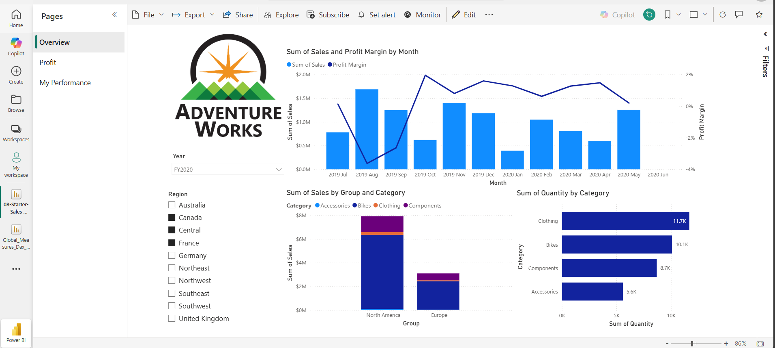

Day 4: Task 2

Please complete Lab 12 ‘Create a Power BI Dashboard’. Once complete, paste a print screen below and in the collaboration board.

“Teaching is the best way to learn, so please listen out for support requests from the class and we’ll work through the challenges together”

Paste your completed lab here | 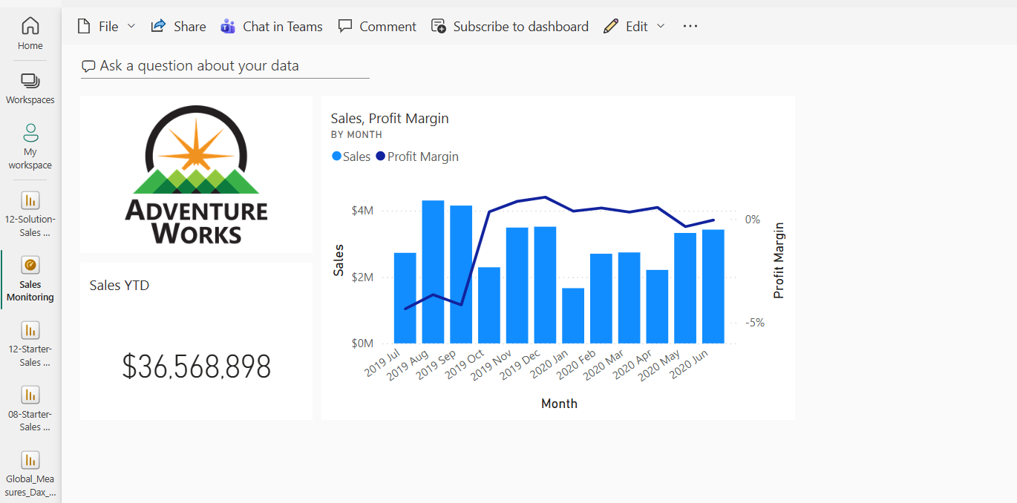

Course Notes

It is recommended to take notes from the course, use the space below to do so, or use the revision guide shared with the class.

We have included a range of additional links to further resources and information that you may find useful, these can be found within your revision guide.

END OF WORKBOOK

Please check through your work thoroughly before submitting and update the table of contents if required.

Please send your completed work booklet to your trainer.

Information

