Data Technician Week 5
Workbook
Azure Data Fundamentals

Name:
Course Date:
Table of contents
Day 1: Task 1 3
Day 1: Task 2 4
Day 1: Task 3 5
Day 2: Task 1 6
Day 3: Task 1 10
Day 3: Task 2 11
Day 3: Task 3 12
Day 4: Task 1 13
Day 4: Task 2 14
1. Scenario Background 14
2. Data Laws and Regulations 14
3. Azure Service Recommendations 14
4. Data Types and Data Modelling 14
5. Data Storage Formats and Structures in Azure 15
6. Additional Considerations 15
Submission Guidelines: 15
Course Notes 18
Additional Information 19

Day 1: Task 1

Please research and complete the below questions relating to key concepts of cloud.

Be prepared to discuss the below in the group following this task.

What can cloud computing do for us in the real-world? | - It allows streaming sites like Netflix exist, without downloading large amounts of data.  - Allows small sites to deal with spikes without wasting money
How can it benefit a business? | - Reduces the cost of purchasing and upkeep of an on-site server.  - Creates scalability as it is much cheaper and cost effective to increase in size. Also it only increases when the site requires it, so you don’t have unused storage that is only required during peaks.  - Allows people to work on the sever away from the site.
What’s the alternative to cloud computing? | - BMC (Bare-metal Cloud), where you can rent physical servers. It allows cloud like access with more security but will cost more and risk having to buy storage that isn’t always needed.  - On-Prem Hosting, where you set up your own server set up on-site. With a good IT team performance will be great and allows for great security. However costs are significantly more, and scalability is slow, so a massive spike in server usage could lead to issues.
What cloud providers can we use, what are their features and functions? | Features AWS Azure GCP  Cost effective Scalability Pricing (Free tier)  Flexibility AI Learning AI Learning  Security Data Backup Debugger

Day 1: Task 2

Please research the below cloud offerings, explain what they are and examples of use cases.

Cloud Offerings | Explain what it is | When / how might you use this service in the real-world?
IaaS (Infrastructure as a service) | Infrastructure as a service, a pay as you go service that provides servers, storage and networking. | A small business that deals with online sales may be fine with a small set up for most days, but during the December period might want it to deal with the surge of orders. Suits someone who wants a lot of control.
PaaS (Platform as a service) | A service that allows you to run applications without the required infrastructure. | A company might use it to run data analysis, especially if an AI is included to allow Machine Learning Analysis. Also allows non coders to create sites.
SaaS (Software as a service) | A service where people access software via the internet. | An example is Microsoft teams, which allows organisations to share files and work together, without having to download lots of files. Any device is capable of working, allowing great connection.

Day 1: Task 3

Please research the below terms and explain what they are, when they would be appropriate and a real-world example of where it could be implemented (i.e. what type of organisation).

Public Cloud | A Cloud Computing model that allows providers to deliver computing resources over the internet via a shared infrastructure. They are appropriate where a business wants a cost effective scalable model.  A small start up that doesn’t have the infrastructure or staff to manage physical infrastructure would find it very useful.
Private Cloud | A Cloud Computing environment that is used by a single organisation. Giving them more control and better security. It is appropriate when a company requires stronger security or more complex functions.  Government organisations which do not need easy public access to private data but it must be kept secure.
Hybrid Cloud | A Cloud computing environment which combines both public and private. Allowing companies to choose what to keep on site or on the public cloud.  It could be used by a company that still has sensitive data it needs to keep private to not break data laws. But doesn’t need to have all of its applications and software on site for cost reasons.  This could be a bank, where the public need access to their data but it must be kept secure in private databases.
Community Cloud | An environment where infrastructure is shared by a group of organisations. They still require hybrid or private models, but the cost is spread out more.  This is appropriate in health care where private data is still needed to be protected, but multiple organisations need the same set up and data.  Another example could be a research project with a number of labs. Here they share the cost while ensuring the private data is kept safe, while also enabling a collective group effort.

Day 2: Task 1

Describe, with examples, the three major areas that the Computer Misuse Act deals with.

Area | Description | Example
Section 1: Unauthorized Access to Computer Material | It is illegal to access data stored on a computer unless you have permission to do so. | An example would be guessing someones password to gain access to their account as it shows intent.
Section 2: Unauthorised Access with Intent to Commit or Facilitate Further Offences | It is illegal to access data on a computer when that data will be used to commit further illegal activity such as fraud or blackmail. | In 2003 a man who worked at a Bank was paid £100 to gain information from other bank details. He was sentenced to four month in jail
Section 3: Unauthorised Modification of Computer Material | It is illegal to make any changes to data stored on a computer when you do not have permsission. | You use a webstresser or booter tool to perform a Distributed Denial of Service (DDoS) attack against a friend, knocking them off an online game.

The computer misuse act 1990 is an act where an individual can be criminalised because of computer related offense. Describe three extra powers that the Police and Justice Act 2006 (Computer Misuse) has added.

Description
- It is illegal to make an object designed for a computer misuse offence
- It is illegal to obtain an object designed for a computer misuse offence
- It is illegal to supply an object designed for a computer misuse offence

Look at the below website to answer the questions:
https://www.gov.uk/personal-data-my-employer-can-keep-about-me

Write down three items of data which a company can store about an employee.
Name
Address
Date of Birth

Give three more examples of data that an employer can only store if they first get the employee’s permission.
Religion
Biometrics
Sexual Orientation

Conduct further research to answer the below questions.

Question | Answer
Provide one example of: Copyright infringement | Sampling an artitsts song to use in your own song without proper credit.
Provide one example of: Plagiarism | Downloading an Essay online from the internet and submitting as your on work at University.
What are two consequences of copyright infringement and software piracy? | Fines with no upper limit  Prison time up to 10 years
Give three possible consequences for individuals when using pirated software | You can suffer from malware that is on the pirated software.  You can be fined  You can be imprisoned

Listed below are some laws which we have covered today:

1. Computer Misuse Act 1990
2. Police and Justice Act 2006 (Computer Misuse)
3. Copyright, Designs and Patents Act 1988
4. Copyright (Computer Programs) Regulations 1992
5. The Health and Safety (Display Screen Equipment) Regulations 1992
6. Data Protection Act 2018
7. Consumer Rights Act 2015
- Insert a number in the first column of each row to match each of the statements with one of the above Acts.

- One of statements is incorrect and not illegal. For this statement, write ‘Not illegal’.

Act number | Clause
3. | With some exceptions, it is illegal to use unlicensed software
7. | Any product, digital or otherwise, must be fit for the purpose it is supplied for
1. | Unauthorised modification of computer material is illegal
2. | It is illegal to create or use a hacking tool for penetration testing
6. | Personal data may only be used for specified, explicit purposes
4. | Employers must provide their computer users with adequate health and safety training for any workstation they work at
2. | It is illegal to distribute hacking tools for criminal purposes
3. | It is illegal to distribute an illicit recording
6. | Personal data may not be kept longer than necessary
1. | Gaining unauthorised access to a computer system is illegal
Not illegal | Employers must ensure that employees take regular and adequate breaks from looking at their screens
2. | It is illegal to prevent or hinder access (e.g. by a denial-of-service attack) to any program or data held in any computer
6. | Personal data must be accurate and where necessary kept up to date

Day 3: Task 1

Please complete the below lab (3) ‘Explore relational data in Azure’ and paste evidence of the completed lab in the box provided.

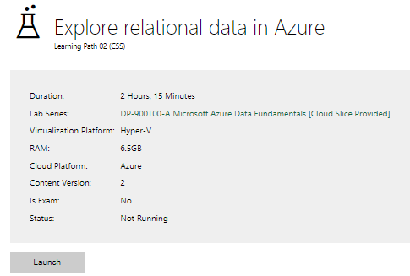

Completed lab | 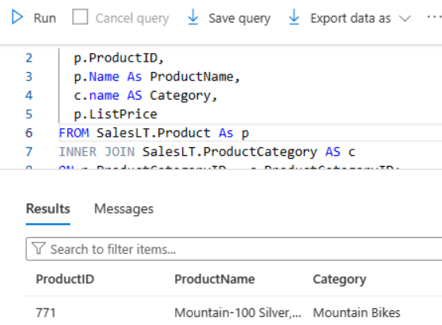

Day 3: Task 2

Please complete the below lab (4) ‘Explore non-relational data in Azure’ and paste evidence of the completed lab in the box provided.

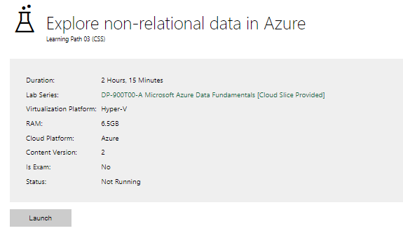

Completed lab | 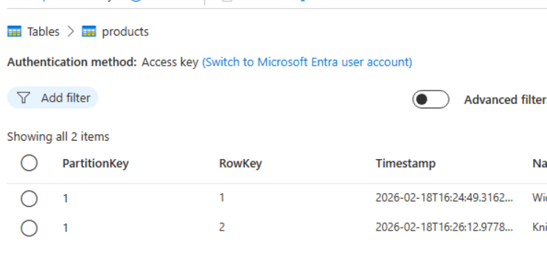  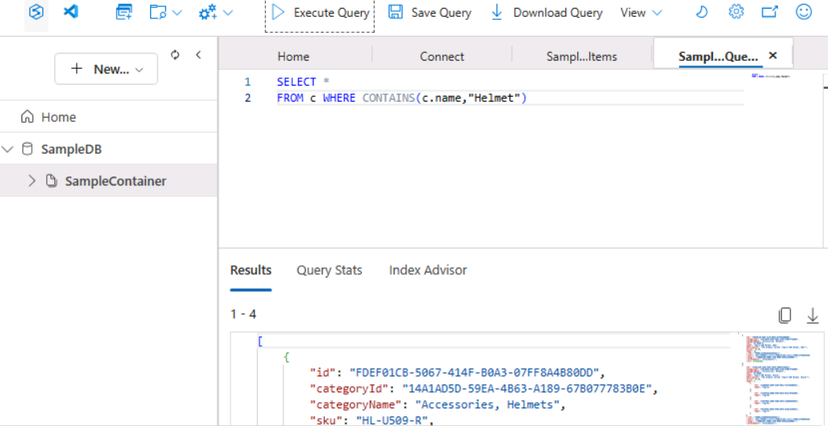

Day 3: Task 3

Please complete the below lab (5) ‘Explore data analytics in Azure’ and paste evidence of the completed lab in the box provided.

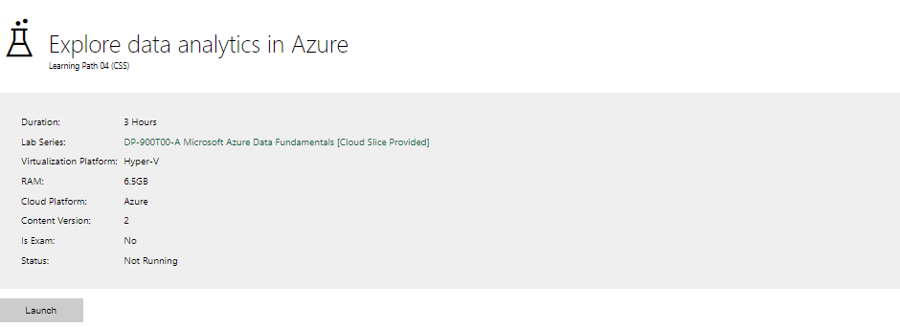

Completed lab | 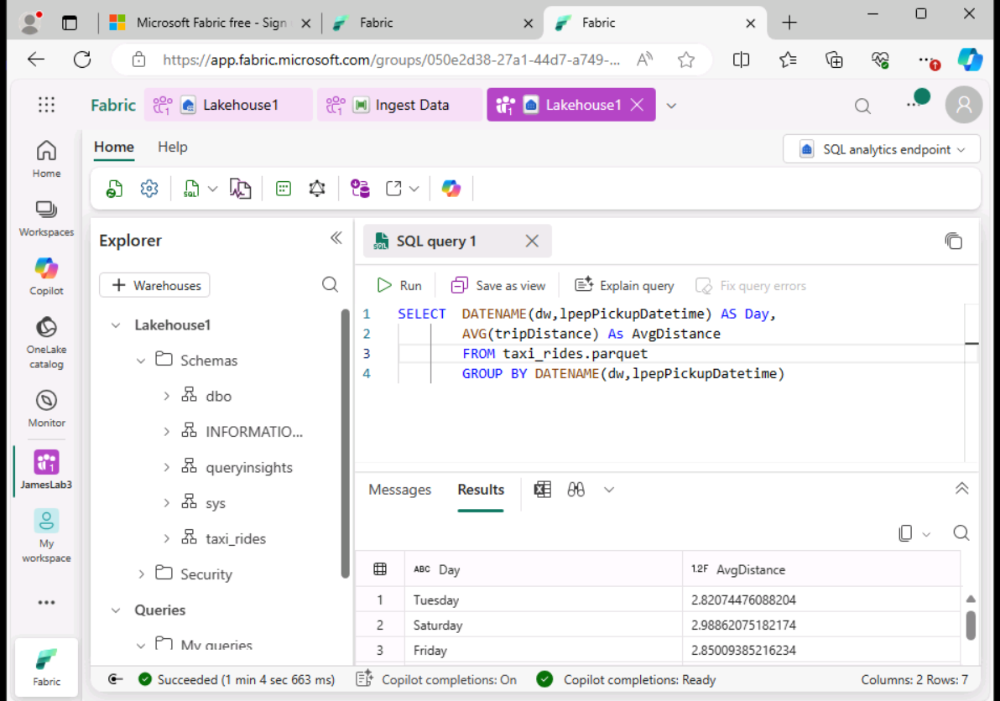  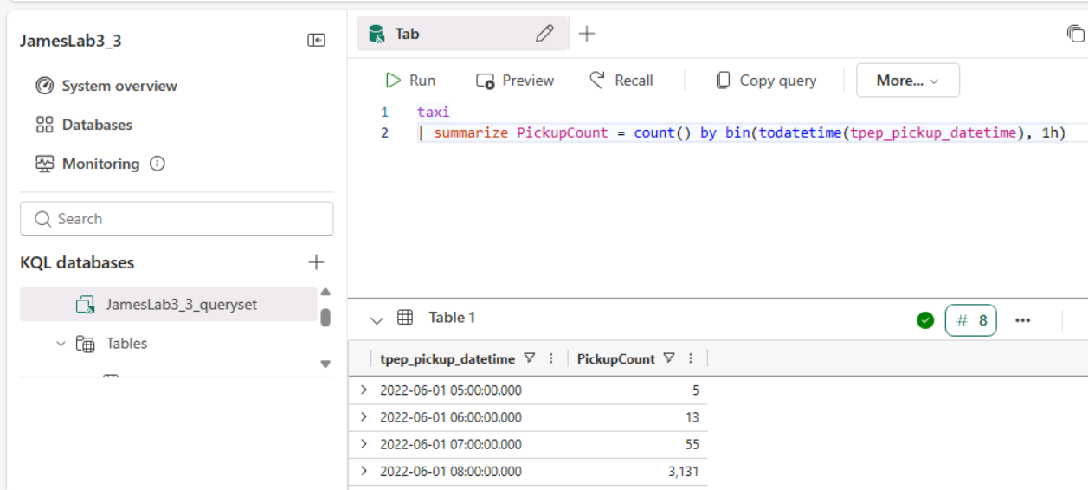  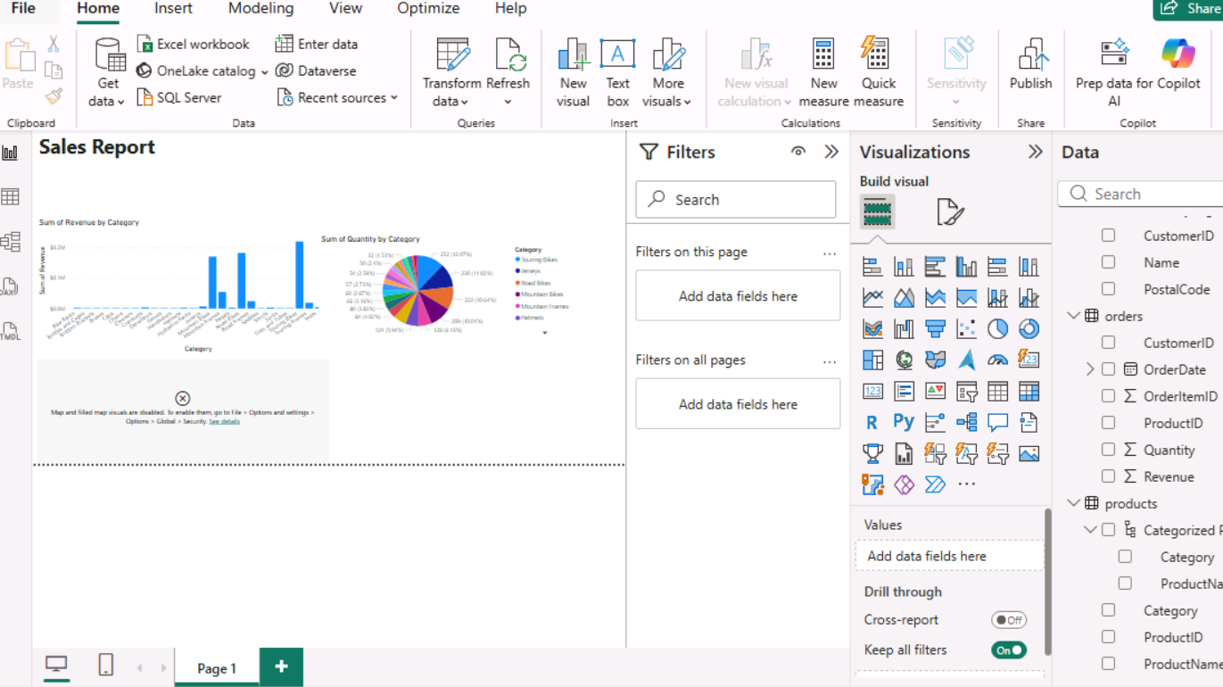  Note, was unable to connect to maps, despite allowing it on option, global, security

Day 4: Task 1

In your teams, complete the Azure DP-900 practice exam and paste your result below – this is open book and please research and discuss your answers as a team.

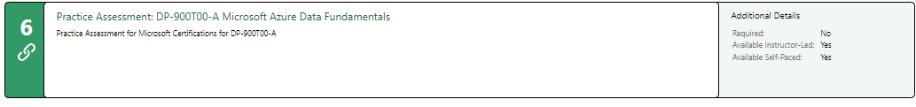
Result | 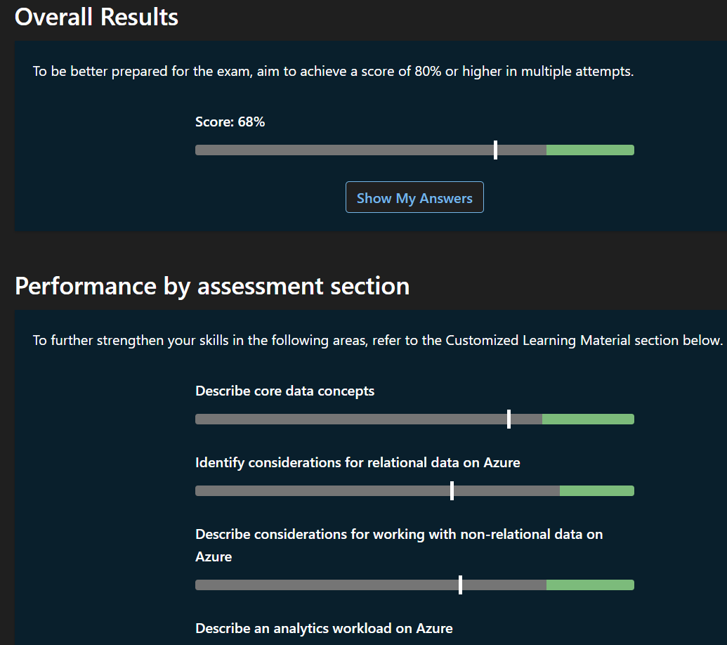

Day 4: Task 2

1. Scenario Background
"Paws & Whiskers" is a growing pet shop that aims to improve its business by analysing sales, customer information, and inventory data. Currently, the data is collected manually or stored in spreadsheets. Management is interested in transitioning to Microsoft Azure to streamline data storage, analysis, and reporting, enabling them to make data-driven decisions.

2. Data Laws and Regulations
Identify and explain the data laws and regulations relevant to handling customer data within the proposal. Ensure you cover the following points:
- GDPR Compliance: Highlight the importance of adhering to the General Data Protection Regulation (GDPR), particularly as it relates to storing and processing customer information.
- Data Protection Act (DPA) 2018: Outline how the DPA 2018 may affect the way "Paws & Whiskers" collects and stores data, ensuring compliance with UK laws on data privacy.
- Other Industry Standards: Research any additional data protection standards or regulations that may apply to pet shop data, particularly if they involve sensitive or payment information.

3. Azure Service Recommendations
Recommend Microsoft Azure services that would suit the company’s data analysis needs and explain why these services are suitable. Your recommendations should include:
- Data Storage: Identify suitable storage options, such as Azure Blob Storage or Azure SQL Database, and discuss the benefits of each for storing large datasets, including inventory, sales transactions, and customer details.
- Data Analysis Tools: Recommend tools such as Azure Machine Learning for customer behaviour analysis or Azure Synapse Analytics for analysing sales trends.
- Data Integration and Automation: Explain how services like Azure Data Factory could automate data collection and integration processes, improving efficiency.

4. Data Types and Data Modelling
Define the types of data "Paws & Whiskers" will need to work with and describe your approach to data modelling:
- Data Categories: Identify key data types, such as customer demographics, transaction history, pet inventory, and product categories.
- Data Modelling Approach: Outline how you would structure this data using a relational model or a data warehouse approach, considering factors like tables, entities, relationships, and primary keys.

5. Data Storage Formats and Structures in Azure
Discuss how you would store data within Azure and the formats you would recommend:
- Data Formats: Specify recommended formats (e.g., CSV for raw data imports, JSON for structured data, Parquet for analytics) and explain why these formats are suitable for specific data types.
- Data Security and Encryption: Include recommendations for securing data using Azure’s built-in encryption features and access controls to ensure compliance with data privacy regulations.

6. Additional Considerations
Provide any other considerations that might enhance data handling and efficiency in Azure, such as:
- Backup and Disaster Recovery: Outline a backup plan using Azure Backup or Azure Site Recovery to safeguard against data loss.
- Data Visualisation: Discuss potential use of Power BI within Azure for creating dashboards that provide management with real-time insights into sales and customer trends.
- Future Scalability: Comment on how Azure services can scale as the business grows, accommodating larger datasets and more complex analyses.

Submission Guidelines:
- Structure: Ensure your report is well-organised, with sections for each task (e.g., Data Laws, Azure Services, Data Types, etc.).
- Formatting: Include headings, bullet points where appropriate, and any visuals or diagrams that support your explanations.
- References: Cite any resources or regulations referenced in the report.
- Length: Aim for 1500-2000 words.

Summary
"Paws & Whiskers" is currently at a pivotal growth stage. Transitioning from manual, spreadsheet-based data management to a modern cloud infrastructure on Microsoft Azure will provide the scalability, security, and analytical depth required to compete in the modern pet retail market. This proposal outlines a comprehensive roadmap for implementing a data-driven ecosystem that complies with UK legal standards while enabling advanced business intelligence.

Data Laws and Regulations
Handling customer data requires strict adherence to legal frameworks to protect privacy and avoid significant financial penalties.
GDPR Compliance
The General Data Protection Regulation (GDPR) is the cornerstone of data privacy for any business operating within the UK. For "Paws & Whiskers", compliance is the foundation of customer trust, especially as the business processes sensitive personal identifiers such as names, contact details, and purchase histories. To ensure compliance, we will adhere to the following principles:
- Lawful Basis for Processing: We will identify a specific legal reason for every data point collected (e.g., "Contractual Necessity" for shipping pet supplies or "Consent" for marketing newsletters).
- Data Minimisation: The shop will only collect data that is strictly necessary. For example, we will not store a customer’s date of birth unless required to verify age for specific restricted products.
- Rights of the Data Subject: We will uphold the customer's "Right to be Forgotten" and "Right of Access." Azure’s data lifecycle management tools will be used to automate the deletion or retrieval of customer records upon request.
Data Protection Act (DPA) 2018 & Data (Use and Access) Act 2025
The DPA 2018 (and its 2026 updates via the Data (Use and Access) Act 2025) provides the UK-specific framework for compliance.
- The 2025 Update: As of 2026, the law has introduced "Recognised Legitimate Interests." This allows "Paws & Whiskers" more flexibility to process data for specific purposes (like fraud prevention or basic business analytics) without needing fresh consent for every minor internal use, provided the impact on the customer is low.
- Accountability: The shop must maintain a "Record of Processing Activities" (ROPA). Azure’s Purview service can automatically scan our databases to map out where sensitive data lives, making audits simple.
- Security Principle: The law mandates "state-of-the-art" security. Using Azure’s enterprise encryption meets the legal definition of "appropriate technical measures."
Other Industry Standards
- PCI DSS: To handle card payments securely, we will utilize tokenization via Azure-compatible gateways (e.g., Stripe). This ensures raw card data never touches our servers, drastically reducing compliance costs. For physical sales, Point-to-Point Encryption (P2PE) terminals will be used, while Azure Key Vault will secure the API keys used for bank communications.
- DMCC Act 2024: If offering subscription services (e.g., monthly pet food), this law mandates transparent "reminder notices" before renewals and a "one-click" cancellation process. Azure’s automated logic apps can be used to manage these notifications and maintain compliance.

Azure Service Recommendations
To support efficient data storage, processing, and analysis, a modern data warehouse architecture is recommended. The following Azure services have been selected to meet the business and analytical needs of Paws & Whiskers.
Data Storage: Speed vs. Scale
- Azure SQL Database: It will house the structured tables for daily operations—sales totals, customer IDs, and inventory levels. It is highly resilient and allows for real-time inventory updates.
- Azure Blob Storage: It will be used to store raw CSV exports from legacy systems, product high-res images, and CCTV footage from the physical shop. It is significantly cheaper than a database for storing unstructured files.
Data Analysis: From Reports to Predictions
- Azure Synapse Analytics: This service bridges the gap between the shop's database and big-picture reporting. It can handle billions of rows of data, allowing management to compare this year's Christmas sales against the last five years in seconds.
- Azure Machine Learning: We can implement a "Churn Prediction" model. The AI looks at customers who haven't visited in 3 months and suggests a targeted "We Miss Your Dog!" coupon to bring them back.
Data Integration and Automation
- Azure Data Factory: It will automate the extraction, transformation, and loading (ETL) of data from spreadsheets, databases, and other sources into Azure. This service reduces the need for manual data entry, improves data accuracy, and ensures consistent and reliable data pipelines. By automating data integration, it allows data analysts to focus more on analysing insights rather than preparing data.

Data Types and Modelling

Data Categories
Key data types include structured and semi-structured data
P&W need structured data to understand buying behaviour, profitability and demographics
Customer data - Customer ID , Full name, Email / phone, Address, Age group, Loyalty membership status, pet type (dog, cat, bird, etc.)
Transaction table- Transaction ID, Date & time, Customer ID (foreign key), Product ID, Quantity, Unit price, Discount applied, Payment method, Store location (if multiple branches)
Inventory- Product ID, Product name, Supplier, Stock quantity, Reorder level, Cost price, expiry date, Warehouse/store location
P&W need semi-structured data for sentiment analysis
Feedback- Online reviews (JSON format), Website clickstream data, Social media feedback
Use a star schema dimensional model to support analytics and reporting in Azure, with the following tables;
FactSales: TransactionID, DateID, CustomerID, ProductID, Quantity, TotalAmount, Discount
DimCustomer: CustomerID, Name, AgeGroup, Location, LoyaltyStatus
DimProduct: ProductID, ProductName, Category, Brand, PetType
DimDate: DateID, Day, Month, Quarter, Year
DimStore (if applicable), StoreID, Location, Manager

Data Modelling Approach
There are two approaches to modelling the data
Online Transactional processing for the company's daily transactions
Online Analytical processing for Business analysis and reporting

Online transactional System
Using Azure SQL Database:
The proposed database design follows a relational data model implemented in Azure SQL Database.
The structure ensures:
Data integrity through primary and foreign keys
Reduced redundancy
Scalable reporting capability
Clear relationships between customers, transactions, and inventory

Tables:
Customer data - Customer ID , Full name, Email / phone, Address, Age group, Loyalty membership status, pet type (dog, cat, bird, etc.)
Transaction table- Transaction ID, Date & time, Customer ID (foreign key), Product ID, Quantity, Unit price, Discount applied, Payment method, Store location (if multiple branches)
Inventory- Product ID, Product name, Supplier, Stock quantity, Reorder level, Cost price, expiry date, Warehouse/store location

Entity Relationships
One-to-Many Relationships
- One Customer → Many Transactions
- One Product → Many Transactions
This ensures:
- Sales analysis per customer
- Sales analysis per product
- Inventory tracking per item

Data Warehouse Model (Online Analytical Processing)
Using Azure Synapse:
Star Schema Approach
FactSales (Fact table)
DimCustomer
DimProduct
DimDate
DimStore
This improves performance for reporting and BI tools.

Recommended Data Formats
CSV will be suitable for customer lists, simple sales transactions and tracking inventory because it is widely supported between different tools. It is a simple format for small to medium datasets and allows quick backups and manual inspections if needed.
Example: daily sales can be stored in CSV for processing and archiving.
Parquet will be suitable for large datasets used for reporting, trend analysis or predictive analytics because this format reduces storage costs and improves readability for analytical workloads. Also, it supports updating schema, allowing new columns to be added without breaking existing data pipelines.
Example: monthly sales data can be stored in Parquet format in Azure Data Lake to enable fast aggregation and analysis using Azure Synapse Analytics
5. Data Security and Encryption
The security of the database is important because there has to be compliance with Laws like GDPR, any governing bodies and maintaining the relationships with the customers that have led to the businesses success. The following is our recommendations for security and encryption of our customers' data to ensure the company is compliant:
· Microsoft Defender with cloud: This anti-virus suite contains everything that is needed to protect from threats that can lead to cyber-attacks. These include threat protection and compliance management for Hybrid data models.
· Firewalls: A firewall protects against any malicious network traffic that may enter your system/database. The Firewalls program allows you to monitor the traffic coming into your database and stop any malicious requests from getting to your database and corrupting your data
· Multi-Factor Authentication: When logging into a system, there needs to be an extra layer of protection other than logging in with your details and password. That’s where multi-factor authentication or M2A comes in. It asks the user logging in for 2 methods to log into a system. This can be a password and number generated by the Microsoft Authenticator app to provide that extra level of security and protect your records stored on the database further.

Additional Considerations
Azure Backup is a failsafe in the cloud that that can be provided via the Azure Recovery Series Vault. It allows us to back up our on-premises files would ensures our hybrid model is protected from on-site hardware failures. We can use a LRS (Locally redundant Storage) as a cost effective method for dealing with local hardware failures. We would schedule, daily, weekly and monthly backups.

Power BI is a strong tool that would allow us to easily create sales reports where we could filter by category of product and by time as well. Sharing it on the Power BI service would allow us to access these reports when not on site. While its report method allows us to compare multiple graphs at the same time, which makes analysing trends easier to visualise.

Since we are a growing business Azures structure is very helpful. Our storage needs will grow along with business growth which ensures the cost of using Azure shouldn't become too high. As we grow we would be able to explore other options such as whether a GRS (Geo-Redundant System) backup would be a safer option. The cloud based structures also means that if we grew into multiple sites, we would be able to combine the databases from multiple sites and compare and analyse together.

Course Notes

It is recommended to take notes from the course, use the space below to do so, or use the revision guide shared with the class:

Additional Information
We have included a range of additional links to further resources and information that you may find useful, these can be found within your revision guide.

END OF WORKBOOK

Please check through your work thoroughly before submitting and update the table of contents if required.

Please send your completed work booklet to your trainer.

