James Meyers
27-JAN-18
EECE-5698

---- Robotics Lab 01 ----

Purpose: To learn the basics of how to use LCM for robotics, how to create a device driver from scratch, and learn about the errors in location sensing of a given gps sensor. Given a USB GPS receiver, a device driver was designed in python to work with an LCM script in order to take 10 minutes of data in one location. Based on errors, a distribution can be made to estimate our position when moving. Data was then collected when walking in a straight line for approximately 1 minute. Matlab was used to analyze this data and come to conclusions about GPS navigation.

Resources:

- GlobalSat BU-353-s4 USB GPS receiver: This was used to make our location measurements (see appendix 1 for specs)

- LCM (Lightweight Communications and Marshalling): LCM is a set of libraries and tools for message passing and data marshalling, targeted at real-time systems where high-bandwidth and low latency are critical. [1]

- UTM python library: Bidirectional UTM-WGS84 converter for python. Converts Latitude (lat) and Longitude (lon) to UTM (Universal Transverse Mercator) coordinates based on the World Goedetic Survey of 1984. [2]

- MATLAB: used to import and analyze data from LCM logs

Procedure:

- Complete LCM tutorials included in lab 1 handout
- Use the exercises above to build a device driver for a GPS receiver. We want to log all the $GGPGA messages and parse them out. In addition to the device driver for the gps please also spawn off a logger process that logs files on an hourly basis.
- Build a struct that includes typedefs for time, lat, lon, and altitude.
- Test this with the real puck (outside!!).
- Also make sure that you can compile the gps struct so that lcm-spy can show you statistics about it in real time.
- Expand device driver to include utm_x, utm_y where these are calculated in-situ with the help of the utm package.
- Now go outside and collect 10 minutes of data at one spot.
- Read this data into matlab (with the lcm_read.m provided) and do a 2D plot of utm_x vs utm_y. What does this say about GPS navigation? Look at the error estimates. What can you say about the distribution of noise in the signal.
- Now start logging again outside and walk in a straight line for about a minute. Plot the trajectory of the GPS hits.
- In addition to checking in your code, write this lab up into 4-5 pdf slides which highlight your data and its analysis.
- Upload files to gitlab repo and email instructors of completed work.

Experiment:

- LCM tutorials were completed, providing examples of code similar to the files to be created for this lab
- Generated structure called “gps_location” with typedefs for timestamp, lat, NS, lon, EW, altitude, utm_x, and utm_y.
- Ran ./gen-types.sh to create exlcm folder and generate necessary files for lcm
- Ran ./buildjar.sh to create necessary jar files to be called in script
- Created script called “run” to run lcm-logger, lcm-spy, and python driver for usb driver (see appendix 2)
- Created USB driver called gps_bu353_s4.py (see appendix 3)
- Confirmed that ./run executed lcm-spy, lcm-logger, and gps_bu353_s4.py driver for GPS indoors.
- Collected 10 mins of data outside in one location in Quincy, MA
- Collected approximately 1 minute of data walking in a straight line in Quincy, MA
- Opened data in Matlab and plotted both stationary data (to estimate distribution) and walking data.

Results/Analysis:

- USB Driver: found USB port by examining files in /dev/ before and after GPS receiver was plugged in. Found port called ttyUSB0. Tested with “sudo minicom” command creating settings (alt +a +z +o) for dev/ttyUSB0 port with a baudrate of 4800 (per specification sheet). Confirmed GPS signals were readable and $GPGGA signals needed were coming through.

Created all necessary files (gps_location structure, run script, and gps_bu353_s4.py driver) and executed necessary files (./gen-types.sh and ./buildjar.sh) before executing ./run. This caused lcm-logger to log all messages received by GPS receiver, lcm-spy to show livetime updates of GPS messages (running at approximately 1 Hz), and gps_bu353_s4.py driver to run. Ultimately this created lcm logs of GPS data to be analyzed later. This test was succesful for running lcm-spy, lcm-logger, and the gps driver.

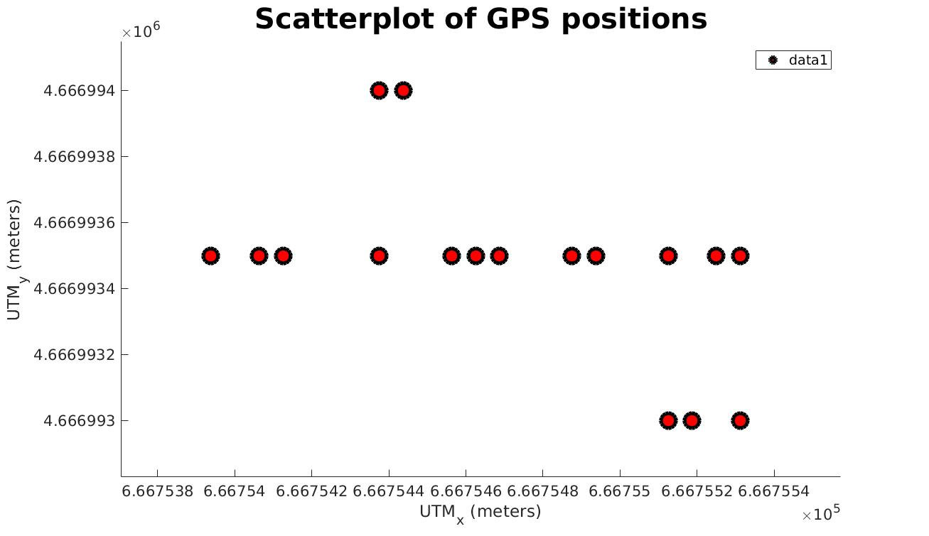
- Stationary GPS Data: Now that the gps driver was working and data could be logged via lcm-logger, a test was conducted in Quincy, MA by collecting 10 mins of data in one location outside. This data was logged to the file “lcm-log-2018-01-24-20:03:10”. The data from this file was then imported into Matlab for analysis, primarily the utm_x and utm_y coordinates. There were 734 separate data points, many overlapping, shown below as a scatter plot.

The two plots below are fitted histograms of both utm_x and utm_y with a normal distribution assumed. This was done using the histfit function as follows for utm_x: histfit(x,’Normal’)
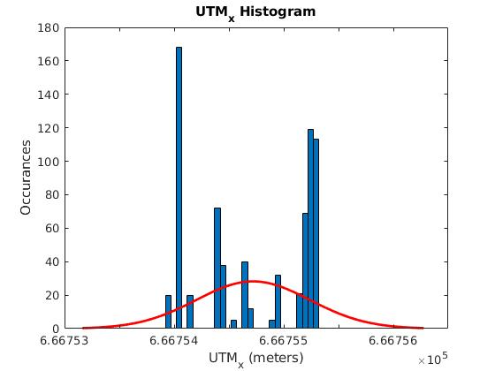
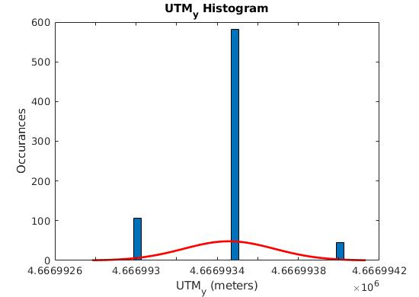

While the utm_y data may have a nearly Gaussian distribution, the utm_x data appears more random and not easily approximated. Some other distibutions were tested (kernel, poisson, inverse normal, etc), but none seemed to fit the curves of the data collected, so normal was assumed. Below are the mean and standard deviations for both the utm_x and utm_y data.

pdx =
Normal distribution
mu = 666755 [666755, 666755]
sigma = 0.518826 [0.493575, 0.546821]

pdy =
Normal distribution
mu = 4.66699e+06 [4.66699e+06, 4.66699e+06]
sigma = 0.224619 [0.213687, 0.236739]

The standard deviation of the utm_y data is significantly smaller than utm_x and the normal Gaussian distribution far better fits the data. This discrepancy could be due to a large number of factors including nearby building interference, low number of data points (734 in this case), or sensor inaccuracies.

Despite some of these possibilities, the data still shows that the standard deviation of utm_x and utm_y position is approximately 0.52 meters and 0.22 meters respectively. While this is based on what is seen to be a poor assumption of distibution for utm_x in particular, it shows that we can be relatively certain we’re within a few meters of our location given by the gps receiver.

Through greater statistical analysis, this certainty can be greatly improved as shown by an interesting article from GPSworld.com [4]

- Walking GPS Data: Data was collected while walking in a straight line for approximately 1 minute in Quincy, MA. The data was saved as an lcm log and imported into Matlab for futher analysis. The plot below shows the plot of utm_x and utm_y position as well as a linear and quadratic fitted curve. The residuals between the plotted utm_x and utm_y positions and the estimated curves are shown in the plot below. The plot below that is a 1:1 ratio of utm_x and utm_y compared to a google maps image of the walking path next to it. Its quite evident that even with some slight human error introduced by not walking an exactly straight line that the gps is not providing accurate estimations of position. The gps output very roughly demonstrates the point the walking started, ended, and the direction taken to get there, but has up to 3 meters of error. This is all assuming that the linear and quadratic fits are the actual path taken which is a generally poor assumption.

Overall, one can assume based on these findings that the gps receiver provided gives very rough estimates of location, but has errors on the order of approximately +/- 3 meters without any additional statistics or math to increase accuracy or certainty of position.

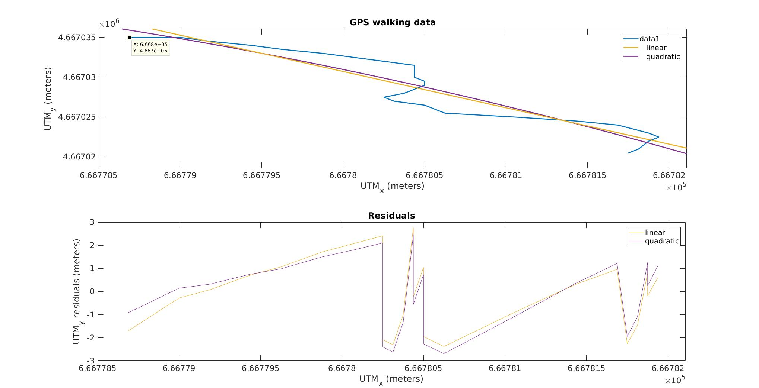
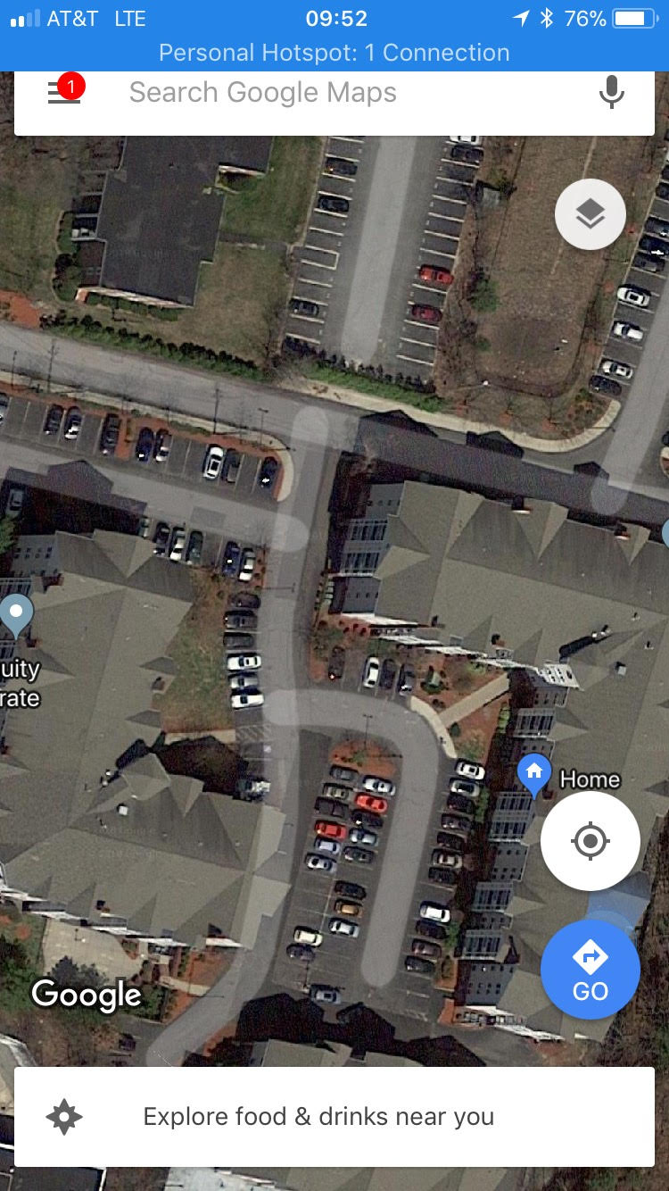
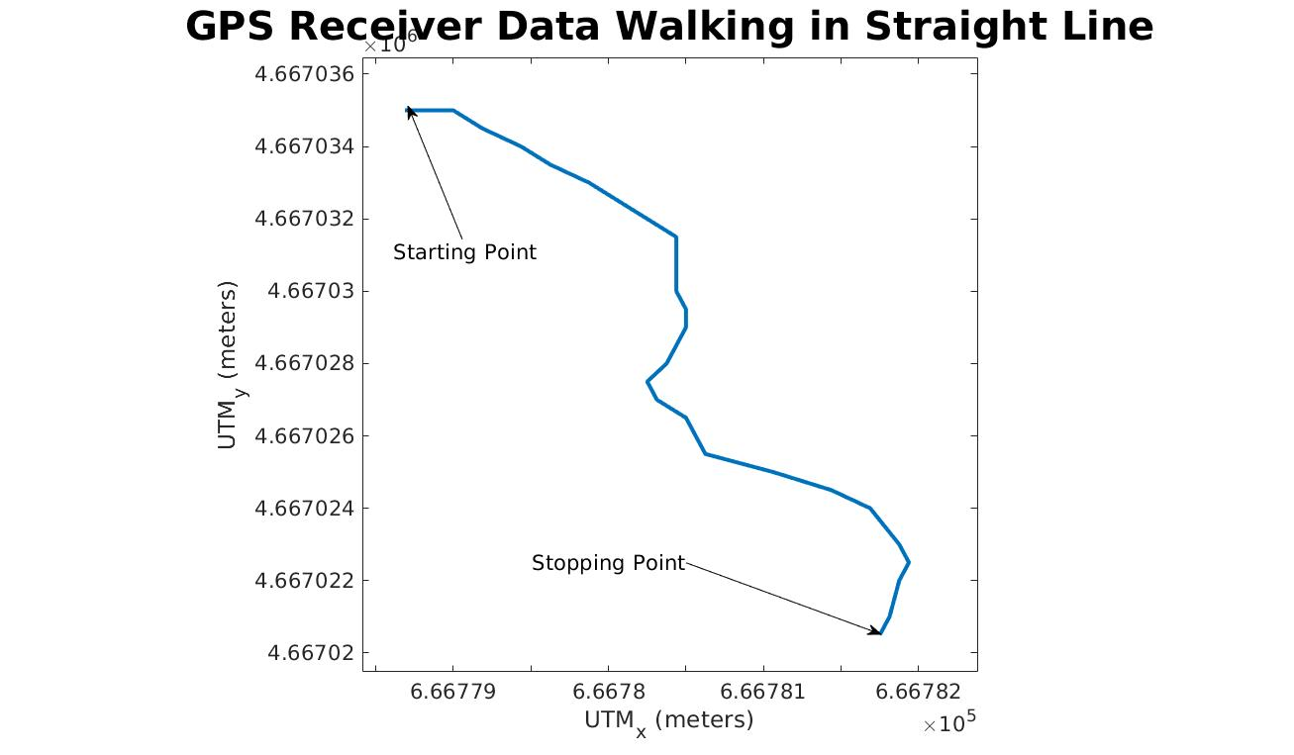

Starting Point
Stopping Point

- Matlab Analysis: There were issues with the lcm_read.m file provided, so a python script called “read-log-gps.py” was created to read lcm log files and output them to comma delimited text files. This data was then brought into Matlab for analysis. The issue with the lcm_read.m file was with accepting the java classes within the generated jar file. Despite using the javaaddpath matlab command for all possible folders or files that would allow the classes to be recognized in Matlab, there were still issues. The gps_location java classes were in the exlcm folder of the working directory and running “jar tvf my_types.jar” showed the gps_location as one of the available classes, so the issue is still unresolved. The workaround involved reading lcm-log files and outputing desired data to txt files to be read into Matlab which was not optimal, but also resulted in the ability to read the lcm-log data and analyze it.

In this lab, we installed LCM (accronym) and the utm (acronym) library for python in order to create a device driver for the (gps driver name). All files are uploaded to https://gitlab.com/Meyers.Jam/EECE-5698/lab1

[1] https://lcm-proj.github.io/
[2] https://pypi.python.org/pypi/utm
[3] http://usglobalsat.com/store/downloads/NMEA_commands.pdf
[4] http://gpsworld.com/gps-accuracy-lies-damn-lies-and-statistics/

