IMDb Top 1000 Movie Data Analysis Project
Prepared by: James Nuccini
Date: April 2025

Introduction
This project explores the IMDb Top 1000 Movies dataset with the goal of uncovering trends in genre frequency, director quality, audience engagement, and historical rating patterns. The dataset was cleaned and analyzed in Microsoft Excel using Power Query, pivot tables, and visualizations. The final deliverables include this report and a companion Excel workbook containing all pivot tables and charts.

Data Cleaning Summary
Initial cleaning addressed null values, formatting inconsistencies, and column standardization. Power Query was used to split multi-genre entries into separate rows to allow meaningful analysis. A new column was created to group movies by decade using a calculated formula: INT(Year/10)*10. All changes were documented in a Cleaning Log and performed on a copy of the original dataset to preserve integrity.

Analysis & Visuals

1. Most Common Genres
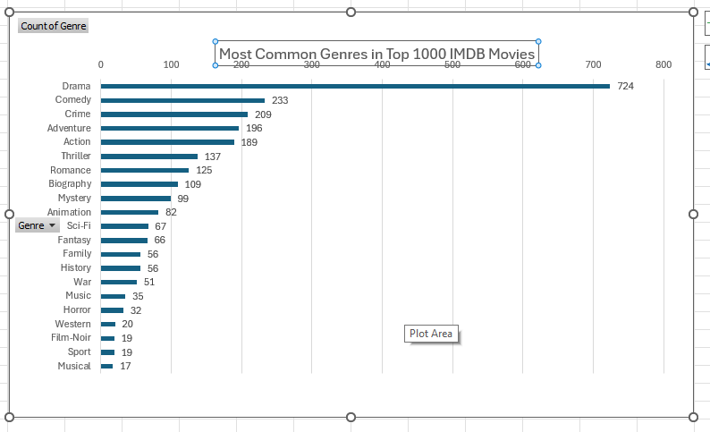
Drama was the most common genre among the top 1000 IMDb films, followed by Comedy and Crime. This suggests that serious, character-driven narratives dominate critical and audience acclaim.

2. Average IMDb Rating by Genre
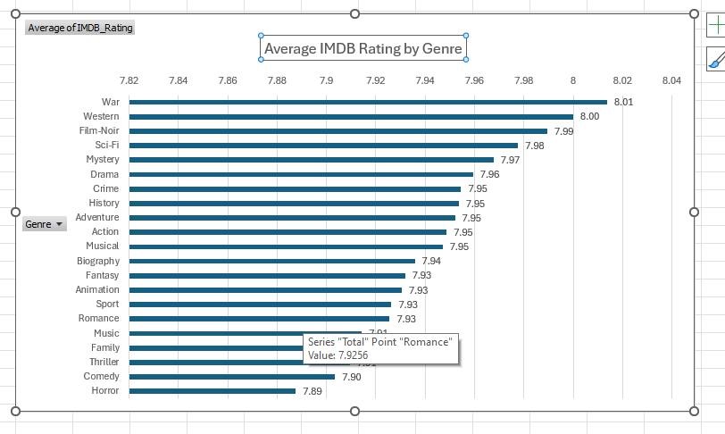
The range of average IMDb ratings across genres was narrow (7.89 to 8.01). Genres like War, Western, and Film-Noir had slightly higher average ratings, suggesting strong critical reception despite lower frequency.

3. Average IMDb Rating by Decade
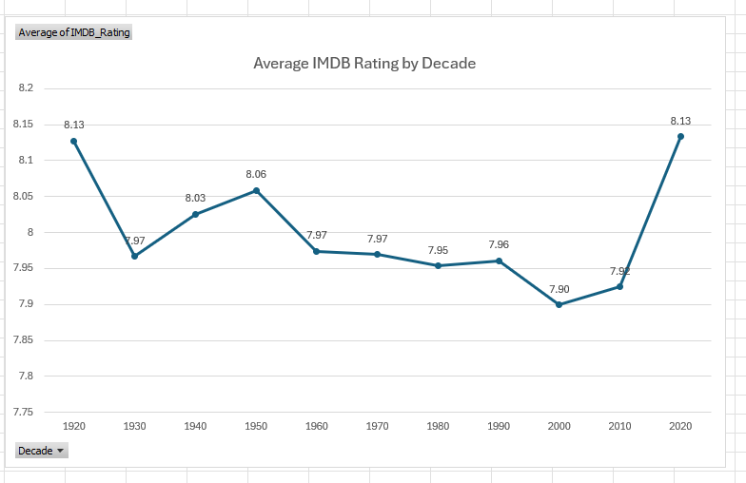
Ratings peaked in the 1920s and 2020s (8.13), while the 2000s showed the lowest average (7.50). The 1990s and 2010s were strong decades as well, reflecting the consistency of well-rated films across modern eras.

4. Top Directors by Average Rating
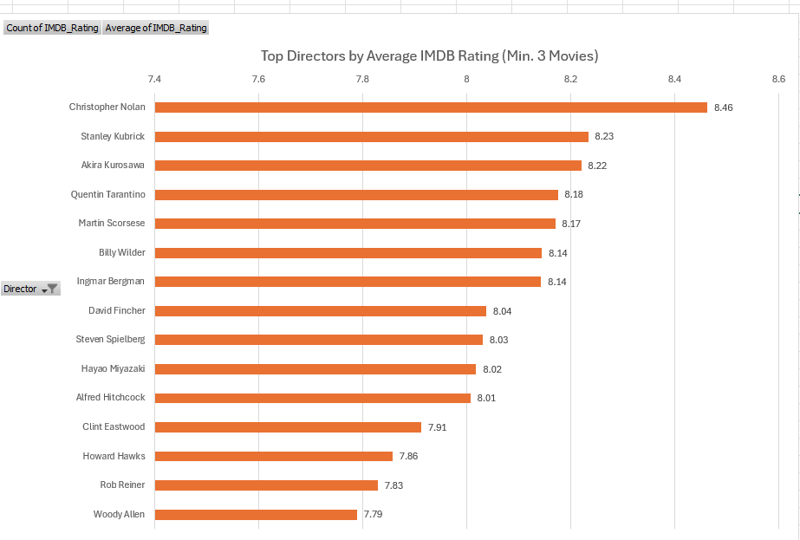
Among directors with at least three films in the dataset, Christopher Nolan had the highest average IMDb rating (8.46), followed by Stanley Kubrick (8.23) and Akira Kurosawa (8.22). The results suggest that top directors can maintain consistent critical acclaim across multiple projects.

5. IMDb Rating vs Number of Votes
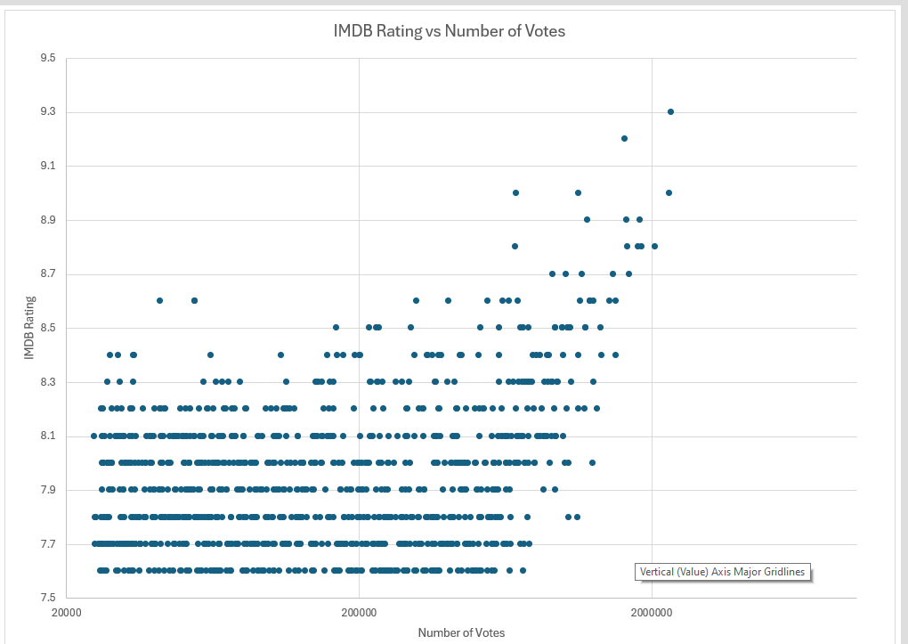
There was no strong correlation between number of votes and IMDb rating. However, movies with higher vote counts tended to cluster around the 7.5–8.5 rating range. This indicates widespread approval among heavily viewed films, while some highly rated, low-vote titles may represent hidden gems or niche favorites.

Conclusion
This project demonstrates the ability to clean and analyze structured movie data using Microsoft Excel, Power Query, pivot tables, and basic visualization techniques. The dataset revealed genre dominance, consistency in ratings over time, and highlighted top directors and audience trends. Future enhancements may include using SQL, Python, or data visualization platforms like Power BI or Tableau to expand insights and build interactive dashboards.

