Working Note
Monday, 11 September 2023
Transit Supply Index (SI) from GTFS
Preliminary SA1_2021 SI scores (one day only) for 2018 through 2023

Dr James Reynolds

Introduction

Previous research (Currie & Senbergs 2007) developed a transit Supply Index (SI) based on calculating the number of transit arrivals at stops within an area of interest for an entire week, adjusted to account for the typical walk-access catchment for each stop. This document is part of a project to develop R code to calculate the SI directly from GTFS data. Researchers from Deakin University have requested that PTRG provide SI scores for all of Victoria.

The status of this project is that SI scores can currently be calculated directly from GTFS data using the developed R code, but the calculation takes approximately one day for every day of input timetable data on a standard personal computer. PTRG are seeking to improve this performance, but in the meantime this document reports preliminary outputs for researchers at Deakin University, reporting SI scores for one day of service in the years 2018 through 2023. This document, and the results, are included in a branch of the overall project on githubThe SI values are calculated here for a Tuesday in the second week of August of each year.

This rest of this document is structured as follows: the next section briefly discusses the research context of transit metrics and the SI. In the third section the methodology for the code development is outlined, including discussion of the cases used to test and verify the code output. In the fourth section results are presented, starting with verification of the code output through hand-calculation of SI scores for a SA1 area in the Victorian Alps. SI scores across Clayton, Melbourne City and Burwood are also presented, comparing transit service levels through 2018 to 2023. The document then closes with a brief discussion and conclusion.

Research context
Even a brief search shows that there is a very large number of metrics available for benchmarking transit service. However, many of these metrics appear difficult to calculate, complex to explain or understand, and developed around the needs of transit specialists. Where pre-calculated metrics are immediately available it may not be possible for practitioners, researchers or advocates to independently generate metrics for proposed system changes or to even know exactly how scores for the existing services levels are calculated. Wong (2013) provides open-source code for calculating some TCQSM metrics.

The Suppy Index
The SI developed by Currie and Senbergs (2007) is open-source, comparatively easy to understand, and can be calculated independently. Its equation is shown below 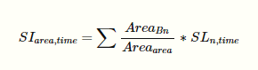
Where:
SIarea,time is the Supply Index score for the area of interest and a given period of time.
AreaBn is the buffer area for each stop (n) within the area of interest. In the original formulation this was based on a radius of 400 metres for bus and tram stops, and 800 metres for railway stations.
Area_area is the area of the area of interest, and
SLn,times is the number of transit arrivals for each stop for a given time period.

Minor adjustments have been made to generalise the equation, as the original version focused on the context of Melbourne’s Census Collection Districts (CCD) and calculations based on a week of transit service.. The SI describes the number of transit arrivals at stops within an area of interest and time frame, multiplied by a factor accounting for the proportion of the area of interest that is within typical walking distance of each stop. Hence, more services, more stops and higher frequencies would all result in increased SI scores. Additionally, the SI is additive, in that SIarea,time scores can be aggregated to calculate an overall score across multiple time periods or for a region encompassing multiple areas of interest1010 For example, if the SI for an entire SA2 area is desired this could be obtained by adding the SI scores for all SA1 zones within the SA2 area. Likewise, the SI score for all of Victoria is simply the sum of SI scores for all SA1s within Victoria..

Currie and Senbergs (2007) calculated the SIarea,time for various Census Collection Districts (CCDs) in Melbourne using a timetable database provided by the Victorian Public Transport Authority (PTA). This was before the widespread availability of General Transit Feed Specification (GTFS) data. A question, therefore, is how to calculate the SI using GTFS data so that SIarea,time scores can be calculated and compared for any area of interest where transit service information is available in that format.

Methodology
This study adopts a case research approach by developing code to calculate SIs for zones within Victoria, Australia.

Code development
This document has been prepared using Rmarkdown, which allows the intermingling of written text, code segments and code outputs and this can be read in a plain-text editor to view the code snippets themselves. If you are reading this in an HTML format you are seeing just the descriptive text, and outputs from the code where it has been run to produce maps, charts etc.. The developed code is included within the Rmarkdown file used to typeset this document.

Various analysis tools are available that make use of GTFS data, including the tidytransit package for the R statistical programming language. The tidytransit manual provides code to calculate a departure timetable from a GTFS feed, and this was adapted to calculate arrivals at a stop and the SL_{Bn} term in the SI equation.

The gtfstools R package was used to split input GTFS feeds by mode to facilitate the buffer zone calculation. Buffer zones of 400 metres for bus and Light Rail Transit (LRT) services and 800 metres for heavy rail were adopted, as per Currie and Senbergs (2007).

Where transit stops are located close to boundaries their catchment areas may fall into multiple areas of interest. The sp package provides tools for manipulating geographic data and shape files in R. This was used to calculate the proportion of each stop’s catchment area that falls into each geographical area of interest.

The SI_{area} term in the SI equation was calculated on a mode-by-mode and stop-by-stop basis, by first determining the amount of the catchment area (Area_{Bn}) that falls into each geographical area of interest for the stop in question. This is then combined with the area for each geographical area of interest (Area_{area}) and the number of stop arrivals (SL_{Bn}) to calculate the contribution to the SI scores made by just that single stop for every area of interest. These are then added to a cumulative total field for each area of interest, and the calculations are repeated until all stops and modes in the GTFS file have been included.

Case research approach
Results were generated for a single case: Victoria, Australia, as per the request of researchers from Deakin University. Results were processed using the ggmaps, ggplot, ggstatsplotand kable packages, with data processing leveraging the tidyverse approach.

Victoria is the southern-most state on the Australian mainland. The state capital is in Melbourne, which has a similar metropolitan area to of Paris or LondonHowever, with only around 5 million people Melbourne has about one-third the population density of Paris and London. Melbourne has an inner Central Business District (CBD) with apartments, commercial skyscrapers and extensive sporting facilities nearby; surrounded by low-density, predominately single-family-housing-dominated, inner, middle and outer suburbs.

The Australian Bureau of Statistics (ABS) provides a range of shape files and other resources. This study made use of the absmapsdata R package to access the 2021 SA1 boundaries for Victoria. The EPSG:28355 transform was used to shift longitude and latitude into metres, as per the Geocentric Datum of Australia 1994 (GDA95 / MGA zone 55) coordinates.

There are train and tram networks radiating from the CBD, but for most of the suburban areas the reality is that transit is provided by circuitous bus routes that are mostly used by those who cannot otherwise drive. An extensive freeway (and tollway) network provides connections across the Greater Melbourne area, further around Port Phillip Bay to Geelong (south-west) and the Mornington Peninsula (south-east) as well as to regional centres elsewhere in Victoria. There is a state-wide regional train and bus network (VLine), which also provides connections into South Australia, New South Wales and the Australian Capital Territory (Canberra) and local bus services in many regional towns and cities. However, accessibility to most of the city and state tends to be car-dominated. The Overland train service to Adelaide and the XPT to Sydney are provided separately to VLine services. Victoria’s GTFS feed is published by Public Transport Victoria (PTV).

The Australian census is undertaken in early August every 5 years. GTFS feeds were therefore selected for the first week of August of each year. Code output was produced for the day of the census itself in 2021. Minor corrections were made to the GTFS files to remove duplicate stop_ids.

Verifying the results
Code output results were verified by comparison to by-hand calculations for a single SA1 area: 20403106915. This SA1 covers Running Creek and Morgans Bridge, two localities in the Victorian Alps. This SA1 was selected for the purposes of verifying the code output as it is relatively easy to calculate the relevant SI values as a cross-check, because there is only one bus service and two stopsto include. The location of the SA1 20403106915 is shown in the following figure. Relevant geographic statistics are shown in the following.
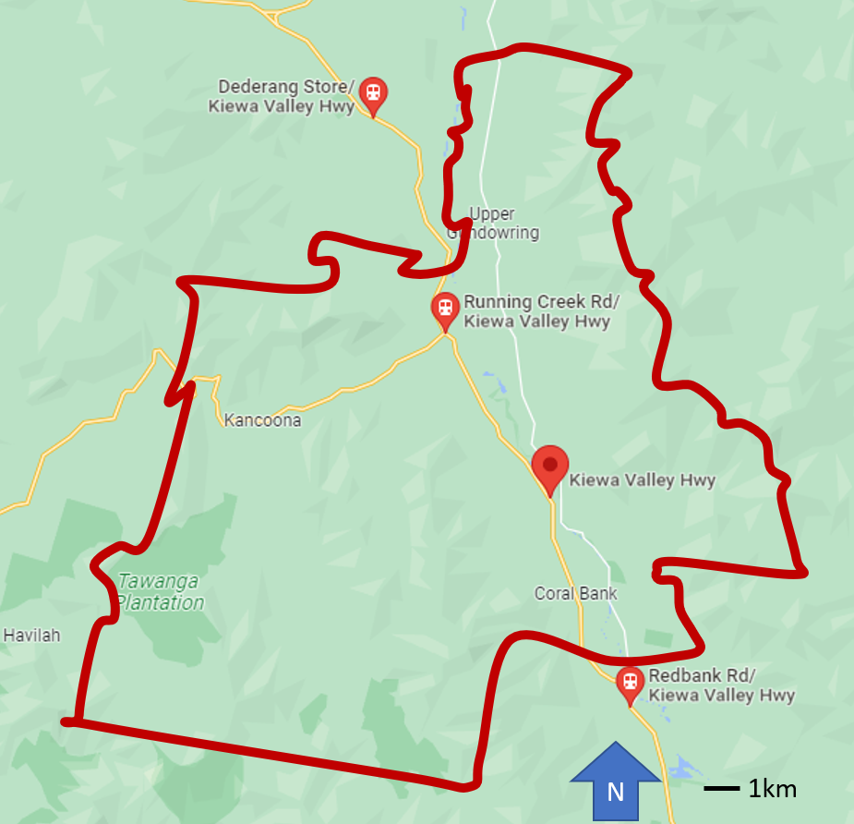
Figure 1 SA1 20403106915, with approximate location of Stop:ID 45125 highlighted, sources ABS and Google Maps

sa1_code_2021 | 20403106915
sa2_name_2021 | Bright - Mount Beauty
sa3_code_2021 | 20403
sa3_name_2021 | Wodonga - Alpine
sa4_code_2021 | 204
sa4_name_2021 | Hume
gcc_code_2021 | 2RVIC
gcc_name_2021 | Rest of Vic.
state_code_2021 | 2
state_name_2021 | Victoria
areasqkm_2021 | 284.598
cent_lat | -36.5788
cent_long | 147.05

The area of SA1 20403106915 is 284.598km². By inspection, the entire 400m radius catchment area of both of the bus stops lie entirely within the SA1 20403106915 boundaries. Hence the AreaBn/AreaSA1Areaerm for each of the bus stops is equal to 1.77e-03.

No printed timetable has been located for the Albury - Mt Beauty via Baranduda and Tawonga South route that services these stops, but stop times are provided on the PTV website. This indicates services on Tuesday August 8, 2023 to Albury at 7:25am, 9:25am and 9:30am and to Mt Beauty at 2:50pm, 4:20pm and 4:40pm. In general, this appears to be a school bus service pattern, with three services in each direction. Therefore the total SI is equal to 0.0211943. This result is compared to the output SI score generated by the code in the Results section below.

Exploring the results
To further review the quality of the output, the calculated scores were briefly explored as follows:
- SI scores for SA1s within the Clayton (North) - Notting Hill Statistical Area Level 2 (SA2), in the vicinity of the Monash Clayton campus, were mapped and reviewed. This sub-unit of the case was selected as the area is familiar to members of the PTRG, and so could be relatively easily reviewed for any unexpected or anomalous results. 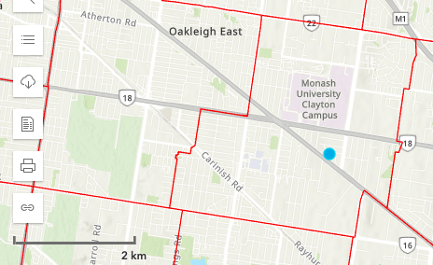
- Output results for SA1 zones within the Melbourne City Statistical Area Level 3 (SA3) were also examined. This SA3 includes Melbourne CBD, north Melbourne, Royal Park, Carlton, East Melbourne. parts of South Yarra and Prahan, and Southbank. Again, it has been selected for familiarity so as to help assess the accuracy of the reported SI results.
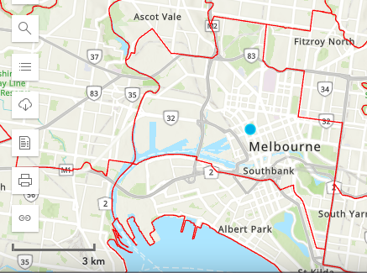
- SI scores for SA1s within the Burwood (Vic.) SA2 area were also examined. This sub-unit of the case was selected as it contains the Burwood campus, and so the area is likely to be familiar to researchers from Deakin University. Hence it should provide a location where it is relatively easy for them to (also) review the SI scores for any unexpected or anomalous results.
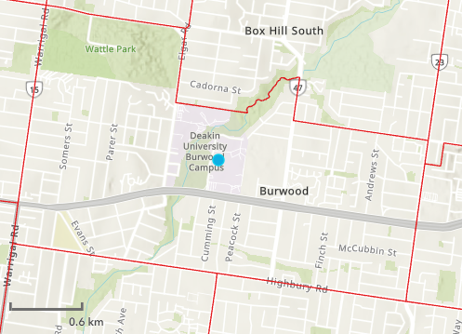

Results

The SA1 20403106915 zone score calculated by the developed code is shown in the following table.
sa1_code_2021 | LRT | subway | rail | bus | Total
20403106915 | 0 | 0 | 0 | 0.0211944 | 0.0211944
The hand-calculated score matches that produced by the developed code, suggesting that the developed code is providing the expected output.

Clayton (North) - Notting Hill SA2: Supply Index results for SA1s
This section briefly reviews the SI scores for SA1 zones within the Clayton SA2 area. SI scores for the day of analysis in 2018 and 2023 are compared in the following
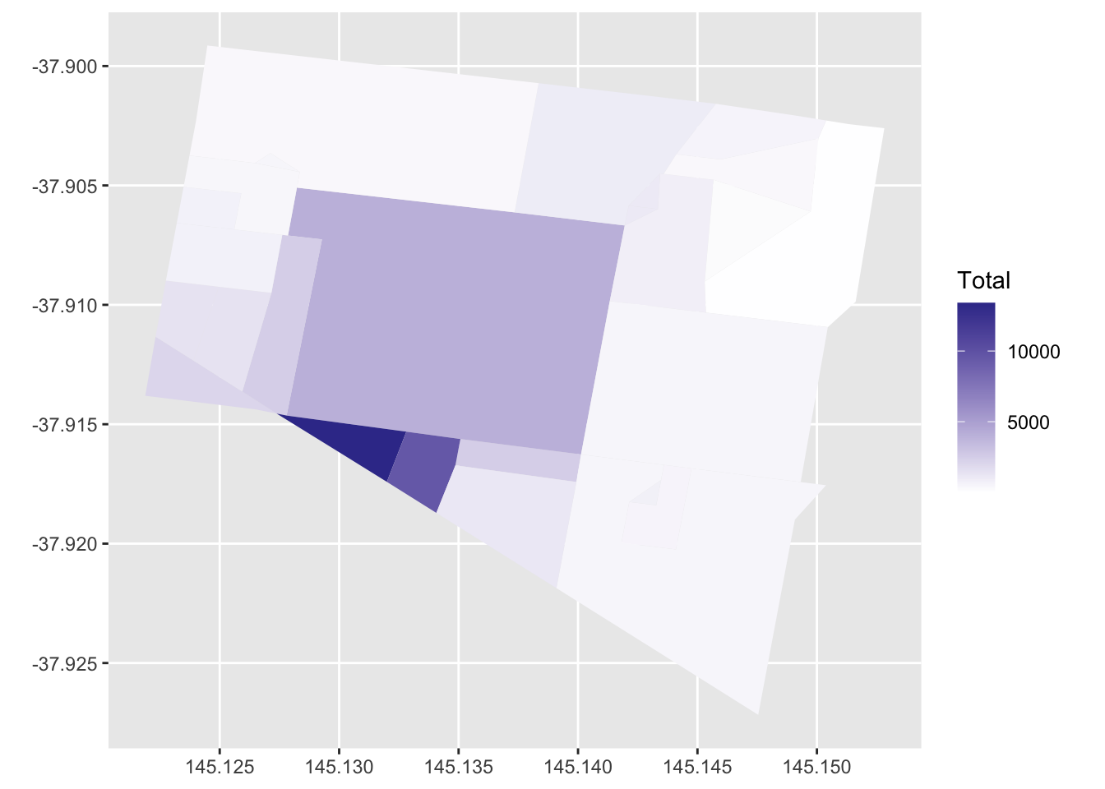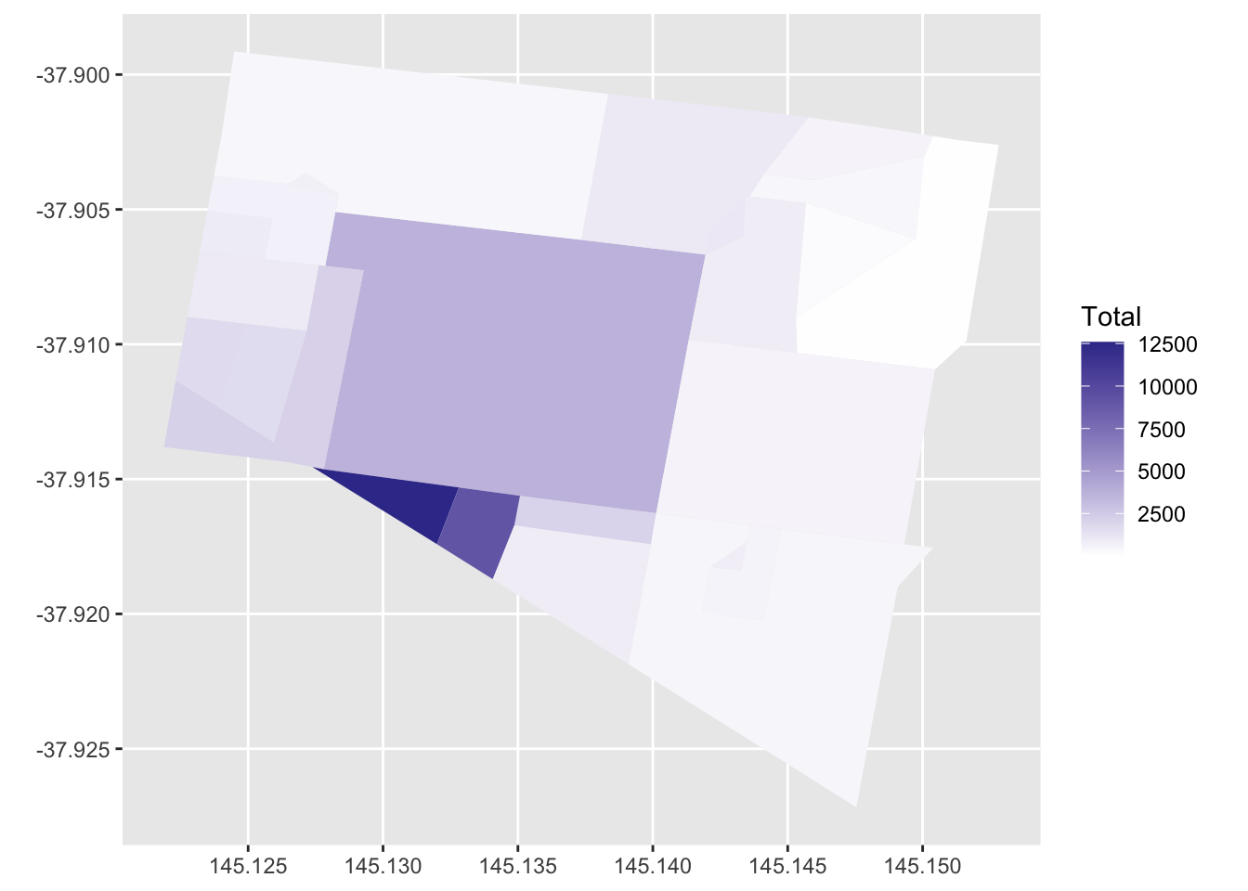
Figure 2 SI scores for SA1 zones within the Clayton SA2 area, 2018 (top) and 2023 (right)
The SI scores for SA1 zones within the Clayton SA2 area appear to meet expectations. Higher scores are reported for SA1 zones that are close to the Monash University bus loop (centre of the Clayton SA2 area) and near the Clayton railway station (south-west of Clayton SA2 area). In general there appear to have been little changes in SI between 2018 and 2023.
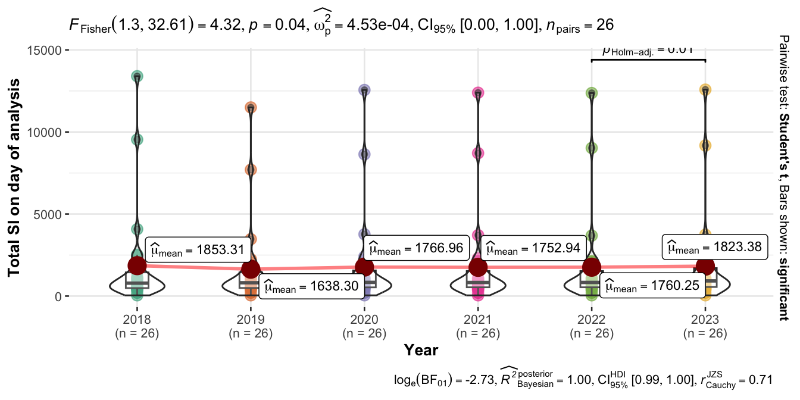
Figure 3SI scores for SA1 zones in the Clayton SA2 area, 2018 to 2023: violin and box plot generated using ggstatsplot package

The box and violin plot above indicates a significant difference across the 2018 to 2023 scores for SA1s in the Clayton North SA2 area. However, the differences appear to be small, with scores in 2019, 2020, 2021 and 2022 generally lower than in 2018 and 2023. Perhaps this may relate to reductions in services during the pandemic2828 The 601 Huntingdale to Clayton shuttle would appear likely to have had reduced service levels during lockdowns and prior to the resumption of on-campus teaching activity. However, this would not explain the low score in 2019, which predates the pandemic itself. Regardless, however, the changes appear to be generally small, so likely just to do with day-to-day operational variation..

Melbourne City SA3: Supply Index results for SA1s
This section briefly reviews the SI scores for SA1 zones within the Melbourne City SA3 area. SI scores for 2018 and 2023 are compared below.
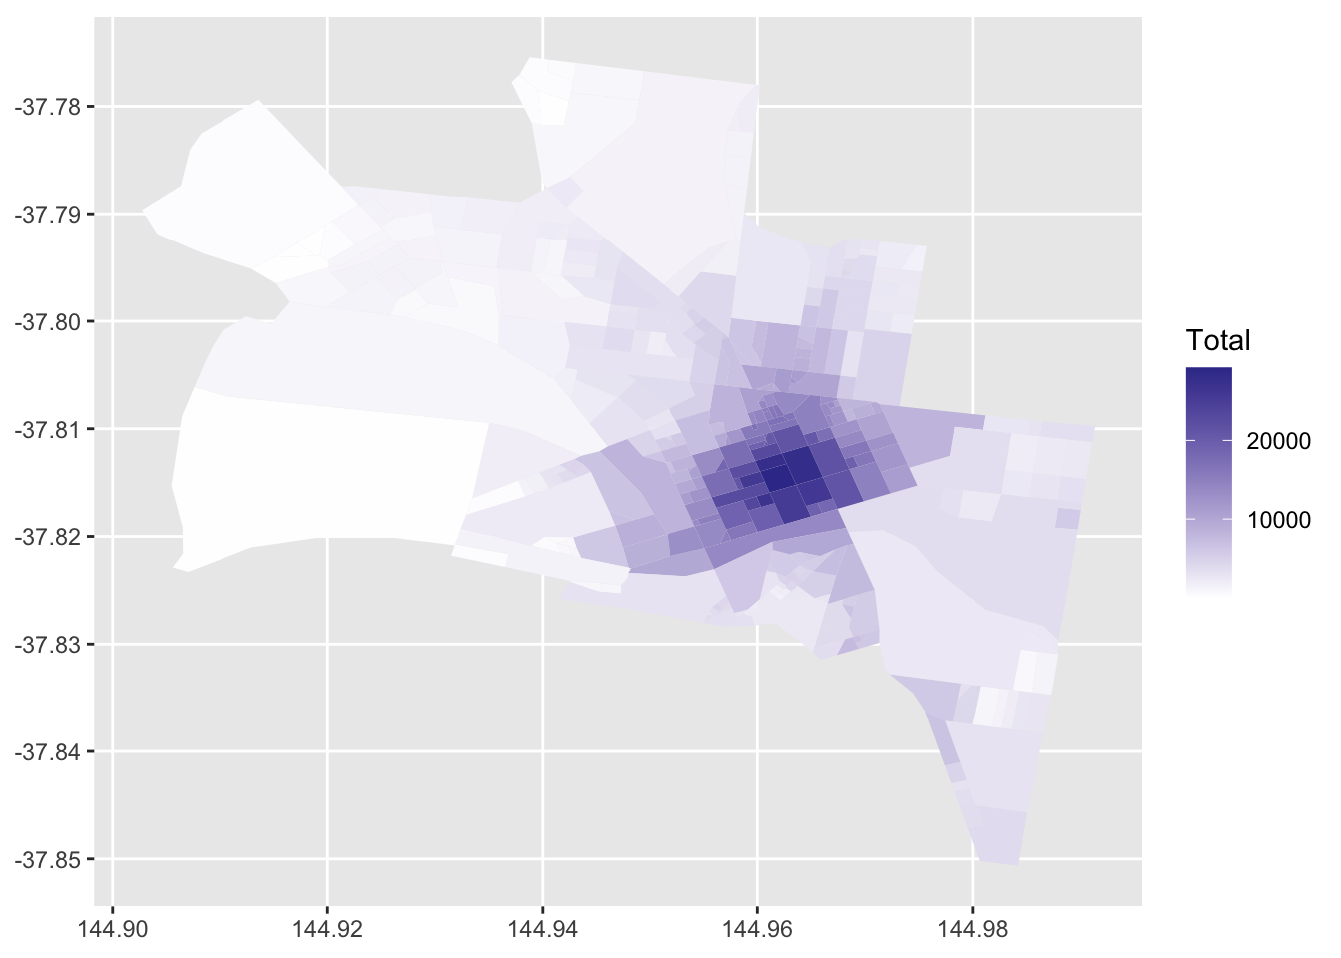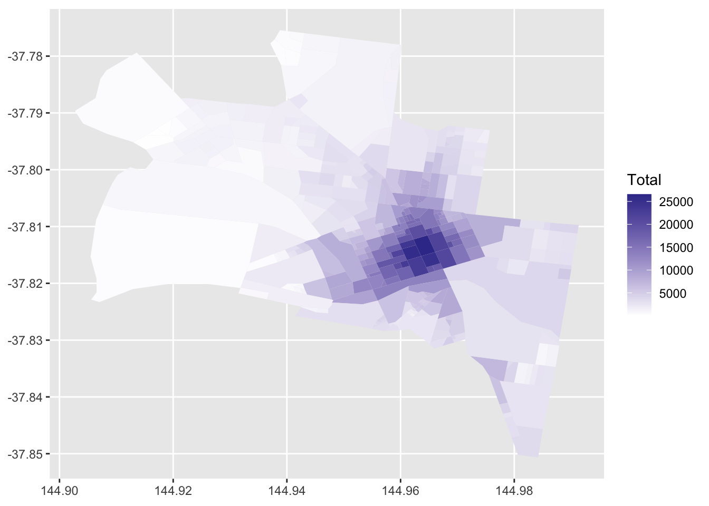
Figure 4 SI scores for SA1 zones within the Melbourne City SA3 area, 2018 (left) and 2023 (right)
The SI scores for SA1 zones within the Melbourne City SA3 area appear to meet expectations. Higher scores are reported for SA1 zones in the Melbourne CBD. In general there appear to have been little changes in SI between 2018 and 2023.
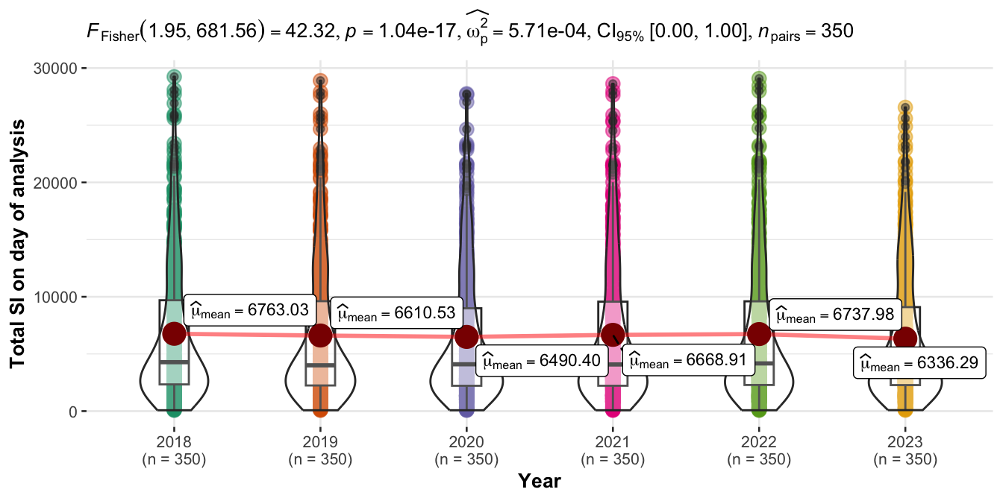
Figure 5 SI scores for SA1 zones in the Melbourne City SA3 area: violin and box plot generated using ggstatsplot package

The box and violin plot shown above indicates significant differences across the 2018 through 2023 scores. However, the differences appear to be small, and likely reflect minor changes to services for operational reasons.

Burwood (Vic.) SA2: Supply Index results for SA1s
This section briefly reviews the SI scores for SA1 zones within the Burwood (Vic.) SA2 area. SI scores for 2018 and 2023 are compared in the below figure.
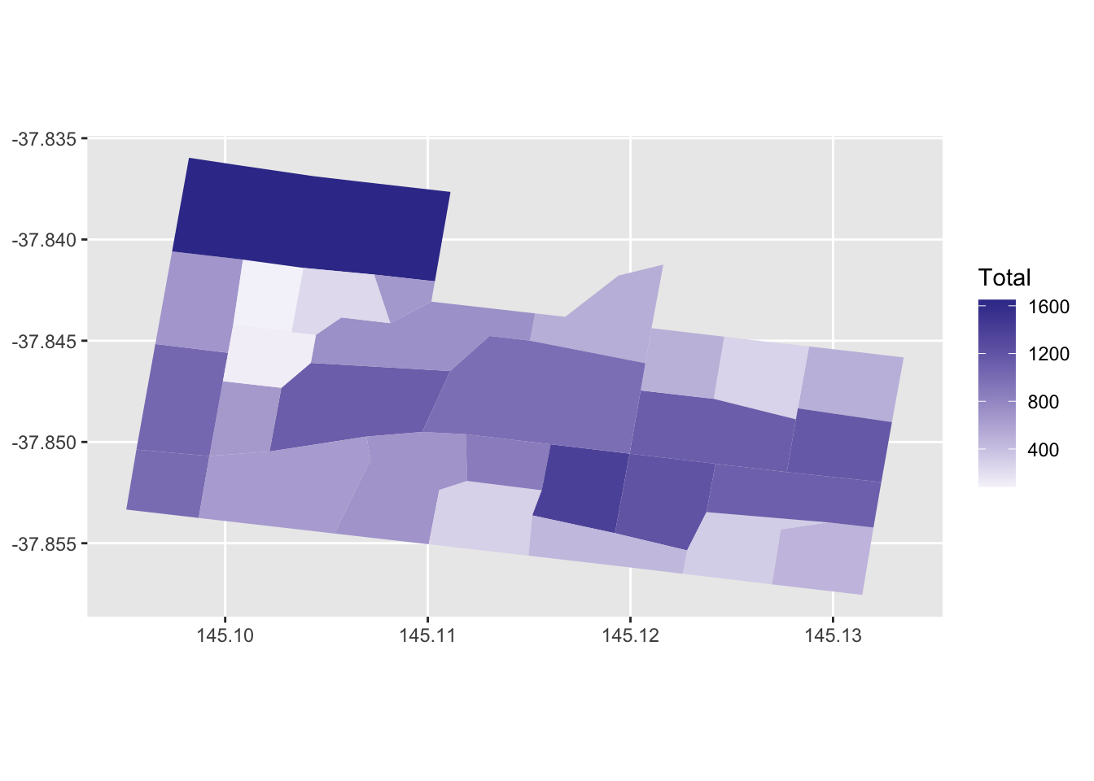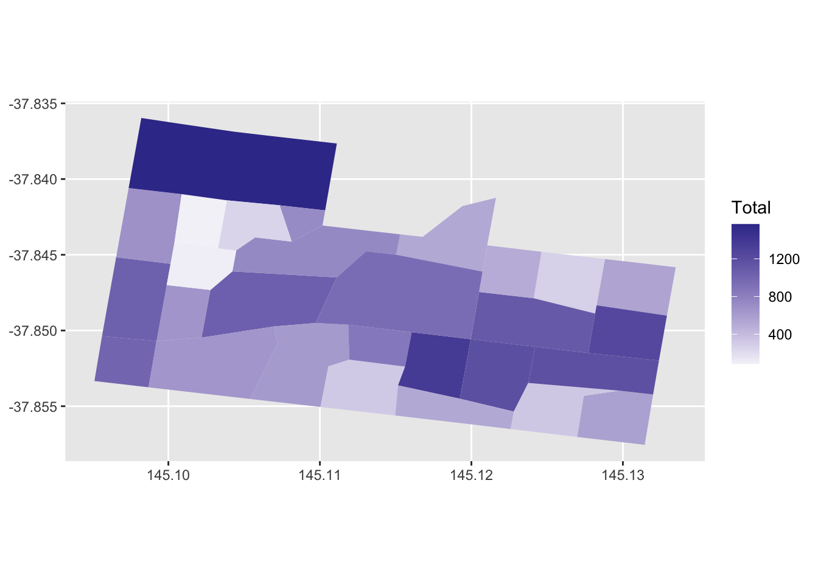
Figure 6 SI scores for SA1 zones within the Burwood (Vic.) SA2 area, 2018 (left) and 2023 (right)
The SI scores for SA1 zones within the Burwood (Vic.) SA2 area appear to meet expectations.. In general there appear to have been little changes in SI between 2018 and 2023.
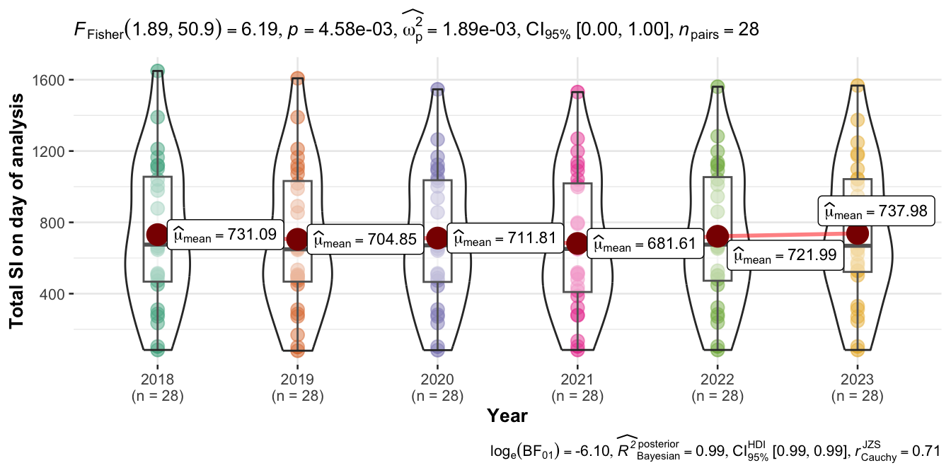
Figure 7 2018 through 2023 SI scores for SA1 zones in the Burwood (Vic.) SA2 area: violin and box plot generated using ggstatsplot package

The box and violin plot above indicates significant differences across the 2018 through 2023 scores. The mean scores are lower in 2019 to 2021 than in 2018, 2022 and 2023. Some of this may be related to minor service level alterations because of the COVID-19 pandemic, but in general the changes appear to be small and hence likely to be associated with day-to-day operational variation across the years.

Methodology
This document presents preliminary results from the development of code to calculate the Currie and Senbergs (2007) transit Supply Index (SI) directly from GTFS data. The developed code is available within the Rmarkdown file used to typeset this document, and available on github.

The code output has been verified by performing hand calculations for an SA1 in the Victorian Alps (Running Creek). This verification check resulted in a match between the hand- and code-calculated values.

Transit SI scores were compared for SA1s across areas of Clayton, the City of Melbourne and Burwood. Results appear to meet expectations, and indicate significant changes in service levels across 2018 to 2023, but that these changes are generally small.

The detailed SA1 results are included on the github page for this branch of the SI calculation project. Further research may involve improving the calculation speed of the developed code, as it is expected that the current code might take around one and a half months of run time to output the 5 full weeks of SI scores requested. In the meantime, however, the results provided and discussed here appear to provide a useful set of preliminary values for downstream research.

References

Specifically, Deakin researchers are seeking SI values for all Statistical Area Level 1 (SA1) zones in Victoria, with the SI calculated using a week’s worth of timetable data from each of the years 2018 to 2023 (inclusive).
Options being explored include improving the code’s efficiency, and seeking ways to run the code on more powerful hardware.
It specifically reports on the calculation of SI scores for Statistical Area Level 1 zones from the 2021 census (SA1_2021) for the years 2018, 2019, 2020, 2021, 2022 and 2023. However, the SI scores are for only one day of timetable data, rather than one week, as in the original formulation of the SI.
The branch can be found at https://github.com/James-Reynolds/Transit_Supply_Index_GTFS/tree/Deakin_1_day_2018_to_2023.
So as to match the 2021 census date.
For example: the Transit Cooperative Research Program (TCRP) Report 88 provides an extensive guidebook on developing a performance-measurement system: the Transit Capacity and Quality of Service Manual (TCQSM)(Ryus et al. 2003); online databases are provided by the Florida Transit Information System (FTIS)(Florida transit information system 2018) and the International Association of Public Transport (UITP) (International Association of Public Transport(UITP 2015)); while the Transport Strategy Centre of Imperial College London runs extensive annual benchmarking programmes across over 100 transit provides around the world.
The TCQSM and Transit Score may provide contrasting examples: TCQSM metrics may require large amounts of network, service, population and other data to be assembled before the indicators can be calculated; whereas Transit Scores are readily available (website shows scores for locations with a published GTFS feed, eliminating the need for any calculations.).The meaning of the Transit Score appears easy to explain (the closer to 100, the better), but as the score is calculated by a patented algorithm (Walk Score 2016) it may not be easy to understand or explain the connection between real-world conditions and the score, or what might need to be done to improve the score and service levels. Nor does it appear to be possible for Transit Scores to be generated for proposed changes to networks. The TCQSM, in contrast is open-source, being a manual describing all the metrics and how to calculate them.
See https://github.com/jcwong86/GTFS_Explore_Tool. However, this is now 11 years old and the code does not appear to be currently maintained. Future research may involve reviewing this code and using it to analyse modern GTFS feeds.
CCDs predate the introduction of Statistical Areas 1, 2, 3, and 4 (SA1, SA2, SA3, SA4), and other geographical divisions currently used by the Australian Bureau of Statistics (ABS), which may be more familiar to readers.
The Rmarkdown file is available at https://github.com/James-Reynolds/Transit_Supply_Index_GTFS/blob/Deakin_1_day_2018_to_2023/Reynolds_Currie_2024_transit_supply_index_GTFS.Rmd
See the .rmd file.
There is an extended mode definition that includes modes beyond the 10 in the GTFS standard, but these are not dealt with by the gtfstools package. Further research may seek to extend this such that other modes can be included, but for the purposes of this study the coded buffer zone was set at 400 metres for cable trams, aerial lifts such a gondolas and trolleybuses, and at 800 metres for ferries, funiculars and monorails.
GTFS files define stop locations based on latitude and longitude, whereas the Area_{Bn} calculation needs to be provided in the same units as the Area_{area} variable, necessitating the use of a geographic transform as part of the code.
Greater Melbourne is the term used to describe the larger metropolitan area, encompassing 30 LGAs. The City of Melbourne LGA covers only a small portion of the inner city..
1717 There are over 400 historical releases of the available on the transitfeeds.com website, with the first dating from March 2015.
Stop:ID 45125, Running Creek Rd/Kiewa Valley Hwy (Running Creek) and Stop ID: 45124, Kiewa Valley Hwy (Mongans Bridge).
The Melbourne Metro tunnel project has been ongoing through this time period, and has likely impacted on services along the Swanston Street tram corridor (especially with the works down at the Domain Interchange), around Flinders Street station and Melbourne Central Station.
Higher scores are reported for SA1 zones along the Burwood Highway corridor. The Burwood Highway runs east-west through centre of the maps. and the SA1 zone to the north-west3131 Tram route 70 runs along Riversdale Road to the north, which is likely the reason for the higher scores in the NW.
See the results subdirectory. However, note that the results have inadvertantly been saved in the European standard csv format, with the decimal point indicated by a comma rather than a full stop.

