1.I confirm that I have read the ATU Research Ethics Policy in advance of completing this form:
Yes
2.I confirm that I have completed the ATU Research Ethics Application Process training:
Yes
3. Title:
Using co-design workshops to explore community needs and future directions for shared electric mobility hubs
4. Full Name
Julian James Reynolds
5.ATU Campus / Department- *
Galway / School of Business
6.ATU Email Address- *
julianj.reynolds@atu.ie
7.Student Number *
N/A
8.Supervisor (s) (if applicable) *
Amaya Vega, Brian McCann
9. Position Held- *
Post-doctoral researcher
10.Other Investigators- *(include name, position and affiliation)
Amaya Vega, Senior Lecturer, Economics, School of Business, ATU Galway
Brian McCann, Lecturer in Civil Engineering, ATU Sligo
Noreen Armstrong, Research Assistant, ATU Galway
Brian Caulfield, Professor in Transportation, Centre for Transport Research, Dept of Civil, Structural and Environmental Engineering, Trinity College Dublin, the University of Dublin
Sarbast Moslem, Researcher in Transportation and Decision Making, Centre for Transport Research, Dept of Civil, Structural and Environmental Engineering, Trinity College Dublin, the University of Dublin
11. Research aims and objectives / research questions (300 words max)
Shared e-mobility hubs implementation may involve considerable capital investment, but also have the potential to support individual and community needs and grow the ‘mobility offer’ through supporting programs. However, it is unclear what additional mobility, community-focused, commercial or other offerings might be desired by communities, or might help to support the use of shared e-mobility hub facilities to improve transport sustatinability. Perhaps such hubs can help to make existing programs (e.g. meals-on-wheels, council officer trips, inter-library loans) more sustainable? Or perhaps such hubs might become places in and of themselves, with a similar mix of services and facilities as might be found in a major railway station.
This research seeks to explore community attitudes, needs and ideas as to how the ‘base’ shared e-mobility hub might be leveraged and enhanced so as to better meet each community’s transport and other needs. The findings might provide policy-makers, practitioners and researchers further insights into the types of offerings that might be provided at shared e-mobility hubs and other transport facilities in a variety of contexts (small town, secondary centre, suburban locations etc.) so as to enhance sustainable mobility and community outcomes in future implementation of such transport facilities.
The overall Electric shaRed mOBility hUbS Trial (ROBUST) program is a partnership between Trinity College Dublin (TCD), Atlantic Technological University, ESB, Enterprise, MOBY, Galway City Council, Donegal County Council, Waterford City and County Council, and Dún Laoghaire-Rathdown County Council. The program is led by TCD, who have already received ethics approval related to the research (see Attachment A). The Using co-design workshops to explore community needs and future directions for shared electric mobility hubs project to which this ethics application is applicable is a component project of ROBUST, focused on a smaller set of research questions.
12. Provide a justification as to why this research project should proceed (i.e. benefit to participants, society, knowledge) *
(100 words max)
As well as the potential benefits to those living/working close to a mobility hub (i.e. through avoided capital expense, improved mobility etc.) shared electric mobility hubs may help to shift transport systems towards more sustainable modes, including those powered electrically, and to improved environmental and other outcomes.
13. Summarise your overall methodology as it affects research participants (i.e. the tasks participants will be asked to complete, estimated time commitment etc.) * (200 words max)
The methodology is based around the Double Diamond approach to design. This is based around iteration within four stages: (1) a diverging ‘discovery’ phase; (2) a converging ‘definition’ stage that seeks to determine the issues to be addressed by the design; (3) a diverging ‘development’ phase where options are explored; and (4) a converging ‘delivery’ phase where design solutions are produced. Participants in this research will be asked to engage in workshops and post-workshop communication (e.g. via email with the research team) that explore all four of these stages, as well as to engage with the (as implemented) mobility hubs in their current form. Nominal Group, Focus Group, Delphi and similar methods may be used to frame the workshops and post-workshop communications so as to iteratively improve understandings of how shared electric mobility hubs might better meet the needs of communities, and how such facilities might best be designed.
14. Type of Research: *
Externally Funded
15 Please list the researcher qualifications, experience and skills relevant to conducting the research for this project. *
(include for all members of the research team)
James Reynolds - PhD, MTraffic, MTransport, BEng(Hons). 20+ years-experience in traffic engineering, road safety and transport planning. Research experience across policymaking and implementation, legitimisation and sustainable transport.
Amaya Vega (PhD) is a Senior Lecturer/Associate Professor in Economics at Atlantic Technological University (ATU) and Visiting Research Fellow at the Institute of International Economics at the University of Valencia, Spain. She has over 20 years’ experience working on transport policy evaluation, focusing on passenger and freight transport demand analysis, maritime transport, and ports. Brian Mcann (PhD) is a Lecturer in Civil Engineering at ATU with extensive experience in research and teaching. He specialises in sustainable transport planning and policy, and transport infrastructure and regional connectivity.
Brian McCann (Phd) is a Lecturer in Civil Engineering at the ATU Sligo Campus. He has thirty years of experience in academia across teaching and research in transport and wastewater engineering.
Noreen Armstrong has experience
Brian Caulfield is a Professor at Trinity College Dublin (TCD) with extensive research experience across transport and related fields.
Sarbast Moslem is a Research Fellow at TCD with a background in transportation.
16. Secondary personal data (with consent for reuse). *
No
17. Does the study involve primary research incorporating direct data collection using human participants, their biological material or personal data? *
No
18 Does the study involve participants who may be vulnerable or who may lack the capacity to give informed consent? *
Children or minors (under the age of 18) No
Adults lacking decision- making capacity No
Individuals in institutions (e.g. prisons, care homes, residential facilities) No
Participants accessed through a gatekeeper No
Participants who may be socially or economically vulnerable (e.g., individuals experiencing homelessness, poverty, addiction, or refugee status) No
Participants from marginalised or stigmatised communities No
Participants with limited ability to engage due to communication, literacy, or language barriers No
Participants with whom you may have a power imbalance (e.g., employers/employee, lecturer/student , service provider/client). No
Relatives/carers of patients Participants who will be discussing sensitive or distressing topics as part of this research No
Participants involved in action research (e.g., co-researchers or reflective practitioners) No
19. If you have selected any of the above categories, please provide:- Details of participant group(s), How consent/assent will be obtained, Clarity around the right to withdraw from the study, Safeguards for participants, Any distress protocols or mitigation strategies, How participant understanding will be supported (e.g., plain language, translation), Whether community or cultural consultation has been sought, Accommodations or supports being provided, How dual roles or conflicts of interest will be managed NA
20. Will the study require the co-operation of a gatekeeper for initial access to the groups or individuals to be recruited? No
21. Please confirm the location(s) where the research will be carried out. If external to ATU, have the necessary permissions
been obtained ROBUST mobility hubs (and surrounds) in Letterkenny, Galway, Waterford and Dublin, along with facilities suitable for hosting workshops (e.g. meeting rooms within local library, ATU campuses, council buildings etc.).
22. Will it be necessary for participants to take part in the study without their knowledge and consent at the time? (e.g. covert
observation of people in public places) No
23. Will you be conducting insider research? * No
24. Do you or other investigators require a Garda Vetting Certificate for the purpose of this study? * No
25. Primary data from participants * Yes
26. If Yes, please provide details of the data collection process, informed consent, and storage/security measures.
Data collected during the workshops and thorough post-workshop communication will include participants’ assessments of: issues with the implemented hubs (or improved hub designs); their own and perceptions of other community members’ needs, preferences and attitudes; concepts, ideas and other design inputs relating to (improved) shared electric mobility hubs; and reviews and commentary on alternative designs and concepts developed iteratively through the Double Diamond process. Such data may take the form of working notes and other materials developed through co-design workshops by participants; field notes or other materials generated by the research team based on observation and interaction with participants; and post-workshop correspondence (via email). Informed consent will be obtained prior to the commencement of the workshops, with a participant information sheet and informed consent form provided. Data storage / security measures will involve digital storage on ATU email servers or other ATU or TCD managed services, and secure storage or destruction of physical outputs. As well, outputs from the co-design workshops will be anonymised, with no collection of data that might link individual participants to specific concepts, ideas or other inputs. Likewise, post-workshop correspondence with participants to seek feedback on refined problem definitions or design outputs will similarly be unlinked from individual participants prior to data analysis, through aggregation once any back-and-forth correspondence with the research team has concluded.
27. Fully anonymised, publicly available data No
28. If Yes, provide source of data and verification of public accessibility and anonymisation. NA
29. Visual data (photos, videos) *Yes – photos of models, design drawings or similar will be generated as part of recording co-workshop outputs, but will not be linked to specific participants (i.e. no photos of participants, their names or other identifying information)
30. Audio recordings (e.g., interviews, focus groups) No
31. Biometric or sensor data (e.g., facial recognition, heart rate, gait) No
32. Geolocation data (e.g., GPS tracking) * No
33. Social media or online behavioural data * No
34. Linked datasets from multiple sources * No
35. Pseudonymised (re-identifiable) coded datasets * No
36. If Yes, describe coding method and security measures to prevent re-identification. the dataset will not be pseudonymised. *
If No, include justification for why NA
37. To your knowledge Are you using a platform not approved by ATU to collect, or analyse, or store data? * No
NOTE: the recommendation is to use software approved by ATU. approved software can be found here: If yes, please upload evidence of committee approval
METHODOLOGY & RISK
Please summarise any overarching ethical issues that may arise and how risks will be addressed.
Does your research involve any of the following activities:
38. Standard or routine practices/procedures in your given field of research. * No
39. Collection of biological samples (blood, tissue, hair) * No
40. Use of drugs, placebos, or medical devices * No
41. Invasive or intrusive procedures * No
42. Repetitive or prolonged testing * No
43. Exposure to ionising radiation * No
44. Non-standard physical interventions or procedures * No
45. Will the study involve clinical trials of medicinal products and or medical devices involving patients or healthy volunteers? * No
46. Will financial inducements/vouchers as an incentive (other than reasonable expenses and compensation for time) be offered to participants? * No
ARTIFICIAL INTELLIGENCE
47. Does this research activity make use of Artificial Intelligence-based systems? * No
DISSEMINATION AND PUBLICATION
48. Do you plan to publish and disseminate the findings of your research. * Yes
49. If Yes, please provide details, including confirmation that this will be included as part of the informed consent process with participants, where relevant. If No, please provide a justification, including why dissemination is not planned despite its importance as part of responsible research practice. *
Outputs of the research will be used for academic publications. This will be included in material provided to participants, and in informed consent forms and participant information sheets.
50. Will your research outputs (data or publications) be made available via open access (e.g., public repository, institutional
archive)? * Yes
51. If Yes, please describe: The type of data/output to be shared Publications may be made available via open access channels.
Where it will be hosted On a TCD or ATU-hosted repository and/or through open access publications
Whether participant consent allows for this sharing Yes
Any measures taken to protect anonymity or confidentiality NA.
52.Do you or any member of your research team have a potential or actual conflict of interest related to this study, including but not limited to financial, personal, professional conflicts, or funding from private individuals or organisations (e.g., business, industry partners, private research bodies) * No
RESEARCH SECURITY & EXPORT CONTROL
53. Have you completed institutional training or received guidance on export control compliance? * Yes
NOTE: The European Union (EU) has established export control legislation and export control lists to regulate and restrict the movement of certain tangible and intangible items, materials, technology, software or knowledge (i.e. controlled items) within EU Member States or to a third country*. This is to protect international peace and security. It is a legal requirement that an export authorisation (i.e. licence) may be required by the Department of Enterprise, Tourism & Employment (DETE) if there is any export of such controlled items contained in any of the export control lists within EU Member States or to third countries.
* A country that is not a member of the European Union as well as a country or territory whose citizens do not enjoy the European Union right to free movement, as defined in Art. 2(5) of the Regulation (EU) 2016/399 (Schengen Borders Code).
54. Could any element of your research involve the transfer of research materials, knowledge, software, or equipment internationally, or otherwise be subject to export control regulations? If yes, complete the remaining questions. * No
All supporting documents should be attached into this application where indicated. Please note that your submission cannot be reviewed without the relevant supporting documentation e.g., Information Sheet(s), Consent/Assent Form(s) being uploaded.
Please note that your Ethics application may include some or all of the following supporting documents.
1. Supervisor Declaration
2. Information sheet for participants
3. Information sheet for parents/guardians
4. Information sheet for children
5. Consent form for participants
6. Consent form for parents/guardians
7. Assent form for children
8. Interview schedule for interviews/focus groups
9. Questionnaire/Surveys
10. Advertisement/Poster/Flyers for recruitment of participants
11. Letter(s) of permission from external organisation(s) granting access to their business, school, charity, databases etc
12. Any other relevant supporting documents specifically required for your study
13. Data Protection Impact Assessment
14. Garda Vetting Certificate
15. Export Controls Certificate (This Certificate is mandatory)
I confirm that: This form gives an accurate account of the proposed research All risks and ethical and procedural implications
have been considered in full Yes
ATTACHMENTS
- TCD ethics approval
- Working draft of paper
- Export Controls Training Certificate
- Gatekeeper Permission Letter (or justification of absence)
- Data Management Plan
- Participant Information Sheet
- Informed Consent Form
- Recruitment Materials
- Workshop / Data Collection Materials
- Supervisor Declaration Form. ‘

- TCD ethics approval

- Working draft of paper

- Export Controls Training Certificate

- Justification of absence of Gatekeeper Permission Letter

There is no gatekeeper for this research. The ROBUST hubs and vehicles are publicly available, and located in publicly accessible places. Participant involvement in the research will generally involve an active decision on the part of the participant to attend and participate in a co-design workshop, or to correspond with the research team.

- Data Management Plan
Data collected during the research may consist of field notes, email communications with participants, co-design workshop outputs, working documents or other materials. All such data collected from or generated through participant-involvement in the research will be stored securely and electronically on TCD or ATU-managed devices, and using TCD or ATU-information technology systems (e.g. emails from/to @atu.ie or @tcd.ie addresses only). Physical material will be digitised and securely stored and/or destroyed.

- Participant Information Sheet
See next pages

PARTICIPANT INFORMATION SHEET
Please read this information carefully before deciding whether to participate in this research study.
- Title of the Study
Using co-design workshops to explore community needs and future directions for shared electric mobility hubs

- Introduction
You are invited to take part in a research study. Before you decide whether to participate, it is important for you to understand why the research is being done and what it will involve. Please take the time to read the following information and ask any questions you may have.

- Research Team & Contact Details
-Researcher: Dr James Reynolds, Research Fellow, ATU Galway
- Supervisors: Dr Amaya Vega and Dr Brian McCann
- Institution: Atlantic Technological University (ATU)
- Contact: julianj.reynolds@atu.ie, +353 87 348 3095
- Independent Queries: University Research Ethics Office (UREC) urec@atu.ie

- Why am I being invited?
You are being invited to participate in this research because we would like your input into the trials of shared electric mobility hubs currently underway in Letterkenny, Galway, Waterford and Dublin. These hubs are an emerging transport approach involving the provision of electric cars, electric bikes, electric cargo bikes and (potentially) other vehicles or facilities that would be available for used by the public on an as-needed and short-term hire basis. Such hubs may help communities transition to more sustainable forms of transport, increase mobility, and improve environmental, social, economic and other outcomes. However, it is currently unclear how best such hubs might be implemented and operated, including with respect what services and facilities are offered at the shared mobility hub, and how such services and facilities are delivered. This study seeks to better understand problems with current approaches, and how best shared electric mobility hubs might meet the needs and preferences of stakeholders, members of the public and others who might have involvement with or potential users of such transport systems.

- What will happen if I take part?
If you take part in the co-design workshops you will be invited to try shared electric mobility hub vehicles and systems for yourself. You will then to be involved in a series of group-based activities to help discover and define problems with the hubs as implemented, and to develop and help towards delivering potential design solutions that might improve understandings of how shared electric mobility hubs might better meet the needs of communities. Your inputs to the co-design workshops will be aggregated with those of other participants so as to be anonymous and not attributable to any particular individual or individuals. Following the co-design workshop you may be invited (via email) to correspond with the research team for the purposes of providing feedback and comments on problem definitions and design options based on refinement of the ideas and other outputs of the co-design workshops.

- Do I have to take part?
Participation is voluntary. You may withdraw at any time without giving a reason. This will not affect your rights or any services to which you are entitled.

- What are the possible risks or inconveniences?
There are some inherent risks related to riding an electric bicycle or electric cargo bicycle, or driving an electric car, in the same way that there are inherent risks involved in any form of travel. Hence, if you choose to ride or drive the ROBUST vehicles as part of becoming familiar with the system for your involvement in the co-design workshop. Otherwise, the co-design workshop will involve interaction and design-related activities with other participants over a half-day period, as well as subsequent correspondence via email, so there will be some time and effort involved.

- What are the possible benefits?
Shared electric mobility hubs may help to increase mobility and provide better social, environmental and economic outcomes including through supporting communities transition to more sustainable forms of transport. More directly, improved public-facing user interfaces, hub offerings or technology and design may make such hubs more easily used by the public, including for individuals with less familiarity with mobile, app-based hire and management systems. Your involvement in this research may provide valuable insights that could make future investments in mobility hubs or similar emerging technologies more likely to be utilised and provide benefits for your and other communities.

- Will I be paid for taking part?
No.

- How will my information be used?
-Data Controller: Atlantic Technological University (ATU)
- Purpose of data collection: To improve understandings of shared electric mobility hub design and implementation.
- Legal basis: Consent
- Storage & protection: Data will be stored securely on ATU-controlled servers, and anonymised at the time of collection.
- Access: The ROBUST research team, which includes researchers at ATU and Trinity College Dublin. Research outputs may be published.
- Retention: Research outputs may be published, and so retained permanently. However, these will include no identifiable information. Research notes, emails and other materials will be retained in accordance with ATU data retention policies.
- Rights: You have the right to access, correct, and request deletion of your data before it is anonymised. Complaints can be made to the Data Protection Commission (www.dataprotection.ie).

- What happens if I withdraw?
Your direct inputs to the research outputs can be removed from the data set where it is still possible to link them to you individually, but the nature of some of the data collection (via group co-design workshops) may mean that your some of your inputs may have been collected in aggregate, rather than individually or apart from those of other study participants. This may limit the ability to remove your individual inputs to the study from the data set if you wish that to be done as part of withdrawing. Otherwise, there are no further implications if you wish to withdraw, and you may withdraw at any time.

- What if there is a problem?
Concerns, complaints or other issues can be raised directly with the research team, or (independently) with the University Research Ethics Office (UREC) urec@atu.ie

- How will I receive information about the results?
You may ask for the researchers to provide a copy of the published research outcomes, or access these yourself independently when/if they are publicly published.

- Future Use of Data
The research outcomes may form the basis of future research, but there will be no other direct future use of data collected during this research.

15. Funding and Conflicts of Interest
This research is funded by the Sustainable Energy Agency of Ireland (SEAI), as part of the Electric shaRed mOBility hUbS Trial (ROBUST) project. Further information is available at https://www.tcd.ie/transport-research/our-research/research-projects/ROBUST-electric-shared-mobility-hubs-trial/.
No conflicts of interest have been identified in relation to this study.

If you have any questions about this study or your rights as a participant, you may contact:
Researcher Contact: Dr James Reynolds, julianj.reynolds@atu.ie, +353 87 348 3095
Ethics Committee Contact: urec@atu.ie
Next Steps
If you are happy to participate, please sign the consent form provided. You will be given a copy of this information sheet and your signed consent form for your records.

- Informed Consent Form
Participant Consent Form

Title of Study: __ Using co-design workshops to explore community needs and future directions for shared electric mobility hubs
Principal Investigator: __Dr James Reynolds___
Supervisor (if applicable): _Dr Amaya Vega and Dr Brian McCann
Institution: __Atlantic Technological University (ATU)__

Consent Confirmation
Please read each statement and tick the box if you agree:
☐ I confirm that I have read and understood the Participant Information Sheet (version [x], dated [xx/xx/xxxx]) for this study.
☐ I have had the opportunity to ask questions, and all of my questions have been answered.
☐ I understand why I have been invited to take part, what participation involves, and the expected duration of my involvement.
☐ I understand that my participation is voluntary, and I may withdraw at any time without giving a reason and without penalty.
☐ I understand what will happen to any data already collected if I withdraw, as explained in the Information Sheet.
☐ I understand the possible risks and inconveniences, and the possible benefits, of participating as described in the Information Sheet.
☐ I understand I will not receive compensation/reimbursement for participating.
☐ I understand how my personal data will be collected, stored, protected, and used by the Data Protection Commission.
☐ I consent to the use of my anonymised data in publications or presentations arising from this study.
☐ I have been informed about the source(s) of funding for this research and any potential conflicts of interest.
☐ I know who to contact if I have questions, concerns, or complaints (researcher, ethics office, Data Protection Commission).
☐ I give my informed consent to take part in this research study.
Participant Name (printed): __________________________
Signature: _________________________________________
Date: __________________
Researcher Name (printed): __________________________
Signature: _________________________________________
Date: __________________

Contacts for questions or concerns:
- Researcher: Dr James Reynolds, : julianj.reynolds@atu.ie, +353 87 348 3095
- Ethics Committee: urec.@atu.ie
- Data Protection Commission: www.dataprotection.ie
- Recruitment Materials

- Workshop / Data Collection Materials

Following pages include examples of Journey Mapping approach, and the use of scale models and mapping for the purposes of design experimentation and iteration.

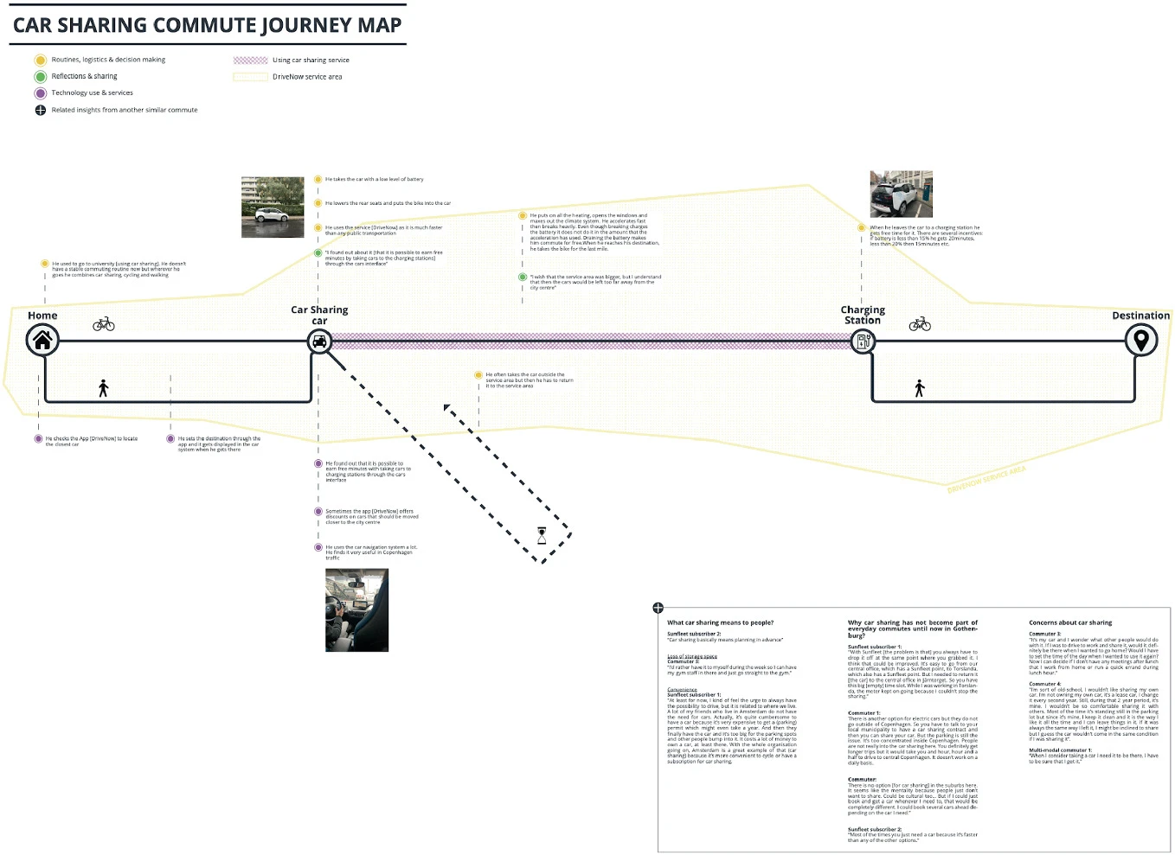

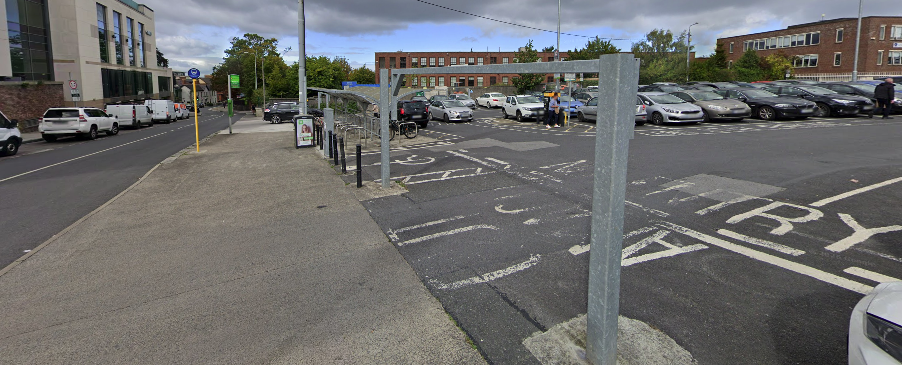
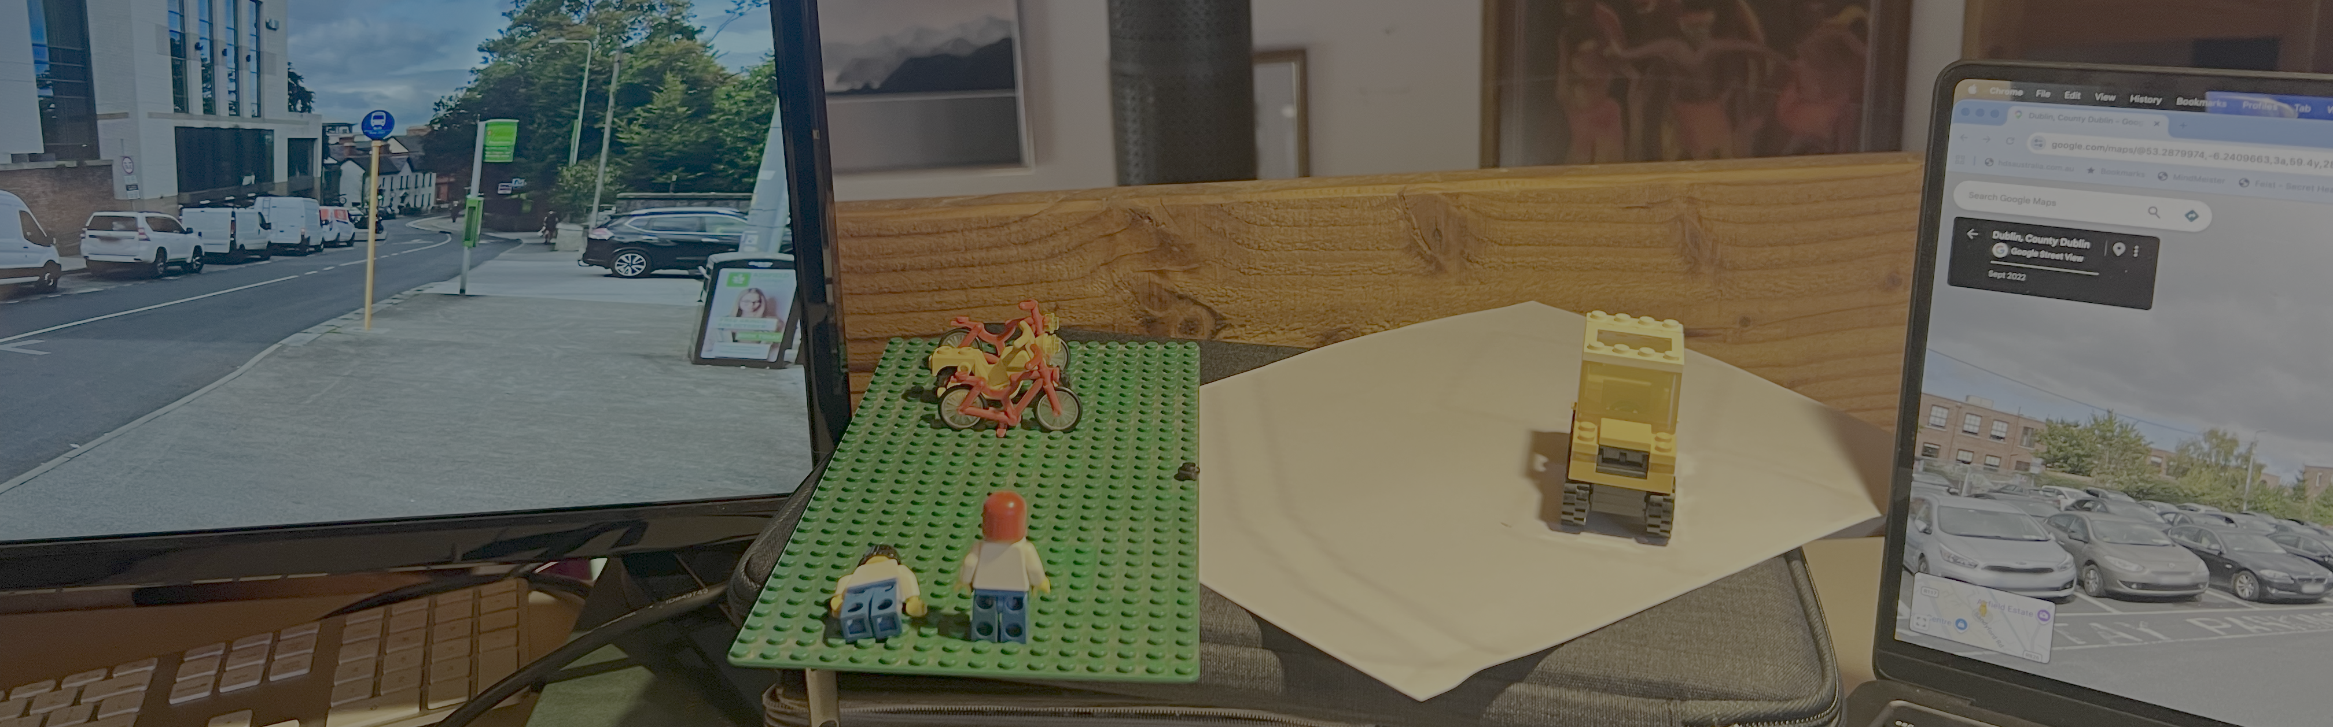
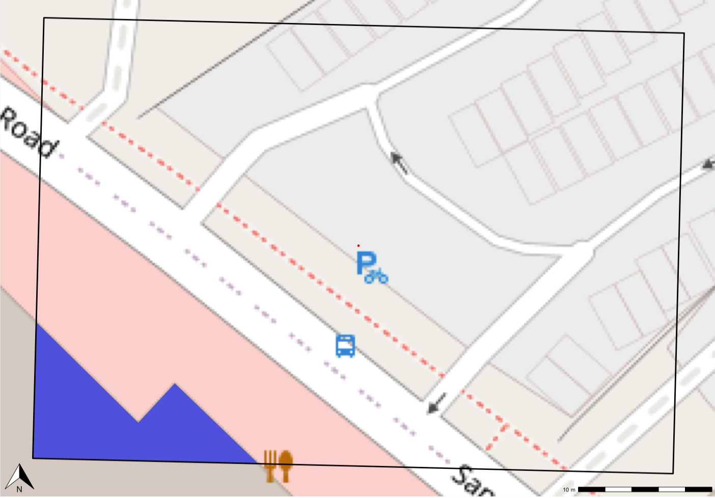
Other Parking
Hub Car
Hub bike parking
Scaled plans, Lego modelling and similar design aids Source: Map tiles from Open Street Maps (copyright OSM contributors)
Streetview images from Google Maps
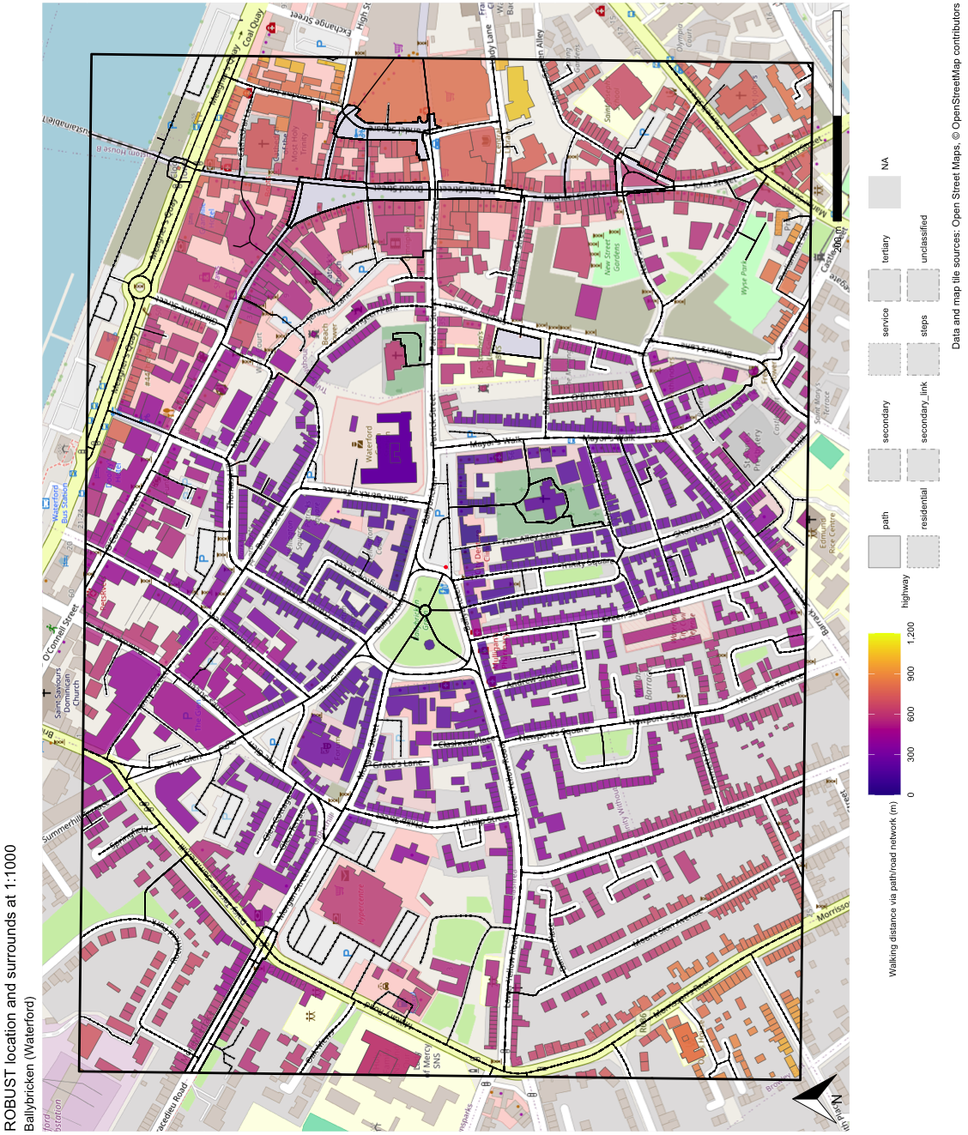
Large scale map for co-design workshops, showing buildings by distance to the hub, road network etc.
- Supervisor Declaration Form.

SUPERVISOR DECLARATION FORM
This form must be completed as part of the ethical review process for any research project involving human participants, sensitive data, or other areas requiring formal ethical oversight. It is intended for use by both research students and academic researchers. By signing this form, all parties confirm their commitment to conducting the research by established ethical and educational standards.

Project Details
Title of Research Project: Using co-design workshops to explore community needs and future directions for shared electric mobility hubs
Name of Researcher: James Reynolds
School/Department: Department of Enterprise and Technology
Level of Study (if applicable): (e.g., Master’s / PhD): NA

Supervisor Details
Name of Supervisor: Amaya Vega and Brian McCann
School/Department: Department of Enterprise and Technology, Department of Civil Engineering & Construction

Co-Researcher(s) (if applicable)
Name(s): Noreen Armstrong
School/Department: Department of Enterprise and Technology

Declaration
I/We confirm that I/We have reviewed the above research proposal. To the best of my/our knowledge, the proposed research:
- complies with recognised ethical principles (including the Declaration of Helsinki, GDPR, the Data Protection Act 2018, and relevant Health Research Regulations where applicable).
- is designed in accordance with the standards of good research practice; and
- is suitable to proceed for full ethics review.
I/We further confirm that:
- The researcher has undertaken the required institutional training in research ethics, GDPR/data protection, Export Controls, and research integrity.
- The research methodology has been reviewed by the supervisor and is appropriate.
- The supervisor will provide ongoing oversight to ensure the project continues to meet ethical and legal requirements throughout its duration.
- any changes to the research design will be promptly reported for further ethical review; and
- This form is being submitted as part of the official ethics application.

Signatures
Researcher Signature: ____________________________Date: __________
Supervisor Signature: ____________________________ Date: __________
Co-Researcher Signature (if applicable): _____________ Date: __________

