Do-It-Yourself information with mobilityHubTools
James, Reynolds (james.reynolds@atu.ie)¹; Brian, McCann²; Noreen Armstrong¹; Sarbast, Moslem³; Agnieszka, Stefaniec⁴; Brian, Caulfield³; Amaya, Vega¹

¹ Faculty of Business, Atlantic Technological University, Ireland
² Faculty of Engineering and Computing, Atlantic Technological University, Ireland
³ Centre for Transport Research, Dept of Civil, Structural and Environmental Engineering,
Trinity College Dublin, Ireland
⁴ Department of Decision Analytics and Risk at Southampton Business School,
University of Southampton, UK

Abstract

Mobility hubs are places where shared bikes/e-bikes, cars, e-scooters or similar modes are co-located, often close to transit and facilities such as charging stations or parcel lockers. The aim is to provide a combined alternative to Internal Combustion Engine (ICE) vehicle ownership and to support more sustainable travel behaviours. Signage, information displays and user guidance will likely be important at such hubs, but not much is known about industry best practices. There do not appear to be tools available to help mobility hub implementers, including for creating hubs where existing services are already co-located. This paper reports case studies of existing practices, and the development of software tools for creating maps and informational displays for mobility hubs in any location. Are there multiple mobility offerings in close proximity in your community? These tools, a printer and somewhere to hang a poster might be all that is needed to spread the word.

Keywords: Mobility hub, informational displays, shared modes, electric mobility.

Introduction
Shared mobility hubs are places where a range of modes and other facilities may be provided to support more sustainable travel. They often include shared bikes, cargobikes, e-bikes, e-scooters or other micromobility vehicles, as well as car share, public car charging and other services. Together, these might help support shifts towards more walking, cycling and public transport transit use, and otherwise improve the sustainability of transport systems through providing options for those (more occasional) trips that are difficult without a private car (Geurs et al., 2024).
____________________________________________________________________
©️ 2026 Copyright for this paper is by its authors.
Use permitted under Creative Commons License Attribution 4.0 International (CC BY 4.0).
Proceedings of the CERC 2026 Conference 16-17 October, Galway, Ireland

Many mobility hubs have already been implemented, but with signage, maps and other informational material created by individual agencies on a site-by-site basis. Some guidance and examples are provided by CoMoUK (2024), but best practices for information provision and user guidance at mobility hubs may be unclear. As well, the graphic design, mapping and similar effort needed to create such material for each site may limit the ability for practitioners to keep information up to date, to trial new hubs, or to use bottom-up implementation approaches to create hubs where shared or other modes are already in close proximity.
This paper aims to explore and better understand mobility hub information provision, and to develop tools to support practitioners. It reports findings from case research examining existing practices at a selection of mobility hubs. Also reported are findings from design-based research that develops software for producing maps and information displays at other mobility hubs, based on both replication and synthesis of industry practices. The rest of this paper is structured as follows: the next section outlines the context for this study. The research methodology is then described, followed by presentation of the results. These are then briefly discussed in a concluding section that also identifies directions for future research.

Research context
An early version of the mobility hub concept was developed in Toronto’s “Big Move” transport plan (Metrolinx, 2008) in the late 2000s. There the term was used to designate selected major regional transit stations around which land uses would be intensified and where intermodal transfers would be facilitated (Salsberg et al., 2010, Engel-Yan and Leonard (2012)). Since then, the mobility hub concept has expanded towards co-locating shared and/or micro-mobility services often, but not always, close to public transport. They might also incorporate other facilities and “should be considered not just a transfer node but as a place where a variety of services come together, such as logistics services or restaurants” (Roukouni et al., 2023). This definition from Roukouni et al. (2023) is based on a review of the literature, and also highlights the need for “integration”, “seamless, flexible connection” and “. . . an enjoyable experience for travelers” . How this might be achieved, implemented and maintained by practitioners remains unclear, but signs, maps and information displays may be an important communication tool.
More broadly, ‘Movement and Place’ and ‘Complete Streets’ (Delbosc et al., 2018), and tactical urbanism approaches (Lydon and Garcia, 2015) suggest ways to challenge prevailing narratives about road space allocation, give communities greater power over (their own) urban environments, and demonstrate the potential of change. Bottom-up and incremental approaches, ‘pop-ups’ and more formal trials have also been found to be pragmatic strategies for building legitimacy through implementation (Reynolds and Currie, 2021). In the context of mobility hubs these might rely on rapid prototyping, iterative co-design or similar approaches and a need for practitioners, tactical urbanists and others to need adopt a ‘do it yourself’ attitude to developing information displays and supporting maps.
As of yet, development of standarised approaches for providing such information, and understandings of best practices for user guidance at mobility hubs appear to be at an early stage. There also do not appear to be tools available that might allow such best practices to be quickly and easily adapted to local contexts, and for updates to be made as a mobility hub or its surrounding urban environment changes over time. The next section, therefore, describes the case- and design-based research methodology adopted in this study to (at least start) filling this gap in knowledge.

Methodology
Research described in this paper aims to improve understanding of ‘best practices’ in mobility hub signage and information provision, and to develop tools to support mobility hub implementation. The research questions relate to: How information is provided at and about mobility hubs; How information at and about mobility hubs might ideally be provided; and how such best practices can be made generally applicable?

Study design
Study design is based around the Double Diamond design process (UK Design Council, undated), which Coxon et al. (2018) and Coxon et al. (2021) identify as a suitable tool for design-based research seeking to develop solutions to mobility problems. The Double Diamond process involves four phases: 1. Discovery, 2. Definition, 3. Development and 4. Delivery. These phases alternate between divergent (1 & 3) and convergent (2 & 4) approaches, although the overall process is iterative and may involve multiple passes through each phase.

Participants, material and instruments
The authors were the only participants in the research reported in this paper. The research described in this paper is part of the larger Electric shaRed mOBility hUbS Trial (ROBUST) project (TRIP - Centre for Transport Research and Innovation for People, 2025). Further research as part of the ROBUST project is expected to involve mobility hub users, stakeholders and others as study participants for testing, co-design and continued iteration of information displays and other hub elements. These, however, are beyond the scope of this paper.
Material for the study was drawn from photos taken during sites visits made by the lead author in the Discovery phase and mapping, imagery and other online resources. Open Street Map (OSM) datasets provided an input for the Development phase.
Instruments included synthesis tables, developed as per Miles and Huberman (1994). The Development Phase was guided by standardised approaches to package development for the R language provided by Wickham and Bryan (2023). R was chosen here because: it is open source and freely available, therefore supporting goals of developing an accessible suite of tools; it has an extensive set of packages for geospatial analysis and mapping; and there is a large community of users who might help support those with less experience in troubleshooting.

Procedure and analysis
The Discovery phase involved case research, which Denscombe (2007), Yin (2018) and others identify as being especially effective for when: theory development is at an early stage; research questions relate to ‘how’ or ‘why’; and when exploring phenomena within real-world contexts (as is the situation here). Cases were selected from https://www.como.org.uk/mobility-hubs/built-andplanned-hubs. Inclusion was constrained by limited resources but guided by the case research methodological literature (see Yin (2018) and others) to include the leading examples of the mobility hubs developed by the West of England Mayoral Combined Authority (WEMCA, Bristol) and Transport for West Midlands (Birmingham). More representative examples from Camden Council (London) and the London Borough of Redbridge (Woodford and Wanstead) were also included to provide polar opposites for cross-case comparison.
The Definition phase involved synthesis of findings from the site visits and about each included case. This provided the basis for defining the problem to be addressed by the research outputs of the Development and Delivery phases.
The Development phase involved iterative software coding to replicate the Bristol and Birmingham style of information displays, first undertaken for cases in the Discovery phase, and then repeated to test the software on the context of the ROBUST hub in Galway. Finally, a combined display style was developed based on the synthesis of industry practices and to respond to the problem developed in the Definition phase.
The research also included iteration through all four phases, but in the interests of clarity the next section presents the results in a linear format, stepping through each phase in turn.

Results
Discovery
Table 1 summarises findings from the case research. Figures 1 show selected images from various hubs. Information displays ranged from small placard signs (South Woodford and Wanstead) to more comprehensive totem displays and posters (Bristol and Birmingham). In Camden there were no information signs specific to the hubs. Sites were labelled as “Mobility Hub” or “Village Hub” (South Woodford and Wanstead) and “Local Travel Point” in Birmingham. There was no labelling on-site in Camden or Bristol. Where present, totems all included two maps: one at a local scale (within 5 minutes walk) and a second showing a larger area (within 15 minutes). These generally showed nearby transit, cafes, shops and other points of interest. Text descriptions of local walking and cycling routes, hub facilities and transit services were also included. Many of the sites had linemarking that highlighted some hub components. The Bristol sites also included cube shaped indicators mounted on poles to highlight individual hub elements (Figure 1, bottom left).

Table 1: Hub characteristics. Source: Authors’ assessment.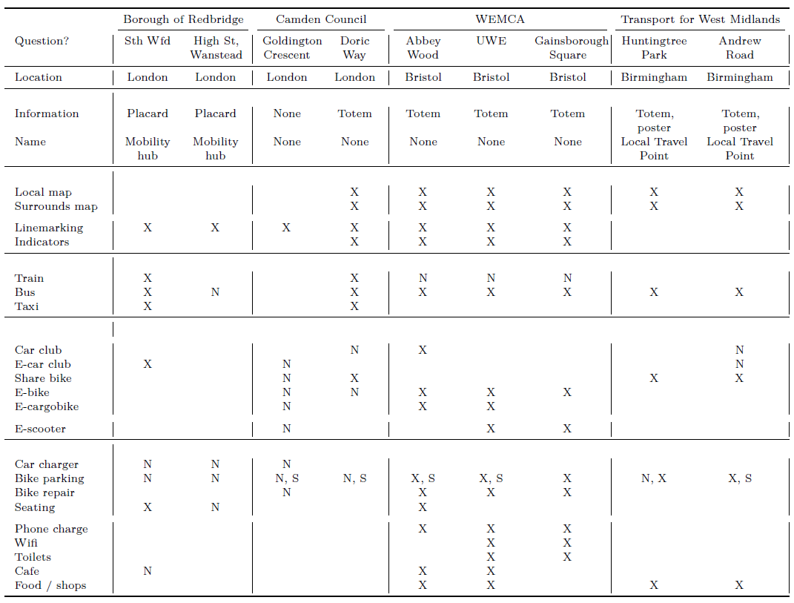
Table notes:
1. Case study questions (column 1) are of the form ‘How are details related to <COLUMN 1> at the hub communicated?’
2. An ‘X’ denotes an explicit mention of the feature in hub information. ‘N’ denotes no explicit mention, and a blank cell indicates the feature is not present at the hub. ‘S’ denotes secure bicycle parking, such as a locker.
3. Totem denotes a free standing information pedestal.
4. The totem information display at the Doric Way mobility hub is specific to the Transport For London ‘Cycles’ docked bike share facility. There is no information provided specifically about the mobility hubat Doric Way.
Bicycle parking hoops were the most commonly provided feature. Some hubs in Camden, Bristol and Birmingham also included bicycle lockers or similar higher security parking. Seating and nearby toilets were available as part of some hubs, but none included comprehensive shelter or access to drinking water. The Bristol hubs included USB connections for phone recharging, and wifi internet connectivity at some locations.
Overall, findings during the Discovery phase suggest that current practices relating to information displays at mobility hubs are inconsistent. Best practices appear to be represented by the totem displays in Bristol and Birmingham.

Definition
Findings from the case research, iteration through the Double Diamond phases and synthesis resulted led to the expression of the design problem to be addressed in this research in the form of: five questions a mobility hub information display needs to answer. These are shown in Table 2. Also shown is an assessment of how each of the cases does (or does not) respond to each.
The first question shown in Table 2 relates to identifying a mobility hub as something in and of itself. Various terms were used in practice (Village Hub, Public Space, Local Travel Point), except in Camden (no information display) and Bristol (place name only).
Figure 1: Selected hub images. Source: authors.

The second question (Where am I?) was answered in the cases either by place names (Redbridge, Bristol and Birmingham) or not at all (Camden). For the third question (What is here?) the best industry practices appear to be identify hub elements through text descriptions, icons, linemarking and cube markers. Notably, hub elements were not always shown on the maps answering the fourth question (What is nearby?). Answers to the final question shown in Table 2 (How can I travel from here?) were similarly limited, although some displays included text descriptions and mapping.
Table 2: Defining the design problem through five questions. Authors’ concept.
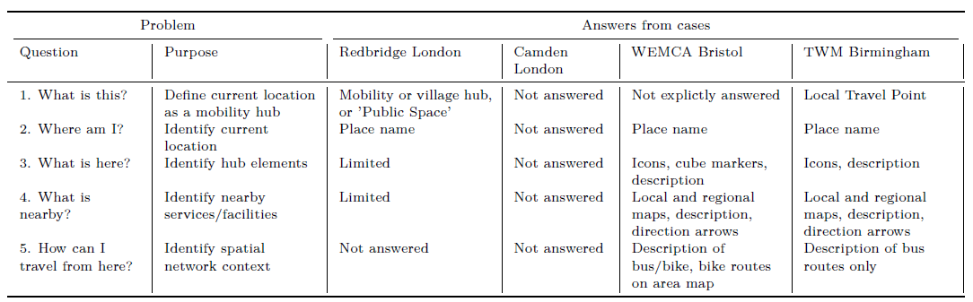

Development
During the Development phase the R language was used to: download Open Street Maps (OSM) data; produce local and regional maps; replicate the Bristol and Birmingham styles of totems; and create a synthesis display format, which responds to the problem Definition. OSM and R were chosen to facilitate reuse of the software, as these are both open source and freely available. Figure 2 shows outputs of the software generated for the Gainsborough Square case location.
These are intended to be printed at A0-scale, but the inset in Figure 2 (bottom left) demonstrates how the mapping labels points of interests The maps include iconographic representation of nearby facilities such as bus stops and cafes, which can be generated automatically from OSM data or from user inputs (i.e. latitude, longitude). Maps included in the synthesis (Figure 2, right) leverage map tiles associated with OSM, including the “Transport” and “Cycle” tile sets from Allan and Thunderforest (undated). Higher resolution images of the software outputs and totems for the Galway ROBUST hub are available on github, along with the software used to prepare this paper.

Delivery
Software developed in this research was assembled into a package of functions, as per the guidance provided by Wickham and Bryan (2023). This package is available at https://github.com/James-Reynolds/mobilityHubTools, and includes documentation and test data.

Discussion and conclusions
The cases studied during the first phase of this research suggest much variability in information displays and user guidance at mobility hubs. Practices include comprehensive displays in (Bristol and Birmingham) and cube shaped markers identifying hub elements (Bristol). At the other end of the spectrum, sites in Camden had only linemarking and did not appear to be identifiable as linked facilities or integrated hubs.
The design problem identified in this study relates specifically to totems and mapping, but clearly there are opportunities for further research into mobility hub wayfinding and information provision. As well, even those more extensive information displays found at some sites do not appear to have fully answered the five questions defined here as the design problem to be addressed.
Figure 1: Software output: Birmingham (left), Bristol (centre) and synthesis (right) display types. Source: authors.

While the synthesis totem display output from the Development phase of the research described here does answer all five questions (multiple times), further design improvements can clearly be made. There may be a need to better understand what facilities and services might best be included as ‘part’ of a hub, as opposed to those that are mapped as being ‘nearby’. More immediately, further development of the software and user testing of the software outputs is a potential direction for future research. As briefly noted earlier, the research described in this paper is part of the ROBUST project, which involves trials of shared electric mobility hubs in various locations across Ireland. Part of this larger program of research will include looking at user behaviour, usability and related issues under real-world conditions. Experiments with information displays, including testing and co-design with users, is a direction for future research during ROBUST. The research described in this paper, however, represents an initial exploration of this topic both through case studies of current practices and use of a design-research approach.
The aim of this research was to improve understandings related to mobility hub informational displays, and explore whether it was possible to develop software tools for communication about mobility hubs at other locations. The maps and other details shown in Figure 2, and materials available online might be suitable for prototyping, public consultation or similar. The flexibility of R might also allow users to adjust layouts, styling and other details as desired. Likewise, the OSM dataset can be freely accessed and edited by anyone. Hence, starting with the developed software and a printer, practitioners or others might be able define a mobility hub in their own community, and keep information displays up to date as circumstances change.
This might raise larger questions, such as who gets to decide what a mobility hub is? Perhaps mobility hubs already exist wherever there are combinations of: railway or electric vehicle charging stations; bus or tram stops; shared bike docks, parking zones or other micro-mobility offerings; or other transport-related facilities and services. Hopefully the software tools developed in this study may help facilitate bottom-up implementation, pop-ups or trials, or other efforts to develop and maintain mobility hubs.
More generally, the research outcomes of this study may provide insights about current mobility hub information displays developed by practitioners, as a step towards identifying ‘best practices’. Mobility hubs are still a new and evolving approach. As per the Roukouni et al. (2023) definition, a mobility hub needs to provide “integration”, “seamless, flexible connection” and “... an enjoyable experience for travelers” across multiple modes, while also connecting users to surrounding services and facilities. The research report here, however, suggests that there may still be some way to go in understanding how to deliver upon this definition, even within the narrower confines of information displays and other guidance for users at mobility hubs.

References
Andy Allan and Thunderforest. Opencyclemap and transport map layers, undated. URL https://www.thunderforest.com/.

CoMoUK. UK Mobility Hub Guidance 2019/20. 2019. URL https://www.como.org.uk/mobility-hubs/starting-and-running-successful-hubs

CoMoUK. Considerations for mobility hub branding and signage 2024. URL https://www.como.org.uk/mobility-hubs/starting-and-running-successful-hubs

Selby Coxon, Robbie Napper, and Mark Richardson. Urban mobility design. Elsevier, 2018. doi: 10.1016/C2017-0-01129-1.

Selby Coxon, Robbie Napper, Ilya Fridman, and Vincent Moug. The power of design to enrich the public transport experience. In Handbook of Public Transport research, chapter 6, pages 92–114. Edward Elgar Publishing, 2021. doi: 10.4337/9781788978668.00012.

Alexa Delbosc, James Reynolds, Wesley Marshall, and Andrew Wall. American complete streets and australian smartroads: what can we learn from each other? Transportation Research Record, 2018. doi: 10.1177/0361198118777379.

Martyn Denscombe. The good research guide. McGraw-Hill International UK Ltd, Maidenhead, Berkshire, UK, 2nd edition, 2007.

Joshua B. Engel-Yan and Amanda Leonard. Mobility hub guidelines: Tools for achieving successful station areas. ITE Journal (Institute of Transportation Engineers), 82(1):42 – 47, 2012. ISSN 01628178.

Karst Geurs, Anna Grigolon, Karla Münzel, Konstantinos Gkiotsalitis, David Duran-Rodas, Benjamin Büttner, Cristoph Kirchberger, Jesse Pappers, Lluis Martinez Ramirez, Antonia Graf, Julia Hansel, Roxani Gkavra and Roman Klementschitz. The Smarthubs integration ladder: a conceptual model for the categorisation of shared mobility hubs. Transport Reviews, 44(1), 2024. doi: 10.1080/01441647.2023.2239499x

Mike Lydon and Anthony Garcia. Tactical urbanism: short-term action for long-term change. Island Press, Washington, DC, 2015. doi: 10.5822/978-1-61091-567-0.

Metrolinx. The Big Move. Technical report, 2008. URL http://www.metrolinx.com/thebigmove/

Matthew B. Miles and A. Michael Huberman. Qualitative data analysis : an expanded sourcebook. Sage Publications, Thousand Oaks, 2nd edition, 1994.

James Reynolds and Graham Currie. New approaches and insights to managing on-road public transport priority, chapter 10, pages 172–201. Edward Elgar Publishing Limited, Cheltenham, UK, 2021. doi: 10.4337/9781788978668.00017.

Anastasia Roukouni, Inés Aquilué Junyent, Miquel Martí Casanovas, and Gonçalo Homem de Almeida Correia. An analysis of the emerging “shared mobility hub” concept in european cities: Definition and a proposed typology. Sustainability (Switzerland), 15(6), 2023. doi: 10.3390/su15065222.

Lisa Salsberg, Abril Novoa Camino, David Sajecki, and Joshua B. Engel-Yan. Planning for mobility hubs: Creating great transit places. Transportation Association of Canada (TAC), 2010.

TRIP - Centre for Transport Research and Innovation for People. ROBUST: Electric shaRed mOBility hUbS Trial, 2025. URL https://www.tcd.ie/transport-research/our-research/research-projects/ROBUST-electric-sharedmobility-hubs-trial/

UK Design Council. The Double Diamond. undated. URL https://www.designcouncil.org.uk/our-resources/the-doublediamond/

Hadley Wickham and Jennifer Bryan. R packages. "O’Reilly Media, Inc.", 2023. URL https://r-pkgs.org/

Robert Yin. Case study research and applications: design and methods. SAGE Publications, Inc., Thousand Oaks, CA, USA, sixth edition, 2018.

CoMoUK (2019) notes examples of “a strong brand on the signage across a network that will help to raise the profile of the mobility hubs, provide a uniform identity and promote a shift to a multi-modal lifestyle”, including the Belgium Mobi-Punt. They also highlight the development of a similar nation-wide branding, signage and wayfinding approach for the UK as a direction for further work, but we are not aware of this having been published to date.
More formally, the (null) hypothesis tested in this study is that it is not possible to develop software tools for generating mobility hub information displays that reflect best practices and are generally applicable to other sites.
The unit of analysis was the implementing agency / location. Within each case a small number of mobility hubs were visited to allow for within-case comparison. These were: (Redbridge) South Woodford and High Street, Wanstead; (Camden) Goldington Crescent, and Doric Way; (Bristol) Abbey Wood, UWE Frenchay, and Gainsborough Square; and (Birmingham) Huntingtree Park and Andrew Road.
These iterations were tracked using the Git version control system, and code used in the production of this paper is available at https://github.com/James-Reynolds/WP5_mobilityHubTools_papers/blob/main/ReynoldsEtAl2026_CERC.Rmd.The software package itself is available at https://github.com/James-Reynolds/mobilityHubTools, and is expected to be developed further during later parts of the ROBUST project.
See https://github.com/James-Reynolds/WP5_mobilityHubTools_papers/tree/main/results
More formally, these results disprove the (null) hypothesis tested in this paper, by showing that it is possible to develop software to produce mobility hub information displays using OSM data.

