To generate the figures below I ran a linear regression with the frequency of the ‘recessive’ (e.g. acyanogenic) phenotype as the response variable and generation as the predictor. I did this for every simulation (i.e. 1000 iterations) and for every variation of the parameter (i.e. population size or initial allele frequencies), each time exporting the slope of the regression.

**Varying population size**

As population size increases, the mean slope of the cline and the proportion of clines with positive slopes decrease (Fig. 1 and Fig. 2). Thus, as population size increases, the effects of drift alone generate weaker clines and results in fewer clines in the predicted direction (e.g. increasing frequency of acyanogenesis, Fig. 2). In fact, at 5000 individuals sampled, ~52% of the clines were positive, with the remaining 48% being negative.

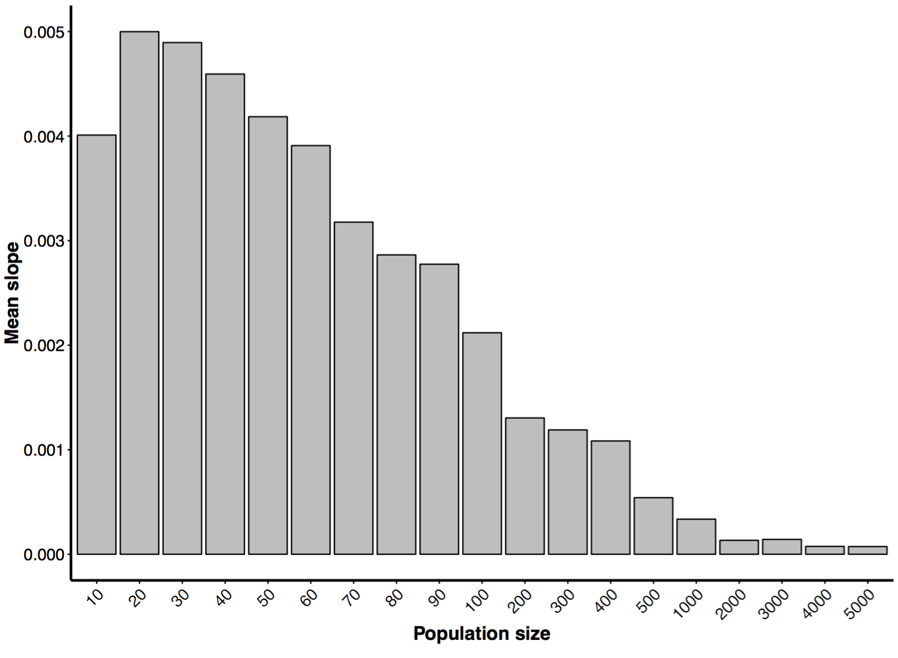

**Fig 1**: Mean slope of the cline by population size.

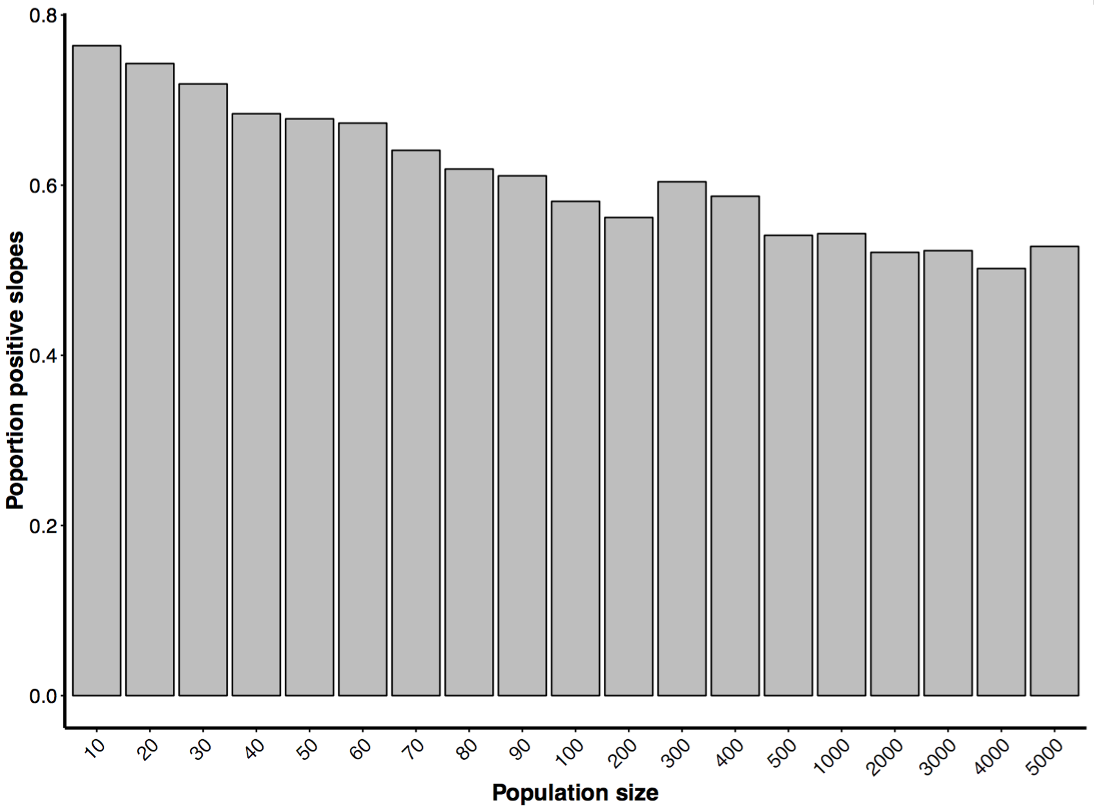

**Fig. 2**: Proportion of positive slopes (i.e. increasing frequency of acyanogenic phenotype) by population size.

**Varying initial allele frequencies**

The strongest clines (i.e. steepest slopes) resulted when the initial frequencies of both dominant alleles were 0.7 (Fig. 3). For alleles frequencies lower or higher than 0.7, the strength of the cline decreased. Also, smaller differences in the initial frequencies of dominant alleles resulted in stronger clines. Increases in the frequencies of initial alleles (and smaller differences in their initial frequencies) also resulted in a reduction in the proportion of positive slopes such that at high initial frequencies of the dominant alleles (e.g. A = 0.9, B = 0.9), the majority of the clines (i.e. > 50%) were in the *opposite* direction (i.e. reduced frequency of acyanogenesis with increasing generations.

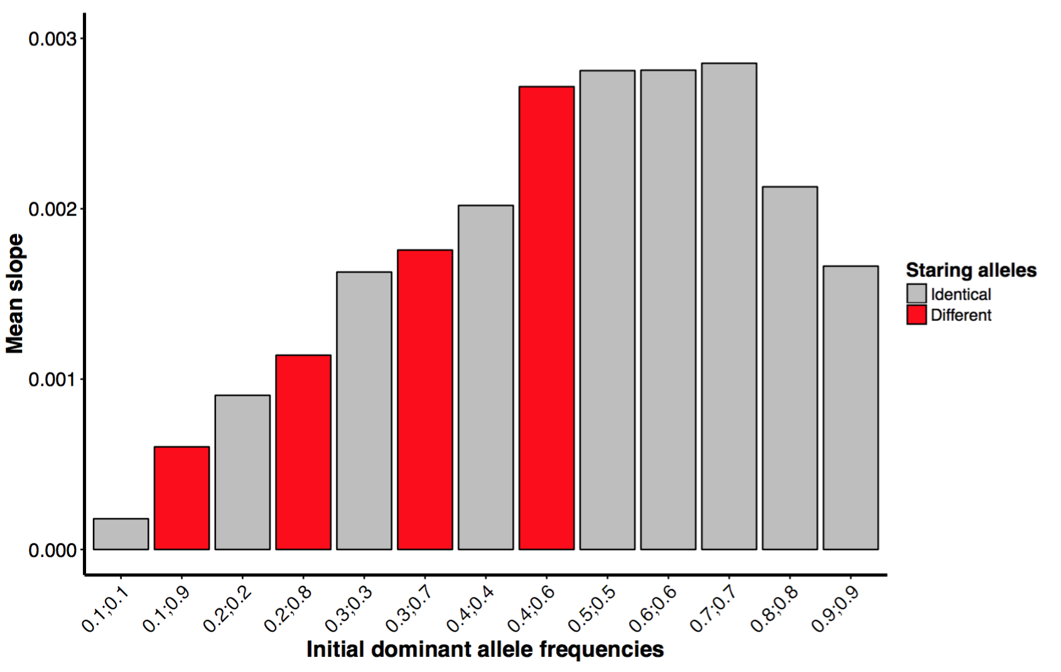

**Fig. 3**: Mean slope by initial frequency of dominant alleles. Note the format of the x-axis — frequency of allele *A* ; frequency of allele *B.* For example, ‘0.1;0.9’ mean the initial frequency of allele *A* was 0.1 while the initial frequency of allele *B* was 0.9. For some simulations, the frequencies of initial alleles were identical (grey bars) whereas in others they were different (red bars).

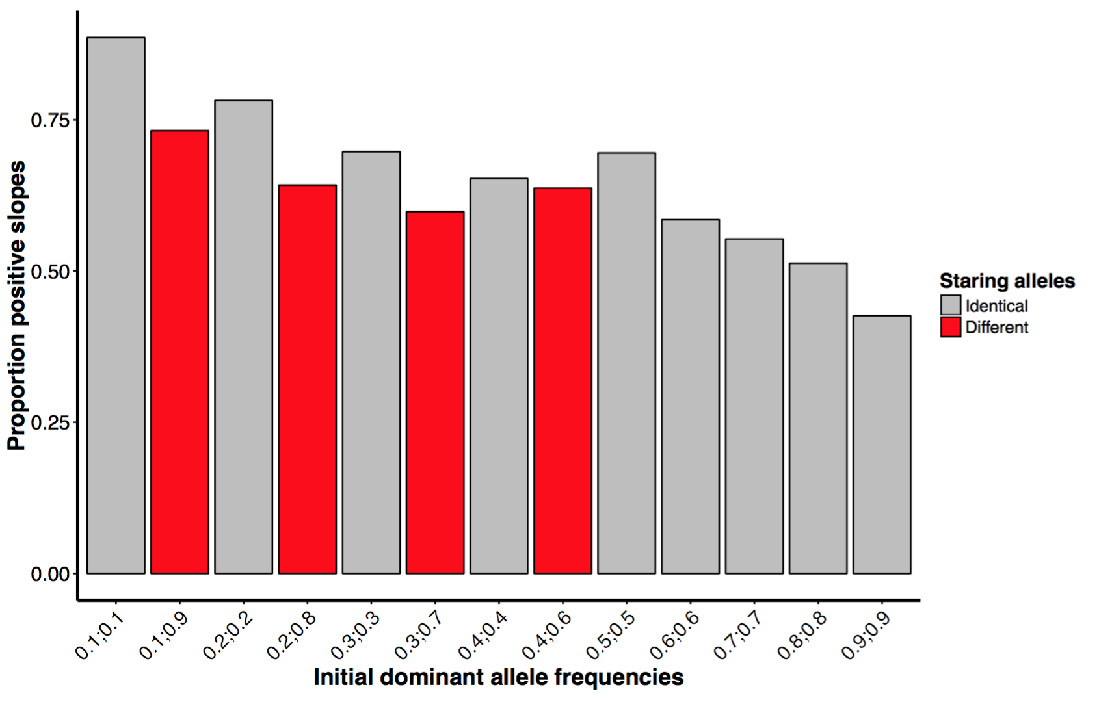

**Fig. 4**: Proportion of positive slopes by initial frequency of dominant alleles. Note the format of the x-axis — frequency of allele *A* ; frequency of allele *B.* For example, ‘0.1;0.9’ mean the initial frequency of allele *A* was 0.1 while the initial frequency of allele *B* was 0.9. For some simulations, the frequencies of initial alleles were identical (grey bars) whereas in others they were different (red bars).