Based on our conversations the last time we met, I have produced figures for each scenario whereby I varied parameters to examine their effects at generating clines in cyanogenesis via genetic drift. I varied the following parameter: population size (i.e. number of individuals sampled per generation), number of steps (i.e. generations) and initial *dominant* allele frequencies. For each scenario, I produced figures showing the change in the frequency the ‘recessive’ phenotype (i.e. resulting from recessive allele at *at least* one locus) as a function of generation number. I also show the time to fixation (or total proportion fixed) of the recessive phenotype given the parameter being varied. I produced all figures by averaging over 1000 simulations. My goal here is only to show trends so I have not included measures of variance around estimates (e.g. SE’s or CI’s).

**Varying population size**

Varied population size as follows: Total of **19** different population sizes used

1. 10 to 100 by 10
2. 100 to 500 by 100
3. 500 to 1000 by 500
4. 1000 to 5000 by 1000
5. Number of generations: Constant at **50**
6. Initial allele frequencies: both at **0.5**

An increase in population size results in a clear reduction in the effects of drift, as evidence by reduced slopes of clines with increasing *N* (Fig. 1). Furthermore, increasing population size resulted in a decrease in the equilibrium frequency of the recessive phenotype (Fig. 1). Equilibrium frequency is also reached sooner at low population sizes, likely due to greater effects of drift and more rapid fixation of either recessive allele — and by extension the recessive phenotype (Fig. 2).

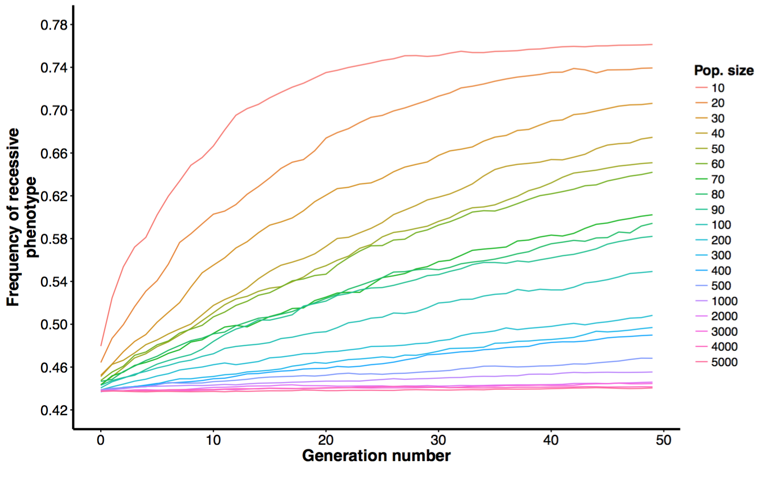

**Fig 1:** Frequency of recessive phenotype by number of generations. Different lines represent different variations of population size.

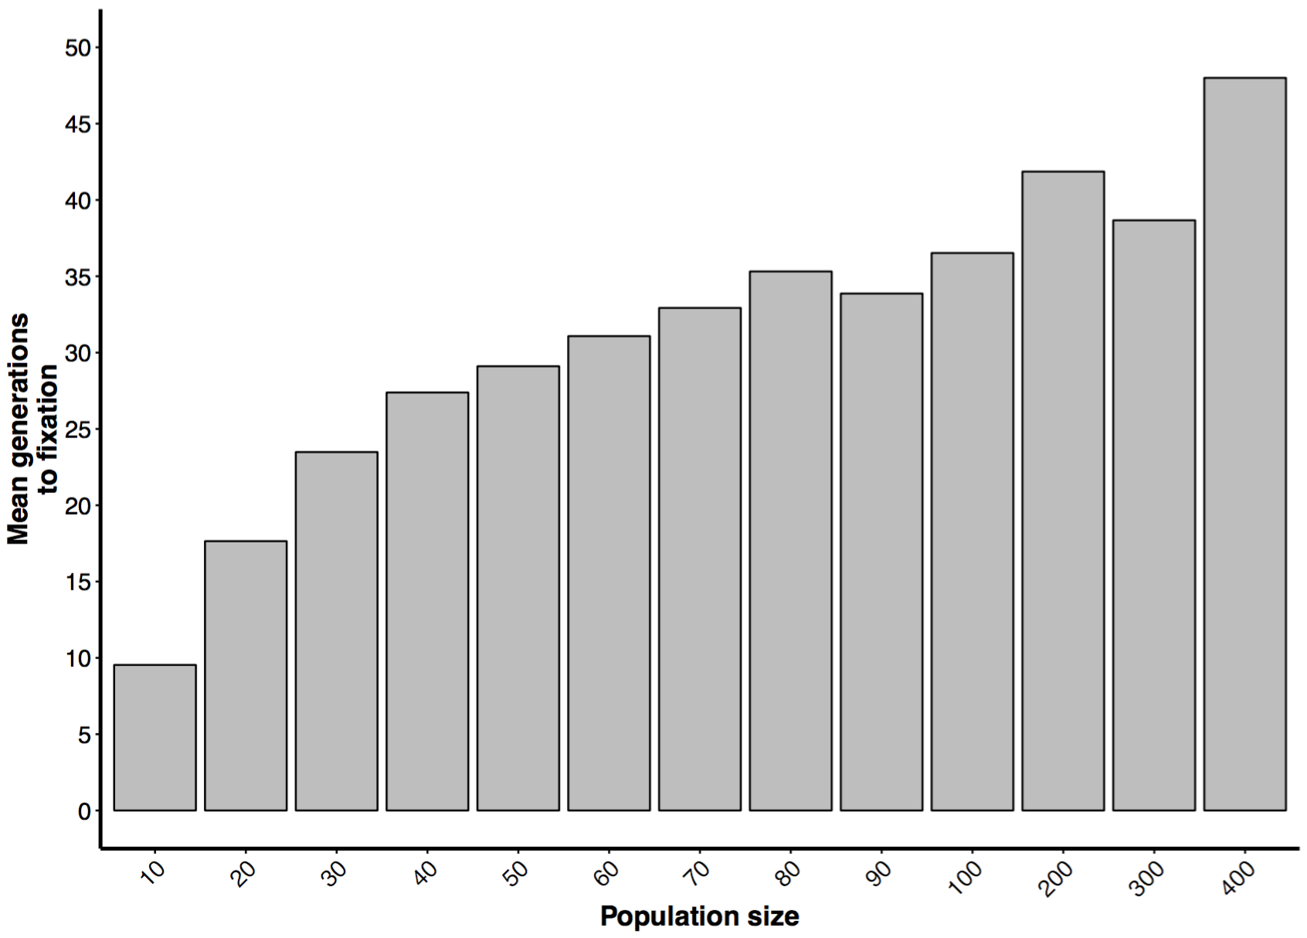

**Fig 2:** Mean number of generations to fixation of the recessive phenotype by population size. Population sizes larger than 400 were excluded do to phenotype never becoming fixed at such high values.

**Varying number of generations**

Varied the number of generations as follows: **23** variations of number of generations used

1. 2 to 10 by 2
2. 10 to 100 by 10
3. 100 to 500 by 100
4. 500 to 1000 by 500
5. 1000 to 5000 by 1000
6. Population size: constant at **100**
7. Initial allele frequencies: both at **0.5**

Increasing the number of generations resulted in an increase in the frequency of the recessive phenotype until 1000 generations, after which point no further increases were observed (i.e. equilibrium frequency, Fig. 3). Also beginning at 1000 generations, 100% of simulations resulted in fixation of either phenotype (i.e. every simulation became fixed, Fig. 4). Note that the majority of these (75%) were fixed for the recessive phenotype. This is not surprising given that 75% of the **genotypes** result in the recessive **phenotype**.

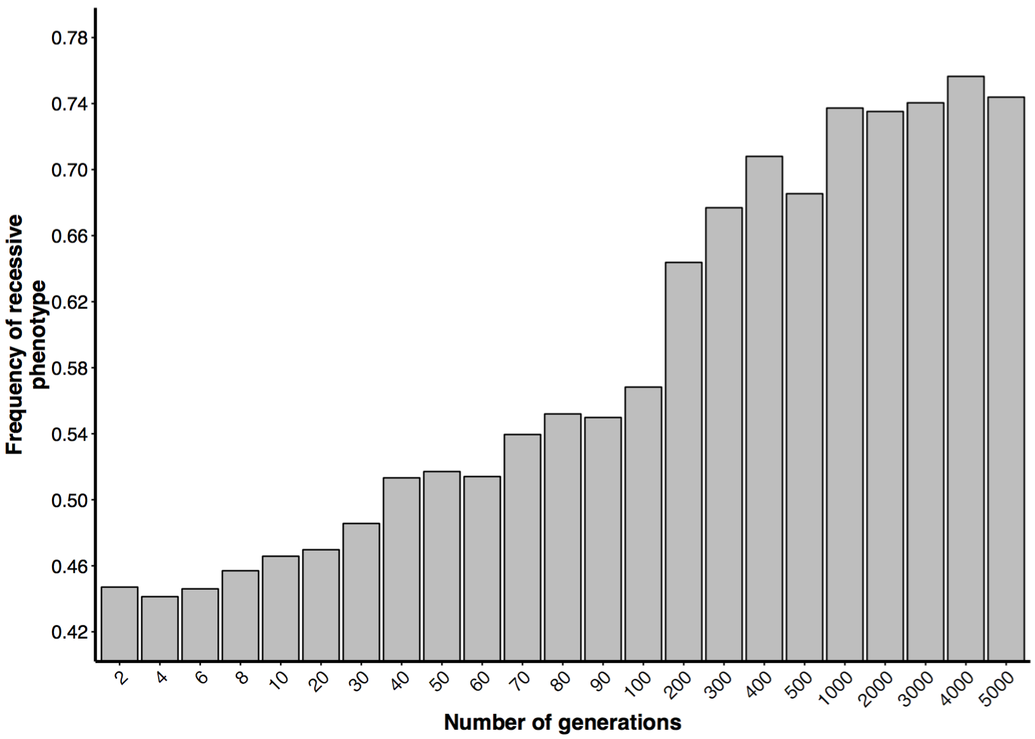

**Fig 3:** Frequency of the recessive phenotype by number of generations.

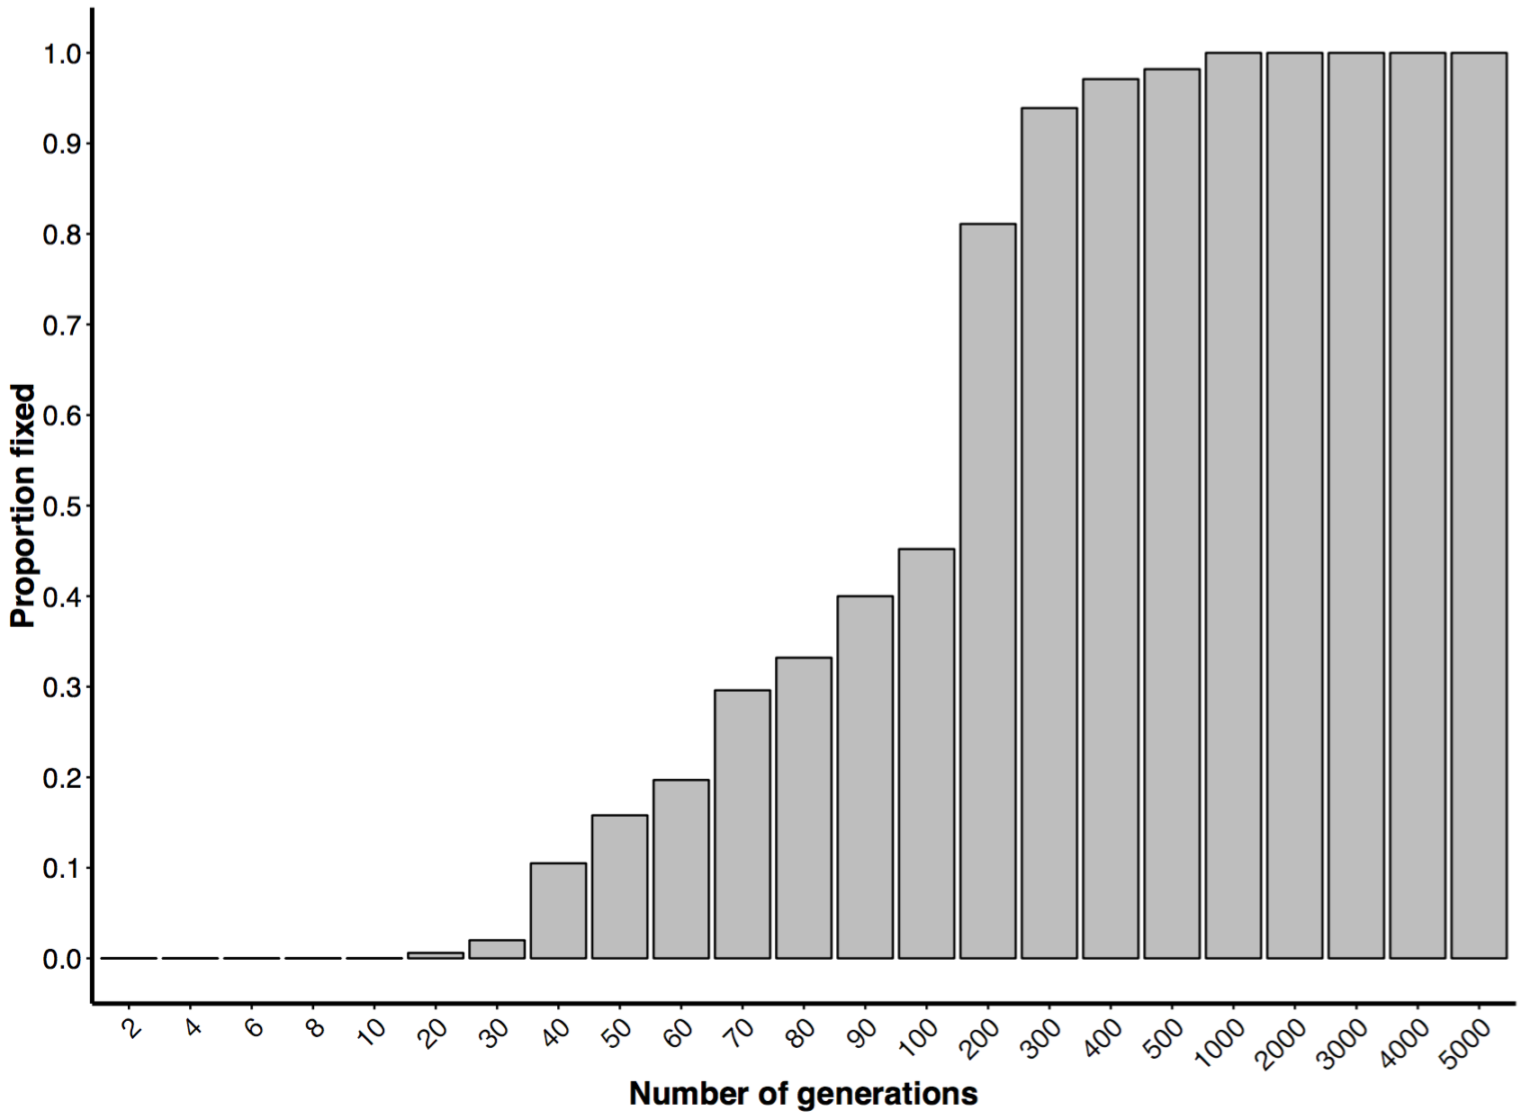

**Fig. 4:** Proportion of simulations resulting in fixation of either phenotype (i.e. recessive or dominant) by number of generations.

**Varying initial allele frequencies**

Varies initial dominant allele frequencies as follows: **13** variations used

1. Both allele starting at 0.1 and increasing by 0.1 to 0.9
2. Allele A starting at 0.1, **increasing** by 0.1 until 0.9 AND allele B starting at 0.9 and **decreasing** by 0.1 until 0.1.
3. Population size: constant at **100**
4. Number of generations: constant at **50**

Unsurprisingly, when the frequency of both dominant alleles are initially low, the

frequency of the recessive phenotype is high. The frequency of the recessive phenotype decreases with the initial frequency of both dominant alleles (Fig. 5). As the initial frequency of both dominant alleles increase, clines appear to become more pronounced (i.e. greater slope), peaking at initial frequencies of ~0.7 and declining thereafter. Likely due to effects of drift having more time to accumulate (i.e. more generations before fixation of phenotype, Fig. 6).

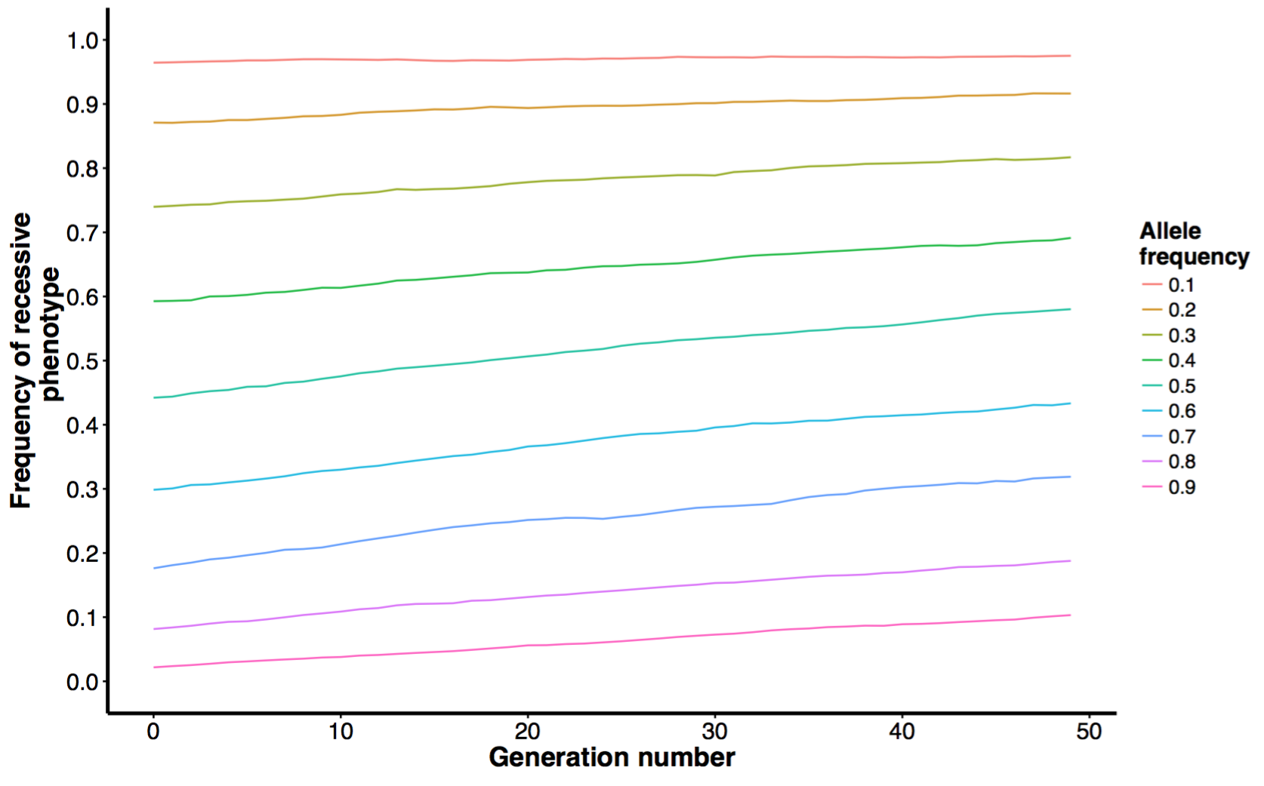

**Fig 5:** Frequency of recessive phenotype by generation number. Line represent initial frequencies of dominant alleles. Note initial frequencies of A and B allele are identical in this scenario.

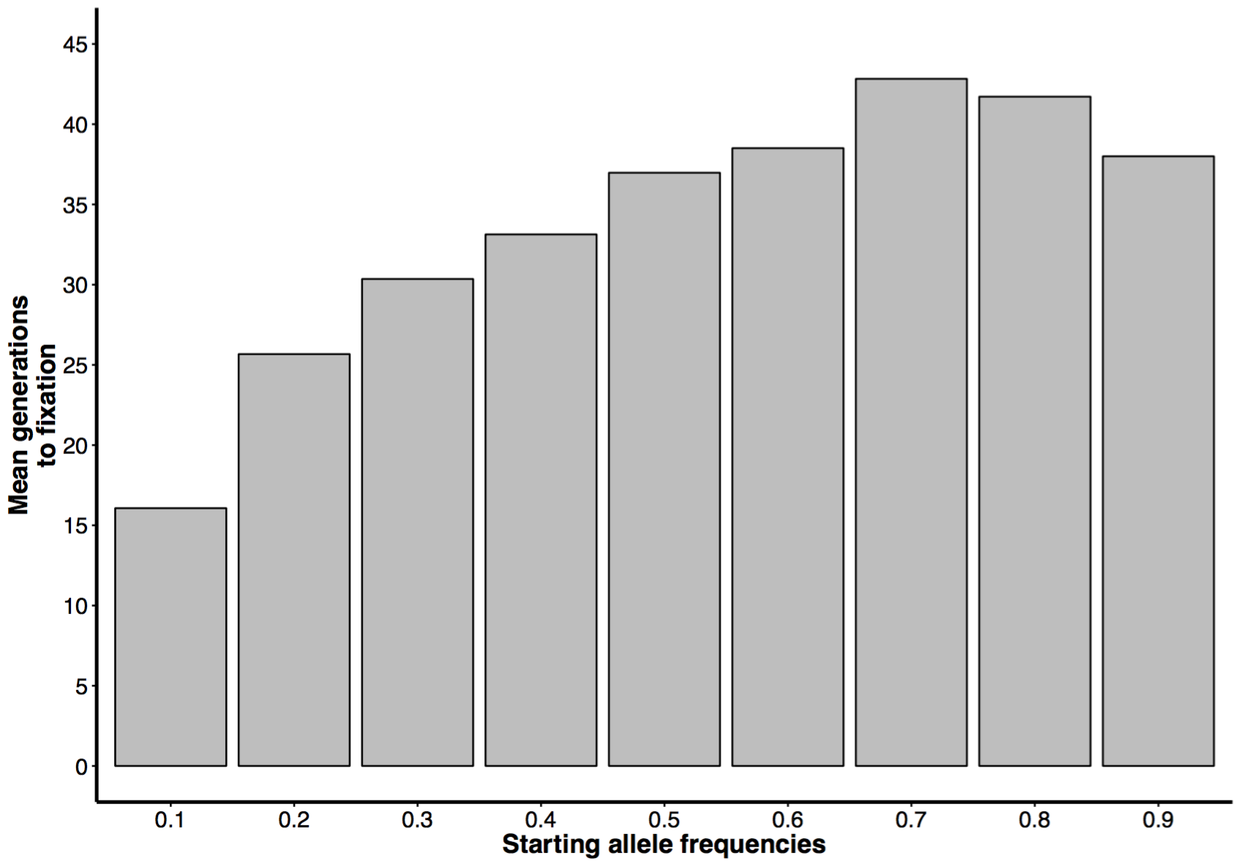

**Fig. 6:** Mean number of generations to fixation of recessive phenotype by initial starting frequency of both A and B allele.

As the difference in initial frequencies of the dominant alleles increases, the clines become more pronounced and equilibrium phenotype frequency takes longer to be reached (Fig. 7). Again, this is likely due to the effects of drift having more time to accumulate as initial allele frequencies become more similar (higher mean time to phenotype fixation with decreasing difference, Fig 8)

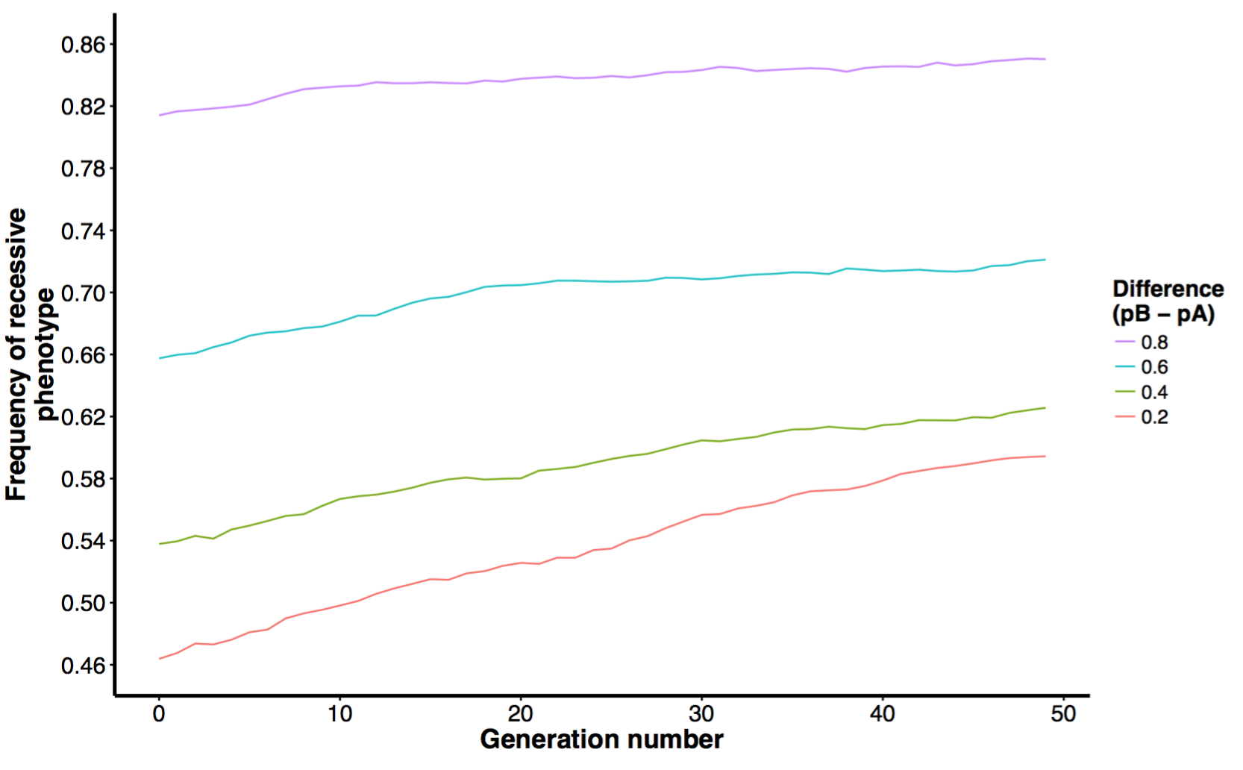

**Fig 7:** Frequency of recessive phenotype by generation number. Lines represent the difference in initial frequencies of the dominant alleles.

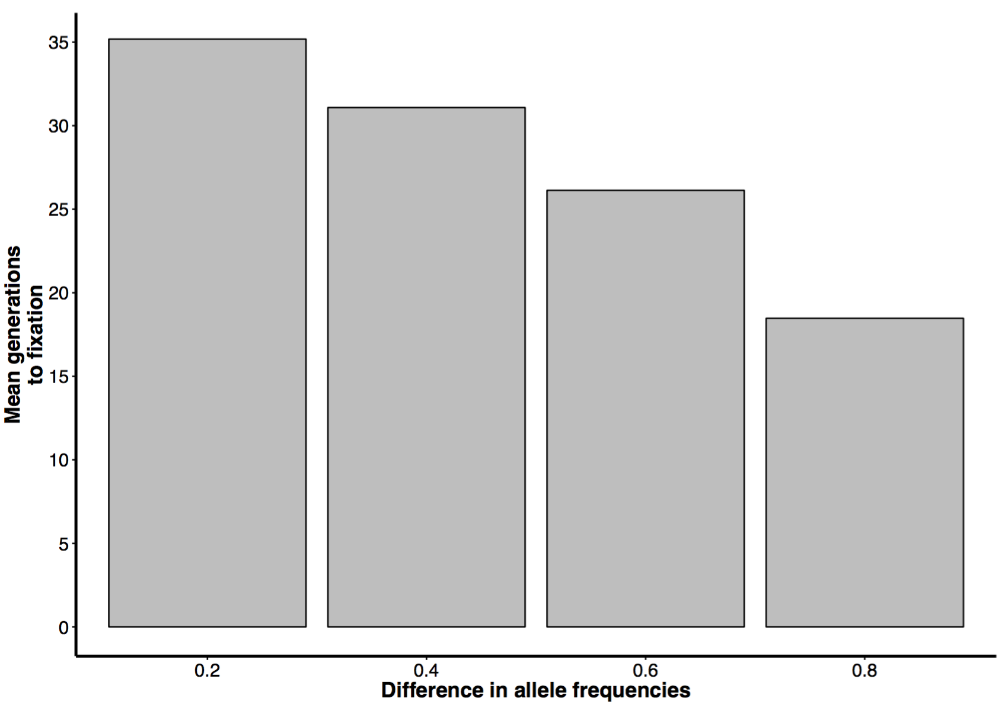

**Fig. 8:**  Mean number of generation to fixation of the recessive phenotype by difference in initial frequencies of dominant alleles.

Taken together these results suggest that in a stepping-stone model, whereby each generation corresponds to the formation of a new population sampled from the previous generation, drift alone can generate clines in a phenotype that is the result of epistatic interactions among underlying genes. However, population size, number of generations and initial allele frequencies all play a role in determining the ‘steepness’ of clines and the equilibrium frequency of the underlying phenotype.

**Next steps**

Examine whether the above is true when migration is considered and perhaps other types of population structure. In thinking about this, it seems there are two primary ways migration can be incorporated:

1. Movement of gametes (e.g. pollen) from one population to the next. In this scenario, **alleles** move from one population to the next at the and are incorporated into the gene pool.
2. Movement of individuals (e.g. seeds) from one population to the next. Here, **individuals** (diploid in our case) move from one population to the next and are allowed to mate with resident individuals

I have to think a little more about whether the above scenarios are actually different. Scenario 1 revolves around the movement of alleles (haploid) whereas scenario 2 revolves around the movement of individuals (diploid). I’m thinking in terms of plants (i.e. movement of pollen vs. movement of seeds) but this can likely be generalized to other systems. I’ll think more about this before out next meeting.