Question A
[120 marks]

- Imagine you are creating an online shopping web site. Give three example scenarios where it is beneficial to have your servers on the cloud rather than in your office. Please give reasons for your answer, so why is it better to have the servers in the cloud rather than in your office for these scenarios? Hint: think about changes in customer demand, disasters, etc.

[10 marks]

It is pay as you go, if the business tanks, you no longer must pay for the service, where if you had bought the servers you would have paid the outright price, and now need to find a way to sell them off.

Potentially infinite resources, just pay a little more hourly, then you have much more storage space, where if you had to buy a new server it might be wasteful.

If there is a problem (disaster, power outage, break in, fire) you are unlikely to lose your saved data.

- Why are virtual machines very useful in the cloud?

[6 marks]
Virtual machines are very useful in the cloud as multiple of them can be run on every host computer, giving more results when needing many different individual processes run.

- Imagine you have decided to create your online shopping web site on Amazon Web Services. Please give examples of how you would use each of the following web services (one example per service) for your online shopping web site:
  - Amazon Elastic Compute Cloud (EC2)
  - S3
  - Amazon Relational Database Service (RDS)
[10 marks]
- EC2 would be good to use for managing the websites and how its run, to make sure all the processes work. Also to calculate so that there is always enough products, but never too much.
- If hosting a shopping website, S3 would be great to hold a database of the items on sale with their details and pictures. It can easily be scaled upwards if more items are added later.
- RDS would be good to store all customer information, new customers, what they buy, addresses and so forth.

- Please describe why the MapReduce framework of Hadoop is so good for processing Big Data.
[10 marks]
The mapreduce framework of Hadoop is good for processing big data because it is based on parallel programming. Parallel programming is very good in functions in which a large amount of data needs to be “touched”, for example the transformation or aggregation of data.

- In the Hadoop MapReduce framework please explain what happens to the data as it is emitted from the mapper and arrives at the reducer. Also how does this help us to achieve the output that we desire?
[8 marks]
When putting large amounts of data through a reducer, all instances of single words are counted and stored. This helps when that data later needs to be searched through for those particular words.

- Please explain what is the advantage of using combiners when writing MapReduce programs.
[7 marks]
Using combines when writing mapreduce programs is advantageous because it is an optimization option, it reduces the need for the data to go through the expensive shuffle phase.

- Please explain the advantages versus disadvantages of using Hive versus programming directly in MapReduce.

[7 marks]
It is advantageous to use hive because you can more clearly see the data that is being manipulated.
It is disadvantageous to use hive over mapreduce, because hive has no control over the data in its schema, while mapreduce does.

- Please describe what types of problems Zookeeper is useful for solving.

[6 marks]
Zookeeper is useful for solving problems in which failures or faults are possible. For instance, when using a high availability file system, it keeps track of users and helps to facilitate the system, even if nodes go down.

- Describe the differences between application masters in YARN and the job tracker of the MapReduce 1 framework.

[8 marks]
Mapreduce provides one jobtracker per cluster, while yarn assigns many “application mastres per cluster” to better track data in the cluster.

- The diagram below describes the lambda architecture. Please explain why the lambda architecture is more desirable for processing streaming data than just using the MapReduce framework alone.

[8 marks]
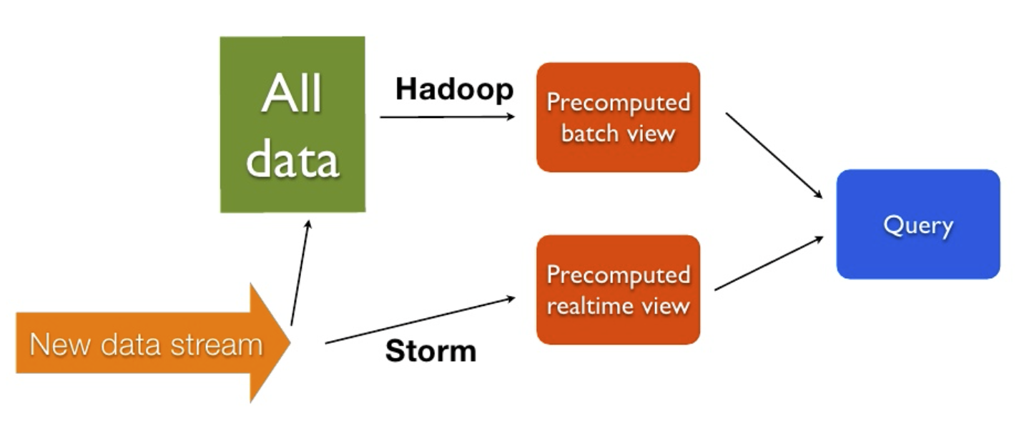
The lambda architecture is more desirable for processing streaming data than just using the MapReduce framework alone because it does not need new data to join with “all data” and having to waste time with batch processing before being streamed. It is more desirable for the many users of the system to immediately be able to view data while mapreduce is batching the data in the background, rather than to wait for the batch before viewing.

- Why is MapReduce so inefficient at executing iterative graph algorithms such as Page Rank? Why is Pregel more efficient at processing iterative graph algorithms.

[9 marks]
Mapreduce is inefficient in comparison to pregel as pregel uses the bulk synchronous processing computational model. Mapreduce would need to read and write an entire graph of data into HDFS for every step, no matter the size of the graph, while pregel loads data once, then uses supersteps to parallel process the data into its end form.

- Why is Spark more efficient at executing iterative algorithms on Big Data compared to the MapReduce framework?

[7 marks]
Spark is more efficient than Mapreduce as it can do everything every function of mapreduce can do, but better. It contains a mapreduce API that runs all mapreduce functions but with up to a 100 times improvement rate. Spark Unifies batch, streaming, interactive comp into an easier and more intuitive program which does it all (while using less code when all put together than any single one).

- Describe what is an RDD? What are the good properties of RDDs?

[7 marks]

- Using the diagram below explain the difference between narrow and wide dependencies in Spark. Include in your answer whether it is desirable to have more wide or more narrow dependencies.
[7 marks]

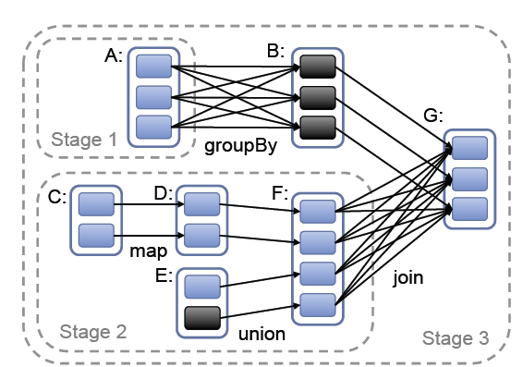

- Please explain the concepts shown in the diagram below.
[10 marks]

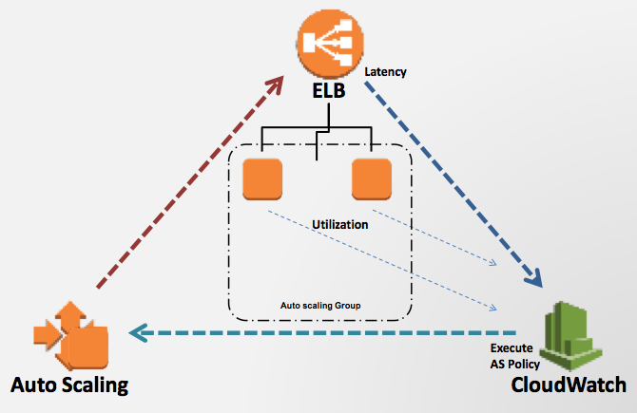

Question B
[30 marks]

Answer the sub-questions of question B using the data described below.

Index | Column Name | Possible values
0 | Animal ID | continuous
1 | Hair | true, false
2 | Number of legs | Continuous
3 | Milk | true, false
4 | Wings | true, false
5 | Weight | Continuous
6 | Type | mammal, amphibian, bird, invertebrates, fish, reptiles
7 | Age | Continuous

Here are a few Spark API calls that maybe useful for you. You do not need to use all these API calls in your answers. Also if you remember some other API calls which are not included here, feel free to use them in your answers.

def collect(): Array[T]

Return an array that contains all of the elements in this RDD.
def count(): Long

Return the number of elements in the RDD.
def distinct(): RDD[T]

Return a new RDD containing the distinct elements in this RDD.
def filter(f: (T) ⇒ Boolean): RDD[T]

Return a new RDD containing only the elements that satisfy a predicate.
def first(): T

Return the first element in this RDD.
def flatMap[U](f: (T) ⇒ TraversableOnce[U])(implicit arg0: ClassTag[U]): RDD[U]

Return a new RDD by first applying a function to all elements of this RDD, and then flattening the results.
def foreach(f: (T) ⇒ Unit): Unit

Applies a function f to all elements of this RDD.
def groupBy[K](f: (T) ⇒ K)(implicit kt: ClassTag[K]): RDD[(K, Iterable[T])]

Return an RDD of grouped items.
def map[U](f: (T) ⇒ U)(implicit arg0: ClassTag[U]): RDD[U]

Return a new RDD by applying a function to all elements of this RDD.
def mapPartitions[U](f: (Iterator[T]) ⇒ Iterator[U], preservesPartitioning: Boolean = false)(implicit arg0: ClassTag[U]): RDD[U]

Return a new RDD by applying a function to each partition of this RDD.
def reduce(f: (T, T) ⇒ T): T

Reduces the elements of this RDD using the specified commutative and associative binary operator.
def sortBy[K](f: (T) ⇒ K, ascending: Boolean = true, numPartitions: Int = this.partitions.size)(implicit ord: Ordering[K], ctag: ClassTag[K]): RDD[T]

Return this RDD sorted by the given key function.
def take(num: Int): Array[T]

Take the first num elements of the RDD.
def zip[U](other: RDD[U])(implicit arg0: ClassTag[U]): RDD[(T, U)]

Zips this RDD with another one, returning key-value pairs with the first element in each RDD, second element in each RDD, etc.
def GroupByKey(): RDD[(K, Iterable[V])]

Group the values for each key in the RDD into a single sequence.
def join[W](other: RDD[(K, W)]): RDD[(K, (V, W))]

Return an RDD containing all pairs of elements with matching keys in this and other.
def reduceByKey(func: (V, V) ⇒ V): RDD[(K, V)]

Merge the values for each key using an associative reduce function.

Also given the code below.

scala> val lines = sc.textFile(“animals.txt”)
// assume all the columns are separated by “, ”
scala> val split_lines = lines.map(_.split(“, “))

Write spark code to do the following. Your solution can consist of one or more lines of Spark code. You do not need to make the output format look good.

- Output all lines of animals whose hair attribute is true and whose age is greater than 1. For selected lines output the entire line including all attributes.
[8 marks]

val result = split_lines.filter(x => x(1) == “true” && x(7) > 1)
result.collect

- Output the entire line for the animal that has the lowest weight. If there is more than one animal with the same lowest weight, just return any one of them. So you should always only return one animal.
[10 marks]

def lowerWeight(animal1:(Array[String]), animal2:(Array[String]) : Array[String] = {
if(animal1(5).toInt < animal2(5).toInt) return Animal1
return Animal2
}

val result = split_lines.reduce(lowerWeight(_, _))

- For each animal type report the number of animals who have 2 legs. So the output should look something like this:

birds, 100
mammals, 110
amphibians, 0
..etc..
[12 marks]

val animalsToCount = split_lines.filter(record(2).toInt == 2)
val result = animalsToCount.map(record => (record(6) + “s”, 1)
.reduceByKey(_ + _)

Question C
[30 marks]

Suppose you are given the data that contains the first 7 columns of the file used for task 1 of your assignment. Shown below.

Attribute number | Attribute name | Description
1 | Age | Numeric
2 | Job | type of job (categorical: "admin.", "unknown", "unemployed", "management", "housemaid", "entrepreneur", "student",  “blue-collar", "self-employed", "retired", "technician", "services")
3 | Marital | marital status (categorical: "married", "divorced", "single"; note: "divorced" means divorced or widowed)
4 | education | (categorical: "unknown", "secondary", "primary", "tertiary")
5 | Default | has credit in default? (binary: "yes", "no")
6 | balance | average yearly balance, in euros (numeric)
7 | housing | has housing loan? (binary: "yes", "no")

Below you are given problems to solve using MapReduce. First, I will explain what I expect in your answer. You do not need to write actual Java code. Just high-level pseudo code is enough. Please specify what is inside the mapper and reducer in terms of the following three aspects:
- What is the input key and value
- What processing is performed by each map/reduce call
  - Include the emitting of the output key, value pairs.
- You may need to specify a cleanup method for some questions. In this case write what processing is done in the cleanup method and what is emitted.
Feel free to use more than one MapReduce phase if required.

Here is an example of what I mean by pseudo code, although of course it is not the answer to any of the questions ☺

Mapper
- Input Key: byte offset of input line, Input Value: input line
- Inside map function
  - Extract from the input line the balance.
  - Extract from the input line the age.
  - Emit (balance, age)

Reducer
- Input Key: balance, Input Values: set of age values
- Inside reduce function
  - For each age value
Emit (balance, age)

- You are asked to use MapReduce to report the age and job of people who has a balance of 0. You can assume the age and balance attributes are integers. Do not write a combiner or do local aggregation for your answer, since that is the next question. Your output should be something like the following (don’t worry about trivial formatting things like whether the output will have “ “ around the words, etc.):

35 admin.
50 self-employed
etc.
[10 marks]

Mapper
- Input Key: byte offset of input line, Input Value: input line
- Inside map function
Extract from the input line the balance.
If balance is equal to 0 then
Extract from the input line the age.
Extract from the input line the job.
Emit (age, job)
End if

Reducer
- Input Key: age, Input Values: set of balance values
- Inside reduce function
For each job value
Emit (age, job)
End for

- Can we use a combiner or local aggregation to reduce the amount of data shuffle for the previous question? If no why not. If yes then write the pseudo code for a combiner or local aggregator for the previous question. Write the combiner or local aggregator in the same format as the pseudo code example given earlier. Please explain how the combiner or local aggregator reduces the amount of data shuffled.

[4 marks]
No, each value from the mapper is emitted the same in the reducer (no transformation on set of value)

- You are asked to use MapReduce to find the number of people who are both married and have a housing loan. Do not write a combiner or do local aggregation for your answer, since that is the next question. So the output should look something like the following (don’t worry about trivial formatting things like whether the output will have “ “ around the words, etc.).

10023

[12 marks]
Mapper
- Input Key: byte offset of input line, Input Value: input line
- Inside map function
Extract from the input line the marital.
Extract from the input line the housing.
If marital is equal to “married” and housing is equal to “yes” then
Emit (marital + housing text, 1)
End if

Reducer
- Input Key: marital + housing text, Input Values: set of int values
- Inside reduce function
var count = 0
For each int value
count = count + value
End for
Emit (marital + housing text, count)

- Can we use a combiner or local aggregation to reduce the amount of data shuffle for the previous question? If no why not. If yes then write the pseudo code for a combiner or local aggregator for the previous question. Write the combiner or local aggregator in the same format as the pseudo code example given earlier. Please explain how the combiner or local aggregator reduces the amount of data shuffled.
[4 marks]

Yes, sum locally. The combiner would be the exact same as the reducer

