MAP524 A

Assignment 1

Professor: John Selmys

Due: Febuary 27 2015

Submitted: Febuary 27 2015
by: James Boyer 020-001-129

Executive Summary:

This application is Average food prices. This application will take in data from a dataset, this data set shows average food prices each month for certain types of food in Canada. It will use this data to provide users with information to allow them to check if they are getting a good deal or not getting overcharged for an item. The dataset currently has each item cost at a set weight/volume, this application will allow you to enter whatever weight/volume you want and it will automatically convert it and get you the average price for the specific item at that specific weight.Users can also view a history of the price of each time through a graph interface as well as other information about that item. This app will also be useful because it requires minimal internet, only when updating the data set each month, this allows user's without a data plan or without a signal to have access to all the information at their fingertips.

Why is this application mobile:

If this was not a mobile app the user's would have to plan out what they want to buy and would have to write the prices down which would make this app not appealing at all. Making this application mobile allows users to check and compare prices on the go. The fact that this is a mobile app is perhaps the most important part, it would be practically useless if it wasn't. I think the most common place this app will be used is in a grocery store. When you are in a grocery store the only computer you have is your phone so ideally a user could check their phone whenever they come across an item they want to compare. Also the user can enter the weight / volume of the item they are looking at in the grocery store and it will be automatically converted to the average price, this allows the app to be applicable for all sizes of a specific item. If it wasn't a mobile app the user would have to be converting all this information on a calculator, and this calculator would be most likely on their phone.

Basic features:

The first feature shown will be a listing and searching section. This will allow users to start typing and it will use the auto complete text view to offer suggestions of foods with available information. The user will also be able to switch to a list view which will list all items available and provide sorting options such as alphabetically and by type. Once an item is clicked the user will be sent to the item view.

The main feature in the item view will be the item average price calculator. This will be available for all items in the dataset and will provide the user with a textbox to input a viable unit of measurement. It will convert the price from its natural dataset price from the most recent month to a scaled price which represents the price in relation to the inputed weight/volume.

Another feature in the item view will be price history. This will allow users to view a graph which shows the history of the price from previous months. Additionally when in the viewing the item history graph the user will be able to compare the current item to a new item which is selected through an auto complete text view.

Potentially there would be additional information in the item view such as nutrient values and calorie count.

Expected users:

Consumers in a large range of ages would have a use for my app. Almost everyone who lives in their own home will buy groceries and this can help them try to get the best deals or at least somewhere close to the average price.

Merchants could have a use for this app to help keep track of the average and adjust their prices accordingly.

Researchers could use this app as an easy way to view and access this information. It would be useful to track trends in food prices over long periods of time.

Mockups:
Home-Search view Home- List view
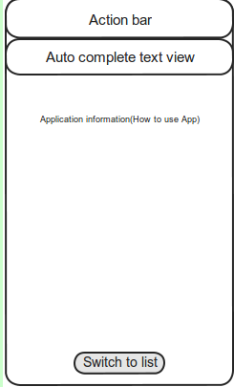
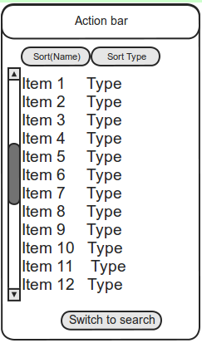

Item price history Item view
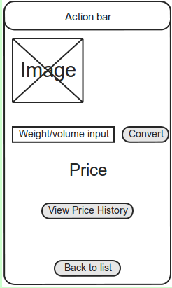
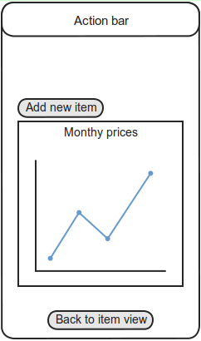

Common use cases
Use case: Switching views
Precondition: The user has installed the application.
User | System
User starts the application | The user is shown a text box to search in and a button to switch view
User clicks switch view | A scrollable list view is displayed which shows every item available
Note: the Textbox is shown first because it would take less time to load a textbox than it would every item in the list

Use case: clicking an item
Precondition: User has started the application and viewing a list of items either from the list view or the auto complete text box
User | System
User hover's over the item | Picture of the food item is displayed
User clicks the item | User is sent to the item view for that specific item

Use case: average price calculator
Precondition: User is in an item view of a specific Item.
User | System
 | A textbox with the weight/volume from the dataset and average price for the most recent month is displayed.
User inputs their specific weight/volume and clicks the convert button | The average price for that item at the specified weight/volume is displayed

Use case: View price history
Precondition: User is in an item view of a specific Item.
User | System
User clicks on the view history button | A graph is displayed with the price history of that item
User clicks compare item | User is prompted to enter a item name( auto complete text view offers suggestions)
Loop: User enters item name and clicks it | A new entry is queued to be added to graph.
User decides he has chosen enough items | All entrys are displayed on graph in different colours.

Timeline:

Weeks starting from March 2nd | Goals
Week 1 | Code basic structure of views and activitys with filler data
Week 2 | Create fully functional unit converter to use for price calculations
Week 3 | Implement a way to retrieve files from internet to put on app
Week 4 | Implement parser to parse data from file and implement graph views for item price history
Week 5 | Buffer week(extra time allocated if things take longer than expected.
Week 6 | Bug testing debugging.

Conclusion

When beginning this project I had hoped to be able to compare prices ahead of time with data collected from grocery store websites, unfortunatly it appears impossible due most of the websites not showing all the items in their store. Regardless I think this will be a useful app that is applicable to many users, It expands on the base functionality of the dataset by converting values and allowing easy access to items. It has a useful purpose to allow users access food price data easily and efficiently.

