Red Team

James Brown

Joshua Frazier

Christopher McCracken

Taylor Reid

Jul 11, 2022

Module 11.1

Reports:

1. Late deliveries

Late Deliveries report displays a month by month tracking of deliveries that were late and the time gap it took to be logged.

* Assumption was made if the deliveries arrived on different dates and were logged.

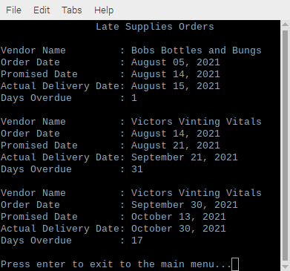

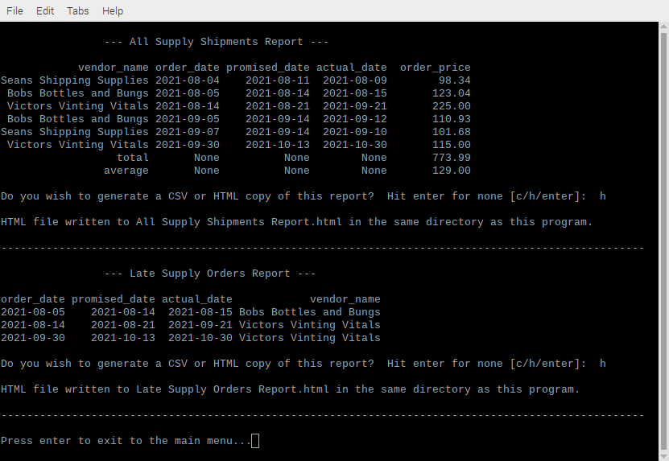

1. Wines sold report - a report showing which wines were most popular with each distributor and ranked by bottles sold.

Wines Sold report identifies the wines by type, which type the distributor carries, and how many were sold for focus.

* Assumption made here is based on region and demand.

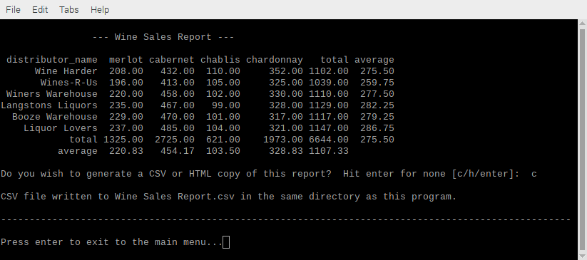

1. Hours worked by employees during each quarter.

Hours Worked breaks down an employee's credentials, role, and quarter on hours worked and provides a total for account budgeting.

* Assumptions made were employees worked only one role and paid hourly per quarter.

