James Brown

CSD-340

Web Development with HTML & CSS

Module 1.2 Assignment

8/11/2022

GitHub Repository: <https://github.com/James072/csd-340>

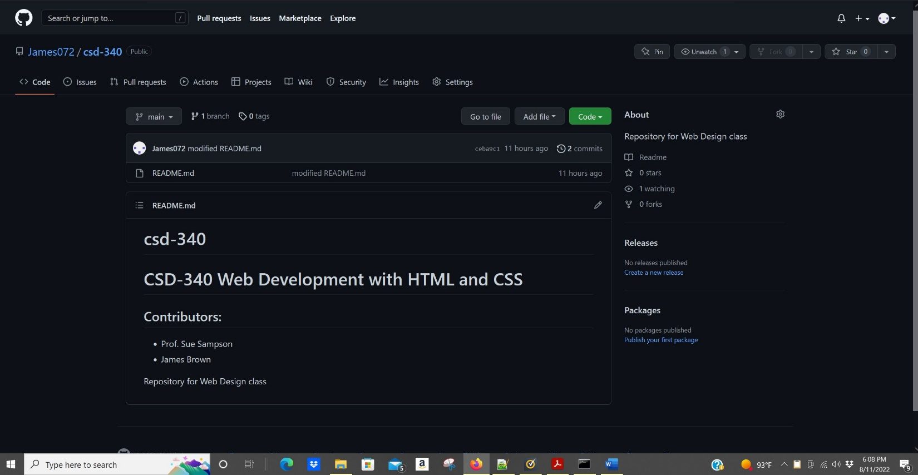**Screenshot #1**

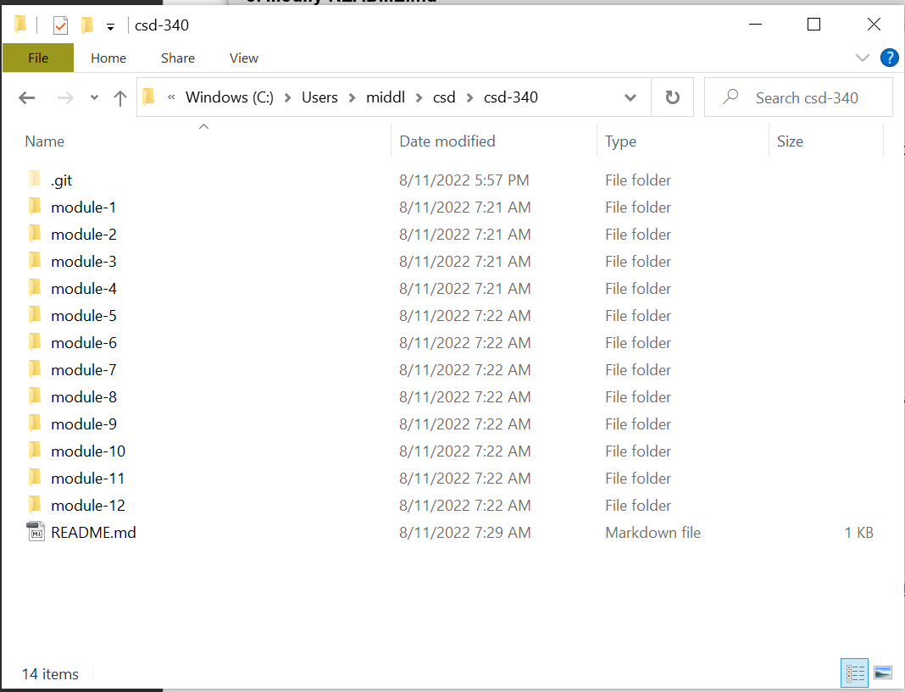 **Screenshot #2**