James Brown

CSD 340

Web Development with HTML & CSS

Module 11.2

10/7/2022

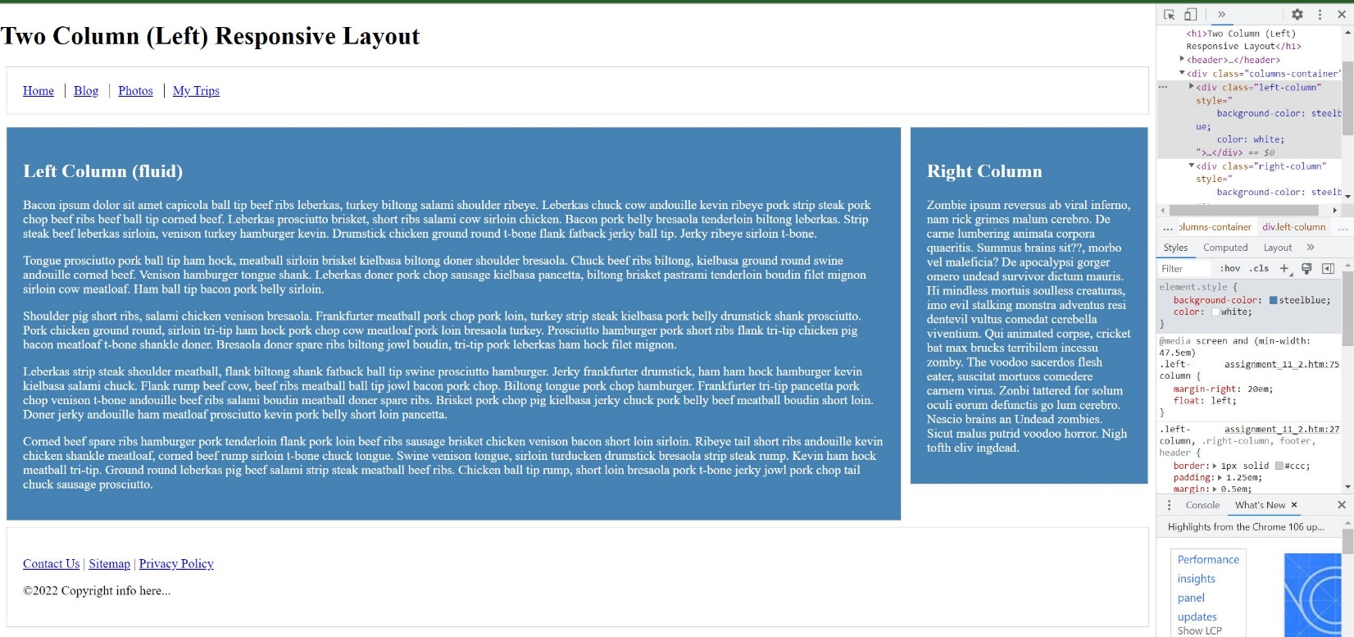**Screenshot of Modified HTML file**