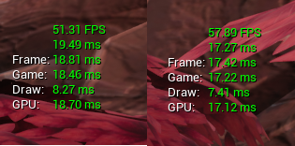After looking at the profilers I noticed that in the statistics panel several textures were being referenced in 4k by hundreds of actors. I went through each texture and reduces their resolution to between 1080p and 512. This improved the games performance to some degree. As seen below, there is still a considerable issue with the GPU bottlenecking in areas of the game. The images on the left are from the initial profiling of the game and the images on the left are after reducing the texture sizes. Then in descending order the areas of testing are:

1. The beginning of the Tiger Level
2. Midway through the Tiger Level
3. 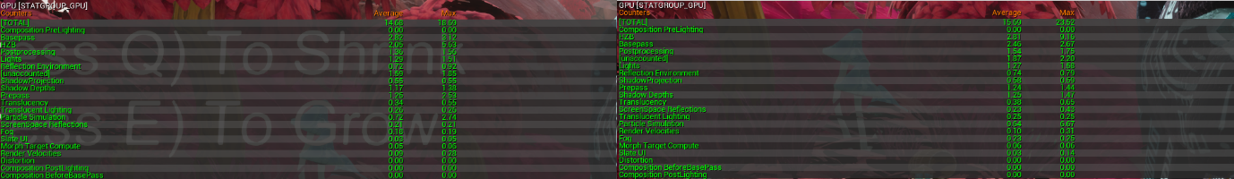Tutorial Level

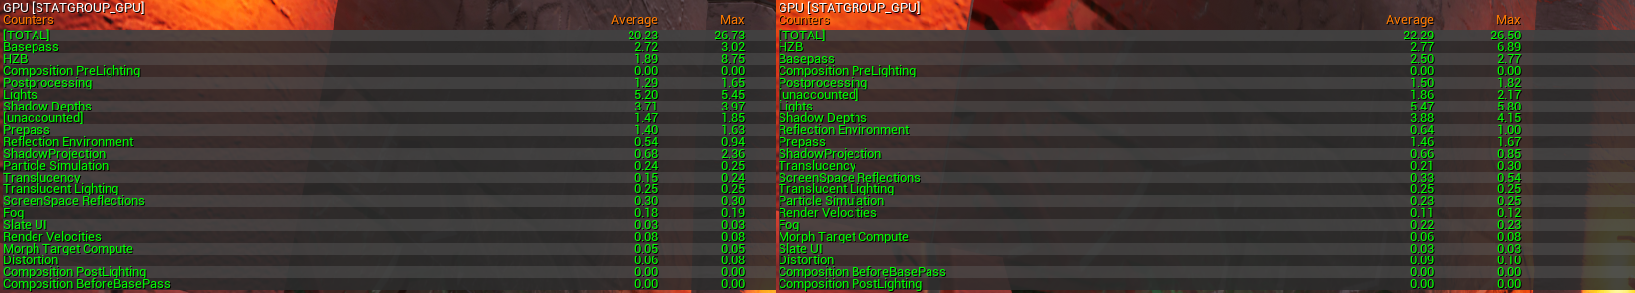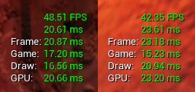From the GPU stats it is unclear at this point what exactly could be causing an issue, but as we can see the Game is almost matching the frame so there is also a bottleneck there too, so one step the I will be taking is to use the profiler for the scripts at this point. Though running at 17-18ms is almost 60fps so not too much of a worry at this point.

Looking at the stats halfway through the level, reducing the textures obviously has not had any effect on the GPU but is most certainly clear the GPU is the issue, as the Game is far quicker with a 15-17ms speed than the GPU with 20-23ms speed. This bottleneck is limiting the game to less than 45fps which is no idea.

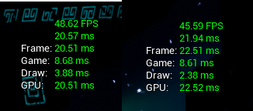Looking at the GPU stats we can see that there is an obvious culprit here, the lighting, at 5+ms this is causing a big drain on the GPU cycles. Unfortunately you can not get much more details from the in game stats, but running the GPU profiler in editor can give you a basic idea of what lighting is the cause of this issue. There is also the issue of shadow depths which is also related to lighting.

In the tutorial level the GPU is also the issue, but looking at the GPU stats it is for a very different reason, as the lighting is down to 1.38ms instead of 5+. Here the issue is the Composition PreLighting, which is mostly affected by the Rendering resolution, and occlusion. This again is an issue with the lighting as this is a costly thing to render.

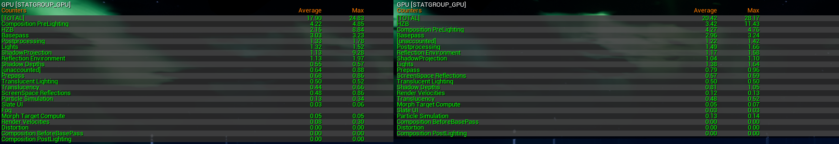

The next step that I shall be taking is to simplify the lighting as much as possible but ensuing that all lights that don’t move are set to static and attempting reduce the amount of lighting used, although this could also include large actors that cast shadows.