HW7 Report

**林峻賢 0711540**

**Part I**

1. **When h1 ping h2, what will happen?**

|  |
| --- |
|  |

|  |
| --- |
| ARP :  h1 sent request  h2 received and replied  h1 received the reply  ICMP :  h1 sent request  h2 received and replied  h1 received the reply |

1. **When h1 ping h3, what will happen?**

|  |
| --- |
|  |

|  |
| --- |
| ARP :  h1 sent request  h3 received and replied  h1 received the reply  ICMP :  h1 sent request  h3 received and replied |

1. **When h3 ping h2, what will happen?**

|  |
| --- |
|  |

|  |
| --- |
| ARP :  h3 sent request  h2 received and replied  h3 received the reply  ICMP :  h3 sent request |

1. **When h1 ping h5, what will happen?**

|  |
| --- |
|  |

ARP :

h1 sent request * 3 times

**Part II**

1. **When h1 ping h5, what will happen?**

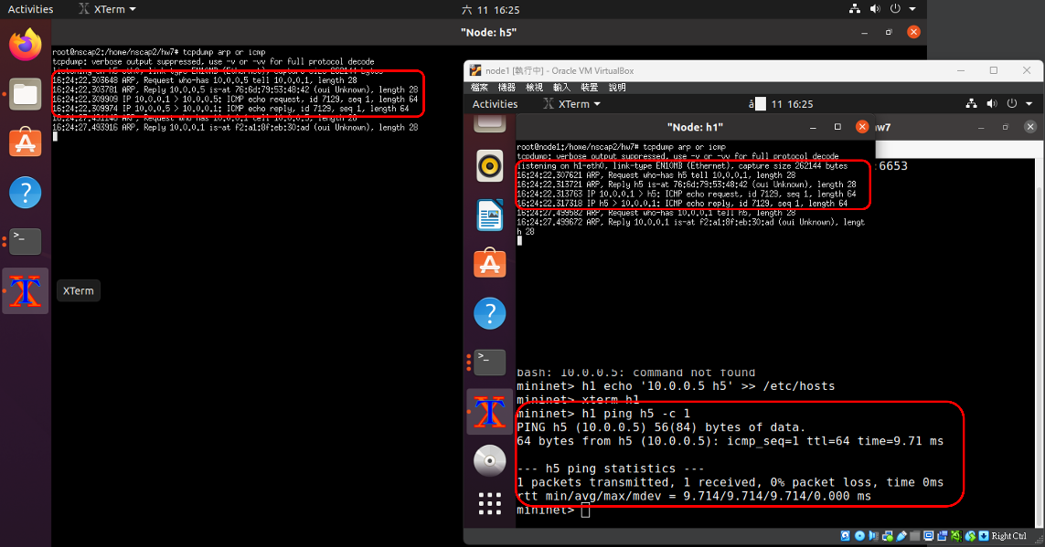

ARP :

h1 sent request

h5 received and replied

h1 received the reply

ICMP :

h1 sent request

h5 received and replied

h1 received the reply

1. **When h1 ping h7, what will happen?**

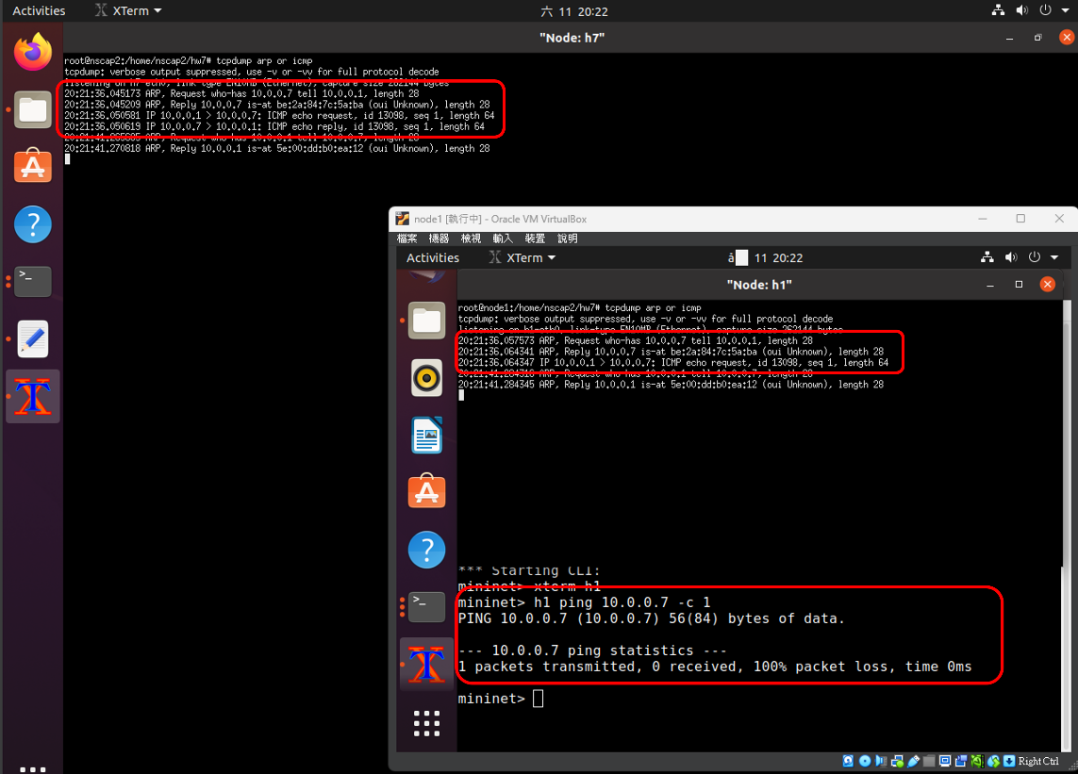

ARP :

h1 sent request

h7 received and replied

h1 received the reply

ICMP :

h1 sent request

h7 received and replied

1. **When h7 ping h1, what will happen?**

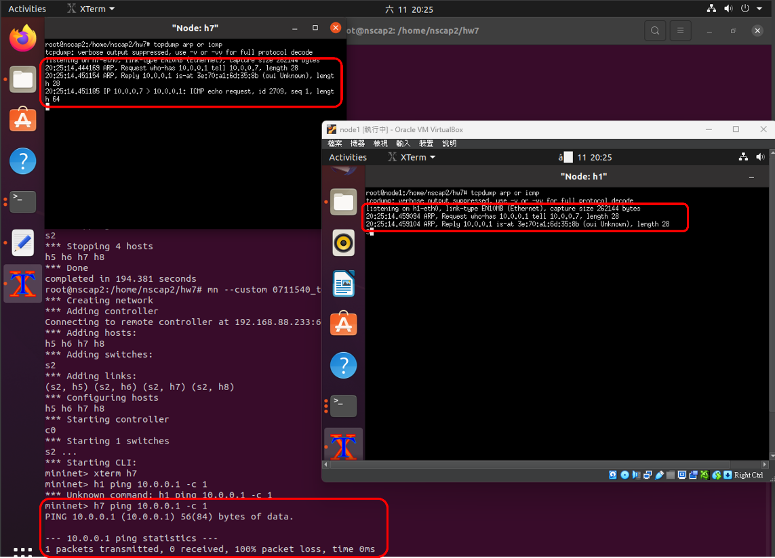

ARP :

h7 sent request

h1 received and replied

ICMP :

h7 sent request

h7 received the reply

1. **If the packet in question 6 or 7 is dropped in some part of the network, are the outcome and explanation the same as that of question 4? (use screenshot to prove)**

ANS：(同Q4、6、7圖)Q6、7(ping)失敗是因為switch 2將h7的icmp request(or reply)丟棄；而Q4(ping)失敗的原因是ARP協議找不到目標host，兩個失敗原因是不同的。

1. **Change filter_table2 rule**

* **From: packets coming from port_3 or port_4 will be dropped, while other packets will be allowed to pass.  
  To: packets coming from port_1 or port_2 will be allowed to pass, while other packets will be dropped.**
* **Will the outcome of questions 5, 6, and 7 differ? (no need to print screenshot), explain why or why not.**

**ANS：**

For Q5：

不同，由於icmp request將由switch 2送往h5時會觸發filter2規則，此封包將被丟棄。

For Q6：

相同，一樣都是h7發送icmp reply時被switch 2丟棄該封包。

For Q7：

相同，一樣都是h7發送icmp request時被switch 2丟棄該封包。