Don’t Isol8 Design Document

1/23/2023

Contents

Introduction 3

Ideas Development 3

Target Audience 3

Age 3

Gender 3

Lifestyle 4

Accessibility 4

Technical Aspects 4

Design Aspects 4

# Introduction

I am going to make an interactive media website for a charity called Don’t Isol8. This website will support teenagers and young adults with their mental health. It will include methods of improving mental health and opportunities for those struggling with their mental health to get support.

# Ideas Development

## Wireframes

### Home Page

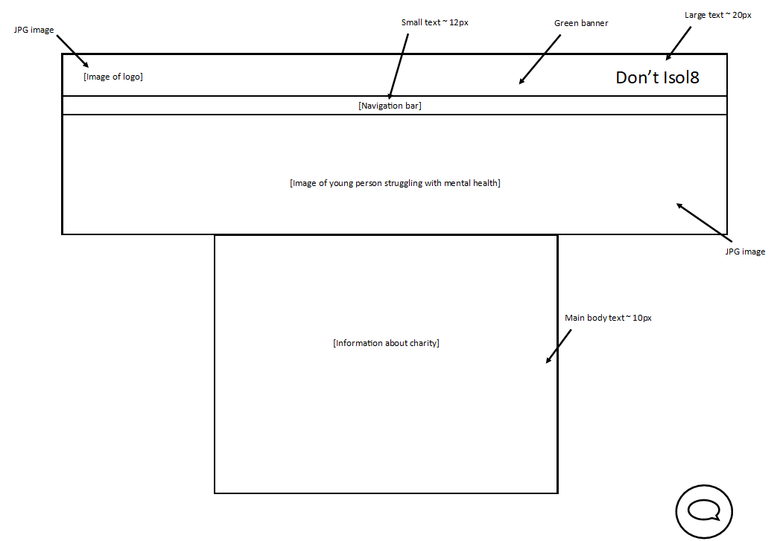

This is my wireframe for the home page. I have decided to go for a design that is engaging for people no matter their age. It is a very universal and familiar website design. It has a green banner across the top of the website because that will be one of the main colours of the website. It will have the logo and name of the charity on the green banner because it means that young people that want to visit the website know where they’re getting help from, so they can recommend it to others who may also need help with their mental health.

I have decided to make the images JPGs because they load very quickly which is essential on a website. Many people will turn away from a website if the images load slowly, which could end with terrible results if people in need of support don’t visit the website just because it is slow.

I have included a navigation bar to help users navigate the site with ease. This is important because it means that people don’t have a difficult time navigating the website. My aim is to make the website as easy to use as possible. This will enable those in need of support to receive it as soon as possible.

The homepage will include a button that allows users to talk to someone as soon as they open the website. This is a very important feature because people struggling with mental health may need someone to talk to, and this means that those people can get the support they need as soon as they visit the website.

# Target Audience

## Age

My target audience is teenagers and young adults up to the age of 25. This is because this is the target audience for the charity that I am creating this website for. I will make my website more suitable for teenagers and young adults by including features such as interactive quizzes. This will appeal to younger people especially because they are generally more interested in technology.

I will make the website a calculated mix between text and information and colourful images. This is so that it appeals to people that are both on the younger and older end of my target audience. Younger people generally like a more colourful website, whereas an older audience may prefer more text.

Websites are a very good way of engaging with young people because they are often very comfortable using the internet and navigating websites. Putting the charity support on a platform that is very familiar for people will help it greatly.

## Gender

My target audience is not gendered, it is targeted to all people. This means that I will need to create a website that is suitable for all genders. This means making a colour scheme that does not favour one gender over another. Some colour schemes are more engaging for some genders. Men may like a colour scheme including more [blues, blacks, olive greens](https://www.supermoney.com/colors/), women may like a colour scheme including more [pink or purple](https://www.supermoney.com/colors/) colours.

I will use a colour scheme that includes more greens and yellows because this is a more [neutral colour scheme](https://www.colorsexplained.com/gender-neutral-colors/) for everyone visiting my website. This means that it will engage everyone that wants to go to the website, meaning higher success for Don’t Isol8.

## Lifestyle

My target audience is all people that fit into the age range previously stated, so I won’t be targeting a specific type of people who have a specific lifestyle. This means that I won’t be creating anything that appears to exclude anyone. I will make a website that is all-inclusive. This means that I won’t make the website too fancy or showy because this could discourage people who aren’t used to that kind of website.

## Accessibility

Because the target audience of my website is all-inclusive within the age-range I will be making my website very accessible for everyone. This will include options to change colours for people that can’t see colour very well, adding alt-text for all images for those with sight-impairments, large text options, links will be very descriptive for screen-readers, etc.

This will ensure that as many people as possible can get support from my website without excluding anyone. This is essential because according to a [report by the CDC in the US](https://www.cdc.gov/ncbddd/disabilityandhealth/features/mental-health-for-all.html), People will disabilities are more prone to mental health issues, and this website will be a resource to help those people.

# Technical Aspects

# Design Aspects